WOXSEN UNIVERSITY
Hyderabad, Telangana

ASSIGNMENT #12
Protected Routes and Session Handling
A React Library Client with Role-Based Access, In-Memory Access Tokens and Rotating HttpOnly Refresh Cookies
Submitted by
K Author Abhikkhyath Gundi
Roll Number: 24WU0101126
B.Tech, Computer Science and Engineering (CSE)
Section: Panther
GitHub Repository
github.com/authorabhikhyath-blip/pbl-fsd-chromedevtools
Academic Year 2026
TABLE OF CONTENTS
Introduction 3
Objective 3
Tools 3
Steps performed 3
Results 3
Observations 3
Before versus after security comparison 4
Industry lesson 4
Conclusion 4
GitHub 4
Demo procedure 4
Screenshots 5
Flow of Authentication 9
Appendix A: Run Log 9
Appendix B: Source Code 10
server/src/index.js 10
server/src/seed.js 11
server/.env.example 12
client/src/api.js 12
client/src/AuthContext.jsx 12
client/src/main.jsx 13

Introduction

Objective
Build a React library client with login, protected routes, role-based menus, in-memory access tokens, and a rotating refresh token held in an HttpOnly cookie. Demonstrate a localStorage-based “before” implementation beside the safer “after” implementation.

Tools
React 18, Vite, React Router 6, Axios interceptors, Express, SQLite (better-sqlite3), bcryptjs, JSON Web Tokens, Zod, Swagger UI, and cookie-parser.

Steps performed
- Scaffolded library-app/server and library-app/client because the supplied workspace had no pre-existing application files to extend.
- Added the users and refresh-token tables, bcrypt-seeded demo accounts, sample books, auth endpoints, rotating SHA-256-hashed refresh tokens, JWT authentication, role authorization, CORS, and Swagger documentation.
- Added the Vite React client, in-memory AuthContext, Axios bearer/refresh/retry handling, React Router guards, role menus, library data views, session countdown panel, and a separate localStorage “before” demo.
- Used a configurable one-minute access-token default. The client schedules refresh twenty seconds before expiry and restores its session by trying /v1/auth/refresh once on load.

Results
The implementation is present in this workspace. The login endpoint returns a short-lived access token and sets a rotating refresh cookie; logout revokes the current refresh token. API authentication returns 401 for missing/invalid/expired tokens, and role mismatches return 403. The application includes a role-specific admin, librarian, or member menu and protected data endpoints.
The application was installed and run; results and screenshots are in the Evidence section. The original project was not present in the workspace, so the library resources were scaffolded as a demonstration API.

Observations
The browser's JavaScript can read a token saved in localStorage; the /before page writes a demo token and logs it to the Console. JavaScript cannot read an HttpOnly refresh cookie, but the browser attaches it to same-origin/cross-origin requests when credentials are enabled and cookie policy permits. The after demo keeps the access token only in application memory, so a page reload loses it and the client uses the refresh cookie to restore a session.
For local HTTP development the cookie's Secure attribute is disabled (NODE_ENV is not production), because browsers will not send a Secure cookie over ordinary http://localhost. Deploy behind HTTPS with NODE_ENV=production; then Secure is enabled. SameSite is Strict and cookie path is /v1/auth in both modes.

Before versus after security comparison
Concern | Before: localStorage access token | After: memory access token + HttpOnly refresh cookie
JavaScript access to credential | Any same-origin script can read it; an XSS can exfiltrate it. | Access token is not persisted; JavaScript cannot read the HttpOnly refresh cookie. An active XSS can still act as the user while the app is running.
Reload behavior | Token remains available after reload. | Memory token disappears; the app silently restores it using the refresh cookie.
Server-side revocation | A copied access token remains valid until expiry. | Hashed refresh token can be revoked; short-lived access token remains valid until its own expiry.
Cross-site request concern | Bearer token normally must be explicitly attached by script. | Cookie requests need CSRF defenses; this demo uses SameSite=Strict, a narrow cookie path, and exact-origin credentialed CORS.
Demo role | Intentionally insecure teaching example. | Preferred session pattern demonstrated by this assignment.

Industry lesson
Storing tokens in localStorage is a common audit finding; memory + httpOnly cookie is the usual fix. The cookie reduces credential exposure to JavaScript, but it does not remove XSS risk or the need for HTTPS, careful CORS, CSRF controls, short token lifetimes, and server-side revocation.

Conclusion
The assignment demonstrates protected navigation, role authorization, refresh-token rotation, silent refresh, refresh failure logout, and the security distinction between browser-readable persistent storage and an HttpOnly cookie. Evidence from a live run is in the Evidence section.

GitHub
Repository: https://github.com/authorabhikhyath-blip/pbl-fsd-chromedevtools

Demo procedure
- Start server and client using the setup commands in the submission response. Open http://localhost:5173.
- Open /before, sign in with any demo user, and inspect Console and Application → Local Storage. Clear this demo token with the page's button before moving on.
- Open /login. Sign in as member: member@library.test / MemberPass123!. Confirm Books and My loans appear, and Members/Loans do not. Open /members directly to show 403.
- Sign out and repeat with librarian: librarian@library.test / LibrarianPass123!. Confirm Books and Loans appear but Manage books/Members do not.
- Sign out and repeat with admin: admin@library.test / AdminPass123!. Confirm Books, Members, and Manage books. Use the Members page to verify the seeded member record.
- For silent refresh, sign in and watch the debug countdown. Keep Network open; around 20 seconds before token expiry, the client calls /v1/auth/refresh, retries transparently if an API request encounters 401, and starts a new countdown.
- To force logout, sign in, then in DevTools Application → Cookies delete refreshToken before the scheduled refresh. Wait until the access token expires (or set ACCESS_TOKEN_TTL=25s and restart). At refresh time the refresh request fails; the app clears its in-memory session and redirects to /login. Alternatively revoke the current refresh token directly in SQLite with UPDATE refresh_tokens SET revoked=1 WHERE revoked=0;.

Screenshots
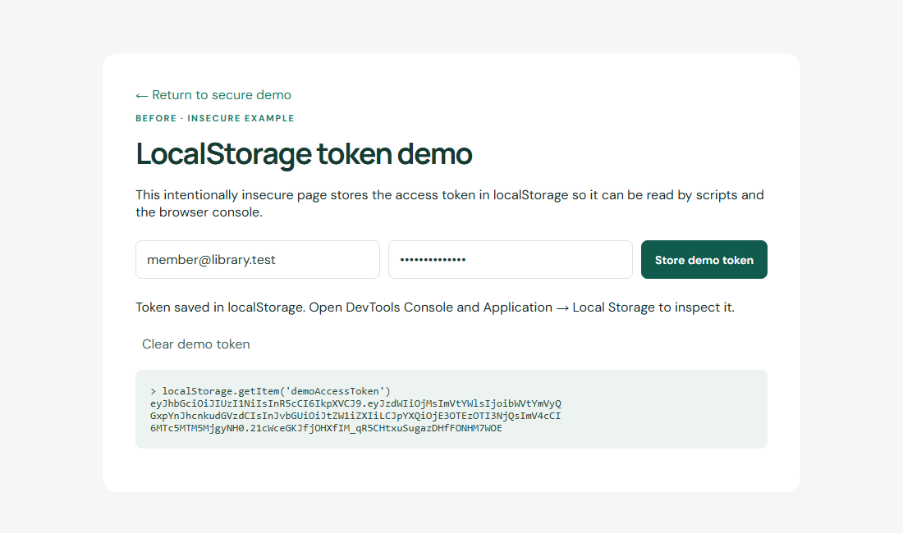
Figure 1: Before: access token stored in localStorage and printed to the Console (insecure demo).
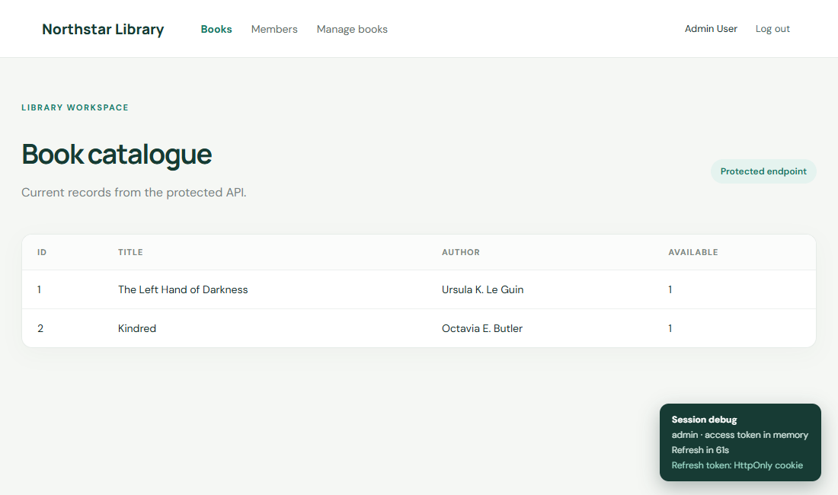
Figure 2: After: admin session with menu Books, Members, Manage books, and the in-memory token countdown.
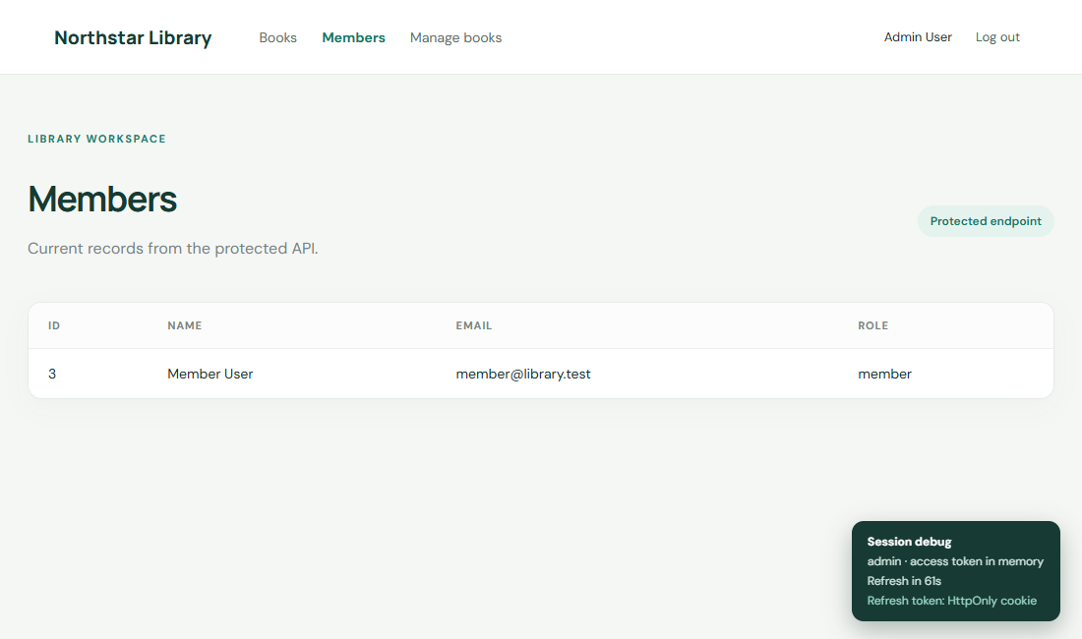
Figure 3: Admin Members page loading from the protected /v1/members endpoint.
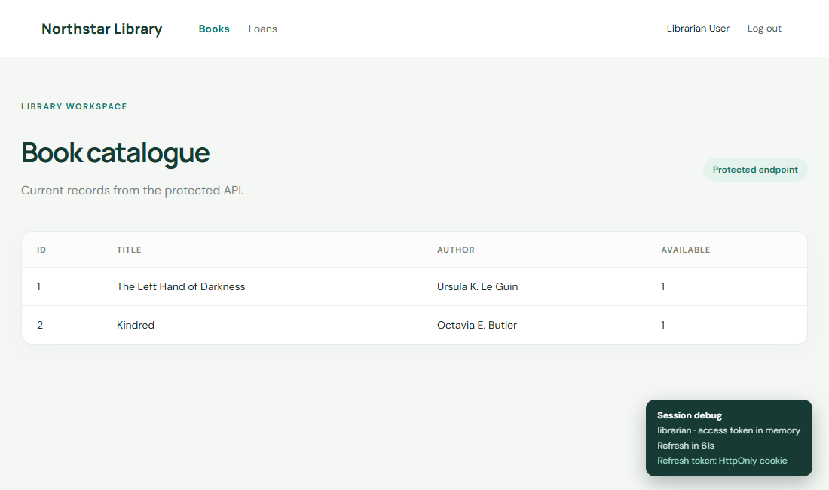
Figure 4: Librarian session with menu Books and Loans.
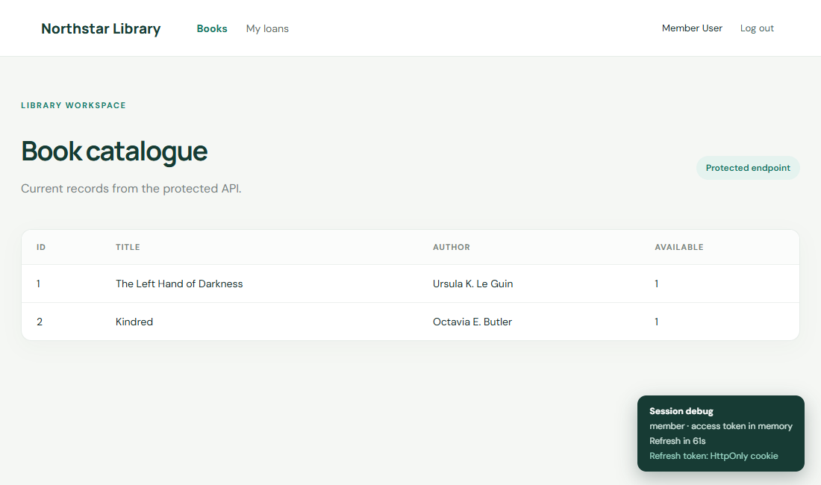
Figure 5: Member session with menu Books and My loans; localStorage empty, refresh token in an HttpOnly cookie.
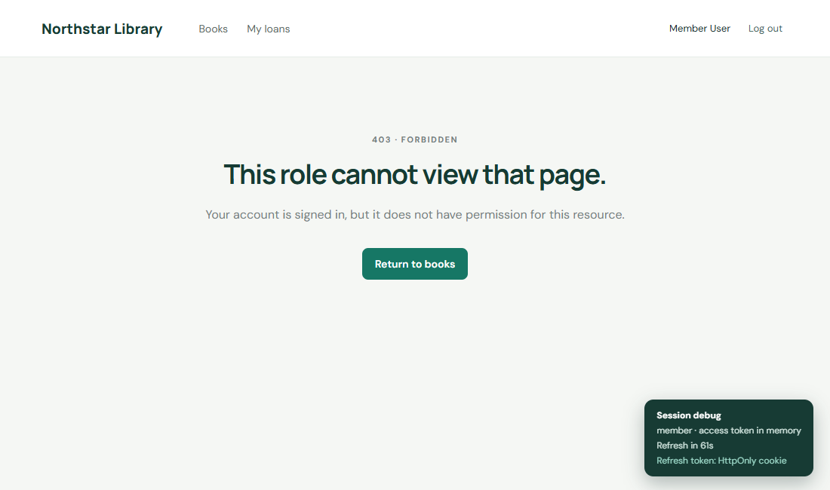
Figure 6: Member navigating directly to /members is shown the 403 Forbidden page.
Figure 7: Session countdown before silent refresh (about 61 s).
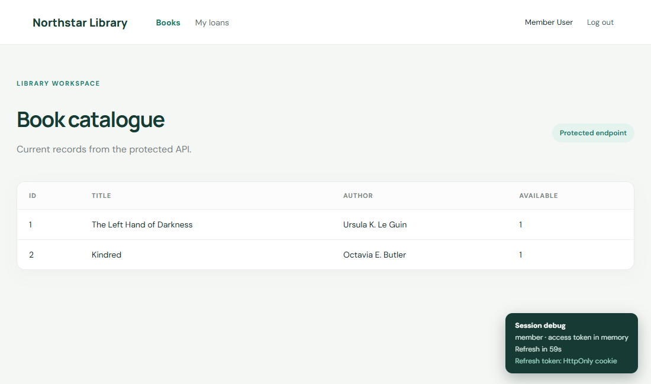
Figure 8: After POST /v1/auth/refresh returned 200, the countdown reset to about 59 s without leaving the page.

Figure 9: Forced logout: refresh cookie deleted, refresh returned 401, and the app redirected to /login.

Flow of Authentication
Login issues an access JWT (kept in memory) and a rotating HttpOnly refresh cookie. The client refreshes 20 seconds before expiry. If refresh fails (cookie missing, expired or revoked) the API returns 401 REFRESH_FAILED and the client clears its session and redirects to /login.

Appendix A: Run Log
[console] INSECURE DEMO access token: eyJhbGciOiJIUzI1NiIsInR5cCI6IkpXVCJ9.eyJzdWIiOjMsImVtY
WlsIjoib…
BEFORE localStorage.demoAccessToken = eyJhbGciOiJIUzI1NiIsInR5cCI6IkpXVCJ9.eyJzdWIiOjMsImVtY
WlsIjo…
admin menu: Books | Members | Manage books
refreshToken cookie httpOnly=true sameSite=Strict path=/v1/auth | document.cookie="" | loc
alStorage keys=0
librarian menu: Books | Loans
refreshToken cookie httpOnly=true sameSite=Strict path=/v1/auth | document.cookie="" | loc
alStorage keys=0
member menu: Books | My loans
refreshToken cookie httpOnly=true sameSite=Strict path=/v1/auth | document.cookie="" | loc
alStorage keys=0
member -> /members shows 403 page at http://localhost:5173/403
countdown at login: Session debug · member · access token in memory · Refresh in 61s · Refre
sh token: HttpOnly cookie
countdown 8s later: Refresh in 53s
silent refresh fired: 17:06:49 POST /v1/auth/refresh -> 200
countdown after refresh: Refresh in 59s
refreshToken cookie deleted; waiting for next refresh…
refresh attempts: 17:07:29 POST /v1/auth/refresh -> 401
redirected to http://localhost:5173/login

All refresh calls:
17:06:08 POST /v1/auth/refresh -> 401
17:06:09 POST /v1/auth/refresh -> 200
17:06:49 POST /v1/auth/refresh -> 200
17:07:29 POST /v1/auth/refresh -> 401
17:07:29 POST /v1/auth/refresh -> 401

Appendix B: Source Code

server/src/index.js
import 'dotenv/config';
import express from 'express'; import cors from 'cors'; import cookieParser from 'cookie-par
ser'; import Database from 'better-sqlite3'; import bcrypt from 'bcryptjs'; import jwt from
'jsonwebtoken'; import {randomBytes,createHash,randomUUID} from 'node:crypto'; import swagge
rUi from 'swagger-ui-express'; import {z} from 'zod';
const app=express(),db=new Database(process.env.DB_PATH||'./library.sqlite'); db.pragma('jou
rnal_mode = WAL');
db.exec(`CREATE TABLE IF NOT EXISTS users(id INTEGER PRIMARY KEY,name TEXT NOT NULL,email TE
XT UNIQUE NOT NULL,password_hash TEXT NOT NULL,role TEXT NOT NULL CHECK(role IN ('admin','li
brarian','member'))); CREATE TABLE IF NOT EXISTS refresh_tokens(id INTEGER PRIMARY KEY,user_
id INTEGER NOT NULL REFERENCES users(id),token_hash TEXT UNIQUE NOT NULL,expires_at INTEGER
NOT NULL,revoked INTEGER NOT NULL DEFAULT 0); CREATE TABLE IF NOT EXISTS books(id INTEGER PR
IMARY KEY,title TEXT NOT NULL,author TEXT NOT NULL,available INTEGER NOT NULL DEFAULT 1); CR
EATE TABLE IF NOT EXISTS loans(id INTEGER PRIMARY KEY,book_id INTEGER NOT NULL,user_id INTEG
ER NOT NULL,status TEXT NOT NULL DEFAULT 'active');`);
const digest=s=>createHash('sha256').update(s).digest('hex'), secret=()=>process.env.JWT_ACC
ESS_SECRET||'development-secret-change-me', duration=process.env.ACCESS_TOKEN_TTL||'60s';
function seconds(v){const m=/^(\d+)(s|m|h|d)$/.exec(v);return m?Number(m[1])*({s:1,m:60,h:36
00,d:86400}[m[2]]):60;}
function access(u){return jwt.sign({sub:u.id,email:u.email,role:u.role},secret(),{expiresIn:
duration});}
function refresh(u){const token=randomBytes(48).toString('base64url'),expires=Date.now()+Num
ber(process.env.REFRESH_TOKEN_DAYS||7)*86400000;db.prepare('INSERT INTO refresh_tokens(user_
id,token_hash,expires_at) VALUES(?,?,?)').run(u.id,digest(token),expires);return {token,expi
res};}
const cookieOptions=req=>({httpOnly:true,secure:process.env.NODE_ENV==='production'&&!['loca
lhost','127.0.0.1'].includes(req.hostname),sameSite:'strict',path:'/v1/auth'});
app.use(cors({origin:process.env.FRONTEND_ORIGIN||'http://localhost:5173',credentials:true})
);app.use(express.json());app.use(cookieParser());app.use((req,res,next)=>{req.requestId=ran
domUUID();res.set('X-Request-Id',req.requestId);next();});
const fail=(req,res,status,code,message,details=null)=>res.status(status).json({error:{code,
message,details,requestId:req.requestId}});
function authenticate(req,res,next){const token=(req.get('authorization')||'').replace(/^Bea
rer\s+/i,'');if(!token)return fail(req,res,401,'UNAUTHORIZED','Access token required');try{r
eq.user=jwt.verify(token,secret());next();}catch(e){return fail(req,res,401,'UNAUTHORIZED',e
.name==='TokenExpiredError'?'Access token expired':'Invalid access token');}}
const authorize=(...roles)=>(req,res,next)=>roles.includes(req.user.role)?next():fail(req,re
s,403,'FORBIDDEN','Your role cannot access this resource',{requiredRoles:roles});
app.get('/health',(req,res)=>res.json({status:'ok'}));
app.post('/v1/auth/login',(req,res)=>{const p=z.object({email:z.string().email(),password:z.
string().min(1)}).safeParse(req.body);if(!p.success)return fail(req,res,400,'VALIDATION_ERRO
R','Invalid login input',p.error.flatten());const u=db.prepare('SELECT * FROM users WHERE em
ail=?').get(p.data.email.toLowerCase());if(!u||!bcrypt.compareSync(p.data.password,u.passwor
d_hash))return fail(req,res,401,'INVALID_CREDENTIALS','Email or password is incorrect');cons
t r=refresh(u);res.cookie('refreshToken',r.token,{...cookieOptions(req),expires:new Date(r.e
xpires)});res.json({accessToken:access(u),expiresIn:seconds(duration),user:{id:u.id,name:u.n
ame,email:u.email,role:u.role}});});
app.post('/v1/auth/refresh',(req,res)=>{const raw=req.cookies.refreshToken;if(!raw)return fa
il(req,res,401,'REFRESH_FAILED','Refresh cookie missing');const old=db.prepare('SELECT * FRO
M refresh_tokens WHERE token_hash=? AND revoked=0').get(digest(raw));if(!old||old.expires_at
<Date.now()){if(old)db.prepare('UPDATE refresh_tokens SET revoked=1 WHERE id=?').run(old.id)
;res.clearCookie('refreshToken',cookieOptions(req));return fail(req,res,401,'REFRESH_FAILED'
,'Refresh token is invalid or expired');}const u=db.prepare('SELECT * FROM users WHERE id=?'
).get(old.user_id);db.prepare('UPDATE refresh_tokens SET revoked=1 WHERE id=?').run(old.id);
const r=refresh(u);res.cookie('refreshToken',r.token,{...cookieOptions(req),expires:new Date
(r.expires)});res.json({accessToken:access(u),expiresIn:seconds(duration),user:{id:u.id,name
:u.name,email:u.email,role:u.role}});});
app.post('/v1/auth/logout',(req,res)=>{const raw=req.cookies.refreshToken;if(raw)db.prepare(
'UPDATE refresh_tokens SET revoked=1 WHERE token_hash=?').run(digest(raw));res.clearCookie('
refreshToken',cookieOptions(req));res.status(204).end();});
const api=express.Router();api.use(authenticate);
api.get('/books',(req,res)=>res.json(db.prepare('SELECT * FROM books ORDER BY id').all()));
api.post('/books',authorize('admin'),(req,res)=>{const p=z.object({title:z.string().min(1),a
uthor:z.string().min(1)}).safeParse(req.body);if(!p.success)return fail(req,res,400,'VALIDAT
ION_ERROR','Invalid book',p.error.flatten());const id=db.prepare('INSERT INTO books(title,au
thor) VALUES(?,?)').run(p.data.title,p.data.author).lastInsertRowid;res.status(201).json(db.
prepare('SELECT * FROM books WHERE id=?').get(id));});
api.get('/authors',(req,res)=>res.json(db.prepare('SELECT DISTINCT author AS name FROM books
ORDER BY author').all()));api.get('/members',authorize('admin'),(req,res)=>res.json(db.prep
are("SELECT id,name,email,'member' AS role FROM users WHERE role='member'").all()));
api.get('/loans',authorize('admin','librarian'),(req,res)=>res.json(db.prepare('SELECT loans
.id,books.title,users.name AS member,loans.status FROM loans JOIN books ON books.id=loans.bo
ok_id JOIN users ON users.id=loans.user_id').all()));api.get('/me/loans',authorize('member')
,(req,res)=>res.json(db.prepare('SELECT loans.id,books.title,loans.status FROM loans JOIN bo
oks ON books.id=loans.book_id WHERE loans.user_id=?').all(req.user.sub)));
api.post('/loans',authorize('admin','librarian'),(req,res)=>{const p=z.object({bookId:z.numb
er().int(),userId:z.number().int()}).safeParse(req.body);if(!p.success)return fail(req,res,4
00,'VALIDATION_ERROR','Invalid loan',p.error.flatten());const id=db.prepare('INSERT INTO loa
ns(book_id,user_id) VALUES(?,?)').run(p.data.bookId,p.data.userId).lastInsertRowid;res.statu
s(201).json({id,...p.data,status:'active'});});app.use('/v1',api);
const spec={openapi:'3.0.3',info:{title:'Library API',version:'1.0.0'},servers:[{url:'http:/
/localhost:4000'}],components:{securitySchemes:{bearerAuth:{type:'http',scheme:'bearer',bear
erFormat:'JWT'}}},paths:{'/v1/auth/login':{post:{summary:'Log in and set HttpOnly refresh co
okie',responses:{'200':{description:'Access token and user'},'401':{description:'Invalid cre
dentials'}}}},'/v1/auth/refresh':{post:{summary:'Rotate refresh cookie and issue access toke
n',responses:{'200':{description:'Rotated'},'401':{description:'Rejected'}}}},'/v1/auth/logo
ut':{post:{summary:'Revoke refresh token',responses:{'204':{description:'Logged out'}}}},'/v
1/books':{get:{summary:'List books',security:[{bearerAuth:[]}],responses:{'200':{description
:'Books'},'401':{description:'Unauthorized'}}},post:{summary:'Create book (admin)',security:
[{bearerAuth:[]}],responses:{'201':{description:'Created'},'403':{description:'Forbidden'}}}
},'/v1/members':{get:{summary:'List members (admin)',security:[{bearerAuth:[]}],responses:{'
200':{description:'Members'},'403':{description:'Forbidden'}}}},'/v1/loans':{get:{summary:'L
ist loans (admin/librarian)',security:[{bearerAuth:[]}],responses:{'200':{description:'Loans
'},'403':{description:'Forbidden'}}}},'/v1/me/loans':{get:{summary:'Member loans',security:[
{bearerAuth:[]}],responses:{'200':{description:'Loans'},'403':{description:'Forbidden'}}}}}}
;
app.use('/api-docs',swaggerUi.serve,swaggerUi.setup(spec));app.use((req,res)=>fail(req,res,4
04,'NOT_FOUND','Route not found'));app.use((err,req,res,next)=>fail(req,res,err.status||500,
err.code||'INTERNAL_ERROR',err.message||'Unexpected server error',err.details||null));app.li
sten(Number(process.env.PORT||4000),()=>console.log(`Library API listening on port ${process
.env.PORT||4000}`));

server/src/seed.js
import 'dotenv/config';import Database from 'better-sqlite3';import bcrypt from 'bcryptjs';
const db=new Database(process.env.DB_PATH||'./library.sqlite');db.exec(`CREATE TABLE IF NOT
EXISTS users(id INTEGER PRIMARY KEY,name TEXT NOT NULL,email TEXT UNIQUE NOT NULL,password_h
ash TEXT NOT NULL,role TEXT NOT NULL CHECK(role IN ('admin','librarian','member')));CREATE T
ABLE IF NOT EXISTS refresh_tokens(id INTEGER PRIMARY KEY,user_id INTEGER NOT NULL REFERENCES
users(id),token_hash TEXT UNIQUE NOT NULL,expires_at INTEGER NOT NULL,revoked INTEGER NOT N
ULL DEFAULT 0);CREATE TABLE IF NOT EXISTS books(id INTEGER PRIMARY KEY,title TEXT NOT NULL,a
uthor TEXT NOT NULL,available INTEGER NOT NULL DEFAULT 1);CREATE TABLE IF NOT EXISTS loans(i
d INTEGER PRIMARY KEY,book_id INTEGER NOT NULL,user_id INTEGER NOT NULL,status TEXT NOT NULL
DEFAULT 'active');`);
for(const [name,email,password,role] of [['Admin User','admin@library.test','AdminPass123!',
'admin'],['Librarian User','librarian@library.test','LibrarianPass123!','librarian'],['Membe
r User','member@library.test','MemberPass123!','member']])db.prepare('INSERT OR IGNORE INTO
users(name,email,password_hash,role) VALUES(?,?,?,?)').run(name,email,bcrypt.hashSync(passwo
rd,12),role);
const ins=db.prepare('INSERT INTO books(title,author) SELECT ?,? WHERE NOT EXISTS(SELECT 1 F
ROM books WHERE title=?)');ins.run('The Left Hand of Darkness','Ursula K. Le Guin','The Left
Hand of Darkness');ins.run('Kindred','Octavia E. Butler','Kindred');console.log('Seeded dem
o accounts: admin@library.test / AdminPass123!, librarian@library.test / LibrarianPass123!,
member@library.test / MemberPass123!');
const member=db.prepare("SELECT id FROM users WHERE email='member@library.test'").get(),book
=db.prepare("SELECT id FROM books WHERE title='Kindred'").get();db.prepare("INSERT INTO loan
s(book_id,user_id,status) SELECT ?,?,'active' WHERE NOT EXISTS(SELECT 1 FROM loans WHERE boo
k_id=? AND user_id=?)").run(book.id,member.id,book.id,member.id);

server/.env.example
PORT=4000
FRONTEND_ORIGIN=http://localhost:5173
JWT_ACCESS_SECRET=replace-with-a-long-random-secret
ACCESS_TOKEN_TTL=60s
REFRESH_TOKEN_DAYS=7
DB_PATH=./library.sqlite

client/src/api.js
import axios from 'axios';
export const api=axios.create({baseURL:import.meta.env.VITE_API_URL||'http://localhost:4000'
,withCredentials:true});
let readToken=()=>null,handleRefresh=async()=>{throw new Error('Auth not ready')},handleLogo
ut=()=>{};let refreshing=null,waiters=[];
export function configureAuth({getToken,refresh,logout}){readToken=getToken;handleRefresh=re
fresh;handleLogout=logout;}
api.interceptors.request.use(config=>{const token=readToken();if(token)config.headers.Author
ization=`Bearer ${token}`;return config;});
api.interceptors.response.use(r=>r,async error=>{const req=error.config;if(error.response?.s
tatus!==401||!req||req._retried||req.url?.includes('/v1/auth/'))return Promise.reject(error)
;req._retried=true;if(!refreshing){refreshing=handleRefresh().then(token=>{waiters.forEach(w
=>w.resolve(token));waiters=[];return token;}).catch(e=>{waiters.forEach(w=>w.reject(e));wai
ters=[];handleLogout();throw e;}).finally(()=>{refreshing=null;});}else return new Promise((
resolve,reject)=>waiters.push({resolve,reject})).then(token=>{req.headers.Authorization=`Bea
rer ${token}`;return api(req);});try{const token=await refreshing;req.headers.Authorization=
`Bearer ${token}`;return api(req);}catch(e){return Promise.reject(e);}});

client/src/AuthContext.jsx
import React,{createContext,useCallback,useContext,useEffect,useMemo,useRef,useState} from '
react';import axios from 'axios';import {api,configureAuth} from './api';
const Auth=createContext(null),base=import.meta.env.VITE_API_URL||'http://localhost:4000';
export function AuthProvider({children}){const [session,setSession]=useState(null),[ready,se
tReady]=useState(false),[now,setNow]=useState(Date.now()),timer=useRef(null);
const logout=useCallback(async(callServer=true)=>{clearTimeout(timer.current);if(callServer)
try{await axios.post(`${base}/v1/auth/logout`,{}, {withCredentials:true});}catch{}setSession
(null);setReady(true);if(location.pathname!=='/login'&&location.pathname!=='/before')locatio
n.assign('/login');},[]);
const accept=useCallback(payload=>{const expiresAt=Date.now()+payload.expiresIn*1000;setSess
ion({...payload,expiresAt});return payload.accessToken;},[]);
const refresh=useCallback(async()=>{const {data}=await axios.post(`${base}/v1/auth/refresh`,
{}, {withCredentials:true});setSession({...data,expiresAt:Date.now()+data.expiresIn*1000});s
etReady(true);return data.accessToken;},[]);
useEffect(()=>{configureAuth({getToken:()=>session?.accessToken,refresh,logout:()=>logout(fa
lse)});},[session,refresh,logout]);
useEffect(()=>{let alive=true;axios.post(`${base}/v1/auth/refresh`,{}, {withCredentials:true
}).then(({data})=>{if(alive){setSession({...data,expiresAt:Date.now()+data.expiresIn*1000});
setReady(true);}}).catch(()=>{if(alive)setReady(true);});return()=>{alive=false;}},[]);
useEffect(()=>{if(!session)return;clearTimeout(timer.current);const delay=Math.max(0,session
.expiresAt-Date.now()-20000);timer.current=setTimeout(()=>refresh().catch(()=>logout(false))
,delay);return()=>clearTimeout(timer.current);},[session,refresh,logout]);
useEffect(()=>{const id=setInterval(()=>setNow(Date.now()),250);return()=>clearInterval(id);
},[]);
const login=useCallback(async(email,password)=>{const {data}=await api.post('/v1/auth/login'
,{email,password});setSession({...data,expiresAt:Date.now()+data.expiresIn*1000});setReady(t
rue);return data.user;},[]);
const value=useMemo(()=>({session,user:session?.user||null,ready,login,logout,remaining:sess
ion?Math.max(0,Math.ceil((session.expiresAt-now)/1000)):null}),[session,ready,login,logout,n
ow]);return <Auth.Provider value={value}>{children}</Auth.Provider>;}
export function useAuth(){return useContext(Auth);}

client/src/main.jsx
import React,{useEffect,useState}from'react';import{createRoot}from'react-dom/client';import
{BrowserRouter,Link,NavLink,Route,Routes,Navigate,Outlet,useLocation}from'react-router-dom';
import{AuthProvider,useAuth}from'./AuthContext';import{api}from'./api';import'./style.css';
function Protected(){const{ready,user}=useAuth(),loc=useLocation();if(!ready)return <p class
Name="center">Restoring session…</p>;return user?<Outlet/>:<Navigate to="/login" replace sta
te={{from:loc.pathname}}/>;}
function Role({allow}){const{user}=useAuth();return allow.includes(user?.role)?<Outlet/>:<Na
vigate to="/403" replace/>;}
function Debug(){const{user,remaining}=useAuth();return user?<aside className="debug"><b>Ses
sion debug</b><span>{user.role} · access token in memory</span><span>Refresh in {remaining}s
</span><span className="cookie-note">Refresh token: HttpOnly cookie</span></aside>:null;}
function Shell(){const{user,logout}=useAuth();return <><header><Link className="brand" to="/
">Northstar Library</Link><nav><NavLink to="/books">Books</NavLink>{user.role==='admin'&&<><
NavLink to="/members">Members</NavLink><NavLink to="/manage-books">Manage books</NavLink></>
}{user.role==='librarian'&&<NavLink to="/loans">Loans</NavLink>}{user.role==='member'&&<NavL
ink to="/my-loans">My loans</NavLink>}</nav><div className="userbox"><span>{user.name}</span
><button className="quiet" onClick={()=>logout()}>Log out</button></div></header><main><Outl
et/></main><Debug/></>;}
function Login(){const{login,user,ready}=useAuth(),loc=useLocation(),[email,setEmail]=useSta
te('member@library.test'),[password,setPassword]=useState('MemberPass123!'),[error,setError]
=useState('');if(ready&&user)return <Navigate to="/books" replace/>;async function submit(e)
{e.preventDefault();setError('');try{await login(email,password);location.assign(loc.state?.
from||'/books');}catch{setError('Login failed. Check the credentials and API server.');}}ret
urn <div className="login-wrap"><div className="login-card"><p className="eyebrow">NORTHSTAR
LIBRARY</p><h1>Welcome back</h1><p className="muted">Sign in to access your library workspa
ce.</p><form onSubmit={submit}><label>Email<input type="email" value={email} onChange={e=>se
tEmail(e.target.value)} required/></label><label>Password<input type="password" value={passw
ord} onChange={e=>setPassword(e.target.value)} required/></label>{error&&<p className="error
">{error}</p>}<button className="primary">Sign in</button></form><p className="muted small">
Demo: admin@library.test / AdminPass123! and other roles use the report credentials.</p><Lin
k to="/before">Open before-security demo →</Link></div></div>;}
function Forbidden(){return <section className="empty"><p className="eyebrow">403 · FORBIDDE
N</p><h1>This role cannot view that page.</h1><p>Your account is signed in, but it does not
have permission for this resource.</p><Link className="primary linkbtn" to="/books">Return t
o books</Link></section>;}
function NotFound(){return <section className="empty"><p className="eyebrow">404 · NOT FOUND
</p><h1>That page isn’t here.</h1><Link to="/books">Back to library</Link></section>;}
function DataPage({title,path,columns,empty}){const[data,setData]=useState(null),[error,setE
rror]=useState('');useEffect(()=>{let alive=true;api.get(path).then(r=>alive&&setData(r.data
)).catch(e=>alive&&setError(e.response?.data?.error?.message||'Unable to load data'));return
()=>{alive=false;}},[path]);return <section><p className="eyebrow">LIBRARY WORKSPACE</p><div
className="page-title"><div><h1>{title}</h1><p className="muted">Current records from the p
rotected API.</p></div><span className="pill">Protected endpoint</span></div>{error?<div cla
ssName="notice error">{error}</div>:data===null?<p>Loading…</p>:data.length===0?<div classNa
me="empty"><h2>{empty||'Nothing to show yet'}</h2></div>:<div className="table-wrap"><table>
<thead><tr>{columns.map(c=><th key={c}>{c}</th>)}</tr></thead><tbody>{data.map((row,i)=><tr
key={row.id||i}>{columns.map(c=><td key={c}>{String(row[c.toLowerCase().replaceAll(' ','')]?
?row[c.toLowerCase()]??'—')}</td>)}</tr>)}</tbody></table></div>}</section>;}
function ManageBooks(){const[title,setTitle]=useState(''),[author,setAuthor]=useState(''),[n
otice,setNotice]=useState(''),[reload,setReload]=useState(0);async function add(e){e.prevent
Default();try{await api.post('/v1/books',{title,author});setNotice('Book added.');setTitle('
');setAuthor('');setReload(x=>x+1);}catch(e){setNotice(e.response?.data?.error?.message||'Co
uld not add book.');}}return <section><p className="eyebrow">ADMIN</p><h1>Manage books</h1><
form className="inline-form" onSubmit={add}><input aria-label="Book title" placeholder="Titl
e" value={title} onChange={e=>setTitle(e.target.value)} required/><input aria-label="Author"
placeholder="Author" value={author} onChange={e=>setAuthor(e.target.value)} required/><butt
on className="primary">Add book</button></form>{notice&&<p>{notice}</p>}<DataPage key={reloa
d} title="Book catalogue" path="/v1/books" columns={['id','title','author','available']}/></
section>;}
function Before(){const[email,setEmail]=useState('member@library.test'),[password,setPasswor
d]=useState('MemberPass123!'),[message,setMessage]=useState('');async function submit(e){e.p
reventDefault();try{const{data}=await api.post('/v1/auth/login',{email,password});localStora
ge.setItem('demoAccessToken',data.accessToken);console.log('INSECURE DEMO access token:',loc
alStorage.getItem('demoAccessToken'));setMessage('Token saved in localStorage. Open DevTools
Console and Application → Local Storage to inspect it.');}catch{setMessage('Login failed.')
;}}return <main className="before"><Link to="/login">← Return to secure demo</Link><p classN
ame="eyebrow">BEFORE · INSECURE EXAMPLE</p><h1>LocalStorage token demo</h1><p>This intention
ally insecure page stores the access token in localStorage so it can be read by scripts and
the browser console.</p><form className="inline-form" onSubmit={submit}><input type="email"
value={email} onChange={e=>setEmail(e.target.value)}/><input type="password" value={password
} onChange={e=>setPassword(e.target.value)}/><button className="primary">Store demo token</b
utton></form>{message&&<p>{message}</p>}<button className="quiet" onClick={()=>{localStorage
.removeItem('demoAccessToken');setMessage('Demo token removed.');}}>Clear demo token</button
><pre>localStorage.getItem('demoAccessToken')</pre></main>;}
function App(){return <AuthProvider><BrowserRouter><Routes><Route path="/login" element={<Lo
gin/>}/><Route path="/before" element={<Before/>}/><Route element={<Protected/>}><Route elem
ent={<Shell/>}><Route index element={<Navigate to="/books" replace/>}/><Route path="books" e
lement={<DataPage title="Book catalogue" path="/v1/books" columns={['id','title','author','a
vailable']}/>}/><Route element={<Role allow={['admin']}/> }><Route path="members" element={<
DataPage title="Members" path="/v1/members" columns={['id','name','email','role']}/>}/><Rout
e path="manage-books" element={<ManageBooks/>}/></Route><Route element={<Role allow={['admin
','librarian']}/> }><Route path="loans" element={<DataPage title="All loans" path="/v1/loans
" columns={['id','title','member','status']}/>}/></Route><Route element={<Role allow={['memb
er']}/> }><Route path="my-loans" element={<DataPage title="My loans" path="/v1/me/loans" col
umns={['id','title','status']}/>}/></Route><Route path="403" element={<Forbidden/>}/></Route
></Route><Route path="*" element={<NotFound/>}/></Routes></BrowserRouter></AuthProvider>;}
createRoot(document.getElementById('root')).render(<App/>);

