**Hello_3d_World Documentation**

**Created by**

Amnard Lungsun 6130627221

**2110215 Programming Methodology**

**Semester 1 Year 2019**

**Chulalongkorn University**

**Class diagram**

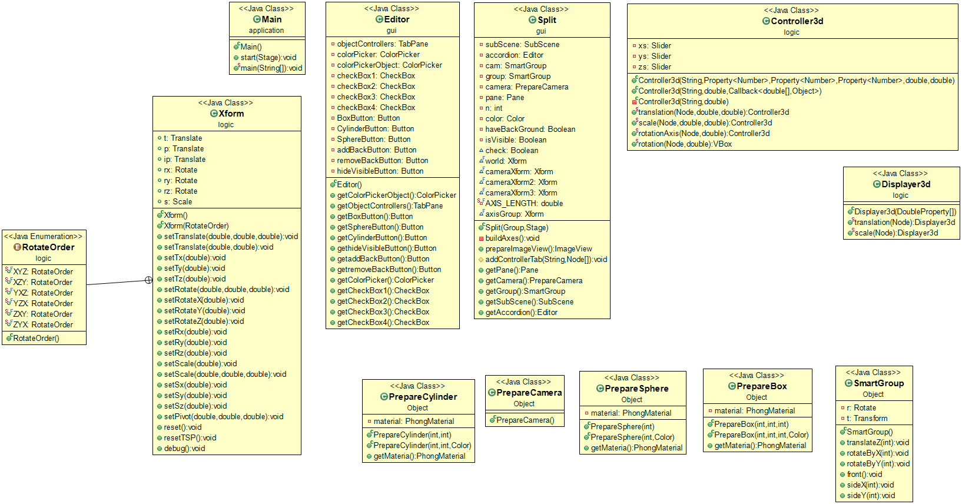

**1.Package Object**

**1.1PrepareBox**

**1.1.1Fields**

|  |  |
| --- | --- |
| - PhongMaterial material | Store texture of shape |

**1.1.2Constructor**

|  |  |
| --- | --- |
| + PrepareBox(int Width, int Height, int Depth) | **Store texture of shape** |
| + PrepareBox(int Width, int Height, int Depth, Color color) |  |

**1.1.3Methods**

|  |  |
| --- | --- |
| + PhongMaterial getMaterial() | **Store texture of shape** |

**1.2PrepareCamera**

**1.2.1Constructor**

|  |  |
| --- | --- |
| + PrepareCamera() | **Store texture of shape** |

**1.3PrepareCylinder**

**1.3.1Fields**

|  |  |
| --- | --- |
| - PhongMaterial material | Store texture of shape |

**1.3.2Constructor**

|  |  |
| --- | --- |
| + PrepareCylinder(int Diameter, int Height) | **Store texture of shape** |
| + PrepareCylinder(int Diameter, int Height, Color color) |  |

**1.3.3Methods**

|  |  |
| --- | --- |
| + PhongMaterial getMaterial() | **Store texture of shape** |

**1.4PrepareSphere**

**1.4.1Fields**

|  |  |
| --- | --- |
| - PhongMaterial material | Store texture of shape |

**1.4.2Constructor**

|  |  |
| --- | --- |
| + PrepareSphere(int Diameter) | **Store texture of shape** |
| + PrepareSphere(int Diameter, Color color) |  |

**1.4.3Methods**

|  |  |
| --- | --- |
| + PhongMaterial getMaterial() | **Store texture of shape** |

**1.5SmartGroup**

**1.5.1Fields**

|  |  |
| --- | --- |
| - Rotate r | Store texture of shape |
| - Transform t |  |

**1.5.2Methods**

|  |  |
| --- | --- |
| + void translateZ(int ang) | **Store texture of shape** |
| + void rotateByX(int ang) |  |
| + void rotateByY(int ang) |  |
| + void front() |  |
| + void sideX(int ang) |  |
| + void sideY(int ang) |  |

**2.Package logic**

**2.1PrepareSphere**

**2.1.1Fields**

|  |  |
| --- | --- |
| - Slider xs | Store texture of shape |
| - Slider ys |  |
| - Slider zs |  |

**2.1.2Constructor**

|  |  |
| --- | --- |
| + Controller3d(String title, Property<Number> x, Property<Number> y, Property<Number> z, double max, double min) | **Store texture of shape** |
| + Controller3d(String title, double max, Callback<double[], Object> apply) |  |
| + Controller3d(String title, double max) |  |

**2.1.3Methods**

|  |  |
| --- | --- |
| + Controller3d translation(Node n, double limit, double min) | **Store texture of shape** |
| + Controller3d scale(Node n, double limit, double min) |  |
| + Controller3d rotationAxis(Node n, double limit) |  |
| + VBox rotation(Node n, double limit) |  |

**2.2Displayer3d**

**2.2.1Constructor**

|  |  |
| --- | --- |
| + Displayer3d(DoubleProperty... ps) | **Store texture of shape** |

**2.2.2Methods**

|  |  |
| --- | --- |
| + Displayer3d translation(Node n) | **Store texture of shape** |
| + Displayer3d scale(Node n) |  |