For this assignment, you must create a program to load data from the csv files contained in the zip file into a mysql database.

College Data Project

**GITHUB ACCOUNT**

**https://github.com/authorpenzwell/College-Data**

For each type of data file there is a data dictionary contained in the xls file. This file explains the contents of the file. You do not need to import the entire file. You should select the fields that will allow you to answer the questions listed below.

You should modify the import for the multi-year files to contain a field that indicates the year that the data comes from, or you should create an additional table that maps the year of the record to the actual record.

The following file contains general data about colleges: hd2011

The following file(s) contain financial information rates: f1011_f1a, f0910_f1a

The following file(s) contain the head count of students enrolled: effy2011, effy2010

**Database Import**

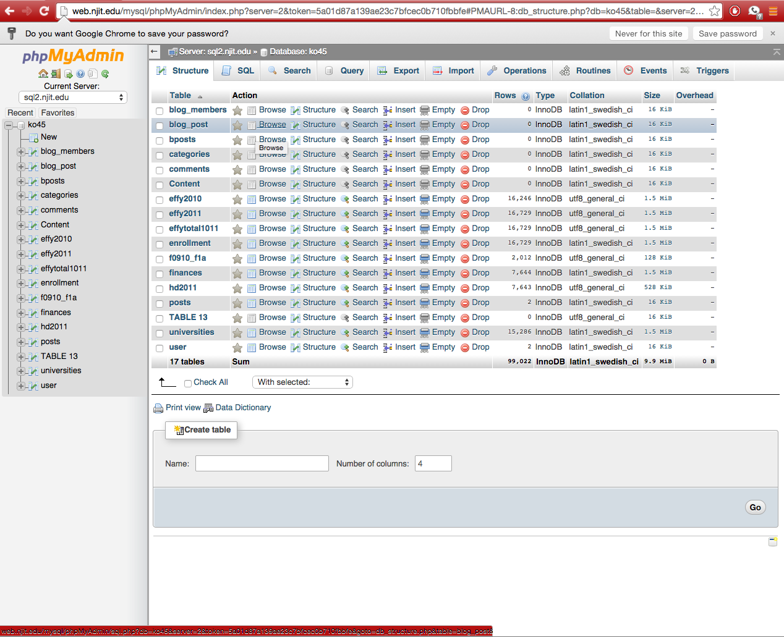

**You should be able to answer the following questions / tasks:**

1. Create a web page that shows the colleges that have the highest enrollment.

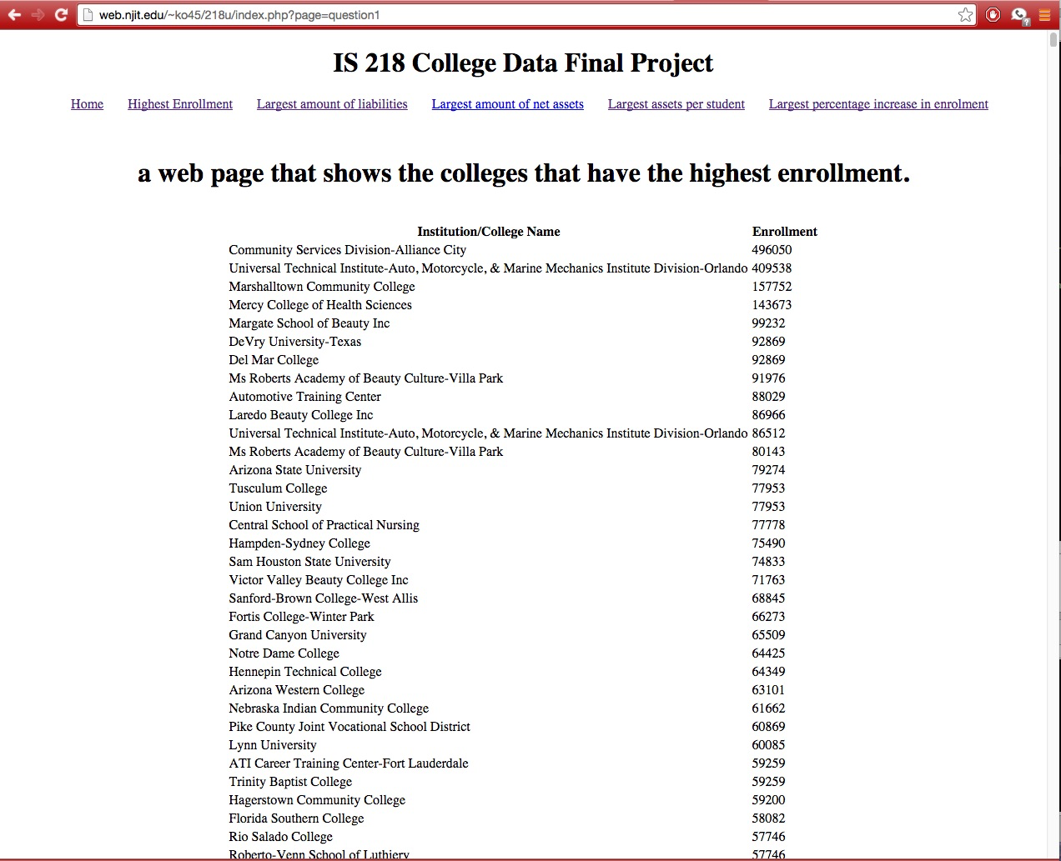

1. Create a web page that that lists the colleges with the largest amount of total liabilities.

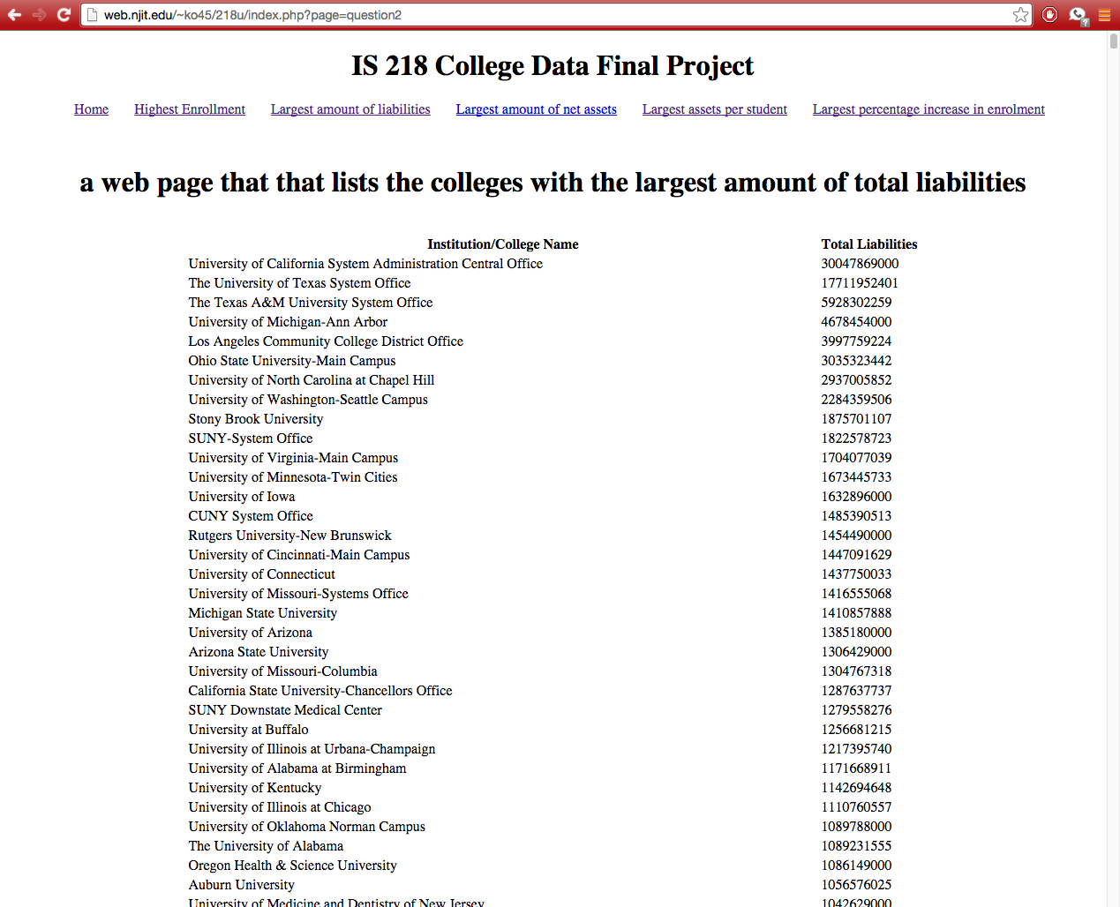

1. Create a web page that lists the colleges with the largest amount of net assets.

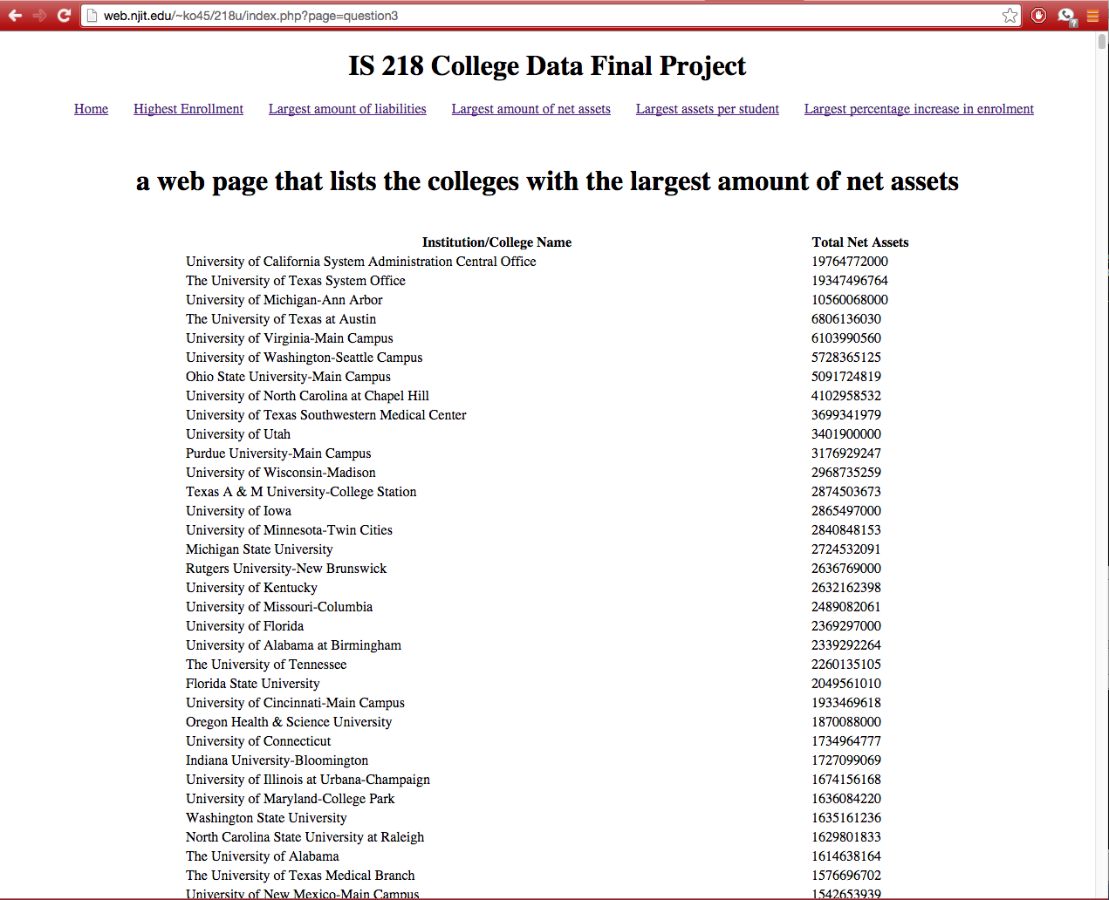

1. Create a web page that lists the colleges with the largest amount of net assets per student.

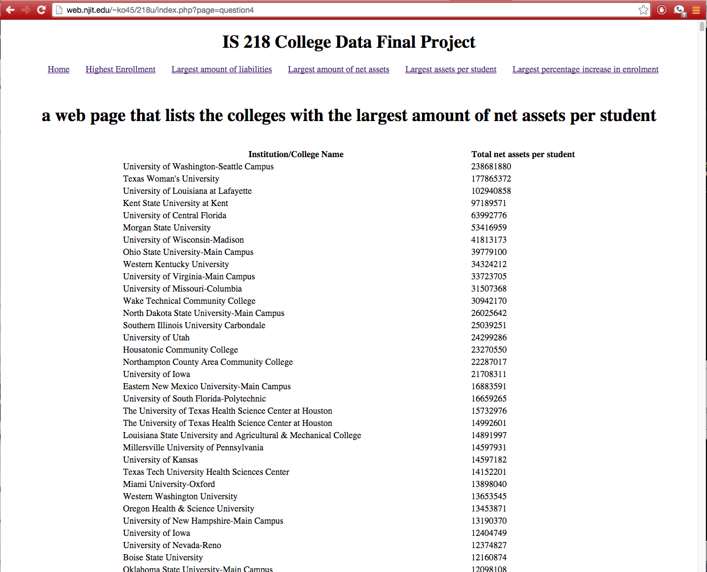

1. Create a web page that shows the colleges with the largest percentage increase in enrollment between the years of 2011 and 2010.

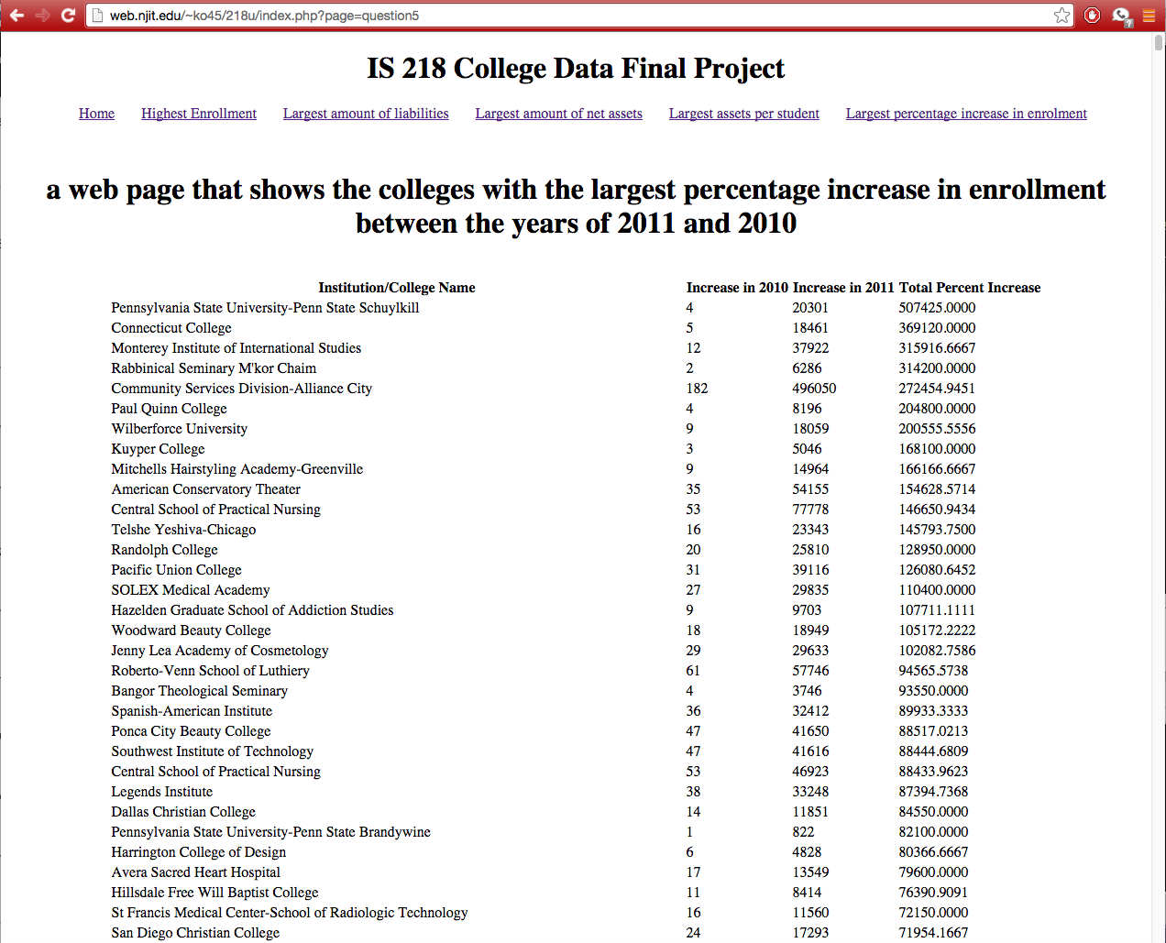

Submission and grading:

You should submit the assignment through Moodle by placing a link to the github repository for the assignment and a link to the working program. You will need to create a home page for the site that has links to the pages that answer each of the questions above.

Grading:

1. ______ out of 15 – Importing the CSV files
2. ______ out of 15 – questions 1,2,3,4
3. _____ out of 25 – question 5