IS217 Homework 2

**Submission Instructions**

This assignment must be submitted to Moodle and must include a link to the github repository that you can put into a word document. Inside this word document, you should put screen shots of each part in the document. The screen shot should show the successful completion of each step.

**Overview**

For this homework you are to install Node.JS onto a virtual machine on your computer using virtualbox and writing a node.js express application that includes unit testing. I have broken this project down into a few steps.

Part 1

The following tutorials should help; however, they may be out of date, so you may run into an issue. I recommend using at least 1GB ram and allocating 10GB of hard drive space for this. You should try to use Ubuntu 13+ server, it may work better for you.

<https://www.virtualbox.org/>

Installing Ubuntu Server in Virtualbox:

Mac:

<http://navet.ics.hawaii.edu/~casanova/VirtualBoxUbuntuHowTo.html>

Windows:

<http://www.psychocats.net/ubuntu/virtualbox>

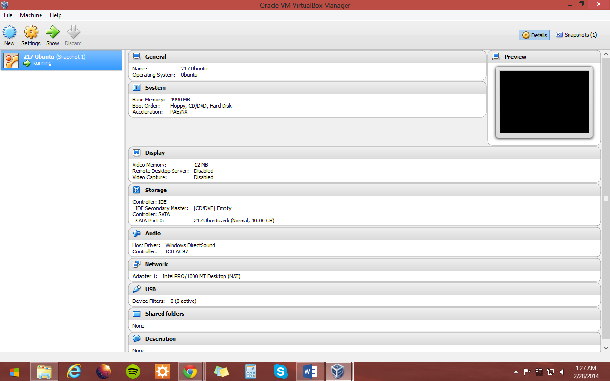

Part 2

Once you have Ubuntu setup, you must now install node.js using this tutorial:

sudo apt-get install python-software-properties

sudo add-apt-repository ppa:chris-lea/node.js

sudo apt-get update

sudo apt-get install nodejs

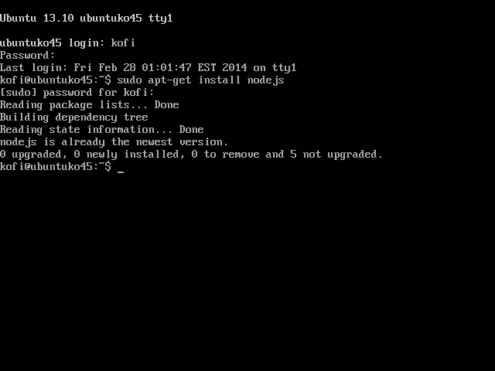

part 3

Once you have the tutorial working in part 3, your next step is to complete the following tutorial on unit testing and node.js

<http://code.tutsplus.com/tutorials/testing-in-nodejs--net-35018>

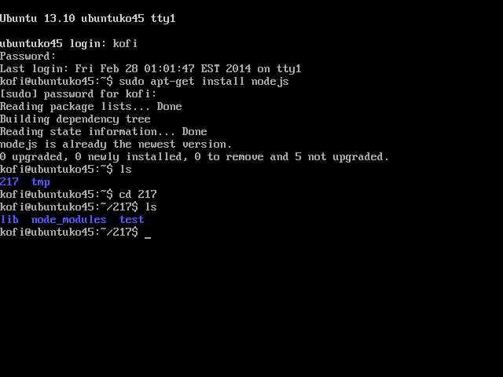

Part 4

For this part, your challenge is to write at least new unit tests that demonstrate the use of at least 5 different types of assertions. You should write your tests first and then write the code that will be tested. You should write 5 tests that pass and three tests that fail. Then take a screen shot of your tests and include that in the word document that you will submit to me.

