Merchant Acquiring Tool
Introduction: -

Merchant Acquiring Tool used for processing refund or reversals request initiated by merchants. These requests arises when transactions are failed, cancelled or required refunds and the amount needs to be returned to the customer.
The system ensure secure transaction processing, automated vendor file handling and complete audit traceability for all user activities.

Scope: -

The MAT application is used by Branch users and DCO Operations Teams to:
- Raised refund/reversal requests
- Approve or reject requests
- Process vendor transaction files.
- Generate operational and audit reports
- Maintain user and role management
- Track transaction lifecycle and approvals
- Monitor vendor file uploads and scheduler execution according.

User Management

User Management: (Branch Team/DCO team User):

Login Screen:
- Branch Team:
• Users: BU
- All type of user/department/position from RBG are allowed for login as a branch user for generating a request and for approval.
• Login Screen Input:
Username (EIN)
Password
Captcha
• Authentication: Active Directory (AD) login

- DCO TEAM:
• Initial Setup – One time activity:
A Maker and Checker with admin rights will be provided from the backend as a process of initial setup (Operation team to provide details).
These users will have rights to add other users and assign appropriate roles to DCO users.
As part of the maker-checker concept, Maker will initiate new user creation request, Checker will approve the request.
Users from SOL (999, 9990, 935) will be considered for DCO users.

• Process Flow:
  - Any DCO User can generate request for adding new user pertaining SOL (999, 9990, 935)
  - User roles [DCO-Maker, DCO-Checker, BOA, DBD, HO, AUDITOR].
- DCO-Maker Role: - Will be allowed for reviewing the refund requests raised by branches & for generating request for addition of new DCO user.
- DCO-Checker Role: - Will be responsible for approving the branch requests already reviewed by DCO-Maker and for approving the new user creation request raised by DCO-Maker.
- BOA, DBD, HO, AUDITOR: - All reports options will be made available (report list to be provided by operation team)
  - DCO user can login to application only after the particular user has been added to MEA/MAT application user list.
  - Users will be validated with HRMS via backend process twice in a month (15th and last day of the month)
• Login Screen Input:
Username (EIN)
Password
Captcha
• Authentication: Active Directory (AD) login

Note: After successful authentication, the system grants access based on role and permissions.
The application displays pages and functionalities specific to each role:
- Branch User - (Maker & checker can be any RBG user but cannot be same)
- DCO User – (Maker & checker can be any RBG user but cannot be same)
- External Auditor
- Internal Auditor
- Temp User BOA
- Temp User (HO/DBD/RO/ZO/BU/Other Business Units /HO-FAD etc)

Role-Based Screen Design:
Depending on the user logged and the role assigned to the user, the menu options and functionality will be as mentioned here after.
The below mentioned menus are common for all the users, sub-menu options will be role-based, ensuring that each user only sees the features relevant to their assigned role and permissions.
The common menu options and sub-menu options are explained in details below.
Home Logo [Dashboard] | Request Handling | Report | File Handling | Profile

🔹 1. Branch User (BU) Maker/Checker : -
Access Screens:-

Dashboard
Summary of requests (Total / Pending / Approved / Rejected/ Referred Back) & also statistics for login user and for complete sol.

Request Handling: -
- Raise Request
For raising new request the below mentioned fields will be filled for validating the refund request to be raised. On successful validation only the request can be raised.
- UPI/Card transactions type – radio box will be provided for selecting any one.
- CustId
- Account number
- RRN
- MID (All characters to be shown in capital letters).
- Transaction Date

The above mentioned fields are taken as input from branch user, after validating the input data with the file data (Downloaded from SFTP), if found in system the details will be displayed on the screen or appropriate error message will be displayed.

In case details are not available in refund software database, pop up to branch user will be displayed stating “No transaction details available in database, please contact merchant”.

As per the transaction type (UPI/POS) corresponding display will be shown for generating the refund request.

UPI Refund Request: -
Field Name | Width and data type | Validation | Input/Display fields
Cust ID | Similar to CBS CUST ID field width and data type | On entry should be validated with CBS and on not availability should message as “The entered Cust ID is not available in CBS, please re-check the entered value” | Input
A/c no. | Similar to CBS Account No (Foracid) field width and data type | On entry should be validated with CBS and on not availability should message as “The entered Account Number is not available in CBS, please re-check the entered value” | Input
Sol of the A/c no. (Not to display in Data Entry field) | Similar to CBS Sol ID field width and data type. | To be fetched from valid Foracid entered in above field and store the value in DB | Display
RRN | xxxxx | Validate in DB | Input
Date of txn | DD-MM-YYYY | Validate in DB | Input
Txn amount | 12 digit including paise | Validate in DB | Display
Refund Amount | 12 digit including paise | The combination of Date of Txn + Txn Amount + RRN to be validated in Database. | Input
 |  | 1. If refund request for matching record exists in DB show error msg as “Refund request <Request_id> for < Date of Txn + Txn Amount + RRN> already exists in system. Thus duplicate entry will not be allowed.
 |  | 2. The refund amount should not exceed Txn Amount for combination of same RRN+Date of Tnx+Refund Amount>
MID | Refer the MID field of MEA App and keep field width and Data type similar to it | Validate the MID from the database. If not found message as “The entered MID value not available in Vendor Transaction File, recheck the entered value. | Input
TID | Refer the MID field of MEA App and keep field width and Data type similar to it | Validate the MID from the database. If not found message as “The entered MID value not available in Vendor Transaction File, recheck the entered value. | Display
Gateway txn ID | To get from Sarvatra or Intech Team supporting UPI Transactions | Validated from Database | Display
Merchant VPA | To check in Vendor Transaction file received on SFTP | Validated from Database | Display
Entry User Name | Similar to HRMS Username width and datatype | To be fetched from HRMS DB and displayed and stored in DB | Display
Enter User Email | Similar to HRMS Username width and datatype | To be fetched from HRMS DB and displayed and stored in DB | Display
Upload of reference document | 300 alphanumberic chracters with special character ‘.’ |  | Input

POS Refund Request
Field Name | Width and data type | Validation | Input/Display fields
Cust ID | Similar to CBS CUST ID field width and data type | On entry should be validated with CBS and on not availability should message as “The entered Cust ID is not available in CBS, please re-check the entered value” | Input
A/c no. | Similar to CBS Account No (Foracid) field width and data type | On entry should be validated with CBS and on not availability should message as “The entered Account Number is not available in CBS, please re-check the entered value” | Input
Sol of the A/c no. (Not to display in Data Entry field) | Similar to CBS Sol ID field width and data type. | To be fetched from valid Foracid entered in above field and store the value in DB | Display
RRN | xxxxx | Validate in DB | Input
Date of txn | DD-MM-YYYY | Validate in DB | Input
Txn amount | 12 digit including paise | Validate in DB | Display
Refund Amount | 12 digit including paise | The combination of Date of Txn + Txn Amount + RRN to be validated in Database. | Input
 |  | 1. If refund request for matching record exists in DB show error msg as “Refund request <Request_id> for < Date of Txn + Txn Amount + RRN> already exists in system. Thus duplicate entry will not be allowed.
 |  | 2. The refund amount should not exceed Txn Amount for combination of same RRN+Date of Tnx+Refund Amount>
MID | Refer the MID field of MEA App and keep field width and Data type similar to it | Validate the MID from the database. If not found message as “The entered MID value not available in Vendor Transaction File, recheck the entered value. | Input
TID | Refer the MID field of MEA App and keep field width and Data type similar to it | Validate the MID from the database. If not found message as “The entered MID value not available in Vendor Transaction File, recheck the entered value. | Display
Card Number | Refer Vendor Transaction file for datatype and width | Validate Card number from Database for matching based on RRN + Date of TXN + TXN amount. Standard practice to mask the card number display in application field is to be applied. Encryption at DB level is also required | Display
Auth code | Refer Vendor Transaction file for datatype and width | Validate Auth code from Database for matching based on RRN + Date of TXN + TXN amount. Standard practice to mask the Auth code display in application field is to be applied. Encryption at DB level is also required | Display
Scheme | 10 Alphabets | Validate Auth code from Database for matching based on RRN + Date of TXN + TXN amount. Usually the field details will be different card issuing authority names like “RUPAY”, ”VISA”, ”MASTER” | Display
Entry User Name | Similar to HRMS Username width and datatype | To be fetched from HRMS DB and displayed and stored in DB | Display
Enter User Email | Similar to HRMS Username width and datatype | To be fetched from HRMS DB and displayed and stored in DB | Display
Upload of reference document | 300 alphanumberic chracters with special character ‘.’ |  | Input

After user validates the details that are being displayed on the screen, by clicking submit button a request will be generated.
A confirmation message will be provided after successful request generation as “<Request ID> captured and sent for further processing”
Search field will be provided on the display page, in the search field any field value of any column can be entered for searching

- Approval Queue (BU requests) : -
All the request generated will be displayed in this menu option (requests that are less than 90 days old).
To ensure proper segregation of duties and maintain the approval workflow's integrity, the Reviewer and Approver must be different individuals. The same user cannot perform both review and approval activities for a request.

Check  box | Request ID (hyperlink) | MID | Transaction Date | Transaction Amount | Refund Amount | Masked Card Number | VPA ID | RRN | Reference Document (hyperlink) | Account Number
At the bottom of the page Approve/Reject/Refer back option will be provided along with the remarks text field. Remark field is mandatory.

In case of Card refund request, the Masked Card Number will be displayed and VPA ID will be blank/NA and in case of UPI, VPA ID will be displayed and Masked Card Number will be blank/NA.

Search field will be provided on the display page, in the search field any field value of any column can be entered for searching

Approved request will be forwarded to DCO user for review/ approval. Approval remarks are optional
Rejected request will be moved to rejected tray. Approval remarks are compulsory.
Referred Back. Referred Back request directly goes to the any branch user (Maker level). Approval remarks are compulsory.
For any process mentioned above automated mail will be marked to branches.

- Vendor Rejected Re-Submit
All the requests that are marked as Vendor Rejected with the below mentioned reasons will be displayed here for generating a refund re-submit request.
Two reasons for refund not processed by Vendor/UPI Team.
- Out of time frame for processing refund (One Year from Transaction date for all scheme for POS)
- Any other technical reason (For Both UPI and POS)

The request will be displayed in the below mentioned format.
User can select single of multiple requests displayed with the check box and submit the selected requests’ for processing i.e. for re-submitting of transaction.

Check  box | Request ID (hyperlink) | MID | Transaction Date | Transaction Amount | Refund Amount | Masked Card Number | VPA ID | RRN | Account Number | Vendor Rejection Reason

Search field will be provided on the display page, in the search field any field value of any column can be entered for searching

- View Refund Requests
All the request generated will be displayed in this menu option (requests that are less than 90 days old).
Here requests raised by any branch user will displayed here and will be allowed for Modification or Deletion before Approval.
Search field will be provided on the display page, in the search field any field value of any column can be entered for searching.

Note: - Once the request raised is approved the same will be displayed in modification menu option (the requests referred back by verifier/DCO user).

Request ID (hyperlink) | RRN | Date of Txn | Txn Amount | Refund Amount | Cust Id | Account No | Gateway txn ID | Reference Document (hyperlink) | Action  (Modify/Delete)

In the last Action column, modify and delete options will be provided.
- Modify request - (allowed before Approval)
- Delete Request - Deletion of request id (records will be logically deleted) (In case of any discrepancy after submission and before approval)

- Referred Back Requests

Request ID (hyperlink) | RRN | Date of Txn | Txn Amount | Refund Amount | Cust Id | Account No | Gateway txn ID | Reference Document (hyperlink) | Remarks | Action  (Modify/Delete)

The above field grid will be available for referred back requests. In the Action column, the following options will be provided:
  - Modify: After editing, a Re-submit button will appear.
  - Delete: request will be logically deletion & will remain available for audit purposes.
If no modifications are made to such requests within 90 days, the referred back requests will be moved to the Archival tray.
Search field will be provided on the display page, in the search field any field value of any column can be entered for searching.

- Rejected Requests

Request ID (hyperlink) | RRN | Date of Txn | Txn Amount | Refund Amount | Cust Id | Account No | Gateway txn ID | Reference Document (hyperlink) | Rejection Reason.

The above field grid will be available for rejected requests. In the Rejection Reason column, the rejection reason will be displayed.

Search field will be provided on the display page, in the search field any field value of any column can be entered for searching.

- Archival Enquiry

In this option all the requests that are older than 90 days and are archived will be displayed on the basis of search criteria mentioned below.

Search Criteria:-
- From Date - Mandatory
- To Date - Mandatory
- RRN Number
- Account Number
Either RRN or Account Number is mandatory.
After entering the required search criteria and submitting the request, the system will display the corresponding results on the search screen. The matching Request IDs will be listed based on the entered criteria. Upon selecting a specific Request ID, the details associated with that request will be displayed, allowing the user to view and proceed with the required actions for that particular request.

Request ID (hyperlink) | RRN | Date of Txn | Txn Amount | Refund Amount | Cust Id | Account No | Gateway txn ID | MID | Reference Document (hyperlink)

Search field will be provided on the display page, In the search field any field value of any column can be entered for searching.

Reports
- Approved / Rejected/ Refer Back History
- Deleted Report
- Audit Logs.
- Transaction Success Report.
- Finacle Failure Report.
- Success with ARN Report.
- Success W/O ARN Report.

Profile
- User Login Info
- Logout

🔹 2. DCO User Maker/Checker
Access Screens:-

Dashboard
For DCO User – SOL selection – a separate field will be provided.
Summary of requests (Total / Pending / Approved / Rejected/ Referred Back) & also statistics for that particular sol will be displayed.

Request Handling
- Approval Queue

All the request generated will be displayed in this menu option (requests that are less than 90 days old).
Check  box | Request ID (hyperlink) | MID | Transaction Date | Transaction Amount | Refund Amount | Masked Card Number | VPA ID | RRN | Reference Document (hyperlink) | Account Number
In this option, all requests approved by the Branch Approver will be routed to the Reviewer for review and subsequently to the Approver for final approval.
To ensure proper segregation of duties and maintain the approval workflow's integrity, the Reviewer and Approver must be different individuals. The same user cannot perform both review and approval activities for a request.
At the bottom of the page Approve/Reject/Refer back option will be provided along with the remarks text field. Remark field is mandatory.
In case of Card refund request, the Masked Card Number will be displayed and VPA ID will be blank/NA and in case of UPI, VPA ID will be displayed and Masked Card Number will be blank/NA.

Search field will be provided on the display page, in the search field any field value of any column can be entered for searching

Approved request will be forwarded to DCO user for review/ approval. Approval remarks are optional
Rejected request will be moved to rejected tray. Approval remarks are compulsory.
Referred Back. Referred Back request directly goes to the any branch user (Maker level). Approval remarks are compulsory.
For any process mentioned above automated mail will be marked to branches.

Remark will be drop down list of common reject reason given below in the drop down list
- Amount mismatch in letter & details submitted
- Date mismatch in letter & details submitted
- MID mismatch in letter & details submitted
- RRN mismatch in letter & details submitted
- Other (on selecting this option another text box should be appear to enter 300 characters)

- Vendor Rejected Re-Submit
All the requests that are marked as Vendor Rejected with the below mentioned reasons will be displayed here for approval a refund reversal request.
Two reasons for refund not processed by Vendor/UPI Team.
- Out of time frame for processing refund (One Year from Transaction date for all scheme for POS)
- Any other technical reason (For Both UPI and POS)

The request will be displayed in the below mentioned format.
User can select single of multiple requests displayed with the check box and submit the selected requests’ for processing i.e. for re-submitting of transaction.

Check  box | Request ID (hyperlink) | MID | Transaction Date | Transaction Amount | Refund Amount | Masked Card Number | VPA ID | RRN | Account Number | Vendor Rejection Reason

Search field will be provided on the display page, in the search field any field value of any column can be entered for searching

- Vendor Rejected Reversal
All the requests that are marked as Vendor Rejected and ARN Not Found will be displayed here for approval a refund reversal request.
The request will be displayed in the below mentioned format.
User can select single of multiple requests displayed with the check box and submit the selected requests’ for processing i.e. for reversal of transaction.
Check  box | Request ID (hyperlink) | MID | Transaction Date | Transaction Amount | Refund Amount | Masked Card Number | Old Credit Account Number | Old Debit Account number | New Credit Account  Number | New Debit Account Number | VPA ID | RRN | Account Number | Vendor Rejection Reason

Search field will be provided on the display page, in the search field any field value of any column can be entered for searching

- Retry Transaction: - This option will be used to retry the failure transaction due to any failure at finacle level to 30 days from the date of creation of request id. In case of deleted account the request will be rejected and mail will be marked to branches. After 30 days the request will be marked as deleted and mail will be shared to branches and requester email id.
Search field will be provided on the display page, in the search field any field value of any column can be entered for searching.

Reports
- Approved / Rejected/ Refer Back History
- Audit Logs for request ids/ Users Added.
- Success Report.
- Failure Report.
- Success with ARN Report.
- Success W/O ARN Report.
- DCO user list Report(Filter –All/Active/inactive)

Profile
- User Login Info
- User Management
ADD: - There will be an option to add a new user. For addition of new user, a drop down will be provided for selecting the below mentioned type of new user.
- DCO user
- Internal Auditor
- External Auditor
- Temp User BOA
- Temp User (HO/DBD/RO/ZO/BU/Other Business Units/HO-FAD etc)

At the time of creating a user’s other than DCO user, time frame will be maintained and user has to input from and to date mandatorily.

The system will also provide functionality to:
Activate/De-Activate:- Activate or deactivate a user vice or versa.
Admin :- Assign admin rights for adding new users.
Delete: - logical deletion of an existing user.

Auto-validate: - Users will be validated with HRMS via backend process twice in a month (15th and last day of the month). Also at the time of validation with HRMS, solid of the user id will be checked and accordingly marked deleted if the user sol is not from (999, 9990, 935).

Inquiry: - Search field in this menu option will be provided on the display page for viewing the details of existing user in application irrespective of the status (active/inactive/deleted).

Note: All Activate, Deactivate and Delete DCO user requests will follow the Maker-checker workflow. The requests will be routed to another DCO user for approval. The DCO user who initiates the request cannot approve or reject their own request. Only another DCO user can approve or Reject the request.

- Logout

🔹 3. DCO Team (Temp User) only view rights
Access Screens:-

Dashboard
NA

Reports

Auditors (internal & external), DBD, Any other department of Bank, any other outside IDBI bank entity to whom Bank has allotted Temp ID.

- Approved / Rejected/ Refer Back History
- Audit Logs for request ids/ Users Added.
- Success Report.
- Failure Report.
- Success with ARN Report.
- Success W/O ARN Report.

Profile
- User Login Info
- Logout

Vendor File Download Process:
- Auto File Process:
- The system shall automatically download vendor files from SFTP using a scheduler running hourly from 8:00 AM to 12:00 PM.
- Successfully downloaded files shall be stored in the database, and a success notification shall be sent to the DCO Team via mail as and when the file is uploaded.
- If files are not received by 12:00 PM, a failure notification shall be sent to the DCO team via mail for manual intervention at 12:05 PM.
- In case of failure of automated process manual upload process will also available. Manual process describe below.
- After successful scheduler run user can view success failure report.

Below are Vendors name, transaction type, standard of file name Verify and remaining fields will provide by DCO team.
Vendor | POS/UPI | Folder Structure on SFTP/Path | Standard File Name
WorldLine | POS/UPI | MAT >> WORLDLINE >> INBOX | ALLTXN-OOO11-NON-MC_DDMMYY.TXT
Hitachi | POS | MAT >> HITACHI >> INBOX | IDI_PoS_Delimiter_UPIQR_DDMMYYYY.xlsx & IDI_PoS_Delimiter_Card_DDMMYYYY.xlsx
Hitachi | UPI | MAT >> HITACHI >> INBOX | IDI_PoS_Delimiter_UPIQR_DDMMYYYY.xlsx & IDI_PoS_Delimiter_Card_DDMMYYYY.xlsx
Sarvatra | UPI | MAT >> Sarvatra >> INBOX

- Manual Upload of Files:
If the automated process fails, the DCO user has to upload the files manually.
There are 2 options for these
- Manual Process from SFTP:
This process will be used when system fails to pick & upload file from SFTP in these DCO team will manually download from IDBI SFTP & upload it on system.

- Manual process from Desktop:
This process will be used when vendor fails to upload files on IDBI SFTP. Vendor will be sending files over mail and DCO team will manually download from SFTP & upload it on system.

File Handling
- View uploaded Files that are uploaded- success/ Failure/ both based of drop down selection.
- Upload Files.
- Delete files. Same day files will be allowed for deletion. Files will be deleted, in case request is already raised the same will be rejected, in case the transaction is also completed for any request the same will also be reversed and then the request will be rejected.
- Deleted File Report. Detail of file that has been raised for rejection – this will show the number of requests raised against the transactions available in the file marked for rejection.

ARN Handling:
- Upload Success transaction to Vendor – This option will generate excel file (Vendor specific & transaction type specific) with all successful transactions and after validating by user the same can be uploaded to the vendor specific SFTP folder within the same menu.
The file to be uploaded will be appended with request id column.
Vendor ARN File. – In this process system will search for ARN file name from SFTP with the file names that are already provided to vendor in the above point. This can be achieved by 2 ways
- A scheduler will be available for checking the ARN files on vendor SFTP only for current date (back dated has to be processed manually), System will download the details, update the ARN in the database based on the details and move the file to done folder on SFTP.

        - For the ARN files received from Vendor as failure with below mentioned rejection reason. Particular request will be marked as rejected by vendor and status will be “Pending at Branch End” and mail will be shared to branches and requester mail id. Hence, the branch would have to either delete the entry or regenerate new request for the same, if required. Till the time, the branch does not either close or resubmit the new request id, auto email need to be sent to branch on daily basis.

Two reasons for refund not processed by Vendor/UPI Team.
- Out of time frame for processing refund (One Year from Transaction date for all scheme for POS)
- Any other technical reason (For Both UPI and POS)
Such request will be processed by branches by raising new request in menu option “Vendor Rejected Reversal”

- This will be menu invoked option that will check the ARN files available on the Vendor specific SFTP folder and will be displayed on screen for selection, on selecting a particular file, System will download the details, update the ARN in the database based on the details like RRN, MID etc.

For both the scenario’s the rejected reason will be emailed to branch and requested email id and the status would be accordingly updated as “Pending at Branch end”.

FORMAT – 5
Format for an auto email from system should be generated to notify Branch and requester email when refund is not processed due to any reason (1. Insufficient balance, 2. Technical error, 3. Chargeback is received, 4. Or any other reason as given in Vendor file).

From : Application Team (given by application team)
To : Branch and requester email
Subject : Refund not processed (reason as given above)
This is to inform that a refund entered by you has not been processed due to (above mentioned reason). Please take it up with your merchant on urgent basis.

This is for your information and necessary action.

Regards,
Pos Refund
Settlement Team

SFTP Folder Structure.

Vendor file process flow:
- Vendors upload transaction files into the /INBOX folder like File1.xlsx, File2.xlsx, File3.xlsx.., etc.
- Once processed, files are moved to /DONE by System to mark acknowledgment.
- The system generates network-wise files and places them into the /OUTBOX folder, organized into separate subfolders such as VISA, RUPAY, and MASTERCARD.
- For Sarvatra UPI files place into /OUTBOX folder.
- Once the files in the folders are picked & processed by vendor, the files needs to be moved to DONE folder. After processing the files at vendor’s end, Vendor to provide Mapping of ARN files network wise and are placed in the /ARN folder.
- After Validated ARN files are then moved into /DONE for finalization.

WORLDLINE:

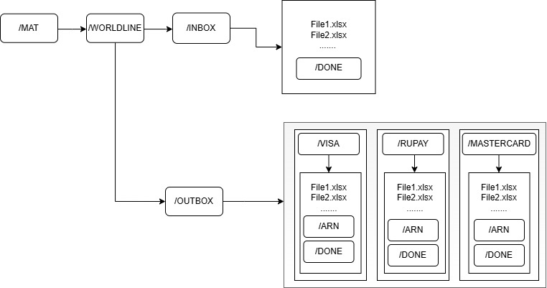

Hitachi:
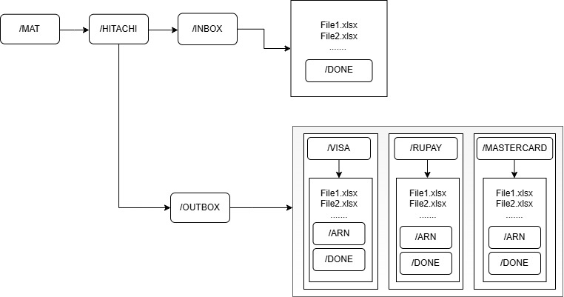

SARVATRA:
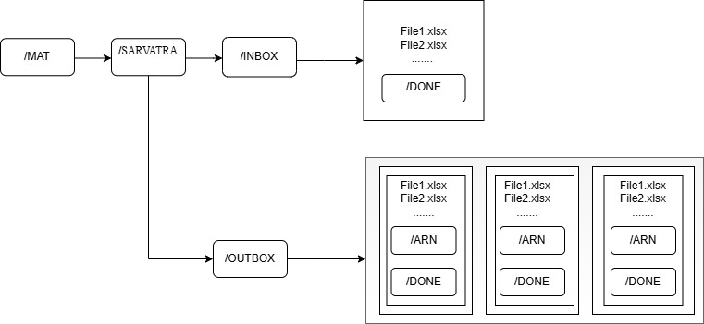

Open Points:-
- Accounting entry to be confirmed by DCO team.
- Transaction particulars/ remarks if any.
- UPI process flow to be checked and confirmed by DCO team.

