Seeing raids

You only can see raids if you’re in the invited group. User ‘phpbb’ can see both raids.

Raid 1 is visible to for moderators, admins and registered users.

Raid 2 is for moderators and admins only.

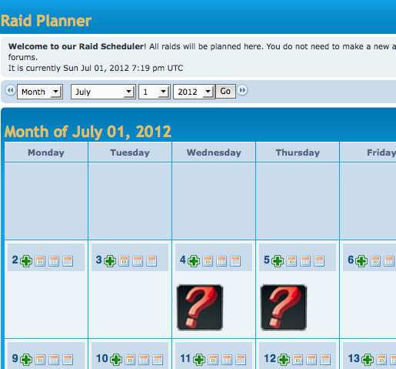

Logged in as a moderator (tester_2) you can confirm or deny everyone.

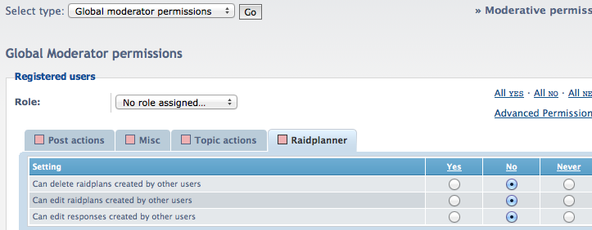

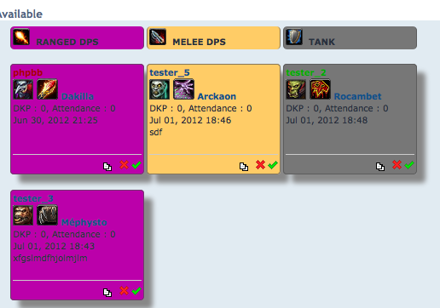

normal users can only edit their own comments

