Autism All Grown Up

Autism Nexus of Oregon

Ariel Balter

2024-06-03

Contents

# Mission

The mission of Autism All Grown Up (AAGU) is to empower autistic adults in Oregon by serving as a nexus that provides accessible information, resources, and services tailored to their unique needs. By bridging gaps in the existing infrastructure, we connect and interconnect the adult autistic community and their supporters, facilitate information exchange, and promote collaboration. This ensures that autistic individuals can access the support and opportunities they need to thrive, enhancing their well-being and independence throughout the state.

# Executive Summary

## Background

Dr. Ariel Balter, an experienced scientist and data analyst, was diagnosed with ADHD and ASD later in life and is raising a teenager with both diagnoses. His desire to understand these challenges led him to study the scientific and social aspects of neurodiversity. Recent changes driven by autistic self-advocates and researchers have reshaped our understanding of autism, revealing significant gaps in support for autistic adults. These changes have led to controversies and arguments that are still unfolding, emphasizing the evolving nature of the understanding of autism.

Through his personal journey and interactions with the local autistic community, Dr. Balter identified significant gaps in services, support, and understanding for autistic adults without intellectual disabilities. He was struck by the level of unmet need he heard from his peers—people with skills, education, and abilities but struggling for reasons related to autism. These personal experiences led Dr. Balter to found Autism All Grown Up (AAGU) to address these gaps.

## Goals

The organization has four key objectives:

1. Facilitate connections and collaboration within the adult autistic community
2. Identify the unmet needs of autistic adults and report on the causes
3. Provide accurate, accessible, and up-to-date information and resources *for* autistic adults
4. Provide accurate, accessible, and up-to-date information and resources *about* autism and *about* the autistic community

## Autism All Grown Up

Autism is all grown up, and it isn’t pretty. The phrase “All Grown Up” captures the bittersweet realization that often occurs when one encounters an individual they knew as a child, only to find that their preconceived notions no longer fit the adult standing before them.

For decades, autism was seen as a developmental challenge that primarily affected children. Outdated notions of what constitutes genuine autism have cause adults to be overlooked by many people. Because so little research has acknowledged the lives of adults with autism, we know close to nothing about what successful adult development looks like. Some existing research suggests that autistic adults face reduced life expectancy, increased risk for physical disability, and an earlier onset of age-related cognitive concerns. Late-identified and never-identified autistic adults face unique challenges with respect to aging, and most of these “lost generation[s]” (Wright 2015) have not yet even been counted.

## The Nexus Approach

Rather than working on advocacy, Dr. Balter feels he can more directly serve the autistic community in Oregon by solving problems on the ground. Systemic and societal problems can only be addressed through advocacy. But many of the real-world problems faced by supporting existing infrastructure by increasing the connectivity and information flow. Rather than being a hub that consumes resources and provides services, AAGU will catalyze and strengthen relationships around it to form a *nexus*.

# Autism in 2024 and The Lost Generations

## The New World of Autism

Recent advancements in autism research, largely driven by autistic self-advocates and researchers, have highlighted the need for a paradigm shift in understanding and supporting autistic individuals. Key findings include:

* **Navigational Challenges:** Most autistic individuals are not intellectually disabled but face substantial challenges navigating society. Navigating society feels like being a left-handed person using right-handed scissors: difficult and unwieldy at best.
* **Lifelong Condition:** Autism is a lifelong neurological difference, not a disorder to be cured. There are roughly the same percentage of autistic adults as children, but there are four times as many adults as children.
* **Neurodiversity:** The neurodiversity paradigm recognizes autism as a natural variation in human neurology. Statistically, fewer than half of autistic people are intellectually disabled but may face challenges navigating a neurotypical world. A significant population of autistic adults has needs that are often unmet.
* **Focus Gaps:** Research and services have predominantly focused on children and intellectually disabled adults, leaving a gap for others. We have failed, and continue to fail, to study autistic life after high school.
* Autism is a lifelong neurological difference, not a disorder to be cured.
* Most autistic people are not intellectually or physically disabled but may face substantial challenges.
* The neurodiversity paradigm recognizes autism as a natural variation in human neurology. For many autistic people, the hardest part about being autistic is navigating a neurotypical world.
* Research and services have predominantly focused on children leaving out adults, especially those without profound disabilities.

# Lost Generations of Autistic Adults

Autistic adults face unique challenges that are often overlooked, such as navigating social and employment environments not designed for neurodivergent individuals. Autistic adults without intellectual disabilities often face a lack of access to appropriate healthcare and support services.

Autistic adults perceived as having lower support needs face a conundrum. While they rarely qualify for existing systems of support, most face significant challenges that are often overlooked, dismissed, or disbelieved. Most autistic people will tell you that the hardest part about being autistic isn’t being autistic but navigating a neurotypical world that includes unconscious bias and ableism. Research backs this up, indicating that discrimination, not autism, is a significant barrier in the workplace.

Autistic adults face unique challenges that are often overlooked, such as navigating social and employment environments not designed for neurodivergent individuals. Key issues include:

Despite these challenges, many autistic adults possess valuable skills, talents, and perspectives that society misses out on by not acknowledging their needs, hearing their voices, and making room for them at the table.

# Autism All Grown Up (AAGU): A Nexus for Change

## Origin

AAGU was born out of Dr. Balter’s desire to use his personal experiences and analytical skills to help his newfound community. By conducting root cause analyses and working with local organizations, he identified key areas where AAGU could make an immediate impact, such as:

* Creating accessible guides for obtaining adult autism diagnoses through Oregon’s Medicaid and Vocational Rehabilitation systems
* Establishing The Uncommons, autism-friendly co-working and community spaces
* Improving online resources for autistic adults and providing consulting services to others to do the same
* Participating in data analysis and research efforts to better understand the needs of autistic adults in Oregon

## What We Have Started

AAGU has already made strides in achieving its objectives through initiatives such as:

* Partnering with Health Share Oregon to create guides for accessing autism assessments through Medicaid and developing a template Letter of Medical Necessity to facilitate evaluations through I/DD and Vocational Rehab programs
* Securing temporary spaces for The Uncommons, autism-friendly co-working and community spaces
* Consulting with the Autism Society of Oregon to improve their online resources
* Participating in the Oregon Commission on Autism Spectrum Disorder’s data working group

## Goals

Autism All Grown Up (AAGU) seeks to activate and empower the autistic community in Oregon by improving communication channels and information resources. Our immediate actions include:

* Establishing The Uncommons, a meeting and coworking space for autistic adults
* Creating comprehensive guides on navigating healthcare, employment, and social services
* Building partnerships with local organizations to enhance service delivery
* Participating in data analysis and research to inform policy and advocacy efforts

Our growth plan consists of three phases:

1. Seed (Weeks 1-8): Set up organizational structure, solicit initial funds, establish community presence, and build initial partnerships
2. Sprout (Weeks 9-26): Continue building community connections, develop The Uncommons, create informational materials, and identify large funding opportunities
3. Grow (Beyond Week 26): Expand The Uncommons, apply for large grants, build information and communication infrastructure, and establish a sustainable model for ongoing operations

## Growth Plan

Our growth plan consists of three phases:

**1. Seed (Weeks 1-8)**

* **Budget:** $2,310/week
* **Effort:** 1.5 FTE
* **Actions:**
  + Set up organizational structure
  + Solicit initial funds
  + Establish community presence
  + Build initial partnerships

**2. Sprout (Weeks 9-26)**

* **Budget:** $4,620/week
* **Effort:** 2.75 FTE
* **Actions:**
  + Continue building community connections
  + Develop The Uncommons
  + Create informational materials
  + Identify large funding opportunities

**3. Grow (Beyond Week 26)**

* **Budget:** $6,468/week
* **Effort:** 4.25 FTE
* **Actions:**
  + Expand The Uncommons
  + Apply for large grants
  + Build information and communication infrastructure
  + Establish a sustainable model for ongoing operations

By establishing a comprehensive support system for autistic adults, AAGU aims to improve their quality of life, promote independence, and foster a sense of community and belonging. Through a phased growth plan, AAGU will continue to expand its reach and impact, with a strong emphasis on hiring autistic individuals and providing them with meaningful employment opportunities. By leveraging the strengths and talents of the autistic community, AAGU is uniquely positioned to create lasting, positive change for autistic adults in Oregon.

We have recently learned that some of these co-occurring neurodivergent traits can be diagnosed independently from autism. We have learned that many non-speaking autistic people can use language and can be brilliant writers with assistive technology. We have scientifically confirmed some anecdotes about autistic people in terms of their increased aptitude for problem-solving, pattern matching, cognitive empathy, and certain types of rational and logical thinking. Perhaps most significantly, we have learned through confirmation of the double empathy hypothesis that autistic people are not deficient in either the ability or the desire to socialize . Instead, autistic and non-autistic people have very different socialization styles, learning and sensory needs, limitations, and expectations. All of this is to say that:

* Autistic children inevitably grow up to be equally autistic adults and later autistic elders.
* Any individual autistic person has a unique combination of traits that may or may not be disabling in certain contexts.
* These same traits can be exceptionally enabling, fulfilling, and productive in other contexts.
* The very fact of being autistic in a predominantly non-autistic world presents obstacles, inflicts subtle and overt traumas, and is extremely exhausting, even for individuals with few intrinsic obvious limitations.

The obvious way to solve problems caused by a lack of correct information is to collect this information. Advocates and researchers have been pushing for this for some time, but political will and funding have been lacking. While we wait for this ongoing effort to bear fruit, AAGU can help make huge improvements simply by supporting the current infrastructure.

# Sidebars

## What is the Autism Spectrum?

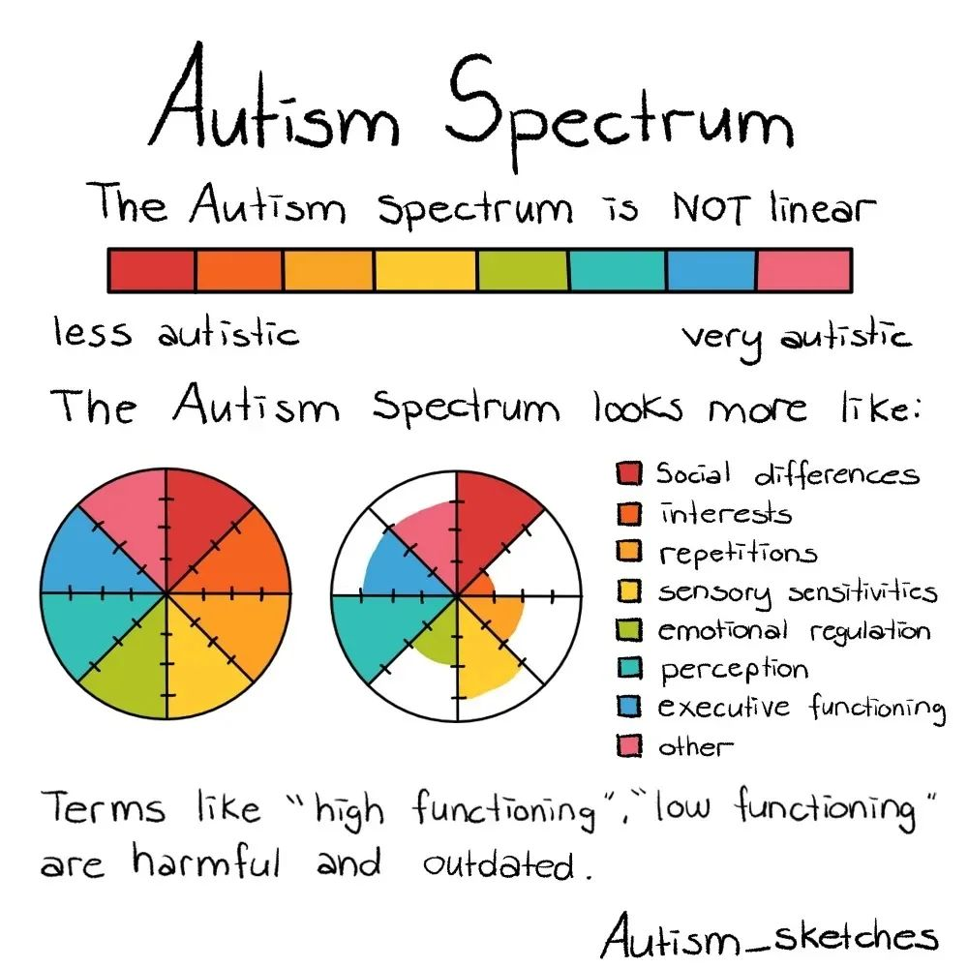

What the autism spectrum means.

## The Services Cliff

* Services Cliff: Young autistic adults also face significant challenges transitioning out of high school, often referred to as the “services cliff.” This sudden drop-off in support can lead to difficulties in finding meaningful work, pursuing higher education, and living independently. [<https://drexel.edu/autismoutcomes/blog/overview/2015/August/falling-off-the-services-cliff/>].

Transition to Adulthood This problem does not just affect existing adults. The sudden drop-off of support upon graduating high school has become known as the services cliff. One of the biggest worries faced by both parents of autistic people and young autistic people themselves is what will happen after they graduate from high school. Will they be offered meaningful work in tolerant and respectful environments? Will they be able to earn enough to live independently? Will they find open doors in trade schools or collegFes and be offered the support they might need?

## Access to Medical Care

There is an immense amount of work to do to help prepare the aging autistic adult community and a poorly informed medical system to successfully face these challenges right now and in the coming decades. Fortunately, there are also many skilled, intelligent, creative, compassionate, and hard-working people in the autistic community who are ready and capable of doing this work. And they are the right people to do it.

## Medical Training

## Autism Research Funding Priorities

Despite the fact that advocates and researchers have been pushing for decades to have autism research funding focus more on quality of life and less on “prevention and cure”, the trend has only gotten worse.

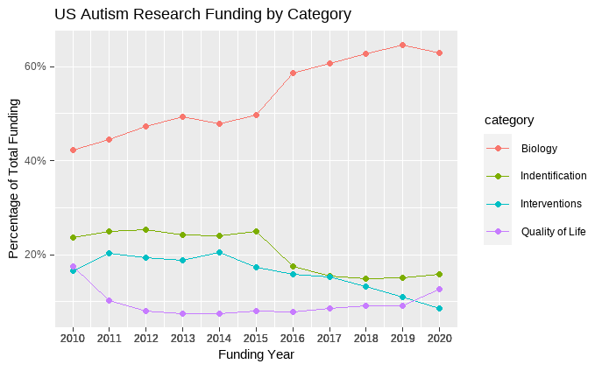

Figure 2. Data from [Interagency Autism Coordination Committee](https://iacc.hhs.gov/funding/data/)

## Marginalized Groups

All of these problems compound for members of intersectional populations who may already be marginalized along other dimensions. Many researchers believe that autism is (Fombonne and Zuckerman 2022), particularly in Black communities (Angell, Empey, and Zuckerman 2018), as well as for (D’Mello et al. 2022). Meanwhile, fluidity in gender and sexual orientation Rita George and Stokes (2018) is more highly represented among autistic people. Little research has been done to assess how autism uniquely affects people in these different subgroups.

## Physical and Mental Health

* Health and Well-being: Autistic adults experience higher rates of mental health issues, physical health disparities, and substantially elevated suicide risk [<https://www.nature.com/articles/s41583-021-00463-7>, <https://pubmed.ncbi.nlm.nih.gov/33407027/>].
* Social Isolation: Negative social experiences can lead to self-isolation, exacerbating feelings of loneliness and exclusion (Loomes, Hull, and Mandy 2017)

Across a variety of health domains, autistic people fare worse Lodi-Smith, Rodgers, et al. (2021). Additionally, we are exposed to risks that are not of primary concern for most people (Muskens, Velders, and Staal 2017). These include autoimmune dysregulation of many kinds, autonomic dysregulation, connective tissue disorders, gastrointestinal disorders, and many other areas of health concerns. A lack of understanding regarding these differences, coupled with communication barriers and false notions about autism all collude to create barriers to accessing health services and care.

## Unemployment

* Employment: Many autistic adults face difficulties finding and maintaining employment due to biases and lack of accommodations. In a study of 254 autistic adults, 77% reported difficulties applying for jobs, and only 16% are in full-time paid work [<https://www.ncbi.nlm.nih.gov/pmc/articles/PMC5215190/>, <https://www.frontiersin.org/articles/10.3389/fpsyg.2021.719827/full>].

## Homelessness

Barriers to entry to the workplace as well as challenges and holding jobs due to ablest attitudes or inflexible policies put us at risk of severe financial strain (Ohl et al. 2017). This coupled with the possibility of reduced social support all increase our risk of exposure to homelessness. The few studies that attempted to investigate autism in homeless populations suggest that rates of autism in homeless populations is much higher than that observed in the general public, and may be ten times higher (Churchard et al. 2019). Autistic people additionally face extra barriers in accessing the few services for unhoused people. Environments created with the intention of providing support may be aversive or even harmful for autistic people (Kargas et al. 2019).

## Suicide

As a group, their suicide risk may be two to seven times higher than the risk for youth and adults who do not have autism. When researchers took into account psychiatric conditions that increase suicide risk, such as depression, anxiety, and substance abuse disorders, autistic people still had a higher risk than the comparison group [@|autism2022]. The International Society for Autism Research says “Suicide in autism is a hidden crisis, overlooked by policymakers, clinicians and researchers worldwide.” and highlights three barriers: a lack of evidence-based assessment tools and interventions to identify and treat suicidal thoughts and behaviors; a lack of access to mental health services10 and exclusion from conversations about policies and guidelines that affect autistic people.” (Cassidy et al. 2021)

Angell, Amber M., Allison Empey, and Katharine E. Zuckerman. 2018. “Chapter Four - A Review of Diagnosis and Service Disparities Among Children With Autism From Racial and Ethnic Minority Groups in the United States.” In *International Review of Research in Developmental Disabilities*, edited by Robert M. Hodapp and Deborah J. Fidler, 55:145–80. International Review of Research in Developmental Disabilities. Academic Press. <https://doi.org/10.1016/bs.irrdd.2018.08.003>.

Cassidy, Sarah, Jane Goodwin, Ashley Robertson, Heather Cogger-Ward, and Jacqui Rodgers. 2021. *Autism Community Priorities for Suicide Prevention*. <https://doi.org/10.13140/RG.2.2.16668.82568>.

Churchard, Alasdair, Morag Ryder, Andrew Greenhill, and William Mandy. 2019. “The Prevalence of Autistic Traits in a Homeless Population.” *Autism: The International Journal of Research and Practice* 23 (3): 665–76. <https://doi.org/10.1177/1362361318768484>.

D’Mello, Anila M., Isabelle R. Frosch, Cindy E. Li, Annie L. Cardinaux, and John D. E. Gabrieli. 2022. “Exclusion of Females in Autism Research: Empirical Evidence for a ‘Leaky’ Recruitment-to-Research Pipeline.” *Autism Research* 15 (10): 1929–40. <https://doi.org/10.1002/aur.2795>.

Fombonne, Eric, and Katharine E. Zuckerman. 2022. “Clinical Profiles of Black and White Children Referred for Autism Diagnosis.” *Journal of Autism and Developmental Disorders* 52 (3): 1120–30. <https://doi.org/10.1007/s10803-021-05019-3>.

George, Rita, and Mark A Stokes. 2018. “Gender Identity and Sexual Orientation in Autism Spectrum Disorder.” *Autism* 22 (8): 970–82. <https://doi.org/10.1177/1362361317714587>.

George, R., and M.a. Stokes. 2018. “Sexual Orientation in Autism Spectrum Disorder.” *Autism Research* 11 (1): 133–41. <https://doi.org/10.1002/aur.1892>.

Kargas, N., K. M. Harley, A. Roberts, and S. Sharman. 2019. “Prevalence of Clinical Autistic Traits Within a Homeless Population: Barriers to Accessing Homeless Services.” *Journal of Social Distress and the Homeless* 28 (2): 90–95.

Lodi-Smith, Jennifer, Elyse J. Ponterio, Nicky J. Newton, Michael J. Poulin, Erica Baranski, and Susan Krauss Whitbourne. 2021. “The Codevelopment of Generativity and Well-Being into Early Late Life.” *Psychology and Aging* 36 (3): 299–308. <https://doi.org/10.1037/pag0000446>.

Lodi-Smith, Jennifer, Jonathan D. Rodgers, Valeria Marquez Luna, Sarah Khan, Caleb J. Long, Karl F. Kozlowski, James P. Donnelly, Christopher Lopata, and Marcus L. Thomeer. 2021. “The Relationship of Age with the Autism-Spectrum Quotient Scale in a Large Sample of Adults.” *Autism in Adulthood* 3 (2): 147–56. <https://doi.org/10.1089/aut.2020.0010>.

Loomes, Rachel, Laura Hull, and William Polmear Locke Mandy. 2017. “What Is the Male-to-Female Ratio in Autism Spectrum Disorder? A Systematic Review and Meta-Analysis.” *Journal of the American Academy of Child and Adolescent Psychiatry* 56 (6): 466–74. <https://doi.org/10.1016/j.jaac.2017.03.013>.

Muskens, Jet B., Fleur P. Velders, and Wouter G. Staal. 2017. “Medical Comorbidities in Children and Adolescents with Autism Spectrum Disorders and Attention Deficit Hyperactivity Disorders: A Systematic Review.” *European Child & Adolescent Psychiatry* 26 (9): 1093–103. <https://doi.org/10.1007/s00787-017-1020-0>.

Ohl, Alisha, Mira Grice Sheff, Sarah Small, Jamie Nguyen, Kelly Paskor, and Aliza Zanjirian. 2017. “Predictors of Employment Status Among Adults with Autism Spectrum Disorder.” *Work (Reading, Mass.)* 56 (2): 345–55. <https://doi.org/10.3233/WOR-172492>.

Wright, Jessica. 2015. “Autism’s Lost Generation.”