Autism All Grown Up
  - The Autism Nexus of Oregon
Ariel Balter
2024-06-26
Contents
Mission 3
Executive Summary 3
Background 3
Goals 4
Autism All Grown Up 4
The Nexus Approach 4
Autism in 2024 5
The New World of Autism 5
Lost Generations of Autistic Adults 6
Unmet Needs 7
Autism All Grown Up (AAGU): A Nexus for Change 7
Origin 7
What We Have Started 7
Goals 8
Growth Plan 8
Funding 9
Budget 10
Seed Phase 10
Sprout Phase 11
Grow Phase 12
References 13
Special Issues and Concerns 16
The Services Cliff 16
Access to Medical Care 16
Medical Training 16
Autism Research Funding Priorities 16
Intersectionally Marginalized Groups 17
Physical and Mental Health 17
Unemployment 18
Homelessness 18
Suicide 18
Glossary 18
Representative Salaries 22
Representative Salaries 22
Data Analyst 22
Data Engineer 22
Database Administrator 22
Director Of Operations 22
Grant Writer 23
Operations Manager 23
Policy Analyst 23
Research Associate 23
Senior Manager 24
Website Designer 24
Website Programmer 24
Potential Funders 25
Healthcare 25
Foundatons and Trusts 26
State 27
Misc 28
Neurodiversity and Neurodivergence 28
Neurodiversity (concept) 28
Neurodiversity (paradigm) 28
Neurodiversity (movement) 29
Neurodivergence 29
Neurodivergent 29
Neurotypical 29

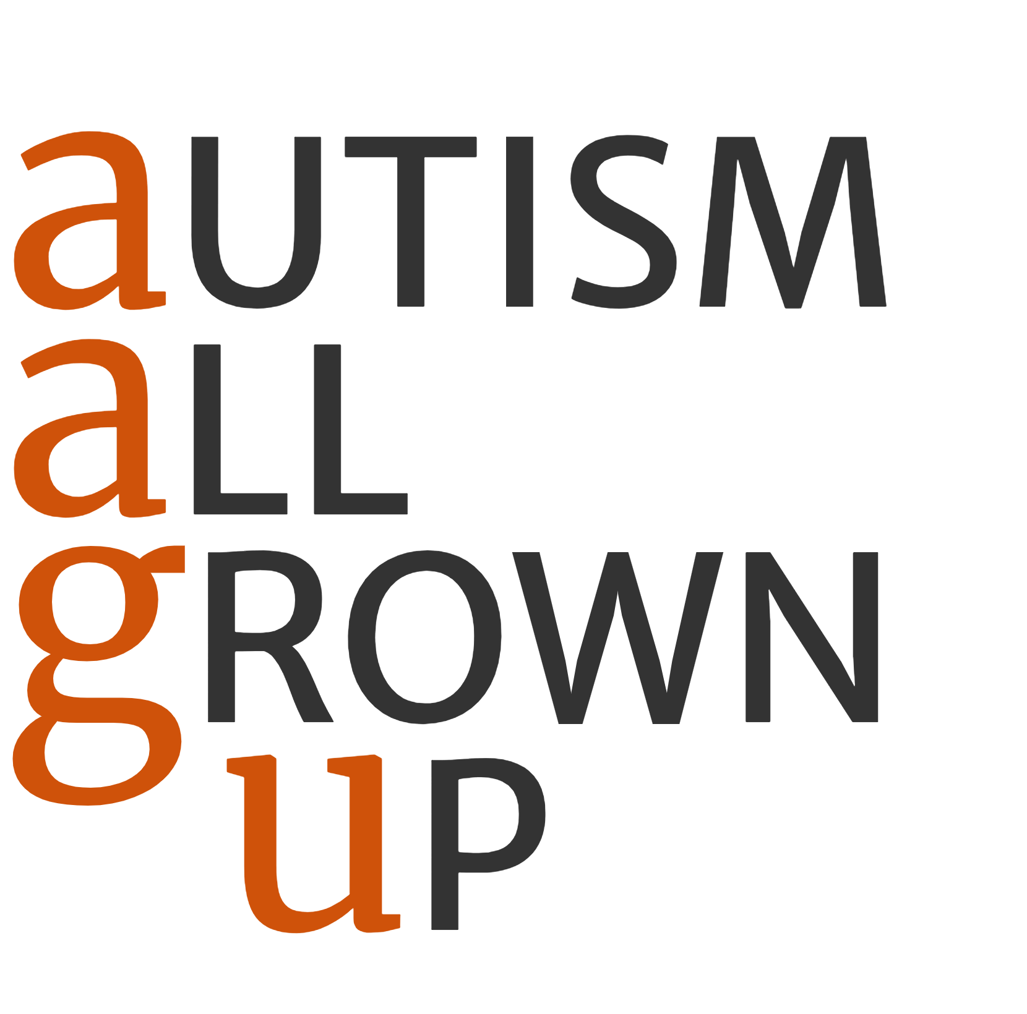

Mission
The mission of Autism All Grown Up (AAGU) is to empower autistic adults in Oregon by serving as a nexus that provides accessible information, resources, and services tailored to their unique needs. By bridging gaps in the existing infrastructure, we connect and interconnect the adult autistic community and their supporters, facilitate information exchange, and promote collaboration. This ensures that autistic individuals can access the support and opportunities they need to thrive, enhancing their well-being and independence throughout the state.

Executive Summary

Background
Dr. Ariel Balter, an experienced scientist and data analyst, was diagnosed with ADHD and ASD later in life and is raising a teenager with both diagnoses. His desire to understand these challenges led him to study the scientific and social aspects of neurodiversity. Recent changes driven by autistic self-advocates and researchers have reshaped our understanding of autism, revealing significant gaps in support for autistic adults. These changes have led to controversies and arguments that are still unfolding, emphasizing the evolving nature of the understanding of autism.
Through his personal journey and interactions with the local autistic community, Dr. Balter identified significant gaps in services, support, and understanding for autistic adults without intellectual disabilities. He was struck by the level of unmet need he heard from his peers—people with skills, education, and abilities but struggling for reasons related to autism. These personal experiences led Dr. Balter to found Autism All Grown Up (AAGU) to address these gaps.

Goals
Autism All Grown Up has four key objectives:
- Facilitate connections and collaboration within the adult autistic community
- Identify the unmet needs of autistic adults and report on the causes
- Provide accurate, accessible content for autistic adults that we will continuously review and update as knowledge evolves
- Provide accurate, accessible content about autism and about the autistic community that we will continuously review and update as knowledge evolves

Autism All Grown Up
Autism is all grown up now, and it isn’t always pretty. The phrase “All Grown Up” captures the bittersweet realization that often occurs when one encounters an individual they knew as a child, only to find that their preconceived notions no longer fit the adult standing before them.
For decades, autism was seen as a challenge that primarily affected children. Outdated notions of what constitutes genuine autism have caused adults to be overlooked by key stakeholders. Because so little research has acknowledged the lives of adults with autism, we know close to nothing about what successful adult development looks like. Some existing research suggests that autistic adults face reduced life expectancy, increased risk for physical disability, and an earlier onset of age-related cognitive concerns^{1,2}. Late-identified and never-identified autistic adults face unique challenges with respect to aging, and most of these “lost generations”^{3–6} have not yet even been identified, accounted for, or documented.

The Nexus Approach
Rather than working on advocacy, Dr. Balter feels he can more directly serve the autistic community in Oregon by solving problems on the ground. Systemic and societal problems can only be addressed through advocacy. But many of the real-world problems can be solved without waiting for systemic changes by increasing the connectivity and information flow within existing infrastructure. Rather than being a hub that consumes resources and provides services, AAGU will catalyze and strengthen relationships around it to form a nexus.

Autism in 2024

The New World of Autism
Recent advancements in the understanding of autism, largely driven by autistic self-advocates and researchers, have highlighted the need for a paradigm shift in understanding, coexisting with, and when necessary, supporting autistic individuals. <something about shift from behavioral description to internal>
Key findings include^{7,8}: <move these citations to where they belong>
- Lifelong Condition:
- Autism is developmental. Autistic people carry their neurological and physiological differences through their entire lives. While society has been hyper-focused on autism in children, autism is not new to the human race. There are four times as many adults as children, so there are four times as many autistic adults as there are autistic children. <citations> <something else about focus on children>
- The Autism Spectrum is not Linear
- Autistic people aren’t “more” or “less” autistic so much as they are autistic in different ways.
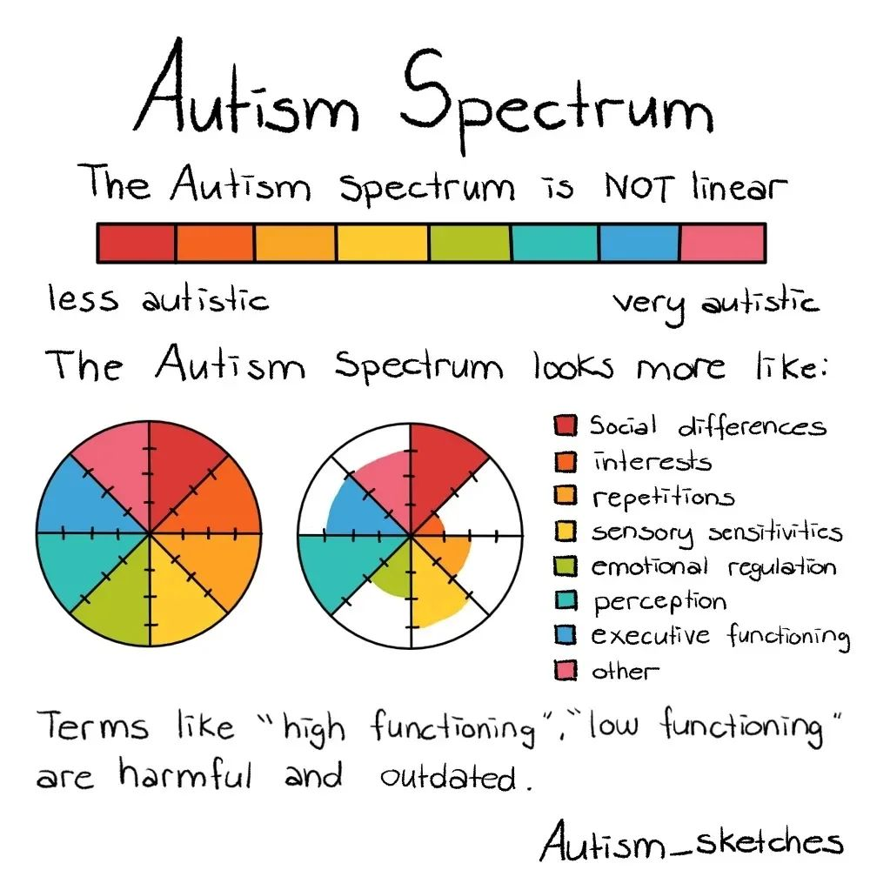
Figure 4.1: Figure 1. What the autism spectrum means.
- Misconceptions:
- New research has refuted many harmful misconceptions about autism. Some autistic people do have accompanying conditions that can result in problems with body awareness, identifying their emotional state, or using speech. However, autistic people do not intrinsically lack feelings, empathy, social skills, or the ability to communicate. <citations>
- Also, by the most current estimates, less than 1/3 of autistic people have intellectual or cognitive difficulties. Many autistic people who are unable to speak (for one or more reasons) do have language skills and can be competent writers and speakers with assistive technology. <citations>
- Disability can be Contextual:
- Most autistic individuals are not intellectually or physically disabled but face substantial challenges navigating a neurotypical world. It can feel like being a left-handed person using right-handed scissors: difficult and unwieldy at best. <something about not wanting to be cured just have life easier> <citations>
- Not Just in the Brain:
- Autism frequently comes with physiological differences that are just beginning to be understood and studied. Autistic people may experience higher or lower risk for certain diseases and conditions as well as different levels of physical abilities like flexibility. Many autistic people experience pain and other sensations differently. <citations> Few doctors are aware of these issues, and most are poorly trained in most aspects of supporting autistic patients. <citations>
- Double Empathy:
- <Describe double empathy with citations>
- The True Challenges:
- Many autistic people will tell you that the hardest part about being autistic isn’t being autistic but navigating a neurotypical world that includes unconscious bias and ableism^{9–15}. Research backs this up, indicating that discrimination, not autism, is a significant barrier in society¹⁶, especially in the workplace^{17,18}.
- Neurodiversity & Neurodivergence:
- The neurodiversity paradigm recognizes autism as a natural variation in human neurology. Individuals with significantly atypical neurotypes are neurodivergent, and sometimes need different things than neurotypical people do.

Lost Generations of Autistic Adults
Research and services have predominantly focused on children and neglected the needs of adults, especially those of us without profound disabilities. Society has failed, and continues to fail, to adequately study autistic life after high school when children lose many supports. <citation>
Despite these challenges, many autistic adults possess valuable skills, talents, and perspectives that society misses out on by not acknowledging their needs, hearing their voices, and making room for them at the table. <citation>

Unmet Needs
Autistic adults who are impacted more profoundly or who have accompanying intellectual or cognitive challenges are generally able to find support through systems of support designed for people with disabilities. However, autistic adults without intellectual disabilities often lack access to appropriate healthcare and support services, if they even exist. <citation>
Autistic adults perceived as having lower support needs face a conundrum. While we rarely qualify for existing systems of support, most face significant challenges that are often overlooked, dismissed, or disbelieved. <citation>

Autism All Grown Up (AAGU): A Nexus for Change

Origin
AAGU was born out of Dr. Balter’s desire to use his personal experiences and analytical skills to help his newfound community. By conducting root cause analyses and working with local organizations, he identified key areas where AAGU could make an immediate impact, such as:
- Creating accessible guides for obtaining adult autism diagnoses through Oregon’s Medicaid and Vocational Rehabilitation systems
- Establishing The Uncommons, autism-friendly co-working and community spaces
- Improving online resources for autistic adults and providing consulting services to others to do the same
- Participating in data analysis and research efforts to better understand the needs of autistic adults in Oregon

What We Have Started
AAGU has already made strides in achieving its objectives through initiatives such as:
- Partnering with Health Share Oregon to create guides for accessing autism assessments through Medicaid and developing a template Letter of Medical Necessity to facilitate evaluations through I/DD and Vocational Rehab programs
- Securing temporary spaces for The Uncommons, autism-friendly co-working and community spaces
- Consulting with the Autism Society of Oregon to improve their online resources
- Participating in the Oregon Commission on Autism Spectrum Disorder’s data working group
- Planning a State-wide conference to *******

Goals
Autism All Grown Up (AAGU) seeks to activate and empower the autistic community in Oregon by improving communication channels and information resources. Our immediate actions include:
- Establishing The Uncommons, a meeting and coworking space for autistic adults
- Creating comprehensive guides on navigating healthcare, employment, and social services
- Building partnerships with local organizations to enhance service delivery
- Participating in data analysis and research to inform policy and advocacy efforts
Our growth plan consists of three phases:
- Seed (Weeks 1-8): Set up organizational structure, solicit initial funds, establish community presence, and build initial partnerships
- Sprout (Weeks 9-26): Continue building community connections, develop The Uncommons, create informational materials, and identify large funding opportunities
- Grow (Beyond Week 26): Expand The Uncommons, apply for large grants, build information and communication infrastructure, and establish a sustainable model for ongoing operations

Growth Plan
Our growth plan consists of three phases:
1. Seed (Weeks 1-8 approx)
- Budget: $2,310/week, approx $18,480 total
- Effort: 1.5 FTE
- Actions:
  - Set up organizational structure
  - Solicit initial funds
  - Establish community presence
  - Build initial partnerships
2. Sprout (Weeks 9-26)
- Budget: sprout_per_week/week, $38,720 total
- Effort: 2.75 FTE
- Actions:
  - Continue building community connections
  - Develop The Uncommons
  - Create informational materials
  - Identify large funding opportunities
3. Grow (Beyond Week 26)
- Budget: $4,840/week, $87,120 total
- Effort: 4.25 FTE
- Actions:
  - Expand The Uncommons
  - Apply for large grants
  - Build information and communication infrastructure
  - Establish a sustainable model for ongoing operations
By establishing a comprehensive support system for autistic adults, AAGU aims to improve their quality of life, promote independence, and foster a sense of community and belonging. Through a phased growth plan, AAGU will continue to expand its reach and impact, with a strong emphasis on hiring autistic individuals and providing them with meaningful employment opportunities. By leveraging the strengths and talents of the autistic community, AAGU is uniquely positioned to create lasting, positive change for autistic adults in Oregon.

Funding
We are poised to launch a GoFundMe crowdsource campaign as soon as we have our nonprofit status confirmed by ARRO. We hope to raise seed money of $2k-$3k per week to jump start formal operations ************* next $34k for our 8-week Sprout phase. We hope to launch the Sprout phase within our first month.
A key element of our first 8 weeks of formal operation (Sprout) will be to create a calendar of funding deadlines and communicate with funders to prioritize our initial grant-writing efforts. It will also be crucial that we complete the initial projects we have started during the Sprout phase to demonstrate our effectiveness to potential supporters. At the end of the Sprout phase, we will report to our umbrella organizations and all funders/sponsors.
We are on the verge of launching a GoFundMe crowdsource campaign, a crucial step that hinges on our nonprofit status being confirmed by ARRO. The urgency is palpable as we aim to raise a substantial seed fund of $2k-$3k per week, a total of $34k, to kickstart our formal operations. This will pave the way for our 8-week Sprout phase, which we plan to initiate within our first month.
Our initial 8 weeks of formal operation, known as the Sprout phase, are meticulously planned. We will create a comprehensive calendar of funding deadlines and proactively communicate with funders to prioritize our grant-writing efforts. Equally important is the completion of our initial projects during this phase, which will serve as tangible proof of our effectiveness to potential supporters. At the end of the Sprout phase, we will provide a detailed report to our umbrella organizations and all funders/sponsors.
We have already identified almost 100 grants and sponsorships (see Appendix E) for which we meet the basic requirements. These include grants from the State of Oregon (e.g. Oregon Health Authority), Oregon healthcare companies (Legacy, Pacific Source, Cambia, etc.), and a mixture of private and public foundations and trusts. We have missed the 2024 funding cycle for some of these, but many have multiple cycles per year or do not run in cycles. Some of these are small pots of money, and others regularly award hundreds of thousands of dollars. We will also collect sliding-scale fees for using The Uncommons co-working spaces.
During our Grow phase, we hope to show that we can collect, analyze, and disseminate information for and about the adult autistic community with a very high level of capacity and efficiency. We hope this expertise will enable us to secure outside contracts as subject matter experts, analysts, and report writers, providing another avenue for revenue. We will complete the Grow phase with a report to our umbrella organization and our financial supporters.

Budget
The kable format is: pipe
Autism All Grown Up will place a strong emphasis on hiring autistic and neurodiverse Oregon adults and paying them a market wage. The wages will be at the low end during the initial Seed and Sprout phases and increase during the later phases. The hourly rates shown represent full compensation on a 1099 and do not include benefits. We will make necessary adjustments when we are able to provide benefits as well.
We have created our budget estimate based on the minimum staffing we believe can meet our performance goals combined with market-rate salary estimates from ZipRecruiter for approximate job titles in the Portland, OR area (see Appendix D). We project a budget of approximately $150,000 for the first six months (26 weeks) of operation.

Seed Phase
Responsibility | Description | FTE | Rate | Weekly Rate | Overhead
Coworking space manager | Research how coworking spaces run. Create a budget and game plan for initial set-up. Begin planning marketing and promotion. | 0.25 | 30 | 300 | 30
Research support | Collect and organize information. Writing. | 0.25 | 30 | 300 | 30
Web Development | Design and build website. | 0.25 | 30 | 300 | 30
Organizing and Directing | Implement business systems--payrol, formal job descriptions, insurance, etc. Hold regular meetings with select partner organizations and individuals. Solicit and apply for funding for Sprout phase. | 0.75 | 40 | 1,200 | 120
Subtotal per Week |  | 1.50 |  | 2,100 | 210
Total per Week |  | 1.50 |  | 2,310
Total for 8 Weeks |  |  |  | 18,480

Sprout Phase
Responsibility | Description | FTE | Rate | Weekly Rate | Overhead
Coworking space manager | Research how coworking spaces run. Solicit community feedback. Run trails. | 0.50 | 30 | 600 | 60
Data engineering | Create databases. Research portal design. | 0.50 | 45 | 900 | 90
Research support | Collect and organize information. Writing. | 0.50 | 35 | 700 | 70
Web Development | Design and build website. | 0.50 | 35 | 700 | 70
Organizing and Directing | Complete current information product projects. Investigate access gaps. Locate resources. Continue building relationships. Oversee and participate in research on community resources and funding opportunities. | 0.75 | 50 | 1,500 | 150
Subtotal per Week |  | 2.75 |  | 4,400 | 440
Total per Week |  | 2.75 |  | 4,840
Total for 8 Weeks |  |  |  | 38,720

Grow Phase
Responsibility | Description | FTE | Rate | Weekly Rate | Overhead
Jr. Data management | Collect data. Enter data. Basic reporting. | 0.20 | 30 | 240 | 24
Web Development | Maintain website. | 0.25 | 45 | 450 | 45
Data engineering | Maintain databases and portal. Assist with analysis and reporting. | 0.30 | 50 | 600 | 60
Coworking space attendant | Oversee operation. | 0.50 | 25 | 500 | 50
Research and analysis | Perform analysis and generate reports. Lead grant-writing efforts. Be responsible for obtaining necessary approvals, meeting all grant requirements, and submitting on time. | 0.50 | 45 | 900 | 90
Research support (Jr.) | Locate resources. Collect and organize information. Conduct surveys. | 0.50 | 25 | 500 | 50
Coworking space manager | Determine best practices. Maintain the physical space. Set and enforce policies. | 1.00 | 40 | 1,600 | 160
Organizing and Directing | Seek out partners and funding opportunities. Work with stakeholders to define contract requirements. Direct grant writing. Meet regularly with partner organizations and individuals. | 1.00 | 65 | 2,600 | 260
Subtotal per Week |  | 4.25 |  | 7,390 | 739
Total per Week |  | 4.25 |  | 8,129
Total for 8 Weeks |  |  |  | 65,032

References
1. Mason D, Mackintosh J, McConachie H, Rodgers J, Finch T, Parr JR. Quality of life for older autistic people: The impact of mental health difficulties. Research in Autism Spectrum Disorders. 2019;63:13-22. doi:10.1016/j.rasd.2019.02.007
2. Mason D, Ronald A, Ambler A, et al. Autistic traits are associated with faster pace of aging: Evidence from the Dunedin Study at age 45. Autism research : official journal of the International Society for Autism Research. 2021;14(8):1684-1694. doi:10.1002/aur.2534
3. Wright J. Autism’s lost generation. Atlantic monthly (Boston, Mass: 1993). Published online December 2015. https://www.theatlantic.com/health/archive/2015/12/the-lost-adults-with-autism/419511/
4. Nyrenius J, Eberhard J, Ghaziuddin M, Gillberg C, Billstedt E. The ’lost generation’ in adult psychiatry: Psychiatric, neurodevelopmental and sociodemographic characteristics of psychiatric patients with autism unrecognised in childhood. BJPsych Open. 2023;9(3):e89. doi:10.1192/bjo.2023.13
5. Lai MC, Baron-Cohen S. Identifying the lost generation of adults with autism spectrum conditions. The Lancet Psychiatry. 2015;2(11):1013-1027. doi:10.1016/S2215-0366(15)00277-1
6. Mason D, Stewart GR, Capp SJ, Happé F. Older Age Autism Research: A Rapidly Growing Field, but Still a Long Way to Go. Autism in Adulthood. 2022;4(2):164-172. doi:10.1089/aut.2021.0041
7. ASAN AA. About Autism - Autistic Self Advocacy Network. Published January 9, 2009. Accessed June 4, 2024. https://autisticadvocacy.org/about-asan/about-autism/
8. Weiss S. I’m an Autistic Woman, and These 7 Stereotypes About Autism Are Flat-Out Wrong. Published June 8, 2023. Accessed June 4, 2024. https://www.wellandgood.com/autism-myths/
9. Sasson NJ, Faso DJ, Nugent J, Lovell S, Kennedy DP, Grossman RB. Neurotypical Peers are Less Willing to Interact with Those with Autism based on Thin Slice Judgments. Sci Rep. 2017;7:40700. doi:10.1038/srep40700
10. Tobin MC, Drager K, Richardson L. A systematic review of social participation for adults with autism spectrum disorders: Support, social functioning, and quality of life. Research in Autism Spectrum Disorders. 2014;8(3). doi:10.1016/j.rasd.2013.12.002
11. Mantzalas J, Richdale AL, Adikari A, Lowe J, Dissanayake C. What Is Autistic Burnout? A Thematic Analysis of Posts on Two Online Platforms. Autism in Adulthood. 2022;4(1):52-65. doi:10.1089/aut.2021.0021
12. Black MH, Mahdi S, Milbourn B, et al. Multi-informant International Perspectives on the Facilitators and Barriers to Employment for Autistic Adults. Autism Research. 2020;13(7):1195-1214. doi:10.1002/aur.2288
13. Cage E, Di Monaco J, Newell V. Understanding, attitudes and dehumanisation towards autistic people. Autism. 2019;23(6):1373-1383. doi:10.1177/1362361318811290
14. Bachmann CJ, Höfer J, Kamp-Becker I, et al. Internalised stigma in adults with autism: A German multi-center survey. Psychiatry Res. 2019;276:94-99. doi:10.1016/j.psychres.2019.04.023
15. Praslova LN. Autism Doesn’t Hold People Back at Work. Discrimination Does. Harvard Business Review. Published online December 2021.
16. Han E, Scior K, Avramides K, Crane L. A systematic review on autistic people’s experiences of stigma and coping strategies. Autism Research. 2021;15(1). doi:10.1002/aur.2652
17. Raymaker DM, Teo AR, Steckler NA, et al. “Having All of Your Internal Resources Exhausted Beyond Measure and Being Left with No Clean-Up Crew”: Defining Autistic Burnout. Autism in Adulthood. 2020;2(2):132-143. doi:10.1089/aut.2019.0079
18. Roux AM, Miller KK, Tao S, et al. Unrealized Cross-System Opportunities to Improve Employment and Employment-Related Services Among Autistic Individuals. The Milbank Quarterly. 2023;101(4):1223-1279. doi:10.1111/1468-0009.12666
19. Fombonne E, Zuckerman KE. Clinical Profiles of Black and White Children Referred for Autism Diagnosis. Journal of Autism and Developmental Disorders. 2022;52(3):1120-1130. doi:10.1007/s10803-021-05019-3
20. Angell AM, Empey A, Zuckerman KE. Chapter Four - A Review of Diagnosis and Service Disparities Among Children With Autism From Racial and Ethnic Minority Groups in the United States. In: Hodapp RM, Fidler DJ, eds. International Review of Research in Developmental Disabilities. Vol 55. International Review of Research in Developmental Disabilities. Academic Press; 2018:145-180. doi:10.1016/bs.irrdd.2018.08.003
21. D’Mello AM, Frosch IR, Li CE, Cardinaux AL, Gabrieli JDE. Exclusion of females in autism research: Empirical evidence for a “leaky” recruitment-to-research pipeline. Autism Research. 2022;15(10):1929-1940. doi:10.1002/aur.2795
22. George R, Stokes Ma. Sexual Orientation in Autism Spectrum Disorder. Autism Research. 2018;11(1):133-141. doi:10.1002/aur.1892
23. George R, Stokes MA. Gender identity and sexual orientation in autism spectrum disorder. Autism. 2018;22(8):970-982. doi:10.1177/1362361317714587
24. Loomes R, Hull L, Mandy WPL. What Is the Male-to-Female Ratio in Autism Spectrum Disorder? A Systematic Review and Meta-Analysis. Journal of the American Academy of Child and Adolescent Psychiatry. 2017;56(6):466-474. doi:10.1016/j.jaac.2017.03.013
25. Lodi-Smith J, Ponterio EJ, Newton NJ, Poulin MJ, Baranski E, Whitbourne SK. The codevelopment of generativity and well-being into early late life. Psychology and Aging. 2021;36(3):299-308. doi:10.1037/pag0000446
26. Lodi-Smith J, Rodgers JD, Marquez Luna V, et al. The Relationship of Age with the Autism-Spectrum Quotient Scale in a Large Sample of Adults. Autism Adulthood. 2021;3(2):147-156. doi:10.1089/aut.2020.0010
27. Muskens JB, Velders FP, Staal WG. Medical comorbidities in children and adolescents with autism spectrum disorders and attention deficit hyperactivity disorders: A systematic review. European Child & Adolescent Psychiatry. 2017;26(9):1093-1103. doi:10.1007/s00787-017-1020-0
28. Ohl A, Grice Sheff M, Small S, Nguyen J, Paskor K, Zanjirian A. Predictors of employment status among adults with Autism Spectrum Disorder. Work. 2017;56(2):345-355. doi:10.3233/WOR-172492
29. Churchard A, Ryder M, Greenhill A, Mandy W. The prevalence of autistic traits in a homeless population. Autism: The International Journal of Research and Practice. 2019;23(3):665-676. doi:10.1177/1362361318768484
30. Kargas N, Harley KM, Roberts A, Sharman S. Prevalence of clinical autistic traits within a homeless population: Barriers to accessing homeless services. Journal of Social Distress and the Homeless. 2019;28(2):90-95.
31. Cassidy S, Goodwin J, Robertson A, Cogger-Ward H, Rodgers J. Autism Community Priorities for Suicide Prevention.; 2021. doi:10.13140/RG.2.2.16668.82568

Special Issues and Concerns

The Services Cliff
- Services Cliff: Young autistic adults also face significant challenges transitioning out of high school, often referred to as the “services cliff.” This sudden drop-off in support can lead to difficulties in finding meaningful work, pursuing higher education, and living independently. [https://drexel.edu/autismoutcomes/blog/overview/2015/August/falling-off-the-services-cliff/].
Transition to Adulthood This problem does not just affect existing adults. The sudden drop-off of support upon graduating high school has become known as the services cliff. One of the biggest worries faced by both parents of autistic people and young autistic people themselves is what will happen after they graduate from high school. Will they be offered meaningful work in tolerant and respectful environments? Will they be able to earn enough to live independently? Will they find open doors in trade schools or collegFes and be offered the support they might need?

Access to Medical Care
There is an immense amount of work to do to help prepare the aging autistic adult community and a poorly informed medical system to successfully face these challenges right now and in the coming decades. Fortunately, there are also many skilled, intelligent, creative, compassionate, and hard-working people in the autistic community who are ready and capable of doing this work. And they are the right people to do it.

Medical Training
Lack of training for healthcare providers

Autism Research Funding Priorities
Despite the fact that advocates and researchers have been pushing for decades to have autism research funding focus more on quality of life and less on “prevention and cure”, the trend has only gotten worse.
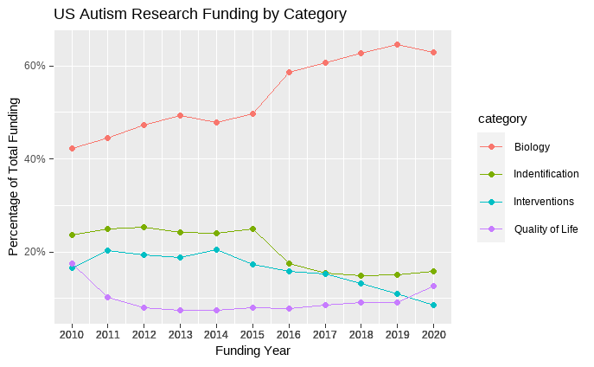
Figure 2. Data from [Interagency Autism Coordination Committee](https://iacc.hhs.gov/funding/data/)

Intersectionally Marginalized Groups
All of these problems compound for members of intersectional populations who may already be marginalized along other dimensions. Many researchers believe that autism is¹⁹, particularly in Black communities²⁰, as well as for²¹. Meanwhile, fluidity in gender and sexual orientation^{22,23} is more highly represented among autistic people. Little research has been done to assess how autism uniquely affects people in these different subgroups.

Physical and Mental Health
- Health and Well-being: Autistic adults experience higher rates of mental health issues, physical health disparities, and substantially elevated suicide risk [https://www.nature.com/articles/s41583-021-00463-7, https://pubmed.ncbi.nlm.nih.gov/33407027/].
- Social Isolation: Negative social experiences can lead to self-isolation, exacerbating feelings of loneliness and exclusion²⁴
Across a variety of health domains, autistic people fare worse^{25,26}. Additionally, we are exposed to risks that are not of primary concern for most people²⁷. These include autoimmune dysregulation of many kinds, autonomic dysregulation, connective tissue disorders, gastrointestinal disorders, and many other areas of health concern. A lack of understanding regarding these differences, coupled with communication barriers and false notions about autism all collude to create barriers to accessing health services and care.

Unemployment
- Employment: Many autistic adults face difficulties finding and maintaining employment due to biases and lack of accommodations. In a study of 254 autistic adults, 77% reported difficulties applying for jobs, and only 16% are in full-time paid work [https://www.ncbi.nlm.nih.gov/pmc/articles/PMC5215190/, https://www.frontiersin.org/articles/10.3389/fpsyg.2021.719827/full].

Homelessness
Barriers to entry to the workplace, as well as challenges and holding jobs due to ablest attitudes or inflexible policies, put us at risk of severe financial strain²⁸. This, coupled with the possibility of reduced social support, increases our risk of exposure to homelessness. The few studies that attempted to investigate autism in homeless populations suggest that rates of autism in homeless populations are much higher than that observed in the general public and may be ten times higher²⁹. Autistic people additionally face extra barriers in accessing the few services for unhoused people. Environments created with the intention of providing support may be aversive or even harmful for autistic people³⁰.

Suicide
As a group, their suicide risk may be two to seven times higher than the risk for youth and adults who do not have autism. When researchers took into account psychiatric conditions that increase suicide risk, such as depression, anxiety, and substance abuse disorders, autistic people still had a higher risk than the comparison group [@|autism2022]. The International Society for Autism Research says “Suicide in autism is a hidden crisis, overlooked by policymakers, clinicians and researchers worldwide.” and highlights three barriers: a lack of evidence-based assessment tools and interventions to identify and treat suicidal thoughts and behaviors; a lack of access to mental health services10 and exclusion from conversations about policies and guidelines that affect autistic people.”³¹

Glossary
ADLs
When a person applies for Medicaid long-term care services in Oregon, we look at how much help they need to perform Activities of Daily Living. Because funding is limited, we use this information (called a service priority level) to decide who is eligible for services. Activities of Daily Living are the basic personal activities all of us need to do that are essential for health and safety. These activities are defined in OAR 411-015-0006 https://www.oregon.gov/odhs/aging-disability-services/pages/adl.aspx
Alexithymia
Alexithymia is the inability for someone to recognize, identify, and describe feelings or emotions. It is sometimes referred to as emotional blindness. https://www.health.com/alexithymia-8361963
Asperger’s Syndrome
Asperger’s syndrome (sometimes called high-functioning autism) is part of a wide diagnosis called autism spectrum disorder (ASD). Since 2013, Asperger’s syndrome is replaced by the broader diagnosis of ASD within the Diagnostic and Statistical Manual of Mental Disorders (DSM-5) revised criteria. https://my.clevelandclinic.org/health/diseases/6436-asperger-syndrome
Co-Occurring Conditions
The preferred term in the autistic community as a replacement for “comorbid” for conditions, traits, and behaviors that are commonly found along with autism.
Double Empathy
Double empathy refers to how: 1. It is easier to understand the mindset of people who are similar to you 2. It is more difficult to understand the mindset of those who are different from you This concept was specifically developed by the autistic autism researcher Damian Milton to explain how autistics and neurotypicals empathize with each other. It explains how allistics (non-autistics) struggle to understand the lived experiences of autistics and autistics struggle to understand the lived experiences of allistics. Likewise, autistics are better at understanding other autistics and allistics are better at understanding other allistics. https://embrace-autism.com/autism-and-the-double-empathy-problem/
Dyslexia
Dyslexia is a specific learning difficulty which primarily affects reading and writing skills. However, it does not only affect these skills. Dyslexia is actually about information processing. Dyslexic people may have difficulty processing and remembering information they see and hear, which can affect learning and the acquisition of literacy skills. Dyslexia can also impact on other areas such as organisational skills. It is important to remember that there are positives to thinking differently. Many dyslexic people show strengths in areas such as reasoning and in visual and creative fields. https://www.bdadyslexia.org.uk/dyslexia/about-dyslexia/what-is-dyslexia
Dyspraxia
Dyspraxia is a term that refers to lifelong trouble with movement and coordination. It’s not a formal diagnosis. But you may still hear people use this term, especially in the U.K. The formal diagnosis is developmental coordination disorder (DCD). https://www.understood.org/en/articles/understanding-dyspraxia
fMRI
Functional MRI is a type of MRI scan that can show which areas of your brain are most active. Tracking and comparing that activity to what you were doing at the time can help “map” your brain activity. It’s most often used for planning surgery or similar procedures in the brain. https://my.clevelandclinic.org/health/diagnostics/25034-functional-mri-fmri
Gender identity
One’s innermost concept of self as male, female, a blend of both or neither – how individuals perceive themselves and what they call themselves. One’s gender identity can be the same or different from their sex assigned at birth. https://www.hrc.org/resources/sexual-orientation-and-gender-identity-terminology-and-definitions
Genome
The genome is the entire set of DNA instructions found in a cell. In humans, the genome consists of 23 pairs of chromosomes located in the cell’s nucleus, as well as a small chromosome in the cell’s mitochondria. A genome contains all the information needed for an individual to develop and function. https://www.genome.gov/genetics-glossary/Genome
Health Share Oregon
One of Oregon’s Community Care Organizations (CCO) for OHP. https://www.healthshareoregon.org/
I/DD
Oregon Department of Human Services: Intellectual and Developmental Disabilities.
Letter of Medical Necessity
A Letter of Medical Necessity (LMN) is the written explanation from the treating physician describing the medical need for services, equipment, or supplies to assist the claimant in the treatment, care, or relief of their accepted work-related illness(es). https://www.dol.gov/sites/dolgov/files/OWCP/energy/regs/compliance/Outreach/Outreach_Presentation/lmn_mba06222022.pdf
Neurodivergent
See Appendix 4: Neurodiversity and Neurodivergence
Neurodiversity
See Appendix 4: Neurodiversity and Neurodivergence
Non-Speaking
When an autistic person doesn’t speak, it’s known as nonspeaking autism. You may also see it described as nonverbal autism. However, the term nonverbal isn’t completely accurate, since it means “without words. Even if an autistic person is nonspeaking, they may still use words in other ways (such as in writing). They may also understand the words that are spoken to them or that they overhear. https://www.healthline.com/health/autism/nonverbal-autism
OCD
Obsessive-compulsive disorder (OCD) is a disorder in which people have recurring, unwanted thoughts, ideas or sensations (obsessions). To get rid of the thoughts, they feel driven to do something repetitively (compulsions). The repetitive behaviors, such as hand washing/cleaning, checking on things, and mental acts like (counting) or other activities, can significantly interfere with a person’s daily activities and social interactions. https://www.psychiatry.org/patients-families/obsessive-compulsive-disorder/what-is-obsessive-compulsive-disorder
ODDS
Oregon Office of Developmental Disabilities Services
OHP
Oregon Health Plan: Oregon Medicaid
Services Cliff
Many high school students on the autism spectrum get help through special education – most commonly including speech-language therapy, service coordination/case management, behavior management, and special transportation. Each student has a team that works with the student and family to decide which services are needed to prepare him or her for young adulthood, and federal law requires schools to offer the necessary services. Sounds like a good plan for how to help vulnerable youth through a challenging period of life. But then, following the last day of high school, the legal mandate for help suddenly ends. https://drexel.edu/autismoutcomes/blog/overview/2015/August/falling-off-the-services-cliff/
Sexual orientation
An inherent or immutable enduring emotional, romantic or sexual attraction to other people. Note: an individual’s sexual orientation is independent of their gender identity. https://www.hrc.org/resources/sexual-orientation-and-gender-identity-terminology-and-definitions
Synesthesia
Synesthesia is when your brain routes sensory information through multiple unrelated senses, causing you to experience more than one sense simultaneously. Some examples include tasting words or linking colors to numbers and letters. It’s not a medical condition, and many people find it useful to help them learn and remember information. https://my.clevelandclinic.org/health/symptoms/24995-synesthesia
Theory of Mind
In psychology, theory of mind refers to the capacity to understand other people by ascribing mental states to them. A theory of mind includes the knowledge that others’ beliefs, desires, intentions, emotions, and thoughts may be different from one’s own. Possessing a functional theory of mind is crucial for success in everyday human social interactions. People utilize a theory of mind when analyzing, judging, and inferring others’ behaviors. The discovery and development of theory of mind primarily came from studies done with animals and infants. Factors including drug and alcohol consumption, language development, cognitive delays, age, and culture can affect a person’s capacity to display theory of mind. Having a theory of mind is similar to but not identical with having the capacity for empathy or sympathy. https://en.wikipedia.org/wiki/Theory_of_mind

Representative Salaries

Representative Salaries

Data Analyst
Earner Class | Annual Salary | Monthly Pay | Weekly Pay | Hourly Wage
Top Earners | $127,790.00 | $10,649.00 | $2,458.00 | $61.00
75th Percentile | $102,900.00 | $8,575.00 | $1,979.00 | $49.00
Average | $87,640.00 | $7,303.00 | $1,685.00 | $42.00
25th Percentile | $66,300.00 | $5,525.00 | $1,275.00 | $32.00

Data Engineer
Earner Class | Annual Salary | Monthly Pay | Weekly Pay | Hourly Wage
Top Earners | $171,801.00 | $14,316.00 | $3,303.00 | $83.00
75th Percentile | $145,800.00 | $12,150.00 | $2,803.00 | $70.00
Average | $138,279.00 | $11,523.00 | $2,659.00 | $66.00
25th Percentile | $121,400.00 | $10,116.00 | $2,334.00 | $58.00

Database Administrator
Earner Class | Annual Salary | Monthly Pay | Weekly Pay | Hourly Wage
Top Earners | $150,061.00 | $12,505.00 | $2,886.00 | $72.00
75th Percentile | $130,400.00 | $10,867.00 | $2,508.00 | $63.00
Average | $108,448.00 | $9,037.00 | $2,086.00 | $52.00
25th Percentile | $84,800.00 | $7,067.00 | $1,631.00 | $41.00

Director Of Operations
Earner Class | Annual Salary | Monthly Pay | Weekly Pay | Hourly Wage
Top Earners | $171,801.00 | $14,316.00 | $3,303.00 | $83.00
75th Percentile | $143,700.00 | $11,975.00 | $2,763.00 | $69.00
Average | $102,922.00 | $8,576.00 | $1,979.00 | $49.00
25th Percentile | $80,100.00 | $6,675.00 | $1,540.00 | $39.00
Top Earners | $171,801.00 | $14,316.00 | $3,303.00 | $83.00
75th Percentile | $143,700.00 | $11,975.00 | $2,763.00 | $69.00
Average | $102,922.00 | $8,576.00 | $1,979.00 | $49.00
25th Percentile | $80,100.00 | $6,675.00 | $1,540.00 | $39.00

Grant Writer
Earner Class | Annual Salary | Monthly Pay | Weekly Pay | Hourly Wage
Top Earners | $91,733.00 | $7,644.00 | $1,764.00 | $44.00
75th Percentile | $77,900.00 | $6,492.00 | $1,498.00 | $37.00
Average | $70,107.00 | $5,842.00 | $1,348.00 | $34.00
25th Percentile | $55,100.00 | $4,592.00 | $1,060.00 | $26.00

Operations Manager
Earner Class | Annual Salary | Monthly Pay | Weekly Pay | Hourly Wage
Top Earners | $115,064.00 | $9,588.00 | $2,212.00 | $55.00
75th Percentile | $82,200.00 | $6,850.00 | $1,580.00 | $40.00
Average | $68,498.00 | $5,708.00 | $1,317.00 | $33.00
25th Percentile | $43,500.00 | $3,625.00 | $836.00 | $21.00

Policy Analyst
Earner Class | Annual Salary | Monthly Pay | Weekly Pay | Hourly Wage
Top Earners | $123,548.00 | $10,295.00 | $2,375.00 | $59.00
75th Percentile | $123,500.00 | $10,291.00 | $2,375.00 | $59.00
Average | $97,464.00 | $8,122.00 | $1,874.00 | $47.00
25th Percentile | $88,000.00 | $7,333.00 | $1,692.00 | $42.00

Research Associate
Earner Class | Annual Salary | Monthly Pay | Weekly Pay | Hourly Wage
Top Earners | $94,915.00 | $7,910.00 | $1,825.00 | $46.00
75th Percentile | $81,700.00 | $6,808.00 | $1,571.00 | $39.00
Average | $71,781.00 | $5,982.00 | $1,380.00 | $35.00
25th Percentile | $57,800.00 | $4,817.00 | $1,112.00 | $28.00

Senior Manager
Earner Class | Annual Salary | Monthly Pay | Weekly Pay | Hourly Wage
Top Earners | $178,695.00 | $14,891.00 | $3,436.00 | $86.00
75th Percentile | $144,800.00 | $12,066.00 | $2,784.00 | $70.00
Average | $93,748.00 | $7,812.00 | $1,802.00 | $45.00
25th Percentile | $52,000.00 | $4,333.00 | $1,000.00 | $25.00

Website Designer
Earner Class | Annual Salary | Monthly Pay | Weekly Pay | Hourly Wage
Top Earners | $109,232.00 | $9,103.00 | $2,101.00 | $53.00
75th Percentile | $84,800.00 | $7,067.00 | $1,631.00 | $41.00
Average | $77,227.00 | $6,436.00 | $1,485.00 | $37.00
25th Percentile | $56,700.00 | $4,725.00 | $1,090.00 | $27.00

Website Programmer
Earner Class | Annual Salary | Monthly Pay | Weekly Pay | Hourly Wage
Top Earners | $119,306.00 | $9,942.00 | $2,294.00 | $57.00
75th Percentile | $100,700.00 | $8,392.00 | $1,937.00 | $48.00
Average | $85,087.00 | $7,091.00 | $1,636.00 | $41.00
25th Percentile | $67,300.00 | $5,608.00 | $1,294.00 | $32.00

Potential Funders

Healthcare

Adventist
- Sponsorship Request
- Community Benefit

Cambia
- Healthy and Connected Aging
- Sponsorship

CareOregon
- Community Giving grants and sponsorships
- HRSN Services

Central Oregon Health Council
- Standard Grants

Health Share
- Sponsorship
- HRSN Services
- HRSN Services

Kaiser
- HRSN Services
- HRSN Services
- HRSN Services
- HRSN Services
- Community Benefit

Legacy
- Community Health Grant
- Legacy Research Institute
- Sponsorship
- HRSN Services

Ochin
- NA

OHSU
- Community Partnership Program
- Community Partnership Program
- Community Partnership Program
- Tiered Grants
- HRSN Services
- Rural Population Health Incubator Program

Pacific Source
- Community Health Excellence Grants
- Community Capacity-Building Funding for HRSN services
- Community Health Excellence Grants
- All
- PacificSource Foundation for Health Improvement
- Healthy Communities Program

Providence
- Community Grants/Donations
- Sponsorship
- HRSN Services

St Charles Health System
- Community Benefit Grants and Sponsorships

Trillium
- Community Benefit Initiatives
- Community Benefit Initiatives
- Community Capacity Building Funding

Foundatons and Trusts

Anna May Family Foundation
- Grant

Autzen Foundation
- Grant

Ben B Cheney Foundation
- Grant

Benton Community Foundation
- Community Grants

Carpenter Foundation
- Grant

Chambers Family Foundation
- Grant

Collins Foundation
- Responsive Grant
- Responsive Grant

Doug Flutie Foundation
- Autism Community Impact Grant
- Flutie Fellows – Career and Life Goal Support
- Financial Relief for Families

Foster Foundation
- Grant

Gordon Elwood Foundation
- Grant

M J Murdock Charitable Trust
- STRATEGIC GRANT

Maybelle Clark Macdonald Fund
- Grant

Meyer Memorial Trust
- Grant

Oregon Community Foundation
- Grant

Reser Family Foundation
- Responsive Grant Programs

Robert Wood Johnson Foundation
- Multiple
- Multiple

Weyerhouser
- Giving Fund

State

Oregon Health Authority
- Block Grants
- Community Capacity Building Funds
- Community Capacity Building Funds
- SHARE Initiative
- PUBLIC HEALTH EQUITY
- PUBLIC HEALTH EQUITY
- GRANT
- HTO CHIP Project Grants

Oregon State
- IMPACTS Grant Program

Misc

Fidget Tech
- Need info

Organization for Autism Research
- Community Grant Competition

Patient Centered Outcomes Research Organization
- Need info

Neurodiversity and Neurodivergence
Many people find this article by Dr. Nick Walker to be the definitive overview of these terms and how they are used and misused. We put together the summary below with the help of chatGPT:

Neurodiversity (concept)
Definition: Neurodiversity is the idea that neurological differences, like autism, ADHD, dyslexia, and others, are natural variations of the human genome. This concept emphasizes that these differences should be recognized and respected as a part of human diversity.
Historical and Social Context: The term “neurodiversity” was coined in the late 1990s by sociologist Judy Singer. It arose from the disability rights movement and the autistic rights movement, which sought to challenge the medical model of disability that views neurological differences as deficits or disorders to be cured. Instead, neurodiversity advocates promote acceptance and understanding, emphasizing the strengths and contributions of neurodivergent individuals.

Neurodiversity (paradigm)
Definition: The neurodiversity paradigm is a framework that challenges traditional views of neurological differences. It posits that these differences should be seen as normal variations rather than abnormalities or deficits. This paradigm promotes the idea that society should adapt to accommodate these differences rather than forcing individuals to conform to a neurotypical standard.
Historical and Social Context: This paradigm shift gained momentum in the early 2000s, aligning with broader social movements advocating for civil rights and inclusion. It has influenced fields like education, employment, and healthcare, encouraging practices that support diverse ways of thinking and learning.

Neurodiversity (movement)
Definition: The neurodiversity movement is a social movement that advocates for the rights and inclusion of neurodivergent individuals. It seeks to promote understanding, acceptance, and accommodation of neurological differences. The movement has worked to reframe autism as a minority identity rather than a disorder.
Historical and Social Context: Emerging in the late 20th century, the neurodiversity movement has been driven by self-advocates and allies. It challenges stigmatizing narratives and calls for systemic changes in how neurodivergent individuals are treated in society. This movement has led to increased visibility and advocacy for policies that support neurodiversity in schools, workplaces, and communities.

Neurodivergence
Definition: Neurodivergence refers to the state of having a brain that functions differently from the typical standards of society. It is an umbrella term that includes various neurological conditions like autism, ADHD, dyslexia, and more.
Historical and Social Context: The term “neurodivergence” gained prominence alongside the neurodiversity movement. It helps to create a more inclusive language that recognizes the spectrum of neurological differences without implying pathology. This shift in terminology supports a more positive and accepting view of diverse cognitive profiles.

Neurodivergent
Definition: Neurodivergent describes individuals whose neurological development and functioning are atypical. This term is used to identify people who have conditions like autism, ADHD, dyslexia, etc.
Historical and Social Context: The adoption of the term “neurodivergent” reflects a growing acceptance of diversity in neurological functioning. It emphasizes identity and self-advocacy, allowing individuals to claim their differences as part of who they are rather than as something to be fixed or hidden.

Neurotypical
Definition: Neurotypical refers to individuals whose neurological development and functioning are considered standard or typical by societal norms. It is often used in contrast to neurodivergent.
Historical and Social Context: The term “neurotypical” originated within the neurodiversity community as a way to distinguish between those who conform to societal norms of neurological functioning and those who do not. It highlights that “typical” neurological functioning is not the only valid or acceptable way of being, promoting a more inclusive view of human diversity.

References
1. Singer, J. (1998). Odd People In: The Birth of Community Amongst People on the ‘Autistic Spectrum’. Honours Thesis, University of Technology, Sydney.
2. Silberman, S. (2015). NeuroTribes: The Legacy of Autism and the Future of Neurodiversity. Avery.
3. Armstrong, T. (2010). Neurodiversity: Discovering the Extraordinary Gifts of Autism, ADHD, Dyslexia, and Other Brain Differences. Da Capo Lifelong Books.
4. Kapp, S. K., et al. (2013). Deficit, Difference, or Both? Autism and Neurodiversity. Developmental Psychology, 49(1), 59–71.

