INTERNAL BRIEFING · KAIZEN INSTITUTE
Caravel Autism Health
Current state and market potential — prepared for Dan Chartier
75+ clinics · 8 US states · PE-owned by GTCR since July 2024 · inbound lead from COO Rob Benson, routed by José Carlos Pires
This is a current-state read only — what Caravel is, what the numbers show today, and where the potential sits. No proposed solution or engagement pitch is included here.

The situation today, in one page
Rob Benson, COO of Caravel Autism Health, contacted Kaizen directly: "Scheduling clients and teammates is central to operational performance and efficiency. I'm interested in engaging in a process improvement/optimization project." The company is owned by GTCR, a private-equity firm that bought it in July 2024 mid-growth-sprint, with an entirely new leadership team hired through 2025 and 2026.
$110–190M  Modeled annual revenue, 77 sites  Industry per-clinic benchmark × site count. Not a confirmed company figure. | $11–19M  Value of closing the utilization gap  10 margin points, industry-published relationship, applied to the modeled base.
30%  ABA industry cancellation ceiling  Well above general healthcare norms — the exact pain Rob named. | 3.3–3.5  Average employee rating (of 5)  Glassdoor. High turnover and burnout described directly by staff.

Who Caravel is, and why now
Caravel Autism Health provides Applied Behavior Analysis (ABA) therapy for children with autism, founded in Wisconsin in 2009. It operates 75+ clinics across 8 states (WI, IL, MN, IA, ID, WA, MO, IN, KS), concentrated in the Upper Midwest, with new sites opening at a pace of roughly one a month through 2026.
Ownership and timing
GTCR, a Chicago private-equity firm, acquired Caravel from Frazier Healthcare Partners in July 2024, one of the few large platform trades in the sector that year. Caravel had previously raised $50M from Frazier in 2018. GTCR's strategy is regional density: cluster clinics tightly rather than spread thin nationally, which is why scheduling consistency across sites matters financially to them today.
Source: bhbusiness.com/2024/05/20 · gtcr.com/portfolio-company/caravel-autism-health
Leadership: almost entirely new
Role | Hired
CEO — Mike Miller | pre-2025
COO — Rob Benson | Jan 2025
Chief Clinical Officer — Adam Hahs | May 2025
Chief People Officer — Amy Messersmith | Jul 2025
CIO — Pete Spivack | Mar 2025
VP Data & Analytics — Charles Bravoco | Sep 2025
CFO — Rudy Blank | Jul 2026
Almost the entire executive bench was hired in the last 18 months by GTCR to build the infrastructure from scratch. Scheduling process is not entrenched with this leadership team — it is still being formed.
Source: caravelautism.com/about/leadership-team
Rob Benson, COO
In role since January 2025. 20+ years in healthcare leadership, a clinical-to-business hybrid background: Duke (economics/sociology), University of Chicago MBA, and a Master's in Nursing (Family Nurse Practitioner). Based in Brentwood, TN, working remote/multi-site.
Source: linkedin.com/in/robert-benson-095228

Why scheduling is genuinely hard here, today
ABA scheduling is not a booking-calendar problem. Every match has to respect three hard constraints at once: which therapists are certified for which client, how many insurance-authorized hours remain this period, and BCBA supervision ratios that regulators actively audit. Add cancellation rates far above general healthcare, and the result is a genuinely hard combinatorial problem, not a UI problem.
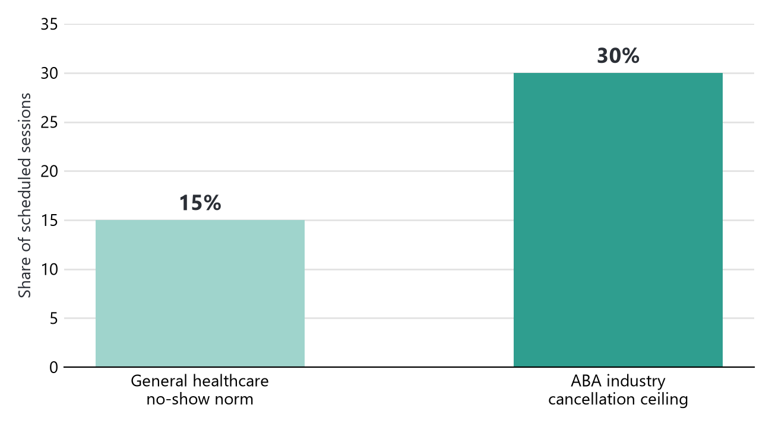
ABA cancellation rates run as high as 30%, roughly double the general-healthcare no-show norm. This is the exact operational pain Rob described in his own words.
Source: leadsquared.com/us/industries/healthcare/kpis-to-track-in-aba-practice-management · theralytics.net/blogs/kpis-every-aba-practice-should-track

Where the potential value sits
ABA clinics run 15% operating margin at typical staffing utilization, 25% at optimized utilization — a published industry relationship, not a Caravel-specific measurement. Ten margin points, applied to the modeled revenue base below, is the largest single number in this picture.
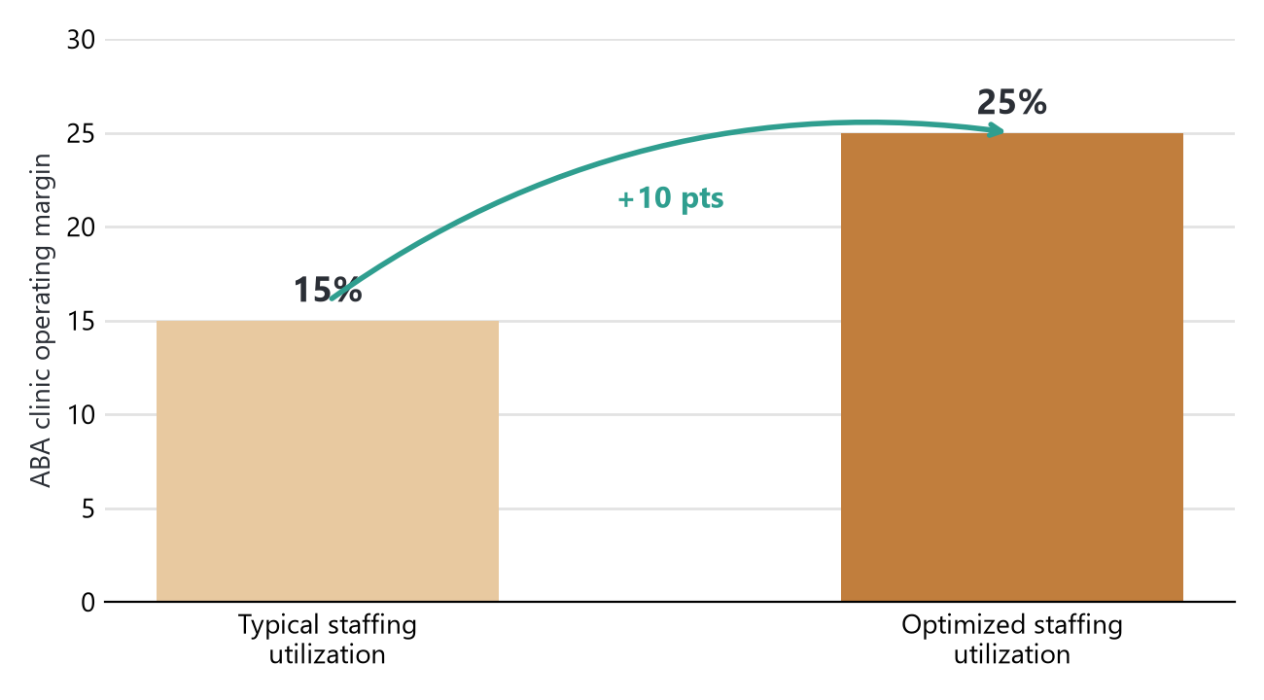
Source: focusbankers.com/behavioral-health-practice-valuation
No public revenue figure exists for Caravel. Two data aggregators gave numbers 25× apart from each other ($18.8M vs. $466.5M), both unreliable. This range is built bottom-up instead: established, multi-therapist ABA clinics typically run $1–4M a year each; applied across 77 mixed-maturity sites (some a decade old, some weeks old), a defensible blended range is $110–190M.
Source: profitableventure.com/how-much-aba-therapy-business-make
Three places the gap shows up
1. Margin left on the table by underused capacity. $11–19M/yr, the number above, applied to the modeled revenue base.
2. Cancelled sessions that disappear instead of getting rebooked. At $45–90 net reimbursement per hour, every unfilled slot is revenue that was on the books and is now gone, with staff still on payroll. Directional, not yet quantified in dollars, until Caravel's own cancellation rate is known.
3. Coordination load that grows with headcount instead of the system. Four new clinics opened in the last 90 days alone — each one currently adds coordination work rather than absorbing into an existing system.

What families and staff say today
Every clinic's own page shows a hand-picked highlight reel, not the raw review feed — almost nothing negative surfaces on-site company-wide. The chart below is the average of those curated ratings, by region, next to the one place an independent number exists to compare against.
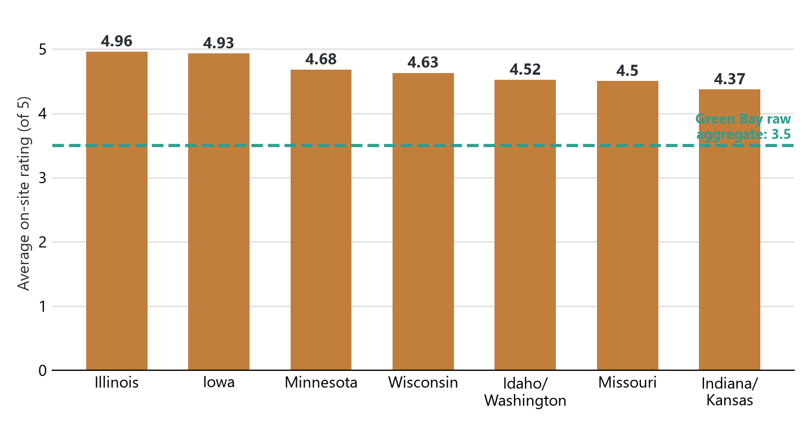
Caravel's own Green Bay widgets show 4.6–5.0 stars. The independent Birdeye aggregate for the same city shows 3.5 stars across 20 reviews. Same clinics, two different pictures.
The quotes that got past the filter
"The staff and leadership were very accommodating when they could be based on staffing."
Google review · Rockford/South, IL
"Their turnaround time is rather quick to get you in and Val has great communication skills."
Google review · Munster, IN
"Hours are not always guaranteed due to cancellations. … no guarantee of staffing for families."
Employee reviews (aggregate) · Glassdoor / Indeed
Source: caravelautism.com clinic pages · reviews.birdeye.com/caravel-autism-health-155775538140065 · glassdoor.com/Reviews/Caravel-Autism-Health-Reviews-E1435673 · indeed.com/cmp/Caravel-Autism-Health/reviews
All figures in this report are either direct citations or explicitly modeled from cited benchmarks, never presented as confirmed company numbers unless sourced as such. Compiled August 2026.

