**CSS vs SCSS:**

**CSS : Cascading Style Sheet** is the basically the scripting language. CSS is used for designing web pages.CSS is the most important web technologies that are widely used along with HTML and JavaScript. CSS have file extension of **.css**.

**SCSS : Syntactically Awesome Style Sheet** is the superset of CSS. SCSS is the more advanced version of CSS. SCSS was designed by Hampton Catlin and was developed by Chris Eppstein and Natalie Weizenbaum. Due to its advanced features it is often termed as Sassy CSS. SCSS have file extension of **.scss**.

**SASS:**

SASS (Syntactically Awesome Style Sheets) is a pre-processor scripting language that will be compiled or interpreted into CSS. SassScript is itself a scripting language whereas SCSS is the main syntax for the SASS which builds on top of the existing CSS syntax.

**Differences:**

1. SCSS includes all of the CSS features and other features that are not available in CSS, making it a strong alternative for developers to use it.
2. CSS is a style language that is used to style and create web pages. While SCSS is a particular type of file for SASS, it used the Ruby language, which assembles the browser's CSS style sheets.
3. SCSS contains advanced and modified features.
4. SCSS is more expressive than the CSS. SCSS uses fewer lines in its code than CSS, which makes loading the code easier.
5. It promotes proper nesting of rules. Nesting is not assisted by regular CSS. Inside another class, we cannot write a class. It brings a readability issue as the project gets larger, and the layout doesn't look good.
6. Various style sheets may be used on a single page by some simple CSS line code changes. It has benefits for usability and the ability to customize a website or site to various target devices.
7. We may include the various features to the code in the form of variables, nesting, and selectors with SCSS. In contrast, these features are not present in the CSS.
8. The SCSS syntax uses indentations that are not present in CSS.
9. SCSS helps us to use the operators to do the math operations. Inside our code, we can make simple calculations for better performance.
10. The knowledge of SCSS helps to customize Bootstrap 4.

**Example: In CSS Example: In SCSS**

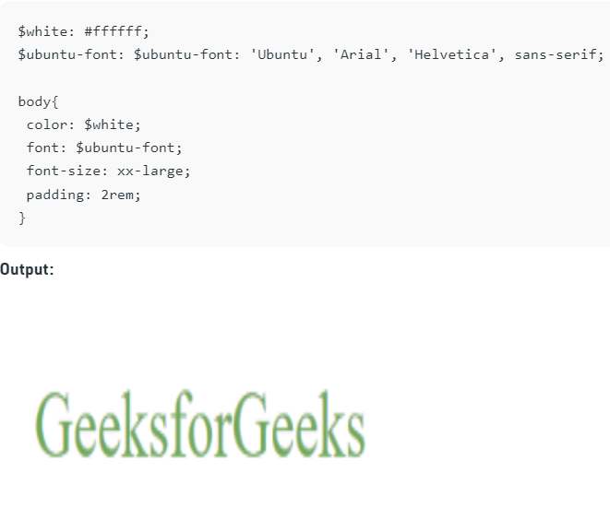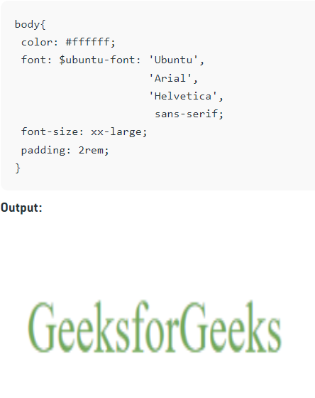

**~ General Sibling Selector:** It is **General Sibling Selector**and similar to Adjacent Sibling Selector. It selects all **next** elements that are siblings of a specified element.

Example:

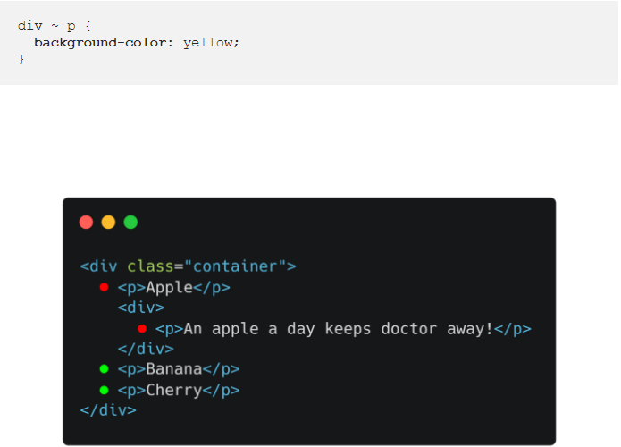

**CSS Selectors:**

|  |  |  |
| --- | --- | --- |
| **Selector** | **Example** | **Example description** |
| [*](https://www.w3schools.com/cssref/sel_all.asp) | * | Selects all elements |
| [*element*](https://www.w3schools.com/cssref/sel_element.asp) | p | Selects all <p> elements |
| [*element.class*](https://www.w3schools.com/cssref/sel_element_class.asp) | p.intro | Selects all <p> elements with class="intro" |
| [*element,element*](https://www.w3schools.com/cssref/sel_element_comma.asp) | div, p | Selects all <div> elements and all <p> elements |
| [*element* *element*](https://www.w3schools.com/cssref/sel_element_element.asp) | div p | Selects all <p> elements inside <div> elements |
| [*element*>*element*](https://www.w3schools.com/cssref/sel_element_gt.asp) | div > p | Selects all <p> elements where the parent is a <div> element |
| [*element*+*element*](https://www.w3schools.com/cssref/sel_element_pluss.asp) | div + p | Selects the first <p> element that is placed immediately after <div> elements |
| [*element1*~*element2*](https://www.w3schools.com/cssref/sel_gen_sibling.asp) | p ~ ul | Selects every <ul> element that is preceded by a <p> element |
| [[*attribute*]](https://www.w3schools.com/cssref/sel_attribute.asp) | [target] | Selects all elements with a target attribute |
| [[*attribute*=*value*]](https://www.w3schools.com/cssref/sel_attribute_value.asp) | [target=_blank] | Selects all elements with target="_blank" |
| [[*attribute*~=*value*]](https://www.w3schools.com/cssref/sel_attribute_value_contains.asp) | [title~=flower] | Selects all elements with a title attribute containing the word "flower" |
| [[*attribute*|=*value*]](https://www.w3schools.com/cssref/sel_attribute_value_lang.asp) | [lang|=en] | Selects all elements with a lang attribute value equal to "en" or starting with "en-" |
| [[*attribute*^=*value*]](https://www.w3schools.com/cssref/sel_attr_begin.asp) | a[href^="https"] | Selects every <a> element whose href attribute value begins with "https" |
| [[*attribute*$=*value*]](https://www.w3schools.com/cssref/sel_attr_end.asp) | a[href$=".pdf"] | Selects every <a> element whose href attribute value ends with ".pdf" |
| [[*attribute*\*=*value*]](https://www.w3schools.com/cssref/sel_attr_contain.asp) | a[href*="w3schools"] | Selects every <a> element whose href attribute value contains the substring "w3schools" |
| [:active](https://www.w3schools.com/cssref/sel_active.asp) | a:active | Selects the active link |
| [::after](https://www.w3schools.com/cssref/sel_after.asp) | p::after | Insert something after the content of each <p> element |
| [::before](https://www.w3schools.com/cssref/sel_before.asp) | p::before | Insert something before the content of each <p> element |
| [:checked](https://www.w3schools.com/cssref/sel_checked.asp) | input:checked | Selects every checked <input> element |
| [:default](https://www.w3schools.com/cssref/sel_default.asp) | input:default | Selects the default <input> element |
| [:disabled](https://www.w3schools.com/cssref/sel_disabled.asp) | input:disabled | Selects every disabled <input> element |
| [:empty](https://www.w3schools.com/cssref/sel_empty.asp) | p:empty | Selects every <p> element that has no children (including text nodes) |
| [:enabled](https://www.w3schools.com/cssref/sel_enabled.asp) | input:enabled | Selects every enabled <input> element |
| [:first-child](https://www.w3schools.com/cssref/sel_firstchild.asp) | p:first-child | Selects every <p> element that is the first child of its parent |
| [::first-letter](https://www.w3schools.com/cssref/sel_firstletter.asp) | p::first-letter | Selects the first letter of every <p> element |
| [::first-line](https://www.w3schools.com/cssref/sel_firstline.asp) | p::first-line | Selects the first line of every <p> element |
| [:first-of-type](https://www.w3schools.com/cssref/sel_first-of-type.asp) | p:first-of-type | Selects every <p> element that is the first <p> element of its parent |
| [:focus](https://www.w3schools.com/cssref/sel_focus.asp) | input:focus | Selects the input element which has focus |
| [:fullscreen](https://www.w3schools.com/cssref/sel_fullscreen.asp) | :fullscreen | Selects the element that is in full-screen mode |
| [:hover](https://www.w3schools.com/cssref/sel_hover.asp) | a:hover | Selects links on mouse over |
| [:in-range](https://www.w3schools.com/cssref/sel_in-range.asp) | input:in-range | Selects input elements with a value within a specified range |
| [:indeterminate](https://www.w3schools.com/cssref/sel_indeterminate.asp) | input:indeterminate | Selects input elements that are in an indeterminate state |
| [:invalid](https://www.w3schools.com/cssref/sel_invalid.asp) | input:invalid | Selects all input elements with an invalid value |
| [:lang(*language*)](https://www.w3schools.com/cssref/sel_lang.asp) | p:lang(it) | Selects every <p> element with a lang attribute equal to "it" (Italian) |
| [:last-child](https://www.w3schools.com/cssref/sel_last-child.asp) | p:last-child | Selects every <p> element that is the last child of its parent |
| [:last-of-type](https://www.w3schools.com/cssref/sel_last-of-type.asp) | p:last-of-type | Selects every <p> element that is the last <p> element of its parent |
| [:link](https://www.w3schools.com/cssref/sel_link.asp) | a:link | Selects all unvisited links |
| [::marker](https://www.w3schools.com/cssref/sel_marker.asp) | ::marker | Selects the markers of list items |
| [:not(*selector*)](https://www.w3schools.com/cssref/sel_not.asp) | :not(p) | Selects every element that is not a <p> element |
| [:nth-child(*n*)](https://www.w3schools.com/cssref/sel_nth-child.asp) | p:nth-child(2) | Selects every <p> element that is the second child of its parent |
| [:nth-last-child(*n*)](https://www.w3schools.com/cssref/sel_nth-last-child.asp) | p:nth-last-child(2) | Selects every <p> element that is the second child of its parent, counting from the last child |
| [:nth-last-of-type(*n*)](https://www.w3schools.com/cssref/sel_nth-last-of-type.asp) | p:nth-last-of-type(2) | Selects every <p> element that is the second <p> element of its parent, counting from the last child |
| [:nth-of-type(*n*)](https://www.w3schools.com/cssref/sel_nth-of-type.asp) | p:nth-of-type(2) | Selects every <p> element that is the second <p> element of its parent |
| [:only-of-type](https://www.w3schools.com/cssref/sel_only-of-type.asp) | p:only-of-type | Selects every <p> element that is the only <p> element of its parent |
| [:only-child](https://www.w3schools.com/cssref/sel_only-child.asp) | p:only-child | Selects every <p> element that is the only child of its parent |
| [:optional](https://www.w3schools.com/cssref/sel_optional.asp) | input:optional | Selects input elements with no "required" attribute |
| [:out-of-range](https://www.w3schools.com/cssref/sel_out-of-range.asp) | input:out-of-range | Selects input elements with a value outside a specified range |
| [::placeholder](https://www.w3schools.com/cssref/sel_placeholder.asp) | input::placeholder | Selects input elements with the "placeholder" attribute specified |
| [:read-only](https://www.w3schools.com/cssref/sel_read-only.asp) | input:read-only | Selects input elements with the "readonly" attribute specified |
| [:read-write](https://www.w3schools.com/cssref/sel_read-write.asp) | input:read-write | Selects input elements with the "readonly" attribute NOT specified |
| [:required](https://www.w3schools.com/cssref/sel_required.asp) | input:required | Selects input elements with the "required" attribute specified |
| [:root](https://www.w3schools.com/cssref/sel_root.asp) | :root | Selects the document's root element |
| [::selection](https://www.w3schools.com/cssref/sel_selection.asp) | ::selection | Selects the portion of an element that is selected by a user |
| [:target](https://www.w3schools.com/cssref/sel_target.asp) | #news:target | Selects the current active #news element (clicked on a URL containing that anchor name) |
| [:valid](https://www.w3schools.com/cssref/sel_valid.asp) | input:valid | Selects all input elements with a valid value |
| [:visited](https://www.w3schools.com/cssref/sel_visited.asp) | a:visited | Selects all visited links |

**CSS Functions:**

|  |  |
| --- | --- |
| **Function** | **Description** |
| [attr()](https://www.w3schools.com/cssref/func_attr.asp) | Returns the value of an attribute of the selected element |
| [calc()](https://www.w3schools.com/cssref/func_calc.asp) | Allows you to perform calculations to determine CSS property values |
| [conic-gradient()](https://www.w3schools.com/cssref/func_conic-gradient.asp) | Creates a conic gradient |
| [counter()](https://www.w3schools.com/cssref/func_counter.asp) | Returns the current value of the named counter |
| [cubic-bezier()](https://www.w3schools.com/cssref/func_cubic-bezier.asp) | Defines a Cubic Bezier curve |
| [hsl()](https://www.w3schools.com/cssref/func_hsl.asp) | Defines colors using the Hue-Saturation-Lightness model (HSL) |
| [hsla()](https://www.w3schools.com/cssref/func_hsla.asp) | Defines colors using the Hue-Saturation-Lightness-Alpha model (HSLA) |
| [max()](https://www.w3schools.com/cssref/func_max.asp) | Uses the largest value, from a comma-separated list of values, as the property value |
| [min()](https://www.w3schools.com/cssref/func_min.asp) | Uses the smallest value, from a comma-separated list of values, as the property value |
| [radial-gradient()](https://www.w3schools.com/cssref/func_radial-gradient.asp) | Creates a radial gradient |
| [repeating-conic-gradient()](https://www.w3schools.com/cssref/func_repeating-conic-gradient.asp) | Repeats a conic gradient |
| [repeating-linear-gradient()](https://www.w3schools.com/cssref/func_repeating-linear-gradient.asp) | Repeats a linear gradient |
| [repeating-radial-gradient()](https://www.w3schools.com/cssref/func_repeating-radial-gradient.asp) | Repeats a radial gradient |

**CSS Reference Aural:**

<https://www.w3schools.com/cssref/css_ref_aural.asp>

**CSS Properties:**

# The position Property: The position property specifies the type of positioning method used for an element.

## **position: static;** HTML elements are positioned static by default.

**position: relative;** is positioned relative to its normal position. Setting the top, right, bottom, and left properties of a relatively-positioned element will cause it to be adjusted away from its normal position. Other content will not be adjusted to fit into any gap left by the element.

## 

**position: fixed;** is positioned relative to the viewport, which means it always stays in the same place even if the page is scrolled. The top, right, bottom, and left properties are used to position the element. A fixed element does not leave a gap in the page where it would normally have been located.

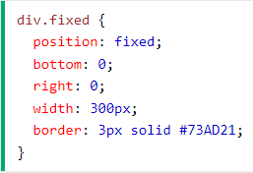

**position: absolute;** is positioned relative to the nearest positioned ancestor (instead of positioned relative to the viewport, like fixed).However; if an absolute positioned element has no positioned ancestors, it uses the document body, and moves along with page scrolling. **Note:** Absolute positioned elements are removed from the normal flow, and can overlap elements.

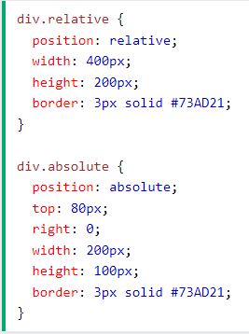

**position: sticky;** is positioned based on the user's scroll position.A sticky element toggles between relative and fixed, depending on the scroll position. It is positioned relative until a given offset position is met in the viewport - then it "sticks" in place (like position:fixed).

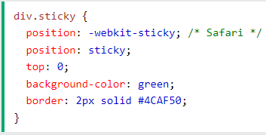

The z-index Property: When elements are positioned, they can overlap other elements.The z-index property specifies the stack order of an element (which element should be placed in front of, or behind, the others).An element can have a positive or negative stack order

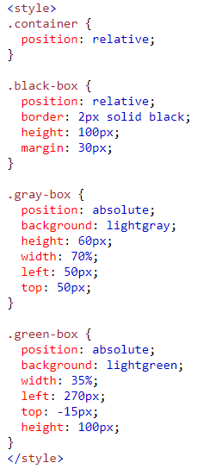

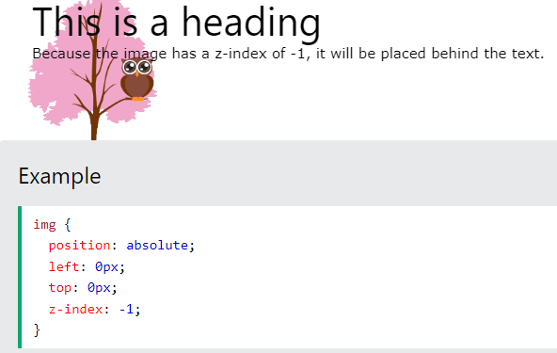

Float and Clear: The CSS float property specifies how an element should float.

The CSS clear property specifies what elements can float beside the cleared element and on which side.