**JS Aync:**

***JavaScript Callbacks:***

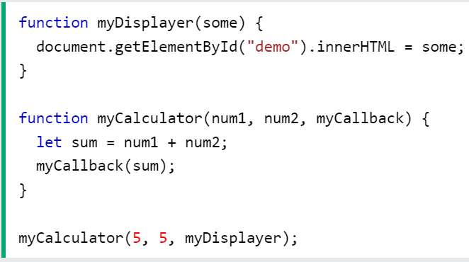JavaScript functions are executed in the sequence they are called. Not in the sequence they are defined.

***JavaScript Asynchronous:***

setTimeout: When using the JavaScript function setTimeout(), you can specify a callback function to be executed on time-out.

setInterval:  you can specify a callback function to be executed for each interval.