**What is TypeScript?**

TypeScript is a syntactic superset of JavaScript which adds **static typing**.

This basically means that TypeScript adds syntax on top of JavaScript, allowing developers to add **types**.

# 

# **TypeScript Tuples:**

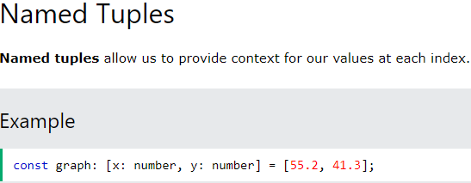

# **TypeScript Enums**

An **enum** is a special "class" that represents a group of constants (unchangeable variables).

Enums come in two flavors string and numeric. Lets start with numeric.

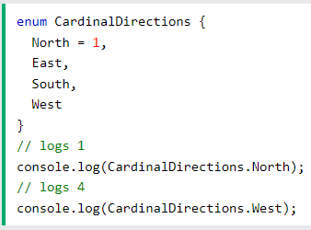

## Type Aliases

Type Aliases allow defining types with a custom name (an Alias).Type Aliases can be used for primitives like string or more complex types such as objects and arrays:

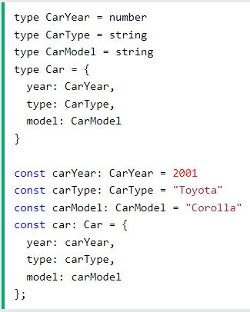

## Interfaces

## Interfaces are similar to type aliases, except they ****only**** apply to object types.

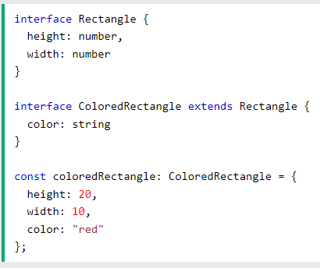

## Named Parameters

Typing named parameters follows the same pattern as typing normal parameters.

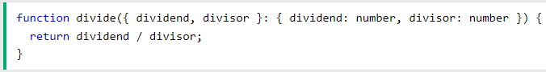

## Rest Parameters

Rest parameters can be typed like normal parameters, but the type must be an array as rest parameters are always arrays.

## 

## Type Alias

Function types can be specified separately from functions with type aliases.

