NPM Publish Package:

Firstly, we will create a “TurkeyCities” folder. We will go to the folder we created.

mkdir TurkeyCities

cd TurkeyCities

npm init

When you run the npm init command, it will ask you to enter the following information on the cmd screen.

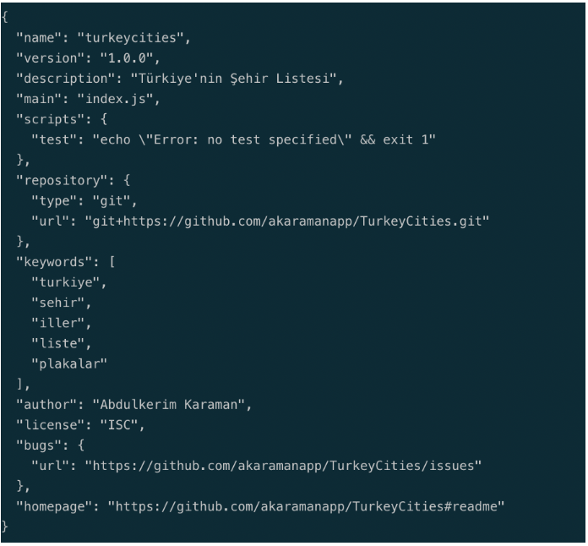

Our npm package will contain the list of provinces belonging to Turkey. Let's add the following provinces by creating an index.js file in the project directory.

Now let's publish the module we wrote. First, let's create an account on npmjs.com and then login with the following command.

npm login

After this command, it will ask you for username, password and email information, and after entering this information, your login process will be completed.

npm publish

Publishing was successful. You can see the package when you go to your profile from npmjs.com.

