SPSU, September 04, 2014

Name: Vinh Nguyen

Email: [baovinh007@yahoo.com](mailto:baovinh007@yahoo.com)

**GUIDE TO RUN PROGRAM**

To run the program on Windows

And here it is.

1. Install the  Microsoft Visual Studio 2012 (any edition works for you, or 2008), just click and go.
2. Download and install the [WxWidgets 3.0.0](https://www.wxwidgets.org/downloads/). (present it's Version 3.0.0 and windows installer edition is recommended). As recommended in the documentation, install it without space in the path name, so I simply use the default: "C:\wxWidgets-3.0.0". If you use Visual Studio 2008 or 2008, you can down load wxWidgets-2.8.12, and put it in "C:\wxWidgets-2.8.12"
3. Open the **Advanced System Settings**(see screenshot) and click on the "**Environment Variables...**".

[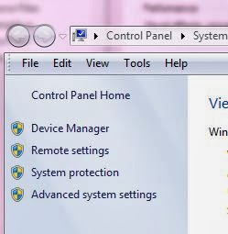](http://4.bp.blogspot.com/-kXL8BRomwzs/UwM-IbNnoWI/AAAAAAAAGv8/r4Hg7xV1YjE/s1600/1.JPG)[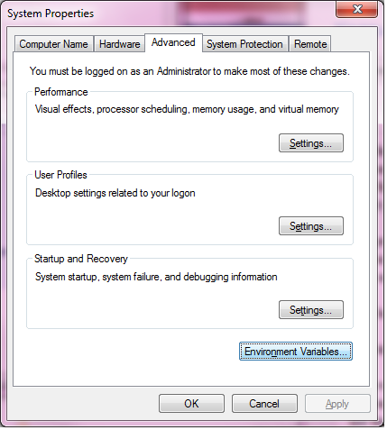](http://1.bp.blogspot.com/-9Zz4t2EVzGo/UwM-POTNbOI/AAAAAAAAGwI/eKhOaiTKrYY/s1600/2.png)

1. Add a New item: Variable name: **WXWIN**, Variable value: **C:\wxWidgets-3.0.0** (path of your wxwidgets);

[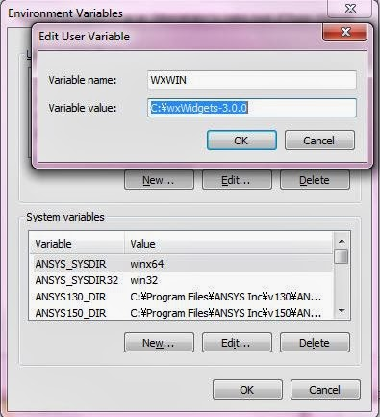](http://4.bp.blogspot.com/-Xokqdv8IPBI/UwM-PL3sWFI/AAAAAAAAGwM/ylWlrH2Aep8/s1600/4.JPG)

1. Go to your wxWidgets folder (here, for example, C:\wxWidgets-3.0.0), open the "**\build\msw\wx_vc10.sln**" file with visual studio (just double click on it).  If prompted with some update of the files, just hit "OK".
2. Build this solution (hit **F7** or from menu) for "Debug" **and** "Release" separately(choose the build type as shown in the picture, each build process needs may be 1~2 min). (Note: If you need DLL, just build the DLL Debug and DLL Release). It should build without error and show something like"========== Build: 23 succeeded, 0 failed, 0 up-to-date, 0 skipped ==========".
3. Go to ColorMRFdemoVinh\windows\ and double click colormrfdemo.sln
4. Change Solution Configure from Debug to Release
5. Right click colormrfdemo project -> Properties

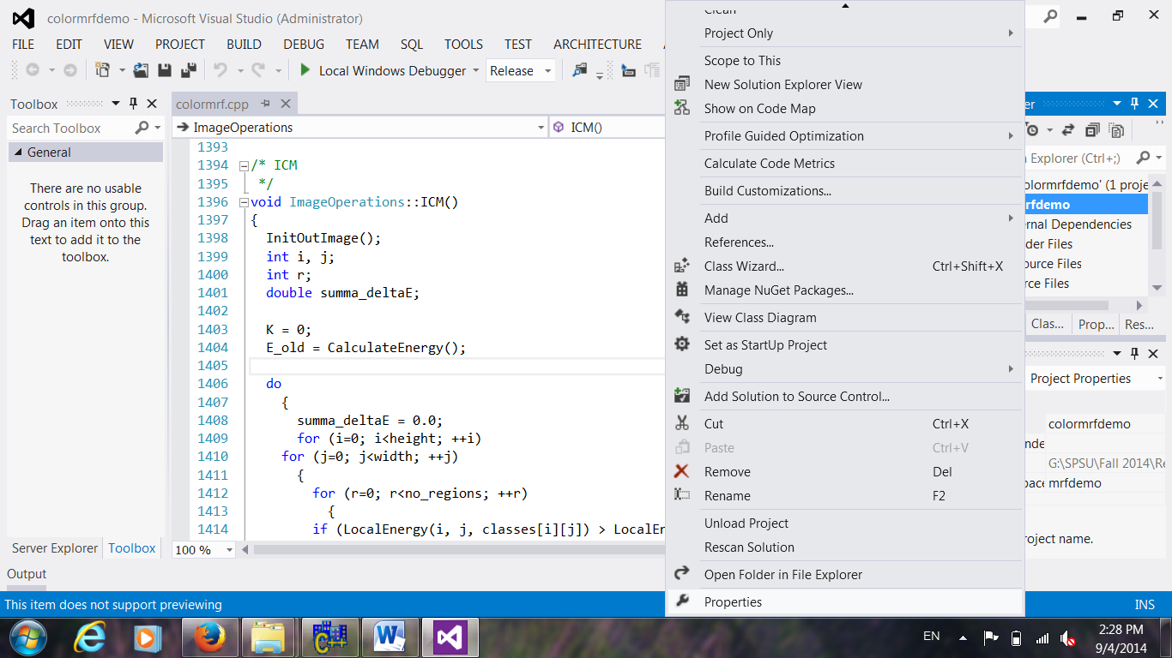

1. Choose C/C++:

Change Additional Include Directories: $(WXWIN)\include;$(WXWIN)\include\msvc;

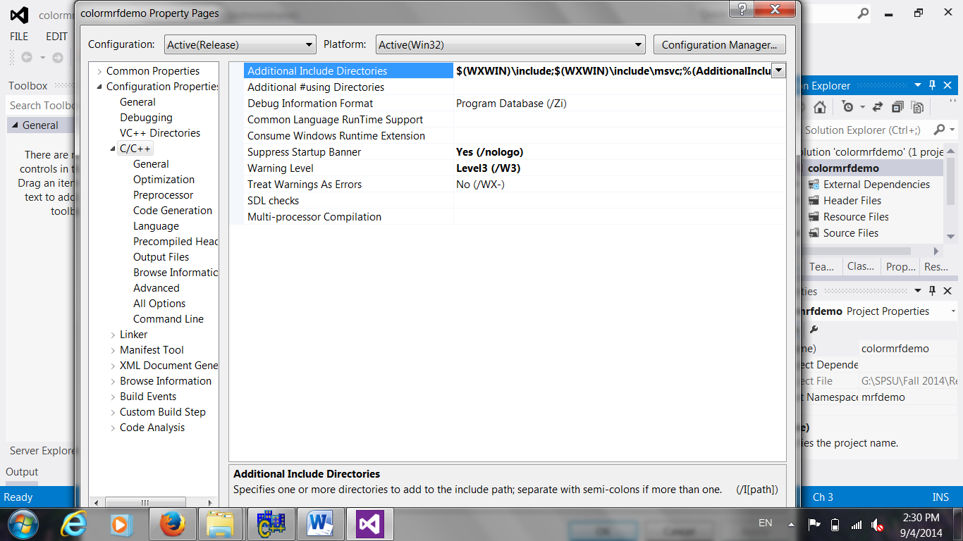

1. DONE. Click F5 to run program.

USAGE NOTES:

============

The program works on BMP images. Some test images are provided under the

'images' subdirectory. The program GUI should be intuitive. Main steps:

1) Load a color image

2) Enter the number of pixel classes (~region type)

3) Push "Select classes" button

4) Press left mouse button over the input image and draw a rectangle

over a representative region of the first class. Then push "Next

class" button. The mean and variance-covariance should appear in the "Class

parameters" window. Continue with the next class until a

representative rectangle for all classes has been selected.

5) Set the weight of doubleton potentials (default is 2.5) and the

stopping threshold (iterations are stopped when the energy change is

less than the specified value).

6) Choose the optimization method from the pull-down list.

7) Adjust the optimization method's parameters:

T0 - Initial temperature

c - temperature scheduler (T(n+1) = c*T(n))

alpha - MMD's probability threshold

8) Push "Do it >>" button to execute segmentation.

9) Optionally, you can save the segmentation result as a BMP image.

During segmentation, the current classification along with the

temperature and global energy are displayed at each iteration. At the

end, the elapsed CPU time is also displayed (excluding GUI oveheaad!).