William Seto

Team B: Auto Pirates

Teammates: Bikramjot Hanzra, Shiyu Dong, Tae-Hyung Kim, Tushar Chugh

ILR05

November 25, 2015

Individual Progress

For this progress review, I focused on two things: making sure we had a successful field test, and then creating a map of the rivers so that we visualize the logged data from the field test.

For the field test, I served as the unofficial test lead. Overall, the field test went well (see Figure 1 below), but we faced some difficulties as well. It took us about an hour to setup the radar logging pipeline we had prepared. Next, I worked with Shiyu and Bikram to identify any obstacles of interest depending on where we were in the river.

Once we were in a good groove for collecting radar data, I worked with Tae-Hyung and Tushar to try and setup the manual yaw and speed control. Although we didn’t succeed in controlling the boat with our custom ROS messages, we managed to record some data of the boat navigating to waypoints we clicked in the GUI. This could help us later on when we go back and replay the data, and analyze the angles the boat had to take and how well the trajectory was followed.

After the field test, I switched gears to learning about maps. For creating the map, I decided to use the QGIS program, which can import OpenStreetMap data directly with a plugin. Also, since we only need our map to have the outline of the river, along with obstacles in the river such as piers and the bridges, I used the Overpass API (also available as a QGIS plugin) to query specific OpenStreetMap metadata. And finally, using QGIS’s “Print Composer”, we can export the canvas as a raster image, along with a world file that geo-references each of the pixels in the image. We can also specify the DPI of the image, giving us control of the map resolution as well. Currently we have ~7 meters per pixel.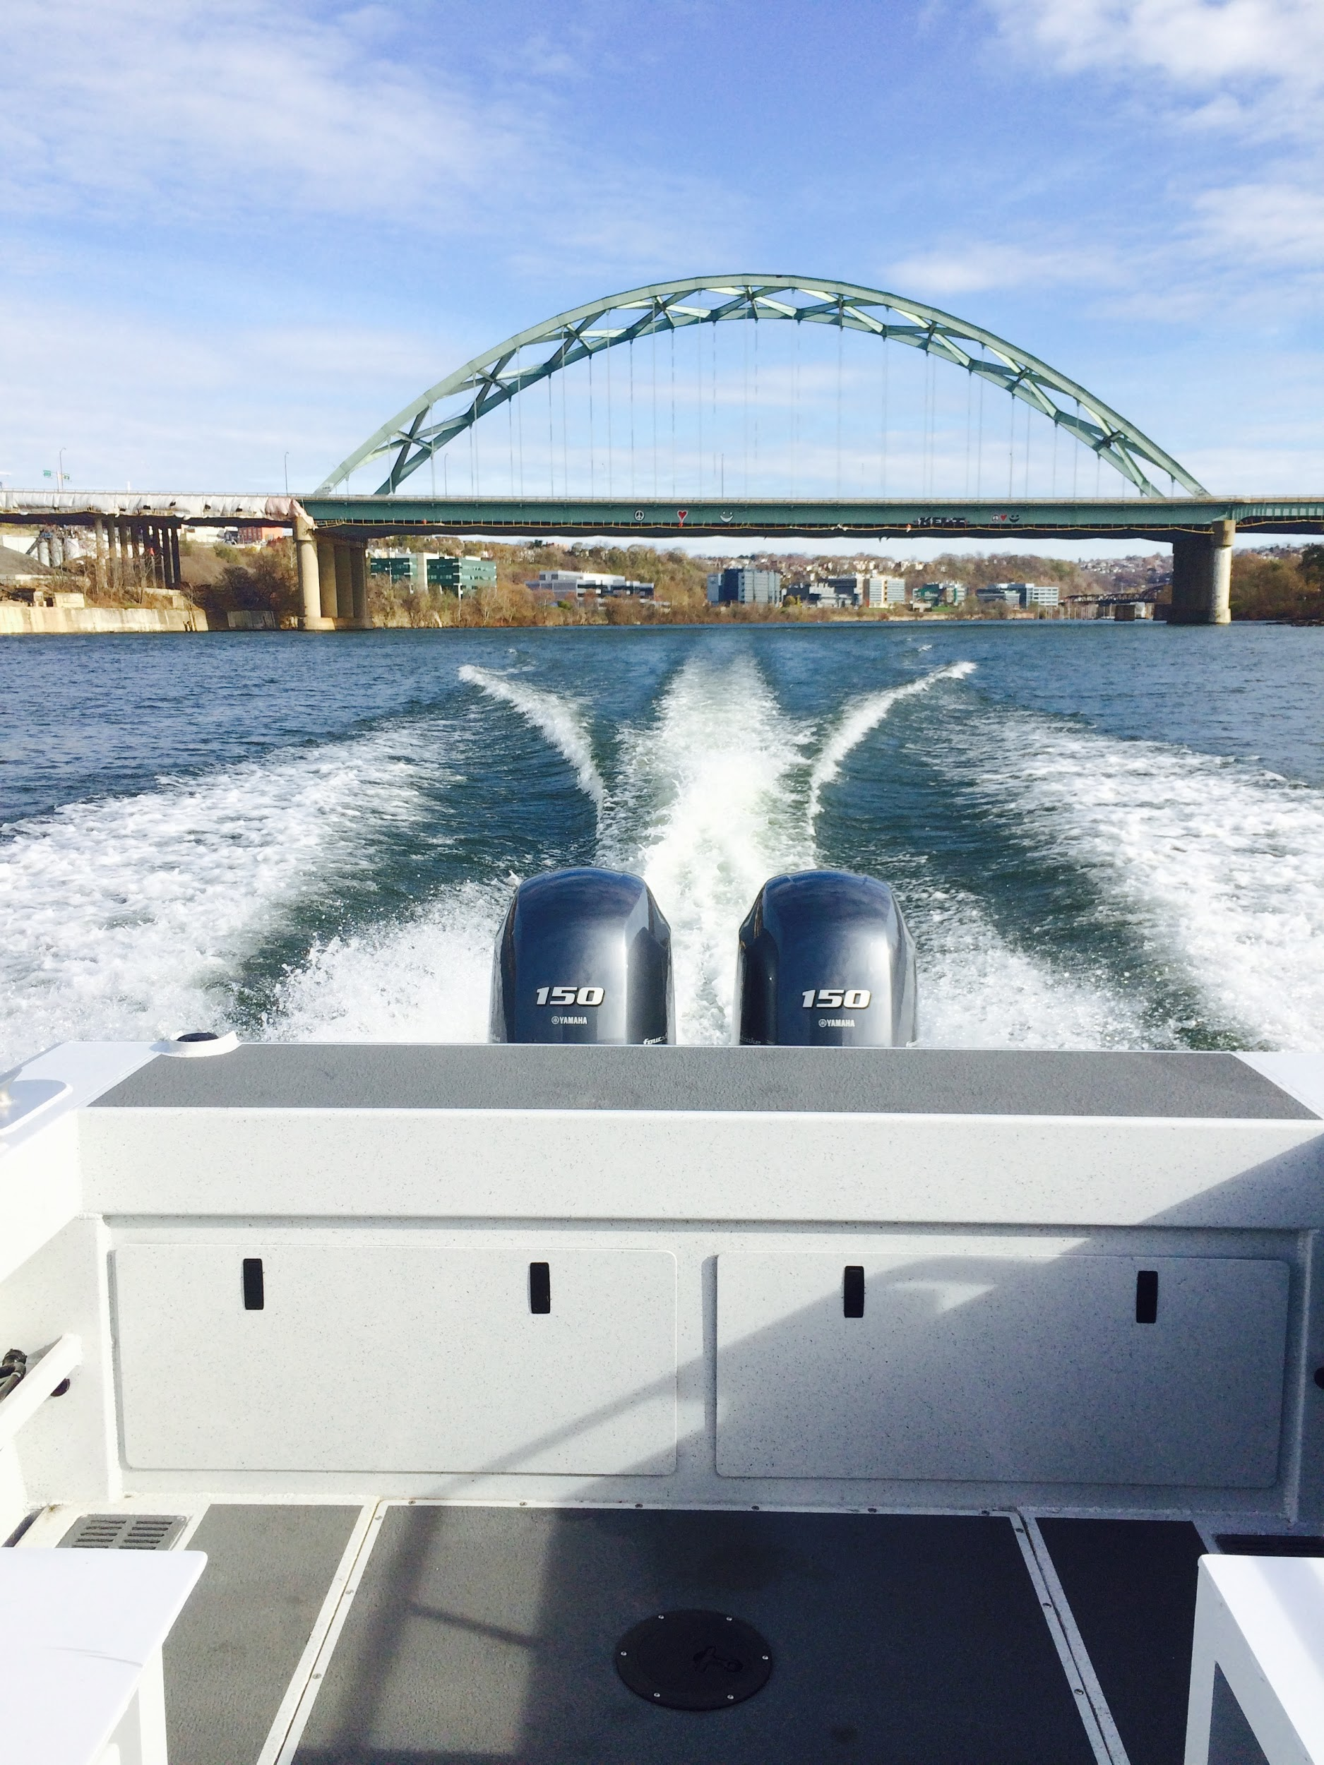

*Figure 1: Nice day to be on the river*

Challenges

Although expected in any field test, we faced more difficulty than we thought we would in our first field test. Even with our own software, which we were comfortable with, gave us trouble. Originally we planned to use 2 laptops for perception, one for publishing radar data, and another for logging data. However, we faced an issue with one laptop not being able to receive the video feed from the other laptop. After trying some time to debug it, we eventually decided to go with just one laptop for both tasks. Going into more detail for the waypoint following of the boat, we were scrambling to look up the documentation of the source code as well as trying to figure out UTM coordinates on the fly to test with. It all felt really rushed, and we could definitely do a better job next time of understanding all the test scenarios as well as the necessary data or equipment needed for the test.

For mapping, I faced the initial learning curve of understanding projections, coordinate systems, and just GIS programs in general. Then I had to figure out what kind of map would be most appropriate for our project. Although our current map isn’t too polished, it will be easier to iterate on from this point.

Teamwork

Shiyu Dong

Shiyu worked on reading in the logged GPS data, and then creating a ROS publisher to visualize the boat on the map. I worked with him to get the map coordinate calculation correct.

Bikramjot Hanzra

Bikram worked on overlaying the radar data onto the map we created. We discussed possible improvements that we could make as to how the radar data is converted to cartesian coordinates.

Tae-Hyung Kim

Tae-hyung continued to debug compilation issues with the SBPL lattice planner. Similarly, he worked to resolve compatibility issues so that we could interface the library with ROS’s navigation package.

Tushar Chugh

Tushar worked with Shiyu to complete initial construction of the PCB. Furthermore, I worked with him to create the map which he then used to import into SBPL, and generate a planned path. Finally, he updated the boat GUI so that we could input custom UTM coordinates and translate them into low level boat commands.

Plans

In preparation for the FVE, we will need to polish up the overlaying of the radar data onto the map. I will work with Bikram to identify possible solutions: either increasing the resolution of the map or do some downsampling and filtering on the radar image.

If time permits, I also plan to help out Tushar and Tae-Hyung with improving the path planning simulation so that we have a nice demo.