APPLICATION SHOWCASE / 10 SEPTEMBER 2026
GHCP AI Credits Simulator
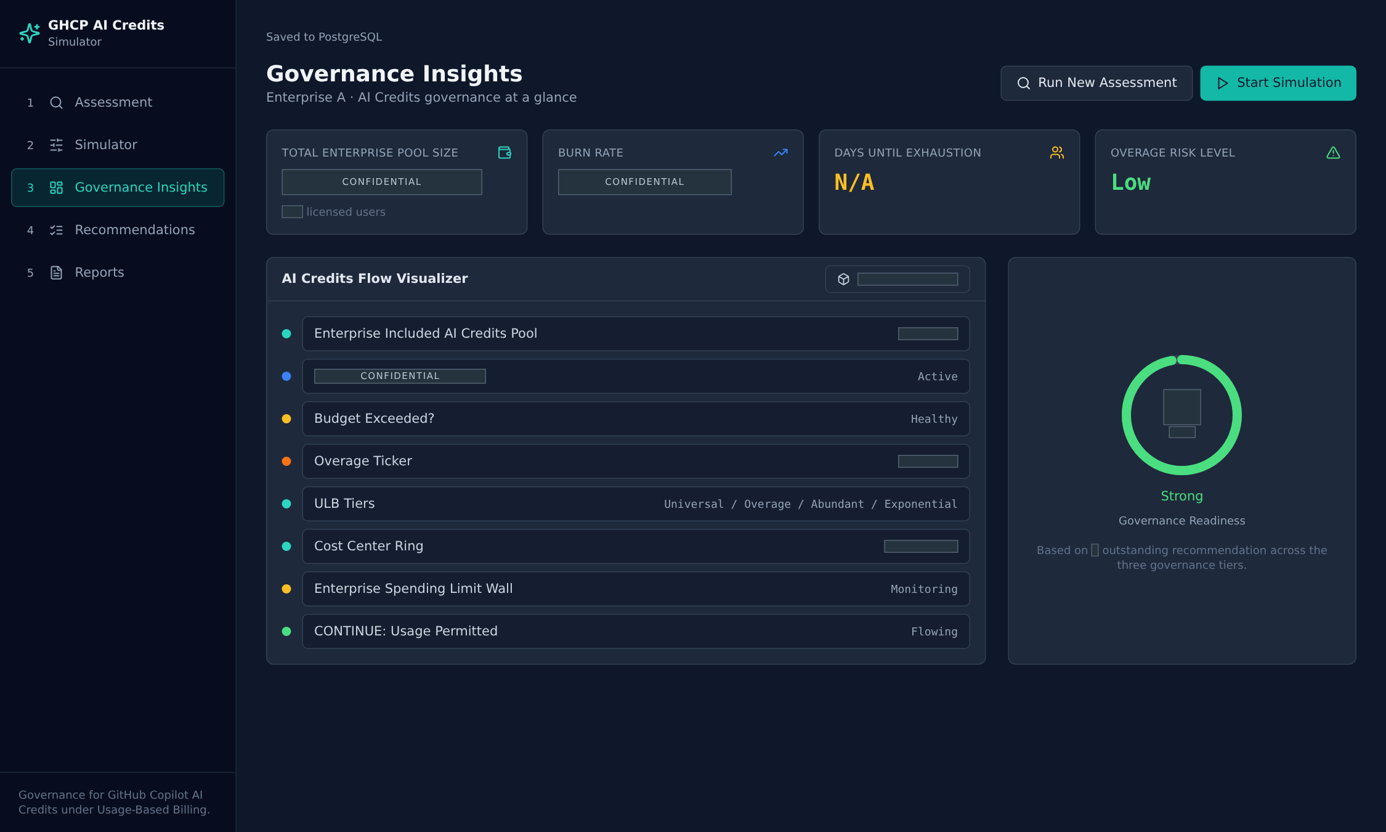
A visual tour of assessment, planning, governance, and reporting. Authorized live assessment data, pseudonymized and redacted for presentation.
Maintainer: Preston K. Parsard
Contributor(s): AI

CONCEPT / PRODUCT CONTEXT
One conversation. Five workspaces.
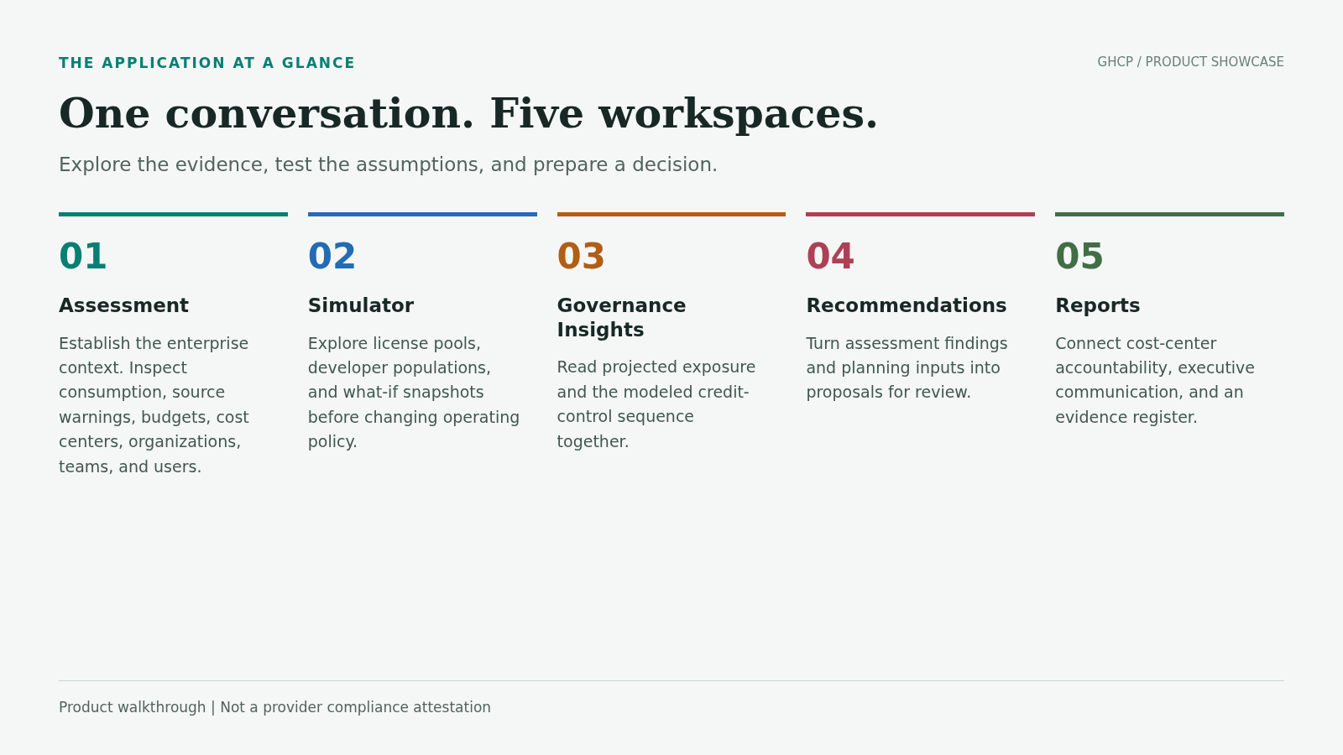
Explore the evidence, test the assumptions, and prepare a decision.

CONCEPT / PRODUCT CONTEXT
Different signals. Different confidence.
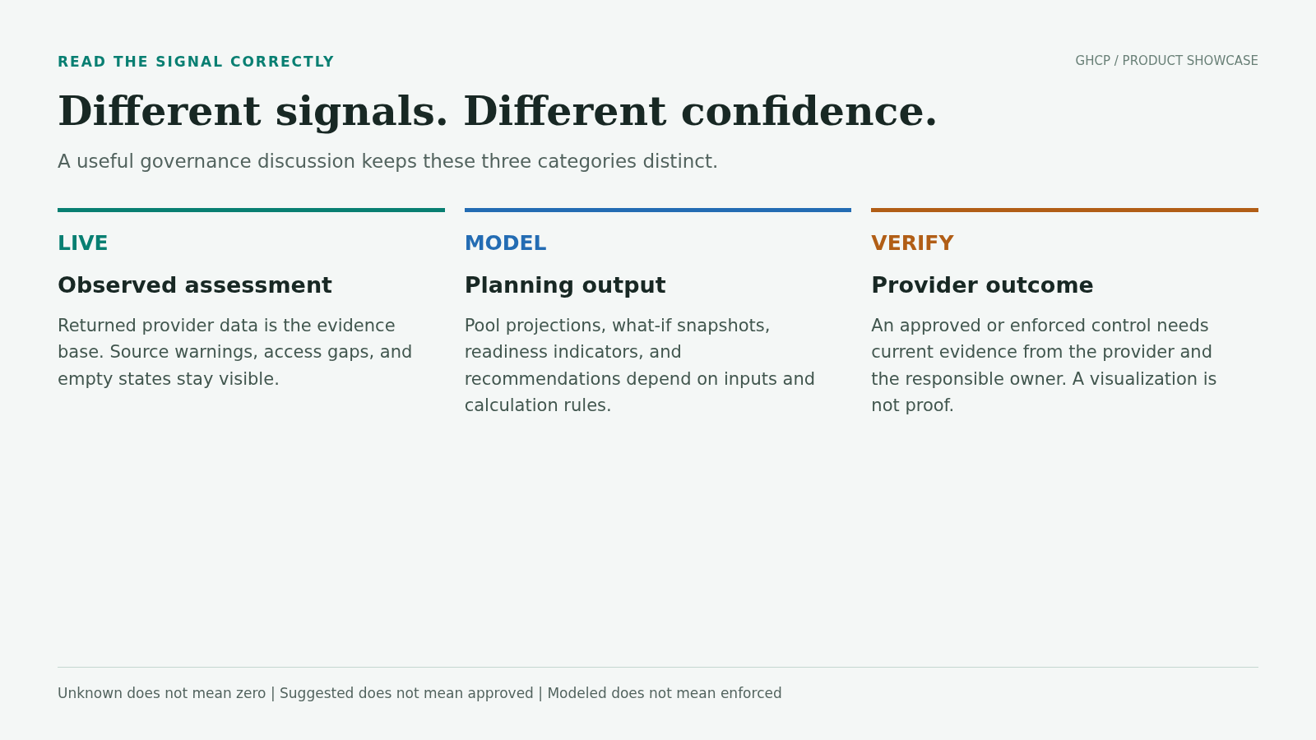
A useful governance discussion keeps these three categories distinct.

APPLICATION / REDACTED CAPTURE
Connect the enterprise context
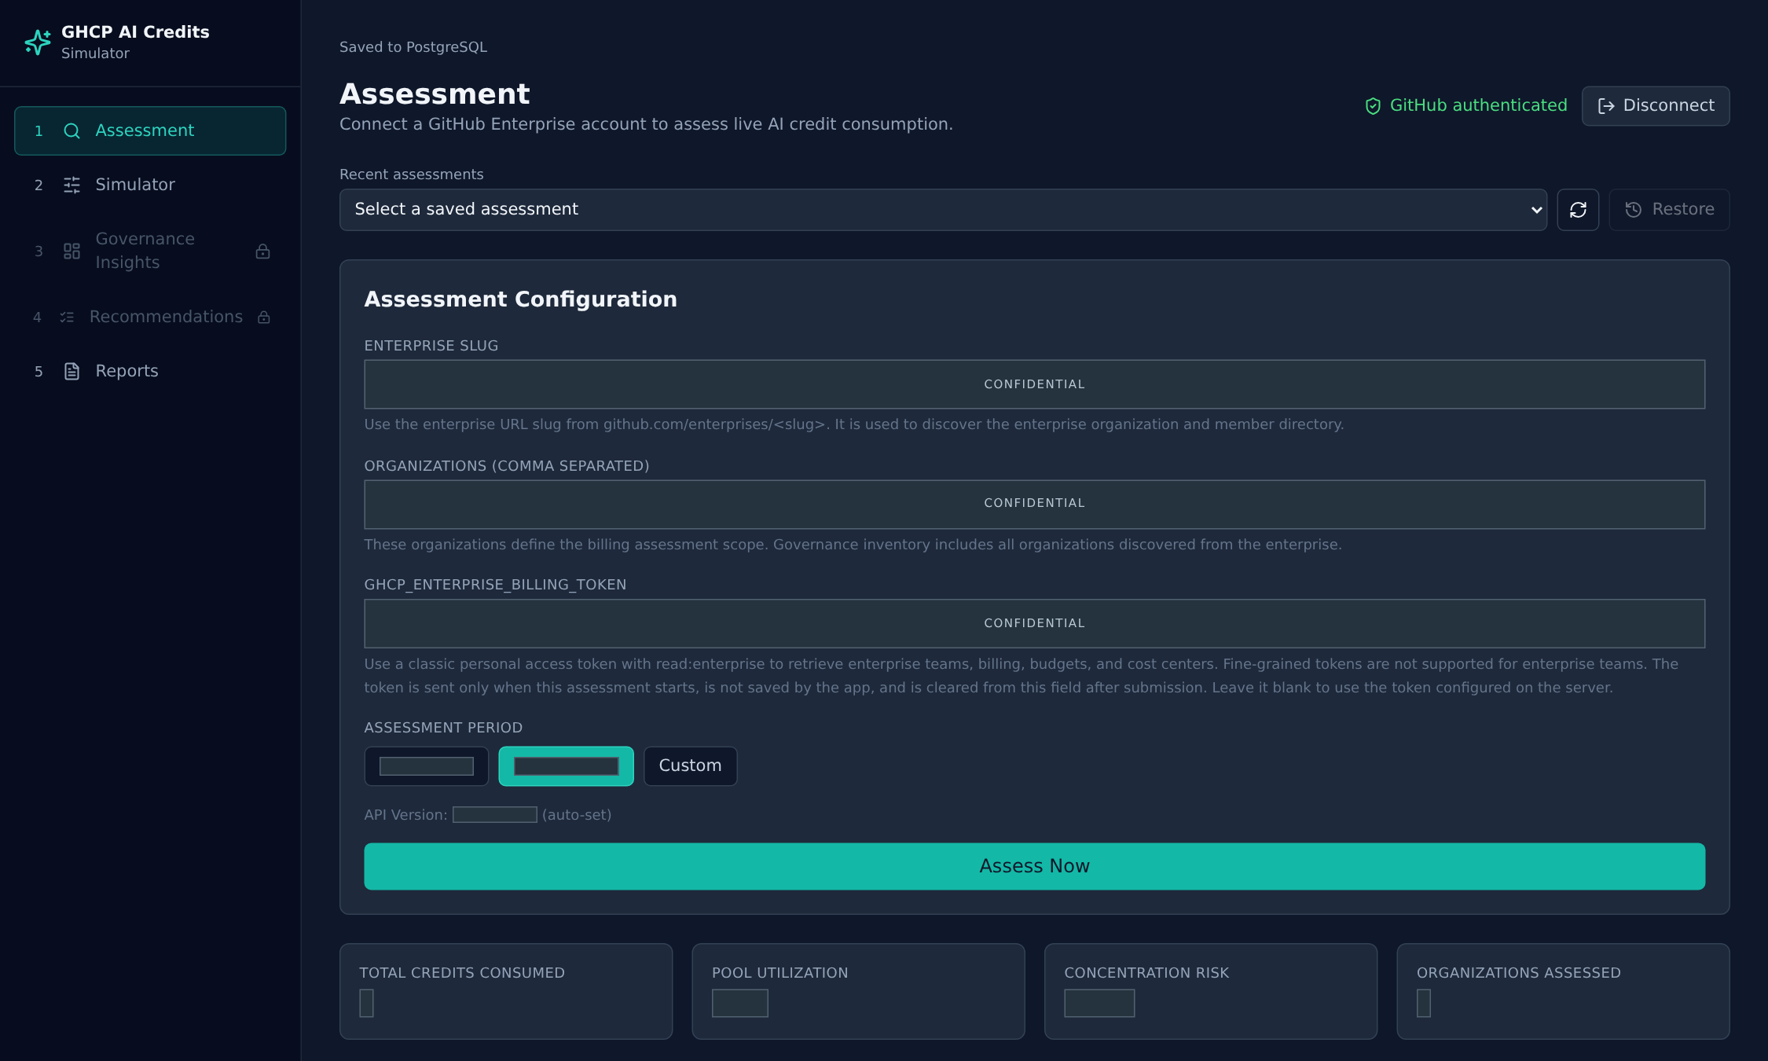
Start with a defined enterprise scope and a reusable assessment history.
Live assessment workflow. Inputs and account details are masked; no credentials were transferred to the capture browser.

APPLICATION / REDACTED CAPTURE
Understand consumption and source coverage
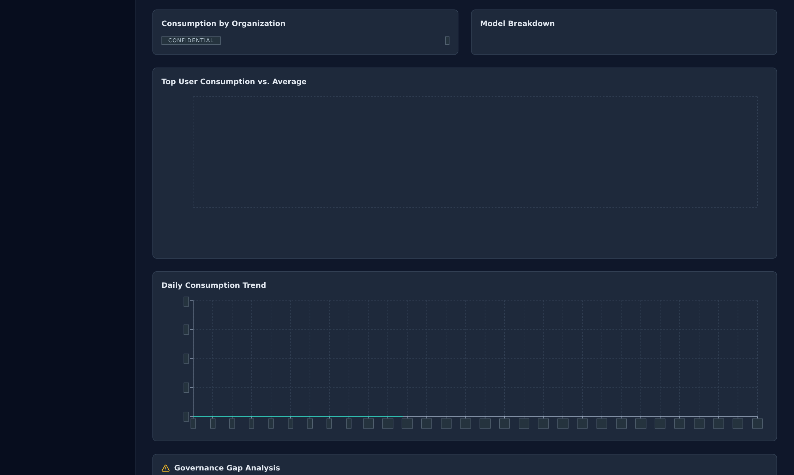
Read availability warnings alongside consumption before making comparisons.
Observed assessment view. Confidential amounts and identities are covered. Missing-source warnings remain visible; empty charts are not populated with invented data.

APPLICATION / REDACTED CAPTURE
Separate the included pool from metered budgets
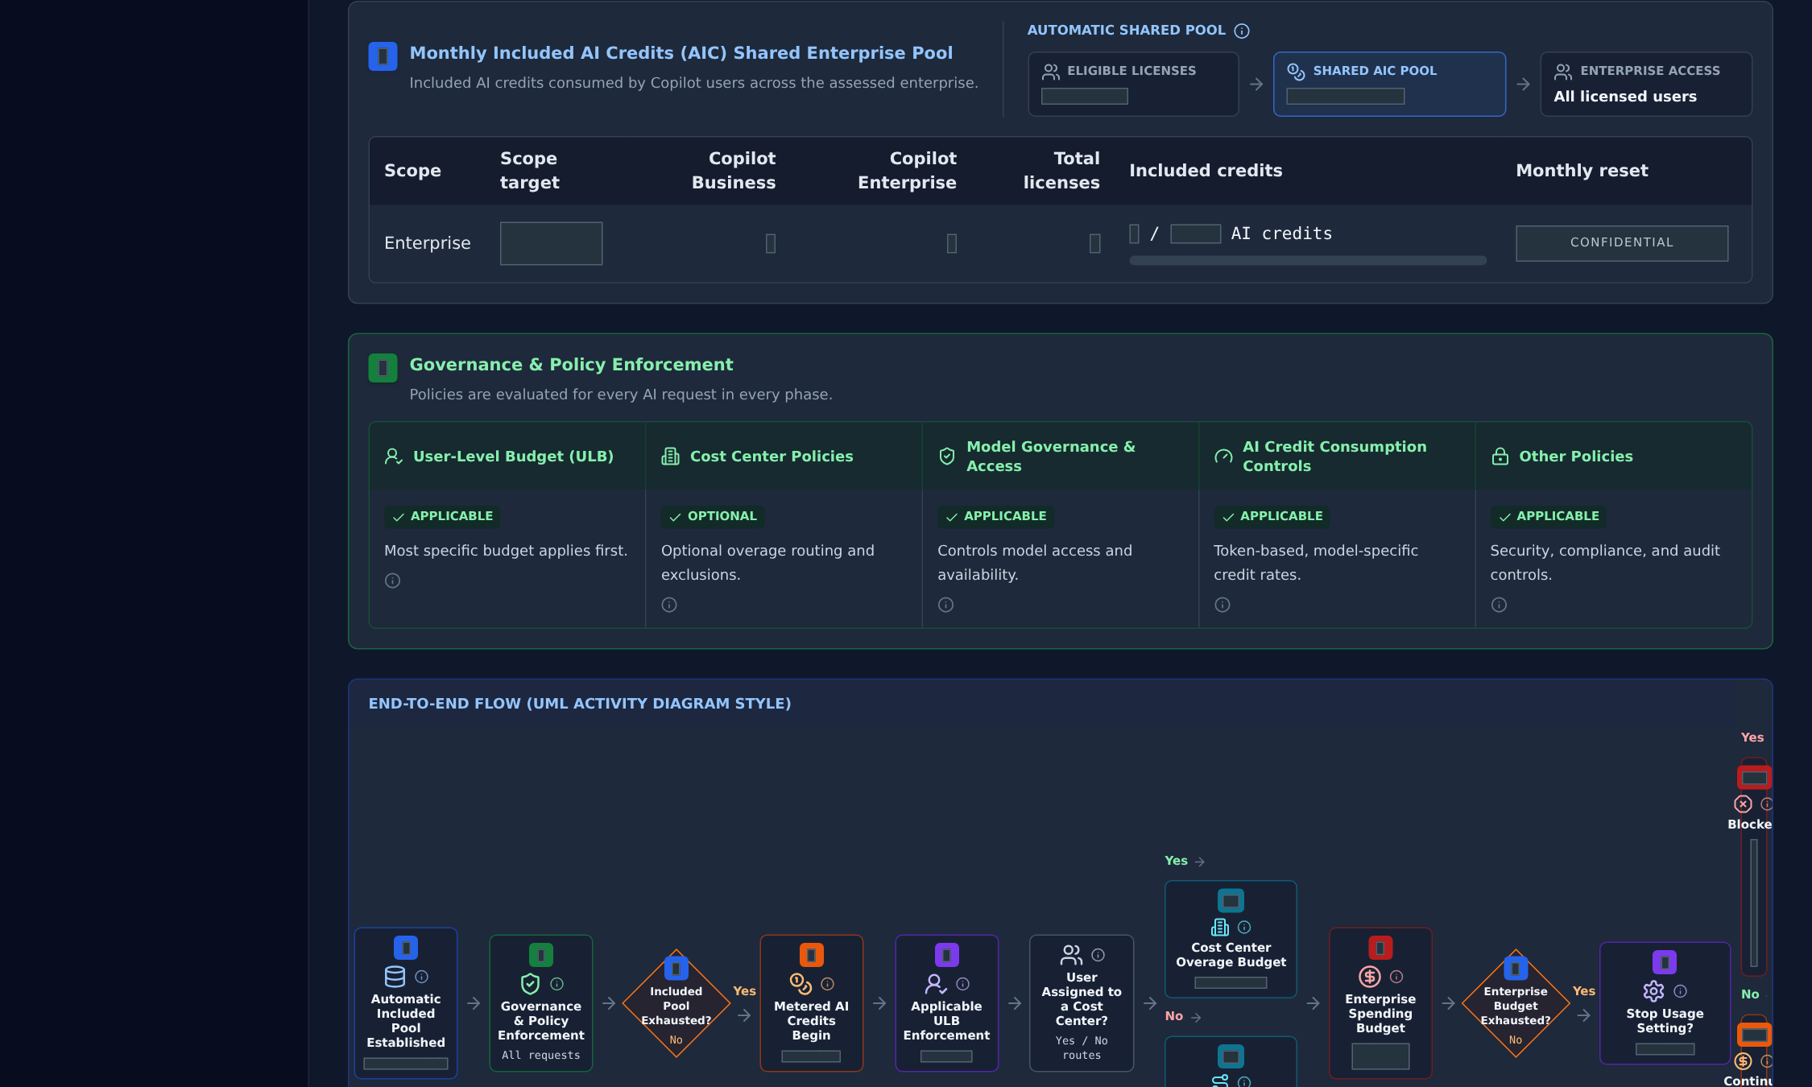
Keep included entitlements distinct from metered budget controls.
Included pool and governance configuration. Values are confidential; the captured state is not evidence that provider controls are enforced.

APPLICATION / REDACTED CAPTURE
Governance inventory / Budgets
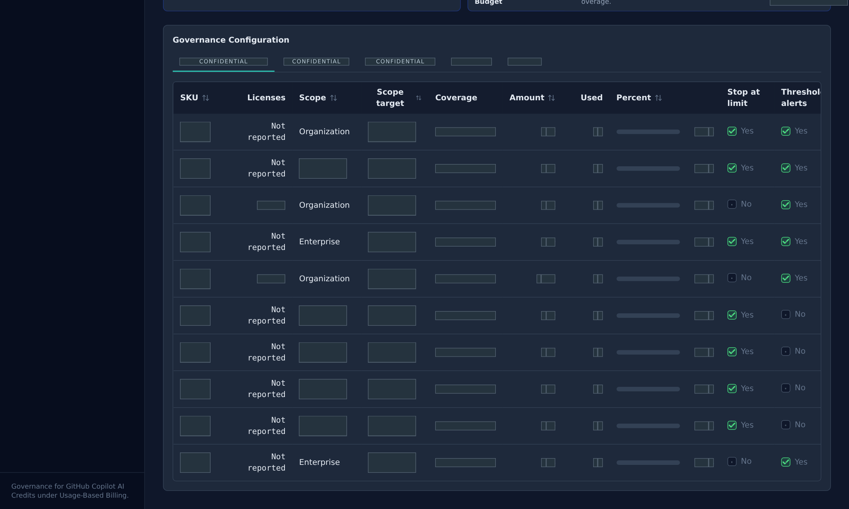
Inspect budget scope and behavior before assigning control ownership.
Live inventory, first visible rows. Identifiers are pseudonymous; amounts and private values are redacted. Unknown and unavailable data remain unknown.

APPLICATION / REDACTED CAPTURE
Governance inventory / Cost centers
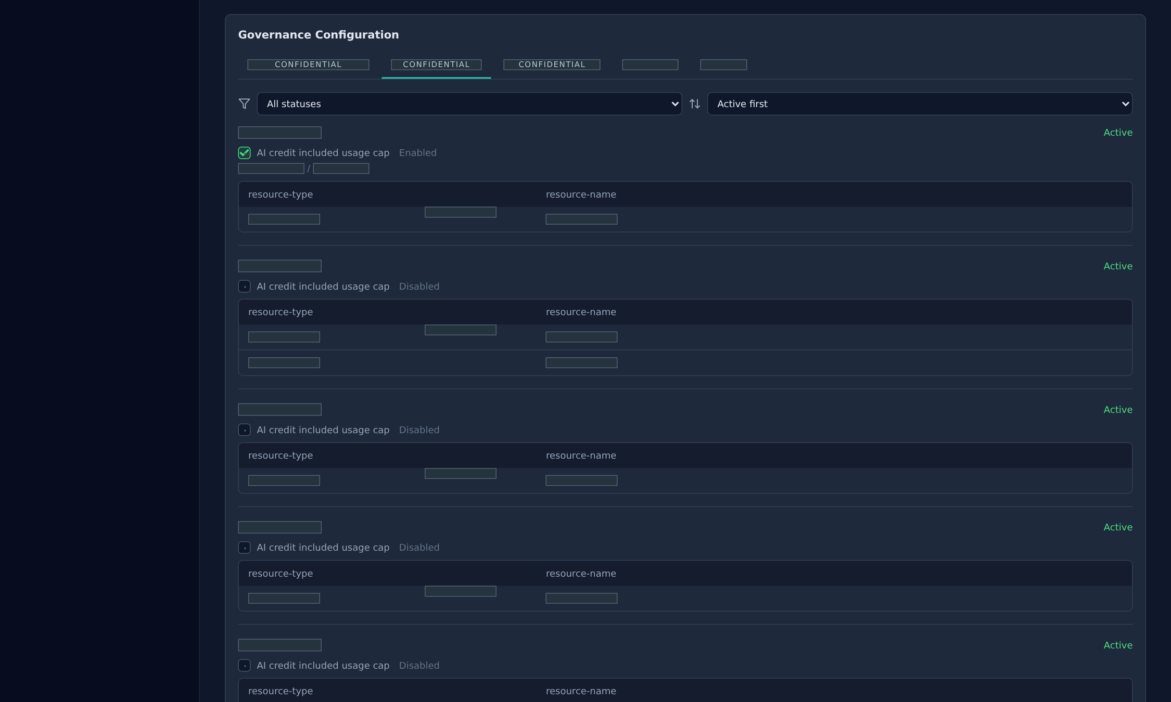
Connect financial accountability to the cost-center inventory.
Live inventory, first visible rows. Identifiers are pseudonymous; amounts and private values are redacted. Unknown and unavailable data remain unknown.

APPLICATION / REDACTED CAPTURE
Governance inventory / Organizations
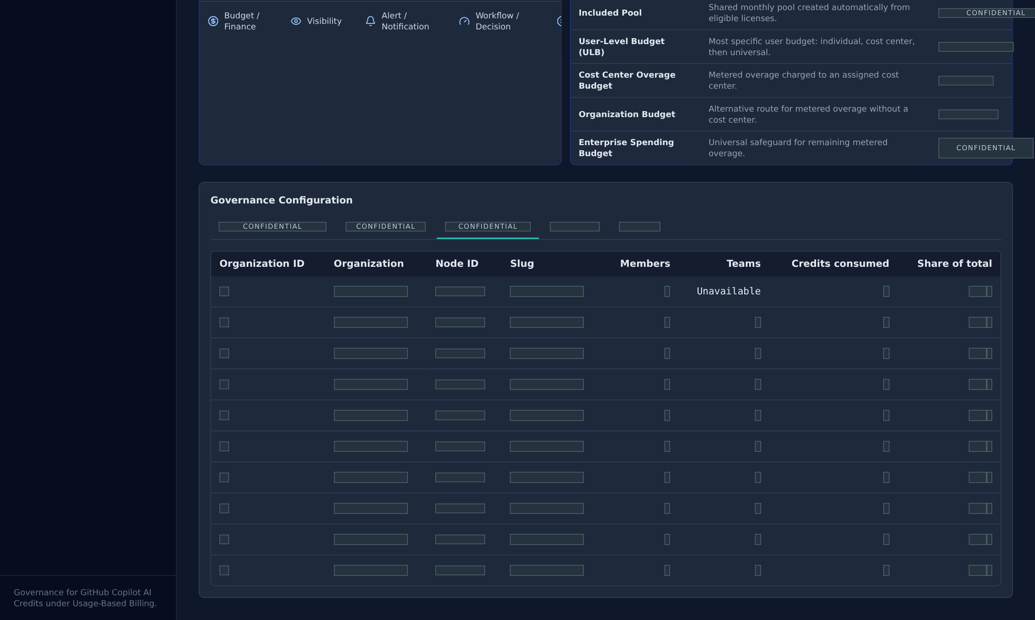
See the organizational context behind enterprise-wide governance.
Live inventory, first visible rows. Identifiers are pseudonymous; amounts and private values are redacted. Unknown and unavailable data remain unknown.

APPLICATION / REDACTED CAPTURE
Governance inventory / Teams
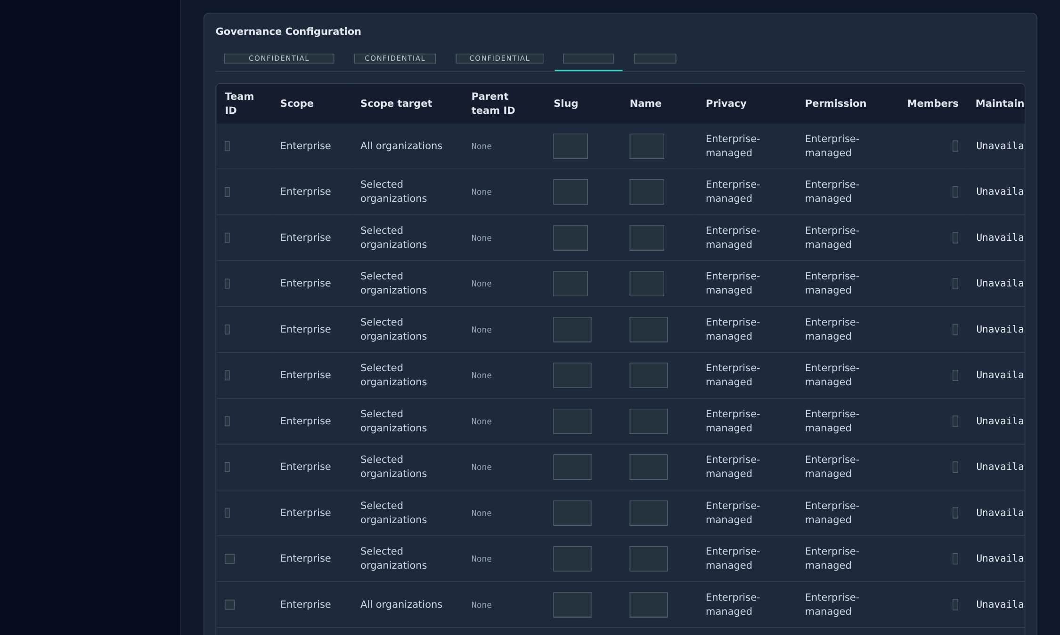
Bring team structure into the governance conversation.
Live inventory, first visible rows. Identifiers are pseudonymous; amounts and private values are redacted. Unknown and unavailable data remain unknown.

APPLICATION / REDACTED CAPTURE
Governance inventory / Users
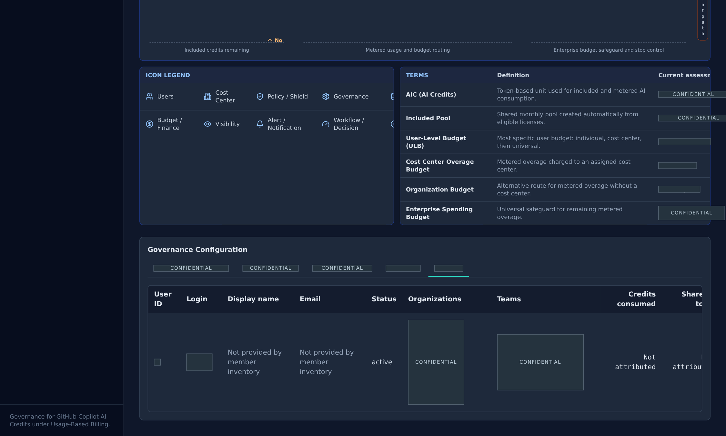
Inspect the user-level view without disclosing personal identifiers.
Live inventory, first visible rows. Identifiers are pseudonymous; amounts and private values are redacted. Unknown and unavailable data remain unknown.

CONCEPT / PRODUCT CONTEXT
Make assumptions visible before decisions.
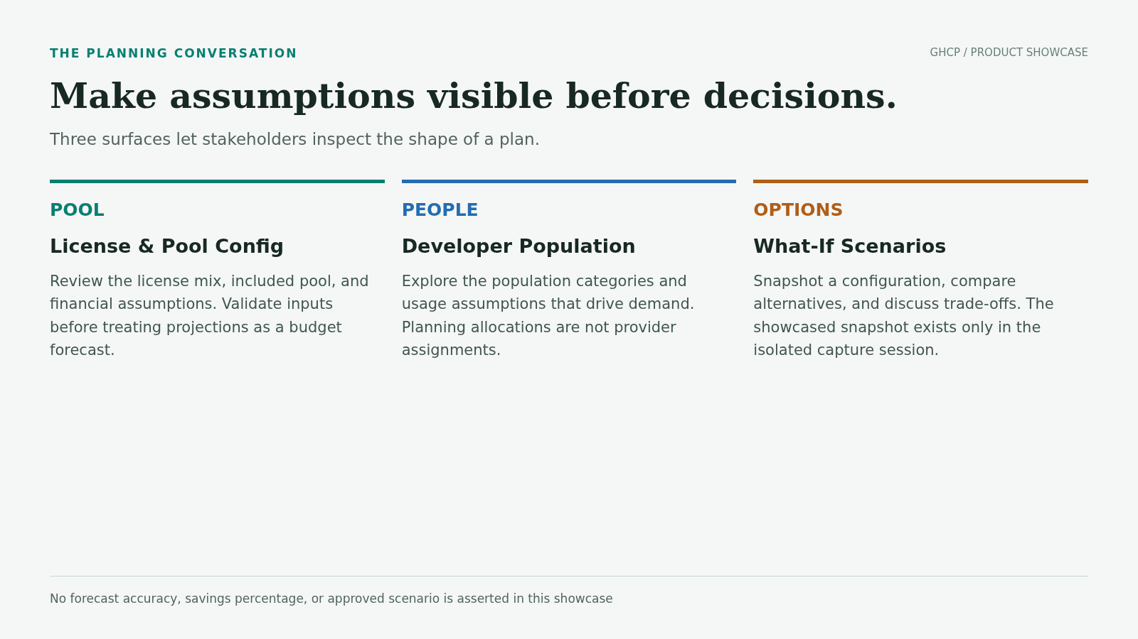
Three surfaces let stakeholders inspect the shape of a plan.

APPLICATION / REDACTED CAPTURE
Model license pools and credit exposure
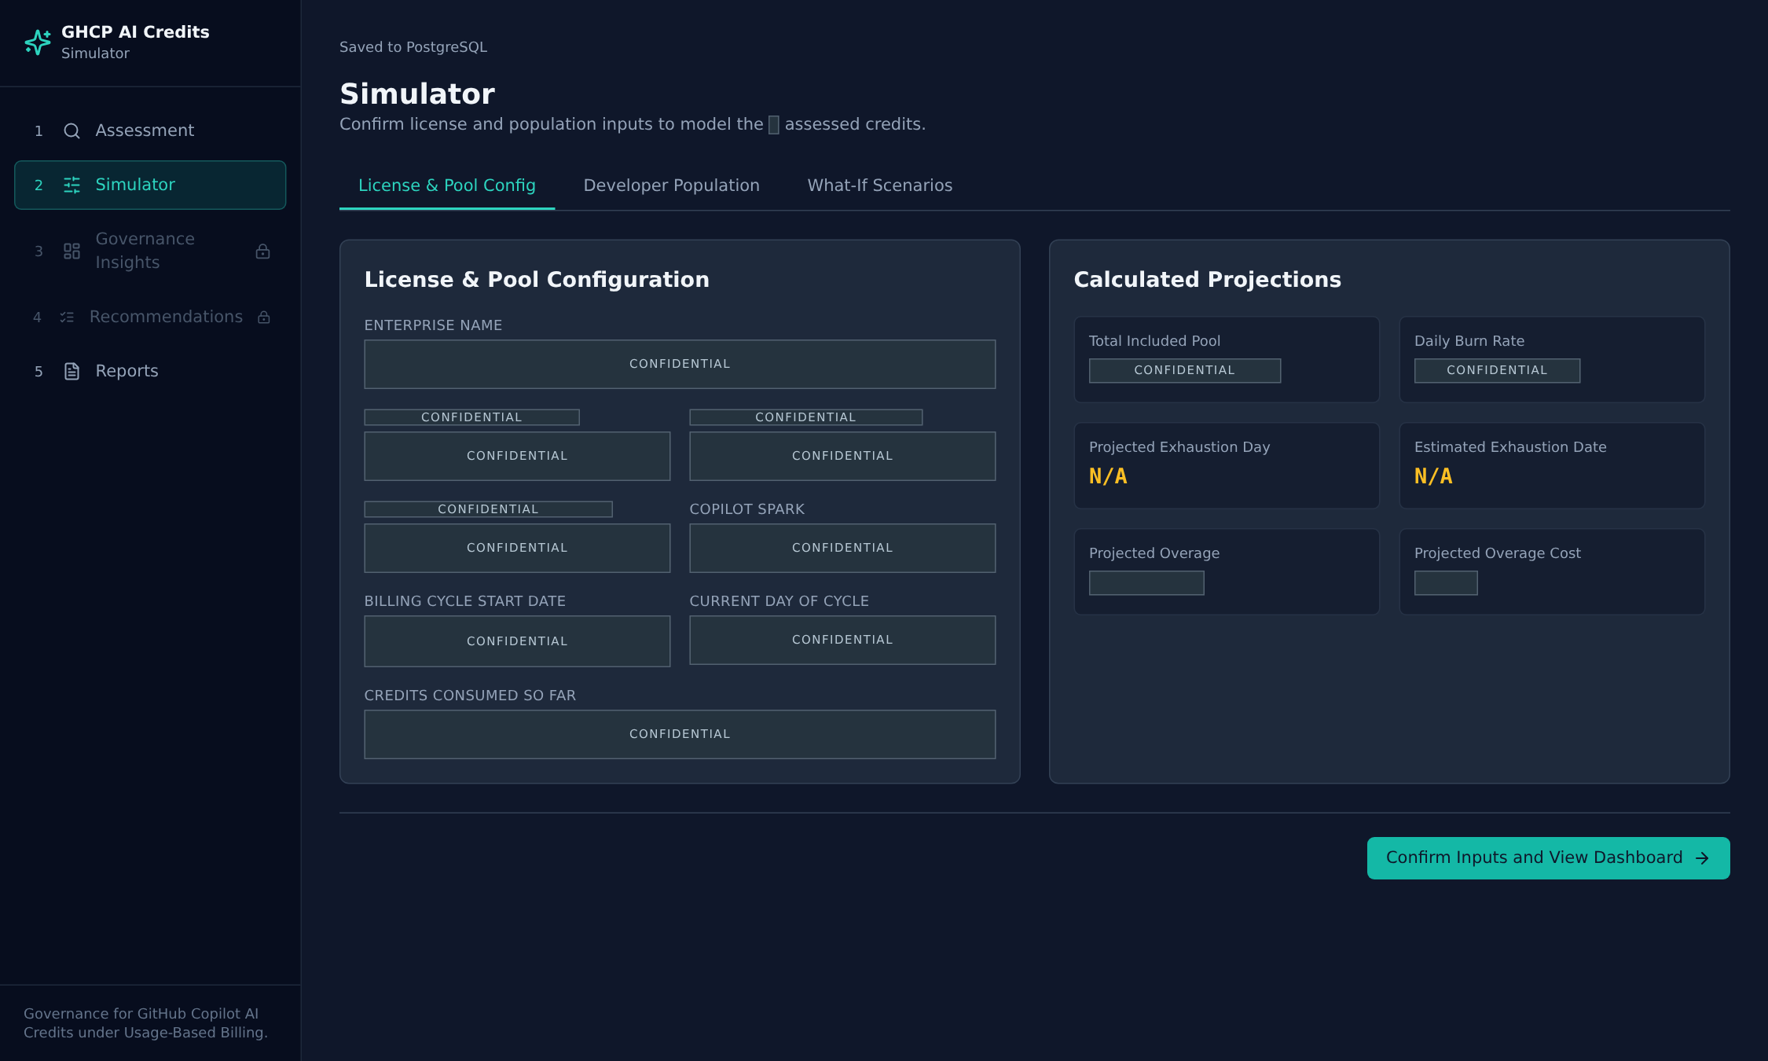
Explain which planning assumptions determine the available credit pool.
Planning inputs restored from the live workflow. These may include assumptions requiring confirmation; projected outcomes are not observed provider enforcement.

APPLICATION / REDACTED CAPTURE
Allocate developer populations
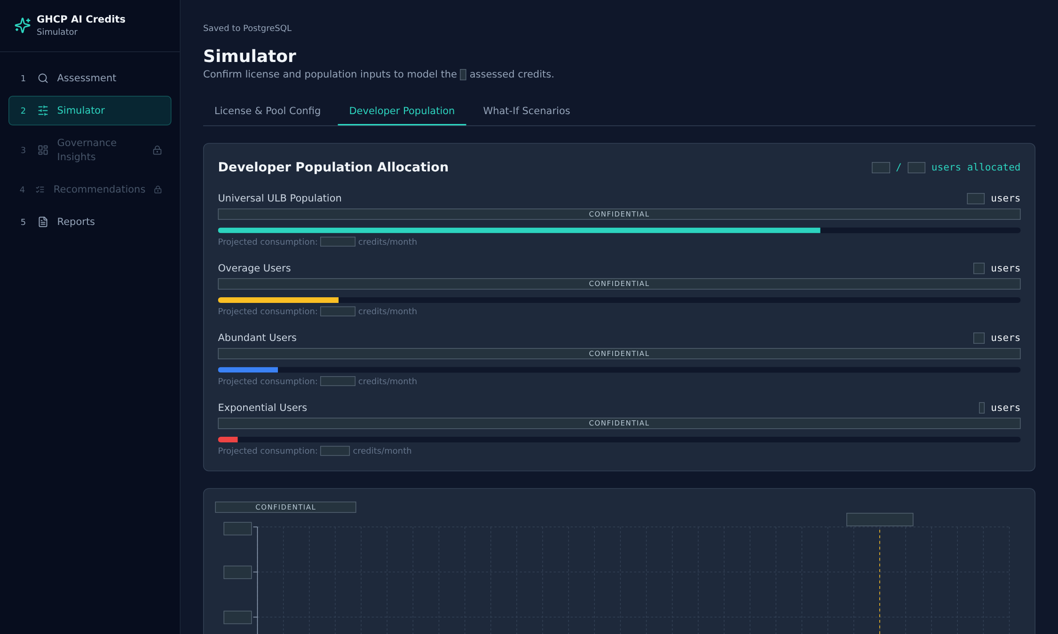
Make the demand assumptions behind a projection explicit.
Population allocation view. Confidential input values and calculated outputs are masked. No changes are saved to the live account.

APPLICATION / REDACTED CAPTURE
Compare options without changing provider controls
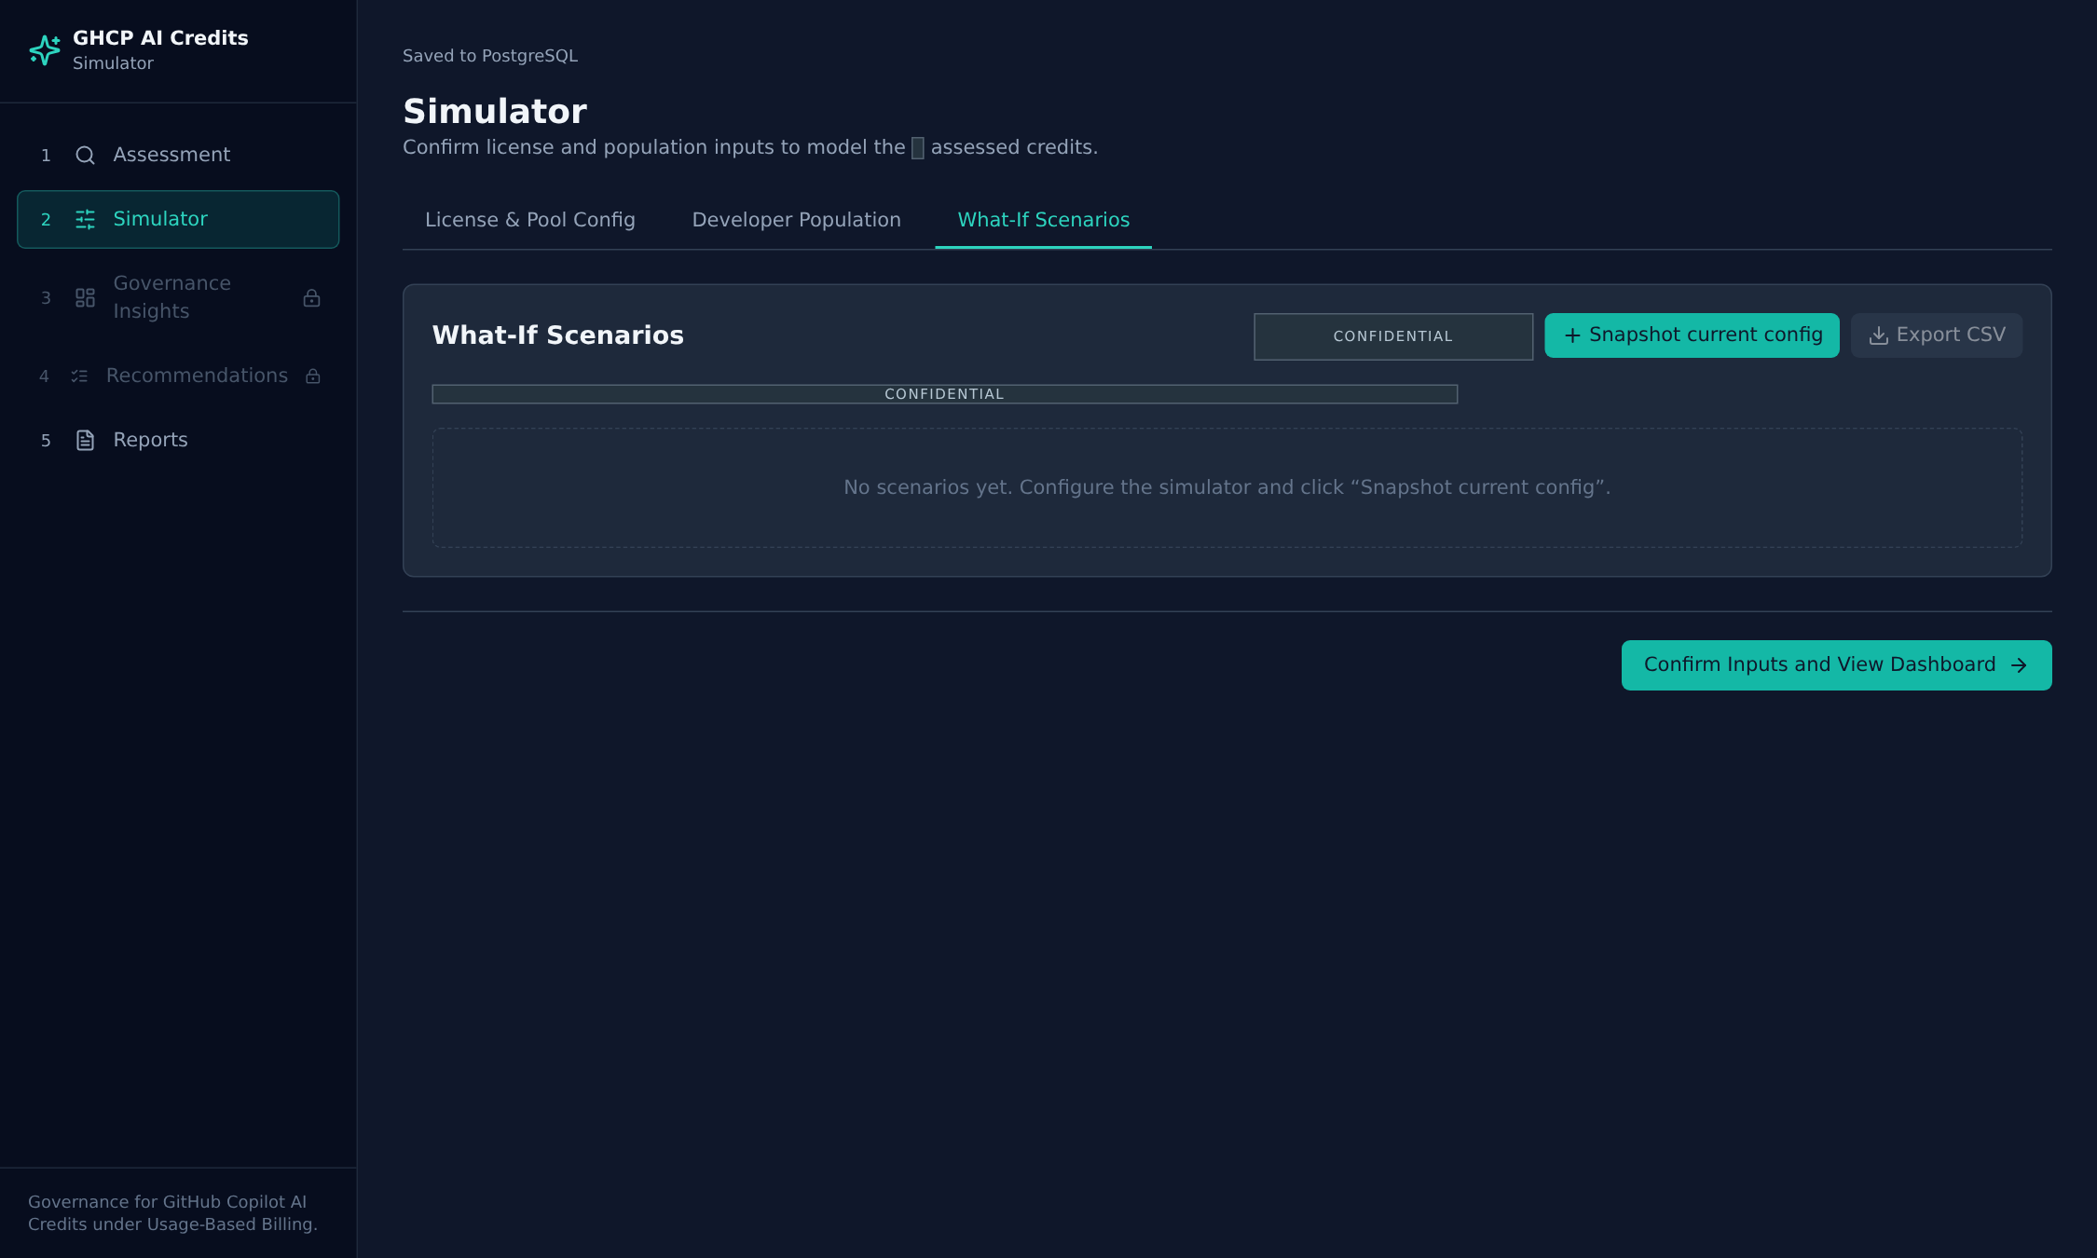
Create space to compare alternatives before committing to a plan.
What-if workspace. No saved scenario set was imported for this capture; the empty state is retained rather than implying a completed comparison.

APPLICATION / REDACTED CAPTURE
Snapshot the current planning configuration
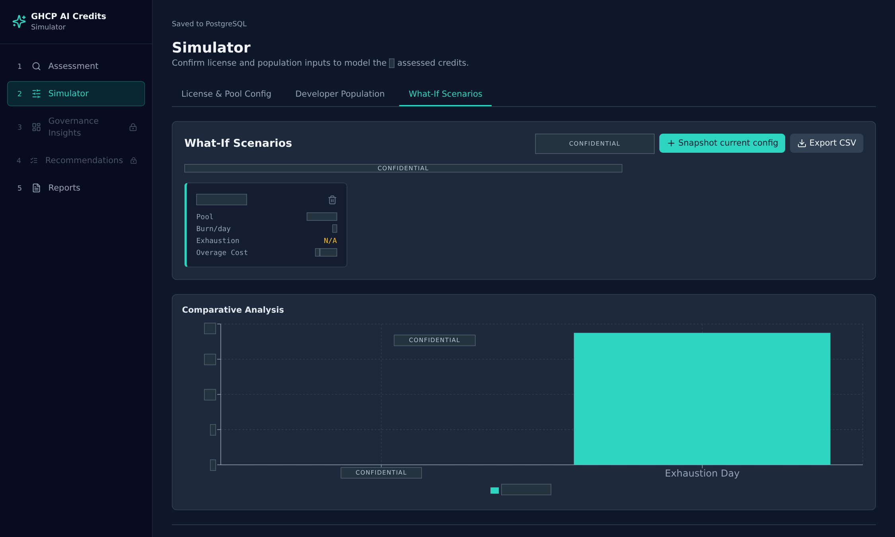
Preserve an option for discussion without changing live provider controls.
Presentation-only interaction: the current configuration was snapshotted in the isolated browser. It is not an approved scenario or a production write.

CONCEPT / PRODUCT CONTEXT
Useful signals, explicit boundaries.
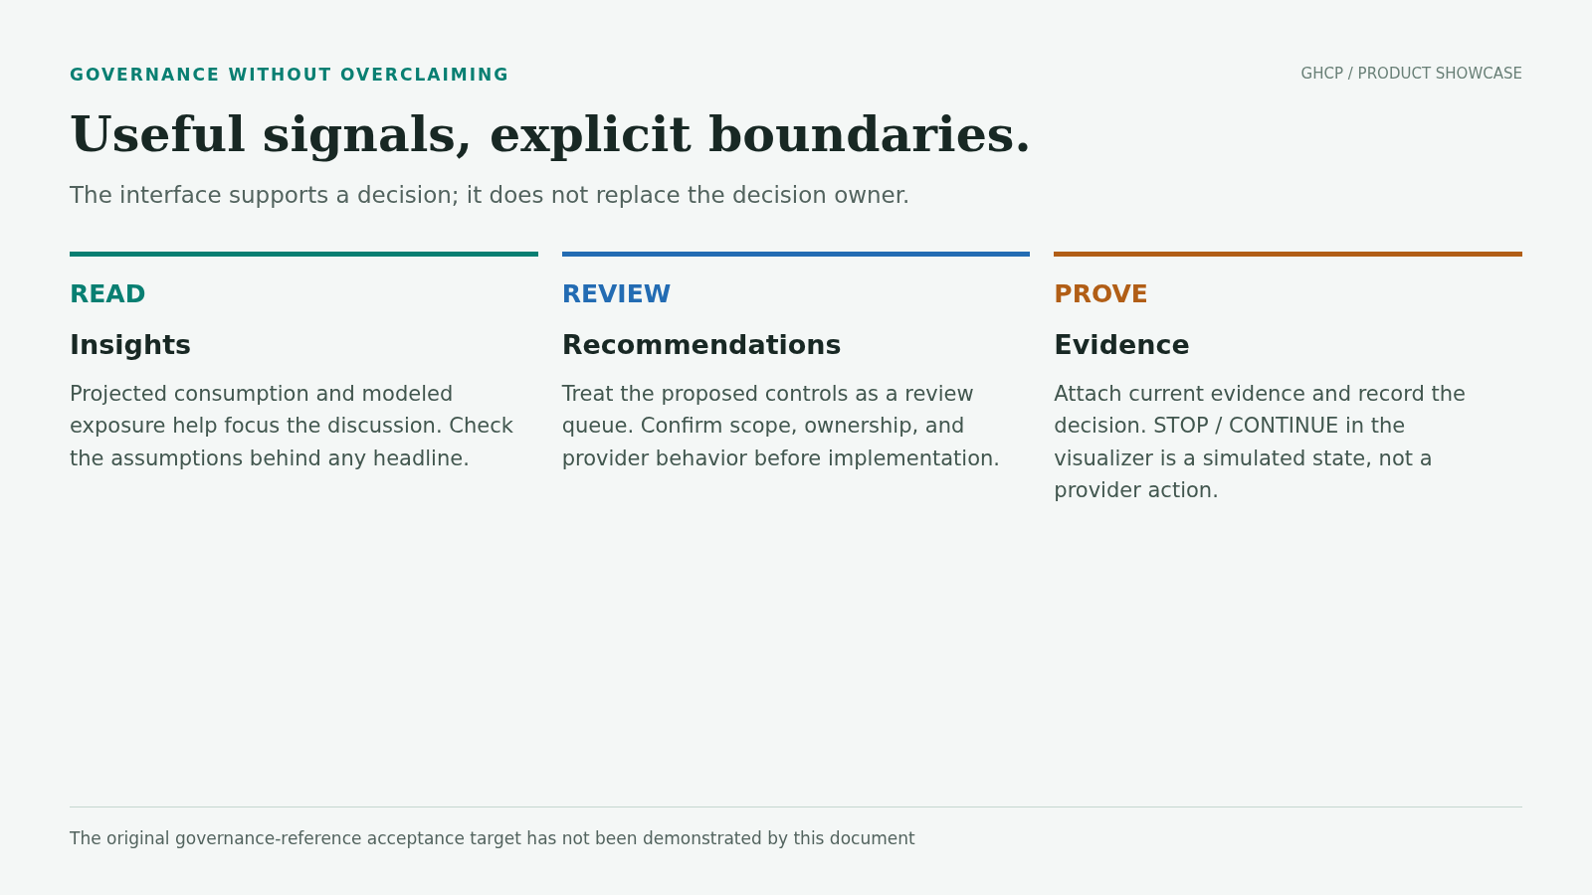
The interface supports a decision; it does not replace the decision owner.

APPLICATION / REDACTED CAPTURE
Bring the planning signals together
Bring several modeled signals into one review surface.
Derived planning view, opened in the isolated session. Readiness and STOP/CONTINUE indicators are simulator output, not verified provider decisions.

APPLICATION / REDACTED CAPTURE
Explain the credit-control sequence
Use the readable flow to discuss modeled decision points.
The two-dimensional flow is the app's readable fallback. It explains modeled behavior; actual enforcement still requires current provider evidence.

APPLICATION / REDACTED CAPTURE
Translate modeled exposure into actions
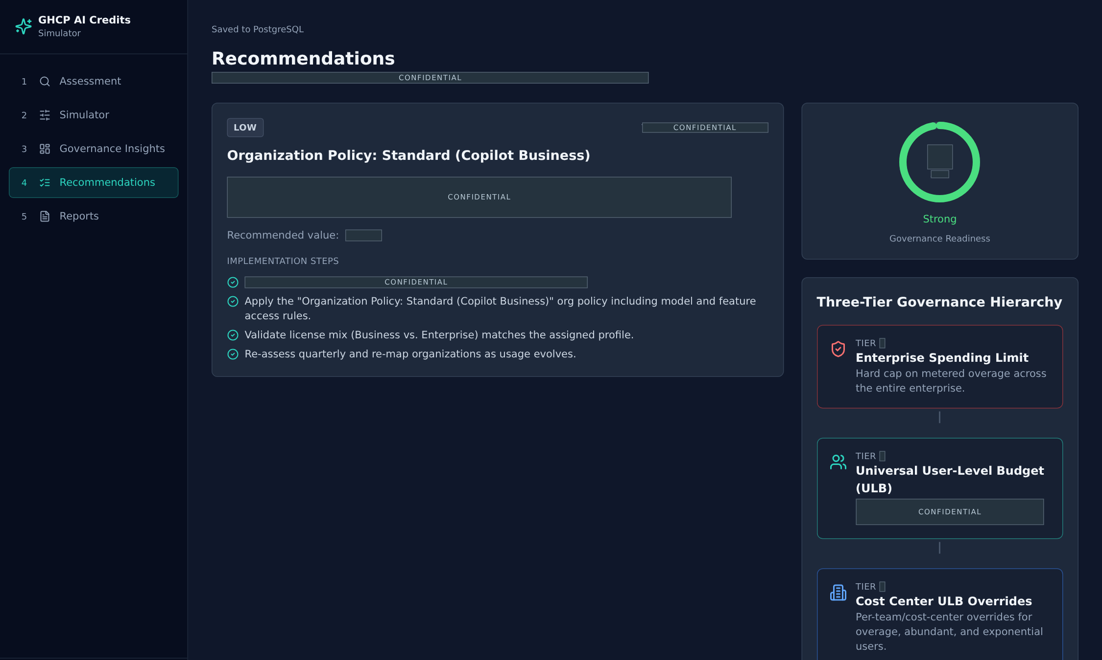
Turn exposure into reviewable, scoped action proposals.
Recommendations are generated from the captured assessment and planning inputs. They are proposals, not approvals, executed changes, or guaranteed savings.

CONCEPT / PRODUCT CONTEXT
Tell the right story to the right audience.
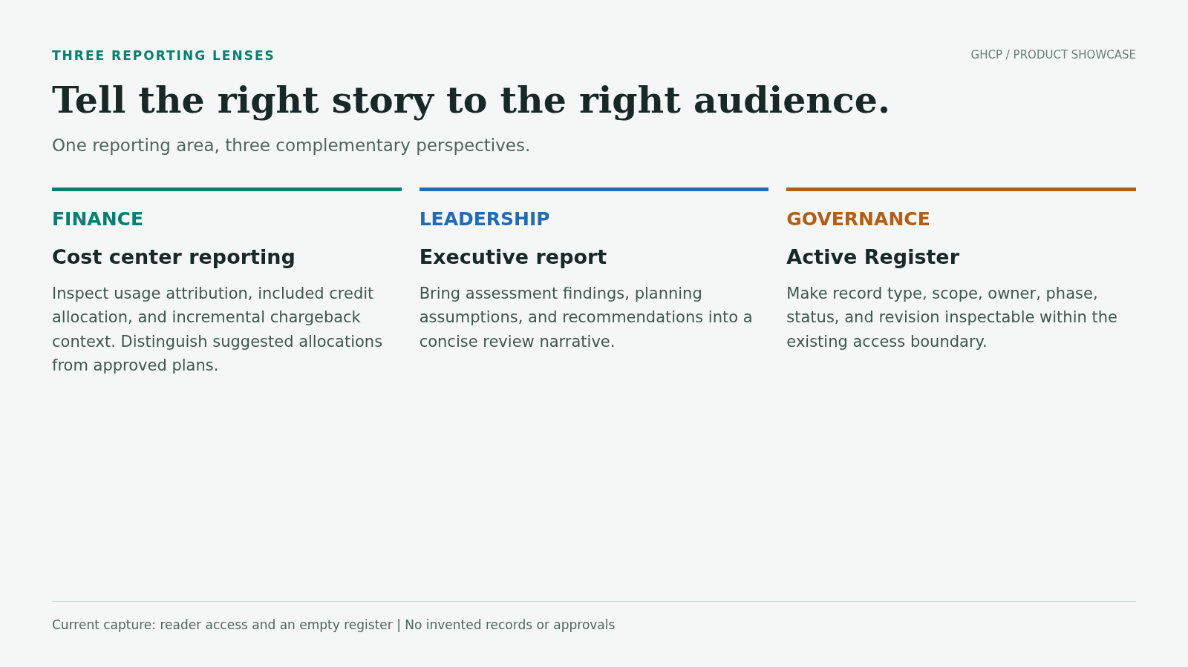
One reporting area, three complementary perspectives.

APPLICATION / REDACTED CAPTURE
Connect usage to accountability
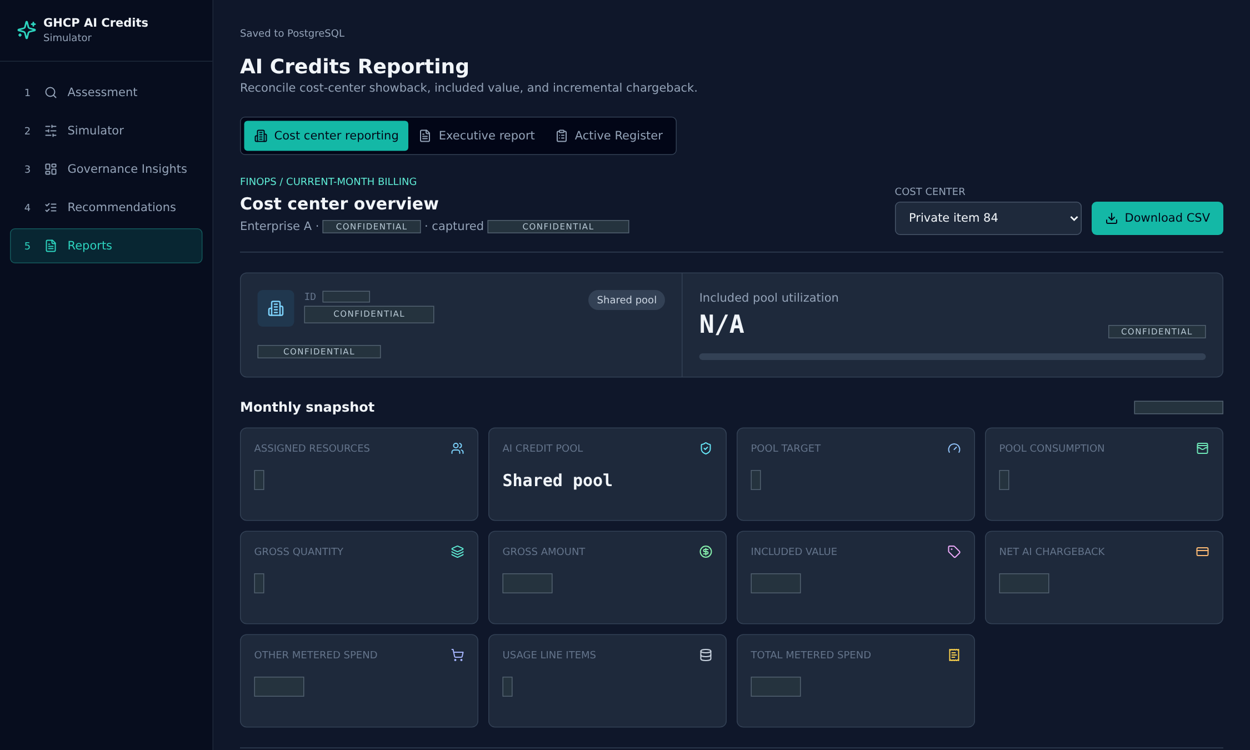
Connect consumption to accountability and showback.
Cost-center reporting from the captured live snapshot. Private names, subscription identifiers, quantities, and financial amounts are redacted.

APPLICATION / REDACTED CAPTURE
Inspect allocation and chargeback context
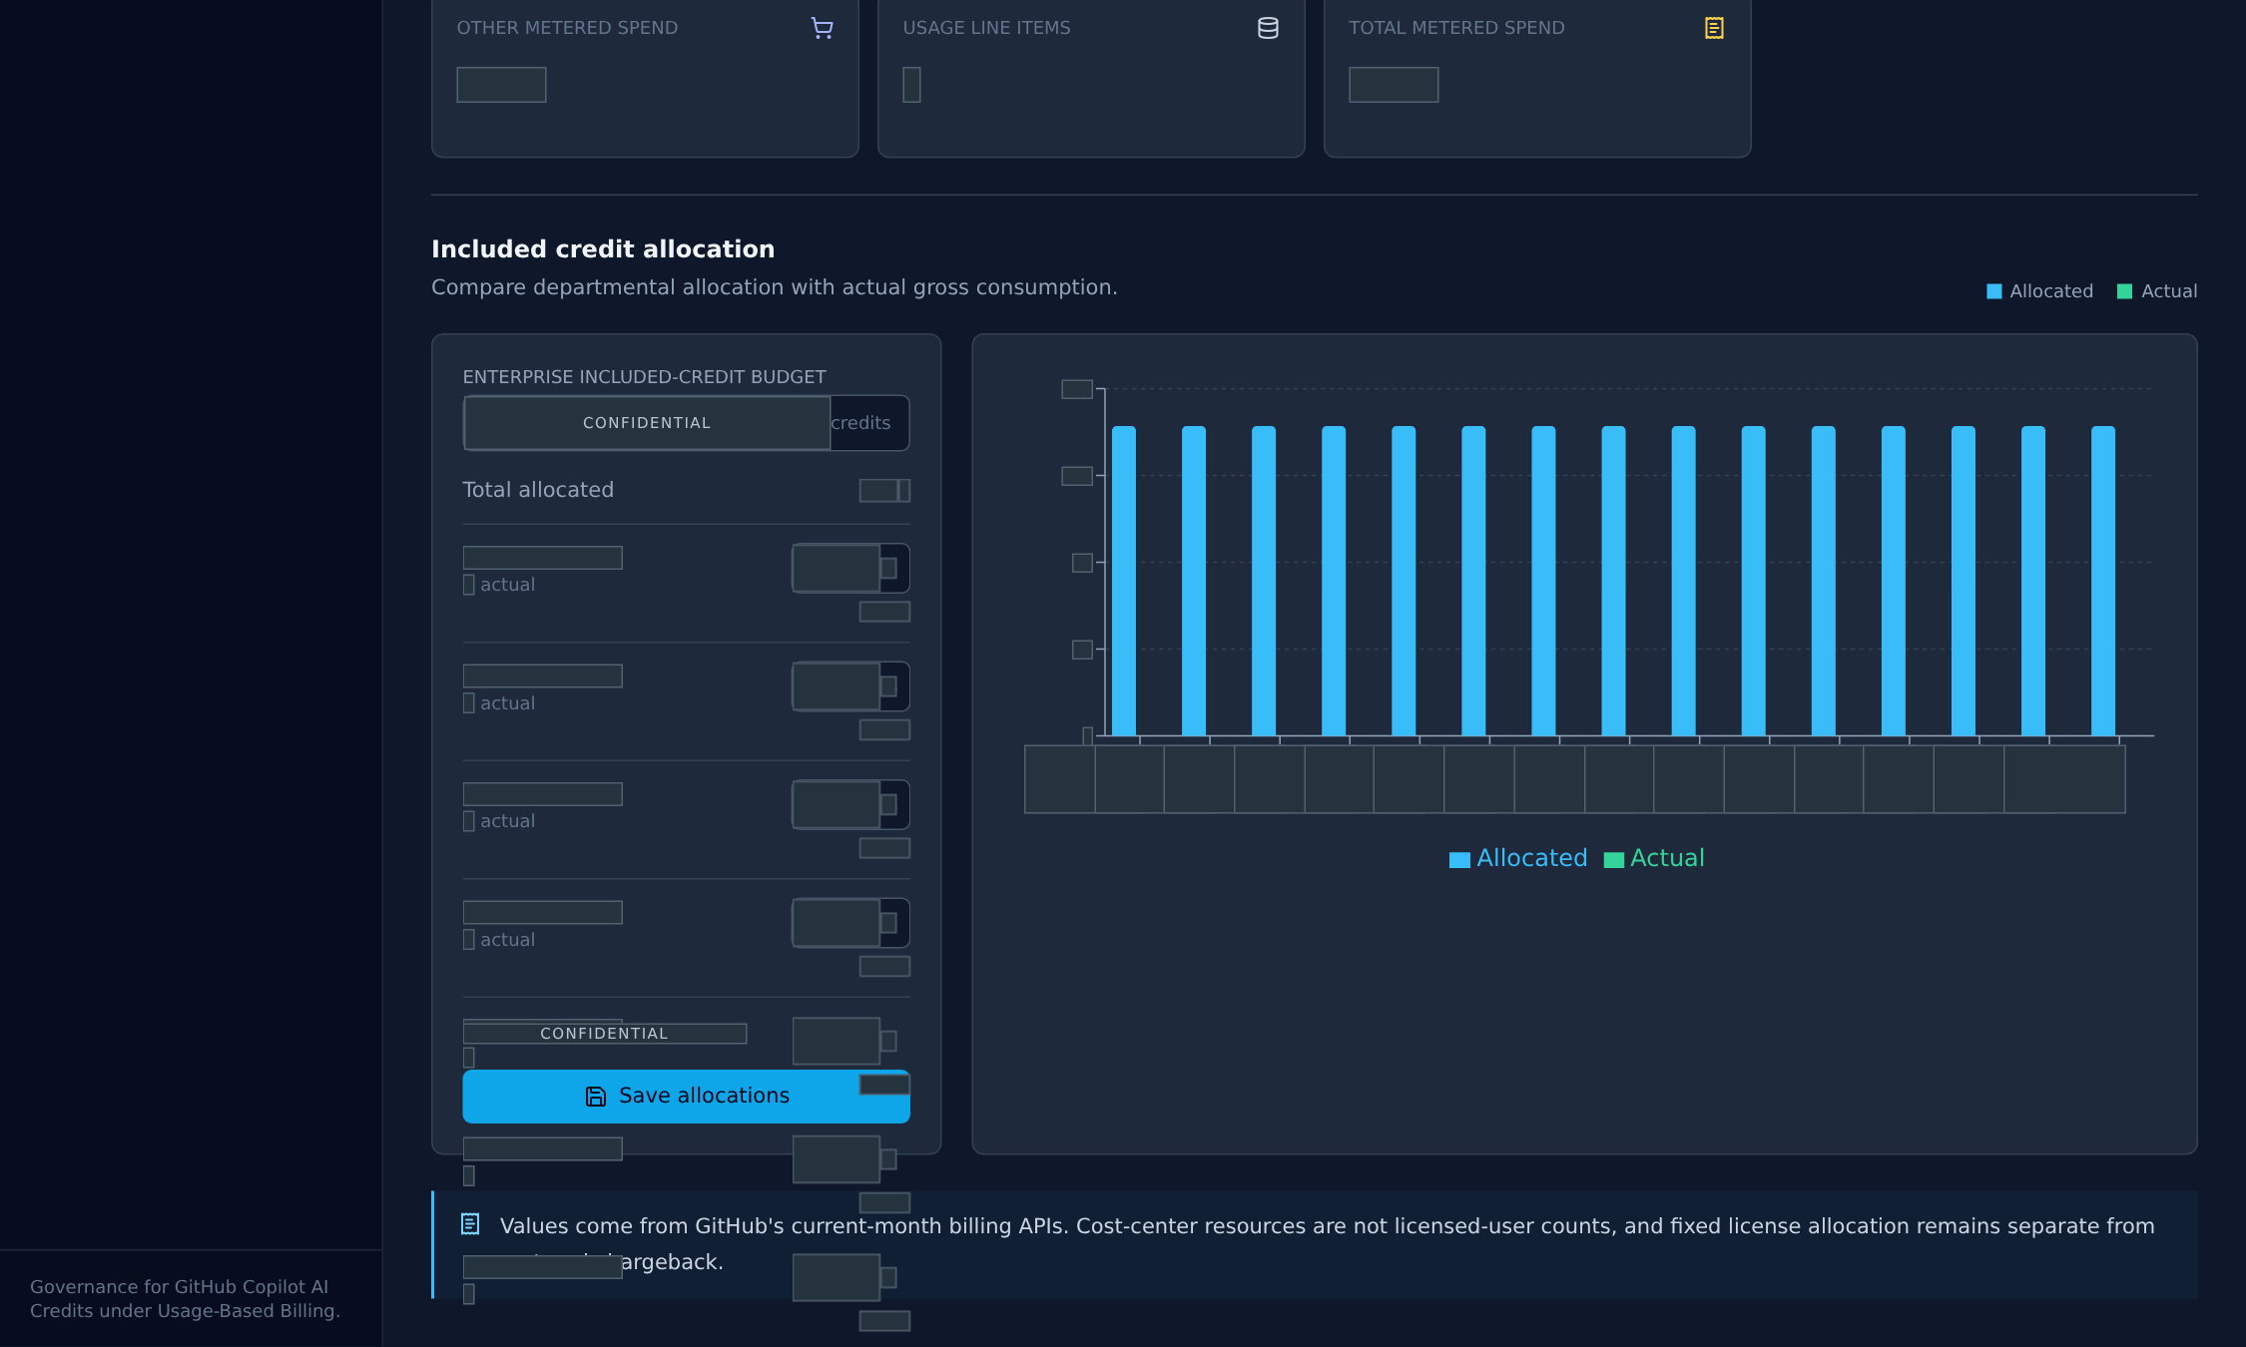
Discuss allocation choices separately from observed consumption.
Reporting detail. Default allocations are planning suggestions, not evidence of an approved allocation plan.

APPLICATION / REDACTED CAPTURE
Prepare the executive narrative
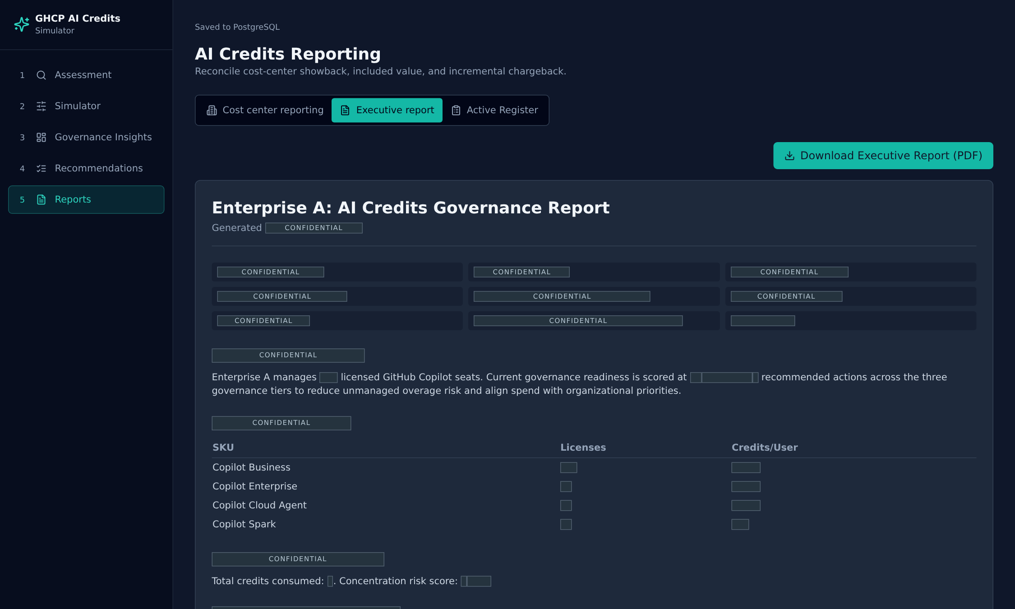
Prepare a shared narrative for an executive review.
Executive preview based on the captured assessment and planning state. PDF generation and saved-report retrieval are not triggered during this showcase.

APPLICATION / REDACTED CAPTURE
Keep evidence and decisions visible
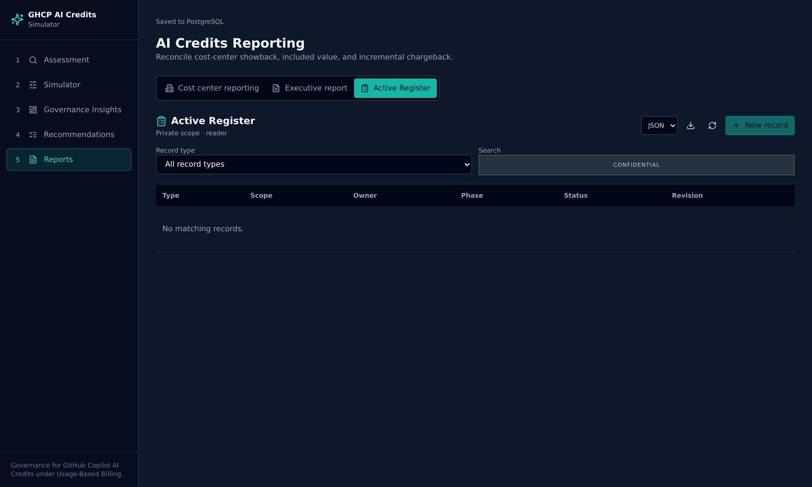
Keep the access boundary visible even when the evidence register is empty.
Active Register with the live account's existing access. Empty or unavailable states are retained; no records, approvals, or evidence have been fabricated.

CONCEPT / PRODUCT CONTEXT
Durable state belongs in PostgreSQL.
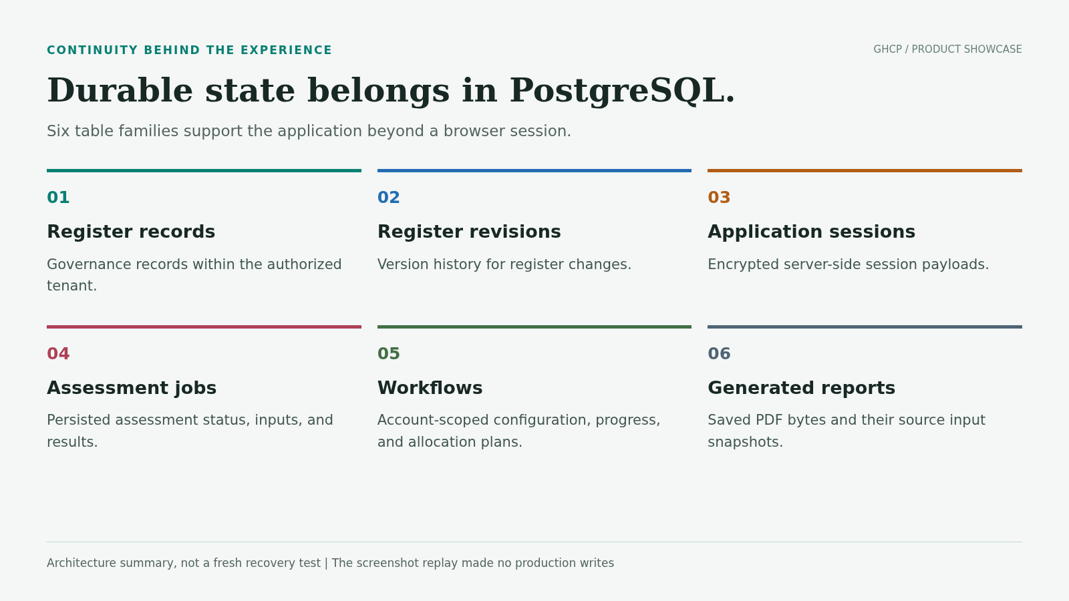
Six table families support the application beyond a browser session.

METHODOLOGY / LIMITATIONS
Capture scope and responsible use
Coverage: all five primary pages, all five Assessment governance tabs, all three Simulator tabs, and all three Reports tabs. Nineteen screenshots include the two-dimensional flow and a presentation-only scenario snapshot. This is a selected-viewport tour, not a screenshot of every row, scroll position, filter, modal, or role-specific editor.
Source: an authorized, authenticated live assessment and current planning inputs were pseudonymized before transfer into a separate browser running the unchanged application. API responses were replayed locally. Workflow changes stayed in that browser; all other API operations and external network requests were blocked.
Redaction: account, organization, team, user, and other private strings were replaced or masked. Numeric text, amounts, input fields, and canvases were covered before PNG files were saved. Chart geometry, categorical states, and visible row presence may still convey qualitative information. This is not a guarantee of complete anonymization; review audience suitability before distribution.
Interpretation: simulator and recommendation views are derived planning output. No provider approvals, executed control changes, savings outcomes, or certifications are asserted. The daily trend shown by the UI must not be treated as independently verified historical evidence in this showcase.
Boundaries: the 3D canvas is not showcased because its numeric labels are not covered by DOM text redaction; the readable 2D mode is included. The live register was empty with reader access, so populated record editors and revision histories are not represented. Saved-report history was not replayed, and no PDF generation or restore action was executed.
Validation: the capture completed without browser application errors. Images are embedded in the Word package, with no live JSON, credentials, or external image links included. The companion HTML provides a visual review of the same content; Word pagination may differ by installed fonts and version. This document is not completion evidence for the earlier governance-reference acceptance audit.

