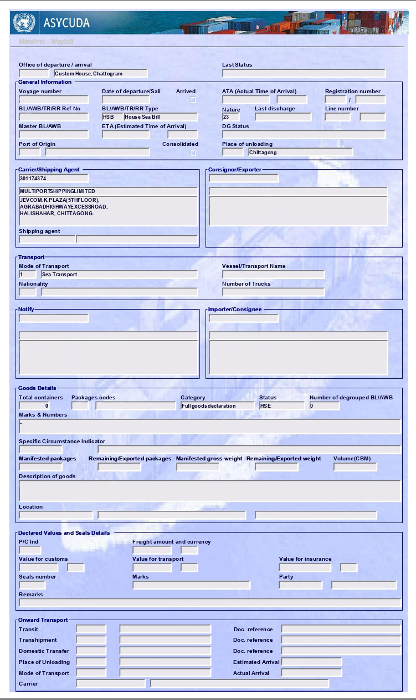
${desc_portcode}
${cargo_name}
${vsl_nationality}
${vsl_nationalitycode}
${companycustomcode}
${loadport}
${line_num}
${bank_bin}
${importer_bin}
1.00
${package_code}
${qty}
${vessel}
${shipper_address}
${shipper_name}
${bl_num}
${arrivaldate_forigm}
${deperture_date}
${msl_num}

