AUDIT REPORT
Mister Waan — launch readiness
Snapshot of the three Next.js apps and their production state, with a prioritized blocker list, open questions, and a concrete unblock sequence.
Repo: /Users/waan/AutoGTG/Waan
Audit date: 2026-05-13
Author: Claude (Opus 4.7)
VERDICT
Do not launch yet. Code builds locally, but neither deployed Netlify site is running the current Mister Waan code.
mistr-waan.netlify.app serves a stale AutoGTG static site. waan-ops.netlify.app 404s on every route. garage-pwa has no Netlify project. The booking flow is end-to-end clickable in source — but on mocks only.

Contents
1 | Executive summary
2 | How we audited
3 | Architecture & deploy status (diagram)
4 | Route map (diagram)
5 | P0 blockers — production
6 | P1 — feature gaps (mocks vs. real)
7 | P2 — polish & hygiene
8 | Booking flow (diagram)
9 | Recommended fix sequence (diagram)
10 | Open questions — please answer
11 | Appendix: raw audit data

1. Executive summary
Two problems sit on top of each other:
- All three Next.js apps build cleanly with no TypeScript errors. Internally, every Link href and router.push target resolves to a real page in source. The code is shippable in principle.
- None of those routes are actually reachable in production. The two Netlify deploys are misconfigured (one is stale, one didn’t run the Next.js plugin), and the third app has never been deployed.

Status at a glance:
App | Audience | Build | Live site | Notes
user-pwa | Consumers | PASS | BROKEN (stale) | Production is the old AutoGTG static site, not the current Next.js code. Last deploy 2026-05-05. plugin_state: none.
ops | Internal ops | PASS | BROKEN (404s) | Every route 404s. .next was uploaded raw via CLI; the Next.js plugin never ran at build time.
garage-pwa | Garage operators | PASS | NOT DEPLOYED | No Netlify project, no netlify.toml, no PWA manifest, default Next.js scaffolding still in public/.

If we fix the two Netlify deploy issues today, the demo flow (home → garages → booking → confirmation, all on mocks) becomes live. Real backend wiring (auth, payments, garages, jobs API) is a separate, larger track and should not gate a soft launch — but the team needs to be clear that V1 is a marketing-grade demo, not a functioning marketplace, until those land.

2. How we audited
- Mapped every page, route handler, and layout in apps/user-pwa, apps/ops, apps/garage-pwa.
- Extracted every internal href and router.push target via grep and cross-referenced against the page set — no broken in-app links found.
- Ran next build on all three apps. All passed. Saw 18 / 7 / 5 routes built respectively.
- Probed every live route on both Netlify sites with curl -I. 200 vs 404 table below.
- Pulled the latest deploy metadata from the Netlify API for both sites — confirmed plugin_state, framework detection, and available_functions.
- Reviewed CLAUDE.md / AGENTS.md guidance, mock-data flags, TODO markers, and stub identifiers.

3. Architecture & deploy status
The monorepo houses three independent Next.js 16.2.5 apps, each with its own Netlify project (or, in garage-pwa’s case, no project yet). Build status is green across the board; deploy status is where things fall apart.
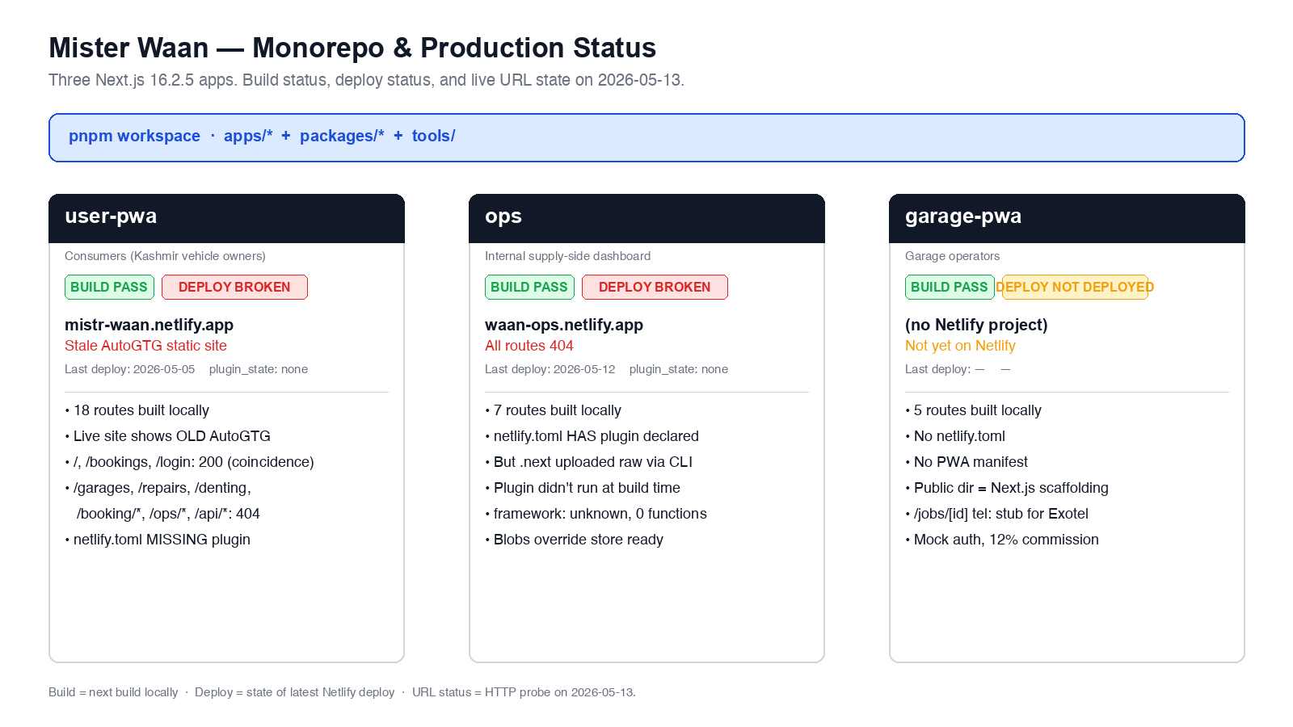
Figure 1 — three apps, three states. Build green; deploy red on the two that are deployed.

4. Route map
All of the routes below build successfully and respond locally in next dev / next start. The route map is informational — it shows what we should expect to reach if production were working.
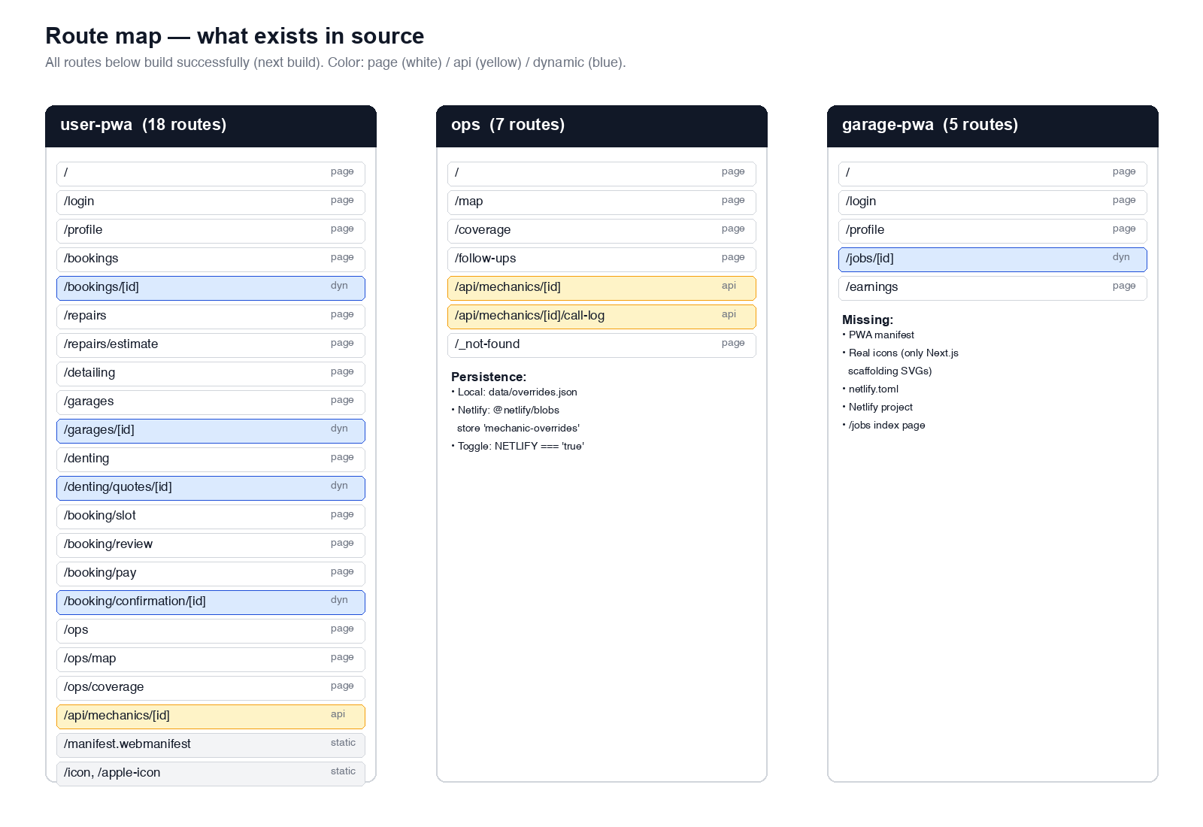
Figure 2 — pages (white), API handlers (yellow), and dynamic routes (blue) across the three apps.

5. P0 blockers — production

5.1 mistr-waan.netlify.app serves the OLD AutoGTG static site
Current production deploy is dated 2026-05-05. The Netlify API reports plugin_state: "none" and available_functions: []. The deploy uploaded 34 static HTML pages with names that do not exist in the current codebase:
index.html, verify.html, m.html, login.html,
help.html, diagnose.html, bookings.html, admin.html,
404.html, services/tow.html, ...
These are leftovers from the pre-rebrand AutoGTG static site. A live WebFetch of the root confirms the page title is still “AutoGTG — Mechanic on demand”, not “Mister Waan”.
Curl confirms most current routes 404 in production. Only /, /bookings, /login return 200 — and only because the old static deploy happens to have HTML files at those paths.

Root cause
- apps/user-pwa/netlify.toml is missing the explicit @netlify/plugin-nextjs declaration that apps/ops/netlify.toml has.
- @netlify/plugin-nextjs is also missing from apps/user-pwa/package.json devDependencies (ops has it).
- With no plugin running, the deploy fell back to whatever was last uploaded — a stale static site.

Fix
Add to apps/user-pwa/netlify.toml:
[[plugins]]
package = "@netlify/plugin-nextjs"
Add to apps/user-pwa/package.json devDependencies:
"@netlify/plugin-nextjs": "^5.15.11"
Then trigger a fresh build-on-Netlify deploy (push to the connected branch, or netlify deploy --build --prod from apps/user-pwa).

5.2 waan-ops.netlify.app 404s on every route
Latest deploy is 2026-05-12. plugin_state: "none", framework: "unknown", available_functions: []. The deploy uploaded 313 raw assets plus exactly two server-rendered HTML files: server/app/_not-found.html and server/app/_global-error.html — i.e., the .next directory was uploaded as static files, with no SSR handler wired.
The ops netlify.toml does declare the plugin, but the plugin never ran at build time. The deploy_source is "cli", which means this was pushed via netlify deploy --dir=.next from a local machine — the Netlify build pipeline (and therefore the plugin) was skipped.

Fix
- Stop deploying a pre-built .next directory.
- Either connect the repo to Netlify (recommended) so pnpm --filter ops run build runs inside Netlify and the plugin fires, or
- Run netlify deploy --build --prod from apps/ops so Netlify wraps the build step.

5.3 garage-pwa is not deployed anywhere
- No Netlify project in the team for garage-pwa.
- No netlify.toml file.
- No PWA manifest (user-pwa has one in src/app/manifest.ts; garage-pwa does not).
- public/ contains only default Next.js scaffolding SVGs (file.svg, globe.svg, next.svg, vercel.svg, window.svg) — no real icons.
If garages are part of the launch story, this app is unshipped. If we’re launching with garages-by-WhatsApp first, this is fine to defer (and we should cut the garage-pwa link from any marketing).

6. P1 — feature gaps (mocks vs. real)
The codebase is honest about being on mocks. The README still says “Backend: not yet wired — mock data only.” The table below maps what’s currently a placeholder to what a real launch requires.
Area | Current (mock) | Needed for launch | Where to look
Auth (user) | sessionStorage, any OTP accepted | Real OTP via WhatsApp / SMS | user-pwa/src/lib/store/auth.ts
Auth (garage) | OTP 000000 fails, anything else passes | Real OTP + garage-side identity | garage-pwa/src/app/login/page.tsx
Garages catalog | lib/mock/garages.ts | Real garage onboarding pipeline (Ubaid) | user-pwa/src/lib/mock/garages.ts
Services & prices | lib/mock/services.ts | Garage Partner Rate Card import | user-pwa/src/lib/mock/services.ts
Reviews | lib/mock/reviews.ts | Real reviews after first jobs | user-pwa/src/lib/mock/reviews.ts
Payments | setTimeout(1500) fake Razorpay | Razorpay / UPI Intent integration | user-pwa/src/app/booking/pay/page.tsx:59
Job persistence | createJob() in localStorage | POST /api/v1/jobs backend handler | user-pwa/src/lib/store/jobs.ts
Garage call DID | tel:+91XXXXXXXXXX | Exotel-masked DID | garage-pwa/src/app/jobs/[id]/page.tsx:48
Brand mark | Wordmark placeholder + 'MW' icon | Designer-shipped wordmark + icons | user-pwa/src/components/layout/TopBar.tsx:42
/garages filters | Stub icon, no UI | Filter UI (price / distance / service) | user-pwa/src/app/garages/page.tsx:14

None of these P1 items are individually blocking — but stacked together, they mean V1 is a demo, not a working marketplace. The team should agree on which mocks are acceptable on day one (see open questions in §10).

6.1 Live URL probe (mistr-waan + waan-ops)
Below is the raw HTTP probe of every notable route, run via curl -I on 2026-05-13.
Route probed (live) | Status | Verdict
https://mistr-waan.netlify.app/ | 200 | Returns the OLD AutoGTG static index.html
https://mistr-waan.netlify.app/bookings | 200 | Old static bookings.html — not current code
https://mistr-waan.netlify.app/login | 200 | Old static login.html
https://mistr-waan.netlify.app/garages | 404 | Page exists in source; not deployed
https://mistr-waan.netlify.app/detailing | 404 | Page exists in source; not deployed
https://mistr-waan.netlify.app/repairs | 404 | Page exists in source; not deployed
https://mistr-waan.netlify.app/denting | 404 | Page exists in source; not deployed
https://mistr-waan.netlify.app/profile | 404 | Page exists in source; not deployed
https://mistr-waan.netlify.app/booking/slot | 404 | Page exists in source; not deployed
https://mistr-waan.netlify.app/booking/review | 404 | Page exists in source; not deployed
https://mistr-waan.netlify.app/booking/pay | 404 | Page exists in source; not deployed
https://mistr-waan.netlify.app/ops | 404 | Page exists in source; not deployed
https://mistr-waan.netlify.app/ops/map | 404 | Page exists in source; not deployed
https://mistr-waan.netlify.app/manifest.webmanifest | 404 | PWA manifest not served
https://mistr-waan.netlify.app/api/mechanics/test | 404 | API handler not deployed
https://waan-ops.netlify.app/ | 404 | Root 404s — plugin never ran
https://waan-ops.netlify.app/map | 404 | Page exists; plugin didn’t deploy functions
https://waan-ops.netlify.app/coverage | 404 | Page exists; plugin didn’t deploy functions
https://waan-ops.netlify.app/follow-ups | 404 | Page exists; plugin didn’t deploy functions

7. P2 — polish & hygiene
- Remove default Next.js scaffolding SVGs from apps/user-pwa/public/ and apps/garage-pwa/public/ (file.svg, globe.svg, next.svg, vercel.svg, window.svg).
- Root README.md still says “Next.js 14” — actual version is 16.2.5. Also references AutoGTG → Mister Waan rebrand as “pending”, which doesn’t match the current branded UI.
- garage-pwa needs a PWA manifest (mirror apps/user-pwa/src/app/manifest.ts) to be installable.
- user-pwa contains its own /ops, /ops/map, /ops/coverage routes that overlap with the standalone ops app. They share no components today. See Q5.
- The follow-ups route exists in the ops app (/follow-ups) but not in user-pwa’s embedded ops surface. Keeping two divergent ops surfaces is a maintenance trap.
- Wordmark and app icons are placeholders (TopBar.tsx:42, icon.tsx:6). The MW icon is okay for V1 but the wordmark is not designer-grade.
- Filter UI on /garages is a stub — the filter icon is wired but there’s no panel. Surface acknowledged at apps/user-pwa/src/app/garages/page.tsx:14.

8. Booking flow
The end-to-end user funnel is built. It runs entirely on mocks but is clickable from home to confirmation, with a conditional auth wall at /booking/pay.
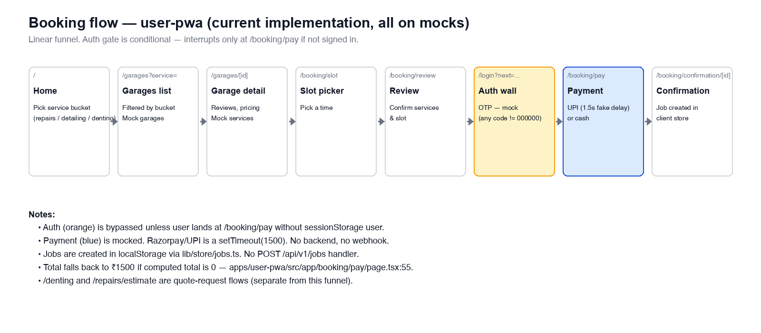
Figure 3 — booking funnel. Orange = auth gate (mocked). Blue = payment (mocked).

9. Recommended fix sequence
Order matters. Steps 1 and 2 are pure config fixes — they should take under an hour combined. Step 3 is verification. Steps 4 and 5 are scoping/product decisions, not necessarily today’s work.
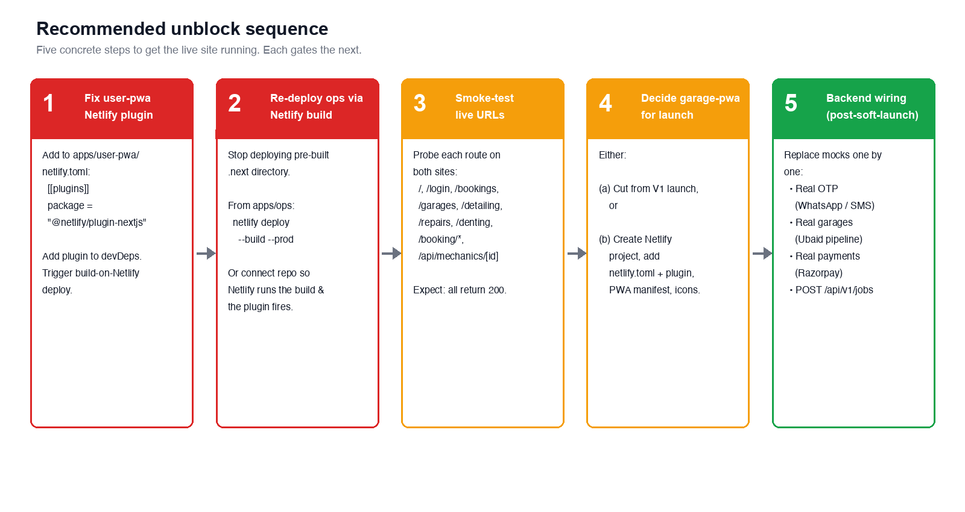
Figure 4 — five-step unblock plan, gated left to right.

10. Open questions — please answer
Answers to these will materially change the next set of recommendations. Pasted as a numbered list so it’s easy to reply inline.
Q# | Question
Q1 | Is garage-pwa in V1 launch scope, or are we cutting it for now and shipping garages-via-WhatsApp?
Q2 | What is the target launch date? That changes the calculus on which mocks are acceptable on day 1.
Q3 | Do you want a real WhatsApp OTP for V1 (e.g., Gupshup / Meta Cloud API), or is SMS-only acceptable to start?
Q4 | Razorpay vs. UPI Intent vs. cash-only for V1 payments? UPI Intent ships fastest; Razorpay needs KYC/onboarding.
Q5 | The user-pwa contains its own /ops, /ops/map, /ops/coverage that overlap with the standalone ops app. Should these be removed from user-pwa (and the ops app be the sole back-office), or are they intentionally duplicated?
Q6 | Do you have the real Mister Waan wordmark / logo asset? TopBar.tsx and icon.tsx both flag the current mark as a placeholder.
Q7 | Backend host & language: still Django + JWT as auth.ts suggests, or has the plan shifted? Knowing the API host shape will let us wire booking-draft to a real POST /api/v1/jobs.
Q8 | Ubaid’s Garage Partner Rate Card & onboarding sheet — is there a shared source we can pull from, or do we hard-code the V1 catalog from a CSV?
Q9 | Exotel/masked-DID number: is the account set up? garage-pwa shows tel:+91XXXXXXXXXX as a stub.
Q10 | /denting is a separate request-quote flow rather than a direct booking. Should it stay that way for V1, or unify under one booking funnel?
Q11 | Should we register a custom domain before launch (e.g., mistrwaan.com)? Netlify currently serves on *.netlify.app.
Q12 | Who is the launch audience for the soft-launch — is it open Srinagar, or a closed beta? That affects what we can ship with mocks vs. what must be real.

11. Appendix: raw audit data

11.1 Build outputs

user-pwa
$ next build (Turbopack)
✓ Compiled successfully in 2.8s
Routes: 18 total
ƒ / ƒ /booking/confirmation/[id]
ƒ /api/mechanics/[id] ƒ /booking/pay
○ /apple-icon ƒ /booking/review
ƒ /booking/slot ƒ /bookings
ƒ /bookings/[id] ƒ /denting
ƒ /denting/quotes/[id] ƒ /detailing
ƒ /garages ƒ /garages/[id]
○ /icon ƒ /login
○ /manifest.webmanifest ƒ /ops
ƒ /ops/coverage ƒ /ops/map
ƒ /profile ƒ /repairs
ƒ /repairs/estimate

ops
$ next build (Turbopack)
✓ Compiled successfully in 1.6s
Routes: 7 total
ƒ / ƒ /api/mechanics/[id]
ƒ /api/mechanics/[id]/call-log ƒ /coverage
ƒ /follow-ups ƒ /map
○ /_not-found

garage-pwa
$ next build (Turbopack)
✓ Compiled successfully in 1.4s
Routes: 5 total
○ / ○ /earnings ƒ /jobs/[id]
○ /login ○ /profile

11.2 Netlify deploy metadata

mistr-waan (siteId 312fad70-…ce52715527e4)
current_deploy: 69fa1d2671f60e705a9c7689 (state: ready)
created_at: 2026-05-05T16:39:02Z
framework: next
plugin_state: none
available_functions: []
deploy_source: cli
summary: 34 generated pages + 33 assets

waan-ops (siteId 0112dfa3-…83bcb453f5d2)
current_deploy: 6a033d33efc1b5f3937048bd (state: ready)
created_at: 2026-05-12T14:46:11Z
framework: unknown
plugin_state: none
available_functions: []
deploy_source: cli
summary: 4 generated pages + 313 assets

11.3 Files referenced in this report
- apps/user-pwa/netlify.toml — missing plugin declaration.
- apps/ops/netlify.toml:14 — plugin declared but not running at build.
- apps/user-pwa/src/lib/store/auth.ts:6 — mock auth note.
- apps/user-pwa/src/app/booking/pay/page.tsx:55 — ₹1500 fallback total.
- apps/user-pwa/src/app/booking/pay/page.tsx:59 — mock Razorpay delay.
- apps/user-pwa/src/lib/store/booking-draft.ts:10 — comment references POST /api/v1/jobs which doesn’t exist.
- apps/user-pwa/src/lib/mock/{garages,services,reviews}.ts — flagged V0 placeholders.
- apps/user-pwa/src/app/garages/page.tsx:14 — filter UI stub.
- apps/user-pwa/src/components/layout/TopBar.tsx:42 — wordmark placeholder.
- apps/user-pwa/src/app/icon.tsx:6 — MW icon placeholder.
- apps/garage-pwa/src/app/jobs/[id]/page.tsx:48 — stub Exotel DID.
- apps/garage-pwa/src/app/login/page.tsx:46 — OTP 000000 = fail; anything else passes.
- apps/garage-pwa/src/lib/mock/jobs.ts:39 — 12% commission placeholder.

11.4 What was NOT audited (and why)
- Cross-browser rendering — out of scope for a static audit; recommend Lighthouse + manual smoke once production unblocks.
- Accessibility (WCAG) — not run; flag for a separate pass before launch.
- Performance budgets — Turbopack-built routes are small but no Lighthouse run yet.
- Backend security — there is no backend yet.
- Real-device PWA install — relies on a working live deploy, which we don’t have.

