Market Segmentation:

desktop pcs: 896,053

<http://www.statista.com/statistics/203585/global-installed-base-of-desktop-pcs/>

<http://www.idc.com/getdoc.jsp?containerId=prUS25077914>

2014 worldwide shipments

Regular Smartphone 1,077.4

Phablet 174.9

Tablet + 2-in-1 233.1

Portable PC 170.0

Desktop PC 133.5

Total 1,789.0

<http://www.pcmag.com/article2/0,2817,2427907,00.asp>

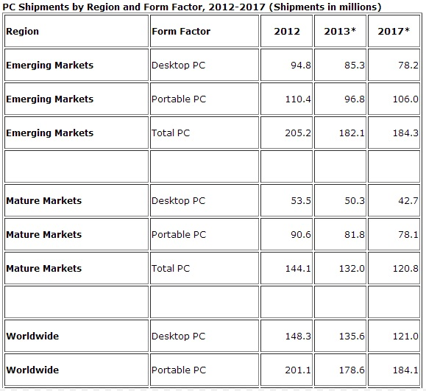

<http://www.gartner.com/newsroom/id/2869019>

Note: Data includes desk-based PCs and mobile PCs, including x86 tablets equipped with Windows 8, but excludes Chromebooks and **other tablets**. apple???

**Table 1  
Preliminary Worldwide PC Vendor Unit Shipment Estimates for 3Q14 (Units)**

|  |  |  |  |  |  |
| --- | --- | --- | --- | --- | --- |
| Company | **3Q14 Shipments** | **3Q14 Market Share (%)** | **3Q13 Shipments** | **3Q13 Market Share (%)** | **3Q13-3Q14 Growth (%)** |
| Lenovo | 15,703,391 | 19.8 | 14,090,273 | 17.7 | 11.4 |
| HP | 14,214,195 | 17.9 | 13,621,160 | 17.1 | 4.4 |
| Dell | 10,185,964 | 12.8 | 9,286,002 | 11.6 | 9.7 |
| Acer Group | 6,830,009 | 8.6 | 6,265,167 | 7.9 | 9.0 |
|  |  |  |  |  |  |
| Asus | 5,768,120 | 7.3 | 4,936,206 | 6.2 | 16.9 |
| Others | 26,684,880 | 33.6 | 31,595,900 | 39.6 | -15.5 |
| **Total** | **79,386,559** | **100.0** | **79,794,707** | **100.0** | **-0.5** |
|  |  |  |  |  |  |

**Table 2  
Preliminary U.S. PC Vendor Unit Shipment Estimates for 3Q14 (Units)**

|  |  |  |  |  |  |
| --- | --- | --- | --- | --- | --- |
| Company | **3Q14 Shipments** | **3Q14 Market Share (%)** | **3Q13 Shipments** | **3Q13 Market Share (%)** | **3Q13-3Q14 Growth (%)** |
| HP | 4,615,335 | 27.8 | 4,216,105 | 26.5 | 9.5 |
| Dell | 3,997,872 | 24.1 | 3,377,468 | 21.2 | 18.4 |
| Apple | 2,366,212 | 14.3 | 2,068,212 | 13.0 | 14.4 |
| Lenovo | 1,747,045 | 10.5 | 1,692,488 | 10.6 | 3.2 |
| Toshiba | 1,011,112 | 6.1 | 1,122,782 | 7.1 | -9.9 |
| Others | 2,851,994 | 17.2 | 3,439,309 | 21.6 | -17.1 |
| **Total** | **16,589,570** | **100.0** | **15,916,365** | **100.0** | **4.2** |

<http://www.gartner.com/newsroom/id/2645115>

**Table 1**

Worldwide Device Shipments by Segment (Thousands of Units)

|  |  |  |  |  |
| --- | --- | --- | --- | --- |
| Device Type | **2012** | **2013** | **2014** | **2015** |
| PC (Desk-Based and Notebook) | 341,273 | 299,342 | 277,939 | 268,491 |
| Tablet (Ultramobile) | 119,529 | 179,531 | 263,450 | 324,565 |
| Mobile Phone | 1,746,177 | 1,804,334 | 1,893,425 | 1,964,788 |
| Other Ultramobiles (Hybrid and Clamshell) | 9,344 | 17,195 | 39,636 | 63,835 |
| **Total** | **2,216,322** | **2,300,402** | **2,474,451** | **2,621,678** |

<http://ansonalex.com/infographics/interesting-stats-about-smartphones/>

<http://www.statista.com/statistics/272571/age-distribution-of-smartphone-owners-in-the-united-states/>

