**Market Segment Interview**

Date/Time:

Name:

Occupation:

Age:

* 13-17
* 18-24
* 25-34
* 35-44
* 45-54
* 55+

Recognize Cable?

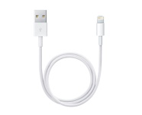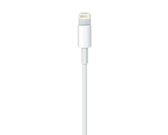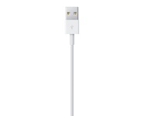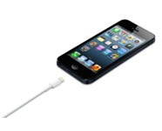

* yes
* no

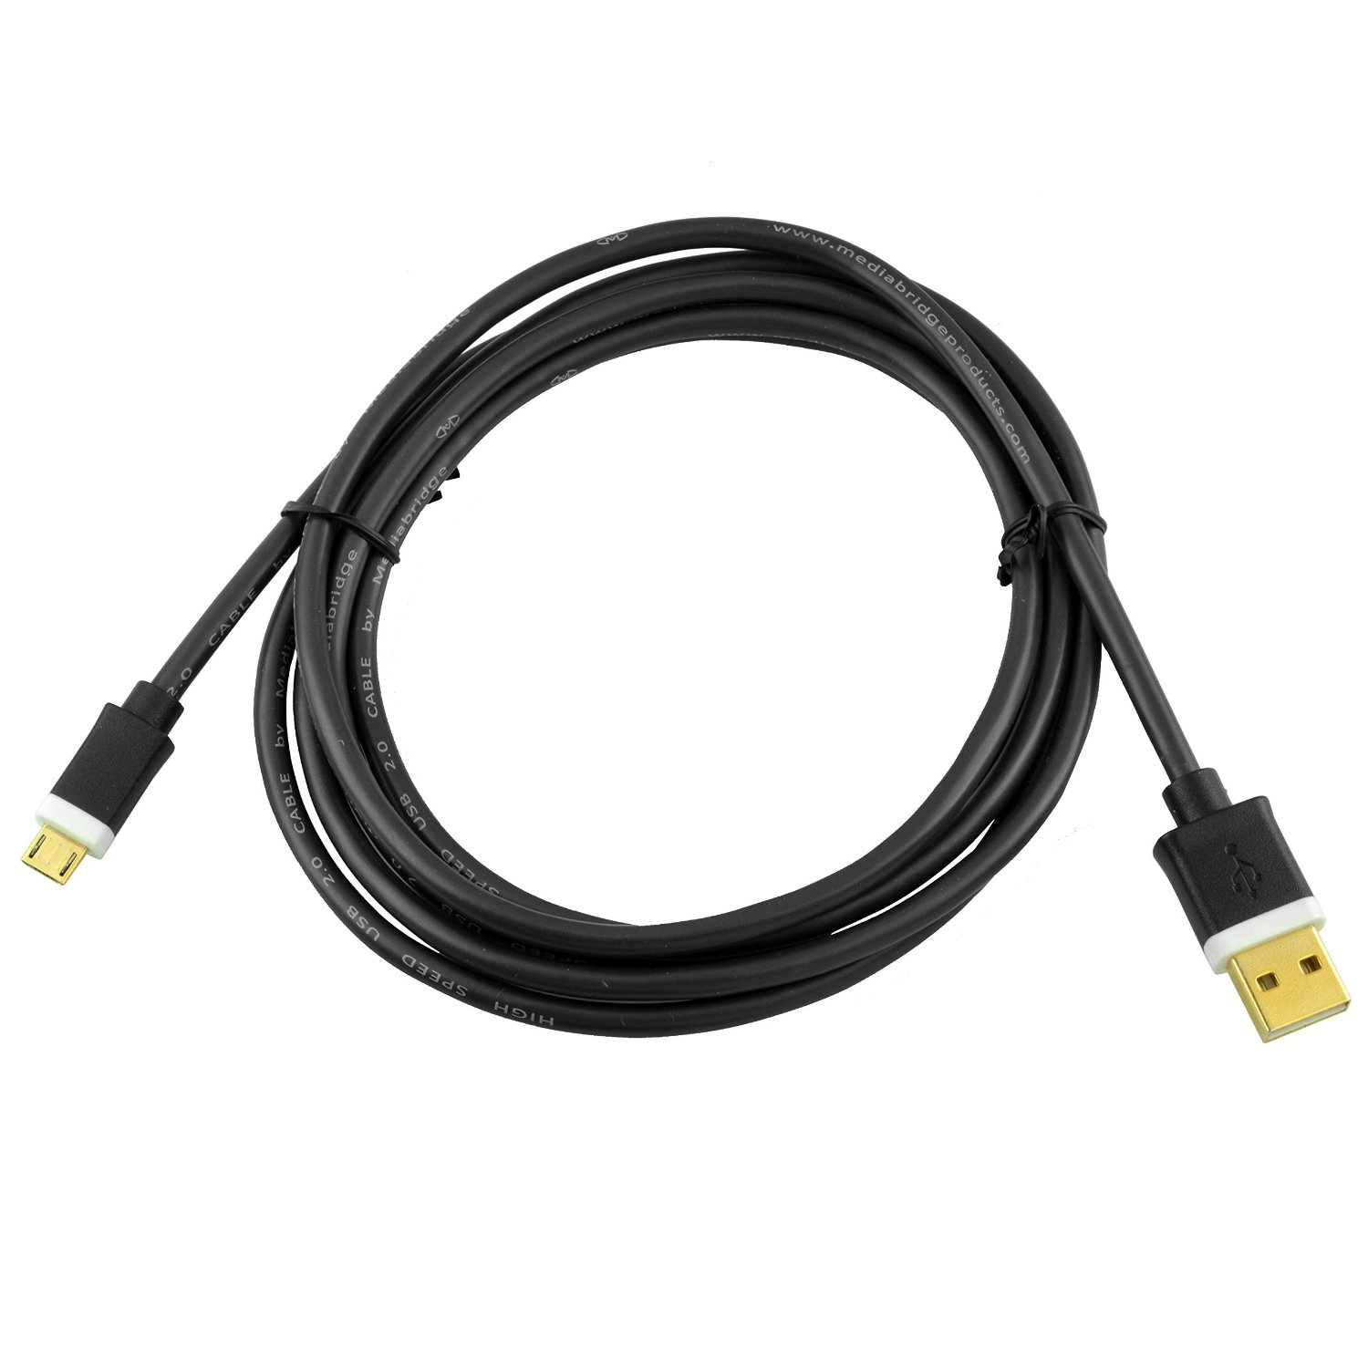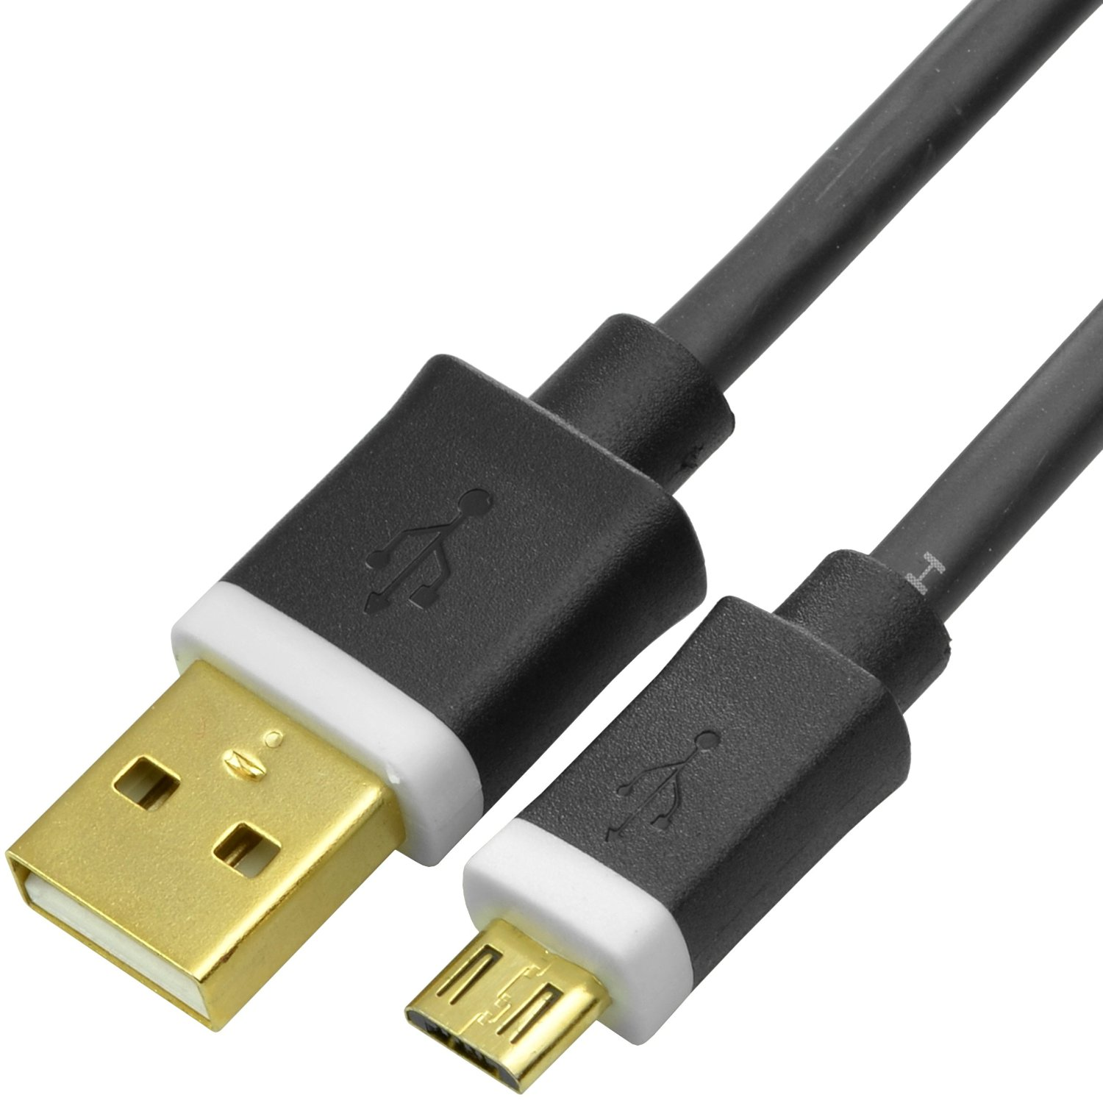 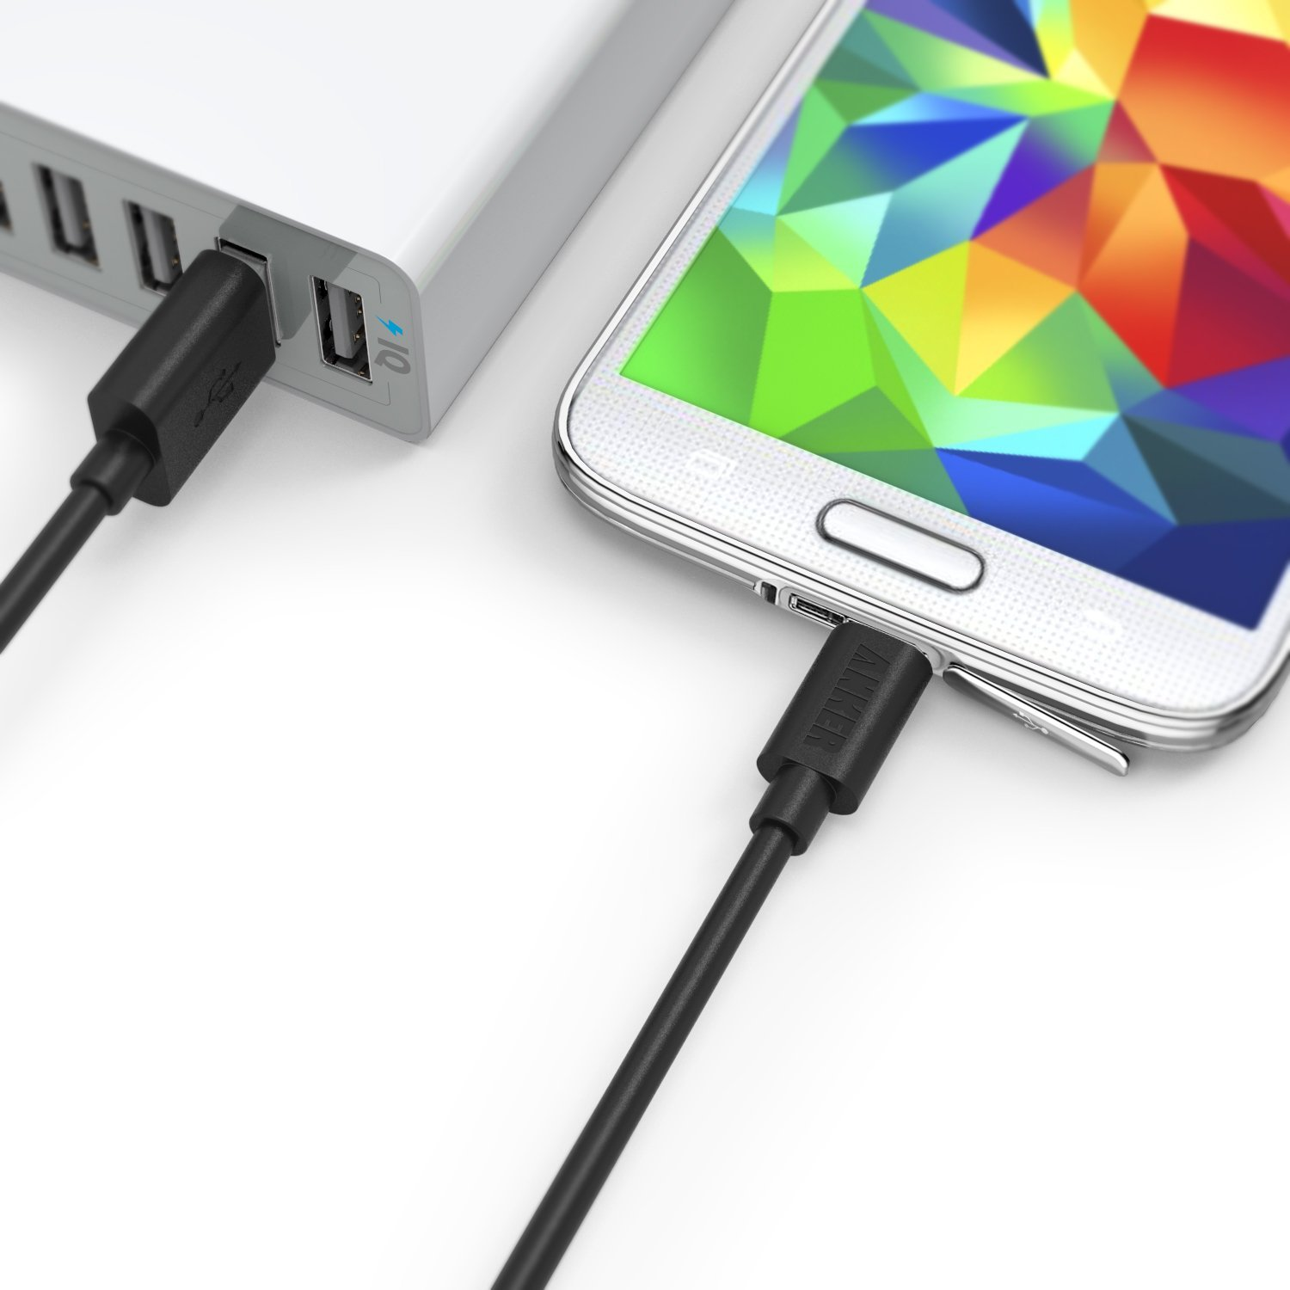

* yes
* no

Use cable how?

* charging
  + phone
    - what kind of phone?
    - charge from what usb?
    - how often?
    - where?
  + tablet
    - what kind of tablet?
    - charge from what usb?
    - how often?
    - where?
  + other
    - what kind of device?
    - charge from where?
    - how often?
    - where?
* data transfer (e.g. internet, itunes, backup)
  + phone
    - what kind of data transfer?
    - what kind of phone?
    - transfer from what usb?
    - how often?
    - where?
  + tablet
    - what kind of data transfer?
    - what kind of tablet?
    - transfer from what usb?
    - how often?
    - where?
  + other
    - what kind?
    - from what usb?
    - how often?
    - where?
* other uses:
  + from what kind of device?
  + to what kind of device?
  + how often?
  + where?

Competitor (<http://keroproducts.com/>):

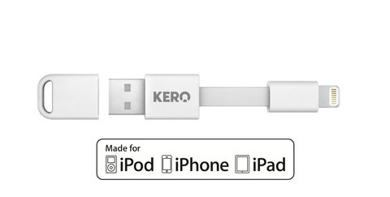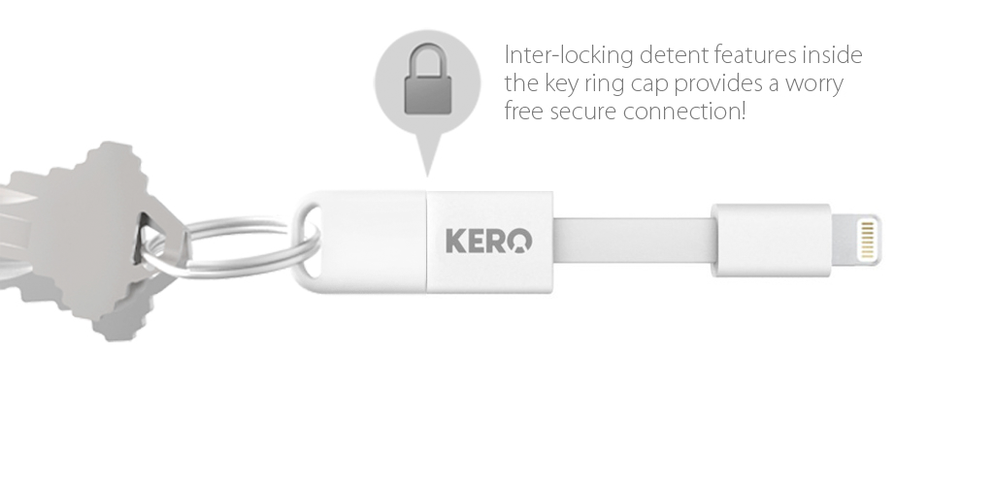

Advantages:

Disadvantages:

Features:

Pricing:

Prototype <https://www.indiegogo.com/projects/incharge-the-smallest-keyring-cable>

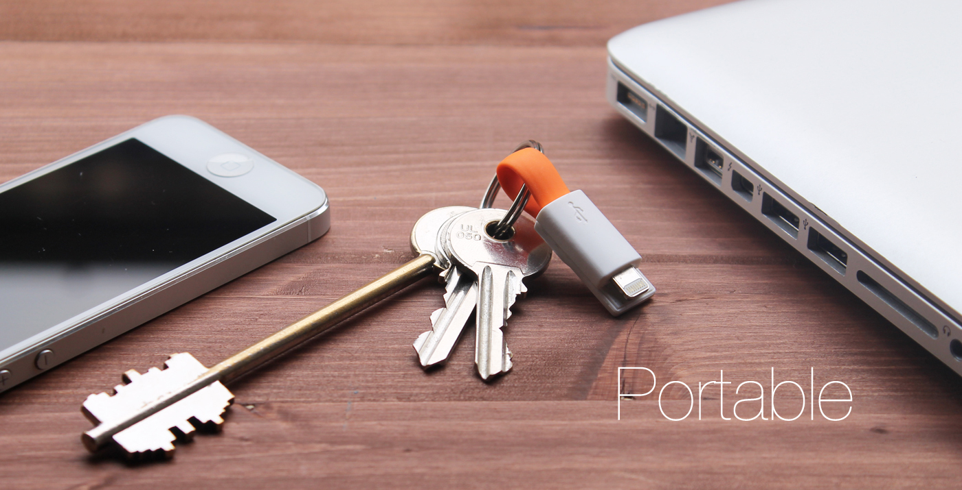 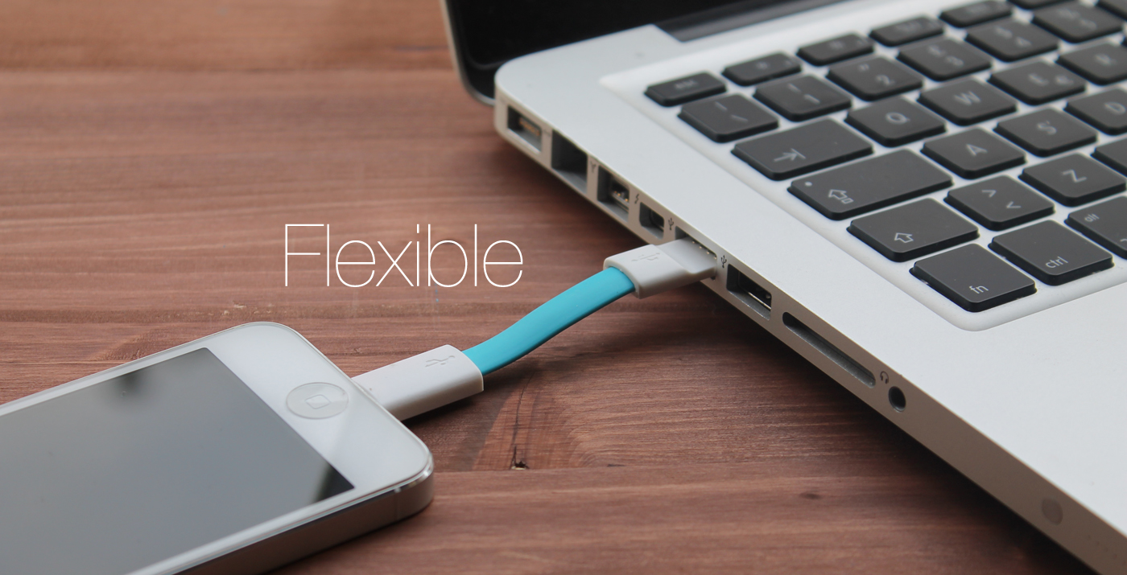 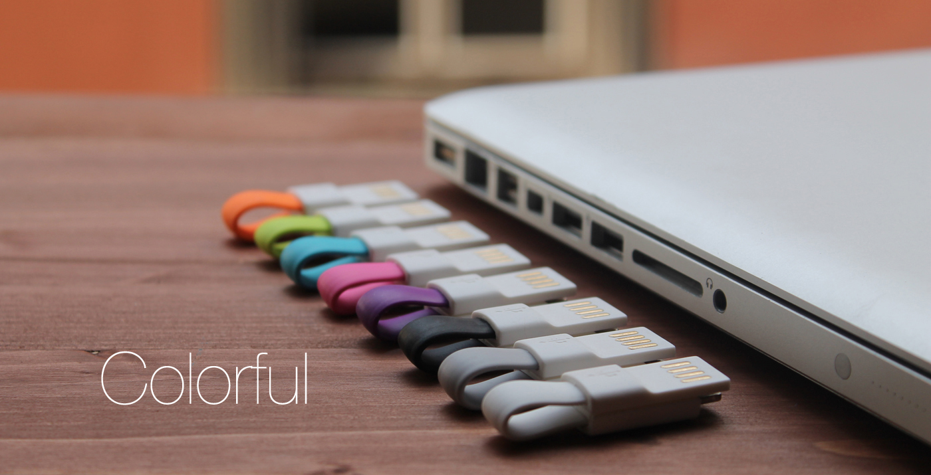

Advantages:

Disadvantages:

Features:

Pricing: