Reference number of working document: ISO/IEC JTC 1/SC 31 N 2638
Date: 2008-10-08
Reference number of document: ISO/IEC 15418:2008
Committee identification: ISO/IEC JTC 1/SC 31/WG 2
Secretariat: ANSI
Information technology - Automatic identification and data capture techniques - GS1 Application Identifiers and ASC MH 10 Data Identifiers and maintenance
Technologie de l'information — Identificateurs de l'application GS1 et Identificateurs de Données d'ASC MH 10 et entretien
Document type: Reaffirmation of International Standard
Document subtype: if applicable
Document stage: (30) Committee
Document language: E

Reaffirmation
Warning
This document is not an ISO International Standard. It is distributed for review and comment. It is subject to change without notice and may not be referred to as an International Standard.
Recipients of this draft are invited to submit, with their comments, notification of any relevant patent rights of which they are aware and to provide supporting documentation.

Copyright notice
This ISO document is a working draft or committee draft and is copyright-protected by ISO. While the reproduction of working drafts or committee drafts in any form for use by participants in the ISO standards development process is permitted without prior permission from ISO, neither this document nor any extract from it may be reproduced, stored or transmitted in any form for any other purpose without prior written permission from ISO.
Requests for permission to reproduce this document for the purpose of selling it should be addressed as shown below or to ISO’s member body in the country of the requester:
ISO copyright office
Case postale 56 • CH-1211 Geneva 20
Tel. + 41 22 749 01 11
Fax + 41 22 749 09 47
E-mail copyright@iso.ch
Web www.iso.ch
Reproduction for sales purposes may be subject to royalty payments or a licensing agreement.
Violators may be prosecuted.
Contents Page
Foreword viii
1 Scope 1
2 Normative references 1
3 Definitions and documentation notation conventions 1
4 Data Identifiers and Application Identifiers 1
4.1 GS1 Application Identifiers 1
4.2 ASC MH10 Data Identifiers 2
5 Maintenance 3
5.1 GS1 Application Identifiers 3
5.2 ASC MH10 Data Identifiers 3
Annex A (informative) User guidance 4
A.1 Choice between GS1 Application Identifiers or ASC MH10 Data Identifiers 4
A.2 Working with GS1 Application Identifiers and ASC MH10 Data Identifiers 4

Foreword
ISO (the International Organization for Standardization) is a worldwide federation of national standards bodies (ISO member bodies). The work of preparing International Standards is normally carried out through ISO technical committees. Each member body interested in a subject for which a technical committee has been established has the right to be represented on that committee. International organizations, governmental and non-governmental, in liaison with ISO, also take part in the work. ISO collaborates closely with the International Electrotechnical Commission (IEC) on all matters of electrotechnical standardization.
International Standards are drafted in accordance with the rules given in the ISO/IEC Directives, Part 2.
The main task of technical committees is to prepare International Standards. Draft International Standards adopted by the technical committees are circulated to the member bodies for voting. Publication as an International Standard requires approval by at least 75 % of the member bodies casting a vote.
Attention is drawn to the possibility that some of the elements of this document may be the subject of patent rights. ISO shall not be held responsible for identifying any or all such patent rights.
Joint Technical Committee ISO/IEC JTC 1, Information technology, Subcommittee SC 31, Automatic identification and data capture techniques prepared International Standard ISO/IEC 15418.
The first edition of this document was issued in 1999. This reaffirmation is the second edition.
Annex A of this International Standard is for information only.

Information technology — GS1 Application Identifiers and ASC MH 10 Data Identifiers and maintenance

Scope
This International standard:
- specifies sets of Data Identifiers and Application Identifiers for the purpose of identifying encoded data;
- identifies the organisations responsible for their maintenance.

Normative references
The following referenced documents are indispensable for the application of this document. For dated references, only the edition cited applies. For undated references, the latest edition of the referenced document (including any amendments) applies.
ISO/IEC 19762 Information Technology AIDC Techniques - Harmonized Vocabulary
ANS MH10.8.2 Data Identifiers and Application Identifiers
GS1 General Specifications

Definitions and documentation notation conventions
For the purposes of this standard, the definitions contained in ISO/IEC 19762, Information Technology – AIDC Techniques – Harmonized vocabulary, shall apply.

Data Identifiers and Application Identifiers
Where appropriate, information encoded shall be identified in accordance with one of the following sets of identifiers:
a) GS1 Application Identifiers
b) ASC MH10 Data Identifiers

GS1 Application Identifiers
The GS1 item identification system and related encodation standard are complemented by the GS1 maintained Application Identifiers, hereafter referred to as “GS1 Application Identifiers” (GS1 AIs). This standard comprises two principal elements that are the key to any encoding system: the data content and the data carrier.

The use of GS1 AIs is subject to the rules established by GS1.
GS1 AIs identify generic and simple data fields for use in cross sectorial and international supply chain applications. The GS1 General Specifications provide rules for the definition, format and structure of the data fields.
Each GS1 AI consists of two or more characters. The first two digits determine the length of the AI. A list of two digit codes indicating the predefined length of existing and future AIs and their data fields is available from the Application Identifier Maintenance Body specified in clause 5, below.

ASC MH10 Data Identifiers
The full list of registered ASC MH10 Data Identifiers and the full specification for their use are found in the American National Standard MH10.8.2 “Data Application Identifier Standard”, hereafter referred to as the “ASC MH10 Data Identifiers”
ASC MH10 Data Identifiers may be used with any alphanumeric data carrier and are designed to ensure cross-industry commonality of data identifiers used in automatic identification technologies.
ASC MH10 Data Identifiers have a format of one alphabetic character alone, or one alphabetic character prefixed by one, two or three numeric characters.
Some ASC MH10 Data Identifiers may incorporate format definitions. The American National Standards Institute (ANSI) has designated ANS MH10.8.2 as a “Continuous Maintenance” standard. As such, the official standard with maintenance updates is available at
http://www.autoid.org/ANSI_MH10/ansi_mh10sc8_wg2.htm
A full list of ASC MH10 Data Identifiers is available from:
Customer Service
Material Handling Industry
8720 Red Oak Blvd., Suite 201
Charlotte, NC 28217-3992 USA
(V): +1 704/522-8644
(F): +1 704/522-7826
(U): http://www.mhiastore.org/moreinfo.cfm?Product_ID=159
or
Customer Service
American National Standards Institute (ANSI)
25 West 43rd Street, 4th Floor
New York, NY 10036 USA
(V): +1 212/642-4900
(F): +1 212/398-0023
(U): http://webstore.ansi.org/

Maintenance
Organisations responsible for the maintenance of GS1 Application Identifiers and ASC MH10 Data Identifiers in accordance with paragraph 4 of this standard are:

GS1 Application Identifiers
GS1 Application Identifier Secretariat:
GS1 Customer Service
Blue Tower, Avenue Louise 326, bte 10,
BE 1050 Brussels, Belgium
Belgium
(V): +32 2/788 78 00
(F): +32 2/788 78 99
(E): contactus@gs1.org

GS1 is a world-wide coding management organisation for identification numbers, encompassing the associations previously known as EAN International and Uniform Code Council. The GS1 System is maintained through a network of national and pluri national agencies known as Member Organisations, named GS1 followed by the country name, for example, GS1 France, GS1 US, or GS1 Russia. The working language of GS1 Application Identifier Secretariat is English. Local language versions of the GS1 Application Identifier, and full information on how to request a new Application Identifier, are available from GS1 Member Organisations. Contact details of GS1 Member Organisations are available from via http://www.gs1.org/contact/worldwide.php

ASC MH10 Data Identifiers
ANSI MH10.8.2 Data Identifiers Maintained by
ASC MH 10 Data Identifier Maintenance Committee
c/o DI Maintenance Committee Chair
Q.E.D. Systems
3963 Highlands Lane, SE
Cedar Rapids, IA 52403
USA
(V): +1 319/364-0212
(E): craig.harmon@qed.org
The purpose of the ASC MH10 Data Identifier Maintenance Committee is to provide ANSI MH10.8.2 DIs for any legitimate data element used between trading partners, as well as for internal applications, providing that there is no conflict with an existing ANSI MH10.8.2 DI. The Chair of the Data Identifier Maintenance Committee provides the secretariat and the working language is English. In order to ensure system integrity, once codified in the standard, ANSI MH10.8.2 DIs are never modified. Should an ASC MH10 DI user find that no ASC MH10 DI meets their specific need, the user is encouraged to contact the Chair of the Data Identifier Maintenance Committee for guidance or submit a request for a new ANSI MH10.8.2 DI. The ASC MH10 Data Identifier Maintenance Committee maintains submittal offices in Europe, Japan, and the United States. Contact details are available from the ASC MH10 Data Identifier Maintenance Committee chair.

Annex A
(informative)
User guidance

A.1 Choice between GS1 Application Identifiers or ASC MH10 Data Identifiers
The choice between GS1 Application Identifiers or ASC MH10 Data Identifiers for any user will normally be defined in the applicable industry convention being followed.
Other industries developing product or shipment identification conventions should consider business practices, information requirements and systems capabilities of the trading partners in choosing between ASC MH10 Data Identifiers and GS1 Application Identifiers. The user may also consider the following guidelines:
a) GS1 Application Identifiers:
The definitions of the GS1 Application Identifiers are supported by application guidelines. The GS1 AIs, and associated guidelines, have been designed for international and multi-sectorial trading purposes.
b) ASC MH10 Data Identifiers:
The descriptions in the ASC MH10 Data Identifier list are general in nature. ASC MH10 Data Identifier users are advised to look in the appropriate ISO or industry application guidelines for guidance.

A.2 Working with GS1 Application Identifiers and ASC MH10 Data Identifiers
This standard recognises two identifier groups: The GS1 Application Identifiers and the ASC MH10 Data Identifiers. The user, normally in association with trading partners, has to decide which to use.
All user organisations would prefer a universal information flow based upon a single system, however the two systems, which have some very different characteristics and functionalities, are used by organisations that have invested in data systems and see a change to another approach as offering an incremental improvement at a relatively high cost.
Thus some manufacturing industries are forced to work with both systems to meet ALL their customer needs. It is therefore necessary for these industries to build internal systems capable of “mapping” the data in one system to the other. Further, it is often required to assign also the information elements of EDIFACT (or other Electronic Data Interchange Message Set) in the electronic data of the orders and deliveries.
Due to the different philosophies used to develop GS1 Application Identifiers and ASC MH10 Data Identifiers it is impossible to provide 100% accurate one-to-one mapping. However, publicly available mappings between GS1 Application Identifiers and ASC MH10 Data Identifiers have been developed (e.g. http://www.autoid.org/ANSI_MH10/Mapping_Identifiers/DI_to_AI.html and http://www.autoid.org/ANSI_MH10/Mapping_Identifiers/AI_to_DI.html).
These mapping tables may be of help to companies in the situation of using GS1 Application Identifiers and ASC MH10 Data Identifiers.
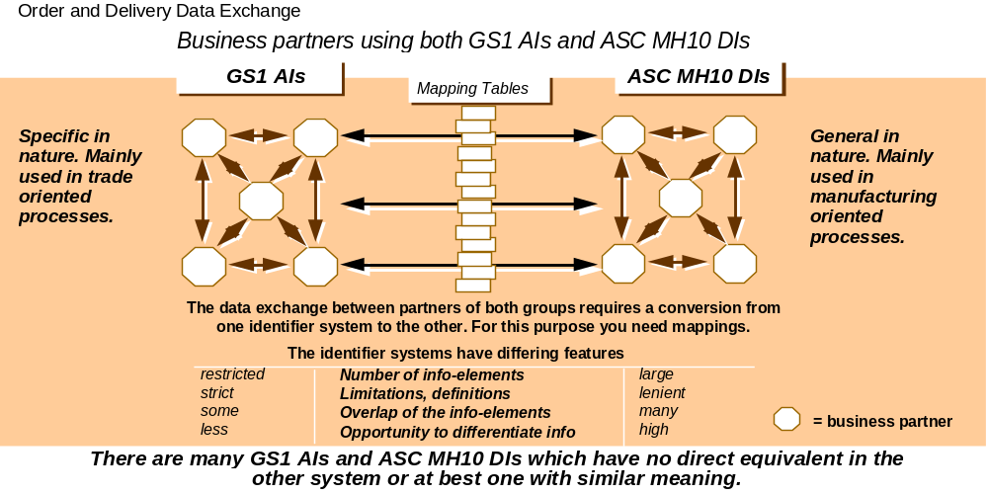
Figure A.1 – Comparisons between GS1 AIs and ASC MH10 DIs

