ANSI MH10.8.1 – XXXX
(revision of
ANSI MH10.8.1 – 2000)

Notice
This is a draft document and thus, is dynamic in nature. It does not reflect a consensus of the MH10.8.1 Committee and it may be changed or modified. Neither ANSI nor the MH10.8.1 Committee makes any representation or warranty, express of implied, with respect to the sufficiency, accuracy or utility of the information or opinion contained or reflected in the material utilized. ANSI and the MH10.98.1 Committee further expressly advise that any use of or reliance upon the material in question is at your risk and neither ANSI nor the MH10.8.1 Committee shall be liable for any damage or injury, of whatever nature, incurred by any person arising out of any utilization of the material. It is possible that this material will at some future date be included in a copyrighted work by ANSI.

Automatic Identification and Data
Capture Techniques Used in Shipping,
Receiving, and Transport Applications

Material Handling Industry
8720 Red Oak Blvd., Suite 201
Charlotte, NC 28217-3992
Printed: XX/XXXX

American  National  Standard | Approval of an American National Standard (ANS) requires verification by the American National Standards Institute (ANSI) that the requirements for due process, consensus, and other criteria for approval have been met by the standards developer.  Consensus is established when, in the judgment of the ANSI Board of Standards Review, substantial agreement has been reached by directly and materially affected interests. Substantial agreement means much more than a simple majority, but not necessarily unanimity. Consensus requires that all views and objections be considered, and that a concerted effort be made toward their resolution.  The use of American National Standards is completely voluntary; their existence does not in any respect preclude anyone, whether he has approved the standards or not, from manufacturing, marketing, purchasing, or using products, processes, or procedures not conforming to the standards.  The American National Standards Institute does not develop standards and will in no circumstances give an interpretation of any American National Standard. Moreover, no person shall have the right or authority to issue an interpretation of an American National Standard in the name of the American National Standards Institute. Requests for interpretations should be addressed to the sponsor whose name appears on the title page of this standard.  CAUTION NOTICE: This American National Standard may be revised or withdrawn at any time. The procedures of the American National Standards Institute require that action be taken periodically to reaffirm, revise, or withdraw this standard. Purchasers of American National Standards may receive current information on all standards by calling or writing the American National Standards Institute.

Published by:

MH10, Unit-Loads & Transport-Packages,
ANSI and Accredited Standards Committee
Secretariat: Material Handling Industry
8720 Red Oak Blvd., Suite 201, Charlotte, NC 28217-3992

Copyright © XXXX by Material Handling Industry
All rights reserved.

No part of this publication may be reproduced in any
form, in an electronic retrieval system or otherwise,
without prior written permission of the publisher

Printed in the United States of America

ANSI MH10.8.1 – XXXX
(revision of ANSI MH10.8.1-2000)

American National Standard
Automatic Identification and Data
Capture Techniques Used in Shipping,
Receiving, and Transport Applications

Secretariat
Material Handling Industry

Approved Month Day, XXXX
American National Standards Institute, Inc.
Table of Contents

Foreword iii
1 Scope 3
2 Normative references 3
3 Definitions 3
4 Concepts 3
4.1 Principles 3
4.2 Transport Package, Unit Load, and Transport Unit 3
4.2.1 Transport Package. 3
4.2.2 Unit Load. 3
4.2.3 Transport Unit. 3
4.3 Unique Transport Unit Identifier 3
4.4 Label formats 3
4.4.1 Base Label for shipping / transport / receiving 3
4.4.2 Extended Label for shipping / transport / receiving 3
5 Data structure 3
5.1 Data presentation 3
5.1.1 Data in linear bar code symbols 3
5.1.2 Data in two-dimensional (2D) symbols 3
5.1.3 Data in human readable form 3
5.2 Data elements 3
5.2.1 Unique Transport Unit Identifier 3
5.2.2 Ship To 3
5.2.3 Ship From 3
5.2.4 Key to carrier's database 3
5.2.5 Key to customer's database 3
5.2.6 Other data elements 3
5.3 Concatenating data fields in linear and composite symbols 3
5.3.1 Using EAN.UCC Application Identifiers (AI) 3
5.3.2 Using ANSI MH10.8.2 Data Identifiers (DI) 3
5.4 Structured data files 3
6 Data carriers 3
6.1 Linear bar code symbols 3
6.2 Two-dimensional symbols 3
6.3 Human readable information 3
6.3.1 Human readable interpretation (HRI) 3
6.3.2 Human translation 3
6.3.3 Data area titles 3
6.3.4 Free text and data 3
7 Label design 3
7.1 General considerations 3
7.2 Layout 3
7.2.1 Base Label layout 3
7.2.2 Extended Label layout 3
7.2.3 Other data 3
7.3 Label dimensions 3
7.3.1 General considerations 3
7.3.2 Label height 3
7.3.3 Label width 3
7.3.4 Data limits 3
7.4 Text size 3
7.4.1 General considerations 3
7.4.2 Specific text dimensions 3
7.5 Material 3
8 Label placement 3
8.1 General considerations 3
8.2 Unitized Loads (pallets) 3
8.3 Transport Packages 3
8.4 Other Transport Units 3
Annex A (normative) Guidelines for using linear bar code symbols 3
A.1 Symbology 3
A.2 Symbol height 3
A.3 Narrow element dimension 3
A.4 Wide to narrow ratio for Code 39 symbols 3
A.5 Quiet zones 3
A.6 Orientation 3
A.7 Placement 3
A.8 Linear bar code symbol print quality 3
B.1 Shipping and receiving applications 3
B.1.1 Symbology recommendation 3
B.1.2 Error correction level 3
B.1.3 Narrow element dimension 3
B.1.4 Row height 3
B.1.5 Quiet zone 3
B.1.6 Symbol size 3
B.1.7 Print quality 3
B.1.8 Orientation and placement 3
B.1.8.1 PDF417 and UCC.EAN Composite symbol orientation 3
B.1.8.2 Label placement 3
B.2 Supporting documentation applications 3
B.2.1 Symbology recommendation 3
B.2.2 Error correction levels 3
B.2.3 Narrow element dimension 3
B.2.4 Row height 3
B.2.5 Quiet zones 3
B.2.6 Print quality 3
B.2.7 Orientation and placement 3
B.2.7.1 Orientation 3
B.2.7.2 Placement 3
B.2.8 Concatenation of symbols 3
B.2.8.1 Planning for large messages 3
B.2.8.2 Printing concatenated symbols 3
B.2.8.3 Reading Macro PDF417 symbols 3
B.3 Printing PDF417 and EAN.UCC Composite CC-C (PDF417) symbols 3
B.3.1 Plan for the maximum amount of data 3
B.3.2 Plan for scanning equipment likely to be used 3
B.3.3 Plan for the maximum X dimension(s) and data columns 3
B.3.4 Determine the appropriate label size 3
B.3.4.1 Symbols for labels having a width of at least 102 mm. 3
B.3.4.2 Symbols for labels having a width of greater than 102 mm. 3
B.4 Carrier sortation and tracking applications 3
B.4.1 Data encoding 3
B.4.1.1 Code set 3
B.4.1.2 Mode 3
B.4.2 Error correction levels 3
B.4.3 Narrow element dimension 3
B.4.4 Quiet zones 3
B.4.5 MaxiCode symbol print quality 3
B.4.6 Orientation and placement 3
B.4.6.1 MaxiCode symbol orientation 3
B.4.6.2 Symbol placement 3
B.4.6.3 Label placement 3
B.4.7 Concatenation 3
B.4.7.1 Printing Structured Append MaxiCode symbols 3
B.4.7.2 Reading Structured Append MaxiCode symbols 3
Annex C (informative) Designing compliant labels using a building block approach Error! Bookmark not defined.
C.1 Label definition 3
C.2 Building blocks 3
C.3 Text lines-per-block 3
C.4 Segments 3
C.5 Label dimensions 3
C.6 Label format 3
C.6.1 Building blocks 3
C.6.1.1 Building block size 3
C.6.1.2 Sub-blocks 3
C.6.2 Text block 3
C.6.3 Text building block and sub-block title line(s) 3
C.6.4 Bar code symbol block 3
Annex D (informative) Issues to consider in the drafting of application guidelines or standards conforming to this American National Standard Error! Bookmark not defined.
D.1 The domain 3
D.2 Data presentation 3
D.3 The label 3
D.4 Data elements 3
D.5 The Unique Transport Unit Identifier 3
D.6 2D symbol 3
D.7 Linear bar code 3
D.8 The X dimension 3
D.9 Symbol quality 3
D.10 Label design 3
D.11 Label placement 3
Annex E (informative) Label examples Error! Bookmark not defined.
E.1 Base Label examples 3
E.1.1 Minimum data examples 3
E.1.2 Bar code symbols as pointers to a trading partner's databases 3
E.2 Extended Label Examples 3
E.2.1 Bar code symbols as pointers to trading partner's databases 3
E.2.2 Using license plate and 2D symbols for trading partner data 3
E.3 Format 02 (with complete EDI message) 3
E.3.1 EDIFICE UN/EDIFACT Despatch Advice (DESADV) in Format 02 3
E.3.1.1 Descriptive transaction 3
E.3.1.2 2D encodation 3
E.3.2 ANSI ASC X12 856 EDI Ship Notice Manifest in Format 02 3
E.3.2.1 Descriptive transaction 3
E.3.2.2 2D encodation 3
E.3.3 ANSI ASC X12 204 EDI Motor Carrier Information in Format 02 3
E.3.3.1 Descriptive transaction 3
E.3.3.2 2D encodation 3
E.4 Format 03 (structured data (EDI segments) using ANSI ASC X12) 3
E.5 Format 04 (structured data (EDI segments) using UN/EDIFACT) 3
E.6 Format 05 (data using EAN.UCC Application Identifiers) 3
E.7 Format 06 (data using ANSI MH10.8.2 Data Identifiers) 3
E.8 Combining Format 01 with Format 03 3
E.8.1 Format 01/03 using a 2D symbol for automated sortation / tracking 3
E.8.2 Format 01/03 using a linear bar code symbol for automated sortation / tracking 3
E.9 Combining Format 01 with Format 06 3
E.10 Combining Format 03 with Format 05 3
E.11 Combining Format 03 with Format 06 3
E.12 Combining Format 04 with Format 06 3
E.13 Combining Format 01 with Format 03 and Format 05 3
E.14 Combining Format 01, Format 06, and Format 03 over two labels 3
E.14.1 Label example: (transportation label) 3
E.14.2 Label example (customer label) 3
E.15 Encoding Mixed Contents in a Transport Container Error! Bookmark not defined.
E.16 Bill of lading example 3
Annex F (informative) Recommended label locations on various containers Error! Bookmark not defined.
Annex G (informative) For applications using Code 39 and Code 128 symbologies Error! Bookmark not defined.
G.1 Systems where a single option is intended to be scanned 3
G.2 Systems where multiple options are intended to be scanned 3
Bibliography 3

Foreword
(This Foreword is not part of American National Standard MH10.8.1-XXXX

This American National Standard was prepared by Subcommittee 8 (Package Labeling) of the MH10 (Unit-Loads and Transport-Packages) ANSI Accredited Standards Committee (ASC).

This standard was developed using ISO 15394, ANSI MH10.8.2 (ISO/IEC 15418), ANS MH10.8.3 (ISO/IEC 15434), and General EAN.UCC Specifications as primary references.

The use of electronic communication in association with the physical transport and handling of packages requires a clear and unique identifier to link electronic data and Transport Units. This is especially true when traceability is appropriate, such as that described in ISO 9000.

Bar code marked transport labels provide clear and unique identification and are in widespread use in global industries. A number of different standards exist, each designed to meet the requirements of the specific industry sector. For effective and economic use within and between industry sectors, one common multi-industry standard is a necessity. A bar code marked transport label is designed to facilitate the automation of shipping and handling administrative operations. The bar code information on the transport label may be used as a key to access the appropriate database containing detailed information about the Transport Unit, including information transmitted via electronic data interchange (EDI). In addition, a transport label may contain other information by agreement between trading partners. Two-dimensional (2D) symbols may be included to assist in moving large amounts of data from sender to recipient and to assist with a transportation carrier's automated sortation and tracking systems.

Committee approval of this standard does not necessarily imply that all committee or subcommittee members voted for its approval. At the time of MH10.8.1 approval, MH10 committee membership consisted of the following organizations:

AIM USA
American Trucking Associations
American Wood Packaging Association
APA – The Engineered Wood Association
Association of American Railroads
Assn. of Professional Material Handling Consultants
ASTM
Automotive Industry Action Group
Comp TIA
Containerization & Intermodal Institute, Inc.
Department of Defense
Electronic Industries Alliance
Fibre Box Association
Flexible Intermediate Bulk Container Assoc.
General Services Admin./Federal Supply Service
Glass Packaging Institute
Graphic Communications Association
Industry Bar Code Alliance
Institute of Packaging Professionals
International Cargo Handling Coordination Assoc.
ISTA
Material Handling & Management Society
Material Handling Industry of America
National American Wholesale Grocer's Association
National Wooden Pallet & Container Association
Paper Shipping Sack Manufacturers Association
Rack Manufacturers Institute
Soap & Detergent Association
Steel Shipping Container Institute
Textile Bag Manufacturers
Uniform Code Council
United Fresh Fruit & Vegetable Association
US Dept. of Agriculture
US Forest Products Laboratory

Scope
This American National Standard:

- specifies the minimum requirements for the design of labels containing linear bar code and two-dimensional (2D) symbols on Transport Units to convey data between trading partners;
- provides for traceability of transported units via a Unique Transport Unit Identifier (license plate);
- provides guidance for the formatting on the label of data presented in linear bar code, 2D symbol, or human readable form;
- provides specific recommendations regarding the choice of linear bar code and 2D symbologies, and specifies quality requirements;
- makes recommendations as to label placement, size, and the inclusion of free text and any appropriate graphics;
- provides guidance in the selection of label material.

Normative references
This American National Standard incorporates, by dated and undated references, provisions from other publications. These normative references are listed as follows. For dated references subsequent amendments to or revisions of any of these publications apply to this American National Standard only when incorporated in it by amendment or revision. For undated references the latest edition of the publication referred to applies.

ANS MH10.8.2 Data Identifier and Application Identifier Standard

ISO/IEC 2382 Information technology – Vocabulary

ANS MH10.8.3 Transfer Syntax for High Capacity ADC Media
General EAN.UCC Available from Uniform Code Council (UCC), 7887 Washington
Specifications Village Drive, Suite 300, Dayton, OH, 45459-8605. Telephone: (937) 435-3870 • Telefax: (937) 435-7317

ISO/IEC 15415 Information technology – Automatic identification and data capture techniques – Bar code print quality test specification – Two-dimensional symbols

ISO/IEC 15416 Information technology – Automatic identification and data capture techniques – Bar code print quality test specification – Linear symbols

ISO/IEC 15417 Information technology – Automatic identification and data capture techniques – Bar code symbology specification – Code 128

ISO/IEC 15438 Information technology – Automatic identification and data capture techniques – Bar code symbology specifications PDF417

ISO/IEC 15459-1 Information technology – Unique identification of transport units – Part 1: General

ISO/IEC 16023 Information technology – International symbology specification – MaxiCode.

ISO/IEC 16388 Information technology – Automatic identification and data capture techniques – Bar code symbology specifications – Code 39

ISO/IEC 19762-1 Information Technology – AIDC Techniques – Harmonized Vocabulary – Part 1: General Terms Relating to Automatic Identification and Data Capture (AIDC)

ISO/IEC 19762-2 Information Technology – AIDC Techniques – Harmonized Vocabulary – Part 2: Optical Readable Media (ORM)

ISO/IEC 24723 Information technology, Automatic identification and data capture techniques – Bar code symbology specificarion – EAN.UCC Composite

Definitions
For the purpose of this American National Standard, the definitions in ISO/IEC 2382 (all parts), ISO/IEC 19762-1, and ISO/IEC 19762-2 shall apply.

Concepts

Principles

The purpose of a bar code label is to facilitate the automatic exchange of data among all members within a channel of distribution, e.g., supplier, carrier, purchaser, and other intermediaries. The amount of data, in a linear bar code, 2D symbol, and in human readable form is dependent on the requirements of the trading partners. Where a bar code label is used in conjunction with electronic databases and/or electronic data interchange (EDI) systems, the amount of data may be significantly reduced and may consist of only one piece of data, the unique identifier for the Transport Unit.

Trading partners have different information requirements. Some information may be common to two or more trading partners while other information may be specific to a single trading partner. Information for various trading partners becomes available at different times, e.g.:

- product specific information at the point of manufacture or packaging,
- order processing information at the time of processing the order,
- transport information at the time of shipment.

Trading partners may find it necessary to include significant data elements dealing with the above, which may be presented both in bar code/2D symbols and human readable form.

This standard shall be used in conjunction with application guidelines defining the parameters chosen by the trading partners concerned. Annex D gives guidance in the definition of these parameters.

Transport Package, Unit Load, and Transport Unit

Transport Package.

For the purposes of this standard, a Transport Package is considered to be a package intended for the transportation and handling of one or more articles, smaller packages, or bulk material.

Unit Load.

For the purposes of this standard, a Unit Load is considered to be one or more Transport Packages or other items held together by means such as pallet, slip sheet, strapping, interlocking, glue, shrink wrap, or net wrap, making them suitable for transport, stacking, and storage as a unit.

Transport Unit.

Both Unit Loads and Transport Packages are referred to as Transport Units in this document.

Unique Transport Unit Identifier

One Unique Transport Unit Identifier shall be assigned and applied to each Transport Unit prior to shipment. The Unique Transport Unit Identifier shall be associated with the highest level of packaging intended to be conveyed as single physical entity by the shipper (e.g., a Transport Package within an unbreakable Unit Load does not require a Unique Transport Unit Identifier). This is a common requirement for all label formats specified by this standard. The identifier or license plate is the key providing access to information stored in computer files and which may be transmitted electronically. The identifier may be used by all of the trading partners to retrieve information about the Transport Unit itself or about the status of the physical movement of the Transport Unit along the supply chain. It enables systems to track and trace individual Transport Units.

Label formats

Base Label for shipping / transport / receiving

The Base Label defined by this standard includes the data that fulfills the minimum requirements of all trading partners in a supply chain when data is exchanged electronically between the parties involved.

A Unique Transport Unit Identifier shall be included on the Base Label. All Base Labels attached to the Transport Unit shall be identical.

In addition to the Unique Transport Unit Identifier (license plate), it is recommended to provide the following information on a Base Label:

- Ship From address (to be able to return the shipment in the case delivery was not possible),
- Ship To address (for shipment delivery),
- key to the carrier's database (if the license plate is not this data element),
- key to the customer's database (if the license plate is not this data element).

Extended Label for shipping / transport / receiving

In practice, fully automated communication channels which make it possible to rely exclusively on electronic files for retrieving information on the movements of the Transport Units are not always available. For this reason, there is a need to indicate relevant information on the Transport Units themselves, in addition to their identification.

The Extended Label is used when the data available from the Base Label is not sufficient to satisfy the requirements of all trading partners. In order to facilitate the processing and interpretation by trading partners, information provided in the Extended Label is organized in three segments:

- Carrier segment. In addition to the key to the carrier's database, this segment may contain additional data, such as shipment identification and delivery instructions;
- Customer segment. In addition to the pointer to the customer's database, this segment may contain additional data such as the customer part number;
- Supplier segment. Additional data may be generated by the supplier, such as product identification, batch number, and dimensions.

Data structure

Data presentation

Data in linear bar code symbols

Data elements in linear bar code symbols shall include Data Identifiers (DI) in accordance with ANSI MH10.8.2 or Application Identifier element strings in accordance with General EAN.UCC Specifications.

EAN.UCC Application Identifiers (AI) shall only be used in conjunction with UCC/EAN-128 symbology (being a subset of Code 128) and EAN.UCC Composite symbols. ANSI MH10.8.2 Data Identifiers shall be used in conjunction with either Code 39 or Code 1282 bar code symbols.

Systems that may be confronted with both UCC/EAN-128 symbols using Application Identifiers and Code128 symbols using ANSI MH10.8.2 Data Identifiers shall have the capability to discriminate between these two structures. The preferred method to accomplish this discrimination is the use of Symbology Identifiers, specifically “]C1” that signifies a UCC/EAN-128 symbol having a FNC1 character in the first position after the start code and “]C0” that signifies a Code 128 symbol without a FNC1 character in the first position after the start code.

Data in two-dimensional (2D) symbols

When mutually agreed by trading partners, information may also be provided in 2D symbols. Data syntax in 2D symbols shall be in accordance with ANS MH10.8.3 (ISO/IEC 15434) or the General EAN.UCC Specifications and ISO/IEC 24723 for EAN.UCC Composite symbols.

Data in human readable form

The human readable interpretation of information presented in linear bar code form should be provided. Some information may be presented in human readable form only (see clause 6.3).

Data elements

Unique Transport Unit Identifier

The Unique Transport Unit Identifier assigned by the labeler shall be encoded in a linear bar code symbol, preceded by the appropriate EAN.UCC Application Identifier or ANSI MH10.8.2 Data Identifier.

The structure of the Unique Transport Unit Identifier is defined in ISO/IEC 15459-1. The Unique Transport Unit Identifier:

- starts with the Issuing Agency Code (IAC), assigned to the issuing agency by the Registration Authority;
- conforms to a format specified by the issuing agency;
- is unique in the sense that no issuer reissues a number until a sufficient period of time has passed so that the first number has ceased to be of significance to any user;
- contains only numeric and upper case alphabetic characters (i.e., does not include lowercase characters or punctuation marks);
- does not contain more than 20 characters, including the ANSI MH10.8.2 Data Identifier or EAN.UCC Application Identifier. The only exception to this rule is when the Unique Transport Unit Identifier is encoded in the Code 39 symbology, in which case the maximum number of characters is 19, in accordance with Table 1 (see clause 7.3.4).

The Unique Transport Unit Identifier shall be either:

- the Serial Shipment Container Code (SSCC), that uses EAN.UCC Application Identifier "00";
- the Unique Transport Unit Identifier using the assigned ANSI MH10.8.2 Category 10 Data Identifiers for License Plates (J-999J) represented in either Code 39 or Code 128 symbologies.

NOTE This standard recognizes the historical practice in some industries and trading partners of using a 2D symbol or two separate linear bar code symbols to create unique license plate information, for example, using DI "V", "2V", "6V", or "13V" to identify the supplier and DI "S", "3S", "4S", "5S", "6S", or "7S" to identify the Package ID. While ANSI MH10.8.2 Data Identifiers such as "13V" (DUNS code) with a serial number can provide unique identification, the use of two separate linear bar code symbols or the 2D symbol to encode or identify the Unique Transport Unit Identifier or similar information is not recommended. Use of ANSI MH10.8.2 Data Identifiers such as "V", and "6V" with a serial number may not provide unique identification throughout the supply chain, and these historical usages should migrate to either the EAN.UCC SSCC or the Unique Transport Unit Identifier using the ANSI MH10.8.2 DI "J" in a single linear bar code.

Ship To

The Ship To data element refers to the address of the party to which Transport Units are to be delivered. When used, it shall be represented in a maximum of five lines of human readable characters comprised of no more than 35 alphanumeric (an..35) characters each. It may also be represented by a number identifying the party, in human readable or in bar code format.

NOTE: Although intended primarily as an American standard, this standard recognizes the need to represent alphabets/languages other than English in sections of the shipping label, particularly the Ship From and Ship To. The space necessary to represent 5 lines of 35 English characters is sufficient for addresses in other character sets. However, when one or more of the trading partners are American, sufficient information shall be presented in English in the Ship To and Ship From data elements to allow native English speakers to handle the shipment effectively.

Ship From

The Ship From data element refers to the address of the party to which Transport Units are to be returned, in case the shipment was unable to be delivered. When used, it shall be represented in a maximum of five lines of human readable characters comprised of no more than 35 alphanumeric (an..35) character each. It may also be represented by a number identifying the party, in human readable or in bar code format. The Ship From information shall be located in the left, upper-most area or building block of the label (see Annex C for building block information).

Key to carrier's database

The key to the carrier's database should be mutually agreed upon with the carrier. If the unique identifier described in 5.2.1 above does not provide the key to the carrier's database, one or more of the following keys may be used:

- carrier tracking number that includes class of service,
- carrier code to identify the shipment,
- carrier code to identify the Transport Unit.

This data element may be included within a 2D symbol, or a linear bar code symbol, or both.

Key to customer's database

The key to the customer's database should be mutually agreed upon with the customer. If the Unique Transport Unit Identifier described in 5.2.1 above does not provide the key to the customer's database, one or more of the following keys may be used:

- customer's purchase order number,
- part number,
- Kanban number/ pull signal number,
- shipment ID.

This data element may be included within a 2D symbol, or a linear bar code symbol, or both.

Other data elements

As much additional data as required may be included in the Extended Label to fulfill the needs of the supplier, carrier, and customer.

Concatenating data fields in linear and composite symbols

Using EAN.UCC Application Identifiers (AI)

When several EAN.UCC Application Identifiers and their data are concatenated into one UCC/EAN-128 symbol, each variable length field shall be followed by the FNC1 character, unless it is the last field encoded in the symbol. The FNC1 character used for this purpose assumes an ASCII character “GS” value when transmitted by the decoder.

When several EAN.UCC Application Identifiers and their data are concatenated into one EAN.UCC Composite symbol, the primary identification data shall be encoded in the UCC/EAN-128 linear component. (The linear component shall contain the SSCC and may contain other logisitical measures.) The remaining, secondary, data shall be encoded in the 2D Composite Component Type C (CC-C) . Each variable length field shall be followed by the Function Code 1 (FNC1) character, unless it is the last field encoded in the linear component or 2D component of the symbol. The FNC1 character used for this purpose assumes an ASCII character “GS” value when transmitted by the decoder. ISO/IEC 24723 gives further detail on the transmission of the FNC1 character for EAN.UCC Composite symbols. Definition and rules for usage of FNC1 are contained in ISO/IEC 15417 for the linear component and ISO/IEC 24723 for the Composite Component.

The linear component's primary data can be read by a UCC/EAN-128 scanner which will ignore the secondary data encoded in the 2D component. A scanner that is programmed to read EAN.UCC Composite symbols will read both the primary data in the linear component and the secondary data in the 2D component. This data will be concatenated into a single data string.

Using ANSI MH10.8.2 Data Identifiers (DI)

When several ANSI MH10.8.2 Data Identifiers and their data are concatenated into one Code 39 or Code 128 symbol, each field shall be followed by a plus "+" symbol, unless it is the last field encoded in the symbol.

Care should be exercised when concatenating data fields in linear symbols since some ANSI MH10.8.2 Data Identifiers prescribe the use of the "+" as an internal data structure syntax. Examples include the ANSI MH10.8.2 Data Identifiers “14K”, “19S”, and “3W”.

Structured data files

Structured data files, such as documentation supporting the handling of the Transport Units or complete EDI messages, may be included, for example, delivery notice, quality certificate, and insurance certificate. High capacity 2D symbols shall be used to represent this data. Structured data files shall comply with the syntax described in ANS MH10.8.3 (ISO/IEC 15434) or the General EAN.UCC Specifications.

Data carriers

Linear bar code symbols

This standard specifies the linear bar code symbologies Code 39, Code 128, and UCC/EAN-128 for all applications covered by this standard. For further information and guidance in the use of linear bar code symbols, see normative Annex A.

Two-dimensional symbols

If more data than can be accommodated with a linear bar code is required to be encoded on the label in optically readable symbol(s), 2D symbols may be used. This standard specifies the use of MaxiCode, PDF417, and EAN.UCC Composite 2D symbologies. This standard recommends the MaxiCode symbol for carrier sortation and tracking applications and PDF417 symbol for shipping and receiving and for supporting documentation applications For further information and guidance in the use of 2D symbols, see normative Annex B.

Human readable information

There are four types of human readable information that may appear on a label. They are:

- human readable interpretation (HRI),
- human translation,
- data area titles,
- free text and data.

Human readable interpretation (HRI)

A human readable interpretation of each linear bar code symbol shall be provided adjacent to the bar code. Such human readable interpretation shall represent the encoded data. A portion of the HRI (i.e., the DI or AI code) may be included in the data area title. See Figures 1a and 1b.

Human translation

Portions of information encoded in linear bar codes or 2D symbols, along with data field descriptions not encoded in the symbols, may be printed in a separate section of the label. The information is known as the human translation of encoded data. See Figures 1a and 1b.

Data area titles

Data areas comprise information in bar code or human readable form. Data areas shall be identified with the corresponding data area title in human readable text, which may be prefixed, if relevant, by the appropriate AI or DI. A data area title is not required when a data area contains:

- a single linear bar code symbol concatenating multiple data elements,
- multiple linear bar code symbols that are intended to be scanned in a single data capture operation;
- a 2D symbol.

Free text and data

Free text is human readable information that is other than what is encoded in a linear bar code or 2D symbol. This information may be needed by one or more trading partners. See Figure 1a for data encoded with ANSI MH10.8.2 Data Identifiers and Figure 1b for data encoded with EAN.UCC Application Identifiers.

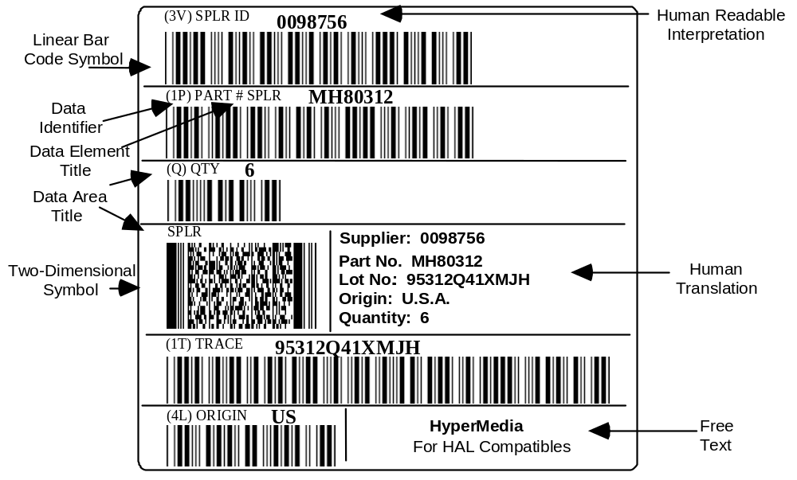
Figure 1a
Data Encoded with ANSI MH10.8.2 Data Identifiers (not to scale)

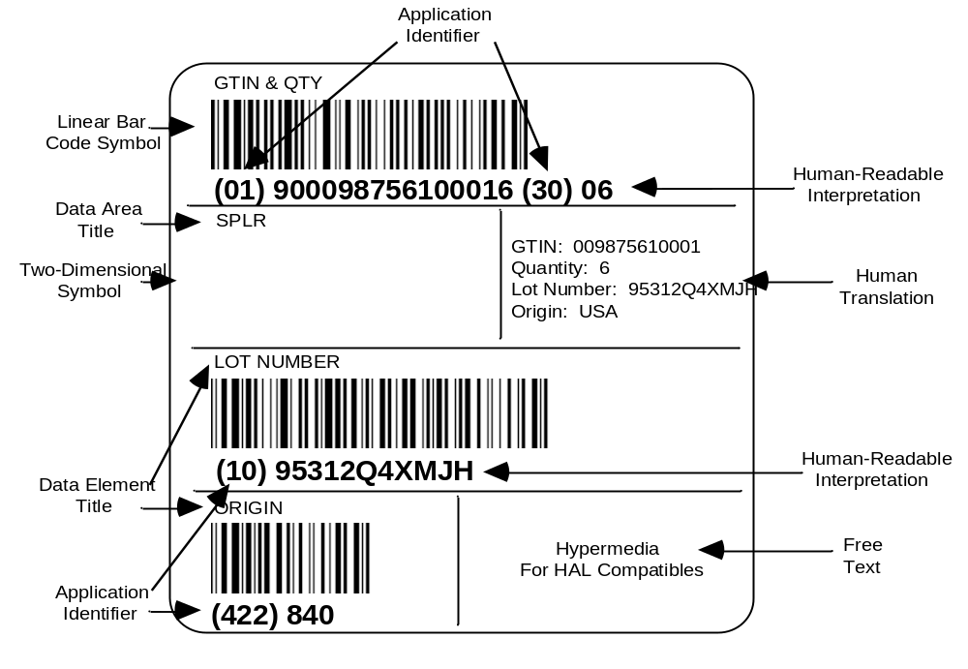

Figure 1b
Data encoded with EAN.UCC Application Identifiers (not to scale)

Label design

General considerations

Label segments are logical groupings of information based on the data needs of the trading partners within the distribution channel. Three segments are defined in clause 4.4.2: carrier segment, customer segment, and supplier segment. Label segments may or may not be printed at the same time on a single physical label. When the size and structure of the Transport Unit permits, segments shall be stacked vertically, from top to bottom, in the following order:

- carrier segment,
- customer segment,
- supplier segment.

Examples of labels are provided in Annexes E and F. The labels shown in Annexes E and F are for illustration only and do not represent all of the possible choices of label designs. Separate sections of the label may be applied at different stages to form the complete label.

Layout

The linear bar code representing the Unique Transport Unit Identifier (license plate), a mandatory element for this standard, shall be printed in the bottom-most area or building block of the label as described in Annex C.

Base Label layout

In addition to the required Ship From human readable information and Unique Transport Unit Identifier, a typical Base Label could include the following data areas:

- Ship To address, human readable;
- Ship To postal code or location number, linear bar code;
- carrier shipment tracking number (if required), linear bar code;
- customer purchase order number (if required), linear bar code.

The Ship To address shall be located below or to the right of the Ship From address. Ship From characters shall be noticeably smaller than the Ship To characters and the fields shall be easily distinguishable.

Extended Label layout

The Extended Label comprises more information than the Base Label. In addition to the information contained in the Base Label, the Extended Label may include:

- linear bar codes representing other discrete data elements;
- linear bar codes representing concatenated data elements;
- 2D symbols;
- human translation of linear bar code information;
- human readable only information;
- graphics.

Other data

This standard does not supersede or replace any applicable safety or regulatory marking or labeling requirements. The standard is to be applied in addition to any other mandated labeling requirements. Free areas or certain graphics such as safety, hazard, quality signs, or logos may be required.

Label dimensions

General considerations

The size of the label shall be consistent with the data requirements of all trading partners in the supply chain, with the only constraint being the size of the Transport Unit.

The label format described does not dictate a fixed size for the total label. To simplify label formatting, a modular building block structure is recommended. The building block structure guidance is described in Annex C and shown in Figure C-1. The physical dimensions of the label shall be determined by the labeler. Considerations for label size selection may include: the amount of data to be printed, the physical characteristics of the printing equipment used, or the size of the Transport Unit.

Label height

The height of the label shall be determined by the labeler based on the requirements and the type of printer used to print the label.

Label width

The width of the label shall be determined by the labeler based on the requirements and the type of printer used to print the label. Label width is determined by bar code symbology printing parameters and the maximum bar code message length. Table 2 shows the correlation between X dimension and label width for selected X dimensions, using the data limits set forth in Table 1.

Some existing industry standards have other data limits. If a trading partner needs a single Code 39 bar code data field that contains more characters than is shown in Table 1, the labeler may choose to use a wider label stock or an X dimension at the lower limits of this standard.

Data limits

Limits on the number of characters which can be required of the labeler for a single linear bar code symbol are shown in Table 1.

Table 1
Maximum character limits for linear symbols

Symbology and format | Character limits
Code 128 (numeric) | 50 digits (after a single character DI)
Code 128 (alphanumeric) | 27
UCC/EAN-128 (all numeric) | 48
UCC/EAN-128 (alphanumeric) | 26
Code 39 | 19
NOTE 1 For UCC/EAN-128, the character count includes all characters between the Function 1 (FNC1) character and the symbology check character.
NOTE 2 For Code 39, character count includes all characters between the start and stop characters.

Table 2
Minimum label width required to print the maximum character limits of Table 1

 | Symbol Maximum Characters and Width (from Table 1)
 | Code 39 | Code 128  all numeric | Code 128  alphanumeric | UCC/EAN-128  SSCC | UCC/EAN-128  all numeric | UCC/EAN-128  alphanumeric
 | 19 | 50  (single- character DI) | 27 | 20  exactly | 48 | 26
X dimension | Symbol Width
0.25 mm | 105 mm | 105 mm | 105 mm |  | 105 mm | 105 mm
0.33 mm | 148 mm | 148 mm | 148 mm | Not | 148 mm | 148 mm
0.38 mm | 148 mm | 148 mm | 148 mm | Recommended | 148 mm | 148 mm
0.43 mm | over 148 mm | 148 mm | over 148 mm |  | over 148 mm | over 148 mm
0.50 mm |  |  |  | 105 mm | over 148 mm | over 148 mm
0.66 mm |  | Not |  | 148 mm | over 148 mm | over 148 mm
0.76 mm |  | Recommended |  | 148 mm | over 148 mm | over 148 mm
0.81 mm |  |  |  | over 148 mm | over 148 mm | over 148 mm
NOTE 1 This table is intended to provide guidance to the printer/applier of a label on the size of label stock needed to accommodate the maximum character limits as stated in Table 1.
NOTE 2 This label width guidance is based on only two label sizes, 105 mm and 148 mm)
NOTE 3 Included in the minimum label width calculations in Table 2 are the following:
- symbology start and stop characters, 2.54 mm print registration, and quiet zones of 6.4 mm or 10 times the bar code symbol X dimension, whichever is greater;
- for UCC/EAN-128 symbols, function one character (FNC1) and symbology check character;
- for Code 39 symbols, a 3:1 wide to narrow ratio and one X intercharacter gap
- for Code 128 symbols, the symbology check character
NOTE 4 EAN.UCC SSCC bar code symbols have minimum X dimensions greater than 0.432 mm. In order to fit on a label size of 102 mm, this symbol should be printed at the smallest X dimension as specified in the General EAN.UCC Specifications for a UCC/EAN-128 symbol.

Text size

General considerations

The height of text characters is associated with the number of characters that can be required on a single line.

Nine sizes may be specified for text. The exact character heights corresponding to the nine text sizes shall be chosen by the labeler based on the capabilities of the printing process.

The characters shall be clearly legible.

Table 3 shows the maximum number of text characters per line that can be required of the labeler.

Table 3
Character height and character limits

Lines-per-block  (LPB) | Approximate character height (millimeters) | Character limits for full width 102 mm label  (# of characters)
1 LPB | 25.4 mm | 8
2 LPB | 12.7 mm | 18
3 LPB | 8.4 mm | 28
4 LPB | 6.4 mm | 34
5 LPB | 5.1 mm | 42
6 LPB | 4.3 mm | 48
7 LPB | 3.6 mm | 59
8 LPB | 3.2 mm | 68
10 LPB | 2.5 mm | 77
NOTE Calculations for the text character count limits are based on the following assumptions: a 102 mm wide label segment, clear distinction between the character sizes used, and fixed-width characters.
The character height includes ascenders, descenders, and leading.

Specific text dimensions

Data area titles shall be no smaller than 10 LPB.

The Ship From address shall be no smaller than 10 LPB, and in any case shall be smaller than the Ship To address text.

The Ship To address shall be not smaller then 6 LPB and in any case shall be larger than the Ship From address text.

The literal translation of the associated linear bar code symbol (also know as human-readable interpretation – HRI) shall be no smaller than 10 LPB.

Primary human-readable information (also know as human translation) shall be no smaller than
5 LPB.

Secondary human-readable information (also known as text or descriptive information) shall be no smaller than 10 LPB.

Material

Label material and the method of attaching the label to the Transport Unit shall be selected to ensure that the label:

- remains attached to the Transport Unit for the intended life of the label;
- remains readable for the life of the label;
- survives the environments for the life of the label, for example, contamination, heat, light, moisture;
- meets disposability requirements.

Label placement

General considerations

Labels should be affixed at a suitable location where there is a minimum risk of damage.

Labels containing carrier sortation and tracking application MaxiCode symbols shall be placed on top of Transport Units (see clause B.4.6.3 and clause ).

Parcel carriers may require the placement of carrier information on the top of a Transport Unit.

All other labels should be placed on the side of the Transport Unit with the human readable information parallel to the natural bottom of the Transport Unit.

Unitized Loads (pallets)

Each Unitized Load shall have at least one bar code label and should have identical labels affixed on two adjacent sides.
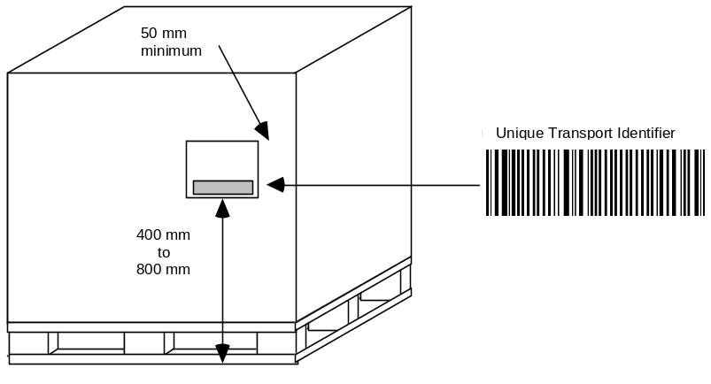
Figure 2
Unitized Load (pallet) label location

Labels shall be placed right of center on a vertical face, allowing a minimum of 50 mm from either edge. Labels should not be placed over a seam, nor should sealing tape or bands be placed over a label in a manner that interferes with the scanning of the label. The bottom edge of the Unique Transport Unit Identifier symbol should be within the range of 400 mm to 800 mm from the bottom of the pallet. If the pallet is less than 500 mm in height, the labels should be placed as high as possible on the pallet.

Transport Packages

For Transport Packages up to 1 meter in height, the target location for the Unique Transport Unit Identifier symbol should be within a range of 25 mm to 430 mm from the natural bottom of the package. Labels containing a MaxiCode symbol for carrier sortation and tracking applications shall be placed on top of the package in accordance with clause B.4.6.3. The edge of the label(s) should be a minimum of 25 mm from any Transport Package top or side edge. Transport Packages greater than 1 meter in height should follow the recommendations of 8.2.

Other Transport Units

Annex F provides examples of the labeling of various Transport Units. Label placement requirements should be developed in conjunction with specific application guidelines.

(normative)

Guidelines for using linear bar code symbols

Symbology
The linear bar code symbologies shall be one of the following:

- Code 39 in accordance with ISO/IEC 16388;
- Code 128 in accordance with ISO/IEC 15417.

NOTE: UCC/EAN-128 is a subset of Code 128.

Symbol height
The minimum bar height of a linear bar code symbol shall be 12.7 mm and should be at least 15% of the length of the symbol including quiet zones.

Narrow element dimension
The minimum narrow element dimension (X dimension) shall not be less than 0.25 mm. The X dimension for Code 39 and Code 128 symbols should be in the range of 0.25 mm to 0.43 mm, as determined by the printing capability of the supplier/printer of the label. The X dimension for UCC/EAN-128 symbols should be in the range of 0.25 mm to 0.81 mm, as determined by the printing capability of the supplier/printer of the label. The X dimension for UCC/EAN-128 SSCC symbols should be in the range of 0.50 mm to 0.81 mm, as determined by the printing capability of the supplier/printer of the label.

In the case that fewer characters than specified in Table 1 are required, a larger X dimension may be used, as long as the bar code print quality requirements specified in A.8 and label width recommendations of Table 2 are met.

NOTE: Symbols with the X dimension at the lower end of this range, specifically 0.25 mm to 0.33 mm, may require special care in order to meet the quality requirements.

Wide to narrow ratio for Code 39 symbols
The wide to narrow ratio of elements of Code 39 symbols should be 3.0:1. The measured ratio shall be between 2.4:1 and 3.2:1.

Quiet zones
Linear bar code symbols should be printed with leading and trailing quiet zones not less than 6.4 mm. Where the X dimension is greater than 0.64 mm, the quiet zones shall not be less than ten (10) times the X dimension. The label registration parameters of the printer being used should be taken into consideration in order to ensure the minimum quiet zones.

Orientation
Linear bar code symbols should be presented on Transport Units with the bars vertical (picket fence orientation) when marked on a flat or slightly curved surface. Subject to agreement between trading partners, bars may be presented horizontally (ladder orientation).

Linear bar code symbols should be presented on Transport Units with the bars perpendicular to the longitudinal axis (ladder orientation) when marked on a tightly curved surface (tubes, rods, cylinders).

Placement
Linear bar code symbols should be placed to ensure that they do not interfere with each other when scanned.

NOTE: No more than two linear symbols should appear side by side on a label. If two linear symbols are placed side by side, the symbols should be placed so that they will not be in the same horizontal scan path to reduce the possibility of interference with successful bar code scanning.

Linear bar code symbol print quality
The ISO/IEC 15416 standard shall be used to determine the print quality of the linear bar code. The grade is expressed in the form of: grade/aperture/wavelength. The minimum symbol grade shall be 1.5/10/660 which is:

- an overall symbol grade greater than or equal to 1.5 (C) at point of production;
- a measurement aperture equal to 0.250 mm diameter (reference number 10),
- a light source wavelength equal to 660 ±10 nanometers.

It is important that the linear bar code be decodable throughout the system of use. Numerous environmental effects can lead to the degrading of the bar code symbol, substrate, adhesive, or laminate. These changes may affect one or more quality parameters of the label, whether they are optical or physical. The net effect of such changes can be to render the label unusable. It is therefore important to consider these effects when producing and applying bar code labels.

Labelers should not be held responsible for damage to the label incurred by shipping or handling subsequent to leaving the supplier’s facilities. Every effort should be made by the labeler to reasonably protect and place the label so it is not damaged in shipment and handling.

It may not be possible to meet the print quality requirements of this standard when printing directly onto kraft colored corrugated surfaces. Users considering the printing of bar code symbols directly onto kraft colored corrugated surfaces should consider the scanning capabilities of their entire trading channel.

Unattended scanning may require a higher print quality grade than identified above. Consequently, those implementing this standard for unattended scanning applications should discuss print quality requirements with trading partners.

(normative)

Guidelines for using 2D symbols

This annex defines the rules for using 2D symbols. These rules apply to the following three applications:

- shipping and receiving (B.1),
- supporting documentation (B.2),
- carrier sortation and tracking (B.4).

Shipping and receiving applications
The shipping and receiving data facilitates staging, transportation, and receipt of goods and materials. This data shall be printed on the label as defined by this document. This symbol is intended to be scanned in the same environment as other symbols on the label. The structure and syntax of the PDF417 symbols for shipping and receiving applications shall conform to the structure and syntax described in ANS MH10.8.3 (ISO/IEC 15434). The structure and syntax of the EAN.UCC Composite shall conform to the General EAN.UCC Specifications.

Symbology recommendation

This standard recommends the use of the PDF417 symbology (see ISO/IEC 15438) for shipping and receiving applications. For trading partners that support the EAN.UCC system, the EAN.UCC Composite symbology (see ISO/IEC 24723) may be used.

For the shipping and receiving applications, the Macro PDF417 symbol which is defined in the ISO/IEC 15438, shall not be used.

For the shipping and receiving applications, the Micro PDF417 symbol, which is defined in ISO/IEC 24728, shall not be used.

Error correction level

For shipping and receiving applications, the minimum PDF417 symbol error correction level shall be level 5. For EAN.UCC Composite symbols, the error correction level shall be level 5.

Narrow element dimension

For shipping and receiving applications, the narrow element dimension (X dimension) range should be from 0.254 mm to 0.432 mm, as determined by the printing capability of the supplier/printer of the label. Symbols with narrow elements at the lower end of this range, i.e., 0.254 mm to 0.330 mm, may require special care to meet the print quality requirements of B.1.7. Conformance to the print quality requirements shall be determined according to B.1.7.

Row height

The PDF417 symbol shall have a minimum row height (height of the symbol element) of three (3) times the width of the narrow element (X dimension). Increasing the row height may improve scanning performance but will reduce the number of characters that can be encoded in a given space.

Quiet zone

For shipping and receiving applications, the PDF417 symbol shall have a minimum quiet zone of 1 mm above, below, to the left, and to the right. The quiet zone is included within the calculation of the size of the symbol.

Symbol size

For shipping and receiving applications, PDF417 symbols shall not exceed a height of 61 mm.

Tables B-2 through B-8 are provided as guidance in planning for the incorporation of PDF417 symbols into the design of the labels described in this standard. Actual achieved size of a PDF417 symbol may vary, based on data content and printing process. The sizes listed should accommodate most situations.

A PDF417 symbol for shipping and receiving applications should be printed with no more than 12 data columns in width (see Figure B-2). This will assure readability by the broadest range of reading devices. In no case shall the number of data columns exceed 18 columns. The use of 13 to 18 columns is allowed with the agreement of trading partners. Table B-1 shows the width of PDF417 symbols (including quiet zones) with 12 data columns at different X dimensions. For further information on data columns, symbol widths, character counts, and print densities, see clause B.3 and its sub-clauses.

Table B-1
Maximum PDF417 symbol width using 12 data columns

X dimension | Maximum width  (including quiet zones)
0.25 mm | 71.37 mm
0.33 mm | 92.20 mm
0.38 mm | 106.17 mm
0.43 mm | 119.89 mm

Print quality

The ISO/IEC 15438 standard shall be used with reference to ISO/IEC 15415 to determine the print quality of the PDF417 and EAN.UCC Composite symbologies. The grade is expressed in the form of: grade/aperture/wavelength. For shipping and receiving applications, the minimum symbol grade should be 2.5/10/660 which is:

- an overall symbol grade greater than or equal to 2.5 (B) at point of production;
- a measurement aperture equal to 0.250 mm diameter (reference number 10),
- a light source wavelength equal to 660 ±10 nanometers.

The above symbol quality and measurement parameters assure scannability over a broad range of scanning environments. The print quality requirement at the point of production should be higher than the requirement at the point of use.

It may not be possible to meet the print quality requirements of this standard when printing directly onto kraft colored corrugated surfaces. Users considering the printing of 2D symbols directly onto kraft colored corrugated surfaces should consider the scanning capabilities of their entire trading channel.

Orientation and placement

PDF417 and UCC.EAN Composite symbol orientation

The bars of the symbol shall be perpendicular to the natural bottom of the label (see Figure B-1).

Label placement

Labels shall be placed on packages as specified in clause 8.

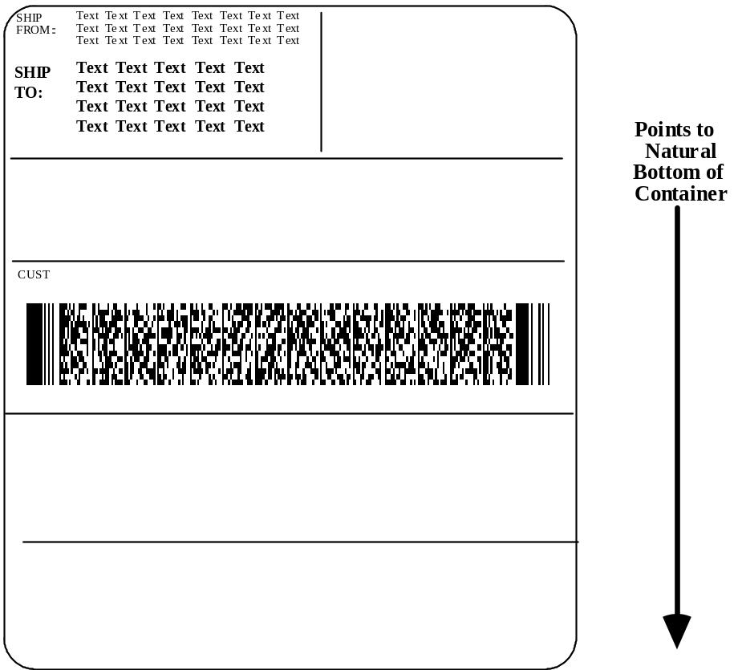

Figure B-1
PDF417 symbol orientation on label (not to scale)

Supporting documentation applications
The shipping, transportation, and receiving of Transport Units often requires supporting documentation data such as a bill of lading, manifest, packing slip, customs data, or information that might also be transmitted by EDI. This data is not intended to be printed on a label. This data is not intended to be scanned in the same environment as data on a label. The application considered in this category involves the encodation of data in 2D symbols in support of the shipping, receiving, and transportation sortation and tracking. See Figure E-33.

Symbology recommendation

This standard recommends the use of PDF417 symbology (see ISO/IEC 15438) for supporting documentation applications. The structure and syntax of the PDF417 symbols for supporting documentation applications shall conform to the structure and syntax described in ANS MH10.8.3 (ISO/IEC 15434).

For supporting documentation applications, a Macro PDF417 symbol, which is defined in ISO/IEC 15438, may be used.

For supporting documentation applications, a MicroPDF417 symbol, which is defined in ISO/IEC 24728, shall not be used.

Error correction levels

For supporting documentation applications, the minimum PDF417 symbol error correction level shall be as identified in Table B-2. Level 5 is the preferred correction level.

Table B-2
PDF417 Error Correction Level

Number of Data Characters | PDF417 Error Correction Level
under 100 | 3
100 to 399 | 4
400 or more | 5

Narrow element dimension

For supporting documentation applications, the PDF417 symbol X dimension should be 0.254 mm.

Row height

For supporting documentation applications, the PDF417 symbol should have a row height (height of the symbol element) three (3) times the width of the narrow element (X dimension).

Quiet zones

For supporting documentation applications, the PDF417 symbol shall have a minimum quiet zone of 1 mm above, below, to the left, and to the right.

Print quality

The ISO/IEC 15438 standard shall be used with reference to ISO/IEC 15416 to determine the print quality of the PDF417 symbol. The grade is expressed in the form of: grade/aperture/wavelength. For supporting documentation applications, the minimum symbol grade shall be 2.5/06/660 which is:

- an overall symbol grade greater than or equal to 2.5 (B) at point of production;
- a measurement aperture equal to 0.150 mm diameter (reference number 06),
- a light source wavelength equal to 660 ±10 nanometers.

In those applications where an aperture size of 0.125 mm (reference number 05) is being used to verify other symbols, the 0.125 mm aperture may be used for PDF417 symbols.

Orientation and placement

Orientation

All PDF417 symbols shall have the same orientation. The bars of the PDF417 symbol shall be oriented such that they are perpendicular to the natural bottom of the page. For supporting documentation applications, symbol skew shall not be more than ±5 degrees.

Placement

All PDF417 symbols for supporting documentation applications shall be placed so that they are clear of any folds or creases in the document itself.

NOTE As the document is likely to be folded after printing, tests should be carried out to select appropriate symbol locations.

Concatenation of symbols

For supporting documentation applications, the Macro PDF417 symbol version of the PDF417 symbology, as defined in the ISO/IEC 15438, shall be used to encode data messages that are greater in length than the maximum amount of data that can be encoded in a single PDF417 symbol. Application programmers should become familiar with the technical specifications for Macro PDF417 symbology to understand how the concatenated data will be transmitted to the application software.

Planning for large messages

When designing an application that will encode large amounts of data, consideration must be given to the amount of data to be encoded in a single message. If it is anticipated that a single data message, including formatting characters, could exceed approximately 1,200 alphanumeric characters, planning must be done to assure that all the concatenated symbols that constitute the entire Macro PDF417 symbol message be read in a single scanning sequence. Scanning an intervening symbol, either linear or 2D, will break the scanning sequence and may give unpredictable results.

Printing concatenated symbols

Printing systems should be configured in such a manner that when the amount of data encoded in a single message for a supporting documentation application exceeds the capacity of a single symbol, the printing system should either automatically use or be configurable to use Macro PDF417 symbology. The Macro PDF417 symbol Control Block should include the optional Segment Count field in addition to the mandatory fields to enable the Macro PDF417 symbols to be scanned in either a buffered or unbuffered mode.

Reading Macro PDF417 symbols

To read Macro PDF417 symbols properly, the transmission protocol of the decoder shall comply with Macro PDF417 symbology as defined in Annex H of ISO/IEC 15438. The symbols may be transmitted in buffered or unbuffered mode.

The decoder shall be capable of fully supporting the Symbology Identifier options for a PDF417 symbol. The decoder will transmit the Symbology Identifier, "]L1". This header signifies that escape and sequence characters have been inserted into the message by the reader, and must be handled by the application program. The application program must then recognize the Symbology Identifier, interpret escape characters, and reassemble the original message. The exact content of the escape and sequence characters, their usage, and the structure of a Macro PDF417 symbol is defined in ISO/IEC 15438.

Printing PDF417 and EAN.UCC Composite CC-C (PDF417) symbols
When printing PDF417 symbols compliant with this American National Standard, several factors must be considered. All of these factors must be used to determine what PDF417 symbol options to use. These considerations include:

- data requirements,
- scanner technologies,
- label area requirements,
- printer technologies.

Developers and users of PDF417 symbol printing software should follow these guidelines when determining what PDF417 symbol options should be used. Since no one solution is optimal, tradeoffs must sometimes be made. These guidelines will assure that valid symbols are printed. In addition, they will assure that a user's scanning and printing requirements have been considered. The following considerations should be used with following Tables B-3 through B-8 to determine approximate symbol size.

Plan for the maximum amount of data

Determine the fields that will be required in the message and the maximum anticipated length of each field. Add the additional characters needed for formatting.

Plan for scanning equipment likely to be used

When choosing a space in which to encode a PDF417 symbol, it is important to consider the capabilities of the scanning equipment likely to be used. For example, if the equipment has a maximum field of view of 76 mm, it would be impossible to read a symbol that is 100 mm wide, but the same data could fit in a taller configuration that is only 66 mm wide.

Plan for the maximum X dimension(s) and data columns

When planning for the space required in which a PDF417 symbol will be placed on the label, the designer should plan for the largest X dimension and the number of data columns that might be used in printing. These two factors essentially determine the width of the symbol.

Since the supplier/printer of the label ultimately determines the X dimension at which the symbol will be printed, it is possible that a PDF417 symbol printed for a shipping and receiving application could be printed at any X dimension from 0.254 mm to 0.432 mm. The capability of the printing equipment being used will determine the possible choices of X dimension.

This standard recommends that PDF417 symbols for shipping and receiving applications be printed with no more than 12 data columns (see Figure B-2), unless otherwise agreed by all trading partners involved. This limitation, combined with the amount of space allocated for the symbol on the label, may influence the choice of X dimension for printing the symbol.

The encoded data is shown below contained within the data columns.
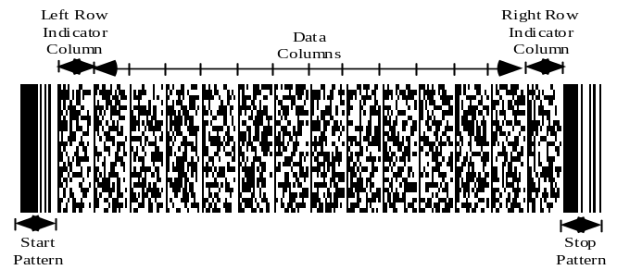
Figure B-2
The anatomy of a PDF417 symbol

Determine the appropriate label size

Tables B-3 through B-8 show the approximate number of characters that can be accommodated by a PDF417 symbol. Within each table, use the height and approximate width combinations to determine the actual width, number of data columns, and the estimated number of characters that can be accommodated. The sizes are an approximation; actual sizes may vary based on factors including the compaction algorithm and the nature of the data to be encoded. Error correction levels are defined as Error Correction Level 5. For all tables, the approximate width in the top row of each table includes symbol quiet zones.

Symbols for labels having a width of at least 102 mm.

Tables B-3 through B-6 illustrate at given X dimensions, at various symbol widths, the number of data columns and the number of alphanumeric characters which can be encoded in PDF417 symbols where the symbols are assumed to be either 25 mm or 50 mm high.

Table B-3
PDF417 symbols
X dimension = 0.25 mm
Approximate alphanumeric capacity

 | Width 39 mm |  | Width 52 mm |  | Width 65 mm |  | Width 78 mm |  | Width 96 mm
 | Actual  mm | Data  columns | Actual  mm | Data  columns | Actual  mm | Data  columns | Actual  mm | Data  columns | Actual  mm | Data  columns
Symbol height | 36.8 | 4 | 49.8 | 7 | 62.7 | 10 | 75.7 | 13 | 93.0 | 17
25 mm | 56 characters |  | 185 characters |  | 315 characters |  | 445 characters |  | 617 characters
50 mm | 293 characters |  | 601 characters |  | 909 characters |  | 1217 characters |  | 1535 characters

Table B-4
PDF417 symbols
X dimension = 0.33 mm
Approximate alphanumeric capacity

 | Width 39 mm |  | Width 52 mm |  | Width 65 mm |  | Width 78 mm |  | Width 96 mm
 | Actual  mm | Data  columns | Actual  mm | Data  columns | Actual  mm | Data  columns | Actual  mm | Data  columns | Actual  mm | Data  columns
Symbol height | 36.1 | 2 | 47.2 | 4 | 55.8 | 6 | 75.4 | 9 | 92.2 | 12
25 mm | N/A |  | 13 characters |  | 77 characters |  | 175 characters |  | 272 characters
50 mm | 41 characters |  | 200 characters |  | 358 characters |  | 596 characters |  | 833 characters
NOTE N/A means not applicable. Where N/A appears, this means that for the associated label width and error correction level 5, no data can be encoded.

Table B-5
PDF417 symbols
X dimension = 0.38 mm
Approximate alphanumeric capacity

 | Width 39 mm |  | Width 52 mm |  | Width 65 mm |  | Width 78 mm |  | Width 96 mm
 | Actual  mm | Data  columns | Actual  mm | Data  columns | Actual  mm | Data  columns | Actual  mm | Data  columns | Actual  mm | Data  columns
Symbol height | 34.8 | 1 | 47.8 | 3 | 60.7 | 5 | 73.7 | 7 | 93.2 | 10
25 mm | N/A |  | N/A |  | 27 characters |  | 85 characters |  | 171 characters
50 mm | N/A |  | 88 characters |  | 225 characters |  | 362 characters |  | 567 characters
NOTE N/A means not applicable. Where N/A appears, this means that for the associated label width and error correction level 5, no data can be encoded.

Table B-6
PDF417 symbols
X dimension = 0.43 mm
Approximate alphanumeric capacity

 | Width 39 mm |  | Width 52 mm |  | Width 65 mm |  | Width 78 mm |  | Width 96 mm
 | Actual  mm | Data  columns | Actual  mm | Data  columns | Actual  mm | Data  columns | Actual  mm | Data  columns | Actual  mm | Data  columns
Symbol height | 31.8 | 0 | 46.5 | 2 | 61.2 | 4 | 75.9 | 6 | 90.7 | 8
25 mm | N/A |  | N/A |  | N/A |  | 34 characters |  | 85 characters
50 mm | N/A |  | N/A |  | 121 characters |  | 239 characters |  | 358 characters
NOTE N/A means not applicable. Where N/A appears, this means that for the associated label width and error correction level 5, no data can be encoded.

Symbols for labels having a width of greater than 102 mm.

Tables B-7 and B-8 illustrate at given X dimensions, at various symbol widths, the number of data columns and the number of alphanumeric characters which can be encoded in PDF417 symbols where the symbols are assumed to be either 25 mm or 50 mm high.

Table B-7
PDF417 symbols
X dimension = 0.38 mm
Approximate alphanumeric capacity

 | Width 122 mm |  | Width 137 mm |  | Width 147 mm
 | Actual  mm | Data  columns | Actual  mm | Data  columns | Actual  mm | Data  columns
Symbol height | 119 | 14 | 132 | 16 | 145 | 18
25 mm | 286 characters |  | 344 characters |  | 401 characters
50 mm | 841 characters |  | 891 characters |  | 920 characters

Table B-8
PDF417 symbols
X dimension = 0.43 mm
Approximate alphanumeric capacity

 | Width 122 mm |  | Width 137 mm |  | Width 147 mm |  | Width 159 mm
 | Actual  mm | Data  columns | Actual  mm | Data  columns | Actual  mm | Data  columns | Actual  mm | Data  columns
Symbol height | 120 | 12 | 135 | 14 | 142 | 15 | 157 | 17
25 mm | 185 characters |  | 236 characters |  | 261 characters |  | 311 characters
50 mm | 596 characters |  | 715 characters |  | 747 characters |  | 770 characters

Carrier sortation and tracking applications
Carrier sortation is the process in which Transport Units are routed between two or more points. Carrier tracking is the process by which the location of Transport Units being transported by a carrier is updated in the carrier's database.

Data to be included comprises that which is required to route Transport Units between multiple points, locate Transport Units, and other supporting data which is relevant to sortation and/or tracking for internal and external processing.

When a 2D symbol is used for carrier sortation and tracking applications, the MaxiCode symbology (see ISO/IEC 16023) is capable of being read in a high speed scanning environment. The structure and syntax of the MaxiCode symbols for carrier sortation and tracking applications shall conform to the structure and syntax described in ANS MH10.8.3 (ISO/IEC 15434).

Data encoding

Code set

When encoding information in the MaxiCode symbol, it is recommended that character selection be limited to Code Set A where possible (see ISO/IEC 16023).

Mode

The MaxiCode symbol incorporates one Mode per symbol. This standard recommends the use of MaxiCode Mode 2 or Mode 3 to ensure the sortation system can decode the Ship To Postal Code, Ship To Country Code, and Class of Service in the event of symbol damage (see ISO/IEC 16023).

The determination of which Mode to use is established by the data characteristics of the Ship To Postal Code and Class of Service. Table B-9 determines the appropriate Mode.

Table B-9
Determining which MaxiCode Mode to use

If the Ship To Postal Code is | and the Class of Service is | then use
numeric-only  maximum of 9 digits | numeric-only | Mode 2
alphanumeric  maximum of 6 characters | numeric-only | Mode 3
other than above | numeric-only | Mode 4
any of the above | alphanumeric | Mode 4

Error correction levels

The MaxiCode symbol has fixed levels of error correction. The MaxiCode symbol should use the Standard error correction level identified within ISO/IEC 16023.

Narrow element dimension

MaxiCode is not a scalable symbol (supporting different X dimensions). The MaxiCode symbol shall have an X dimension (the width of a symbol module) and all other dimensions consistent with ISO/IEC 16023. Each symbol, including the quiet zone, is of a fixed physical size, nominally 28.14mm wide x 26.91mm high.

Quiet zones

For carrier sortation and tracking applications, the MaxiCode symbol shall have a minimum quiet zone of 1 mm above, below, to the left, and to the right.

MaxiCode symbol print quality

ISO/IEC 15415 shall be used to determine the print quality of the MaxiCode symbol. For carrier sortation and tracking applications, the minimum symbol grade shall be 2.5/10/W is:

- an overall symbol grade greater than or equal to 2.5 (B) at point of production;
- a measurement aperture equal to 0.250 mm diameter (reference number 10),
- a broad band light source.

The above symbol quality and measurement parameters assure scannability over a broad range of scanning environments. Labelers may not be able to guarantee the print quality of a label when it is received by the customer. Therefore, the print quality requirement at the point of production should be higher than the requirement at the point of use.

It may not be possible to meet the print quality requirements of this standard when printing directly onto kraft colored corrugated surfaces. Users considering the printing of bar code symbols directly onto kraft colored corrugated surfaces should consider the scanning capabilities of their entire trading channel.

Orientation and placement

MaxiCode symbol orientation

Due to the nature of the MaxiCode symbology, specific symbol orientation is not required.

Symbol placement

If the symbol is included in the Extended Label described in this standard, the MaxiCode symbol shall be placed in the carrier segment. See Figure B-3 for example of placement.

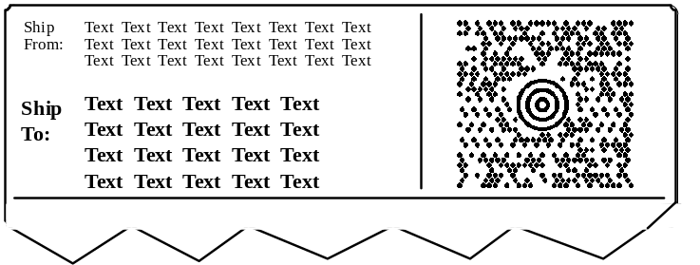
Figure B-3
MaxiCode symbol placement on a label (not to scale)

Label placement

Labels shall be placed on the top of Transport Units.

Concatenation

If the data message is greater in length than the maximum amount of data that can be encoded in a single MaxiCode symbol, two Structured Append symbols shall be used as follows. As this standard recommends the use of Modes 2 and 3, Structured Append shall be as defined in ISO/IEC 16023, and particularly:

- the primary message shall be repeated in both symbols;
- the Structured Append indicator sequence shall be placed in the first two data symbol characters in the secondary message;
- the continuation of the data message shall be in the secondary message of the second symbol.

Printing Structured Append MaxiCode symbols

Printing systems should be configured in such a manner that when the amount of data to be encoded in a single message for a carrier sortation and tracking application exceeds the capacity of a single symbol, the printing system will automatically use the Structure Append sequence.

The symbols shall be printed side by side.

Reading Structured Append MaxiCode symbols

When Structured Append is used with Modes 2 and 3 symbols, the primary message may be decoded from any of the symbols in the Structured Append sequence.

The entire message shall be reconstructed as defined in normative Annex B of ISO/IEC 16023.

(informative)

Designing compliant labels using a building block approach

Label definition
The general term “label” means the printed area on the package that includes the text and/or bar code data (including linear bar code, composite, or 2D symbols), as covered in this document. The label is constructed by the use of indirect marking (e.g., pressure-sensitive labels, tags). Separate sections of the label may be applied at different stages to form the complete label.

Direct marking (e.g. inkjet, letterpress, and flexographic directly onto the package) may also be used, if it meets the quality requirements in Annexes A and B,. The label layout and principles still apply.

Building blocks
To simplify label formatting, a modular building block structure is described. The building block is the basic standard unit of the label format. An individual building block or sub-block may contain one of the following:

- text or graphics,
- bar code symbol (2D symbol, composite, or linear bar code symbol with human readable interpretation),
- 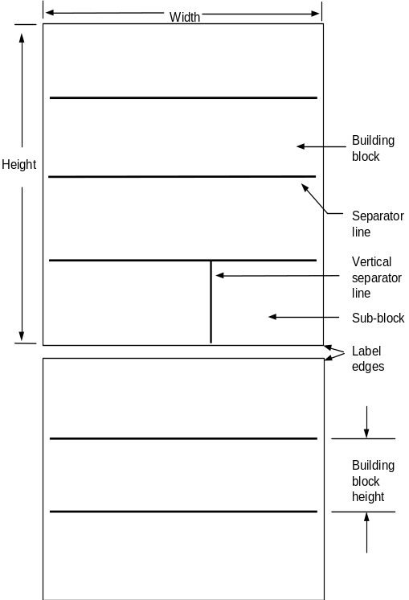a blank.

Figure C-1. Modular label structure
Each building block may be physically produced separately or in combination with other building blocks. This provides the option of printing data as it becomes known. Generally, building blocks should be stacked vertically.

Text lines-per-block
The height of text characters is defined using a unit of measure called lines-per-block (LPB), rather than inches, millimeters, or points. This enables the printer of the label to determine the actual height and font of text for a given LPB requirement. See clause C.6.2.

Segments
Segments are logical groupings of information based on the data needs of the trading partners within the distribution channel. Three segments are defined below: carrier segment, customer segment, and supplier segment.

When the size and structure of the package permits, segments shall be stacked vertically, from top to bottom, in the following order:

- carrier segment,
- consignee segment,
- shipper segment.

When stacked vertically, information required by carriers shall be placed top-most on the label.

Label dimensions
The size of the label should be consistent with the data requirements of all trading partners in the supply chain, with the only constraint being the size of the Unit Load or Transport Package.

The label format described does not dictate a fixed size for the total label. The physical dimensions of the label shall be determined by the labeler. Considerations for label size selection may include: the amount of data to be printed, the physical characteristics of the printing equipment used, or the size of the Transport Units.

The full label height will be determined by the number of building blocks included on the label.

The width of the label shall be determined by the labeler.

Label format
This section defines a standardized format for shipping labels.

Building blocks

Building blocks are stacked vertically to construct the label. Building blocks should be separated from each other by a horizontal line.

Building block size

Building block height shall be 25 mm ± 5 mm, as determined by the printing capability of the labeler. The width of a building block is the width of the label.

One double-height bar code block per segment may be used to satisfy special scanning requirements (e.g., automated conveyor scanning, long range planning). Double-height building blocks shall be 51 mm ± 10.2 mm.

One half-height text building block per segment may be used at the discretion of the labeler. Half-height building blocks shall be 13 mm ± 2 mm.

Sub-blocks

Building blocks can be divided into no more than four sub-blocks. The minimum width of a sub-block shall be determined by the amount of data that will be printed in that sub-block. A sub-block shall be the full height of the building block. Vertical lines should be used between sub-blocks.

Text block

A text building block or sub-block may contain text or graphics or both. A text building block or sub-block shall not contain a bar code symbol.

Table C-1
Lines-per-block (LPB) alternatives and measurements calculated

Lines-per-block | Character Height  (Points) | Character Height (Millimeters) | Character Height  (Inches)
1 LPB | 72 pts | 25.4 mm | 1.00 in
2 LPB | 36 pts | 12.7 mm | 0.50 in
3 LPB | 24 pts | 8.4 mm | 0.33 in
4 LPB | 18 pts | 6.4 mm | 0.25 in
5 LPB | 14 pts | 5.1 mm | 0.20 in
6 LPB | 12 pts | 4.3 mm | 0.17 in
7 LPB | 10 pts | 3.6 mm | 0.14 in
8 LPB | 8 pts | 3.2 mm | 0.13 in
10 LPB | 7 pts | 2.5 mm | 0.10 in
NOTE The character height includes ascenders, descenders, and leading.

Nine LPB sizes may be specified for text, ranging from one to eight and ten LPB. The exact character heights corresponding to the nine LPB sizes shall be chosen by the labeler based on the capabilities of the printing process.

Labelers shall choose a single height for each of the nine LPB sizes so that clear distinctions shall be evident between character heights (i.e., 8 LPB text shall be smaller than 7 LPB text, etc.). Table C-1 provides dimensional considerations for 1, 2, 3, 4, 5, 6, 7, 8, and 10 LPB printing.

The characters shall be clearly legible. For maximum legibility, the ratio of the height to width of a character should not exceed 2:1 (measured on an "M" character).

Character heights for double-height and half-height building blocks shall be the same as specified for a single-height block.

Text building block and sub-block title line(s)

A title should be used. When a title is used, it should be printed in the upper left corner of the text building block or sub-block. The title should be printed in upper case characters at a height of 6 LPB, two lines maximum, left justified.

Bar code symbol block

A bar code symbol may be specified for either a building block or sub-block.

A title should be used for a bar code symbol building block. Title exceptions are in clause 6.3.3. When a title is used, it should be printed in the upper left corner of the bar code symbol building block or sub-block. In the case when two linear symbols appear in the same building block, the right-hand symbol may have the title printed in the lower left corner of the machine readable building block or sub-block. The title should be printed in upper case characters at a height of 6 LPB, two lines maximum, left justified. The title should consist of a description of the data type. The title should also identify the respective ANSI MH10.8.2 Data Identifier or EAN.UCC Application Identifier if not part of the printed human readable interpretation of the bar code symbol.

(informative)

Issues to consider in the drafting of application guidelines
or standards conforming to this American National Standard

This standard is a framework to which various industry application standards for a bar code shipping and receiving label should conform. The American National Standard defines the minimum and common elements and specifies the symbology options. The application guideline should, within the overall constraint of complying with this American National Standard, be more specific. This annex describes the features which need to be defined in the application guideline.

The domain
Define the domain of the application guideline or standard in terms of:

- the responsible agent (typically, a trade association, federation, or similar body) publishing and maintaining the application guideline,
- the industry sector,
- the geographic domain,
- classes of trading partners covered by the application guideline.

Data presentation
Define which method(s) of data presentation (see clauses 5.1.1 and 5.1.2) is (are) to be used:

- linear Code 39 and Code 128 bar codes,
- 2D PDF417, UCC.EAN Composite, or MaxiCode symbols.

The label
The document should make it clear whether the Base Label and/or Extended Label (see clause 4.4) are acceptable to trading partners.

Data elements
Specify the set of data elements together with a definition of whether they are required or optional:

- The required data element of the Unique Transport Unit Identifier (see clauses 5.2.1 and D.5) shall be fully defined as per ISO/IEC 15459-1.
- If EAN.UCC Application Identifiers are used, then those suppliers shall comply with the rules ofthe General EAN.UCC Specifications.
- If ANSI MH10.8.2 Data Identifiers are used, then those labelers shall comply with the rules for ISO/IEC 15459-1.
- The information needs of the carrier shall be considered, particularly for the key to carrier information (see clause 5.2.4).
- The information needs of the customer shall be considered, particularly for the key to customer information (see clause 5.2.5).
- Other data shall be considered by mutual agreement between the supplier, carrier, and customer (see clause 5.2.6).

The Unique Transport Unit Identifier
When the Unique Transport Unit Identifier is encoded with the ANSI MH10.8.2 Data Identifiers:

- A single international Registration Authority is designated in accordance with ISO/IEC 15459-2.
- The Registration Authority assigns a unique Issuing Agency (IAC) code.
- The Issuing Agency then controls and assigns identifiers to individual organizations or persons, ensuring that those identifiers are unique within the system of the Issuing Agency.
- The organizations or persons then use the IAC and their own Issuing Agency assigned identifier to create a license plate number for the Transport Unit, using the ANSI MH10.8.2 Data Identifier "J". The data following the "J" identifier starts with the Issuing Agency Code (IAC), and then conforms to a format specified by the Issuing Agency; this will ensure that the data will be unique in a sense that no issuer re-issues a number until a sufficient period of time has passed so that the first number has ceased to be of significance to any user of data.

2D symbol
If 2D symbol(s) are incorporated, specify the selected ANS MH10.8.3 (ISO/IEC 15434) formatsThe precise rules of normative Annex B need to be incorporated.

Linear bar code
Specify which linear symbology shall be used (see clause 6.1). If migrating from Code 39, see Annex G.

The X dimension
Specify the narrow element X dimension (see clauses A.3 and B.1.3). Ideally, this should offer the full range of 0.25 mm to 0.43 mm in accordance with this American National Standard. However, there can be industry-specific reasons for being more restrictive within this range.

Symbol quality
Specify the symbol quality (see clauses A.8, B.1.7, B.2.6, and B.4.5). Ideally, this should be identical to that of this American National Standard. However, there can be industry-specific requirements which call for a higher print quality. In drafting the application guideline, consideration needs to be given to the cross-over effect both for:

- labels from suppliers covered by the application guideline going to customers outside the domain of the industry,
- labels coming from suppliers outside the domain of the industry.

In both these cases, the expectation of trading partners will be to conform to the print quality as specified in the American National Standard.

Label design
Specify, in as much detail as is appropriate for the application, the label design (see clause 7) taking into consideration the size of label (see clause 7.3) and any special label materials (see clause 7.5).

Label placement
Specify the label placement appropriate for the application (see clause 8).

(informative)

Label examples

Base Label examples

Minimum data examples

At a minimum, one of the two following formats shown in Figures E-1 or E-2 is required. Exceptions are described in the note at clause 5.2.1.
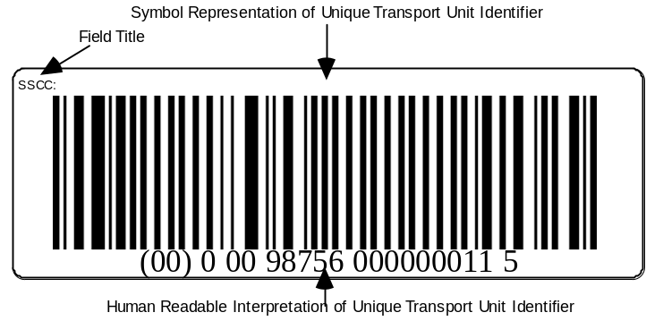

Figure E-1
Base Label using UCC/EAN-128 license plate (not to scale)

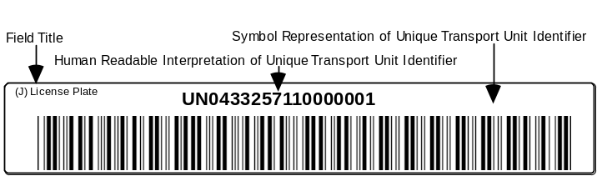

Figure E-2
Base Label using "J" ANSI MH10.8.2 Data Identifier license plate (not to scale)

Bar code symbols as pointers to a trading partner's databases

When, with mutual agreement of the trading partner, pointers to the carrier's or customer's databases are needed, the formats shown in either Figure E-3 or Figure E-4 are recommended.

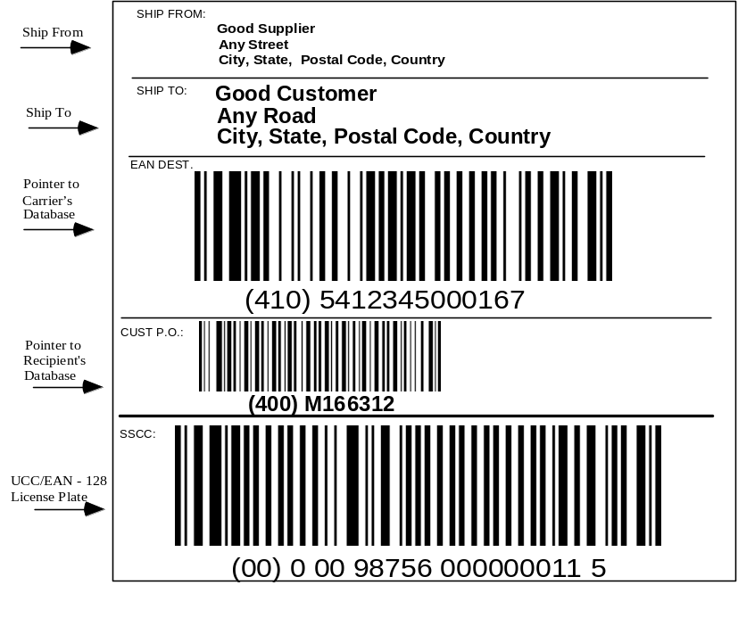
Figure E-3
Label using UCC/EAN-128 license plate
with pointers to carrier's and customer's databases (not to scale)

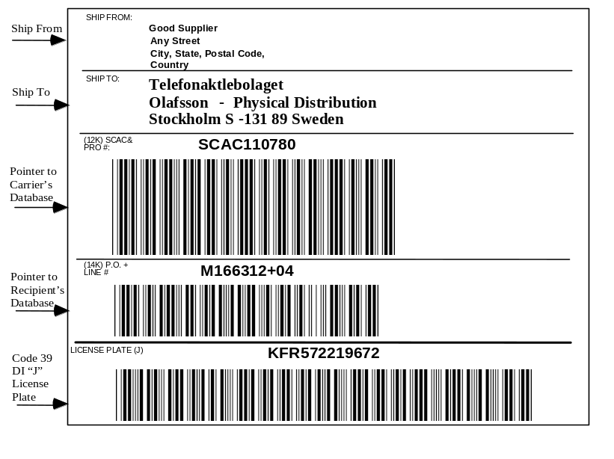
Figure E-4
Label using "J" ANSI MH10.8.2 Data Identifier license plate
with pointers to carrier's and customer's databases (not to scale)

Extended Label Examples

Bar code symbols as pointers to trading partner's databases

When, with the mutual agreement of the trading partners, pointers to the carrier's or customer's databases and additional information are needed, the formats shown in either Figure E-5 or Figure E-6 are recommended.

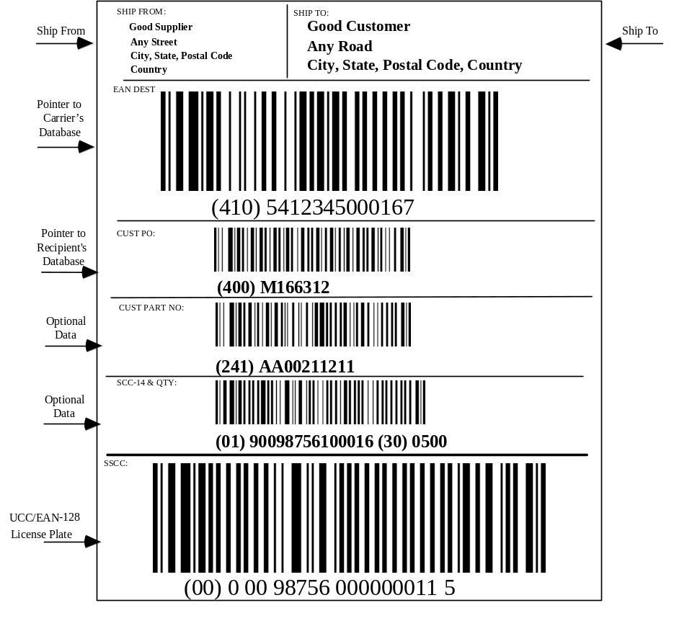
Figure E-5
Label using UCC/EAN-128 license plate with
pointers to carrier's and customer's databases (not to scale)

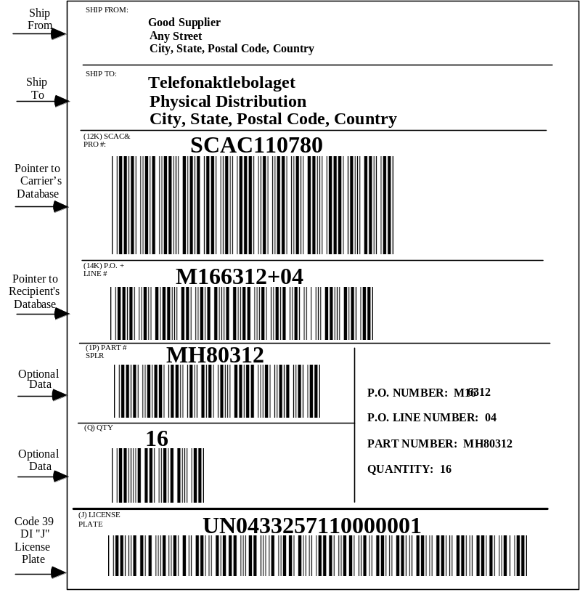

Figure E-6
Label using "J" ANSI MH10.8.2 Data Identifier license plate
with pointers to carrier's and customer's databases (not to scale)

Using license plate and 2D symbols for trading partner data

When, with mutual agreement of the trading partner, data in 2D symbols are needed, the formats shown in Figure E-7, Figure E-8, Figure E-9, or Figure E-10 are recommended. The 2D symbol examples in Figure E-7, Figure E-8, and Figure E-9 are encoded in accordance with ANSI MH10.8.2 data formats identified as Format 01 through Format 06. The 2D EAN.UCC Composite symbol example in Figure E-10 is encoded directly with EAN.UCC Application Identifier element string data according to the General EAN.UCC Specifications.

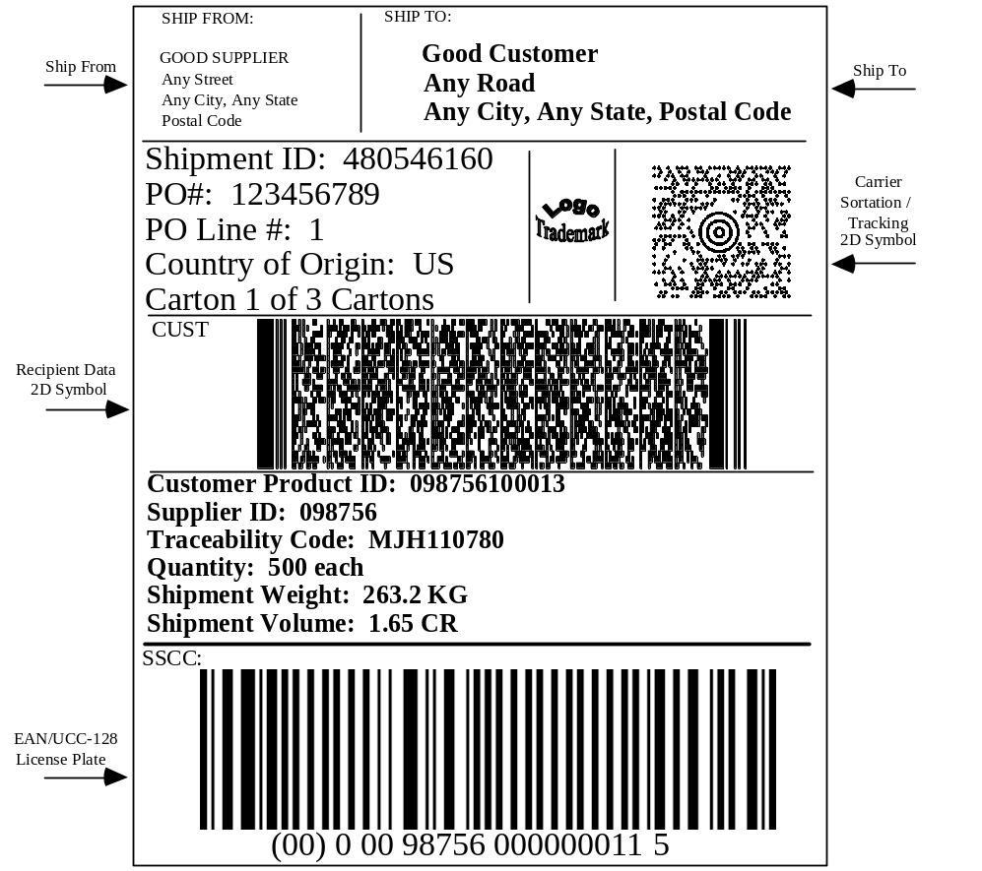

Figure E-7
Label using UCC/EAN-128 license plate and
additional trading partner data in 2D symbols (not to scale)
The data encoded in the MaxiCode symbol in Figure E-7 is as follows:

Compliance Indicator [)>RS
Format 01 Sortation/Tracking Header 01GS96
Carrier Data 352440000GS840GS001GS
9631415926535984147098GSSCACGS
5215716587GSGS480546160GSGS580RS
Format 05 Application Identifier Header 05GS
Supplier’s Transport Unit ID 00000987560000000115RSEOT

The data encoded in the PDF417 symbol in Figure E-7 is as follows:

Header [)>RS
Format 03 Header 03003030FSGSUS
Ship From Name N1GSSFGSGOOD SUPPLIERFS
Ship From Street Address N3GSANY STREETFS
Ship From City, State, and Postal Code N4GSANY CITYGSANY STATEGSPOSTAL CODEFS
Ship To Name N1GSSTGSGOOD CUSTOMERFS
Ship To Street Address N3GSANY ROADFS
Ship To City, State, and Postal Code N4GSANY CITYGSANY STATEGSPOSTAL CODERS
Format 05 Application Identifier Header 05GS
Shipment ID 902S480546160GS
Transport Unit ID (Container License Plate) 00000987560000000115GS
Carrier Shipment Number 9631415926535984147098GS
Customer PO # and Line Item # 400123456789+001GS
SCC-14 (Item Code) & Quantity (Each) 019009875610001630500GS
Customer Product ID 241AA00211211GS
Country of Origin 904LUSGS
Lot / Batch Number 10MJH110780GS
Carton “n of x” 9013Q1/3GS
Shipment Weight 3301263GS
Shipment Volume 3362165CRRS
Trailer EOT

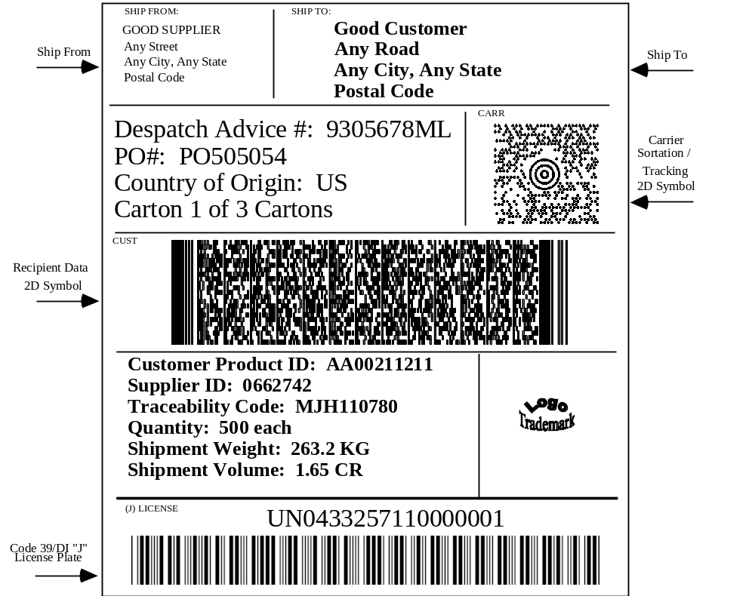

Figure E-8
Label using "J" ANSI MH10.8.2 Data Identifier license plate
and additional trading partner data in 2D symbols (not to scale)
The carrier data encoded in the MaxiCode symbol in Figure E-8 is as follows:

Header [)>RS
Format 01 Sortation/Tracking Header 01GS96
Carrier Data S-13189GS752GS006GSMH80312GSSCACGS
5215716587GSGS1JEABCXXXAGSGS580RSEOT

The customer data encoded in the PDF417 symbol in Figure E-8 is as follows:

Header [)>RS
Format 04 Header 04092001FSGSUS
Ship From Name & Address NADGSSFGSGSGSGOOD SUPPLIERGSANY STREETGSANY CITYGSANY STATEGSANY STATEGSPOSTAL CODEFS
Ship To Name & Address NADGSSTGSGSGSGOOD CUSTOMERGSGSGSANY CITYGSANY STATEGSPOSTAL CODEFS
Despatch Advice Number BGMGS351GS93-5678MLGS9RS
Format 06 Data Identifier Header 06GS
Transport Unit ID (Container License Plate) JUN0433257110000001GS
Carrier Shipment Number 12KSCACMH80312GS
Customer PO # KPO505054GS
Quantity (Each Implied) Q500GS
Supplier ID 3V0662742GS
Customer Product ID PAA00211211GS
Country of Origin 4LUSGS
Lot / Batch Number 1TMJH110780GS
Carton “n of x” 13Q1/3GS
Shipment Weight 7Q263.2KGGS
Shipment Volume 7Q1.65CRRS
Trailer EOT
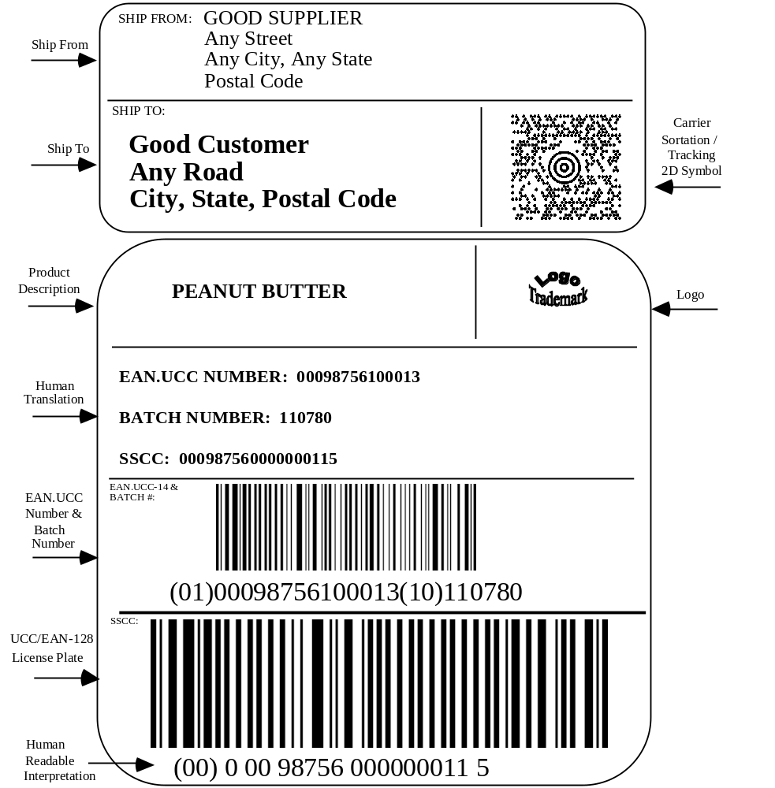

Figure E-9
Two labels (top label is carrier label,
bottom label is supplier label (not to scale)

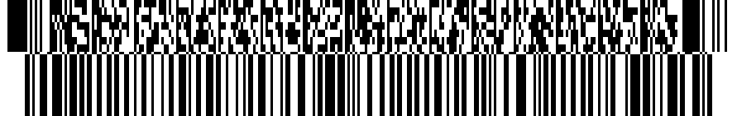
(00)000614141012345677(3301)002632(3362)000165
SSCC + logistical data
Pallet contents:
Transport Unit ID: 000614141012345677
Pallet Weight: 263.2 kg. Pallet Volume: 1.65 cub. m.
Case GTIN: 00614141000015 Case Qty: 500
Traceability Code: MJH110780
Customer product ID: AA00211211

Shipment data:
P.O. no: 123456789 P.O. line no: 001
Consignment no: 9631415926535984147098
Shipment ID: 480546160 Country of origin: USA
Ship from:
Good Supplier
Elm St.
Fromtown, TX 012345
USA
Ship to:
Good Customer
Kodiak Rd.
Totown, AK 98765USA

Figure E-10
Label using EAN.UCC Composite data carrier with
additional contents and carrier data

The data encoded in the EAN.UCC Composite symbol in Figure E-10 is as follows:

Encoded in UCC/EAN-128:
Header ^{F}₁
Transport Unit ID (Container License Plate) 00000614141012345677
Shipment Weight 3301002632
Shipment Volume 3362000165

Encoded in CC-C:
Case GTIN 0200614141000012
Case Quantity 37500 ^{F}₁
Lot / Batch Number 10MJH110780 ^{F}₁
Customer Product ID 241AA00211211 ^{F}₁
Ship From Location Code 4120614141900015
Ship To Location Code 4100614141900992
Country of Origin 422123
Ship To Postal Code 42098765 ^{F}₁
Shipment ID 402480546160 ^{F}₁
Carrier Shipment Number 4019631415926535984147098 ^{F}₁
Customer PO # and Line Item # 400123456789+001

where ^{F}₁ is a FNC1.

Format 02 (with complete EDI message)
A simple License Plate on all cartons provides instant access to previously received EDI data from suppliers. However, as a result of EDI message spooling, the nearness of suppliers to customers, and the batch nature of many EDI systems, freight may arrive prior to the electronic message detailing the contents of the shipment. Accordingly, this guideline identifies two formats for ensuring that the data arrives, at the latest, with the shipment in the form of a machine-readable symbol encoding a specific EDI message. The two methods of encoding EDI messages are UN/EDIFACT, administered by the United Nations (UN) and ASC X12, administered by the ANSI Accredited Standards Committee X12. This standard provides for encodation of both UN/EDIFACT and ANSI ASC X12 messages.

EDIFICE UN/EDIFACT Despatch Advice (DESADV) in Format 02

The following example of a Despatch Advice message provides the description of a shipment of goods that have been despatched by the supplier of the goods, identified as Company A. The buyer of the goods is identified as Company B, and the warehouse where the goods are to be delivered is identified as Location B.

The Despatch Advice, reference number 93-5678ML, is sent on 20 April 1993 at 14:50. The goods to be despatched are a complete shipment of the goods purchased on 17 April 1993 according to the buyer's purchase order number PO505054. They are despatched on 20 April at 14:30 and are expected to arrive the next day at 12:00.

The Despatch Advice refers to a shipment of goods containing two pallets. Each pallet is uniquely identified by a bar coded serial number.

The first pallet is identified by a package ID number ABCXXX90 and contains three cartons of the product identified by the number ABCDE-AA, each carton containing a number of units. The pallet is a standard 800 mm x 1200 mm pallet with a gross weight of 263.2 kilograms.

The second pallet has an ID number of ABCXXX91 and has a mixed product load: 1 carton of product 12345-AA and 1 carton of product 67890-AB. The pallet has the same dimensions as the first one with a gross weight of 305.1 kilograms.

Each of the cartons has their own associated barcode Package ID number.

A contact code is given for Company A, along with a telephone number.

The Despatch Advice describes the shipment as being composed of two pallets, providing for each pallet a description of the type of pallet in terms of dimensions and weight, as well as the pallet's unique identity number. The contents of each pallet are then described in terms of the despatch units it contains, including the package serial number.

Examples shown below of Format 02 are not intended to show how to construct an EDI message.

Descriptive transaction

The following example uses DESADV “package” related logic, i.e., there is a one-to-one relationship between the CPS and PAC segments.

Consider the example of an EDIFICE UN/EDIFACT Despatch Advice (DESADV):

Message Header UNH+1+DESADV:1:921:UN:EIVER1'
Shipment 93-5678ML BGM+351+93-5678ML+9'
Date/time of Despatch Advice DTM+137:199304201450:203'
Actual Ship Date and Time DTM+11:199304201430:203'
Est Delivery Date and Time DTM+17:199304211200:203'
Total Gross Shipment Weight MEA+WT+AAD+KGM:568.3'
Number of Unit Loads MEA+CT+SQ+NMP:2'
Purchase Order No. RFF+ON:PO505054'
Date of PO DTM+4:19930417:102'
Code Assigned by Seller NAD+SE+COMPANYA::91'
Contact Person CTA+IC+John Smith'
Contact Telephone Number COM+883306:TE'
Buyer Code Assigned by Seller NAD+BY+COMPANYB::91'
Ship to Location NAD+DP+LocationB::92'
Main-Carriage, by Road TDT+20++30+++++:::H1234 CFD'
Trailer EQD+TE'
Trailer Seal No. Assigned by Customs SEL+ABCD123456+CU'
1st Unit Load CPS+1'
Unit Load is Shrink Wrapped PAC+1++SW'
Gross Weight in Kilograms MEA+WT+G+KGM:263.2'
Unit Load Contains 3 Boxes QTY+52:3'
Heavy Cargo HAN+HEA::EAN'
Labels/IDs Supplied by Seller PCI+17'
Invoice Number RFF+IV:V1013-015'
Unit Identification GIN+ML+ABCXXX90'
Second Level of Description CPS+2+1'
1st box, 1st Unit Load PAC+1++BX'
Gross Weight of Box MEA+WT+G+KGM:100'
Labels/IDs Supplied by Seller PCI+17'
Package ID of Box GIN+ML+ABCXXXA'
First Line Item LIN+1++ABCDE-AA:SA::91'
500 X ABCDE-AA Despatched QTY+12:500'
Serial Numbers GIN+BN+999001:999500'
Third Level of Description CPS+3+1'
2nd Box, 1st Unit Load PAC+1++BX'
Gross Weight of Box MEA+WT+G+KGM:100'
Labels/IDs Supplied by Seller PCI+17'
Package ID of Box GIN+ML+ABCXXXB'
First Line Item LIN+1++ABCDE-AA:SA::91'
500 X ABCDE-AA Despatched QTY+12:500'
Serial Numbers GIN+BN+998001:998500'
Fourth Level of Description CPS+4+1'
3rd box, 1st Unit Load PAC+1++BX'
Gross Weight of Box MEA+WT+G+KGM:63.2'
Labels/IDs Supplied by Seller PCI+17'
Package ID of Box GIN+ML+ABCXXXC'
First Line Item LIN+1++ABCDE-AA:SA::91'
250 X ABCDE-AA Despatched QTY+12:250'
Serial Numbers GIN+BN+997001:997250'
2nd Unit Load CPS+5'
Unit Load is Shrink Wrapped PAC+1++SW'
Gross Weight in Kilograms MEA+WT+G+KGM:305.1'
Unit Load Contains 3 Boxes QTY+52:3'
Heavy Cargo HAN+HEA::EAN'
Labels/IDs Supplied by Seller PCI+17'
Invoice Number RFF+IV:V1013-015'
Package ID of Pallet GIN+ML+ABCXXX91'
Sixth Level of Description CPS+6+5'
1st Box in 2nd Unit Load PAC+1++BX'
Gross Weight in Kilograms MEA+WT+G+KGM:65.1'
Contains 50 Items QTY+52:50'
Labels/IDs Supplied by Seller PCI+17'
Package ID of Box GIN+ML+ABCXXXA1’
1st Line Item LIN+1++12345-AA:SA::91'
50 X 12345-AA Despatched QTY+12:50'
Serial Numbers GIN+BN+996001:996050'
Seventh Level of Description CPS+7+5'
2nd Box in 2nd Unit Load PAC+1++BX'
Gross Weight in Kilograms MEA+WT+G+KGM:120'
Contains 100 Items QTY+52:100'
Labels/IDs Supplied by Seller PCI+17’
Package ID of Box GIN+ML+ABCXXXA2'
1st Line Item; Product Type LIN+1++67890-AB:SA::91'
Buyer's Item Number PIA+1+SD12345:IN::92'
100 X 67890-AB Despatched QTY+12:100'
Country of Origin ALI+US'
Serial Numbers GIN+BN+995001:995100'
Invoice Number RFF+IV:V1013-015'
Eighth Level of Description CPS+8+5'
3rd Box in 2nd Unit Load PAC+1++BX'
Gross Weight in Kilograms MEA+WT+G+KGM:120’
Contains 100 Items QTY+52:100'
Labels/IDs Supplied by Seller PCI+17'
Package ID of Box GIN+ML+ABCXXXA3’
1st Line Item; Product Type LIN+1++67890-AB:SA::91'
Buyer's Item Number PIA+1+SD12345:IN::92’
100 X 67890-AB Despatched QTY+12:100'
Country of Origin ALI+US'
Serial Numbers GIN+BN+995101:995200'
Invoice Number RFF+IV:V1013-015'
Message Trailer UNT+91+1'

2D encodation

A Despatch Advice might be encoded as follows (1,345 characters):

[)>RS
02
UNH+1+DESADV:1:921:UN:EIVER1'BGM+351+93-5678ML+9'DTM+137:199304201450:203'
DTM+11:199304201430:203'DTM+17:199304211200:203'MEA+WT+AAD+KGM:568.3'MEA+CT+SQ+NMP:2'RFF+ON:PO505054'DTM+4:19930417:102'NAD+SE+COMPANYA::91'CTA+IC+John Smith'COM+883306:TE'NAD+BY+COMPANYB::91'NAD+DP+LocationB::92'TDT+20++30+++++H:::1234 CFD'EQD+TE'SEL+ABCD123456+CU'CPS+1'PAC+1++SW'MEA+WT+G+KGM:
263.2'QTY+52:3'HAN+HEA::EAN'PCI+17'RFF+IV:V1013-015'GIN+ML+ABCXXX90'CPS+2+
1'PAC+1++BX'MEA+WT+G+KGM:100'PCI+17'GIN+ML+ABCXXXA'LIN+1++ABCDE-AA:SA::
91'QTY+12:500'GIN+BN+999001:999500'CPS+3+1'PAC+1++BX'MEA+WT+G+KGM:100'PCI+17'GIN+ML+ABCXXXB'LIN+1++ABCDE-AA:SA::91'QTY+12:500'GIN+BN+998001:998500'CPS+
4+1'PAC+1++BX'MEA+WT+G+KGM:63.2'PCI+17'GIN+ML+ABCXXXC'LIN+1++ABCDE-AA:
SA::91'QTY+12:250'GIN+BN+997001:997250'CPS+5'PAC+1++SW'MEA+WT+G+KGM:305.1'QTY+52:3'HAN+HEA::EAN'PCI+17'RFF+IV:V1013-015'GIN+ML+ABCXXX91'CPS+6+5'PAC+1++
BX'MEA+WT+G+KGM:65.1'QTY+52:50'PCI+17'GIN+ML+ABCXXXA1'LIN+1++12345-AA:SA::
91'QTY+12:50'GIN+BN+996001:996050'CPS+7+5'PAC+1++BX'MEA+WT+G+KGM:120'QTY+52:100'PCI+17'GIN+ML+ABCXXXA2'LIN+1++67890-AB:SA::91'PIA+1+SD12345:IN::92'QTY+12:
100'ALI+US'GIN+BN+995001:995100'RFF+IV:V1013-015'CPS+8+5'PAC+1++BX'MEA+WT+G+
KGM:120'QTY+52:100'PCI+17'GIN+ML+ABCXXXA3LIN+1++67890-AB:SA::91'PIA+1+
SD12345:IN::92'QTY+12:100'ALI+US'GIN+BN+995101:995200'RFF+IV:V1013-015'UNT+91+1'

NOTE The Format Trailer Character (RS) and the Message Trailer Character (EOT) are not used with Format 02.

When encoded in sequential PDF417 symbols, the 2D EDI (syntactically compliant message) would appear as shown in Figure E-11.
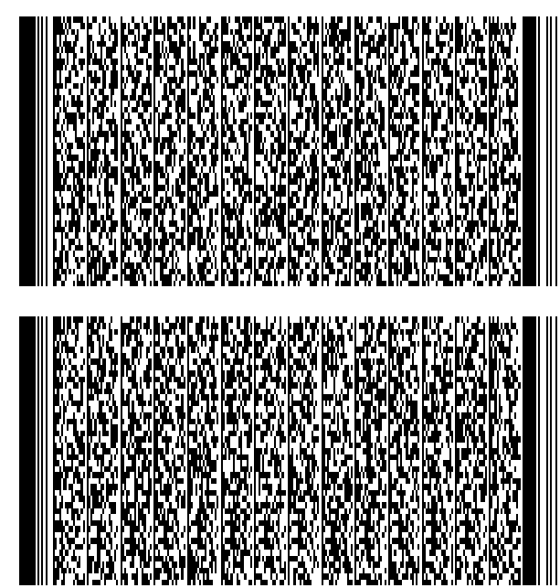

Figure E-11
PDF417 symbol encoding EDIFICE UN/EDIFACT DESADV

ANSI ASC X12 856 EDI Ship Notice Manifest in Format 02

The data to be formatted and encoded into a message in this example is an entire EDI transaction, a formatted ANSI ASC X12 Ship Notice/Manifest (856). Since the data is intended to be passed directly to an EDI translator and includes full EDI headers and trailers, Format 02 is the appropriate data format. The descriptive transaction clause below shows the data as it would be formatted under ANSI ASC X12 rules, with brief explanations of each segment type. The 2D encodation with envelopes clause shows the data as it would be formatted in a complete 2D message.

Descriptive transaction

Transmission Header ISA*00*bbbbbbbbbb*00*bbbbbbbbbb*16*
0433257110000bb*16*0118504840000bb*
920926*1705*U*00302*000002327**0*TCR
Functional Group Header GS*SH*0433257110000bb*0118504840000bb*
920926*1045*145*X*003020CR
Transaction Header ST*856*579333453CR
Beginning Segment BSN*00*MH80312*920223*1442*0001CR
Hierarchical Level HL*1**SCR
Carrier Details (Qty/Wt) TD1*PLT94*36****G*220*KGCR
Carrier Details (Routing) TD5***2*SCAC*AE**CC*****WD*2CR
Carrier Details (Special Handling) TD4*AMMCR
Carrier Tracking Number REF*AW*3115387693CR
Ship Date DTM*017*921012*0800*GM*19CR
Ship To Co. & DUNS N1•ST*ABCbSYSTEMS*9*0433257110000CR
Other Name N2*ORDERbFULFILLMENTCR
Street Address N3*ANY STREETCR
City, State, ZIP N4*CITY*STATE*12345-6789CR
Hierarchical Level HL*2*1*OCR
Purchase Order Reference PRF*MH80312**920512CR
Carrier Details (Qty/Wt) TD1*CTN25*48CR
Carrier PRO # REF*CN*ABC123CR
FOB Instructions FOB*PPCR
Hierarchical Level HL*3*2*TCR
Item Physical Details P04*64*8*BX***320*LB***60*60*60*INCR
Carrier Details (Qty/Wt) TD1*CTN25*40CR
Pallet License Plate MAN*GM*100987560000000112CR
Hierarchical Level HL*4*3*PCR
Item Physical Details P04*8*6*EA***8*LB***8.5*11*2.2*INCR
Pack License Plate MAN*GM*000987560000000115CR
Pack Container Code MAN*UC*50098756100018CR
Hierarchical Level HL*5*4*QCR
Item Physical Details P04***6*EA***8*LB***8.5*11*2.2*INCR
Carrier Details (Qty/Wt) TD1*PCS71*40CR
Marks & Numbers MAN*UC*30098756100014CR
Hierarchical Level HL*6*5*ICR
Item Identification LIN**UP*098756100013*BP*P16235128LCR
Shipment Item Detail SN1*12*EA*12*12*EACR
Sub line Item Detail SLN*ABC123**A*1****VP*0098756XYZ12345789CR
Sub line Item Detail SLN*ABC567**A*1****VP*0098756ABC00110010CR
Item Physical Details P04***20*FTCR
Product/Item Descript. PID*F*08***ABC QUARTERMASTERCR
Product Serial Numbers REF*LS*00987563115387693CR
Hierarchical Level HL*7*5*ICR
Item Identification LIN**UP*098756100020*BP*A53261652RCR
Shipment Item Detail SN1*12*EA*12*12*EACR
Sub line Item Detail SLN*ABC345**A*1****VP*0098756QED97531246CR
Sub line Item Detail SLN*ABC897**A*1****VP*0098756ABC00110010CR
Item Physical Details P04*1*1*EACR
Product/Item Descript. PID*F*08***ABC BEST PARTCR
Product Serial Numbers REF*LS*00987563111111111CR
Transaction Totals CTT*7CR
Transaction Trailer SE*47*579333453CR
Functional Group Trailer GE*1*732CR
Transmission Trailer IEA*1*000002327CR

2D encodation

[)>RS
02
ISA*00*bbbbbbbbbb*00*bbbbbbbbbb*16*0433257110000bb*16*0118504840000bb*920926*1705*U*00302*000002327**0*TCRGS*SH*0433257110000bb*0118504840000bb*920926*1045*145*X*003020CRST*856*579333453CRBSN*00*MH80312*920223*1442*0001CRHL*1**SCRTD1*PLT94*36****G*220*KGCRTD5***2*SCAC*AE**CC*****WD*2CRTD4*AMMCRREF*AW*3115387693CRDTM*017*921012*0800*GM*19CRN1•ST*ABCbSYSTEMS*9*0433257110000CRN2*ORDERbFULFILLMENTCRN3*ANY STREETCRN4*CITY*STATE*12345-6789CRHL*2*1*O
CRPRF*MH80312**920512CRTD1*CTN25*48CRREF*CN*ABC123CRFOB*PPCRHL*3*2*TCRP04*64*8*BX***320*LB***60*60*60*INCRTD1*CTN25*40CRMAN*GM*100987560000000112CRHL*4*3*PCRP04*8*6*EA***8*LB***8.5*11*2.2*INCRMAN*GM*000987560000000115CRMAN*UC*50098756100018CRHL*5*4*QCRP04***6*EA***8*LB***8.5*11*2.2*INCRTD1*PCS71*40CRMAN*UC*30098756100014CRHL*6*5*ICRLIN**UP*098756100013*BP*P16235128LCRSN1*12*EA*12*12*EACRSLN*ABC123**A*1****VP*0098756XYZ12345789CRSLN*ABC567**A*1****VP*0098756ABC00110010CRP04***20*FTCRPID*F*08***ABC QUARTERMASTERCRREF*LS*00987563115387693CRHL*7*5*ICRLIN**UP*098756100020*BP*A53261652RCRSN1*12*EA*12*12*EACRSLN*ABC345**A*1****VP*0098756ABC97531246CRSLN*ABC897**A*1****VP*0098756ABC00110010CRP04*1*1*EACRPID*F*08***ABC BEST PARTCRREF*LS*00987563111111111CRCTT*7CRSE*47*579333453CRGE*1*732CRIEA*1*000002327CR

When encoded in a PDF417 symbol, the 2D EDI message / transaction would appear as shown in Figure E-12.

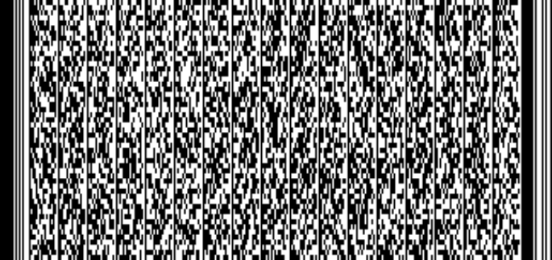
Figure E-12
PDF417 symbol encoding ANSI ASC X12 856 data with envelopes

ANSI ASC X12 204 EDI Motor Carrier Information in Format 02

The data to be formatted and encoded into a message in this example is an entire EDI transaction, a formatted ANSI X12 Motor Carrier Information transaction (204), commonly used as an electronic Bill of Lading. Since the data is intended to be passed directly to an EDI translator and includes full EDI headers and trailers, Format 02 is the appropriate data format. The EDI transaction below shows the data as it would be formatted under ANSI ASC X12 rules, with brief explanations of each segment type.

Descriptive transaction

Transmission Header ISA*00*bbbbbbbbbb*00*bbbbbbbbbb*16*043325
7110000bb*02*ABCDbbbbbbbbbbb*920926*170
5*U*00302*000002327*0*P: CR
Functional Group Header GS*SH*0433257110000bb*0118504840000bb*9
20926*1045*145*X*003020CR
Transaction Header ST*204*001*840001CR
Beginning Segment B2**ABCD*****13216**CC*C*M****6CR
Set Purpose B2A*00*BLCR
Carrier PRO # N9*CN*0877208484CR
Ship Notice/Manifest Number N9*MA*00184CR
Ship Date G62*11*910617CR
Shipper N1*SH*LANDA, INC. CR
Street Address N3*13705 N.E. AIRPORT WAYCR
City, State, Zip N4*PORTLAND*OR*97230CR
Consignee N1*CN*ROTARY DRILLING SUPPLYCR
Street Address N3*HWY 61 67 SOUTHCR
City, State, Zip N4*FESTUS*MO*63028CR
Assigned Number LX*1CR
Description L5**OUTFITS, CLEANING STEAM OR WATER
(147300)*147300*NCR
Weight and Quantity L0****80*N***1*PLTCR
Tariff Reference L7********77.5CR
Total Weight and Charges L3*80*G*********1**T5013CR
Transaction Trailer SE*18*001840001CR
Functional Group Trailer GE*1*732CR
Transmission Trailer IEA*1*000002327CR

2D encodation

The 2D EDI message with envelopes should appear as follows (569 characters):

[)>RS
02
ISA*00*bbbbbbbbbb*00*bbbbbbbbbb*16*0433257110000bb*16*0118504840000bb*920926*1705*U*00302*000002327**0*P:CRGS*SH*0433257110000bb*0118504840000bb*920926*1045*145*X*003020CRST*204*001*840001CRB2**SCAC****13216**CC**C*M****6CRB2A*00*BLCRN9*CN*0877208484CRN9*MA*00184CRG62*11*910617CRN1*SH*LANDA, INC.CRN3*13705 N. E. AIRPORT WAYCRN4*PORTLAND*OR*97230CRN1*CN*ROTARY DRILLING SUPPLYCR
N3*HWY 61 67 SOUTHCRN4*FESTUS*MO*63028CRLX*1CRL5**OUTFITS, CLEANING STEAM OR WATER (147300)*147300*NCRL0****80*N***1*PLTCRL7*******77.5CRL3*80*G*********1**
T5013CRSE*18*001840001CRGE*1*732CRIEA*1*000002327CR

When encoded in a PDF417 symbol, the 2D complete EDI message / transaction would appear as shown in Figure E-13.

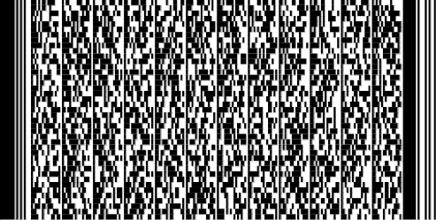
Figure E-13
PDF417 symbol encoding a simple LTL
bill of lading ANSI ASC X12 204 transaction set (one item)

Format 03 (structured data (EDI segments) using ANSI ASC X12)
In some cases it may be desirable to communicate specific text in a structured format, but a complete, enveloped EDI transaction would not be necessary. When EAN.UCC Application Identifiers (example in clause E.6) and ANSI MH10.8.2 Data Identifiers (example in clause E.7) cannot accommodate the data that needs to be formatted, the rules used for formatting individual segments of EDI transactions could provide a model for structuring the data. This is the case in the following example.

In this example, address data for the Ship From and Ship To are formatted using individual segments from the ANSI ASC X12 EDI standards using Format 03. This data is not intended to be passed to an EDI translator, since it is not a complete EDI transaction.

An example of structured data using ANSI ASC X12 segments is shown in the following Ship From and Ship To portion of a shipping label:

Figure E-14
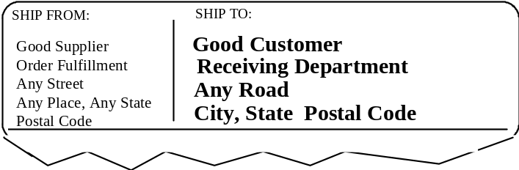
Ship From and Ship To portions of a shipping label (not to scale)

When coded in ANSI ASC X12 segments, the above example of Ship From and Ship To portions of a shipping label might be encoded as follows:

Header [)>RS
Format 03 Header 03003030FSGSUS
Ship From Name N1GSSFGSGOOD SUPPLIERFS
Ship From Additional Name N2GSORDER FULFILLMENTFS
Ship From Street Address N3GSANY STREETFS
Ship From City, State, and Postal Code N4GSANY PLACEGSANY STATEGSPOSTAL CODEFS
Ship To Name N1GSSTGSGOOD CUSTOMERFS
Ship To Additional Name N2GSRECEIVING DEPARTMENTFS
Ship To Street Address N3GSANY ROADFS
Ship To City, State, and Postal Code N4GSCITYGSSTATEGSPOSTAL CODERS
Trailer EOT

When this format is used within a shipping and receiving application, this data would be encoded in a PDF417 symbol. When encoded in a PDF417 symbol, the above data would appear as follows:

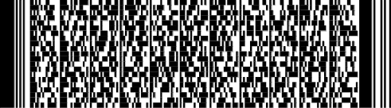
Figure E-15
PDF417 symbol encodation of Ship From and
Ship To data in ANSI ASC X12 segment format (not to scale)

Format 04 (structured data (EDI segments) using UN/EDIFACT)

In some cases, it may be desirable to communicate specific text in a structured format, but a complete, enveloped EDI transaction would not be necessary. When EAN.UCC Application Identifiers (example in clause E.6) or ANSI MH10.8.2 Data Identifiers (example in clause E.7) cannot accommodate the data that needs to be formatted, the rules used for formatting individual segments of EDI transactions could provide a model for structuring the data. This is the case in the following example.

In this example, address data for the Ship From and Ship To fields are formatted using individual segments from the UN/EDIFACT EDI standards using Format 04. This data is not intended to be passed to an EDI translator, since it is not a complete EDI translation.

An example of structured data using UN/EDIFACT segments is shown in the following Ship From and Ship To portion of a shipping label:


Figure E-16
Ship From and Ship To portions of a shipping label (not to scale)

When coded in UN/EDIFACT segments, the above example of Ship From and Ship To portions of a shipping label might be encoded as follows:

Header [)>RS
Format 04 Header 04092001FSGSUS

Ship From Name & Address NADGSSFGSGSGSGOOD SUPPLIER+ORDER FULFILLMENTGS3618 NEW CONFED ROADGSPLACESGSOHGS45458GSUSAFS
Ship To Name & Address NADGSSTGSGSGSTELEFONAKTLEBOLAGET OLAFSSON+PHYSICAL DISTRIBUTIONGSGS
GSSTOCKHOLMGSGSGSS-131 89GS SEKRS
Trailer EOT

When this format is used within a shipping and receiving application, this data would be encoded in a PDF417 symbol. When encoded in a PDF417 symbol, the above data would appear as follows:

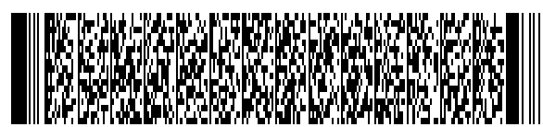
Figure E-17
PDF417 symbol encodation of Ship From and
Ship To data in UN/EDIFACT segment format (not to scale)

Format 05 (data using EAN.UCC Application Identifiers)
EAN.UCC Application Identifiers (AIs) are recognized in this standard as one method of identifying what specific type of information was encoded in a bar code symbol.

An example of data using EAN.UCC Application Identifiers is shown in the following bar code symbols that might be found on a shipping label:

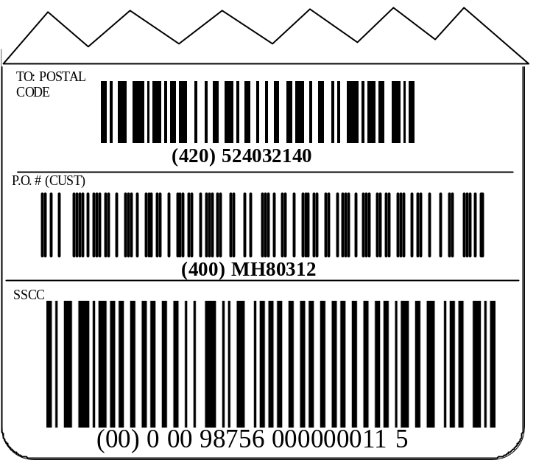
Figure E-18
Shipping Label segments using EAN.UCC Application Identifiers (not to scale)

When coded in Format 05 of this standard, the EAN.UCC Application Identifier data in the above example portions of a shipping label would be encoded as follows:

Header [)>RS
Format 05 Application Identifier Header 05GS
Ship To Postal Code 420524032140GS
Customer Purchase Order Number 400MH80312GS
SSCC License Plate 00000987560000000115RS
Trailer EOT

When this format is used within a shipping and receiving application, this data would be encoded in a PDF417 symbol. When encoded in a PDF417 symbol, the above data would appear as follows:

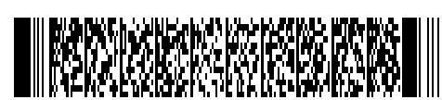
Figure E-19
PDF417 symbol encoding EAN.UCC Application Identifier data (not to scale)

When directly encoded in EAN.UCC Application Identifier syntax, the Application Identifier data in the above example data in the shipping label would be encoded as follows:

Encoded in the UCC/EAM-128 linear component:
Header ^{F}₁
SSCC License Plate 00000987560000000115

Encoded in the CC-C 2D component:
Ship To Postal Code 420524032140^{F}₁
Customer Purchase Order Number 400MH80312

When this format is used within a shipping and receiving application, this data would be encoded in a EAN.UCC Composite symbol, the above data would appear as follows:


Figure E-20
EAN.UCC Composite symbol encoding Application Identifier data (not to scale)

Format 06 (data using ANSI MH10.8.2 Data Identifiers)
ANSI MH10.8.2 Data Identifiers (DIs) are recognized in this standard as one method of identifying what specific type of information was encoded in a bar code symbol.

An example of data using ANSI MH10.8.2 Data Identifiers is shown in the following bar code symbols that might be found on a shipping label:

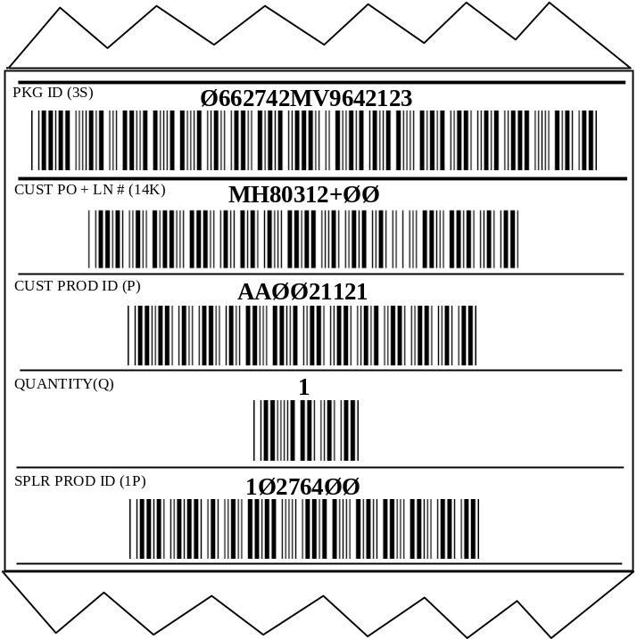
Figure E-21
Shipping label segments using ANSI MH10.8.2 Data Identifiers (not to scale)
When coded in Format 06 of this standard the ANSI MH10.8.2 Data Identifier data in the above example portions of a shipping label would be encoded as follows:

Header [)>RS
Format 06 Data Identifier Header 06GS
Package ID (Container License Plate) 3S0662742MV96421234GS
Customer PO # and Line Item # 14KMH80312+001GS
Customer Product ID PAA00211211GS
Quantity (Each Implied) Q1GS
Supplier Product ID 1P102764007RS
Trailer EOT

When this format is used within a shipping and receiving application, this data would be encoded in a PDF417 symbol. When encoded in a PDF417 symbol, the above data would appear as follows:


Figure E-22
PDF417 symbol encoding ANSI MH10.8.2 Data Identifier data (not to scale)

Combining Format 01 with Format 03
Two examples are provided for combining carrier data (Format 01) with ANSI ASC X12 EDI segments (Format 03).

Format 01/03 using a 2D symbol for automated sortation / tracking

The following example depicts a situation in which a carrier might be using a MaxiCode symbol for sortation and tracking and desires to capture additional data, as well as allowing for the encodation of packing slip data for its customer.

The carrier data (Format 01) would be encoded in a MaxiCode symbol as well as being combined with ANSI ASC X12 EDI segments (Format 03) in a PDF417 symbol. The MaxiCode symbol would be used for automated sortation / tracking and the PDF417 symbol for additional carrier and customer data. In this example, the MaxiCode symbol might appear as follows:

Compliance Indicator [)>RS
Format 01 Sortation/Tracking Header 01GS96
Carrier Data 52403GS840GS001GS31415926535984147098GS
SCACGS678202GSGS93527GSGS25.2GSGS
RETAIL STORE #325GS CITYGSSTATERSEOT

In this example, the PDF417 symbol might appear as follows:

Compliance Indicator [)>RS
Format 01 Sortation/Tracking Header 01GS96
Carrier Data 52403GS840GS001GS31415926535984147098GS
SCACGS678202GSGS93527GSGS25.2GSGSRETAIL STORE #325GSCITYGSSTATERS
Format 03 ASC X12 Segments Header 03FSGSUS003050
Purchase Order Number PRFGSMH80312FS
Shipment ID REFGSSIGS93527FS
SSCC Data MANGSGMGS000987560000000115FS
Consignee's DUNS+4 N1GSCNGSGS9GS2749746924523FS
Consignee's Store Number N4GSGSGSGSGSSNGS325FS
1st Item - Customer Catalog Number LINGSGSCBGS1234567FS
1st Item - Quantity SN1GSGS3GSEAFS
2nd Item - Customer Catalog Number LINGSGSCBGS5828233FS
2nd Item - Quantity SN1GSGS5GSEAFS
3rd Item - Customer Catalog Number LINGSGSCBGS8447272FS
3rd Item - Quantity SN1GSGS3GSEAFS
4th Item - Customer Catalog Number LINGSGSCBGS6723113FS
4th Item - Quantity SN1GSGS4GSEAFS
5th Item - Customer Catalog Number LINGSGSCBGS4637721FS
5th Item - Quantity SN1GSGS5GSEARSEOT

In the following example, carrier data (Format 01) is encoded in a MaxiCode symbol. Carrier data (Format 01) is also combined with ANSI ASC X12 EDI segments (Format 03) and encoded in a PDF417 symbol. The MaxiCode symbol would be used for automated sortation / tracking and the PDF417 symbol for additional carrier and customer data.

Linear symbol data (data Format "01") is also combined with ASC X12 EDI segments (Format "03") shown in the example below to illustrate situations where the linear symbols may coexist with 2D symbols.

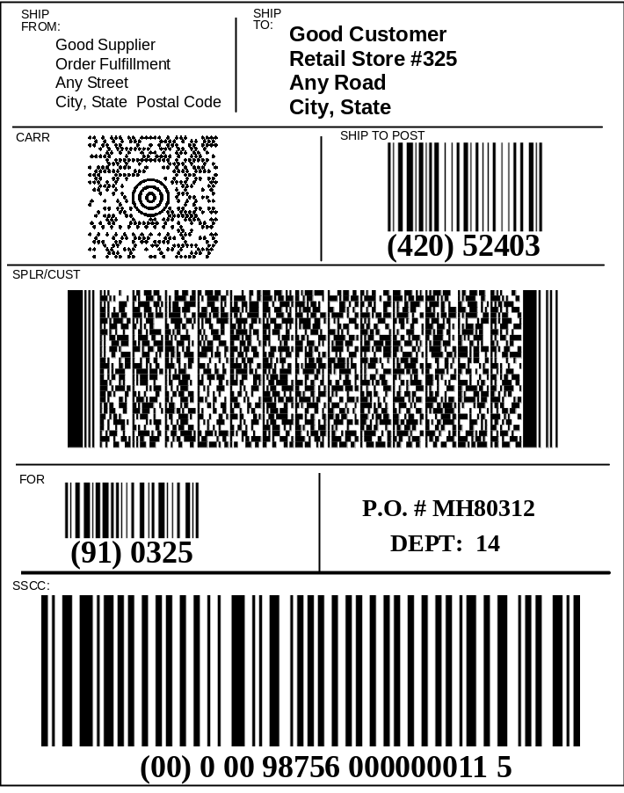

Figure E-23
Example of combination of Format 01 and Format 03 (not to scale)

Format 01/03 using a linear bar code symbol for automated sortation / tracking

The following example depicts a situation in which a carrier might be using a linear bar code symbol for sortation and tracking and desires to capture additional data, as well as allowing for the encodation of packing slip data for the customer.

In the following example, carrier data (Format 01) is combined with ANSI ASC X12 EDI segments (Format 03). Because it is anticipated that such a combination would appear on a shipping label, the PDF417 symbol would be used to encode packing slip data in a shipping and receiving application.

The following figure also includes a linear bar code symbol for sortation and tracking.

The 2D data stream might appear as follows:

Compliance Indicator [)>RS
Format 01 Sortation/Tracking Header 01GS96
Carrier Data 52403GS840GS001GS
1234123456712345678901GSSCACGS
678202GSGS93527GSGS25.2GSGSRETAIL
STORE #325GSCITYGSSTATERS
Format 03 ASC X12 Segments Header 03003050FSGSUS
Purchase Order Number PRFGSMH80312FS
Shipment ID REFGSSIGS93527FS
Tracking # (Carrier) REFGS08GS1234123456712345678901FS
SSCC Data MANGSGMGS000987560000000115FS
Consignee's DUNS+4 N1GSCNGSGS9GS2749746924523FS
Consignee's Store Number N4GSGSGSGSGSSNGS325FS
1st Item - Customer Catalog Number LINGSGSCBGS1234567FS
1st Item - Quantity SN1GSGS3GSEAFS
2nd Item - Customer Catalog Number LINGSGSCBGS5828233FS
2nd Item - Quantity SN1GSGS5GSEAFS
3rd Item - Customer Catalog Number LINGSGSCBGS8447272FS
3rd Item - Quantity SN1GSGS3GSEAFS
4th Item - Customer Catalog Number LINGSGSCBGS6723113FS
4th Item - Quantity SN1GSGS4GSEAFS
5th Item - Customer Catalog Number LINGSGSCBGS4637721FS
5th Item - Quantity SN1GSGS5GSEARSEOT

The following label format is an example of what a label might look like when encoding Format 01 and Format 03 in a PDF417 symbol for a shipping and receiving application. The linear bar code symbol, as shown in the bar code block entitled SSCC is used for automated sortation / tracking and depicts the relative size and location of the linear bar code symbol which may be used by carriers. Specific requirements for size and location of linear symbols on the label are found in normative Annex A.

Linear symbols are shown in the example below to illustrate situations where the linear symbols may coexist with 2D symbols.

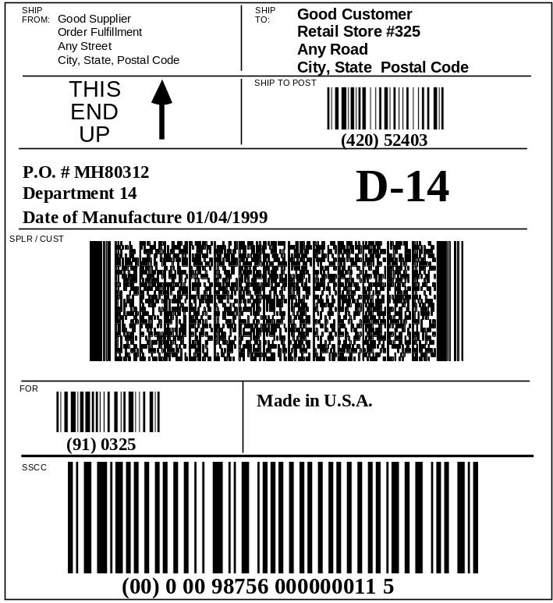

Figure E-24
Combination of Format 01 and Format 03 (not to scale)

Combining Format 01 with Format 06
The following example depicts a situation in which a carrier might be using a MaxiCode symbol for sortation and tracking and offers the customer the ability to also track the customer's purchase order number. In the following example carrier data (Format 01) is combined with ANSI MH10.8.2 Data Identifier data (Format 06). In this example the MaxiCode symbol data would appear as follows:

Compliance Indicator [)>RS
Format 01 Sortation/Tracking Header 01GS96
Carrier Data 52403GS840GS001GS07388978815GSSCACGS
678202GSGS93527GSGS25.2GSNGSGS
CITYGS STATERS
Format 06 Data Identifier Header 06GS
Customer’s P.O. Number KMH80312RSEOT

The following label format provides a representative example of what labels might look like when complying with this standard encoding Format 01 and Format 06 using a MaxiCode symbol for automated sortation/tracking and a purchase order using ANSI MH10.8.2 Data Identifiers. When used within a carrier sortation and tracking application, this data would be encoded in a MaxiCode symbol. Linear symbols are shown in the example below to illustrate situations where the linear symbols may coexist with 2D symbols.

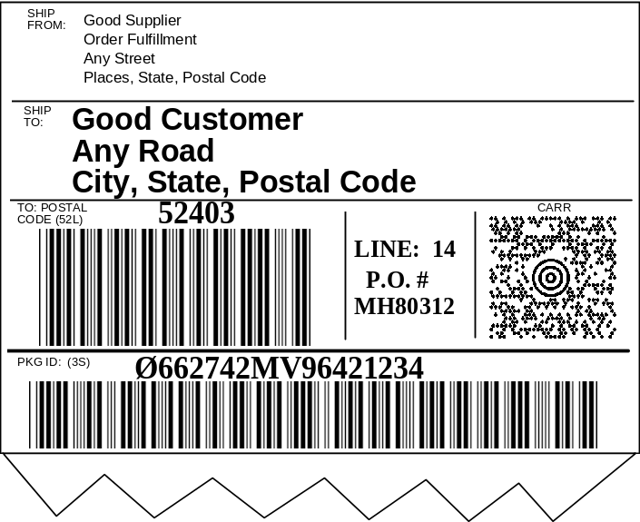
Figure E-25
Combination of Format 01 and Format 06 (not to scale)

Combining Format 03 with Format 05
To encode information commonly found on a shipping label, Format 03 (ANSI ASC X12 segments) and Format 05 (EAN.UCC Application Identifier) data might be encoded as follows.

Compliance Indicator [)>RS
Format 03 ASC X12 Segments Header 03003030FSGSUS
Ship From Name N1GSSFGSGOOD SUPPLIERFS
Ship From Additional Name N2GSORDER FULFILLMENTFS
Ship From Street Address N3GSANY STREETFS
Ship From City, State, and Postal Code N4GSPLACESGSSTATEGSPOSTAL CODEFS
Ship To Name N1GSSTGSGOOD CUSTOMERFSShip To Additional Name N2GSRETAIL STORE #325FS
Ship To Street Address N3GSANY ROADFS
Ship To City, State, and Postal Code N4GSCITYGSSTATEGS5POSTAL CODEFS
Product Description PIDGSFGS02GSGSGSRINGER C4CFS
Carrier Bar Code REFGS08GSSCAC31415926535984147098RS
Format 05 Application Identifier Header 05GS
SSCC (Container License Plate) 00000987560000000115GS
Customer PO # and Line Item # 400123456789+001GS
Quantity of 12 (Each Implied) 3012GS
Supplier Product ID 01500098756100018GS
Package Weight 32003RSEOT

The following label format provides an example of what labels might look like encoding Format 03 and Format 05 using a linear bar code symbol (carrier bar code) for automated sortation/tracking and a PDF417 symbol to encode all label data. When this format is used within a shipping and receiving application, this data would be encoded in a PDF417 symbol. The carrier bar code (linear symbol) is intended to show the location and relative size used by many carriers. Different carriers use different linear bar code symbologies for container tracking.

Linear symbols are shown in the example below to illustrate situations where the linear symbols may coexist with 2D symbols. The carrier bar code shows a combined use of AI “90” and DI “12K”).

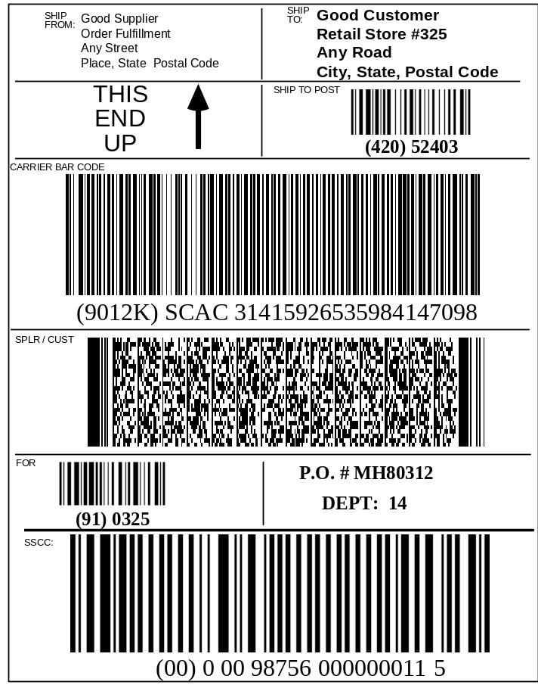
Figure E-26
Combination of Format 03 and Format 05 (not to scale)

The following label format provides an example of what labels might look like encoding Format 03 and Format 05 using a PDF417 symbol to encode all label data. Also included is a MaxiCode symbol for carrier automated sortation and tracking. When used within a carrier sortation and tracking application, this data would be encoded in a MaxiCode symbol. When used within a shipping and receiving application, this data would be encoded in a PDF417 symbol. Linear symbols are shown in the example below to illustrate situations where the linear symbols may coexist with 2D symbols.

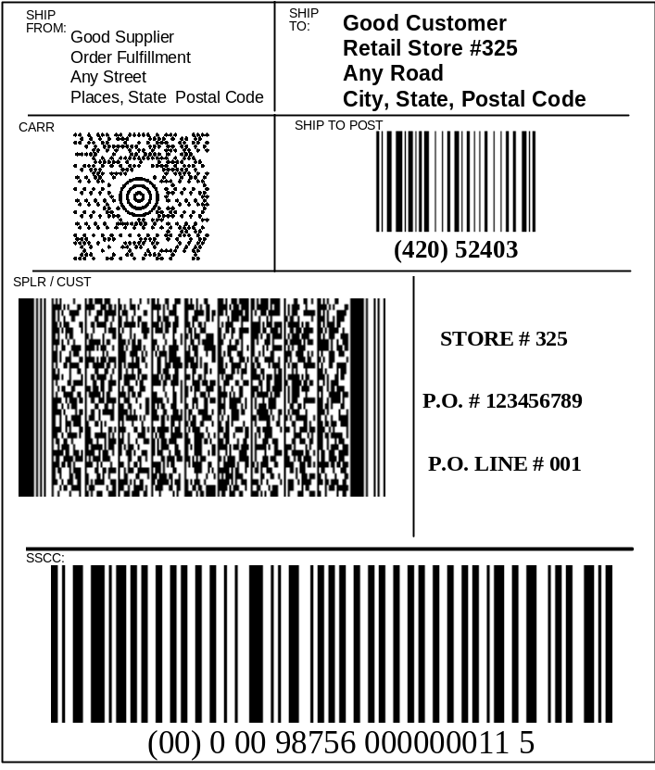
Figure E-27
Combination of Format 03 and Format 05 (not to scale)

Combining Format 03 with Format 06
To encode information commonly found on a shipping label, Format 03 (ANSI ASC X12 segments) and Format 06 (ANSI MH10.8.2 Data Identifier) data might be encoded as follows and might be represented as shown in Figure E-28. When this format is used within a shipping and receiving application, the data would be encoded in a PDF417 symbol.

Compliance Indicator [)>RS
Format 03 ASC X12 Segments Header 03003030FSGSUS
Ship From Name N1GSSFGSGOOD SUPPLIERFS
Ship From Street Address N3GS123 ANY STREETFS
Ship From City, State, Zip N4GSYOUR TOWNGSSTGS12345-6789FS
Ship To Name N1GSSTGSGOOD CUSTOMERFS
Ship To Street Address N3GSANY ROADFS
Ship To City, State, Zip N4GSCITYGSSTATEGSPOSTAL CODEFS
Product Description PIDGSFGS02GSGSGSRINGER C4CRS
Format 06 Data Identifier Header 06GS
Carrier SCAC and PRO # 12KSCAC1234567890GS
Package ID (Pallet License Plate) 5S0662742MV96421234GS
Customer PO # and Line Item # 14KMH80312+001GS
Customer Product ID PAA00211211GS
Quantity (Each Implied) Q40GS
Supplier Product ID 1P102764007GS
Supplier DUNS 13V043325711GS
Pallet Weight 2Q120LBRSEOT

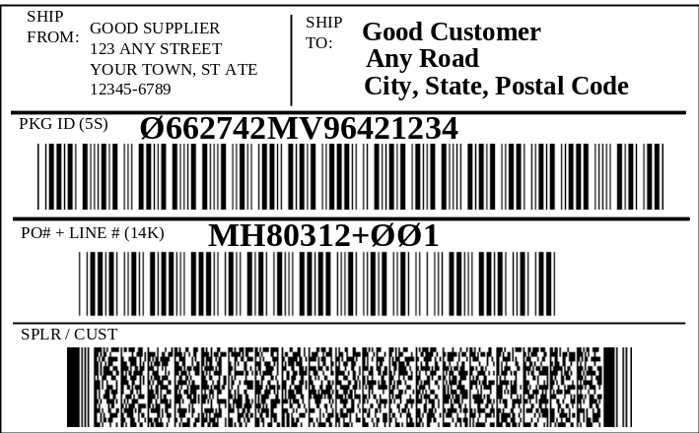
Figure E-28
Combination of Format 03 and Format 06 (not to scale)

Combining Format 04 with Format 06
To encode information commonly found on a shipping label, Format 04 (UN/EDIFACT segments) and Format 06 (ANSI MH10.8.2 Data Identifier) data might be encoded as follows and appear as in Figure E-29. When used within a shipping and receiving application, this data would be encoded in a PDF417 symbol.

Compliance Indicator [)>RS
Format 04 UN/EDIFACT Header 04092001FSGSUS
Ship From Name & Address NADGSSFGSGSGSGOOD SUPPLIER+ORDER
FULFILLMENTGSANY STREETGSPLACESGS
STATEGS12345-6789GSUSAFS
Ship To Name & Address NADGSSTGSGSGSTELEFONAKTLEBOLAGET
OLAFSSON+PHYSICAL DISTRIBUTIONGSGSGS
STOCKHOLMGSGSGSS-131 89GS SEKRS
Format 06 Data Identifier Header 06GS
Package ID (Pallet License Plate) 5S0662742MV96421234GS
Customer PO # and Line Item # 14KMH80312+001GS
Customer Product ID PAA00211211GS
Quantity (Each Implied) Q40GS
Supplier Product ID 1P102764007GS
Supplier DUNS 13V043325711GS
Package Weight 2Q120LBRSEOT

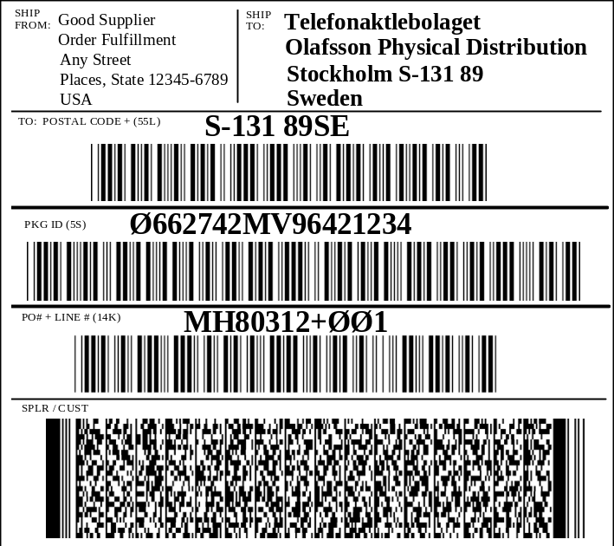

Figure E-29
Combination of Format 04 and Format 06 (not to scale)

Combining Format 01 with Format 03 and Format 05
In Figure E-30, carrier data (Format 01) is combined with ANSI ASC X12 EDI segments (Format 03) and EAN.UCC Application Identifiers (Format 05). Because it is anticipated that such a combination would appear on a shipping label, PDF417 symbol would be used to encode the shipping and receiving application data.

Figure E-30 also depicts a label with a linear bar code symbol that may be used by a carrier for sortation and tracking. The PDF417 symbol encodes transportation information and additional customer data.

In Figure E-30, the linear bar code symbol is used for carrier sortation and tracking applications, not the PDF417 symbol.

The data stream might appear as follows:

Compliance Indicator [)>RS
Format 01 Sortation/Tracking Header 01GS96
Carrier Data 52403GS840GS001GS31415926535984147098GS
SCACGS678202GSGS93527GSGS25.2GSGS
RETAIL STORE #325GSCITYGSSTATERS
Format 03 ASC X12 Segments Header 03003050FSGSUS
Shipment ID REFGSSIGS93527FS
Carrier Bar Code REFGS08GSSCAC31415926535984147098FS
Consignee's DUNS+4 N1GSCNGSGS9GS2749746924523RS
Format 05 Application Identifier Header 05GS
SSCC (Container License Plate) 00000987560000000115GS
Customer PO # plus Line Item # 400123456789+001GS
Quantity of 12 (Each Implied) 3012GS
Supplier Product ID 0150098756100018GS
Package Weight 32003RSEOT

Linear symbols are shown in the example below to illustrate situations where the linear symbols may coexist with 2D symbols.

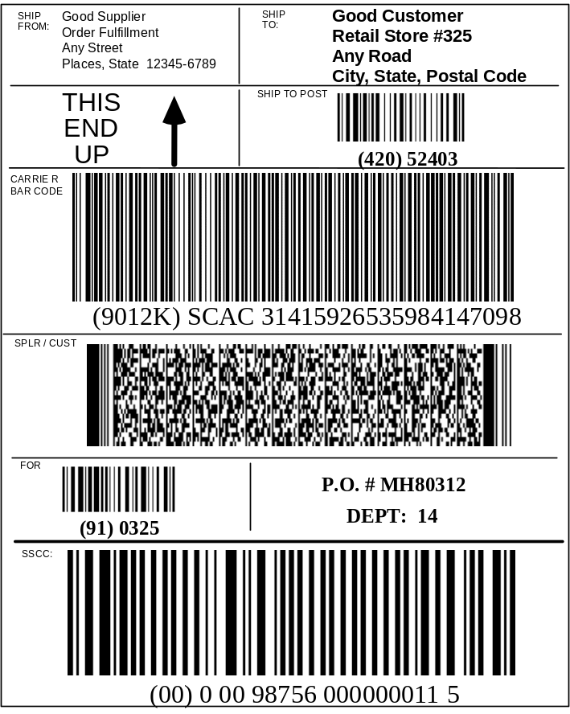
Figure E-30
Combination of Format 01, Format 03, and Format 05 (not to scale)

Combining Format 01, Format 06, and Format 03 over two labels
In this example two labels are employed: one for carriers and a second for customers.

Label example: (transportation label)

Figure E-31 depicts a situation in which a carrier might be using a MaxiCode symbol for sortation and tracking, and offers the customer the ability to also track the customer's purchase order number. In the following example, carrier data (Format 01) is combined with ANSI MH10.8.2 Data Identifier data (Format 06). In this example the MaxiCode symbol data would appear as follows:

Compliance Indicator [)>RS
Format 01 Sortation/Tracking Header 01GS96
Carrier Data 146524316GS840GS001GSMH80312GSSCACGS
678202GSGS93527GSGS5.2GSNGSGS
ROCHESTERGSNYRS
Format 06 Data Identifier Header 06GS
Customer’s P.O. Number KMH80312RSEOT

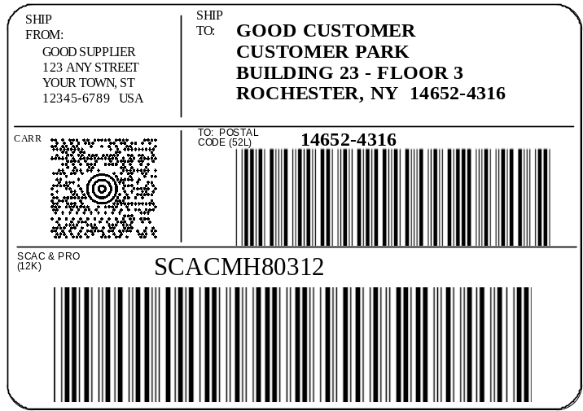
Figure E-31
Combination of Format 01, Format 03, and Format 06 (not to scale)

Label example (customer label)

The second label in the following example provides customer data. In Figure E-32, ANSI ASC X12 Segment Data (Format 03) is combined with ANSI MH10.8.2 Data Identifier data (Format 06). Linear symbols are shown in the example below to illustrate situations where the linear symbols may coexist with 2D symbols. When this format is used within a shipping and receiving application, this data would be encoded in a PDF417 symbol. In this example the PDF417 data would appear as follows:

Compliance Indicator [)>RS
Format 03 ASC X12 Segments Header 03003030FSGSUS
Product Description PIDGSFGS02GSGSGSRINGER C4CRS
Format 06 Data Identifier Header 06GS
Package ID (Container License Plate) 3S0662742MV96421234GS
Customer PO # and Line Item # 14KMH80312+001GS
Customer Product ID PAA00211211GS
Quantity (Each Implied) Q1GS
Supplier Product ID 1P102764007GS
Supplier DUNS 13V043325711GS
Package Weight 2Q3LBRSEOT

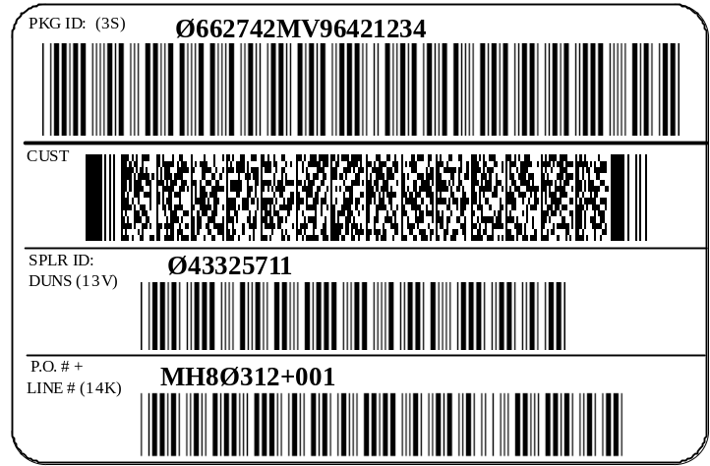
Figure E-32
Combination of Format 03 and Format 06 (not to scale)

EAN.UCC Looping and Compaction Encodation for use with Composite Symbols
In this example a label encodes mixed transport container contents, e.g., different cases mixed on a single pallet. This mixed pallet data can facilitate the receiving and put away of transport containers and their contents.

An EAN.UCC Composite symbol is used to encode the transport container's data. The transport unit ID, SSCC, is encoded in the UCC/EAN-128 linear component. The mixed contents are encoded in the 2D component using "looping compaction" encodation which compresses the mixed contents data. All the element strings are identified by EAN.UCC Application Identifiers.

This label can be used to read the transport unit ID as a key to the advance ship notice database by all users, or in addition to read the mixed contents data by users that support the "looping compaction" encoding.

The data encoded in the EAN.UCC Composite symbol in Figure E-33 is as follows:

Header: ^{F}₁
SSCC: 00376109170100130481
PO: 400AB123450^{F}₁ GTIN: 0200614141987658 Qty: 3717^{F}₁ Lot: 21ABC000987^{F}₁
PO: 400AB123456^{F}₁ GTIN: 0200614141012565 Qty: 371^{F}₁ S/N: 2120010904050002^{F}₁
PO: 400AB123456^{F}₁ GTIN: 0200614141012565 Qty: 371^{F}₁ S/N: 2120010904050001^{F}₁
PO: 400AB123456^{F}₁ GTIN: 0200614141012565 Qty: 371^{F}₁ S/N: 2120010904050003^{F}₁
PO: 400AB123456^{F}₁ GTIN: 0200614141012565 Qty: 371^{F}₁ S/N: 2120010904050004 ^{F}₁
PO: 400AB123456^{F}₁ GTIN: 0200614141012565 Qty: 371^{F}₁ S/N: 2120010904050008 ^{F}₁
PO: 400AB123456^{F}₁ GTIN: 0200614141012565 Qty: 371^{F}₁ S/N: 2120010904050013 ^{F}₁
PO: 400AB123456^{F}₁ GTIN: 0200614141012565 Qty: 371^{F}₁ S/N: 2120010904050007 ^{F}₁
PO: 400AB123456^{F}₁ GTIN: 0200614141012565 Qty: 371^{F}₁ S/N: 2120010904050005 ^{F}₁
PO: 400AB123456^{F}₁ GTIN: 0200614141012565 Qty: 371^{F}₁ S/N: 2120010904050009^{F}₁
PO: 400AB123456^{F}₁ GTIN: 0200614141012565 Qty: 371^{F}₁ S/N: 2120010904050006^{F}₁
PO: 400AB123456^{F}₁ GTIN: 0200614141012565 Qty: 371^{F}₁ S/N: 2120010904050011^{F}₁
PO: 400AB123456^{F}₁ GTIN: 0200614141012565 Qty: 371^{F}₁ S/N: 2120010904050012^{F}₁
PO: 400AB123456^{F}₁ GTIN: 0200614141012565 Qty: 371^{F}₁ S/N: 2120010904050010^{F}₁
PO: 400AB123458^{F}₁ GTIN: 0200614141012343 Qty: 371^{F}₁ S/N: 2110063009060058^{F}₁
PO: 400AB123458^{F}₁ GTIN: 0200614141012343 Qty: 371^{F}₁ S/N: 2110063009060068^{F}₁
PO: 400AB123458^{F}₁ GTIN: 0200614141012343 Qty: 371^{F}₁ S/N: 2110063009060066^{F}₁
PO: 400AB123458^{F}₁ GTIN: 0200614141012343 Qty: 371^{F}₁ S/N: 2110063009060060^{F}₁
PO: 400AB123458^{F}₁ GTIN: 0200614141012343 Qty: 371^{F}₁ S/N: 2110063009060061^{F}₁
PO: 400AB123458^{F}₁ GTIN: 0200614141012343 Qty: 371^{F}₁ S/N: 2110063009060064^{F}₁
PO: 400AB123458^{F}₁ GTIN: 0200614141012343 Qty: 371^{F}₁ S/N: 2110063009060063^{F}₁
PO: 400AB123458^{F}₁ GTIN: 0200614141012343 Qty: 371^{F}₁ S/N: 2110063009060062^{F}₁
PO: 400AB123458^{F}₁ GTIN: 0200614141012343 Qty: 371^{F}₁ S/N: 2110063009060067^{F}₁
PO: 400AB123458^{F}₁ GTIN: 0200614141012343 Qty: 371^{F}₁ S/N: 2110063009060069^{F}₁

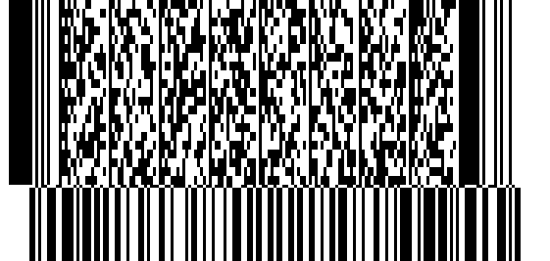
SSCC and pallet contents:
(00)376109170100130481
Shipment data:
Transport Unit ID: 376109170100130481

Pallet contents:
PO number: AB123450:
GTIN: 00614141987658 Qty: 27 Lot #: ABC000987
PO number: AB123456:
GTIN: 00614141012565 Qty: 13
S/N: 20010904050002 S/N: 20010904050001
S/N: 20010904050003 S/N: 20010904050004
S/N: 20010904050008 S/N: 20010904050013
S/N: 20010904050007 S/N: 20010904050005
S/N: 20010904050009 S/N: 20010904050006
S/N: 20010904050011 S/N: 20010904050012
S/N: 20010904050010
PO number: AB123458:
GTIN: 00614141012343 Qty: 10
S/N: 10063009060058 S/N: 10063009060068
S/N: 10063009060066 S/N: 10063009060060
S/N: 10063009060061 S/N: 10063009060064
S/N: 10063009060063 S/N: 10063009060062
S/N: 10063009060067 S/N: 10063009060069

Ship to:
Good Customer
Kodiak Rd.
Totown, AK 98765USA

Figure E-33
Label encoding the mixed contents of a transport container

Bill of lading example
Figure E-34 is an example of PDF417 use on Transport Unit supporting documentation.

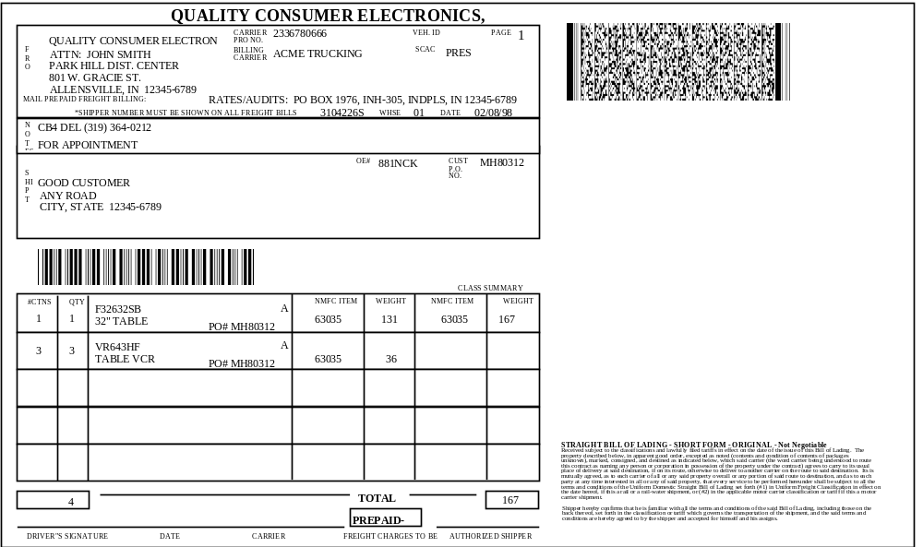

Figure E-34
Bill of Lading with PDF417 symbol encoding
an ANSI ASC X12 204 transaction set (not to scale)

(informative)

Recommended label locations on various containers

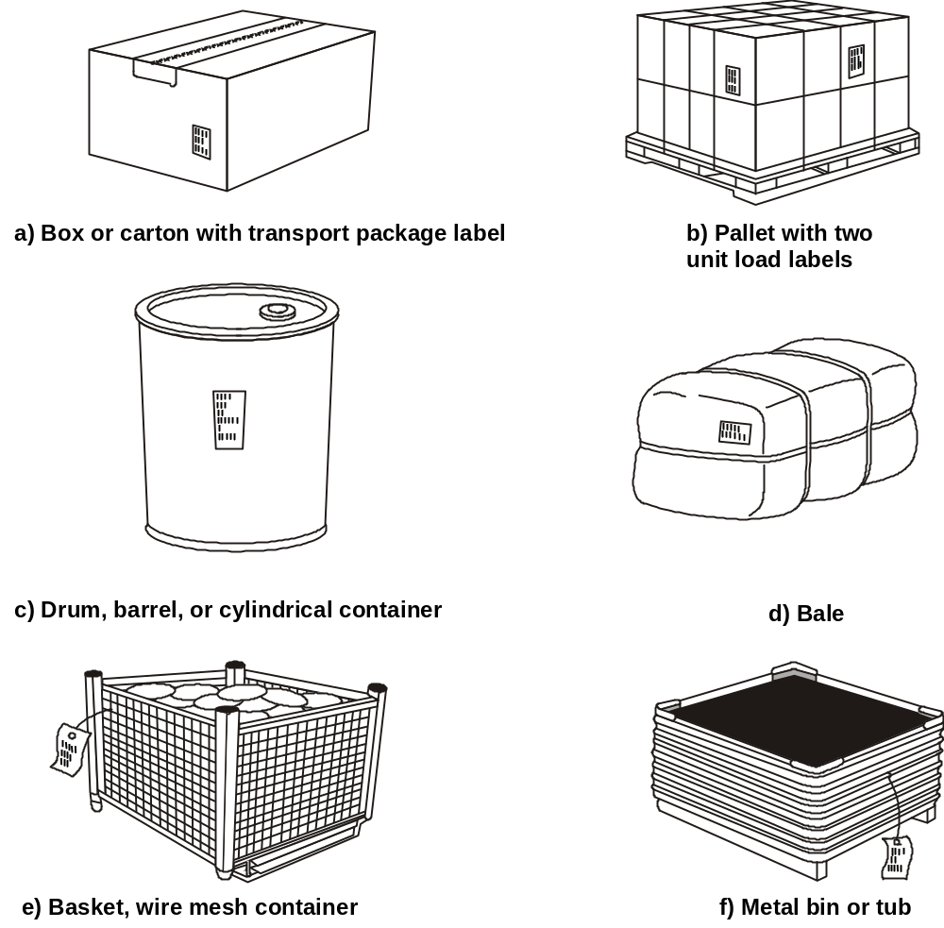

Annex F – Label placement on various packages

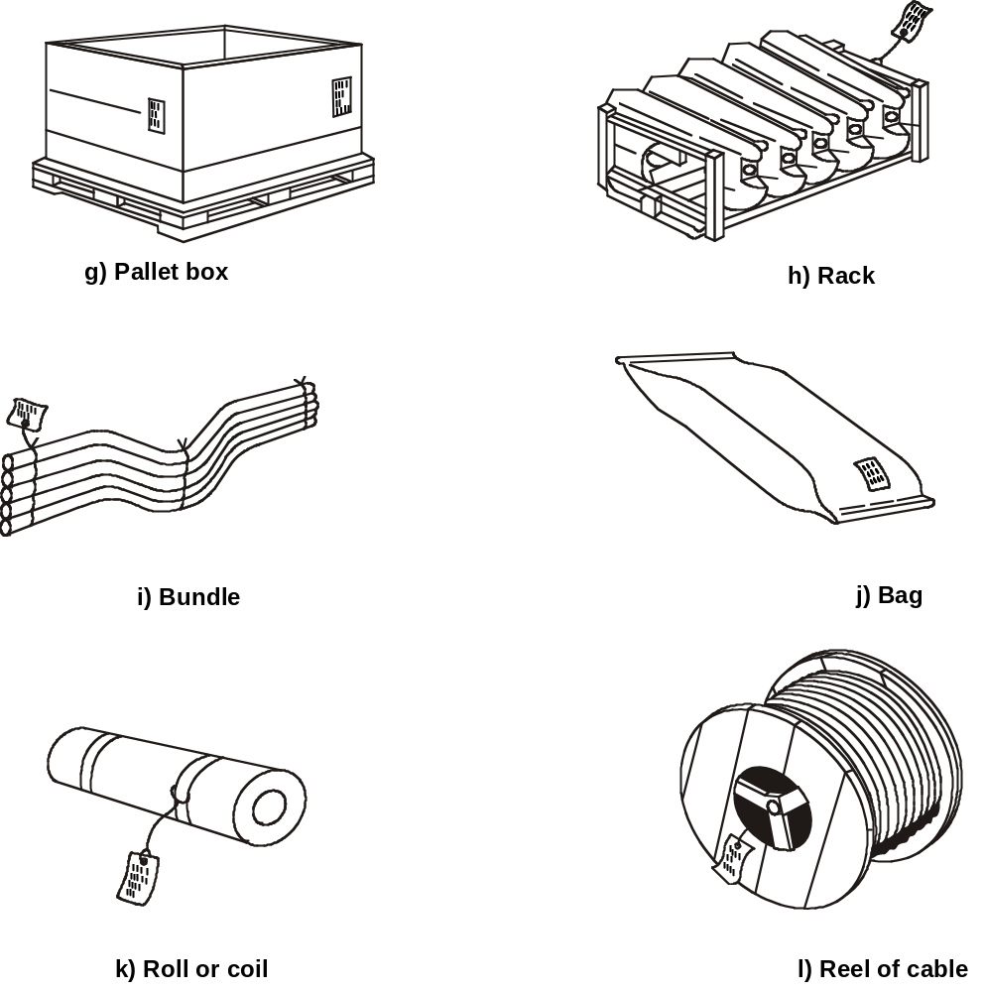
(m) below shows possible locations for the transportation MaxiCode sortation/tracking label and for the customer’s label.

- Users may choose one label combining the needs of both transportation and customer.

- Also see above for additional label placement examples.

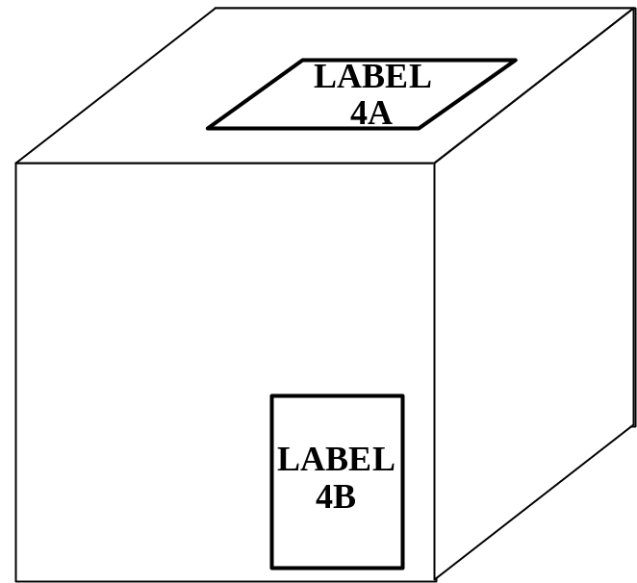

m) Location of transportation (4A) and customer labels (4B); (not to scale)

(informative)

Applications using Code 39 and Code 128 symbologies

Open systems, such as identified in this standard, encourage the free movement of products between any supplier and customer. Organizations scanning the bar code label for shipping and receiving may be presented with symbols which do not conform to their specific requirements but are useful elsewhere in the supply chain. This annex addresses issues which are associated with this situation. These issues can affect any organization. The annex also addresses the issues which need to be considered in a planned migration between options.

This annex describes the use of Symbology Identifiers as identified in ISO/IEC 15424. The Symbology Identifier is a prefix to the data transmitted by a decoder. Symbology Identifiers are not encoded in the symbol.

The options are:

- Application Identifiers with UCC/EAN-128 symbology,
- ANSI MH10.8.2 Data Identifiers with Code 39 symbology,
- ANSI MH10.8.2 Data Identifiers with Code 128 symbology.

Although it may be intended that only one of these combinations be in a system, it is important for all users to be aware that any of the other combinations can appear in a scanning system. Given this fact, organizations may choose to support a single option or support other options as well. These are discussed below.

Systems where a single option is intended to be scanned
For users selecting to operate in a single option environment, there are three procedures to consider.

- For single use of option 1, users may be able to switch off all other symbologies in a decoder, including Code 128, as described in option 3. If the decoder supports Symbology Identifiers, the host system shall validate the appropriate Symbology Identifier, specifically “]C1”, that signifies a UCC/EAN-128 symbol having a FNC1 character in the first position after the start code.
- For single use of option 2, users switch off all other symbologies in any decoder. If the decoder supports Symbology Identifiers, the host computer system shall validate the appropriate Symbology Identifier, specifically “]A0”.
- For single use of option 3, users will need to implement fully the Symbology Identifier capability. For decoders that do not support Symbology Identifiers, host computer systems will be unable to automatically distinguish between option 1 and option 3. By using the Symbology Identifier, the host computer can distinguish between the different options and filter out the unwanted options. The host computer shall validate the appropriate Symbology Identifier, specifically “]C0”.

Systems where multiple options are intended to be scanned
Users who choose to provide their systems with information scanned from labels using two or all of the options, shall fully implement Symbology Identifier capabilities. For decoders that do not support Symbology Identifiers, host computer systems will be unable to automatically distinguish between option 1, option 2, and option 3. By using the Symbology Identifier, the host applications can be coded to distinguish between the different options and filter out the unwanted options. The combination of the Symbology Identifier and the ANSI MH10.8.2 Data Identifier or EAN.UCC Application Identifier will provide the user with reliable input.
Bibliography

- ASCII/ISO 646 Information technology – ISO 7-bit coded character set for information interchange

- D-U-N-S® Number Available from Dun & Bradstreet, 1 Diamond Hill Road, Murray,
Users' Guide NJ, 07974

- EAN Standards EAN International, Rue Royale 145, B-1000 Brussels, Belgium. Telephone: +32 2 218 76 74 • Telefax: +32 2 218 75 85

- ISO 15394 Packaging – Bar code and two-dimensional symbols for shipping, transport and receiving labels

- ISO/IEC 15418 Information technology – EAN/UCC Application Identifiers and Fact Data Identifiers and Maintenance

- ISO/IEC 15419 Information technology -- Automatic identification and data capture techniques -- Bar code digital imaging and printing performance testing

- ISO/IEC 15421 Information technology -- Automatic identification and data capture techniques -- Bar code master test specifications

- ISO/IEC 15424 Information technology – Automatic identification and data capture techniques – Data Carrier Identifiers (including Symbology Identifiers)

- ISO/IEC 15434 Information technology – Transfer syntax for high capacity ADC media

- ISO/IEC 15459-2 Information technology – Unique identification of transport units – Part 2: Registration procedures

- ISO/IEC AWI 24728 Information Technology -- Automatic Identification and Data Capture techniques -- Bar Code Symbology Specification -- MicroPDF417

- UCC Standards Membership, and to receive a UCC Company Prefix – Uniform Code Council, 7887 Washington Village Drive, Suite 300, Dayton, OH, 45459-8605. Telephone: (937) 435-3870 • Telefax: (937) 435-7317

In accordance with General EAN.UCC Specifications
Compliant to ISO/IEC 15417
Compliant to ISO/IEC 16388
2

