ANSI MH10.8.8-2005

American National Standard

Radio Frequency Identification for
Packages, Parcels, and Flat Mail

Approved: xx Month 2005

Abstract
This standard provides guidance for the use of radio-frequency identification (RFID) for the handling and tracking of packages, parcels, and flat mail. The standard identifies minimum data requirements as well as semantic and syntactical recommendations. This standard further provides specific recommendations for the air interface communications of RFID devices based on the application requirements identified by the carriers.



Material Handling Industry
8720 Red Oak Blvd., Suite 201
Charlotte, NC 28217-3992
Printed: Month 2005

American  National  Standard | Approval of an American National Standard requires verification by the American National Standards Institute (ANSI) that the requirements for due process, consensus, and other criteria for approval have been met by the standards developer  Consensus is established when, in the judgment of the ANSI Board of Standards Review, substantial agreement has been reached by directly and materially affected interests. Substantial agreement means much more than a simple majority, but not necessarily unanimity. Consensus requires that all views and objections be considered, and that a concerted effort be made toward their resolution  The use of American National Standards is completely voluntary; their existence does not in any respect preclude anyone, whether he has approved the standards or not, from manufacturing, marketing, purchasing, or using products, processes, or procedures not conforming to the standards  The American National Standards Institute does not develop standards and will in no circumstances give an interpretation of any American National Standard. Moreover, no person shall have the right or authority to issue an interpretation of an American National Standard in the name of the American National Standards Institute. Requests for interpretations should be addressed to the sponsor whose name appears on the title page of this standard  CAUTION NOTICE: This American National Standard may be revised or withdrawn at any time. The procedures of the American National Standards Institute require that action be taken periodically to reaffirm, revise, or withdraw this standard. Purchasers of American National Standards may receive current information on all standards by calling or writing the American National Standards Institute.

Published by:

Material Handling Industry for:
MH10, Unit-Loads & Transport-Packages,
MH10 is an ANSI Accredited Standards Committee

Secretariat: Material Handling Industry
8720 Red Oak Blvd., Suite 201, Charlotte, NC 28217-3992

Copyright © 2005 by Material Handling Industry
All rights reserved

No part of this publication may be reproduced in any
form, in an electronic retrieval system or otherwise
without prior written permission of the publisher

Printed in the United States of America

Foreword (this forward is not part of American National Standard MH10.8.8-2005)

Increasingly, commercial and government letter, parcel, and small package carriers are finding needs to have interoperable methods of handling, processing, and tracking of items sent through postal and logistics services. Many industries have adopted the framework of a specific standard, American National Standards (ANS) MH10.8.1, in their implementation of shipper-to-consignee information with respect to optically readable media. This standard addresses the carrier implementation of the MH 10/SC 8 standards while expanding the applications to radio frequency identification.

Internationally, the ISO TC 122 (Packaging)/TC 104 (Freight Containers) Joint Working Group – Supply Chain Applications of RFID is addressing standards for product packages (ISO 17366) and transport units (ISO 17365). There is a close coordination between the efforts of the international community and the development of this standard.

At the time of approval, the MH10 committee consisted of the following members:

AIM, Inc. | Integrated Business Communications Alliance
American Trucking Associations | Intermec Technologies
American Wood Packaging Association | International Cargo Handling Coordination Association
APA - The Engineered Wood Association | International Safe Transit Association
Association of American Railroads | Material Handling Industry
Assoc. of Professional Material Handling Consultants | Material Handling Management Society
Association of American Railroads | National Wooden Pallet & Container Association
ASTM | Plastic Drum Institute
Automotive Industry Action Group | Q.E.D. Systems
CompTIA | Rack Manufacturers Institute
Containerization & Intermodal Institute, Inc. | Reusable Industrial Packaging Association
Electronics Industries Association | Steel Shipping Container Institute
Fibre Box Association | Textile Bag Manufacturers Association
Flexible Intermediate Bulk Containers Association | U.S. Dept. of Agriculture
Food Marketing Institute | U.S. Dept. of Defense Logistics
Glass Packaging Institute | U.S. Forest Products Laboratory
Graphic Communications Association | Uniform Code Council
Industrial Metal Containers & Wire Decking (IMC&WD) | United Fresh Fruit & Vegetable Association
Institute of Packaging Professionals | United Parcel Service

At the time of approval, the MH10.8 committee consisted of the following members:

AIAG
Allied Labels and Ribbons
ATA
Boeing
Bruno Associates
Canada Post
CDO
DLA
DoD AIT Project Office
Fed Express
General Motors
Hand Held Products
High Tech Aid
IBM
Intermec
Motorola
QED Systems
Strategic Consulting Services
Telecordia Tech/ATIS BCSC
Texas Instruments
Uniform Code Council
UPS
USAF
USPS

DOCUMENT MAINTENANCE SUMMARY

This document has had the following changes since its issuance as ANSI MH10.8.8 – 200x.

Date | Action | Summary

TABLE OF CONTENTS

1. Scope 7
2. Normative References 7
3. Terms and Definitions 8
3.1 carrier pickup 8
3.2 container 8
3.3 delivery 8
3.4 delivery preparation 8
3.5 dock operations 8
3.6 flat 8
3.7 flat mail (flat-size mail) 9
3.8 item 9
3.9 letter mail 9
3.10 mail 9
3.11 package 9
3.12 packaging 9
3.13 parcel 9
3.14 pure URI 9
3.15 sortation 9
3.16 tag 9
3.17 transport unit 9
3.18 transport package 9
3.19 transportation 10
3.20 UII (Unique Item Identifier) 10
3.21 unit load (unitized load) 10
3.22 URI 10
4. Application description(s) 10
4.1 Survey results 10
4.2 How far? 10
4.3 How fast 10
4.4 How much 11
4.5 How many 11
4.6 Environmental conditions 11
4.7 General characteristics 11
5. Technology Considerations 12
5.1 Antenna placement/design 12
5.2 Frequency applicability 12
6. Concepts 13
6.1.1 Principles 13
6.2 Unique identifier (UII) 13
6.3 Label formats 13
6.3.1 Base item label/tag 13
6.3.2 Extended mail piece label/tag 14
7. Data structure 14
7.1 Data 14
7.1.1 License plate application 14
7.1.2 Data rich application. 14
7.2 Data presentation 14
7.2.1 Data semantics 14
7.2.2 Data syntax 14
7.2.3 Data in human readable form 14
7.3 Data elements 15
7.3.1 Unique item identifier (UII) (Mandatory) 15
7.3.2 Ship to (Optional) 15
7.3.3 Ship from (Optional) 15
7.3.4 Key to carrier's database (Optional) 15
7.3.5 Key to consignee's database (Optional) 15
7.3.6 Key to consignor's database (Optional) 15
7.3.7 TAG Unique identifier (TID) (Optional) 16
7.3.8 Hazardous Material (HazMat) (Optional) 16
7.3.9 Other data elements (Optional) 16
8. Data Security 16
8.1 Data integrity 16
8.2 Confidentiality 16
8.3 Identification of RFID labeled material 17
9. Tag operation 17
9.1 Data protocol 17
9.2 Minimum performance requirements 17
9.3 Environmental requirements 17
9.4 Air interface 17
9.5 Memory requirements for application 17
9.6 Safety and regulatory considerations 17
9.7 Tag Reliability requirement 17
9.8 Tag privacy 17
10. Material 17
10.1 Tag recyclability 18
11. Conformance 18
12. Label placement 18
12.1 General considerations 18
13. Bibliography 18
13.1 Useful references: 18
13.1.1 aggregation 18
13.1.2 bundle 18
13.1.3 returnable transport item (RTI) 18
13.1.4 totes 19
Annex A : Survey results Normative 20
A.1 Survey results 20
Annex B (normative) Label adhesive characteristics 32
B.1 General 32
B.2 Requirements 32
B.2.1 Adhesion characteristics 32
B.2.2 Use and protection 32
B.2.3 Storage Conditions 32
B.2.4 Longevity 32
B.2.5 Blank label stock contamination 32
B.3 Method of test 33
B.3.1 Adhesive strength 33
B.3.1.1 Label test panel preparation: 33
B.3.1.2 Initial adhesion strength: 33
B.3.1.3 Short term 49 degrees centigrade 95% RH - temp/humidity 33
B.3.2 Blank label stock contamination 33
B.3.3 Recyclability 33
Annex C (normative) Testing 35
C.1 Testing of tag under various environmental conditions 35
C.2 Testing of reading equipment 35
C.3 Testing of the complete system 35
Annex D (normative) Examples 36
D.1 Label Examples 36
D.1.1 Ship to (Optional) 36
Annex E (informative) Recommended label locations on various containers 37

RFID for Packages, Parcels, and Flat Mail

Scope

This standard provides guidance for the use of radio-frequency identification (RFID) for the handling and tracking of packages, parcels, and flat mail from the pickup to the delivery of the item. This standard does not address any warehousing or inventory control requirements of package logistics.
The standard identifies minimum data requirements as well as semantic and syntactical recommendations. This standard further provides specific recommendations for the air interface communications of RFID devices based on the application requirements identified by the carriers.
This standard does not supersede or replace any applicable safety or regulatory marking or labeling requirements. The standard is to be applied in addition to any other mandated labeling requirements. This standard covers all mailable items other than letter mail.

Normative References

The following referenced documents are indispensable for the application of this document. For dated references, only the edition cited applies. For undated references, the latest edition of the referenced document (including any amendments) applies.

ISO/IEC 15418 | EAN.UCC Applications Identifiers and ASC MH10.8 Data Identifiers
ISO/IEC 15434 | Information technology - Automatic identification and data capture techniques - Syntax for high capacity ADC media
ISO/IEC 15459-1 | Information Technology - Unique identification - Part 1: Unique identification of transport units
ISO/IEC 15459-2 | Information Technology - Unique identification - Part 2: Registration procedures
ISO/IEC 15459-3 | Information Technology - Unique identification - Part 3: Common rules for unique identification
ISO/IEC 15459-4 | Information Technology - Unique identification - Part 4: Unique item identification for supply chain management
ISO/IEC 15961 | Information technology -- Radio frequency identification (RFID) for item management -- Data protocol: application interface
ISO/IEC 15962 | Information technology -- Radio frequency identification (RFID) for item management -- Data protocol: data encoding rules and logical memory functions
ISO/IEC 15963 | Information technology -- Radio frequency identification for item management -- Unique identification for RF tags
ISO/IEC 17365 | Supply chain applications of RFID – Transport units
ISO/IEC 17366 | Supply chain applications of RFID – Product packaging
ISO/IEC 18000, Part 3 | Information technology -- Automatic identification and data capture techniques -- Radio-frequency identification for item management, Part 3: Parameters for air interface communications at 13,56Mhz
ISO/IEC 18000, Part 6 | Information technology -- Automatic identification and data capture techniques -- Radio-frequency identification for item management, Part 6: Parameters for air interface communications at 860 – 930 MHz
ISO/IEC 18000, Part 7 | Information technology -- Automatic identification and data capture techniques -- Radio-frequency identification for item management, Part 7: Parameters for active RFID air interface communications at 433 MHz
ISO/IEC 18046 | Information technology – Automatic identification and data capture – RFID device performance test methods
ISO/IEC TR 18047-3 | Information technology -- Radio frequency identification device conformance test methods -- Part 3: Test methods for air interface communications at 13,56 MHz
ISO/IEC TR 18047-6 | Information technology -- Automatic identification and data capture techniques -- RFID device conformance test methods -- Part 6: Test methods for air interface communications at 860 - 960 MHz
ISO/IEC TR 18047-7 | Information technology -- Automatic identification and data capture techniques -- RFID device conformance test methods -- Part 7: Test methods for air interface communications at 433 MHz
ISO/IEC 19762 | Information technology - AIDC techniques - Harmonized vocabulary
ANS MH10.8.1 | Automatic Identification and Data Capture Techniques Used in Shipping, Receiving, and Transport Applications
ANS MH10.8.2 | Data Identifier and Application Identifier Standard
General EAN.UCC Specifications | General EAN.UCC Specifications
EPCglobal™ Tag Data Standard v1.3
AIM SAG 0501 v2.1 | AIM RFID Emblem Standard

Terms and Definitions
For the purposes of this document, the terms and definitions given in ISO/IEC 19762 and the following apply.

carrier pickup
process of tendering a single or multiple non aggregated item(s) not containerized or associated with a unit load at the time of pickup
Note: Aggregated carrier pickup (e.g. items in pallets, returnable containers etc.) is an extension of the transportation process.

container
non-specific term for a receptacle capable of closure. [adapted from ISO 830]

delivery
process of tendering the item to consignee

delivery preparation
process of placing items into a vehicle for delivery
Note: Can be loose or containerized. Sometimes called pre-loading.

dock operations
process of loading or unloading vehicles at a facility
Note: May include the process of manually separating and sorting aggregated items into newly aggregated items, cross docking etc.

flat
general term for flat-size mail, so called because the mail is sorted without bending so that it remains flat

flat mail (flat-size mail)
mailpiece that exceeds one of the dimensions for letter-size mail (291mm long, 159mm high, 6 mm thick) but that does not exceed the maximum dimension for the mail processing category (381mm long, 305mm high, 19mm thick)
Note: Dimensions are different for automation rate flat-size mail eligibility. Flat-size mail may be unwrapped, sleeved, wrapped, or enveloped.

item
(1) a whole individual unit; especially when included in a list or collection (2) a distinct part that can be specified separately in a group of things that could be enumerated on a list, (3) a small part that can be considered separately from the whole.

letter mail
mail processing category of mailpieces, including cards, that do not exceed any of the dimensions for letter-size mail (that is, (291mm long, 159mm high, 6 mm thick)

mail
mailable matter that is accepted for mail processing and delivery by a postal operator. Also, the sum total of the mail at any time that is in postal operator custody

package
containerized group of addressed pieces assembled and secured together to make up a basic unit of bulk items for processing purposes.

packaging
products made of any materials of any nature to be used for the containment, protection, handling, delivery and presentation of goods, from raw material to processed goods, from the producer to the user or the consumer. Non-returnable items used for the same purpose shall also be considered to constitute packaging. Packaging consists of industrial packaging, sales packaging, grouped packaging, and transport packaging. [adapted from ISO 21067]

parcel
item that does not meet the mail processing category of letter-size mail or flat-size mail. It is usually enclosed in a mailing container such as a carton.

pure URI
an abstract name or number used to identify an entity shown as a character string representation

sortation
process of automatically or manually separating and sorting items or aggregated singulated items into newly aggregated items

tag
transponder plus the information storage mechanism attached to the object
Note: The tag is typically either supplied in a paper label or embedded in a corrugated box.

transport unit
Either a transport package or a unit load

transport package
package intended for the transportation and handling of one or more articles, smaller packages, or bulk material. [adapted from ISO 21067]

transportation
process of moving collections of items (singly or aggregated) from one facility to another facility. Includes containers and trailers

UII (Unique Item Identifier)
identification that uniquely identifies a specific entity during its life
Note: may be used with qualifier: UII-Returnable UII-Container UII-Transport, etc

unit load (unitized load)
one or more transport packages or other items held together by means such as pallet, slip sheet, strapping, interlocking, glue, shrink wrap, or net wrap, making them suitable for transport, stacking, and storage as a unit. In distribution, an item or assembly of items assembled or restrained for handling and transportation as a single entity. [adapted from ISO 21067]

URI
uniform resource identifier encodings that provide the means for application software to process EPC tag encodings, either literally i.e. at the bit level, or at various levels of semantic abstraction that is independent of tag variations

Application description(s)

Survey results
A survey was sent to logistics providers to gain information on the RFID needs for handling packages. The results of the survey are shown in Annex A. The following requirements are the committees interpretation of those results.

How far?
For each of the application areas the results show the typical distance (minimum and maximum) over which the RFID tag will be expected to function.

 | Carrier Pickup | Sortation | Transportation | Delivery Preparation | Delivery | Dock Operations
Tag to Reader Distance
Range | 100mm – 1m | 100mm – 2m | Truck loading 100mm – 3m | 100mm - 3m | 100mm – 1m | 100mm – 3m

The above results suggest that the tag could be used as close as 100mm but as far as 3m in different applications.

How fast
For each of the application areas the results show the typical speed of the package (minimum and maximum) that the RFID tag over which will be expected to function.

 | Carrier Pickup | Sortation | Transportation | Delivery Preparation |  | Delivery | Dock Operations
Speed range of tags for read and write operations | Stationary | 1-3 m/s | 2-7 m/s |  | 0.5 – 1.5 m/s | Stationary | 0 – 1 m/s
Number of tags read or written in the field at one time | 1-5 | 1 to 10 | 10-100 |  | 5 - 40 | 1 to 5 | >=40
Singulation (Identify one tag from among many) | Yes | Yes | Yes |  | Yes | Yes | Yes
Spatial Separation / Tags to One and the Other | 5 mm to 150 mm | 5 mm to 150 mm | 5 mm to 150 mm/ |  | 5 mm to 150 mm | 5 mm to 150 mm | 5 mm to 150 mm
NOTE: Tags closer that 10 mm could show reduced functionality. Tags and readers must be appropriately selected.

How much
For each of the application areas the results show the amount of data that the RFID tag will be expected to handle.

 | Carrier Pickup | Sortation | Transportation | Delivery Preparation | Delivery | Dock Operations
Number of characters stored on tag and being transferred during read or write | <= 500 | <= 500 | <= 500 | <= 500 | <= 500 | <= 500

For each application the results show how the data should be treated.

Read specific field without reading entire tag Yes
Data changed or appended during tag life Yes
Data Encryption Yes
Unique tag ID Yes

How many
For each of the application areas the results show the typical speed of the package (minimum and maximum) that the RFID tag over which will be expected to function.

 | Carrier Pickup | Sortation | Transportation | Delivery Preparation | Delivery | Dock Operations
Maximum number of tags in field | Up to 500 | 5 to 20 | Up to 5000 | 5 to 20 | Up to 500 |  | Up to 40
Multiple tags read at same time? | Yes | Yes | Yes | Yes | Yes |  | Yes
Read/write a continuous flow of multiple tags | Yes | Yes | Yes | Yes | Yes |  | Yes

Environmental conditions
The following environmental conditions are common across all the applications.

8. Environmental Conditions
Operating Temperature | -20 to +60 C
Non-operating Temperature | - 40 to +85 C
Humidity | 5% - 100% @ 50C for 8 hours
Shock | TIA/EIA 603 para 3.3.4
Vibration | TIA/EIA 603 para 3.3.5
Tag life | Single use or reusable

General characteristics
The following general attributes were recorded for the various applications:
Read-only / Read-write Read/write
Orientation (perpendicular / omni-directional) Omni
Metal storage racks/cages? - Proximity Yes (25 mm – 600 mm)
Obstructions Yes
Visible / embedded (plastic, cardboard, wood, metal Visible/Embedded
Requisite mounting apparatus Adhesive backed
Requisite tag size (height, width, thickness) No requirement, thickness shall not impede the use of the tag (printing etc.)
Reclaimable/Reusable tag Yes
NOTE: Labels that include an RFID tag must be printed with care. Printers that are designed to print RFID media must be used.

Technology Considerations

Antenna placement/design
The antenna design on the tag will be appropriate for the frequency and application chosen. Location of this chip/antenna on a label shall be such that the following considerations are given:

- The location of the RFID chip should not interfere with any printing that has to be applied to the label.
- The printing process, label design, and tag design shall be selected to minimize damage to tags and printers during processing
- The location of the chip/antenna should be such that normal use of the label does not require the antenna to be bent.
- Labels should always be placed on an object such that they are in the most stable position and not on the seam of a parcel or package.
- Flat mail, packages and parcel may include metallic content and the label shall be designed and placed accordingly.
- ISO/IEC 24729-1 provides guidance on implementation, including label placement. Design of reader antenna systems should be appropriate to the location and orientation of the antenna on the object.

Frequency applicability
ISO/IEC JTC 1/SC 31 has defined acceptable international air interfaces for RFID standards. These standards and the basic properties of each are listed below.
Table 1 — Properties of popular RFID frequencies
Regulation | Frequency | Regulation | Range | Data Speed | Comments
ISO/IEC 18000, Part 2 | 125-150 kHz | Basically unregulated | < 1m | Low | Animal identification and factory data collection systems
ISO/IEC 18000, Part 3 | 13.56 MHz | ISM band, differing power levels and duty cycle | < 1m | Low to high | Popular frequency for I.C. Cards (Smart Cards), EPCglobal
ISO/IEC 18000, Part 4 | 2450 MHz | ISM band, differing power levels and duty cycle | 1 – 2 m | High | IEEE 802.11b, Bluetooth, CT, AIAG B-11
ISO/IEC 18000, Part 6 | 860-960 MHz | ISM band (Region 2); increasing use in other regions, differing power levels and duty cycle | 2 – 5 m | Low to moderate | EAN.UCC GTAG, MH10.8.4 (RTI), AIAG B-11 (Tires), EPCglobal
ISO/IEC 18000, Part 7 | 433 MHz | Non-specific Short Range Devices (SRD), Location Systems | 1 – 100 m | Moderate | Container security and tracking, asset tracking for DoD (Pallets-containers)

The following requirements are identified above (section 4):

Read range: 100mm to 3 m
Data content: Up to 512 characters
Read speed: Tags moving from 0 to 3 m/s
Field of view: 1 to 100 tags per second

Based on the application requirements stated above the better frequency range for battery-less, passive tags, for applications of 0 - 3 meters – ISO/IEC 18000, 6 is most suitable.

Concepts

Principles
The purpose of an RF tag within package, parcel, and flat mail applications is to support the carrier’s material handling application while providing the opportunity of added value to the consignees and consignors. The minimum amount of data, in an RF tag, and in human readable form, is dependent on the requirements of the carrier. Where an RF tag is used in conjunction with electronic data bases and/or electronic data interchange (EDI) systems the amount of data may be significantly reduced and may consist of only one piece of data, the unique identifier for the package, parcel, or flat mail piece.
Different consignees and consignors have different information requirements. Some information may be common to two or more trading partners while other information may be specific to a single trading partner. Information for various trading partners becomes available at different times, e.g.:
• product specific information at the point of manufacture or packaging
• order processing information at the time of processing the order
• transport information at the time of shipment.

Trading partners may find it necessary to include significant data elements to support the information needs of all trading partners including the carrier which may be presented both in RF tags and human readable form.

Unique identifier (UII)
The labeler applies an identifier to each mail piece prior to shipment in conformance with the carriers requirements. This is a common requirement for all label formats specified by this standard. The identifier or “license plate” is the key providing access to information stored in computer files and which may be transmitted electronically. The identifier may be used by all of the trading partners to retrieve information about the mail piece itself or about the status of the physical movement of the mail piece along the supply chain. It enables systems to track and trace individual mail pieces.

Label formats

Base item label/tag
The Base Label defined by this standard includes the data that fulfills the minimum requirements of all trading partners in a supply chain when data is exchanged electronically between the parties involved.

A Unique Transport Unit Identifier shall be included on the Base Label. All Base Labels attached to the Transport Unit shall be identical.

In addition to the Unique Transport Unit Identifier (license plate), it is recommended to provide the following information on a Base Label:

- Ship From address (to be able to return the shipment in the case delivery was not possible),
- Ship To address (for shipment delivery),
- key to the carrier's database (if the license plate is not this data element),
- key to the customer's database (if the license plate is not this data element).

Extended mail piece label/tag
In practice, fully automated communication channels which make it possible to rely exclusively on electronic files for retrieving information on the movements of the mail pieces are not always available. For this reason, there may be a need to indicate relevant information on the mail pieces themselves, in addition to their identification.

The Extended label/tag is used when the data available from the Base label/tag is not sufficient to satisfy the requirements of all trading partners. In order to facilitate the processing and interpretation by trading partners, information provided in the Extended label/tag is organized in three segments:
• Carrier segment. In addition to the key to the carrier’s data base this segment may contain additional data, such as shipment identification and delivery instructions;
• Customer segment. In addition to the pointer to the customer’s data base, this segment may contain additional data such as the customer part number;
• Supplier segment. Additional data may be generated by the supplier, such as product identification, batch number, dimensions.

Data structure

Data
The data encoded on the tag shall either be of a license plate type application or a data rich application.

License plate application
In the case of a license plate application, the registration authority for the application shall be as defined in ISO/IEC 15962 AFI field.

Data rich application.
The information contained in the tag will conform to 7.3 below.

Data presentation

Data semantics
Data elements shall include the appropriate identifiers called out in either the General EAN.UCC Specifications (Application Identifiers) or within the ANS MH10.8.2 (Data Identifiers). These conventions comply with ISO/IEC 15418, EAN.UCC Application Identifiers and ASC MH 10 Data Identifiers.

Data syntax
When mutually agreed by trading partners, information beyond the Unique Item Identifier may also be provided in the mail piece label/tag. Data syntax for such mail pieces shall be in accordance with ISO/IEC 15434, Syntax for high capacity ADC media. Only Format Indicators “01”( Carrier Sortation & Tracking), “05” (EAN/UCC Application Identifiers), and “06” (Using Data Identifiers) shall be used.

Data in human readable form
The human readable information representing the data presented in the label/RF tag shall be provided on the mail piece.

Data elements

Unique item identifier (UII) (Mandatory)
A unique item identifier (UII) shall be assigned by the labeler prior to shipment of each item. The item identifier shall be preceded by the appropriate Application Identifier or Data Identifier.
The structure of the item identifier is defined in ISO/IEC 15459-1. The item identifier:
1. starts with the Issuing Agency Code (IAC), assigned to the issuing agency by the Registration Authority;
2. conforms to a format specified by the issuing agency;
3. is unique in the sense that no issuer re-issues a number until a sufficient period of time has passed so that the first number has ceased to be of significance to any user (one year is a recommended minimum);
4. contains only numeric and upper case alphabetic characters (not including lower case characters or punctuation marks);
5. if an Application Identifier for an SSCC is used (00) the UII will contain 20 characters or the "pure URI" as defined in the EPCglobal™ Tag Data Standard v1.3. If a Data Identifier is used up to 35 characters may be used.
The unique transport unit identifier shall be either:
• the SSCC, that uses Application Identifier “00”;
• the unique transport unit identifier using the ANS MH10.8.2 Data Identifier “J”.

Ship to (Optional)
The “Ship to” data element refers to the address of the party to which items are to be delivered. When used, it shall be represented in a maximum of five lines of human readable characters comprised of no more than 35 alphanumeric (an..35) characters each.

Ship from (Optional)
The “Ship from” data element refers to the address of the party to which items are to be returned, in case the shipment was unable to be delivered. When used, it shall be represented in a maximum of five lines of human readable characters comprised of no more than 35 alphanumeric (an..35) characters each.

Key to carrier's database (Optional)
If the unique transport unit identifier described in 7.2.1 above does not provide the key to the carrier’s data base, one or more of the following keys may be used:
- Carrier tracking number that includes class of service
- Carrier code to identify the shipment
- Carrier code to identify the transport unit
- EPC identifying key to carrier’s data base

Key to consignee's database (Optional)
If the unique transport unit identifier described in 7.2.1 above does not provide the key to the customer's database, one or more of the following keys may be used:
- Consignee's purchase order number
- Part Number
- KANBAN / Pull Signal Number
- EPC identifying key to consignee’s data base, e.g. SSCC or
- Shipment ID or Unique shipment control number e.g. TCN, FedEx number, UPS tracking number

Key to consignor's database (Optional)
If the unique transport unit identifier described in 7.2.1 above does not provide the key to the customer's database, one or more of the following keys may be used:
- Consignor's order number
- Tracking Number
- Shipment ID or Unique shipment control number e.g. TCN, FedEx number, UPS tracking number

TAG Unique identifier (TID) (Optional)
The TID is a unique number encoded in the RFID integrated circuit during manufacture to enable the tracking of the IC. This number is not related to the unique number assigned to the item that the tag is placed on. ISO/IEC 15963, Automatic identification – Radio Frequency Identification for item management – Unique identification for RF tags provides for the unique identification of RF tags.

The Unique Identifier as defined by ISO/IEC 15459, Information technology - Item Management - Unique item identification for supply chain management, provides for the establishment of license plates for tracking items.

RF tags as defined in this standard shall comply with both ISO/IEC 15963 and ISO/IEC 15459.

Hazardous Material (HazMat) (Optional)
If RFID tags include classification of items that are hazardous for storage, transportation, or use the tag will represent this indication within the user data storage as defined in ISO/IEC 15962.

The data element shall be identified as HazMat with an appropriate Data Identifier (5P or 10P)
The following information shall be recorded on the tag.

- Proper Shipping Name as identified by International Maritime Organization (IMO) associated with IMDG (International Maritime Dangerous Goods) (1965) codes
- Emergency Contact – This is a telephone number and a company name. It generally appears under the product description.
- IMO Class – Three digits as in “1.2” or “4.1”
- United Nations (U.N.) Number – Four digits, e.g. 2922
- Packaging Group – Choices are I, II or III

This standard does not supersede or replace any applicable safety or regulatory marking or labeling requirements. This standard is meant to satisfy the minimum product identification requirements of numerous applications and industry groups. As such its applicability is to a wide range of industries, each of which may have specific implementation guidelines for this standard. This standard is to be applied in addition to any other mandated labeling requirements.

Other data elements (Optional)
As much additional data as required may be included in the Extended label to fulfill the needs of the supplier, carrier, and customer.

Data Security

Data integrity
Tags shall have the ability to prevent the alteration or erasure of data commonly known as "locking" data. This shall be at the discretion of the user. Tag manufacturers shall have the option of locking a portion of the tag data for identification and storage of data related to that manufacturer and not the user.

Confidentiality
Tag users desiring to protect their data shall have the ability to store the data in an encrypted form. The encryption process shall be external to the tag. The mandatory required data shall not be encrypted. The tag shall be capable of having encrypted data written to it and read from it without interference from the tag design or structure. Use of this feature shall be at the discretion of the user and will be agreed by trading partners.

Identification of RFID labeled material
A tag may be marked to show that an RFID tag is present. The mark shall conform to the AIM RFID Mark Standard NASAG 0401. Information on this standard may be obtained from http://www.aimglobal.org/rfidmark.asp.

Tag operation

Data protocol
The data protocol for RF tags shall support the requirements of ISO/IEC 15961 and ISO/IEC 15962. The data syntax and semantics shall be as identified in Clause 7.1 of this American National Standard.

Minimum performance requirements
Range and rate performance requirements shall be stated as set forth in ISO/IEC 18046. Minimum performance requirements are defined in section 5.2. Passing speed, range, discrimination (tag separation) and presentation angle requirements are found in Section 5.2, above

Environmental requirements
Minimum environmental requirements are defined in section 4.6.

Air interface
The air interface requirements for item tag operation are as defined in ISO/IEC 18000-6

Memory requirements for application
The suggested memory capacity for license plate tags is 512 bits
The suggested minimum memory capacity for data rich passive tag operations is 512 bytes.

Safety and regulatory considerations
All tags conforming to this standard shall meet the safety and regulatory requirements of FCC Part 15/EU ERC 70-03/NTIA (as required), to include power, duty cycle and electromagnetic radiation.

Tag Reliability requirement
The tags used in accordance with this standard shall be capable of being read and if so structured written to with a reliability of 99.99%. The reliability shall be first read and first write reliability. The testing shall be over the environmental conditions specified in Annex C.

Tag privacy
The nature of tag privacy is such that individual tag applications shall utilize whatever privacy measures they choose provided that the privacy measures do nothing to impact on, interfere with or deteriorate the operation of other tags in the supply chain. Tags that are intended for use over the supply chain shall have the mandatory data elements readable.

Material
Label material and the method of attaching the label to the transport unit shall be selected to ensure that the label complies with MIL-L-61002, Military specification, Labels, pressure-sensitive adhesive, for bar codes and other markings, Annex B of this standard and:
• remains attached to the transport unit for the intended life of the label
•. remains readable for the life of the label;
• survives the environments for the life of the label, for example, contamination, heat, light, moisture;
•. meets disposability requirements.

Tag recyclability
The recyclability of RF tags is dependent upon the component materials used in the individual tags. In agreement with local regulations mail pieces tagged with RF tags that require recycling, shall be marked with an appropriate logo or other visible symbol that indicates the required recycling. Tags that should be recycled but for which such recycling is not mandated by regulation, statute or operating condition, shall be marked with an appropriate recycling symbol to assist the user in the proper disposal of the tag.

Conformance
The conformance to the required technical specification (i.e. 18000 part 6) shall be measured using ISO/IEC 18047-6..

Label placement

General considerations

Labels should be affixed at a suitable location where there is a minimum risk of damage. The RF tag should be placed on the same face of the mail piece as the current label. The exact placement shall be specified by the trading partners.

Examples of label placement are shown in Annex E.

Bibliography

ISO 3166-1 | Codes for the representation of names of countries and their subdivisions, Part 1: Country Codes
ISO 4217 | Codes for the representation of currencies and funds
ISO/IEC 15424 | Information technology – Automatic identification and data capture techniques – Data Carrier Identifiers (including Symbology Identifiers)
UPU Standard M82-3 | Universal Postal Union – Attribute Definitions
UPU Standard S26-5 | Universal Postal Union – License Plates for Parcels
ANSI INCITS:256 | Radio-frequency identification (RFID)

Useful references:

aggregation
process of combining items into collections of multiple items by size, destination, etc.

bundle
aggregation of items bound together and treated as a single item

returnable transport item (RTI)
means to assemble goods for transportation, storage, handling and product protection in the supply chain which are returned for further usage, including for example pallets with and without cash deposits as well as all forms of reusable crates, totes, trays, boxes, roll pallets, barrels, trolleys, pallet collars and lids. The term “returnable transport item” is usually allocated to secondary and tertiary packaging. But in certain circumstances also primary packaging may be considered as a form of RTI.
Freight containers, trailers and other similar enclosed modules are not covered by the term returnable transport item.

totes
form of reusable or returnable transport item

- : Survey results
Normative
  - Survey results

Company: | Canada Post Corp | FedEx Services | USPS
 | Carrier Pickup | Carrier Pickup | Carrier Pickup
1. Tag to Reader Distance
1a. Minimum | 3 ft | 1in | 3 ft
1b. Maximum | 10 ft | 12in | 3 ft
1c. Maximum distance for handheld reader, if different | - |  | -
2. Read-only / Read-write | Read Only | Read-Write | Read Only
3. Tag stationary or moving when read
3a. If moving, what speed | Stationary | Stationary | Stationary
3b. Tags per second when reading | 5 | 5 | 1-5 at once
4. Tag stationary or moving when written | na | Stationary | Stationary
4a. If moving, what speed | na |  | na
4b. Tags per second when writing | na | 1 | 1-5 at once
5. Number of characters transferred during read | Up to 300 | Up to 500 | Up to 300
6. Number of characters transferred during write | na | Up to 500 | Up to 300
7. Number of characters being stored on tag | Up to 300 | Up to 500 | Up to 300
8. Environmental Conditions
8a. Temperature | -20 to +60 C | -20 to +55 C | -40 to +60 C
8b. Humidity | 5% - 95% @ 50C for 8 hours Non Condensing | 5% - 95% @ 50C for 8 hours Non Condensing | 5% - 95% @ 50C for 8 hours Non Condensing
8c. Shock | TIA/EIA 603 para 3.3.4 | Minimum same as FedEx packaging spec. | TIA/EIA 603 para 3.3.4
8d. Vibration | TIA/EIA 603 para 3.3.5 | Minimum same as FedEx packaging spec. | TIA/EIA 603 para 3.3.5
8e. Tag life | 90 days | 30 days | Reusable
8f. Chemical Resisitance | No |  | Yes--environmental
8g. Dirt, dust, precipitation | IP64 |  | Yes--environmental
8h. Rough handling | TIA/EIA 603 para 3.3.4 | Minimum same as FedEx packaging spec. | TIA/EIA 603 para 3.3.4
8i. Electromagnetic interference | Per ETSI, EMC and RTTE | per FAA requirements | Per ETSI, EMC and RTTE
9. Presence of metal |  | YES - < 1 in
9a. Attached to metal? | No | No | No
9b. Metal storage racks/cages? - Proximity | Yes (min 1 inch max 2 ft) | YES | Yes (2" to 2')
10. Orientation (perpendicular / omni-directional) | Omni | Omni | Omni
11. Tag data
11a. Read specific field without reading entire tag | Yes | Yes | Yes
11b. Data changed or appended during tag life | No | Yes | No
11c. Encryption | No | Yes | No
12. Obstructions | Yes | Yes | Yes
13. Handheld / Fixed position | Handheld | Handheld | Handheld
13a. Batch or RFDC | RFDC | RFDC | RFDC
14. Multiple tags read at same time? |  | Yes
14a. Read a continuous flow of multiple tags | Yes | Yes | Yes
14b. Write a continuous flow of multiple tags | No | Yes | Yes
15. Reclaimable / reusable tag | No | No | Yes
16. Unique tag ID | Yes | Yes | Yes
17. Visible / embedded (plastic, cardboard, wood, metal | visible on pkg | Visible | Visible/Embedded
18. Requisite mounting apparatus |  | Adhesive backed | Low Probability
19. Requisite tag size (height, width, thickness) | flat on pkg | flat on pkg | Dependant on 18
 | H = 100 mm max | Must go through a
 | W = 100 mm max | thermal printer.
 | T = 5 mm max | Min. label size 3x4"
20. Singulation (Identify one tag from among many) | Yes | Yes | Yes
21. Spatial Separation / Tags to One and the Other | min 5 mm | 2in | 5 mm to 6 in.
22. Movement Speed During Write | na | Stationary | See 4a/b above
23. Movement Speed During Read | Stationary | Stationary | See 3a/b above
24. Group Select | Yes | Yes | Yes
25. Requisite reader size (height, width, thickness) | Handheld - Fits in Portable Data Terminal | Handheld | Handheld - Fits in Portable Data Terminal
 | H = 25 mm max | Fit into current
 | W = 25 mm max | courier hand held
 | T = 25 mm max | terminal
26. Maximum number of tags in field | Up to 500 | 20 | Up to 500
27. Comments | Similar to Delivery | Contents of package tag is placed on might contain metal. | Implementation in this area is conceptualized; no plans for implementation discussed as yet

Company: | Canada Post Corp | FedEx Services | USPS
 | Sortation | Sortation | Sortation
1. Tag to Reader Distance
1a. Minimum | 5 ft | 3in | 5 ft
1b. Maximum | 15 ft | 5ft | 15 ft
1c. Maximum distance for handheld reader, if different
2. Read-only / Read-write | Read Only | Read-Write | Read Only
3. Tag stationary or moving when read
3a. If moving, what speed | 500 fpm | 600fpm | 250 fpm
3b. Tags per second when reading | 1 | 10 | 1 (singulated) at once
4. Tag stationary or moving when written | na | moving | Moving
4a. If moving, what speed | na | < 200 fpm | 250 fpm
4b. Tags per second when writing | na | 5 | 1 (singulated) at once
5. Number of characters transferred during read | Up to 300 | Up to 500 | Up to 300
6. Number of characters transferred during write | na | Up to 500 | Up to 300
7. Number of characters being stored on tag | Up to 300 | Up to 500 | Up to 300
8. Environmental Conditions
8a. Temperature | +10 to +40 C | -20 to +55 C | +10 to +40 C
8b. Humidity | 5% - 95% @ 50C for 8 hours Non Condensing | 5% - 95% @ 50C for 8 hours Non Condensing | 5% - 95% @ 50C for 8 hours Non Condensing
8c. Shock | TIA/EIA 603 para 3.3.4 | Minimum same as FedEx packaging spec. | TIA/EIA 603 para 3.3.4
8d. Vibration | TIA/EIA 603 para 3.3.5 | Minimum same as FedEx packaging spec. | TIA/EIA 603 para 3.3.5
8e. Tag life | 90 days | 30 days | Reusable
8f. Chemical Resisitance | No |  | Yes--environmental
8g. Dirt, dust, precipitation | IP64 |  | Yes--environmental
8h. Rough handling | TIA/EIA 603 para 3.3.4 | Minimum same as FedEx packaging spec. | TIA/EIA 603 para 3.3.4
8i. Electromagnetic interference | Per ETSI, EMC and RTTE | per FAA requirements | Per ETSI, EMC and RTTE
9. Presence of metal |  | YES - pan under belt
9a. Attached to metal? | No | No | No
9b. Metal storage racks/cages? - Proximity | No | YES | Yes--conveyor system
10. Orientation (perpendicular / omni-directional) | Omni | Omni | Omni
11. Tag data
11a. Read specific field without reading entire tag | Yes | Yes | Yes
11b. Data changed or appended during tag life | No | Yes | No
11c. Encryption | No | Yes | No
12. Obstructions | Yes | Yes | Yes
13. Handheld / Fixed position | Fixed Position | Fixed | Fixed Position
13a. Batch or RFDC | RFDC | RFDC | RFDC
14. Multiple tags read at same time? |  | Yes
14a. Read a continuous flow of multiple tags | No | Yes | Yes
14b. Write a continuous flow of multiple tags | No | Yes | Yes
15. Reclaimable / reusable tag | No | No | Yes
16. Unique tag ID | Yes | Yes | Yes
17. Visible / embedded (plastic, cardboard, wood, metal | visible on pkg | Visible | Visible/Embedded
18. Requisite mounting apparatus |  | Adhesive backed | Low Probability
19. Requisite tag size (height, width, thickness) | flat on pkg | flat on pkg | Dependant on 18
 | H = 100 mm max | Must go through a
 | W = 100 mm max | thermal printer.
 | T = 5 mm max | Min. label size 3x4"
20. Singulation (Identify one tag from among many) | Yes | Yes | Yes
21. Spatial Separation / Tags to One and the Other | 50 - 150 mm | 2in | 50 - 150 mm
22. Movement Speed During Write | na | < 200 fpm | See 4a/b above
23. Movement Speed During Read | 500 fpm | 600fpm | See 3a/b above
24. Group Select | Yes | Yes | Yes
25. Requisite reader size (height, width, thickness) |  | Smaller is better | Fit over conveyor @  4ft max. width
 |  | Must fit with current
 |  | laser scanners
26. Maximum number of tags in field | 5 | 20 | 5
27. Comments |  | Must be able to locate tag location by its x, y, and z coordinates in the field of view | Implementation in this area is conceptualized; no plans for implementation discussed as yet

Company: | Canada Post Corp | FedEx Services | USPS
 | Transportation | Transportation | Transportation  (Vehicles/Air Carriers)
1. Tag to Reader Distance
1a. Minimum | 25 ft | 6in | 4 ft
1b. Maximum | 100 ft | 20ft | 45 ft
1c. Maximum distance for handheld reader, if different
2. Read-only / Read-write | Read Only | Read-Write | Read/Write
3. Tag stationary or moving when read
3a. If moving, what speed | 10 - 15 mph | 10-15mph | 5-25 mph
3b. Tags per second when reading | 100 | 100 | 40-100 at once
4. Tag stationary or moving when written | na | moving | Moving
4a. If moving, what speed | na | <5 mph | 5-25 mph
4b. Tags per second when writing | na | 10 | 40-100 at once
5. Number of characters transferred during read | Up to 35 | Up to 500 | Up to 300
6. Number of characters transferred during write | na | Up to 500 | Up to 300
7. Number of characters being stored on tag | Up to 300 | Up to 500 | Up to 300
8. Environmental Conditions
8a. Temperature | -20 to +40 C | -20 to +55 C | -40 to +60 C
8b. Humidity | 5% - 95% @ 50C for 8 hours Non Condensing | 5% - 95% @ 50C for 8 hours Non Condensing | 5% - 95% @ 50C for 8 hours Non Condensing
8c. Shock | TIA/EIA 603 para 3.3.4 | Minimum same as FedEx packaging spec. | TIA/EIA 603 para 3.3.4
8d. Vibration | TIA/EIA 603 para 3.3.5 | Minimum same as FedEx packaging spec. | TIA/EIA 603 para 3.3.5
8e. Tag life | 90 days | 30 days | Reusable
8f. Chemical Resisitance | No |  | Yes--environmental
8g. Dirt, dust, precipitation | IP64 |  | Yes--environmental
8h. Rough handling | TIA/EIA 603 para 3.3.4 | Minimum same as FedEx packaging spec. | TIA/EIA 603 para 3.3.4
8i. Electromagnetic interference | Per ETSI, EMC and RTTE | per FAA requirements | Per ETSI, EMC and RTTE
9. Presence of metal |  | YES - Pallet floor
9a. Attached to metal? | No | No | Yes
9b. Metal storage racks/cages? - Proximity | Yes (min 1 inch max 2 ft) | YES | Yes (2" to 2')
10. Orientation (perpendicular / omni-directional) | Omni | Omni | Omni
11. Tag data
11a. Read specific field without reading entire tag | Yes | Yes | Entire
11b. Data changed or appended during tag life | No | Yes | Changed/Appended
11c. Encryption | No | Yes | Yes
12. Obstructions | Yes | Yes | Yes
13. Handheld / Fixed position | Fixed Position | Fixed & Handheld | Fixed Position
13a. Batch or RFDC | RFDC | RFDC | RFDC
14. Multiple tags read at same time? |  | Yes
14a. Read a continuous flow of multiple tags | Yes | Yes | Yes
14b. Write a continuous flow of multiple tags | Yes | Yes | Yes
15. Reclaimable / reusable tag | No | No | Yes
16. Unique tag ID | Yes | Yes | Yes
17. Visible / embedded (plastic, cardboard, wood, metal | visible on pkg | Visible | Visible
18. Requisite mounting apparatus |  | Adhesive backed | High Probability
19. Requisite tag size (height, width, thickness) | flat on pkg | flat on pkg | Dependant on 18
 | H = 100 mm max | Must go through a
 | W = 100 mm max | thermal printer.
 | T = 5 mm max | Min. label size 3x4"
20. Singulation (Identify one tag from among many) | Yes | Yes | Yes
21. Spatial Separation / Tags to One and the Other | 50 - 150 mm | 2in | 0.5 in to vehicle separation
22. Movement Speed During Write | na | <5 mph | See 4a/b above
23. Movement Speed During Read | 10 - 15 mph | 10-15mph | See 3a/b above
24. Group Select | Yes | Yes | Yes
25. Requisite reader size (height, width, thickness) |  | Smaller is better | Fixed mount at gate or  in the yard
 |  | Must fit with current
 |  | laser scanners
26. Maximum number of tags in field | Up to 5000 | 300+ | Up to 5000
27. Comments |  |  | Requirements identified for reading/writing to tags on vehicles, containers, or handling units

Company: | Canada Post Corp | FedEx Services | USPS
 | Delivery
 | Delivery Preparation | Delivery Preparation | Delivery Preparation
1. Tag to Reader Distance
1a. Minimum | 5 ft | 3in | 5 ft
1b. Maximum | 15 ft | 5ft | 15 ft
1c. Maximum distance for handheld reader, if different
2. Read-only / Read-write | Read Only | Read-Write | Read Only
3. Tag stationary or moving when read
3a. If moving, what speed | 250 fpm | 100fpm | 1-2 mph (walking spd.)
3b. Tags per second when reading | 5 | 10 | >=40 at once
4. Tag stationary or moving when written | na | moving | na
4a. If moving, what speed | na | <200fpm | na
4b. Tags per second when writing | na | 5 | na
5. Number of characters transferred during read | Up to 300 | Up to 500 | Up to 300
6. Number of characters transferred during write | na | Up to 500 | na
7. Number of characters being stored on tag | Up to 300 | Up to 500 | Up to 300
8. Environmental Conditions
8a. Temperature | +10 to +40 C | -20 to +55 C | +10 to +40 C
8b. Humidity | 5% - 95% @ 50C for 8 hours Non Condensing | 5% - 95% @ 50C for 8 hours Non Condensing | 5% - 95% @ 50C for 8 hours Non Condensing
8c. Shock | TIA/EIA 603 para 3.3.4 | Minimum same as FedEx packaging spec. | TIA/EIA 603 para 3.3.4
8d. Vibration | TIA/EIA 603 para 3.3.5 | Minimum same as FedEx packaging spec. | TIA/EIA 603 para 3.3.5
8e. Tag life | 90 days | 30 days | Reusable
8f. Chemical Resisitance | No |  | Yes--environmental
8g. Dirt, dust, precipitation | IP64 |  | Yes--environmental
8h. Rough handling | TIA/EIA 603 para 3.3.4 | Minimum same as FedEx packaging spec. | TIA/EIA 603 para 3.3.4
8i. Electromagnetic interference | Per ETSI, EMC and RTTE | per FAA requirements | Per ETSI, EMC and RTTE
9. Presence of metal |  | YES - pan under belt
9a. Attached to metal? | No | No | No
9b. Metal storage racks/cages? - Proximity | No | YES | Yes (2" to 2')
10. Orientation (perpendicular / omni-directional) | Omni | Omni | Omni
11. Tag data
11a. Read specific field without reading entire tag | Yes | Yes | Entire
11b. Data changed or appended during tag life | No | Yes | No
11c. Encryption | No | Yes | No
12. Obstructions | Yes | Yes | Yes
13. Handheld / Fixed position | Handheld and Fixed | Fixed & Handheld | Handheld and Fixed
13a. Batch or RFDC | RFDC | RFDC | RFDC
14. Multiple tags read at same time? |  | Yes
14a. Read a continuous flow of multiple tags | No | Yes | Yes
14b. Write a continuous flow of multiple tags | No | Yes | na
15. Reclaimable / reusable tag | No | No | Yes
16. Unique tag ID | Yes | Yes | Yes
17. Visible / embedded (plastic, cardboard, wood, metal | visible on pkg | Visible | Visible/Embedded
18. Requisite mounting apparatus |  | Adhesive backed | Low Probability
19. Requisite tag size (height, width, thickness) | flat on pkg | flat on pkg | Dependant on 18
 | H = 100 mm max | Must go through a
 | W = 100 mm max | thermal printer.
 | T = 5 mm max | Min. label size 3x4"
20. Singulation (Identify one tag from among many) | Yes | Yes | Yes
21. Spatial Separation / Tags to One and the Other | 50 - 150 mm | 2in | 5 mm to 6 in.
22. Movement Speed During Write | na | <200fpm | See 4a/b above
23. Movement Speed During Read | 250 fpm | 100fpm | See 3a/b above
24. Group Select | Yes | Yes | Yes
25. Requisite reader size (height, width, thickness) |  | Smaller is better | Fixed mount on ceiling  or at door
 |  | Must fit with current
 |  | laser scanners
26. Maximum number of tags in field | 5 | 20 | 5
27. Comments |  |  | Implementation in this area is conceptualized; no plans for implementation discussed as yet

Company: | Canada Post Corp | FedEx Services | USPS
 | Delivery | Delivery | Delivery
1. Tag to Reader Distance
1a. Minimum | 3 ft | 1in | 3 ft
1b. Maximum | 10 ft | 12in | 3 ft
1c. Maximum distance for handheld reader, if different
2. Read-only / Read-write | Read Only | Read-Write | Read Only
3. Tag stationary or moving when read
3a. If moving, what speed | Stationary | Stationary | Stationary
3b. Tags per second when reading | 5 | 5 | 1 (sigulated) at once
4. Tag stationary or moving when written | na | Stationary | na
4a. If moving, what speed | na |  | na
4b. Tags per second when writing | na | 1 | na
5. Number of characters transferred during read | Up to 35 | Up to 500 | Up to 300
6. Number of characters transferred during write | na | Up to 500 | na
7. Number of characters being stored on tag | Up to 300 | Up to 500 | Up to 300
8. Environmental Conditions
8a. Temperature | -20 to + 60C | -20 to +55 C | -40 to + 60C
8b. Humidity | 5% - 95% @ 50C for 8 hours Non Condensing | 5% - 95% @ 50C for 8 hours Non Condensing | 5% - 95% @ 50C for 8 hours Non Condensing
8c. Shock | TIA/EIA 603 para 3.3.4 | Minimum same as FedEx packaging spec. | TIA/EIA 603 para 3.3.4
8d. Vibration | TIA/EIA 603 para 3.3.5 | Minimum same as FedEx packaging spec. | TIA/EIA 603 para 3.3.5
8e. Tag life | 90 days | 30 days | Reusable
8f. Chemical Resisitance | No |  | Yes--environmental
8g. Dirt, dust, precipitation | IP64 |  | Yes--environmental
8h. Rough handling | TIA/EIA 603 para 3.3.4 | Minimum same as FedEx packaging spec. | TIA/EIA 603 para 3.3.4
8i. Electromagnetic interference | Per ETSI, EMC and RTTE | per FAA requirements | Per ETSI, EMC and RTTE
9. Presence of metal |  | YES - < 1 in
9a. Attached to metal? | No | No | No
9b. Metal storage racks/cages? - Proximity | No | YES | Yes (2" to 2')
10. Orientation (perpendicular / omni-directional) | Omni | Omni | Omni
11. Tag data
11a. Read specific field without reading entire tag | Yes | Yes | Yes
11b. Data changed or appended during tag life | No | Yes | No
11c. Encryption | No | Yes | No
12. Obstructions | Yes | Yes | Yes
13. Handheld / Fixed position | Handheld | Handheld | Handheld
13a. Batch or RFDC | RFDC | RFDC | RFDC
14. Multiple tags read at same time? |  | Yes
14a. Read a continuous flow of multiple tags | Yes | Yes | Yes
14b. Write a continuous flow of multiple tags | Yes | Yes | na
15. Reclaimable / reusable tag | No | No | Yes
16. Unique tag ID | Yes | Yes | Yes
17. Visible / embedded (plastic, cardboard, wood, metal | visible on pkg | Visible | Visible/Embedded
18. Requisite mounting apparatus |  | Adhesive backed | Low Probability
19. Requisite tag size (height, width, thickness) | flat on pkg | flat on pkg | Dependant on 18
 | H = 100 mm max | Must go through a
 | W = 100 mm max | thermal printer.
 | T = 5 mm max | Min. label size 3x4"
20. Singulation (Identify one tag from among many) | Yes | Yes | Yes
21. Spatial Separation / Tags to One and the Other | min 5 mm | 2in | 5 mm to 6 in.
22. Movement Speed During Write | na | Stationary | See 4a/b above
23. Movement Speed During Read | Stationary | Stationary | See 3a/b above
24. Group Select | Yes | Yes | Yes
25. Requisite reader size (height, width, thickness) | Handheld - Fits in Portable Data Terminal | Handheld | Handheld - Fits in Portable Data Terminal
 | H = 25 mm max | Fit into current
 | W = 25 mm max | courier hand held
 | T = 25 mm max | terminal
26. Maximum number of tags in field | Up to 500 | 20 | Up to 500
27. Comments | Similar to carrier pickup | Must be able to deactivate tags permanently at delivery | Implementation in this area is conceptualized; no plans for implementation discussed as yet

Company: | USPS
 | Dock Operations
1. Tag to Reader Distance
1a. Minimum | 5 ft
1b. Maximum | 12 ft
1c. Maximum distance for handheld reader, if different
2. Read-only / Read-write | Read/Write
3. Tag stationary or moving when read
3a. If moving, what speed | 1-2 mph (walking spd.)
3b. Tags per second when reading | >=40 at once
4. Tag stationary or moving when written | Stationary & Moving
4a. If moving, what speed | 1-2 mph (walking spd.)
4b. Tags per second when writing | >=40 at once
5. Number of characters transferred during read | Up to 300
6. Number of characters transferred during write | Up to 300
7. Number of characters being stored on tag | Up to 300
8. Environmental Conditions
8a. Temperature | -40 to +60 C
8b. Humidity | 5% - 95% @ 50C for 8 hours Non Condensing
8c. Shock | TIA/EIA 603 para 3.3.4
8d. Vibration | TIA/EIA 603 para 3.3.5
8e. Tag life | Reusable
8f. Chemical Resisitance | Yes--environmental
8g. Dirt, dust, precipitation | Yes--environmental
8h. Rough handling | TIA/EIA 603 para 3.3.4
8i. Electromagnetic interference | Per ETSI, EMC and RTTE
9. Presence of metal
9a. Attached to metal? | Yes
9b. Metal storage racks/cages? - Proximity | Yes (2" to 2')
10. Orientation (perpendicular / omni-directional) | Omni
11. Tag data
11a. Read specific field without reading entire tag | Entire
11b. Data changed or appended during tag life | Changed/Appended
11c. Encryption | Yes
12. Obstructions | Yes
13. Handheld / Fixed position | Fixed Position
13a. Batch or RFDC | RFDC
14. Multiple tags read at same time?
14a. Read a continuous flow of multiple tags | Yes
14b. Write a continuous flow of multiple tags | Yes
15. Reclaimable / reusable tag | Yes
16. Unique tag ID | Yes
17. Visible / embedded (plastic, cardboard, wood, metal | Visible
18. Requisite mounting apparatus | High Probability
19. Requisite tag size (height, width, thickness) | Dependant on 18
20. Singulation (Identify one tag from among many) | Yes
21. Spatial Separation / Tags to One and the Other | 5 mm to 6 in.
22. Movement Speed During Write | See 4a/b above
23. Movement Speed During Read | See 3a/b above
24. Group Select | Yes
25. Requisite reader size (height, width, thickness) | Fixed mount on ceiling  or at door
26. Maximum number of tags in field | Up to 40
27. Comments | Added this field to identify unique requirements for possibly reading/writing tags on containers or handling units
- (normative)
Label adhesive characteristics
  - General
Observed or calculated values obtained from analysis, measurement, or test shall be rounded off in accordance with the Rounding-Off Method per ASTM E 29 to the nearest unit in the last right-hand place of figures used in expressing the specified limit.
Where reference is made to an ASTM designation in this specification, the issue listed in the latest published ASTM index to standards shall apply unless otherwise specified
  - Requirements
The labels shall be capable of meeting the symbology requirements as defined within these guidelines and B.2, Requirements when tested in accordance with Clause B.3, Methods of Test.

    - Adhesion characteristics
The labels shall show no evidence of delamination, bubbles, adhesive migration or degraded image quality for the text or the RF tag.. When a release liner is used, the label adhesive shall also enable the label to be easily removed from the release liner to the back of a page, where pages are stacked, or to the underside of the release liner for roll form labels.
The minimum initial adhesion strength two hours after application shall be 0.23 Newton/mm. (25.0 oz/inch).
The minimum adhesion strength after test panel application and conditioning shall be 0.44 Newton/mm (40.0 oz/inch).
The label base material shall be capable of resisting tearing during the adhesion testing specified in Clause B.3 of this standard.
The labels shall show no evidence of delamination, bubbles, adhesive migration or degraded image quality for the text.

    - Use and protection
Label protection against moisture, weathering, abrasion, etc., may be required in harsh environments and is encouraged wherever practicable. Laminates, sprays, window envelopes, and clear plastic pouches are examples of possible protection methods.
In choosing any protection method, however, care must be taken to assure that labels meet print quality requirements of this Annex when the label or tag is in its final configuration affixed to the package.
    - Storage Conditions
Labels affixed to packages that are to be stored for prolonged periods and which are intended to be subsequently scanned, should be stored in areas which do not consistently maintain temperatures above 120 degrees F (49 degrees C) without being protected.
    - Longevity
Labels should continue to be scannable on the package and meet the print quality requirements of this standard for a minimum period of 6 months in a protected environment.
    - Blank label stock contamination
Blank label stock purchased for the use of on-site printing shall be free of dust and particulate contamination.
  - Method of test
    - Adhesive strength
Obtain a rubber-covered steel roller and prepare at least 2 stainless steel panels per ASTM D 1000, Method A.
      - Label test panel preparation:
Remove labels from the release liner and apply at least four labels to an ASTM stainless steel test panel, and roll per ASTM D 1000 taking care to leave approximately 3 mm (0.125 inch) of release liner on each label for clamping purposes.
      - Initial adhesion strength:
Remove at least three labels from the release liner, apply them to 1 or more stainless steel panels, and roll per ASTM D 1000 taking care to leave approximately 3 mm (0.125 inch) of release liner on each label for clamping purposes. In 2 hours (±10 minutes, measure the adhesion strength to conform to the requirements of B.2.1 using a crosshead tensile tester making a 90-degree peel (Figure B.1) at a rate of 50 mm (2 inch) per minute using a wire length of approximately 762 mm (30 inch). Calculate the average value of adhesion.
      - Short term 49 degrees centigrade 95% RH - temp/humidity
Place the panel in an oven maintained at 49 degrees Centigrade (120 degrees Fahrenheit) and a controlled relative humidity of 95% non-condensing. At the end of 96 hours remove the panel and allow it to cool to room temperature. Within 1 to 3 hours of removing the panel from the conditioning chamber, measure the bar code print quality of the labels on one panel as defined within these guidelines as appropriate and the adhesion strength of the labels on the other panel in accordance with clause B.3.1 and sub-clauses to determine conformance with the requirements of clause B.2.1. Determine the adhesion strength by measuring the adhesive strength of at least 3 test labels and averaging the results for the overall value. The labels shall show no evidence of self-lifting, delaminating, smudging, or discoloring after conditioning.
    - Blank label stock contamination
Prior to installing the roll of blank label stock into an on-site printer, a minimum of 50 consecutive labels shall be visually inspected for evidence of dust or particulate contamination. Use either a piece of black cloth or velvet and wipe lightly over the face of the 50 labels, examine the cloth or the velvet for particles of paper, dust or other foreign material. If any particulate is evident to the unaided eye, the test has been failed and the blank label stock shall be considered nonconforming. Nonconforming stock shall not be used.
    - Recyclability
When possible, the label material should be compatible with the substrate material to which it is attached for recyclability.
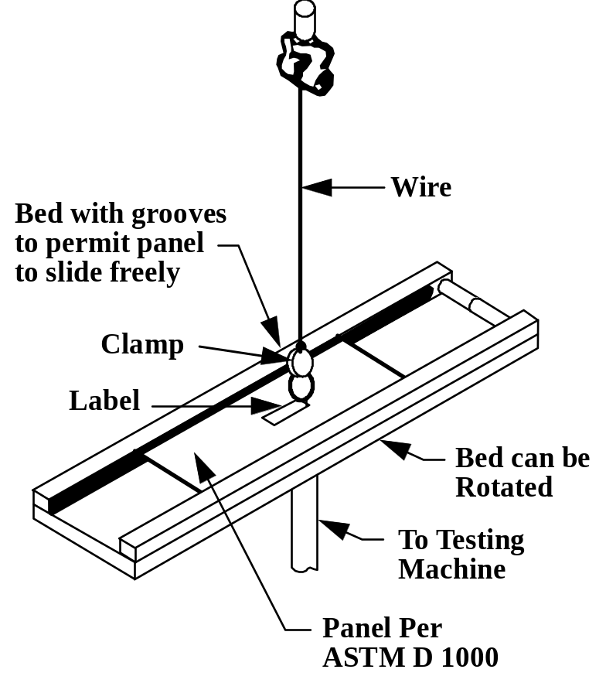

Figure B.1 - Adhesion tester
- (normative)
Testing
C.1 Testing of tag under various environmental conditions
The tag shall function correctly during and after each of the following tests,
Low temperature – IEC 60068-2 (MIL-STD-810 Method 502.2); minimum temperature of -50°C
High temperature – IEC 60068-2 (MIL-STD-810 Method 501.2, Procedure II); cycled between +70°C and +38°C, temperatures specified in 4.6.1.
Mechanical shock – IEC 60068-2 (MIL-STD-810 Method 615.3, Procedure I); 30g for 11 ms, half-sine pulse.
Random vibration – IEC 60068-2 (MIL-STD-810 Method 520.0, Procedure II); 2 hour duration, axis up to 3g at -50°C, ambient, and + 70°C ambient.
Humidity – IEC 60068-2 (MIL-STD-810 Method 507.2); 95 % non-condensing.
Rain – IEC 60068-2 (MIL-STD-810 Method 506.1, Procedure II).
Salt fog – IEC 60068-2 (MIL-STD-810 Method 509.2, Procedure I).
Drop shock – IEC 60068-2 (MIL-STD-810 Method 516.3, Procedure II); height 3,3 m, impact surface 5 cm plywood backed with concrete.
Sand and dust – IEC 60068-2 (MIL-STD-810, Method 510.2)
Electromagnetic environment – The tag shall survive and maintain the integrity of stored data in a maximum peak field strength of 50 V/m for 60 s.
C.2 Testing of reading equipment
The testing of reading equipment shall be agreed between the user and the supplier,
C.3 Testing of the complete system
Testing of the combined system requirements shall be carried out to prove the ability of the system to function properly under normal operating conditions at locations where the system is intended to operate.
- Normal operating conditions include the following:
- Temperature: between -50°C and +70°C;
- Humidity: up to 100 %, condensing;
- Random vibration: frequencies as specified in IEC 68-2 (Mil. Std. 810D Method 520.0, Procedure II) at amplitudes up to 0,29g.

- (normative)
Examples
  - Label Examples
The following shows examples of labels that may include at RFID Tag.

    - Ship to (Optional)
The “Ship to” data element refers to the address of the party to which items are to be delivered. When used, it shall be represented in a maximum of five lines of human readable characters comprised of no more than 35 alphanumeric (an..35) characters each. Figure D.1 shows the layout of a possible label using "J" ANSI MH10.8.2 Data Identifier license plate and additional trading partner data in 2D symbols.
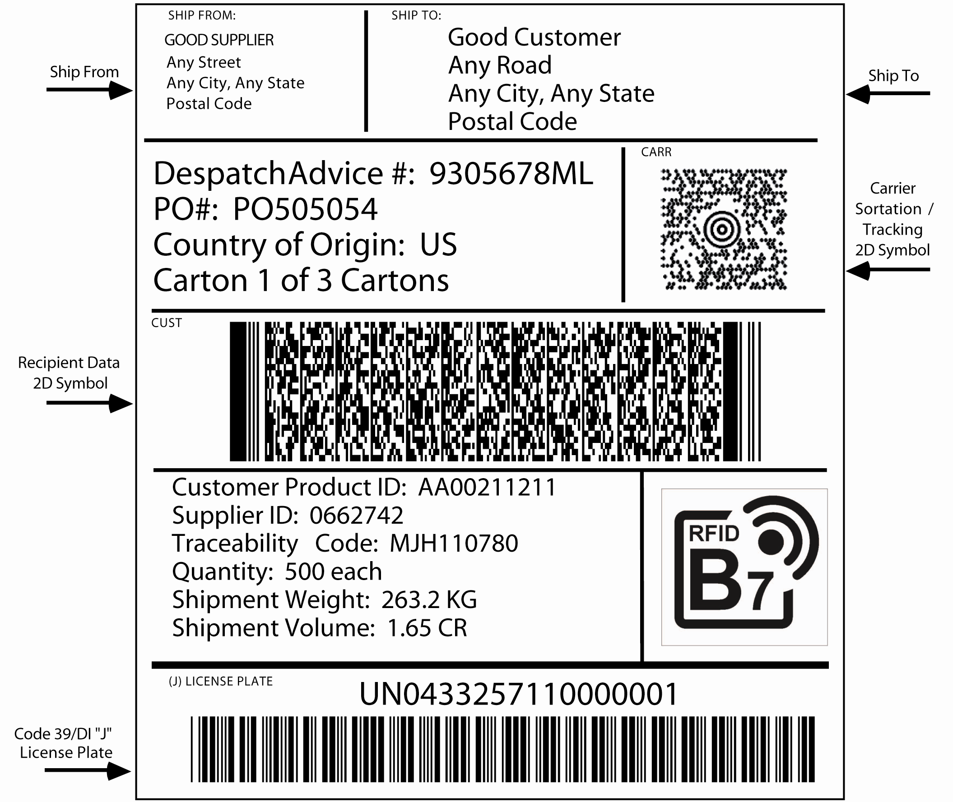

Fig D.1. Label using "J" ANSI MH10.8.2 Data Identifier license plate
and additional trading partner data in 2D symbols (not to scale)

- (informative)
Recommended label locations on various containers

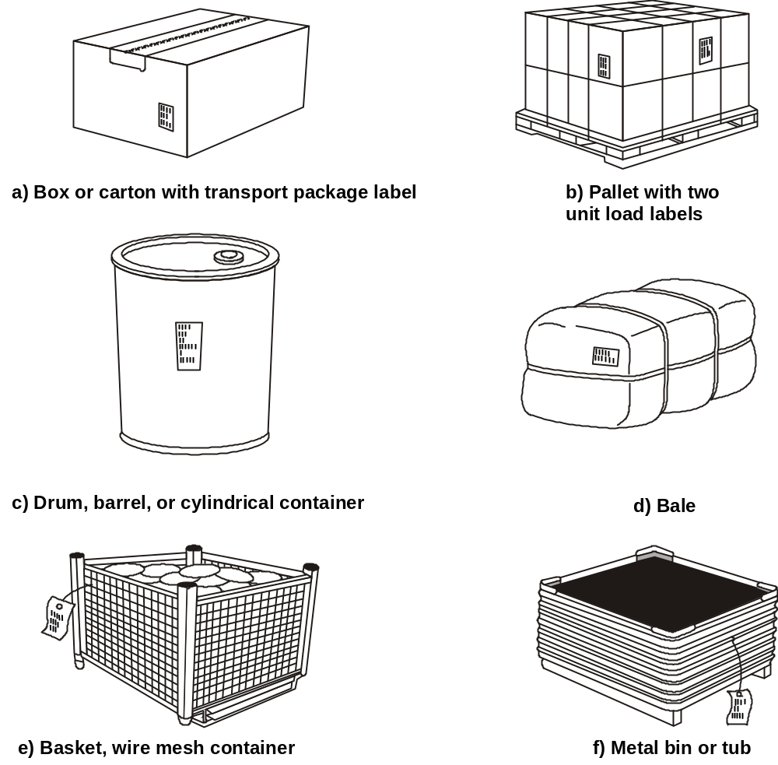

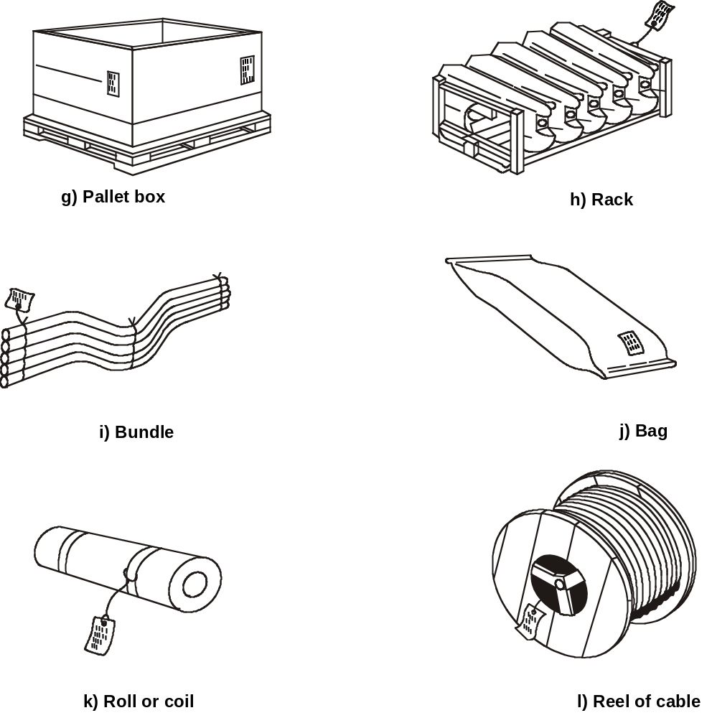

Fig E.1 – Label placement on various packages

