DRAFT REPORT OF MINUTES ANSI MH10/SC8

Meeting Date: | May 12, 2006 from 0900 – 0945 hours
Meeting Location: | Telecon

Friday, May 12, 2002

Welcome and Introductions
The Chair, Mark Reboulet, U.S. Air Force, convened the meeting at 0900 hours

Members and Observers Present
Allied Labels & Ribbons | Joe | Lemieux | Member | ejl@alliedlabels.com
ATIS/BCSC - Telcordia ATIS/BCSC | Bob | Fox | Member | rfox@telcordia.com
ATIS / Lucent Technologies | Dave | Holleson | Member | hollesen@lucent.com
CDO Technologies | Rick | Lafferty | Member | ricklafferty2@cs.com
Evanhoe & Associates | Chuck | Evanhoe | Member | chuck@evanhoe.com
GS1 US | Frank | Sharkey | Member | fsharkey@gs1us.org
High Tech Aid | Steve | Halliday | Member | steve@hightechaid.com
Monode Marking Products | J.T. | Mackey | Member | jt@monode.com
Northrop Grumman | Keith | Maxwell | Observer | k.maxwell@ngc.com
Philips Semiconductors | Michael | Guillory | Member | michael.guillory@autoid.org
Savi Technology | Rich | Vossell | Observer | rvossel@savi.com
Texas Instruments | Dan | Wikander | Member | d-wikander@ti.com
US Air Force | Mark | Reboulet | Member | mark.reboulet@wpafb.af.mil
USD (AT&L) –VID PMD | Rob | Leibrandt | Observer | robert.leibrandt@osd.mil

AGENDA FOR THIS MEETING:
To resolve ISO/IEC 173xx final comments that were not discussed at the April meeting in Williamsburg VA

Comment Resolution Discussion
- The final items were discussed and Form 13B was created (MH108_06023_ ISO173XX_13B.doc) and posted to the MH10.8 Committee website.
- Craig Harmon provided the Figure 1 (Memory Map) file which includes the User Memory mapping shown below.
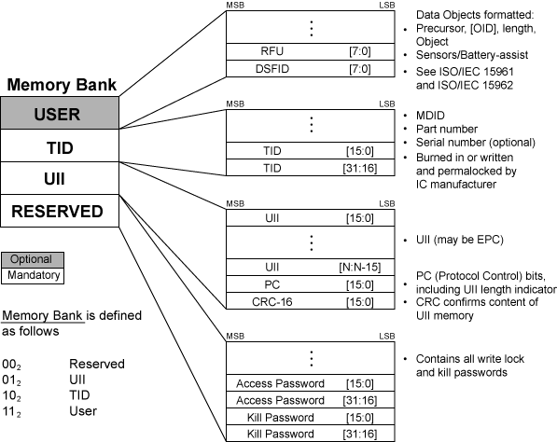

- The Figure 1 File is posted in two formats a standard PDF and also as an Adobe Illustrator file.

Action Item Discussions
- Mark Reboulet will forward the comment resolution to Mike Ogle (AIM)

The chair adjourned the meeting at 0945.

Attachments are found at the MH10.8 committee web site
http://www.autoid.org/ANSI_MH10/ansi_mh10sc8.htm:
MH108_06023_ ISO173XX_13B.doc
MH108_06025_6C_Memory_wMB11.pdf
MH108_06026_6C_Memory_wMB11.ai

………………………..
Respectfully submitted on May 13, 2006.
Joe Lemieux, Secretary MH10.8, Allied Labels & Ribbons, Inc.

