RF-01 | 1 | Before last para. in clause | TE | Add a paragraph to note that this document supersedes CEA-621-A and CEA-624-A or | New paragraph:  This document supersedes and replaces CEA-621-A and CEA-624-A since CEA has transferred maintenance of these standards to MH10.  Or add Bibliography:  CEA-621-A, … - This standard supersedes and replaces this CEA standard, since CEA has transferred maintenance of CEA R9 Automatic Data Capture Committee standards to MH10.  CEA-624-A, … - This standard supersedes and replaces this CEA standard, since CEA has transferred maintenance of CEA R9 Automatic Data Capture Committee standards to MH10.
AG-01 | CEA 621-A 4.0 |  | ED | Do we need to add symbol placement reqts for CEA? Is this covered in GS1?  GS1 standard specifies the GTIN always on the left. This may, however, be meant to address GTIN manufacturer ID info rather than SN. | Exhibit 1 illustrates a typical format for displaying the U.P.C. Version A (UPC-A) point-of-sale (POS) bar code symbol and a typical item serial number bar code symbol. The item serial number bar code symbol should be above the point-of-sale bar code symbol. The serial number bar code human readable information should be printed above the actual bar code.
AG-02 | CEA 621-A 4.0 |  | TE | Is this a GS1 requirement?  GS1 specifies this requirement as a “should”. (2.2.4.4.1.5). GS1 specifies a 32mm (1.25”) clearance between the GTIN and other markings that would affect scannability. | All bar code symbols shall be printed as horizontal bar code symbols with the bars being vertical and the human readable characters being horizontal. A minimum of 3.2 millimeters (1.25 inch) space shall separate the bottom of the serial number bar code symbol from the top of the point-of-sale bar code symbol.
AG-03 | CEA 621-A 4.2.1 |  | TE | Placement of Item Serial Number on the package is a requirement in CEA 621A. This should be included. These requirements for SNs are not addressed in GS1 standards. | For serialized products, the manufacturer shall assign a unique serial number to the product and the sales package containing the product. This serial number shall be represented in the form of a bar code symbol. A human readable representation of the serial number should be printed above the symbol.
AG-04 | CEA 621-A 5.0 |  | TE | Is this a GS1 requirement? Not easily found in GS1 Solutions Center. | Since this standard addresses applications where more than one symbology will be read and where it is advantageous to be able to distinguish between scanned and key-entered data, bar code readers should be configured to attach symbology identifiers to data messages.
AG-05 | CEA 621-A 8.2 |  | TE | Add this to MH10.8.6 | Label Recyclability  When possible, the label material, printing ink and adhesive should be specified to be recyclable materials. In particular, care should be taken that all label materials be compatible with the substrate packaging material for purposes of recyclability.
RF-02 | 5.2.3 | Table 7 | TE | Add Secondary serial number/Interior service number DI | Add in Table 4.3 in Data Identifiers area after DI = 22S:  Data Identifier: 30S  Data Field: Secondary serial number/Interior service number  Data characteristics Type/length: n3+an...21  Description: Secondary serial number or interior service number*** of a component of a trade item^{Note}
RF-03 | 5.2.3 | Table 8 | TE | Remove AI -= 250. This should be moved to ANS MH10.8.7. | Remove row with AI=250. See 13B for MH10.8.7.
AG-06 | CEA 621-A | Exhibits 7 & 8 | ED | Add exhibits 7 & 8 to MH10.8.6

EXHIBIT 7

Calculating a typical Interior Service Number from an all numeric Item Serial Number using a Mod-10 check character algorithm:

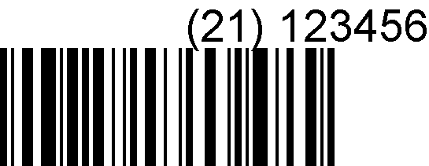
Item Serial
Number
12.7 mm (0.5 in)

IMPORTANT: Character positions are numbered from RIGHT to LEFT in this algorithm with the check character in the first (rightmost) position. (See Exhibit 4.)

The item serial number application identifier shall not be included in the check character calculation.

EXAMPLE: Assume an item serial number of (21) 123456 as shown above.

(21) 123456

Position 1 reserved for check character

Step 1: |  | 2 + 4 + 6 (from right) | = 12
Step 2: |  | x 3 | = 36
Step 3: |  | 1 + 3 + 5 (from right) | = 9
Step 4: |  | 36 (Step 2) + 9 (Step 3) | = 45
Step 5: |  | 45/10 = 4 with a Remainder of 5; 10 - 5 | = 5 (check character)

EXHIBIT 7 (continued)

The resulting interior service number would be:

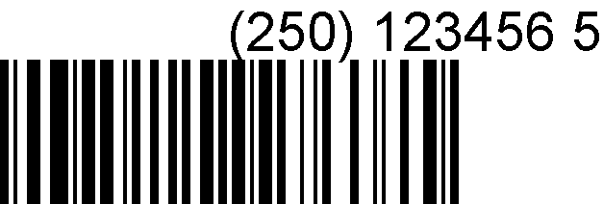
Interior Service
Number
12.7 mm (0.5 in)

NOTE: (250) is the Interior Service Number Application Identifier and "5" in the rightmost position is the calculated "check character" value.

EXHIBIT 8
Figure 1
Item Serial Number Bar Code Label

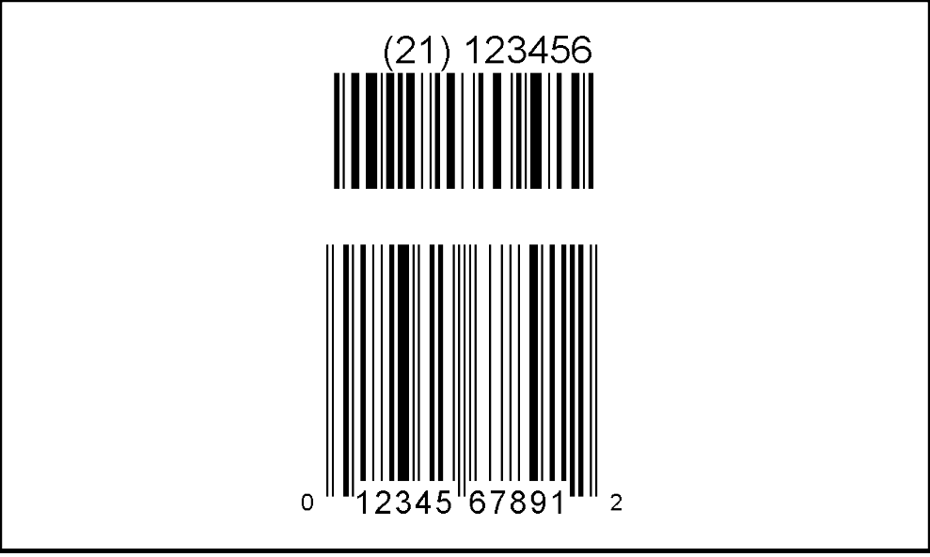
Item Serial
Number
b
c
d
e
f
a
EXHIBIT 8 (continued)

Figure 2
Interior Service Number Bar Code Label

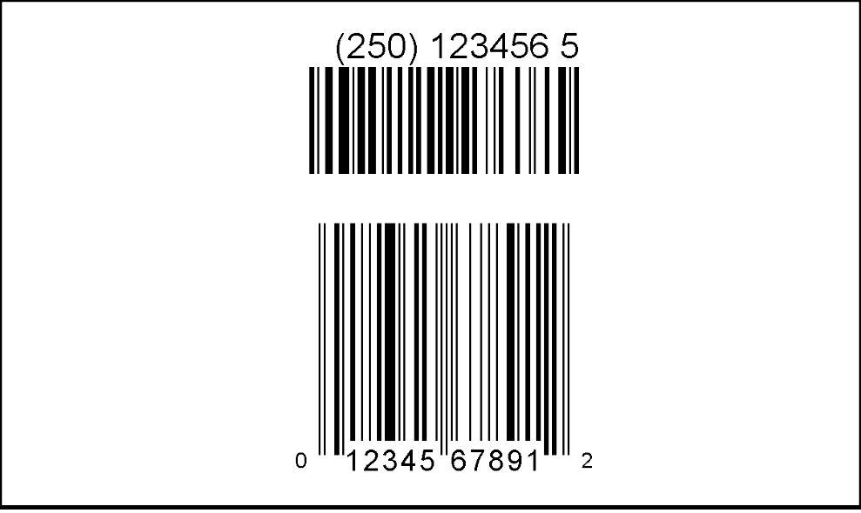
Interior Service
Number
b
c
d
e
f
a

Label Specifications

b
c
a
The overall height of the label should be a
minimum of 60.9 mm (2.4 in).
The two line human readable title information
should be a minimum height of 6.4 mm (0.25 in).
The human readable encodation height should
be a minimum of 4.8 mm (0.19 in).
e
f
d
The overall height of the UCC/EAN-128 bar
code should be a minimum of 12.7 mm (0.5 in).
The distance dividing the UCC/EAN-128 and the
Point-of-sale bar code should be a minimum height of
3.2 mm (0.13 in).
The overall height of the point-of-sale bar code
should be a minimum of 25.9 mm (1.02 in).

NOTE: There should be a minimum of 6.4 mm (0.25 in) margin between the edge of the label and the information included in the label (including bar code quiet zones).

