30 December 2008

To: Honorable Members of ISO TC 122

RE: 122n0485
Change in responsibility of ISO 17363 to ISO/TC104

Dear Honorable Members of ISO TC 122:

On December 22, 2008 you received a request from the ISO TC 122 Secretariat to vote on whether the responsibility for ISO 17363, Supply chain applications of RFID — Freight containers should be transferred from ISO TC 122 to ISO TC 104.

I humbly request that you vote “No” on this ballot, for the reasons that I will describe below. The citation of this paper, JWG_Chair_Ltr_to_TC122_Members_20081230.doc suffices for the rationale of the negative.

The justification ISO TC 104/SC 4 provides for this change of responsibility (sc4n266) includes the following:
- The cargo shipment tag is explicitly intended to be used for containerized shipments and thus be a container-specific cargo-shipment tag.
- Experimental knowledge with cargo-shipment tags is available only with freight container operation.
- Further efforts to make the two tag types applicable with the aim to enhance transparency and efficiency for containerized shipments, their routing, their content etc. require that both, the cargo-shipment tag and the container license plate tag are under control of one and the same standardization committee, which needs to be a committee having the container owners and operators well represented.
- Looking forward toward eventual products to do these functions, it needs to be assured that the chosen technologies and operational scenarios are compatible (not interfering) and that, done in a harmonized manner, readers could be integrated devices rather than two separate devices to read the prescribed tags.

The justification described above is specious at best, and contradicts the very core sentiments expressed by the same group in the development of ISO 17363. This paper will attempt to explain the true rationale for the request and the lack of success this group has experienced in the development of similar standards.

There are two (2) RFID standards that relate specifically to marine cargo containers. These standards are:
- ISO 18185, Freight containers — Electronic container seals,
- ISO 10891, Freight containers — RF automatic identification (Note that ISO 10891 has been re-designated from ISO 10374)

There are also five (5) RFID standards that relate specifically to the “CONTENTS” of marine cargo containers. These standards are:
- ISO 17363, Supply chain applications of RFID – Freight containers
- ISO 17364, Supply chain applications of RFID – Returnable transport items
- ISO 17365, Supply chain applications of RFID – Transport units
- ISO 17366, Supply chain applications of RFID – Product packaging
- ISO 17367, Supply chain applications of RFID – Product tagging

The relationships among these five standards are shown in Figure 1, below:

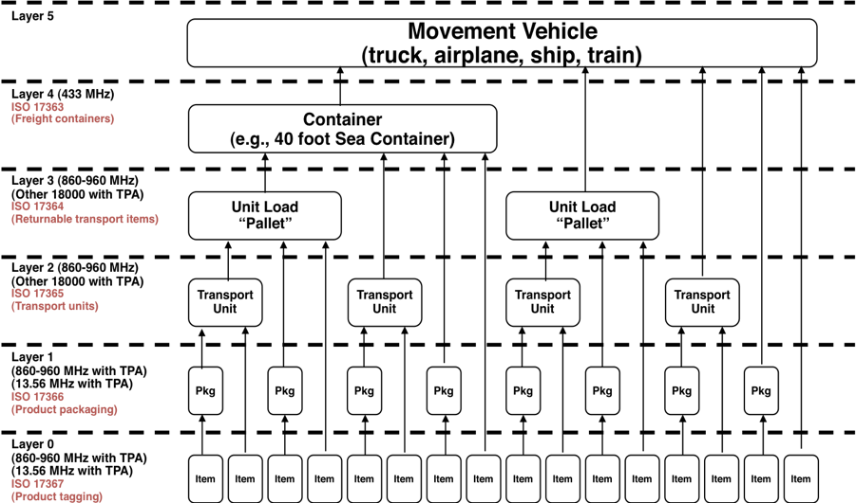
Figure 1 – Layers of the supply chain (RFID)

ISO 17363 is published and its companion standards 17364 through 17367 are awaiting the 2008-01-08 Committee Draft Ballot Resolution Meeting of ISO/IEC 18000-3 to permit inclusion in these standards. Once this meeting has advanced 18000-3 to FCD stage, ISO 17364 through 17367 will advance to publication.

The supply chain needs commonality in the identification of items through packaging, transport units, returnable transport items, and into the freight container. By tracking the freight container, the products, packaging, transport units, and returnable transport items contained therein can then be tracked and accounted for. In the title of the standard, it is “supply chain applications of RFID” that is the operative portion, not “freight container”.

Various participants in the standards development process believe that TC 122 should retain the lead for this work. Those participants also believe there are members of TC 104/SC 4 who want to assume control of this work to basically kill it, as they have effectively accomplished with two other standards, ISO 10374/10891 and ISO 18185. The following examples are cited:

- By creating an air interface that would not be implemented, ISO 18185 was effectively killed. The 18185 tag requires the tag to support both ISO/IEC 18000-7 (433 MHz) and ISO/IEC 24730-2 (2450 MHz). It is conservatively estimated that the incremental cost for a tag to support both air interfaces as opposed to supporting only one of the protocols would be $10.00 (USD). Realizing that these tags are disposable, single-use tags, the incremental cost to the marine shipping industry of supporting both air interfaces in a single tag would be over $1 billion per year. Twenty months after the publication of 18185 (2007-04-26) there is no manufactured or marketed device compliant with the standard.

- ISO 10374 had a perfectly acceptable air interface (ISO/IEC 18000-6B) but some TC 104 members found an opportunity to create confusion in the industry by re-numbering the standard to 10891 and then relegating it to a Technical Specification with an unknown date of publication as an ISO standard.

This is the group that now wants to assume control of ISO 17363, the sole surviving standard having any association with freight containers. If those forces within TC 104 are successful in wresting 17363 away from TC 122, it seems apparent that they will make an effort to ensure that this standard is effectively killed, as well.

Notwithstanding the title of 17363, Supply chain applications of RFID, Freight containers, this is not a standard for the carrier community; it is a standard for the supply chain, shippers and consignees. During the development of 17363, the carrier community was adamant that they wanted nothing to do with this specific RFID tag. Below is an excerpted passage from the Application Requirements White Paper created and presented by the World Shipping Council on March 19, 2004 (104sc4wg2n0160_WSCcmnts_AR.doc):

Such tags (ISO 17363) would serve the shipper’s/importer’s supply chain management requirements. They and the information embedded in them would not be the responsibility of the carrier. The shipper/importer would be responsible for uploading, maintaining and protecting the supply chain information on the tag that they would deem appropriate to upload on it. The shipper/importer would be responsible for affixing the tag on the container. Because these tags would be shipment-specific, there would no responsibility on the part of the carrier for deleting the information in, or disposing of, the tag after final delivery of the container and before the container is deployed again in international transportation. The tag would simply be removed from the container by the consignee upon final delivery.

This group has continued the perspective that they want nothing to do with the tag. However, it appears they want to control the standard with a goal to emasculate it as they did with 18185 and 10374/10891.

Your attention is further invited to Annex A, which describes the four basic tags associated with a freight container. These are:
- The permanent container identification tag, standardized in ISO 10374 (Note that ISO 10374 has been re-designated as ISO 10891)
- The electronic container seal, standardized in ISO 18185
- The cargo specific shipment tag, standardized in ISO 17363,
- Item tags contained within the container; on individual items, transport units, and returnable transport items.

As can be seen from the scope and definitions, the “17363 tag” (cargo specific shipment tag) is the responsibility of the shipper and is removed by the consignee. The carriers specifically required that the carrier have no responsibility for the 17363 tag, to the point of encrypting the data preventing the carrier from observing the data (Clause 8.1 of 17363). It is quite obvious that this “Supply chain applications of RFID” tag is not intended for the benefit of the carrier (TC 104) but for the shipper and consignee in the supply chain (TC 122).

The rationale provided by ISO TC 104/SC 4 (sc4n266) for the transfer of responsibility of ISO 17363 to their group is shown in italics below and the counter argument in normal blue type.
- The cargo shipment tag is explicitly intended to be used for containerized shipments and thus be a container-specific cargo-shipment tag. The same logic would reckon that since ships, rail, and truck carry containerized shipments, the tag should be controlled by ISO TC 8, the International Union of Railways (UIC), and TC 204. In fact, throughout the supply chain, it is not the carrier who owns or controls the information, but the shipper and the consignee.

- Experimental knowledge with cargo-shipment tags is available only with freight container operation. Freight container operations are not the sole responsibility of TC 104. The supply chain is dependent upon all forms of carriers, forwarders, consolidators, de-consolidators and warehousing operations. It is for this reason that broader representation, as was originally constituted with the ISO TC 122/104 JWG, be included in the development of the 17363 standard. TC 104/SC 4 seems to believe that only the carriers should be represented, while TC 122 has consistently reached out to the broadest participation. TC 104/SC 4 has a questioned history of excluding participation in the work of its sub-groups, e.g. Tripartite meetings. ISO TC 122 has always provided complete transparency of operations.

- Further efforts to make the two tag types applicable with the aim to enhance transparency and efficiency for containerized shipments, their routing, their content etc. require that both, the cargo-shipment tag and the container license plate tag are under control of one and the same standardization committee, which needs to be a committee having the container owners and operators well represented. The ISO TC 122/104 JWG was consistently open to container owners and operators, and was well participated by these sectors. Its openness and transparency was in stark contrast to the Tripartite meetings sponsored by 104/SC 4 and its WGs. It appears, by the statement:
the cargo-shipment tag and the container license plate tag are under control of one and the same standardization committee
that 104/SC 4 proposes that 17363 should wait for technology, and not as an ISO standard.

- Looking forward toward eventual products to do these functions, it needs to be assured that the chosen technologies and operational scenarios are compatible (not interfering) and that, done in a harmonized manner, readers could be integrated devices rather than two separate devices to read the prescribed tags. One implementation of the technology of 17363 has been in place for nearly a decade, tracking nearly 3 million tags around the world. The success of TC 104/SC 4, in doing anything more than ensuring that freight containers DO NOT implement wireless technology, is checkered at best. This is the group that brought us the ISO 18185 eSeal that requires two, non-harmonized technologies, adding an estimated $1 billion per year to maritime operations. This is the group that requires three tags on a freight container and eschews technologies to implement a consolidated wireless device. This is the group that stopped efforts to incorporate sensor technology interfaces to wireless device(s), denying cold chain, safety, and security benefits from implementing sensor technology.

The failure of ISO TC 104/SC 4 to provide usable standards for wireless devices should be ample proof that it is not interested in advancing standards, but in preventing advancement.

I ask you to resist the effort of TC 104/SC 4 to take over 17363.

Sincerely,
Craig K. Harmon
Chairman
ISO/TC 122 and ISO/TC 104 Joint Working Group – Supply chain applications of RFID

Annex A
Excerpts from Supply Chain & Container Related Standards

1 Scope (17363)
This International Standard defines the usage of read/write radio-frequency identification technology (RFID) cargo shipment-specific tags on freight containers for supply chain management purposes (“shipment tags”). This International Standard, through reference to other standards within ISO/TC 122, ISO/TC 104 and ISO/IEC JTC 1/SC 31, defines the air-interface communications, a common set of required data structures, and a commonly organized set of optional data requirements (through common syntax and semantics).

It contains the following recommendations:
a) recommendations about a containerized cargo supply chain RFID system, based on shipment tags;

NOTE Such a containerized cargo supply chain RFID system would co-exist with, but be separate from, a container security and identification RFID framework using permanent container lifetime RFID tags (“container tags”), described in ISO 10374, and cargo shipment-specific electronic seals (e-seals) for which a standard in multiple parts (ISO 18185) is being developed. Specifically, readings for container security and identification purposes of the information in the container tags and e-seals are intended to be in separate messages and not through the shipment tag.

b) specific recommendations about mandatory non-reprogrammable information on the shipment tag;

c) specific recommendations about optional, reprogrammable information on the shipment tag.

Identified within this International Standard are the air-interface and communication parameters for active radio-frequency identification communications using ISO/IEC 18000-7.

This International Standard is applicable to freight containers as defined in ISO 668 and to freight containers that are not defined by other ISO standards. It complements ISO 10374 for permanent container license-plate tags (see 4.7), hereinafter referred to as “container tags”.

This International Standard fully describes cargo shipment-specific tags (see 4.8), hereinafter referred to as “shipment tags”.

It does not address “smart” container technologies affixed to, or inside, freight containers (e.g. sensors) for supply chain management purposes. These issues will be addressed in future revisions.

4.8 (ISO 17363)
cargo shipment-specific tag
shipment tag
read-write tag into which data specific to a containerized cargo shipment can be stored
NOTE 1 The tag and the data uploaded in it are the responsibility of the shipper.
NOTE 2 The tag may be affixed to the container by the shipper or, per the shipper’s instructions, by the party that physically performs the loading (“stuffing”) of the container.
NOTE 3 Data capabilities are flexible and may, at the shipper’s discretion, include destination, routing, conveyance or other transportation information, cargo information (including hazardous material information, where applicable) or other trip-specific information.
NOTE 4 The tag is intended to perform reliably from the point of stuffing of the container to delivery destination, and to be removed by the consignee upon final delivery. The tag may be re-usable.

4.10 (ISO 17363)
permanent container tag information
non-reprogrammable information that resides on the container tag for the duration of the lifetime of the container (or until the container changes ownership and/or equipment ID), and which is uploaded and maintained by, or on behalf of, the container owner and at its responsibility
NOTE The permanent, non-reprogrammable information elements are specified in ISO 10374.

3.1 (ISO 18185-2)
electronic seal
e-seal
read-only, non-reusable freight container seal conforming to the high security seal defined in ISO 17712 that electronically evidences tampering or intrusion through the container doors
NOTE The electronic seal is read-only in all aspects except being able to electronically record date and time of sealing (as described in 4.2), and date and time of opening (as described in 4.3).

5.3 Types of tags (ISO 17363)

There are four types of RF device envisioned for use with freight containers. The individual uses of each of these devices are as given in 5.3.1 to 5.3.4.

5.3.1 Permanent container license-plate tag
This tag, referred to as the “container tag”, is defined in 4.7 and is fully described in ISO 10374.

5.3.2 Cargo shipment-specific tag
This tag, referred to as the “shipment tag”, defined in 4.8, is fully discussed in this International Standard.

5.3.3 Container electronic seal
This is a read-only, non-reusable freight container seal conforming to the specifications for a high security seal. It is defined in ISO/PAS 17712, and conforms to the ISO 18185 series; it electronically reveals tampering or intrusion through the container doors.

5.3.4 Item tag
This is typically a passive tag that is affixed to an item that is to be tracked. This item may be a product itself, the packaging around a product, or the transportation method used to convey the product (pallet, case, etc.). This tag is usually disposable, although in the case of returnable transport items, etc., it may be reusable.

