- (informative)
Returnable Packaging Items
  - General
The concepts of returnable, reusable, and recyclable are frequently used interchangeably, though conceptually they are quite different. A key underlying concept of difference is ownership, whereby returnable items maintain the original ownership, while the ownership of reusable and recyclable items is transferred between parties. Figure A.1 shows a consumer lifecycle explaining the differences.
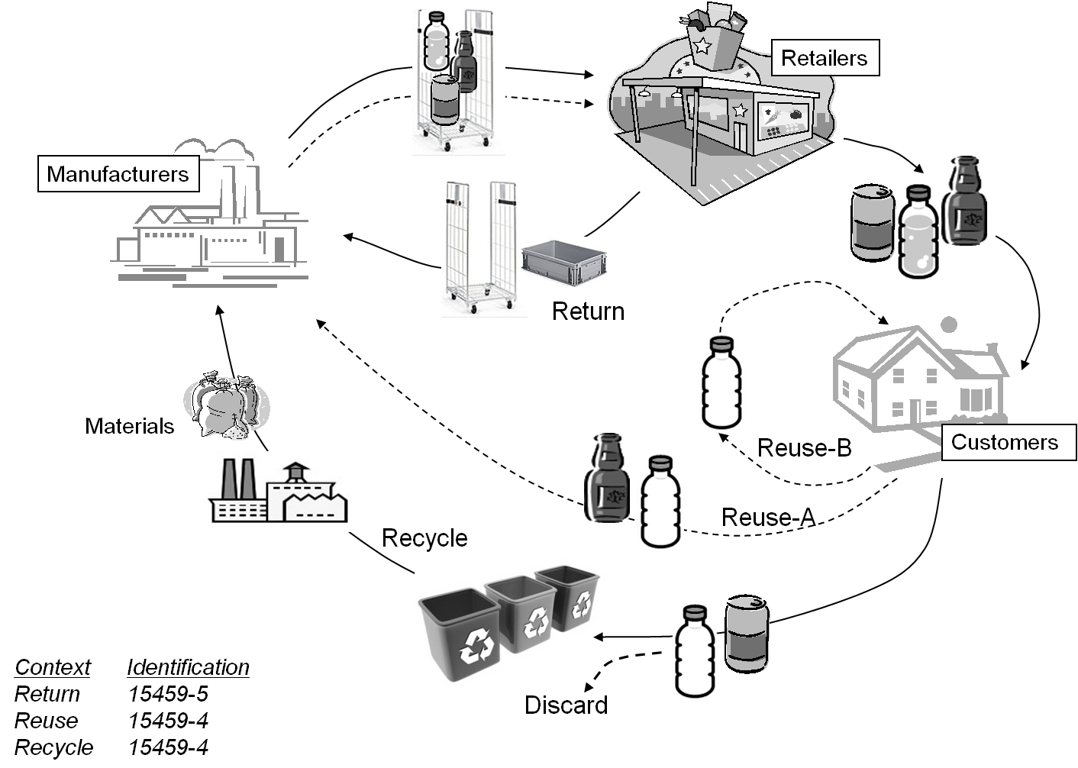
Figure A.1 – Returnable, reusable, and recyclable lifecycle
  - Recyclable item
With a recyclable item, the ownership of the item is transferred when the item is sold. A typical use recyclable item is a battery, which can be disposed at a recycling station and parts of the content can be recycled and used for manufacturing of new batteries.
    - Identification
ISO/IEC 15459-4 addresses unique identification for individual recyclable items (products).
  - Reusable item
With a reusable item the ownership of the item is transferred when the item is sold. In some jurisdictions an incentive to return the reusable packaging is provided at the time of purchase, a deposit, which can be recovered when the item is returned to the location from which the item was purchased.
A typical use recyclable item is a hard plastic bottle, which can either be reused by the user (i.e. filling the bottle with new content after cleaning it) or disposed at a recycling station and depending on whether its constituents parts can be reused (i.e. cleaned and refilled) or recycled and used for “manufacturing” of new bottles.
    - Identification
ISO/IEC 15459-4 addresses unique identification for individual reusable items (products).
  - Returnable items
With a returnable item the ownership of the item remains with the party providing the item, even though the item is sent to a customer. The supplier retains ownership of the asset with the anticipation that the customer will return the asset once it has served its original purpose
A typical use of a returnable item is for transportation of goods where the item can be reused in terms of that the content and carrier can change but the owner is still the same.
    - Identification
ISO/IEC 15459-5 addresses unique identification for returnable items.
  - Returnable Transport Items and Returnable Packaging Items
    - Overview
Some pallets and returnable boxes are equipped with shock absorbing material to protect them from potential damage occurring during in the transportation and handling process. An effective solution is the use of partitions or sorting boards for separating the contents into appropriate groups, making it possible to place many items on a single pallet or returnable box. This kind of accessory for a pallet or returnable box is defined as a “partition”. The typical example of this is a post-type partition used with the post pallet. Also included in this group is packing material used to place or arrange the contents between the posts, or a packaging material for dividing the inside of the returnable box into several smaller sections.
    - Partitions
Some pallets and returnable boxes are equipped with shock absorbing material to protect them from potential damage occurring during in the transportation and handling process. An effective solution is the use of partitions or sorting boards for separating the contents into appropriate groups, making it possible to place many items on a single pallet or returnable box. This kind of accessory for a pallet or returnable box is defined as a “partition”. The typical example of this is a post-type partition used with the post pallet. Also included in this group is packing material used to place or arrange the contents between the posts, or a packaging material for dividing the inside of the returnable box into several smaller sections.

    - Posts
Figure A.2 shows a post that is normally used to securely fix packing materials or returnable box on the pallet. Most of these posts are made of high durable substances like plastic or metal.

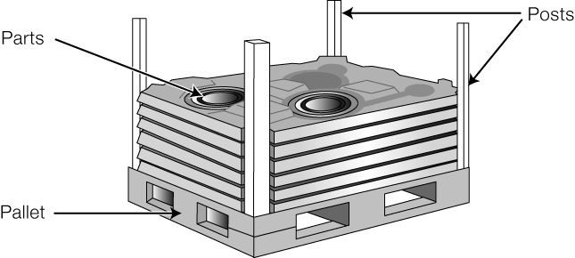

Figure A.2 – Post

    - Packing materials
Some kind of packing materials should be provided to protect the items from a shock or vibration that may be encountered during transportation, or protect them from being touched or hit by the pallet or returnable box in which they are placed. Most of the packing materials are made of high resilient flexible substances like plastic, urethane, and polystyrene foam. This guideline is applicable to these kinds of packing materials (see Figure A.3 and Figure A.4).

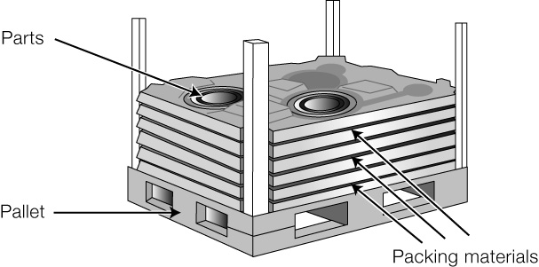

Figure A.3 – Packing material

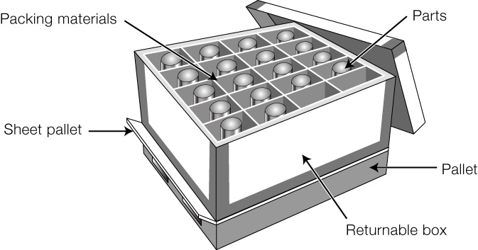

Figure A.4 – Packing material

    - Identification
In Figure A.3, the base pallet is the actual RTI and the moulded plastic layers and posts are the RPIs. If each is serialized, it may be important to associate the RPIs with the parent RTI. In this example, the RTI may have a unique identity of “25BUN0433257110000001”. The four posts might have a unique identity of
“25SUN043325711P000001”
“25SUN043325711P000002”
“25SUN043325711P000003”
“25SUN043325711P000004”

. . . and the six plastic layers might have a unique identity of
“25SUN043325711L000001”
“25SUN043325711L000002”
“25SUN043325711L000003”
“25SUN043325711L000004”
“25SUN043325711L000005”
“25SUN043325711L000006”

      - My parent is . . .
One possibility to associate the RPIs with the parent RTI is with the use of the Data Identifier “iF” which declares, “My parent is . . . “ Using this example the 3rd plastic layer would be encoded 25SUN043325711L000003<GS>1F25BUN0433257110000001.
The other layers and posts would be similarly encoded.
      - My children are . . .
Another possibility to associate the parent RTI with all of its RPIs is with the use of the Data Identifier “2F” which declares, “My children are . . . “ Using the same example the base pallet would be encoded
25BUN0433257110000001<GS>2F25SUN043325711L000003<GS>1F25BUN0433257110000001<GS>25SUN043325711L000001<GS>25SUN043325711L000002<GS>25SUN043325711L000003<GS>25SUN043325711L000004<GS>25SUN043325711L000005<GS>25SUN043325711L000006“25SUN043325711P000001<GS>25SUN043325711P000002<GS>25SUN043325711P000003<GS>25SUN043325711P000004
      - I have _____ children
Yet another possibility is to simply identify the number of RPIs associated with the parent RTI using the Data Identifier “3F” which declares, “I have ____ children“. Using the same example the base pallet would be encoded
25BUN0433257110000001<GS>3F10
Likewise, any combination of the three associative DIs, might be used.

