Language for §6.2.2 – 122wg10nXXXX_17363_20100228.doc

Current language:
- A minimum requirement of being able to be written to at a distance of 35 meters, as the tag remains within the 35 m range of the communicating interrogator and when:
  - Sufficiently separated from other ISO 17363 tags by more than 3 m to allow discrimination
  - Operated and stored in the environmental conditions specified in ISO 18185-3
- A minimum requirement of being able to be read from at a distance of 100 meters and when:
  - Moving in relation to the RFID reading system at a speed of 50 km/h or less.
  - Sufficiently separated from other ISO 17363 tags by more than 3 m to allow discrimination
  - Operated and stored in the environmental conditions specified in ISO 18185-3.
or
- Being read when the shipment tag when
  - A minimum requirement exists to be read a node from a distance of 35 m and whose network shall have a minimum range of 100 m.
  - Moving in relation to the RFID reading system at a speed of 50 km/h or less.
  - Sufficiently separated from other ISO 17363 tags by more than 3 m to allow discrimination
  - Operated and stored in the environmental conditions specified in ISO 18185-3.

This is to permit a choice of either a) and b) or a) and c).
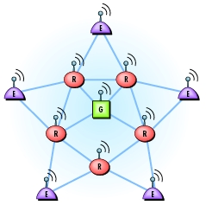

Figure 1 – Fault tolerant mesh network

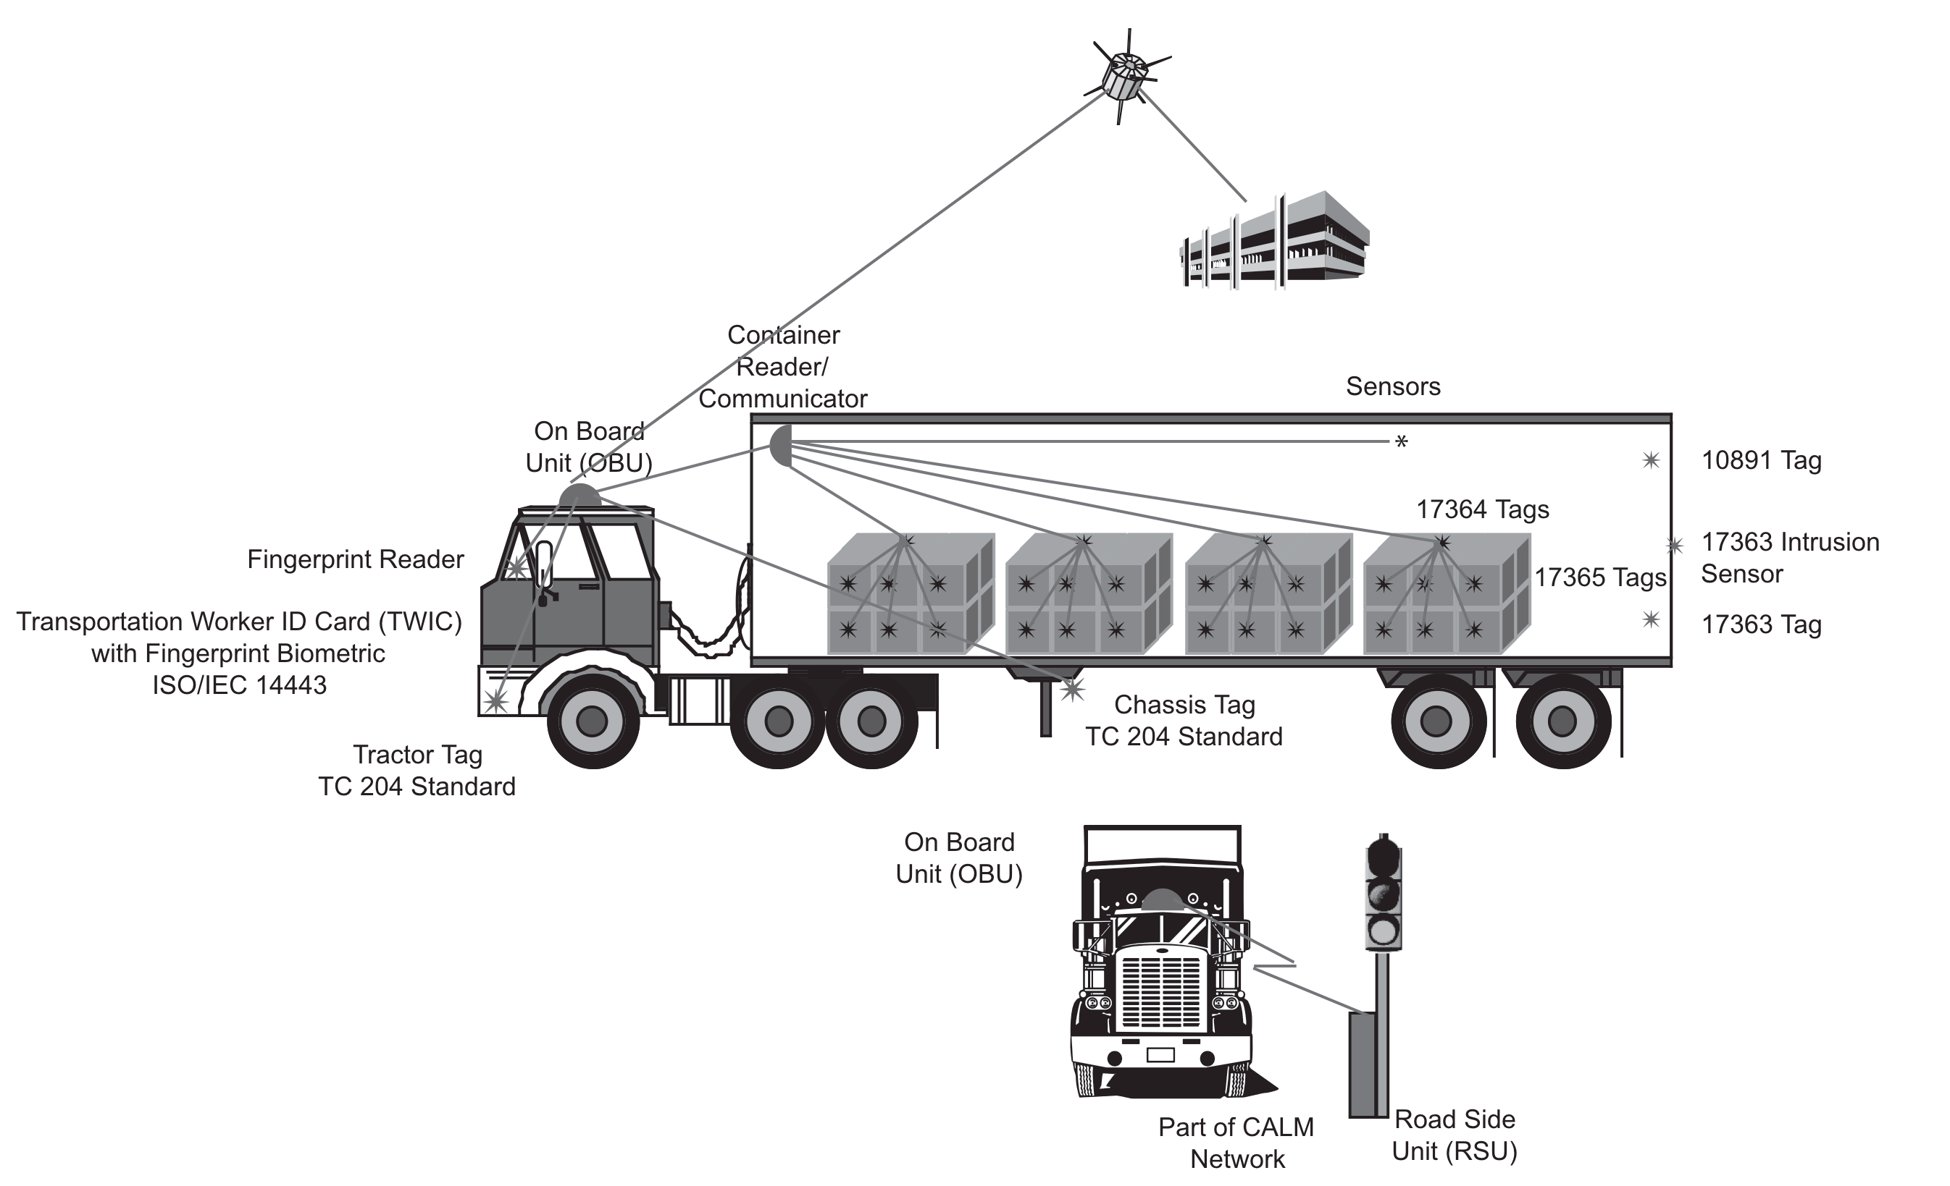
Figure 2 – Tractor/Trailer Container configuration

