Implementation of ISO/IEC/IEEE 21451.7 Sensors into ISO/IEC 18000-7

Version 1.0
June, 2010

Richard Schnell, Savi Technology, Inc.

Introduction

This document describes an optional method in which ISO/IEC/IEEE 21451.7 – an application protocol for sensors – can be implemented into ISO/IEC 18000-7 (433 MHz Active RFID) tags. The method uses the Enhanced ISO/IEC 18000-7 Extended Services command to access and control the sensor application. Included herein are a description of the Extended Service command and other features of the Enhanced ISO/IEC 18000-7, and an example of how to interface to the ISO/IEC/IEEE 21451.7 sensor application. The physical sensor(s) may be internal or external to the tag. This method along with other Enhanced ISO/IEC 18000-7 features will be proposed as an addition to the ISO/IEC 18000-7 standard.

Extended Services Architecture

The Enhanced ISO/IEC 18000-7 defines an architecture that enables new applications (services), beyond what is specified in the standard, to be included in ISO/IEC 18000-7 tags. These applications are independent of ISO/IEC 18000-7, thus they do not require additional commands, data structures, or definitions to be added to the standard. ISO/IEC/IEEE 21451.7 is one of these new applications and is the recommended sensor interface for ISO/IEC 18000-7 tags.

The Enhanced ISO/IEC 18000-7 Extended Service command is a simple transport mechanism so interrogators can control and access extended service applications. The Extended Services command encapsulates the application's payload within its command packet for transport over the air. When an Extended Service command is received by the tag its Extended Services Message Handler strips the payload from the packet and routes it to the appropriate application for processing. After processing, the application's response is encapsulated into the Extended Service's response and transported back over the air to the interrogator. Enhanced ISO/IEC 18000-7 also provides additional UDB structures so that extended service applications and their associated alarms may be discovered.

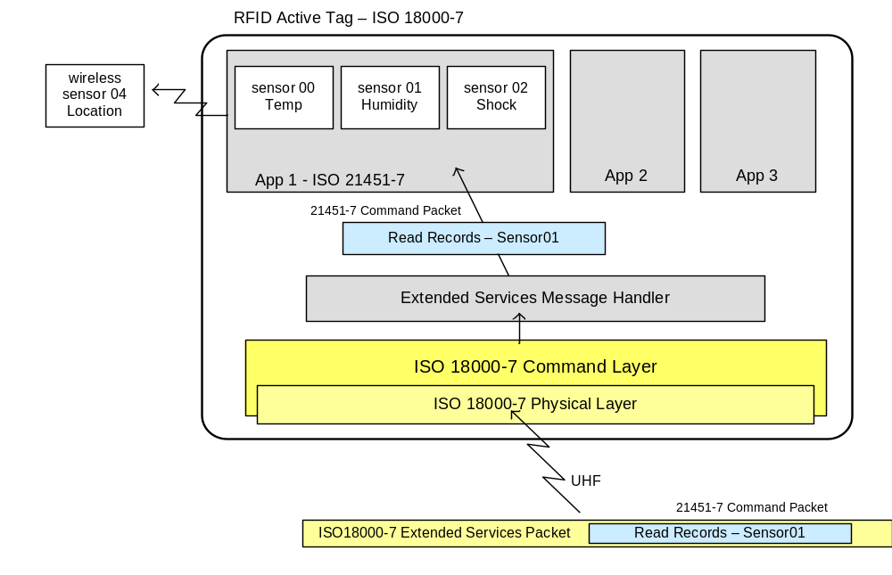
Figure 1 – Extended Services Architecture

Along with the Extended Service command the Enhanced ISO/IEC 18000-7 adds two new UDB Elements, the Extended Services List Element and Alarm Summary Element, to enable discovery of extended services implemented and their associated alarms. Additionally, a set of "Mailboxes" have been reserved for each extended service so that messages and information may be exchanged.

Extended Service ID

Extended services are identified using an Extended Service ID (ESID). The ESID is a unique identifier value in the range of 0x80 to 0x8F that is assigned by the tag when the extended service registers its availability. The ESID is also the UDB Type Code used with the Read UDB command to access the application's Extended Service Data "Mailbox" where it deposits data to be read. The ESID is also used in the Alarm Summary UDB element and the Extended Services List UDB element. Once assigned, the ESID for the service shall remain constant until the extended service is removed. The true identity of the extended service along with its ESID is described in the Extended Services List Element which is included in the “Capability Data” UDB.

Extended Service Command

The Enhanced ISO/IEC 18000-7 Extended Service command is a simple transport mechanism so interrogators can control and access extended service applications. It encapsulates the application's payload within its command packet for transport over the air, and then the tag strips the payload from the packet and routes it to the appropriate application for processing. After processing, the application's response is encapsulated into the Extended Service's response for transport back over the air to the interrogator. The format of the command and response packets are shown in Table 1.

Table 1 - Extended Service Packet Format (Command and Response)

Command Code | Sequence ID | Extended Service ID | Payload
0x27 | 1 byte | 1 byte | N bytes

Sequence ID: Identifies a specific payload segment among a sequence of payload segments. For a sequence of N invocations of this command to transport the complete payload the Sequence ID is N-1 for the first invocation, N-2 for the second invocation, and so forth, down to 0 (zero) for the Nth invocation.
Extended Service ID: The identifier of the extended application that will process the payload packet.
Payload: The data packet to be passed to/from the application defined by the Extended Service ID. The format and content of the payload are defined by the application.

The Sequence ID identifies a specific payload segment among a sequence of payload segments when the total payload size exceeds the amount that can be transported with a single ISO/IEC 18000-7 command packet. For example, if the total payload is 300 bytes and the maximum payload size with each invocation of this command is 239 bytes then a minimum of two (2) commands would be necessary to transport the payload in whole. The minimum number of payload segments the tag can accept is implementation dependent. For each non-final invocation (Sequence ID is not 0) of a multi segmented Extended Service command the tag shall verify the CRC and parameters are correct, including verification that the Sequence ID is one less than the previous invocation. The payload is not inspected. If the packet validation is successful the tag shall return a non-error response to the interrogator to indicate a successful receipt of that payload segment. After receipt of a valid final invocation of the command (Sequence ID = 0) the tag shall defer its response and transfer execution to the application.

If the Extended Service ID is invalid the tag shall return an Operation Failed (0x09) error. The Extended Service ID is assigned by the tag and can be discovered in the Extended Service List UDB element (see section below).

The extended service application may execute either synchronously, as any other ISO/IEC 18000-7 command, or asynchronously with a deferred response. The tag shall not accept another command until processing of this command completes and a response is returned. The execution is synchronous if the application can guarantee its execution and respond within a maximum response time as defined by ISO 18000-7. However, if the application cannot guarantee its execution and respond within the maximum response time it shall, instead, return an immediate notification within the payload of the Extended Service response that its response is deferred. The application's final response payload, when available, can then be placed in its associated mailbox for indirect pickup by the interrogator at a later time, or the application may provide a command to retrieve the deferred response directly. Implementation of a deferred response is determined by the extended service itself.

When execution of the application ends, with or without a payload, the tag shall respond using the same packet format as was sent with the command. However, the Sequence ID shall be 0x00 for the response and the payload in the Extended Service response is limited to a maximum of 60 bytes. If the response payload is larger than 60 bytes then it may be placed instead in the extended service's mailbox and retrieved by the interrogator using the ISO/IEC 18000-7 Read UDB command. Alternatively, the extended service may supply some other method (e.g. another command) for direct retrieval of the payload from the extended service.
The tag has no knowledge of the results of the extended service's operation or its payload. The result of the extended service's operation may be included with its response payload.

Bit Padding of Extended Service Payload

Some protocols such as ISO/IEC/IEEE 21451.7 may use a bit oriented data link whereas ISO 18000-7 uses a byte oriented data link. Therefore, additional bits may need to be appended to the Payload to form a byte multiple for transport over the ISO/IEC 1800-7 air interface. These appended bits shall be added to the end of the payload by the initiator of the message. Likewise, the receiver of the message shall be responsible for understanding and parsing the message to delimit any added bits.

In the example below a payload packet of 29 bits is not a byte multiple. For use with ISO/IEC 18000-7 three bits are appended (padded) to the end of the payload creating 32 bits or 4 bytes. The value of the appended bits is irrelevant.

Figure 2 - Bit-Padded Payload for ISO/IEC/IEEE 21451.7 Messages
00101001
11010011
11110010
00101011
00011000
Byte 0
Byte 1
Byte 2
Byte 3
Byte 4

Extended Services List Element

The Extended Services List Element is a UDB data set that provides a list of extended services supported by the tag. This element shall be included in the “Capability Data” UDB (type 0x01). The Extended Services List Element consists of one or more Extended Service Description elements shown below.

Table 2 - Extended Services List UDB Element

Field | UDB Element Type ID | Length | Data
Size | 1 byte | 1 byte | N bytes
Value | 0x17 | N | Service 1 | Service 2 | … | Service N

Extended Service Description element

Field | Descriptor Type | Length | ESID | Descriptor data
Size | 1 byte | 1 byte | 1 byte | M bytes
Value | 0x00 – 0x01 | M+1 | 0x80 – 0x8F | numeric or text

Descriptor Format: The format of the Descriptor data defined as follows:
- 0x00 = Numerical value (e.g. Manufacturer ID - the 16-bit Tag Manufacturer's ID assigned and called out in ISO/IEC 15963).
- 0x01 = ASCII string (e.g. "ISO/IEC/IEEE 21451.7") terminated by 0x00.
Length: The number of bytes in the element to the end
ESID: The Extended Service Identifier
Descriptor Data: The description of the extended service defined by the application

The diagram below is a sample Extended Services List UDB with a single entry for ISO/IEC/IEEE 21451.7

17 0F 01 0D 80 49 53 4F 20 32 31 34 35 31 2E 37 00
Extended Services List UDB Element ID
Size of Extended Services List (15 bytes)
1st Extended Services Element
Size of remaining Extended Services Element (13 bytes)
Extended Service ID (ESID) = 0x80
Extended Service Description = "ISO 21451.7 "
Extended Service Type = ASCII string

Figure 3 – Sample Extended Services List Element

Alarm Summary UDB Element

Every ISO/IEC 18000-7 tag response contains an Alarm (bit 11) within the Tag Status field to indicate one or more alarms on the tag. Alarms are non-command and non-hardware reportable conditions defined by the implementation. ISO/IEC 18000-7 does not define any specific alarms.

The Alarm Summary UDB Element summarizes the existing alarms on the tag by a list of Extended Service Identifiers (ESID). An ESID present in the Alarm Summary UDB Element indicates an existing service has one or more alarms activated. No single alarm shall be handled by more than one ESID and only one instance of an ESID shall be listed. If there are no activated alarms the Alarm Summary Element may either not be present, or if present, the Length shall be 0x00. The Alarm Summary Element shall be included within the Transit Data UDB (UDB Type 0x00).

Table 3 - Alarm Summary UDB Element

Field | UDB Element Type ID | Length | Data
Size | 1 byte | 1 byte | N bytes (1 byte per each Extended Service with an alarm)
Value | 0x18 | N | ESID 1 | ESID 2 | ESID 3 | … | ESID N

The figure below shows a sample Alarm Summary UDB element with a one active alarm.
18 02 80
Alarm Summary UDB Element ID
Size of Alarm Summary (2 bytes)
ESID of 1st active alarm

Figure 4 – Sample Extended Services List Element

Extended Service Data "Mailbox" UDB

UDB Types 0x80 through 0x8F are reserved as "mailboxes" for use by individual extended services implemented on the tag. Each extended service is assigned a unique UDB Type, which is also its ESID, to store data that can be shared by other services or the interrogator. The Extended Service Data "Mailbox" consists of one or more TLD elements (messages) whose use and content is defined by the application.

The example below shows an Extended Service Data "Mailbox" of 28 bytes total with two TLD structures (messages): Type 01 has 20 bytes of data; Type 02 has 4 bytes of data.

Type | Length | Data | Type | Length | Data
0x01 | 0x14 | 0x0204FE7162637790A1C300D355662358200DDD71 | 0x02 | 0x04 | 0xFE01DD24

Figure 5 – Sample Extended Services List Element
Example of Extended Service Command/Response to Read Sensor Alarm Status

The following is an example of the process to read an ISO 18000-7 tag's sensor' alarm status using the ISO 21451.7 application resident in the tag. There may be other methods to perform the same process. Refer to the ISO/IEC 18000-7:2009 standard and the ISO/IEC/IEEE 2145.7 standard for additional details.

- IDENTIFY A TAG WITH AN ALARM: An interrogator does an typical ISO 18000-7 Collect with UDB command (0x1F) and requests all "Transit Data" (UDB Type 0x00) to collect tags. However, it is noticed in one tag has its Alarm set (bit 11 in Tag Status).
- IDENTIFY THE ALARM'S OWNER: The interrogator collected the Transit Data with the previous collection, and the Transit Data includes the Alarm Status element which identifies the owner of the alarm. The interrogator searches the Transit Data for the Alarm Summary element and finds only one alarm is active. Refer to figure 4 and see the owner of the alarm is ESID 0x80.
- IDENTIFY THE APPLICATION: If the interrogator was familiar with the application on the tag with ESID 0x80 it could go directly to the application to handle the alarm (step 4). However, in this example the interrogator is unfamiliar with the tag's applications and must get more information. It does this by issuing a Read UDB command (0x70) for the "Capabilities" data (UDB Type 0x01). It finds the Extended Services List and searches for an entry with an ESID of 0x80. Refer to figure 5 and see this is the "ISO 21451.7" protocol which is for sensors.
- IDENTIFTY THE SENSOR: To get the alarm status of the sensor the interrogator must first identify the sensor. It does this using an ISO 21451.7 Read Sensor Identifier command transported to the application on the tag by way of the ISO 18000-7 Extended Service command. As shown in figure 6 the Read Sensor Identifier command is encapsulated in the Extended Service Payload field. Note the Read Sensor Identifier packet size is only 6 bits so 2 extra bits of padding are added to form a byte multiple as required by ISO 18000-7. Padding is not a field of that command packet.

Figure 6 – ISO 21451.7 Read Sensor command using ISO 18000-7 Extended Service command

ISO 18000-7 Extended Service Command
Protocol ID | Packet Options | Packet Length | Tag Mfr ID | Tag Serial Number | Session ID | Command | Sequence ID | ESID | Payload | CRC
0x40 | 0x06 | 0x10 | 2 bytes | 4 bytes | 2 bytes | 0x27 | 0x00 | 0x80 | 0x06 | 1 byte

Read Sensor Identifier command
Field | Command | Parameter |  | Padding
Value | 00001b | 1b |  | 00b

The Extended Service response packet is shown in figure 7 with the Read Sensor Identifier response encapsulated in the Payload field of the Extended Service response packet. In this example, the sensor type is C° temperature. Padding for the response requires only 1 bit to form a byte multiple.
Note the Read Sensor Identifier response reported no error (Response Code = 111b) , but had an error occurred the Extended Service response packet would not report an error since its delivery of the command payload and response payload was successful. Additionally, note the Extended Service response's Tag Status field shows the Alarm (bit 11) still set. This is because the Alarm sensor alarm has not yet been cleared.

Figure 7 – ISO 21451.7 Read Sensor response using ISO 18000-7 Extended Service response
Read Sensor Identifier response
Field | Response | Response Code | Battery Status | 7-bit sub-address | Sensor Type | Padding
Value | 00001b | 111b | 0b | 0000000b | 001010101100000b | 0b

ISO 18000-7 Extended Service Response
Protocol ID | Tag Status | Packet Length | Session ID | Tag Mfr ID | Tag Serial Number | Command | Sequence ID | ESID | Payload | CRC
0x40 | 0x0800 | 0x14 | 2 bytes | 2 bytes | 4 bytes | 0x27 | 0x00 | 0x80 | 0x0F002AC0 | 1 byte

- READ SENSOR ALARM STATUS: Now that the sensor is identified the interrogator can issue an ISO 21451.7 Read Alarm Status command to determine the alarm status. This is left to the reader, but the procedure is the same as the previous step using the ISO 18000-7 Extended Service command, except that the command payload will contain the Read Alarm Status command packet and the response packet will contain the Read Alarm Status response packet.

END OF EXAMPLE

