I created a formula that satisfies most of what Dan is looking for. With the variables a (read range), b (distance of truck from reader), c (travel distance within the RF field) and kph (vehicle speed in kilometers per hour) you can see the time available for tags to be read. What is apparent, but not covered within 17363, is the minimum read distance of the system which has significant impact. Note in the table on the left (100m read range) that sufficient time is available to read tags at 50 kph, including any wakeup time. However, as noted in the table to the right, when you reduce the read range requirement to 35m or less (as proposed) there is significantly less time available to read tags at 50 kph. An acceptable time to read a tag assuming a 4 second wakeup time is not less than 5 seconds, including at least 1 retry for possible interference.

In summary, the requirement for a system have a read range of only 35 m is insufficient to read tags at the required 50 kph. Mesh capability only extends the transmission distance, not the read distance. Note also that mesh takes additional time to propagate a message through all nodes.

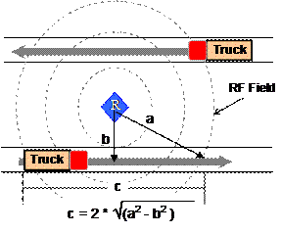

100m Read Range @ 50kph |  |  |  |  |  |  | 35m Read Range @ 50kph
Scenario | Speed (kph) | Read Range (a) | Reader/Truck Distance (b) | Truck Travel (c) | Read Time (secs) |  | Scenario | Speed (kph) | Read Range (a) | Reader/Truck Distance (b) | Truck Travel (c) | Read Time (secs)
1 | 50 | 100 | 10 | 199 | 14.3 |  | 5 | 50 | 35 | 10 | 67 | 4.8
2 | 50 | 100 | 20 | 196 | 14.1 |  | 6 | 50 | 35 | 20 | 57 | 4.1
3 | 50 | 100 | 35 | 187 | 13.5 |  | 7 | 50 | 35 | 35 | 0 | 0.0
4 | 50 | 100 | 50 | 173 | 12.5 |  | 8 | 50 | 35 | 50 | N/A | N/A

Richard

