Sample ISO/IEC 15434 messages:

First Example:
The first example, is from the new annex in ISO/IEC 15962 on 15434 support:

[)> ^{R}_{S} 06 ^{G}_{S} 25SUN043325711MH8031200000000001 ^{G}_{S} 1T110780 ^{G}_{S} Q21 ^{G}_{S} 4LUS ^{R}_{S} ^{E}O_{T}

Second Example:
The second example, is from the AIAG’s B11 Item-Level Radio Frequency Identification (RFID) Standard. It contains multiple “Format 06” (DI) format envelopes within a single 15434 Message envelope, to represent a series of “records,” each record being one component of a completed assembly:

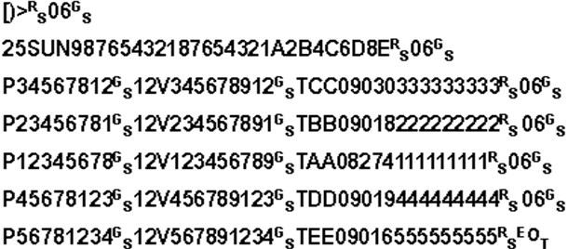

Which is the 15434 representation of the following table:

Asmbly | DI | Part Number | DI | DUNS | DI | Trace Code
Gas Tank | 25S | 12345678 |  | 987654321 |  | A2B4C6D8E
A | P | 34567812 | 12V | 345678912 | T | CC09030333333333
B | P | 23456781 | 12V | 234567891 | T | BB09018222222222
C | P | 12345678 | 12V | 123456789 | T | AA08274111111111
D | P | 45678123 | 12V | 456789123 | T | DD09019444444444
E | P | 56781234 | 12V | 567891234 | T | EE09016555555555

