ANSI MH10.8.15 – xxxx
Committee Draft

Notice
This is a draft document and thus, is dynamic in nature. It does not reflect a consensus of the MH10.8.15 Committee and it may be changed or modified. Neither ANSI nor the MH10.8.15 Committee makes any representation or warranty, express of implied, with respect to the sufficiency, accuracy or utility of the information or opinion contained or reflected in the material utilized. ANSI and the MH10.8.15 Committee further expressly advise that any use of or reliance upon the material in question is at your risk and neither ANSI nor the MH10.8.15 Committee shall be liable for any damage or injury, of whatever nature, incurred by any person arising out of any utilization of the material. It is possible that this material will at some future date be included in a copyrighted work by ANSI.

American National Standard
for Material Handling - Specification for XML Reader Output from ISO/IEC 15434 formatted AIDC Media


Material Handling Industry
8720 Red Oak Blvd., Suite 201
Charlotte, NC 28217-3992
Printed: XX/XXXX
American  National  Standard | This is a draft proposed American National Standard (ANS) of the accredited standards committee (ASC) MH 10. As such, this is not a completed standard. The MH 10/SC 8 Committee may modify this document as a result of comments received during public review and its approval as a standard.  Permission is granted to members of MH 10, its subcommittees, and their associated work groups to reproduce this document for the purposes of MH 10 standardization activities without further permission, provided this notice is included. All other rights are reserved. Any commercial or for-profit duplication is strictly prohibited.  Approval of an ANS requires verification by the American National Standards Institute (ANSI) that the requirements for due process, consensus, and other criteria for approval have been met by the standards developer. Consensus is established when, in the judgment of the ANSI Board of Standards Review, substantial agreement has been reached by directly and materially affected interests. Substantial agreement means much more than a simple majority, but not necessarily unanimity. Consensus requires that all views and objections be considered and that effort be made toward their resolution.  The use of an ANS is voluntary. Existence of the standard does not in any respect preclude anyone, whether he or she has approved the standards or not, from manufacturing, marketing, purchasing, or using items, processes, or procedures not confirming to the standards.  ANSI does not develop standards and in no circumstances will give interpretation on any ANS in the name of the ANSI. Address requests for interpretations to the secretariat or sponsor whose name appears on the title page of this standard.  CAUTION NOTICE: This ANS may be revised or withdrawn at any time. The ANSI procedures require periodic action to reaffirm, revise, or withdraw this standard. Purchasers of ANSs may receive current information on all standards by calling or writing the ANSI.

Introduction v
1 Scope 7
2 Normative references 7
3 Terms and definitions 7
4 Specification Details 7
4.1 Symbol output encoding 7
4.2 Encoding of Binary Data 10
4.3 XML reserved characters 10
4.4 Examples of ISO/IEC 15434 message encoding: 10
4.5 Processing of concatenated symbols 12
ANNEX A – Processing Steps (Informative) 13
ANNEX B – Subset of ISO/IEC 646 (Normative) 15
ANNEX C – Format “09” encoding method example (Informative) 16

Introduction
The ISO/IEC 15434 syntax for high-capacity AIDC media standard provides a standard manner of transferring data to and from high-capacity AIDC media. However this standard creates some difficulty for the systems integrator/end user to develop the interface to receive and process the data from AIDC readers through a computer keyboard wedge, USB port, Bluetooth device or other similar interfaces (e.g., interfaces to systems that do not use an RS-232 transmission protocol) and transmit to their Information Systems. This is due to the ISO/IEC 15434 specification of certain “unprintable” characters that are not easily processed by these hardware interfaces. This requires that the systems integrator/end user develop vendor specific interfaces to their Information Systems. The purpose of this standard is to provide a uniform alternate output in a popular format, XML, from AIDC readers to Information Systems for high capacity AIDC Media encoded per the ISO/IEC 15434 syntax, eliminating the need for vendor specific interfaces to Information Systems.
Readers enabled with the method described in this standard will be able to transmit the ISO/IEC 15434 syntax data using only "printable" characters thereby avoiding the "unprintable" characters used with the ISO/IEC 15434 syntax that can disrupt some data systems (e.g. systems not using an RS-232 transmission protocol).

ANSI MH10.8.15 — Specification for XML Reader Output from ISO/IEC 15434 formatted AIDC Media

Scope
This standard describes the requirements for a uniform alternate output format for transmission from AIDC readers to Information Systems for data encoded according to ISO/IEC 15434 Syntax for high-capacity ADC media ("15434 syntax"). This standard includes support for all current and future ISO/IEC 15434 syntax assignments using a defined set of XML tags according to the XML protocol. This standard provides a process for converting ISO/IEC 15434 syntax messages into XML-compliant output and includes several examples so that manufacturers of reader equipment can provide an optional standardized output for ISO/IEC15434 syntax data that can be interpreted unambiguously by application software.

Normative references
The following referenced documents are indispensable for the application of this document. For dated references, only the edition cited applies. For undated references, the latest edition of the referenced document (including any amendments) applies.
ISO/IEC 646:1991, Information technology -- ISO 7-bit coded character set for information interchange
ISO/IEC 15434, Information technology — Syntax for high capacity ADC media
ISO/IEC 19762 (all parts), Information technology -- Automatic identification and data capture (AIDC) techniques -- Harmonized vocabulary
XML Specification: http://www.w3.org/TR/REC-xml/

Terms and definitions
For the purposes of this document, the terms and definitions contained in ISO/IEC 19762 (all parts) apply.
Non-printable character
ISO 646 character not in the range of decimal 32 to 126

Specification Details

Symbol output encoding
Error: Reference source not foundand Figure 1 show the full set of ISO/IEC 15434 Message Formats that are currently defined. TError: Reference source not foundhe set of XML tags shown in Error: Reference source not found is recommended for all of these Formats.

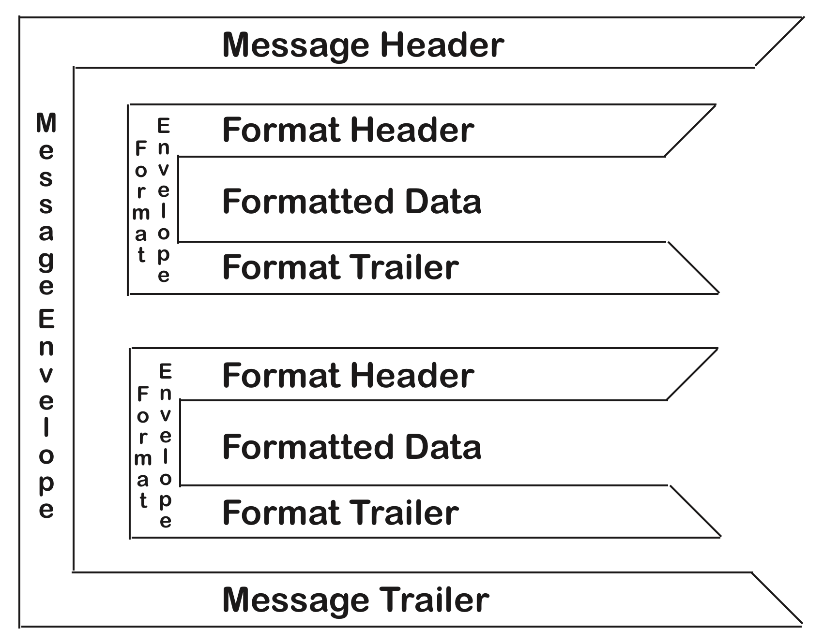
Figure 1 — ISO/IEC 15434 Enveloping Structure

Table 2 — ISO/IEC 15434 format header table showing associated separators
Format Indicator | Variable Header Data | Format Trailer | Format Description
00 |  |  | Reserved for future use
01 | ^{G}_{S}vv | ^{R}_{S} | Transportation
02 |  |  | Complete EDI message / transaction
03 | vvvrrr^{F}_{S}^{G}_{S}^{U}_{S} | ^{R}_{S} | Structured data using ANSI ASC X12 Segments
04 | vvvrrr^{F}_{S}^{G}_{S}^{U}_{S} | ^{R}_{S} | Structured data using UN/EDIFACT Segments
05 | ^{G}_{S} | ^{R}_{S} | Data using GS1 Application Identifiers
06 | ^{G}_{S} | ^{R}_{S} | Data using ASC MH 10 Data Identifiers
07 |  | ^{R}_{S} | Free form text
08 | vvvvrrnn |  | Structured data using CII Syntax Rules
09 | ^{G}_{S}ttt…t ^{G}_{S}ccc…c ^{G}_{S}nnn…n ^{G}_{S} | ^{R}_{S} | Binary data (file type) (compression technique) (number of bytes)
10-11 |  |  | Reserved for future use
12 | ^{G}_{S} | ^{R}_{S} | Structured data following Text Element Identifier rules
12-99 |  |  | Reserved for future use

Note: See ISO/IEC 15434 for a full description of the various structures shown in Table 1 and Figure 1
The XML tags and their defined usage for this standard are described in the following Table 2.
Table 3 — XML Tags
XML Tag | Usage
MSG_ISO_IEC_15434 | Message Envelope root element
FMT | Format Envelope element with a 2 character attribute indicating the associated Format Indicator
DATA | Data child element
BYTE | Non-printable elements with an encoding attribute indicating the encoding method used for the associated data. Encode attribute values to be used: BASE16.
RS | Record separator
GS | Group separator
FS | File separator
US | Unit Separator
EOT | End of transmission

The following figure shows the basics of the use of XML tags to encode an ISO/IEC 15434 message.
<?xml version="1.0" encoding="UTF-8"?>
<MSG_ISO_IEC_15434>
<RS/>
<FMT FI="03">
<DATA>vvvrrr</DATA>
<FS/>
<GS/>
<US/>
<DATA>user data</DATA>
<RS/>
</FMT>
<FMT FI="06">
<GS/>
<DATA> user data </DATA>
<GS/>
<DATA> user data </DATA>
<GS/>
<DATA> user data </DATA>
<RS/>
</FMT>
<EOT/>
</MSG_ISO_IEC_15434>
Figure 2 — XML Format Structure
Note: Figure 2 — XML Format Structure, as well as the rest of the examples within this document, is only indented for readability and any spaces and/or tabs used for indentation will not be required in the scanner output.
Note: The default XML end-of-line character is LF but CR-LF is acceptable in the scanner output.
Note - when ISO/IEC 15424 Symbology Identifiers are activated in a reader at the same time as the XML transmission option, the standard Symbology Identifier is used. For example, if Data Matrix is used to encode the 15434 message, the beginning of the transmission would be prefaced by the Symbology Identifier “]d1”, as follows:
]d1<?xml version="1.0" encoding="UTF-8"?>
<MSG_ISO_IEC_15434>

Encoding of Binary Data
A non-printable character would be presented by <BYTE >xx</BYTE>, where xx is the associated hexadecimal value of the character. Special tags will be used to represent FS, GS, RS, and US. 15434 Format “09” allows a message to include binary data. See Annex C for an example of the XML method of encoding Format “09”.

XML reserved characters
There are five XML reserved characters that need to be converted if they appear in ISO/IEC 15434 data. Error: Reference source not found displays the standard XML conversion for the XML reserved characters.
Table 4 — Example of XML Reserved Character Conversion
Character | Description | Entity Name | Entity Number
< | Less than | &lt; | &#x3C;
> | Greater than | &gt; | &#x3E;
& | Ampersand | &amp; | &#x26;
‘ | Apostrophe | &apos; | &#x27;
“ | Quote | &quot; | &#x22;
Note: In addition to the special treatment of these reserved characters, the scanner will replace any line feed (LF) characters within the data with the entity number &#xA;.

Examples of ISO/IEC 15434 message encoding:
Example: A Single Format 06 message
[)> ^{R}_{S} 06 ^{G}_{S} 25SUN043325711MH8031200000000001^{G}_{S}1T110780^{G}_{S}Q1^{G}_{S}4LUS^{R}_{S}^{E}O_{T}

<?xml version=”1.0” encoding=”UTF-8”?>
<MSG_ISO_IEC_15434>
<RS/>
<FMT FI=”06”>
<GS/>
<DATA>25SUN043325711MH8031200000000001</DATA>
<GS/>
<DATA>1T110780</DATA>
<GS/>
<DATA>Q1</DATA>
<GS/>
<DATA>4LUS</DATA>
<RS/>
</FMT>
<EOT/>
</MSG_ISO_IEC_15434>

Figure 3 — Single Format “06” XML message
Example: Multiple Format “06” Message
This example is from the AIAG’s B11 Item-Level Radio Frequency Identification (RFID) Standard. It contains multiple Format “06” (DI) format envelopes within a single ISO/IEC 15434 Message envelope, to represent a series of “records,” each record being one component of a completed assembly:
[)>^{R}_{S}
06^{G}_{S}25SUN98765432187654321A2B4C6D8E^{R}_{S}
06^{G}_{S}P34567812^{G}_{S}12V345678912^{G}_{S}TCC09030333333333^{R}_{S}
06^{G}_{S}P23456781^{G}_{S}12V234567891^{G}_{S}TBB09018222222222^{R}_{S}
06^{G}_{S}P12345678^{G}_{S}12V123456789^{G}_{S}TAA08274111111111^{R}_{S}
06^{G}_{S}P45678123^{G}_{S}12V456789123^{G}_{S}TDD09019444444444^{R}_{S}
06^{G}_{S}P56781234^{G}_{S}12V567891234^{G}_{S}TEE09016555555555^{R}_{S}^{E}O_{T}

Figure 4 – Multiple Format “06” Data
Which is the ISO/IEC 15434 representation of the following table:
Table 4 — ISO/IEC 15434 Representation
Assembly | DI | Part Number | DI | DUNS | DI | Trace Code
Gas Tank | 25S | 87654321 |  | 987654321 |  | A2B4C6D8E
A | P | 34567812 | 12V | 345678912 | T | CC09030333333333
B | P | 23456781 | 12V | 234567891 | T | BB09018222222222
C | P | 12345678 | 12V | 123456789 | T | AA08274111111111
D | P | 45678123 | 12V | 456789123 | T | DD09019444444444
E | P | 56781234 | 12V | 567891234 | T | EE09016555555555

Note: The sequence of the data elements of the Gas Tank line in Table 4 does not track with the second line of Figure 4 because of the sequencing of 25S data elements: DI (25S) + IAC (UN) + CIN (DUNS Number) + SN (Part Number + Trace code)

<?xml version=”1.0” encoding=”UTF-8”?>
<MSG_ISO_IEC_15434>
<RS/>
<FMT FI=”06”>
<GS/>
<DATA>25SUN98765432187654321A2B4C6D8E</DATA>
<RS/>
</FMT>
<FMT FI=”06”>
<GS/>
<DATA>P34567812</DATA>
<GS/>
<DATA>12V345678912</DATA>
<GS/>
<DATA>TCC09030333333333</DATA>
<RS/>
</FMT>
<FMT FI=”06”>
<GS/>
<DATA>P23456781</DATA>
<GS/>
<DATA>12V234567891</DATA>
<GS/>
<DATA>TBB09018222222222</DATA>
<RS/>

</FMT>
<FMT FI=”06”>
<DATA>P12345678</DATA>
<GS/>
<DATA>12V123456789</DATA>
<GS/>
<DATA>TAA08274111111111</DATA>
<RS/>
</FMT>
<FMT FI=”06”>
<GS/>
<DATA>P45678123</DATA>
<GS/>
<DATA>12V456789123</DATA>
<GS/>
<DATA>TDD09019444444444</DATA>
<RS/>
</FMT>
<FMT FI=”06”>
<GS/>
<DATA>P56781234</DATA>
<GS/>
<DATA>12V567891234</DATA>
<GS/>
<DATA>TEE09016555555555</DATA>
<RS/>
</FMT>
<EOT/>
</MSG_ISO_IEC_15434>
Figure 5 — Multiple Format “06” XML message

Processing of concatenated symbols
In some cases a message may come from a symbol that requires concatenation of multiple bar codes. In these cases the concatenation processing is performed within the reader and the XML output will be the content of the concatenated symbols.
ANNEX A – Processing Steps (Informative)
The translation from ISO/IEC 15434 to XML may be accomplished using the following processing steps:
- If the input message does not begin with the ISO/IEC 15434 compliance indicator “[)>”, abort processing, otherwise emit the first two XML output lines:
<?xml version=”1.0” encoding=”utf8”?>
<MSG_ISO_IEC_15434>
- Set the Boolean variable inData to False, and set integer variable currentFormat to -1
- Loop repeatedly through the following steps, until either the end of the input message has been reached, an EOT is encountered or an “abort processing” condition causes processing to exit this loop:
  - If the next input character is EOT, then emit <EOT/> on a line by itself, exit loop
  - Else If the next input character is an RS, then:
    - if inData is True, then emit <\DATA> to terminate the current line of output, and set inData to False
    - emit <RS/> on a line by itself
    - if currentFormat is not -1, then emit <\FMT>, set currentFormat to -1
    - if the next character after the RS is EOT, then continue loop processing
- else if the next two characters after the RS are a digit string “nn”, then:
      - get these next two characters “nn”, set process variable currentFormat to the binary value of “nn”, and emit the XML line <FMT FI=”nn”>
      - Look ahead, and if the next character after “nn” is not GS, then set inData to True, and emit <DATA> to start the next line
    - Else abort processing
    - If currentFormat is 09, then invoke the Format_09 procedure, then continue looping
  - Else If the next input character is a GS character, then:
    - if inData is True, then emit <\DATA>
    - emit <GS\> on a line by itself
    - emit <DATA> to start the next line, and set inData to True
  - Else If the next input character is an FS or US character, then:
    - if inData is True, then emit <\DATA> and set inData to False
    - emit <FS\> or <US\> (to match the input character) on a line by itself, followed by <DATA> to start the next line, and set inData to True
  - Else If the next input character is an LF character, then emit &#xA; and continue
  - Else if the next character is from Table 3 then emits the corresponding entity name and continue loop processing
  - Else if the next character is not in the range 0x20 to 0x7E:
    - Emit <BYTE> at the start of a new line
    - Convert the character’s base 256 value to a pair of Base 16 values using characters from the set [0-9A-F], then advance to the next input character
    - Repeat the above step until a character is encountered that is less than 0x7F, and is either greater than 0x1F, or is one of the ASCII characters GS, RS, FS, US, LF or EOT. When such a character is encountered, do not convert it to Base 16 values; instead, emit </BYTE> and continue loop
  - Else (the next character is a regular printable 7-bit ASCII character)
    - copy the next character to the output unchanged
- After exiting the main loop, emit </DATA> and/or </FMT> if needed to close the tag(s)
- Emit the following line to complete XML processing:
</MSG_ISO_IEC_15434>
Format_09 procedure for processing the contents of a Format “09” envelope:

- Set integer variables numGS and numBytes to zero
- Loop, until a step inside this loop causes loop termination
  - Fetch the next input character
  - If the next input character is a GS character, then:
    - if inData is True, then emit <\DATA>
    - emit <GS\> on a line by itself, and increment numGS,
    - emit <DATA> to start the next line, and set inData to True
    - if numGS is 4, then
      - Emit <BYTE> at the start of a new line
      - While numBytes is greater than 0:
        - advance to the next input byte, and decrement numBytes
          - If a next input byte is unavailable, then the “number of bytes” was incorrectly represented in the Format “09” envelope; abort processing
        - convert the next input byte’s base 256 value to a pair of Base 16 values using characters from the set [0-9A-F], and emit these two characters
      - emit </BYTE> to end the line, then exit this loop of procedure Format_09.
  - Else (the next character ‘c’ is a regular printable 7-bit ASCII character)
    - If numGS is 3, then:
      - if ’c’ is not a decimal digit ‘0’ through ‘9’, this is an error condition – abort processing
      - numBytes = (numBytes * 10) + (‘c’ – 48).
    - copy the next character to the output unchanged
- look ahead to confirm that the next character is the RS at the end of the Format “09” envelope (if not, abort processing)
- Return to the main procedure, starting a new loop iteration that will process the RS at the end of the Format “09” envelope

ANNEX B – Subset of ISO/IEC 646 (Normative)
Table B.1 – Table of hexadecimal and decimal values

HEX | DEC | ISO/IEC 646 | HEX | DEC | ISO/IEC 646 | HEX | DEC | ISO/IEC 646
00 | 00 | NUL | 30 | 48 | 0 | 60 | 96 | ‘
01 | 01 | SOH | 31 | 49 | 1 | 61 | 97 | a
02 | 02 | STX | 32 | 50 | 2 | 62 | 98 | b
03 | 03 | ETX | 33 | 51 | 3 | 63 | 99 | c
04 | 04 | EOT * | 34 | 52 | 4 | 64 | 100 | d
05 | 05 | ENQ | 35 | 53 | 5 | 65 | 101 | e
06 | 06 | ACK | 36 | 54 | 6 | 66 | 102 | f
07 | 07 | BEL | 37 | 55 | 7 | 67 | 103 | g
08 | 08 | BS | 38 | 56 | 8 | 68 | 104 | h
09 | 09 | HT | 39 | 57 | 9 | 69 | 105 | i
0A | 10 | LF* | 3A | 58 | : | 6A | 106 | j
0B | 11 | VT | 3B | 59 | ; | 6B | 107 | k
0C | 12 | FF | 3C | 60 | <* | 6C | 108 | l
0D | 13 | CR | 3D | 61 | = | 6D | 109 | m
0E | 14 | SO | 3E | 62 | >* | 6E | 110 | n
0F | 15 | SI | 3F | 63 | ? | 6F | 111 | o
10 | 16 | DLE | 40 | 64 | @ | 70 | 112 | p
11 | 17 | DC1 | 41 | 65 | A | 71 | 113 | q
12 | 18 | DC2 | 42 | 66 | B | 72 | 114 | r
13 | 19 | DC3 | 43 | 67 | C | 73 | 115 | s
14 | 20 | DC4 | 44 | 68 | D | 74 | 116 | t
15 | 21 | NAK | 45 | 69 | E | 75 | 117 | u
16 | 22 | SYN | 46 | 70 | F | 76 | 118 | v
17 | 23 | ETB | 47 | 71 | G | 77 | 119 | w
18 | 24 | CAN | 48 | 72 | H | 78 | 120 | x
19 | 25 | EM | 49 | 73 | I | 79 | 121 | y
1A | 26 | SUB | 4A | 74 | J | 7A | 122 | z
1B | 27 | ESC | 4B | 75 | K | 7B | 123 | {
1C | 28 | FS* | 4C | 76 | L | 7C | 124 | |
1D | 29 | GS* | 4D | 77 | M | 7D | 125 | }
1E | 30 | RS* | 4E | 78 | N | 7E | 126 | ~
1F | 31 | US* | 4F | 79 | O | 7F | 127 | DEL
20 | 32 | SP | 50 | 80 | P
21 | 33 | ! | 51 | 81 | Q
22 | 34 | “ * | 52 | 82 | R
23 | 35 | # | 53 | 83 | S
24 | 36 | $ | 54 | 84 | T
25 | 37 | % | 55 | 85 | U
26 | 38 | &* | 56 | 86 | V
27 | 39 | ‘ * | 57 | 87 | W
28 | 40 | ( | 58 | 88 | X
29 | 41 | ) | 59 | 89 | Y
2A | 42 | * | 5A | 90 | Z
2B | 43 | + | 5B | 91 | [
2C | 44 | , | 5C | 92 | \
2D | 45 | - | 5D | 93 | ]
2E | 46 | . | 5E | 94 | ^
2F | 47 | / | 5F | 95 | _
*These Characters have special handling within this standard.
ANNEX C – Format “09” encoding method example (Informative)
Binary data is encoded using a subset of the printable characters to avoid non-printable characters and XML reserved characters. While not the most efficient method, two hexadecimal characters are used to represent each byte because of the ease of implementation.
Format “09” has the following structure.
09 GS ttt...t GS ccc...c GS nnn...n GS RS
where ttt is file type, such as “jpg” or “bmp”, ccc is the compression technique, if any, and nnn is the decimal number of bytes between the GS and the RS.
The XML output contains two hex characters for every byte of data. Following is an example for a small photo shown below.

Figure C.1 - Sample photo
The file is in the JPG format and contains 877 bytes beginning and ending as follows
Table C.1 - Encoded sample photo in characters, decimal and hexadecimal values
Position | Character | Decimal ASCII value | Hex ASCII Value
1 | ÿ | 255 | FF
2 | Ø | 216 | D8
3 | ÿ | 255 | FF
4 | à | 224 | E0
5 |  | 0 | 00
6 |  | 16 | 10
7 | J | 74 | 4A
8 | F | 70 | 46
…
869 |  | 24 | 18
870 | ! | 33 | 21
871 | B | 66 | 42
872 | ˜ | 152 | 98
873 | c | 99 | 63
874 | » | 187 | BB
875 | Ì | 204 | CC
876 | ó | 243 | F3
877 | 2 | 50 | 32
The encoded data representation follows:
[)> RS 09 GS JPG GS GS 877 GS ÿØÿà JF … !B˜c»Ìó2 RS EOT
The actual data encoded in a Data Matrix symbol is shown below.
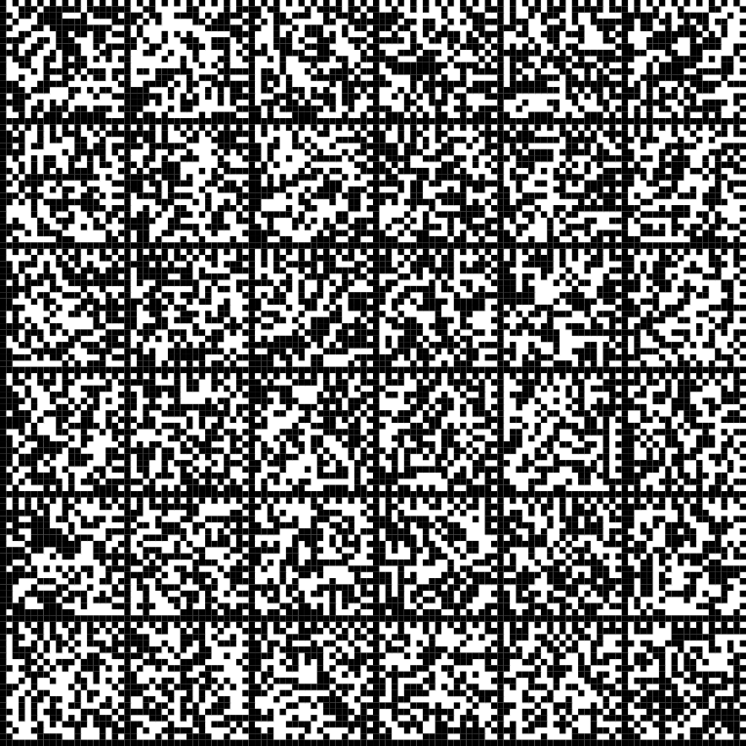
Figure C.2 – Encoded JPG of sample photo in Data Matrix
The XML transmitted data representation follows.
Table C.2 – Decoded data from figure C.2 transmitted in XML format
XML Data | XML Data Annotation
<?xml version="1.0" encoding="UTF-8"?> | Start of XML Data Stream
<MSG_ISO_IEC_15434> | Start of ISO/IEC 15434 Message
<RS/> | Record Separator
<FMT FI="09"> | Format = 09
<GS/> | Group Separator
<DATA>JPG</DATA> | File Type (ttt) = JPG
<GS/> | Group Separator
<DATA></DATA> | Compression (ccc) = none
<GS/> | Group Separator
<DATA>877</DATA> | Decimal Number of Bytes (nnn) = 877
<GS/> | Group Separator
<DATA><BYTE>FFD8FFE000104A46…1821429863BBCCF332</BYTE></DATA> | Data = 2 Character Hex data representation
<RS/> | Record Separator
</FMT> | End of Format
<EOT/> | End of Transmission
</MSG_ISO_IEC_15434> | End of ISO/IEC 15434 Message

