ANSI MH10.8.12 – xxxx
(revision of CEA/EIA-706)
Committee Draft

Notice
This is a draft document and thus, is dynamic in nature. It does not reflect a consensus of the MH10.8.12 Committee and it may be changed or modified. Neither ANSI nor the MH10.8.12 Committee makes any representation or warranty, express of implied, with respect to the sufficiency, accuracy or utility of the information or opinion contained or reflected in the material utilized. ANSI and the MH10.8.12 Committee further expressly advise that any use of or reliance upon the material in question is at your risk and neither ANSI nor the MH10.8.12 Committee shall be liable for any damage or injury, of whatever nature, incurred by any person arising out of any utilization of the material. It is possible that this material will at some future date be included in a copyrighted work by ANSI.

American National Standard
for Material Handling -
Component marking


Material Handling Industry
8720 Red Oak Blvd., Suite 201
Charlotte, NC 28217-3992
Printed: XX/XXXX
American  National  Standard | This is a draft proposed American National Standard (ANS) of the accredited standards committee (ASC) MH 10. As such, this is not a completed standard. The MH 10/SC 8 Committee may modify this document as a result of comments received during public review and its approval as a standard.  Permission is granted to members of MH 10, its subcommittees, and their associated work groups to reproduce this document for the purposes of MH 10 standardization activities without further permission, provided this notice is included. All other rights are reserved. Any commercial or for-profit duplication is strictly prohibited.  Approval of an ANS requires verification by the American National Standards Institute (ANSI) that the requirements for due process, consensus, and other criteria for approval have been met by the standards developer. Consensus is established when, in the judgment of the ANSI Board of Standards Review, substantial agreement has been reached by directly and materially affected interests. Substantial agreement means much more than a simple majority, but not necessarily unanimity. Consensus requires that all views and objections be considered and that effort be made toward their resolution.  The use of an ANS is voluntary. Existence of the standard does not in any respect preclude anyone, whether he or she has approved the standards or not, from manufacturing, marketing, purchasing, or using items, processes, or procedures not confirming to the standards.  ANSI does not develop standards and in no circumstances will give interpretation on any ANS in the name of the ANSI. Address requests for interpretations to the secretariat or sponsor whose name appears on the title page of this standard.  CAUTION NOTICE: This ANS may be revised or withdrawn at any time. The ANSI procedures require periodic action to reaffirm, revise, or withdraw this standard. Purchasers of ANSs may receive current information on all standards by calling or writing the ANSI.

Foreword vi
Introduction vii
1 Scope 1
2 Normative references 1
3 Terms and definitions 1
4 Data content 2
4.1 Field length 2
4.2 Mandatory data 2
4.2.1 Manufacturer identification 2
4.2.1.1 Overview 2
4.2.1.2 Manufacturer identification Data Identifier 2
4.2.2 Item identification 3
4.2.2.1 Overview 3
4.2.2.2 Item identification Data Identifier 3
4.2.3 Traceability information 3
4.2.3.1 Overview 3
4.2.3.2 Unique traceability Data Identifier 3
4.2.4 Additional data fields 3
4.2.5 Data field syntax 4
4.3 Example of maximum length message with 7-character manufacturer identification 4
4.4 Example of reduced length message 5
4.5 Example of maximum length message using 9-character GS1 manufacturer identification 5
4.6 Example of maximum message length using 25S Data Identifier 6
5 Symbology requirements 7
5.1 Level of error correction 7
5.2 Physical characteristics of the symbol 7
5.2.1 Symbol size 7
5.2.2 Feature size cell width and height 8
5.2.3 Quiet zones 8
5.2.4 Surface topography 8
5.2.5 Substrate properties 8
5.2.6 Symbol and text orientation 8
5.2.6.1 Symbol orientation and placement 8
5.2.6.2 Text 10
5.3 Print quality 10
5.3.1 Test set-up measurement methodology 10
5.3.2 Test set-up calibration of measurement systems 11
5.3.3 Print quality of the symbol 11
5.4 Encryption 11
5.5 Character set 11
6 Reader considerations 12
6.1 Fixturing 12
6.2 Focus 12
Annex A (Informative) Commonly used Data Identifiers 13
Annex B (Normative) Subset of ASCII/ISO 646 (Table of hexadecimal and decimal values) 15
Annex C (Informative) Data Matrix ECC 200 dimensions 17
Bibliography 18

Foreword
This standard preserves the work of earlier standards development, while at the same time provides valuable insight and guidance on the direct marking of electronic components.
The original work was designated EIA-706, from the Electronics Industry Association PEPS (Packaging of Electronic Products for Shipment) R9 Bar Code Subcommittee) who began working on this standard in 1993. The first edition was published 1997-06-30.
In a reorganization of EIA in 2000, the work of PEPS R9 was transferred to the Consumer Electronics Association (CEA).
Under an agreement between CEA and MH10/SC8 in April 2006, CEA-706Awas transferred from CEA to MH 10/SC 8. The content of CEA 706A is incorporated into this standard.
This American National Standard now serves as the re-designation of CEA-706-A to ANS MH10.8.12.

Introduction
The purpose of this standard is to establish a common structure for encoding data to be marked on electronic components to facilitate automation. This standard provides a means for components to be marked and read in a fixtured environment at any manufacturer's facility and be read by customers purchasing components for subsequent manufacturing operations. Intended applications include, but are not limited to:
- component traceability
- component tracking
- automated manufacturing process control
- logistics
- inventory management
- robotic assembly
- configuration management
- automated inspection and quality control
- Computer-Aided Design (CAD) engineering and automated revision control
- anti-counterfeiting systems
- automated testing

Component marking

Scope
This standard describes the requirements for using formatted two-dimensional machine-readable symbols for the marking of electronic components of first level assemblies.
Note: Marking of reels, tubes, and trays containing components is subject to Product Package marking. (See MH10.8.6 and ISO 22742)

Normative references
The following referenced documents are indispensable for the application of this document. For dated references, only the edition cited applies. For undated references, the latest edition of the referenced document (including any amendments) applies.
ANS MH10.8.2, Data Identifier and Application Identifier Standard
ISO 3166-1, Codes for the representation of names of countries and their subdivisions -- Part 1: Country codes
ISO/IEC 15415, Information technology -- Automatic identification and data capture techniques -- Bar code print quality test specification -- Two-dimensional symbols
ISO/IEC 15434, Information technology – Automatic identification and data capture techniques – Syntax for high capacity ADC media
ISO/IEC 19762 (all parts), Information technology -- Automatic identification and data capture (AIDC) techniques -- Harmonized vocabulary
ISO 21067, Packaging – Vocabulary
ISO/IEC 16022, Information technology -- Automatic identification and data capture techniques -- Data Matrix bar code symbology specification

Terms and definitions
For the purposes of this document, the terms and definitions contained in ISO/IEC 19762 (all parts) and ISO 21067 apply.

Data content

Field length
Field length is the number of data characters in a data field. The character count of data characters is exclusive of overhead characters.

Mandatory data
The Mandatory Data shall be represented by a maximum of 50 user data characters (see 4.6). It is the recommendation of this standard that Data Identifiers be used to identify data fields. Application Identifiers may be used only with mutual agreement between trading partners. The Manufacturer Identification (see 4.2.1), Item Identification (see 4.2.2) and Traceability (see 4.2.3) data shall be included in the symbol.

Manufacturer identification

Overview
Each item shall have the manufacturer identified. Allowed Manufacturer IDs include the GS1 Company Prefix, Data Universal Numbering System (D-U-N-S®) code, Commercial And Government Entity (CAGE) code or as agreed to between the trading partners. Other Electronic Identification (EID) registration authorities may be used upon agreement of the trading partners.

Manufacturer identification Data Identifier
The Manufacturer ID shall be identified with a data identifier indicating the type of enterprise ID as follows. When possible, Data Identifiers identifying the registration authority should be used.
Table 1 – Manufacturer identification code
Enterprise ID type | Data Identifier | Sample | Notes
GS1 Company Prefix | 3V | 3V07164181 | The GS1 Company Prefix is all numeric and is of variable length (7 to 11 digits). 07164181 is the 8 digit GS1Company Prefix in this example.  The Issuing Agency Code (any digit 0 through 9), per ISO/IEC 15459, is the first digit of the GS1 Company Prefix for all GS1 Company Prefixes.
D-U-N-S Number | 12V | 12V436929531 | The D-U-N-S number is 436929531
CAGE Code | 17V | 17V12592 | The CAGE code is 12592
Manufacturer ID | 18V | 18VUN436929531 | Uses Issuing Agency Code (per ISO/IEC 15459) and Company Identification Number. IAC for D-U-N-S is “UN” and the D-U-N-S number is 436929531
Customer's Supplier ID | V | V23NPNSA2 | 23NPNSA2 is the supplier ID assigned by the customer; no EID registration authority is implied.

Item identification

Overview
The maximum length of the Item Identification shall be 25 data characters. Item identification codes may be concatenated with the manufacturer identification to produce a component identification.
The 14-digit GTIN-14 is a fixed length numeric example of such component identification.

Item identification Data Identifier
The Data Identifier “25P” shall precede Supplier Assigned Item Identification data.
The Data Identifier “P” shall precede Customer Item Identification data.
When using GS1 item identification and Data Identifier, the Data Identifier 3P shall precede the GTIN-13 or GTIN-12 combined manufacturer and item identifier. The GTIN-12 shall be prefixed with one zero for a total data length of 13 to be consistent with GS1 coexistence recommendations.
Note that the GS1 identification scheme does not allow the user to parse a GS1 number to determine the manufacturer. As a consequence the manufacturer ID must also be marked per 4.2.1 in addition to the GS1 number.

Traceability information

Overview
Traceability information is assigned by the manufacturer or supplier. Traceability information may incorporate the following data fields: lot or batch number, manufacturing location, date of manufacture, serial number, revision level, country of origin, etc. These fields may be encoded as a single Traceability data element. The data element consists of the appropriate Data Identifier and its associated data.
The maximum length of Traceability information shall be 18 characters, which excludes the associated Data Identifier. If more Traceability data is required, then it may be included in additional data fields (see 4.2.4).

Unique traceability Data Identifier
The appropriate Data Identifier shall precede the Traceability data. See Annex A for a listing of commonly used Data Identifiers. Absent specific trading partner agreements, the Data Identifier “25S” shall be used.

Additional data fields
Additional data fields consistent with ANSI MH10.8.2 may be included in the symbol as long as the symbol size does not exceed 7 mm by 7 mm. See Annex A for commonly used Data Identifiers and Annex C for Data Matrix symbol sizes.
Separate symbols may be added, at the discretion of the manufacturer, when additional data is required. Placement of any additional symbol shall not interfere with the requirements of 5.2.6 Symbol and Text Orientation for primary symbol placement.

Data field syntax
The message shall be encoded using the ANSI MH10.8.3 format. The message Header, the first 7 characters “[)>^{R}_{S}06^{G}_{S}”, and the Trailer, the last 2 characters “^{R}_{S} ^{E}O_{T}”, are fixed for this application, in accordance with the ANSI MH10.8.3 standard, when Data Identifiers are used within the message.
When combining data fields within a two-dimensional symbol, the <GS> (ASCII/ISO 646 Decimal “29", Hex “1D”) character shall be used with the appropriate Data Identifier to identify each of the combined fields.

Example of maximum length message with 7-character manufacturer identification
This example is a symbol comprising the mandatory fields with the Manufacturer, Item Identification and Traceability at their maximum length, which contains:
- 50 user data characters, comprised of a 7-Character Manufacturer Identifier (character length of seven character GS1 Company Prefix), 25-Character Item Identification, and 18-Character Traceability Code
- 6 identifier characters, (3V, 1P, 1T)
- 2 separator characters (^{G}_{S})
- 9 Message Header (i.e. [)>^{R}_{S}06^{G}_{S}) and Trailer (i.e. ^{R}_{S}^{E}o_{T}) characters
. . . for a total of 67 characters.
When using optimal Data Matrix compaction (see ISO/IEC 16022) features, a symbol containing the three mandatory fields, each of maximum length, will fit in a 2.9 mm by 2.9 mm area when using 0.102 mm (0.004 inch) cells. See Figure 1 and Table 2.
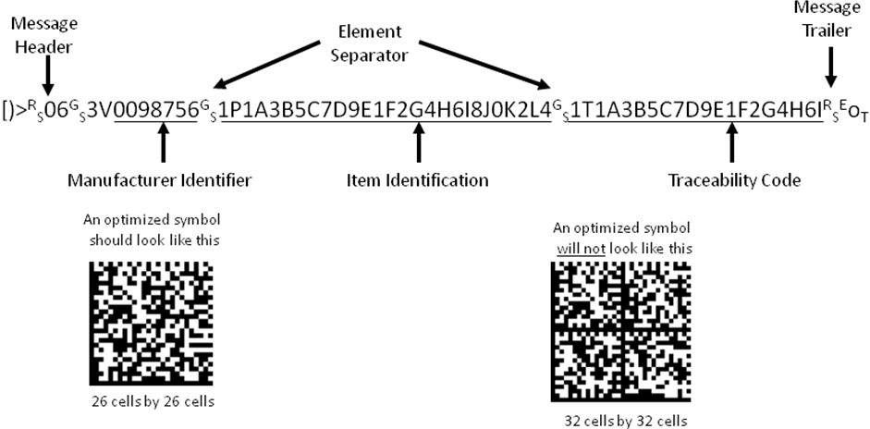
GRAPHIC ABOVE NOT ACTUAL SIZE
Figure 1 – Data and acceptable and unacceptable symbols encoding mandatory fields

Example of reduced length message
The total message length, using the ISO/IEC 15434 format, can be reduced by using a Global Trade Item Number product code, such as the GTIN-12 (formerly the Universal Product Code (U.P.C.)), or GTIN-13 (formerly the EAN Code), or GTIN-14 as the Item ID and a Serial Number as the Traceability identification. The total message length using this format may contain as many as 44 characters, assuming that a maximum length (18 characters) Traceability Identification is used. See Figure 2.
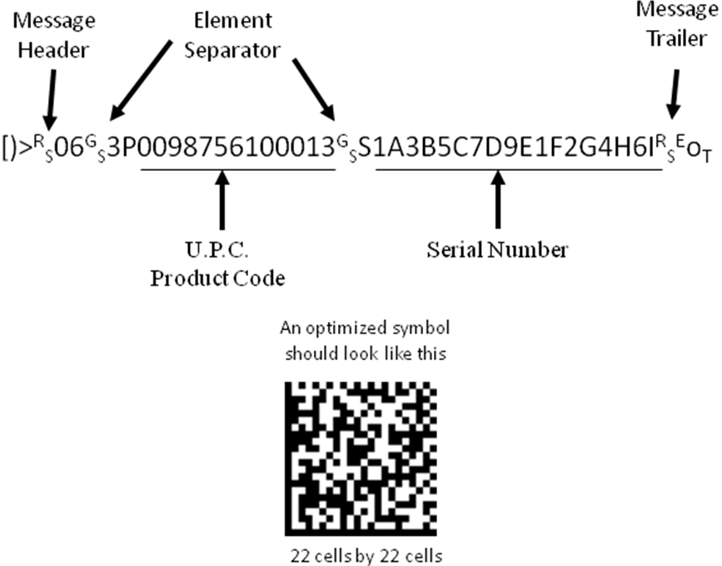
GRAPHIC ABOVE NOT ACTUAL SIZE
Figure 2 – Data and symbol encoding reduced length message
Where the space available to mark a component is restricted, the number of characters that can be encoded in the item identification or traceability information will be reduced.

Example of maximum length message using 9-character GS1 manufacturer identification
A symbol comprising the mandatory fields with the maximum length GS1 Company Prefix, the maximum length Manufacturer Item Identification and a reduced length Traceability Code contains:
- 50 user data characters, comprised of a 9-Character Manufacturer Identifier (maximum character length of GS1 Company Prefix), 25-Character Item Identification, and 16-Character Traceability Code
- 6 identifier characters, (3V, 1P, 1T)
- 2 separator characters (^{G}_{S}), and
- 9 Message Header and Trailer characters ([)>^{R}_{S}06^{G}_{S}) and Trailer characters (^{R}_{S}^{E}o_{T})
. . . for a total of 67 characters. See Figure 3.
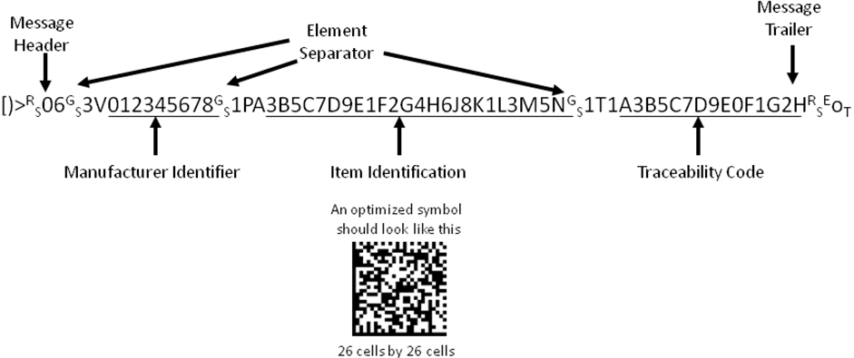
GRAPHIC ABOVE NOT ACTUAL SIZE
Figure 3 – Data and symbol encoding message with 9-character GS1 manufacturer identification

Example of maximum message length using 25S Data Identifier
A symbol comprising the mandatory fields while using the Data Identifier 25S contains:
- 50 user data characters, comprised of 25-Character Item Identification, an 11-Character Manufacturer Identifier (a 2-character Issuing Agency Code followed by a 9-character DUNS number), and 14-Character Traceability Code
- 5 identifier characters, (1P, 25S)
- 2 separator characters (^{G}_{S}), and
- 9 Message Header and Trailer characters ([)>^{R}_{S}06^{G}_{S}) and Trailer characters (^{R}_{S}^{E}o_{T})
. . . for a total of 66 characters
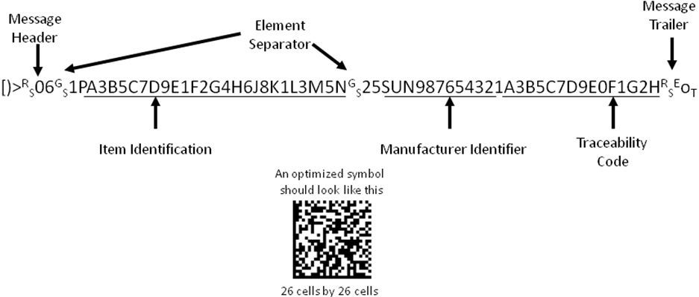
GRAPHIC ABOVE NOT ACTUAL SIZE
Figure 4 – Data and symbol encoding message with 25S Data Identifier at maximum length

Symbology requirements
The symbology specified by this standard is Data Matrix ECC200, as defined by ISO/IEC 16022.

Level of error correction
The error correction level shall be ECC200.

Physical characteristics of the symbol
This section defines the marking requirements for the symbol.

Symbol size
The maximum symbol size shall be 7 mm by 7 mm. The reason for this requirement is to establish a known field of view for reading the mark. No minimum symbol size is specified. However, a minimum cell size is specified in 5.2.2.
It is recommended that the user implement their system using the largest cell size that will fit in the available area, up to the maximum dimensions shown in Table 2. This will allow for the best possible scanner performance. Cell sizes below 0.150 mm (0.006 inch) are not recommended because these symbols cause a reduced depth of field. Cell sizes below 0.150 mm (0.006 inch) may only be appropriate for use when the marking area on a component will not permit the use of 0.150 mm (0.006 inch) or greater cell sizes. The particular symbol size that is realized will depend on the amount and type of data encoded.
Table 2 - Symbol size versus cell size based on mandatory fields at maximum length
(size includes quiet zones)
 | Cell Size
 | 0.102 mm  (0.004 inch) | 0.150 mm  (0.006 inch) | 0.175 mm  (0.007 inch) | 0.200 mm  (0.008 inch) | 0.250 mm  (0.010 inch)
Symbol Size | 2.9 x 2.9 mm | 4.2 x 4.2 mm | 4.9 x 4.9 mm | 5.6 x 5.6 mm | 7.0 x 7.0 mm

Feature size cell width and height
The feature size is determined by many factors including marking area available, surface type, environment and reading device(s) used. The minimum open system width of the cell shall be 0.102 mm (0.004 inch). The minimum open system height of the cell shall be 0.102 mm (0.004 inch) in a non clean room environment.
The minimum symbol size to encode the maximum 50 user data character message shall be 2.9 mm by 2.9 mm, including quiet zones, based on a cell size of 0.102 mm (0.004 inch) and an error correction level of ECC200.

Quiet zones
The quiet zones are specified as a minimum of one (1) cell width on all four sides of the mark area. The quiet zone may be the space contiguous to the edge(s) of the mark where the imaged area abuts the physical edge or edges of the item being imaged. It is not the intent of this standard to require additional quiet zone beyond the minimum required by the symbology specification.

Surface topography
In order to achieve an acceptable print quality with a cell width/height of 0.102 mm (0.004 inch), it may be necessary to specify a particular component surface finish and/or geometry of lighting conditions. Molded component surface finish should be Charmille VDI 3400 Scale of 18-24 or EDM finish of .8-1.6 micrometers on RA scale.

Substrate properties
Substrates may be various colors and marks on these substrates may be light or dark. The ISO/IEC 16022 Standard will provide guidance for marking substrates that are dark or light.

Symbol and text orientation

Symbol orientation and placement
The symbol shall be oriented such that the intersection of the two solid lines of the symbol's finder pattern points to the lower left of the component. The bottom solid line of the symbol should be parallel to the lines of text. The symbol should be visible on the finished assembly. When this surface is covered, e.g., with a heat sink, the symbol should be placed on the pin side.
The symbol should be placed at the center of the left side of the component as determined by the orientation of the human-readable text for reading. The human-readable text should be placed to the right of the symbol. See Figures 5 through 10, for examples of symbol placement.
When component orientation is not critical or related to component functionality, the symbol shall be located and oriented as mutually agreed to between trading partners.
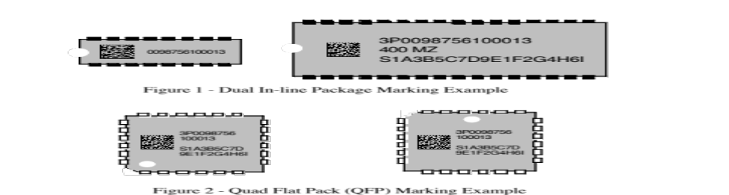
Figure 5 – Dual In-line package marking example
Figure 6 – Quad Flat Pack (QFP) marking example
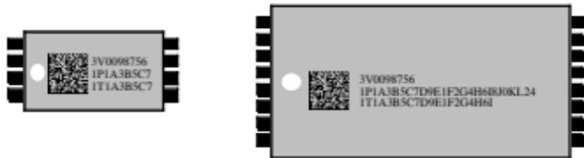
Figure 7 – Thin Small Outline Package (TSOP) marking example
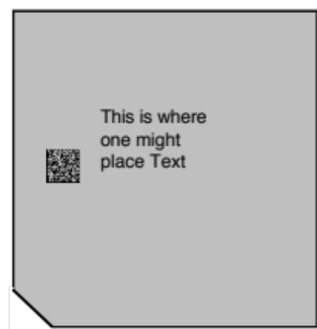
Figure 8 - pin grid array marking example

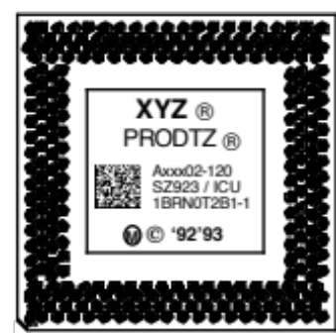
Figure 9 - Pin grid array marking with other product ID marking
Figure 10 - Circular component marking

Text
This standard does not address the marking of human-readable interpretation of symbol data or text. This standard does not supersede or replace any applicable safety or regulatory marking or labeling requirements. This standard is to be applied in addition to any other mandated labeling requirements.

Print quality

Test set-up measurement methodology
The printed or marked symbol to be measured shall be illuminated by a white light source such as a Stocker and Yale 9-Series Circular Illuminator (70 mm (2.9 inch) diameter fluorescent ring light) or equivalent. The light source shall be mounted at a height to provide a 35 to 45 degree angle of incidence, relative to the symbol surface.
The distance from the bottom of the fluorescent bulb to the marked surface should be approximately 24 mm (40 degree angle of incidence). Consistent measurements have been achieved using an NEC Model TI324A CCD camera having a shutter speed of 1/2000th of a second, a 20 mm lens extension tube, and a 50 mm lens set at an f-stop of f.8. The image shall be in focus. The distance from the bottom of the lens to the top of the component (image plane) is recommended to be approximately 160 mm (6.25 inches). See Figure 11.

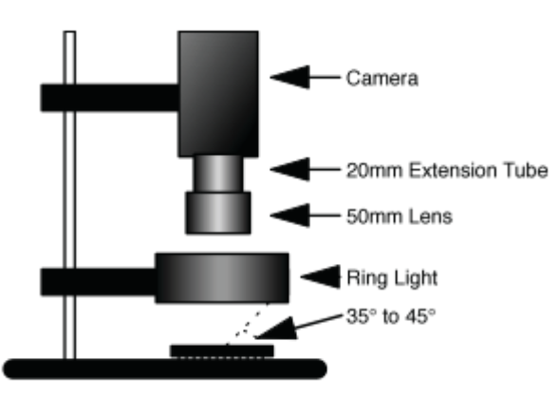
Figure 11 – Print quality equipment set-up

Test set-up calibration of measurement systems
Calculate the reference reflectivity per ISO/IEC 15416, where a working standard symbol shall be obtained by 1) buying a pre-measured symbol or 2) measuring a diffuse white and carbon black symbol with a MacBeth reflectometer at 680 nm. Determine the Symbol Contrast (SC) of the working standard symbol. The working standard symbol shall be an "A" quality symbol according to ISO/IEC 15415. Verify that the measured gray level of the working standard symbol sample is between 150 and 200, out of 256. Ambient light levels shall be controlled in order not to have any influence on the measurement results.

Print quality of the symbol
The Print Quality shall be measured per ISO/IEC 15415. Note that the reflectivity measurements in the Optical Geometry clause of ISO/IEC 15415 shall be performed, since the risk of excessively high or low reflectance values in the extended area is significant for this application.
The symbol grade shall be reported per ‘Reporting of Symbol Grade’ clause of ISO/IEC 15415 as grade/aperture/light/angle. The minimum print quality requirement shall be 1.5*/03/W/40. The asterisk following the value for grade indicates that the surroundings of the symbol contain extremes of reflectance that may interfere with reading, ’W’ is for white light (see the clause on Optical Geometry in ISO/IEC 15415) and the angle shall be 40 ±5 degrees corresponding to the actual set-up used in the same clause. It is recommended that every attempt be made to achieve a minimum print quality grade of 2.5*/03/W/40.

Encryption
Encryption shall not be used for mandatory data fields.

Character set
The character set shall be upper case alphabetic characters, numeric digits, and the eight characters (-, ., Space, $, /, +, *, and %), as well as the recommended field separators, record separators, segment terminators and compliance indicators. A table of these characters and their hexadecimal and decimal equivalent is included as Annex B.

Reader considerations

Fixturing
Fixturing is an environment where a mechanical system positions both the component and the reading device. Due to the small cell sizes possible in this application, small Depth of Field (less than 2.5 mm) will be common. Reading stations will need to be designed to read at a relatively precise setting. One method that could be used is to fixture both the reader and component during the reading process.

Focus
In order to be able to read the range of different cell sizes with a single reader configuration, it is recommended that the optimum focus of the read system be determined with a symbol utilizing the minimum cell size (0.102 mm).

- (Informative)
Commonly used Data Identifiers
Note: This is a partial listing. The complete listing is included in ANS MH10.8.2.
Data Identifier | Identifier Description | Application Identifier
5D | ISO format YYMMDD immediately followed by an ANSI X12.3 Data Element Number 374 Qualifier providing a code specifying type of date (e.g., manufacture date “094”) | 11  (Production Date)
6D | ISO format YYYYMMDD immediately followed by an ANSI X12.3 Data Element Number 374 Qualifier providing a code specifying date type (e.g., manufacture date “094”) | No Equivalent
4L | Country of Origin, two-character ISO 3166 country code | 422 (3-digit ISO 3166 Code)
N | National/NATO Stock Number (NSN) | 7001
P | Item Identification Code assigned by Customer | 241
1P | Item Identification Code assigned by Supplier | 01  (GTIN -14)
2P | Code assigned to specify the revision level for an Item (e.g., engineering change level, edition, or revision) | 240
3P | Combined manufacturer identification code/item code (GTIN-12 preceded by the digit zero [0]) | No Equivalent
8P | 14-digit UCC/EAN format for Product Shipping Container Symbol code structure | 01  (GTIN -14)
9P | Combined DUNS-9 supplier identification and item code assigned by the supplier | No Equivalent
11P | 10-character (alphanumeric) CLEI Code for Telecommunications Equipment | No Equivalent
25P | Identification of a party to a transaction as identified in 18V, followed by the supplier assigned part number. | No Equivalent
Q | Quantity, Number of Pieces, or Amount (numeric only) (unit of measure and significance mutually defined) | 30
7Q | Quantity, Amount, or Number of Pieces in the format: Quantity followed by the two character ANSI X12.3 Data Element Number 355 Unit of Measurement Code
S | Serial number or code assigned by the Supplier to an entity for its lifetime, (e.g., computer serial number, traceability number, contract tool identification) | 21
1S | Additional code assigned by the Supplier to an entity for its lifetime (e.g., traceability number, computer serial number) | 250
18S | CAGE Code & Serial Number unique within CAGE | No Equivalent
25S | Identification of a party to a transaction as identified in 18V, followed by the supplier assigned serial number. | No Equivalent
1T | Traceability Number assigned by the Supplier to identify/trace a unique group of entities, (e.g., lot, batch, heat) | 10
25T | Identification of a party to a transaction as identified in 18V, followed by the supplier assigned traceability number. | No Equivalent
V | Supplier Code assigned by Customer | No Equivalent
1V | Supplier Code assigned by Supplier | No Equivalent
3V | Company Code as assigned by the Uniform Code Council (UCC) or EAN international | No Equivalent
12V | 9-digit DUNS number as assigned by Dun & Bradstreet to identify a manufacturer | No Equivalent
13V | 9-digit DUNS number as assigned by Dun & Bradstreet to identify a supplier | No Equivalent
17V | U.S. DoD CAGE Number | No Equivalent
18V | Identification of a party to a transaction in which the data format consists of two concatenated segments. The first segment is the unique code assigned to an issuing agency by NEN in accordance with ISO/IEC 15459, the second segment is a unique entity identification assigned in accordance with rules established by the issuing agency (see http://www.nen.nl/web/Normen-ontwikkelen/ISOIEC-15459-Issuing-Agency-Codes.htm) | No Equivalent
20V | Identification of a party to a transaction as identified in 18V, followed by a plus (+) character followed by one or more code values from EDIFACT Code List 3035 “Party Qualifier”, separated by plus (+) characters (Never to be concatenated with other DIs in a linear symbol or other media where the concatenation character is a plus (+) character) | No Equivalent
- (Normative)
Subset of ASCII/ISO 646 (Table of hexadecimal and decimal values)
HEX | DEC | ASCII / ISO 646 | HEX | DEC | ASCII / ISO 646 | HEX | DEC | ASCII / ISO 646
00 | 00 | NUL | 30 | 48 | 0 | 60 | 96 | '
01 | 01 | SOH | 31 | 49 | 1 | 61 | 97 | a
02 | 02 | STX | 32 | 50 | 2 | 62 | 98 | b
03 | 03 | ETX | 33 | 51 | 3 | 63 | 99 | c
04 | 04 | EOT | 34 | 52 | 4 | 64 | 100 | d
05 | 05 | ENQ | 35 | 53 | 5 | 65 | 101 | e
06 | 06 | ACK | 36 | 54 | 6 | 66 | 102 | f
07 | 07 | BEL | 37 | 55 | 7 | 67 | 103 | g
08 | 08 | BS | 38 | 56 | 8 | 68 | 104 | h
09 | 09 | HT | 39 | 57 | 9 | 69 | 105 | i
0A | 10 | LF | 3A | 58 | : | 6A | 106 | j
0B | 11 | VT | 3B | 59 | ; | 6B | 107 | k
0C | 12 | FF | 3C | 60 | < | 6C | 108 | l
0D | 13 | CR | 3D | 61 | = | 6D | 109 | m
0E | 14 | SO | 3E | 62 | > | 6E | 110 | n
0F | 15 | SI | 3F | 63 | ? | 6F | 111 | o
10 | 16 | DLE | 40 | 64 | @ | 70 | 112 | p
11 | 17 | DC1 | 41 | 65 | A | 71 | 113 | q
12 | 18 | DC2 | 42 | 66 | B | 72 | 114 | r
13 | 19 | DC3 | 43 | 67 | C | 73 | 115 | s
14 | 20 | DC4 | 44 | 68 | D | 74 | 116 | t
15 | 21 | NAK | 45 | 69 | E | 75 | 117 | u
16 | 22 | SYN | 46 | 70 | F | 76 | 118 | v
17 | 23 | ETB | 47 | 71 | G | 77 | 119 | w
18 | 24 | CAN | 48 | 72 | H | 78 | 120 | x
19 | 25 | EM | 49 | 73 | I | 79 | 121 | y
1A | 26 | SUB | 4A | 74 | J | 7A | 122 | z
1B | 27 | ESC | 4B | 75 | K | 7B | 123 | {
1C | 28 | FS | 4C | 76 | L | 7C | 124 | |
1D | 29 | GS | 4D | 77 | M | 7D | 125 | }
1E | 30 | RS | 4E | 78 | N | 7E | 126 | ~
1F | 31 | US | 4F | 79 | O | 7F | 127 | DEL
20 | 32 | SP | 50 | 80 | P
21 | 33 | ! | 51 | 81 | Q
22 | 34 | " | 52 | 82 | R
23 | 35 | # | 53 | 83 | S
24 | 36 | $ | 54 | 84 | T
25 | 37 | % | 55 | 85 | U
26 | 38 | & | 56 | 86 | V
27 | 39 | ' | 57 | 87 | W
28 | 40 | ( | 58 | 88 | X
29 | 41 | ) | 59 | 89 | Y
2A | 42 | * | 5A | 90 | Z
2B | 43 | + | 5B | 91 | [
2C | 44 | , | 5C | 92 | \
2D | 45 | - | 5D | 93 | ]
2E | 46 | . | 5E | 94 | ^
2F | 47 | / | 5F | 95 | _
Values shown in BOLD are specifically supported by this standard.

- (Informative)
Data Matrix ECC 200 dimensions
Table C.1 – Data Matrix dimensions based on element count
Symbol Size |  | Data Region |  | Total |  | Reed-Solomon |  |  | Inter- |  | Data |  | Error
(in x) |  |  |  | Codewords |  | Block |  |  | leaved | Numeric | Alphanumeric | 8-bit byte | Correction
Row | Col | Size | Number | Data | Error | Data | Error | Total | Blocks | Capacity | Capacity | Capacity | Overhead %
10 | 10 | 8x8 | 1 | 3 | 5 | 3 | 5 | 8 | 1 | 6 | 3 | 1 | 62.5
12 | 12 | 10x10 | 1 | 5 | 7 | 5 | 7 | 12 | 1 | 10 | 6 | 3 | 58.3
14 | 14 | 12x12 | 1 | 8 | 10 | 8 | 10 | 18 | 1 | 16 | 10 | 6 | 55.6
16 | 16 | 14x14 | 1 | 12 | 12 | 12 | 12 | 24 | 1 | 24 | 16 | 10 | 50.0
18 | 18 | 16x16 | 1 | 18 | 14 | 18 | 14 | 32 | 1 | 36 | 25 | 16 | 43.8
20 | 20 | 18x18 | 1 | 22 | 18 | 22 | 18 | 40 | 1 | 44 | 31 | 20 | 45.0
22 | 22 | 20x20 | 1 | 30 | 20 | 30 | 20 | 50 | 1 | 60 | 43 | 28 | 40.0
24 | 24 | 22x22 | 1 | 36 | 24 | 36 | 24 | 60 | 1 | 72 | 52 | 34 | 40.0
26 | 26 | 24x24 | 1 | 44 | 28 | 44 | 28 | 72 | 1 | 88 | 64 | 42 | 38.9
32 | 32 | 14x14 | 4 | 62 | 36 | 62 | 36 | 98 | 1 | 124 | 91 | 60 | 36.7
36 | 36 | 16x16 | 4 | 86 | 42 | 86 | 42 | 128 | 1 | 172 | 127 | 84 | 32.8
40 | 40 | 18x18 | 4 | 114 | 48 | 114 | 48 | 162 | 1 | 228 | 169 | 112 | 29.6
44 | 44 | 20x20 | 4 | 144 | 56 | 144 | 56 | 200 | 1 | 288 | 214 | 142 | 28.0
48 | 48 | 22x22 | 4 | 174 | 68 | 174 | 68 | 242 | 1 | 348 | 259 | 172 | 28.1
52 | 52 | 24x24 | 4 | 204 | 84 | 102 | 42 | 144 | 2 | 408 | 304 | 202 | 29.2
64 | 64 | 14x14 | 16 | 280 | 112 | 140 | 56 | 196 | 2 | 560 | 418 | 278 | 28.6
72 | 72 | 16x16 | 16 | 368 | 144 | 92 | 36 | 128 | 4 | 736 | 550 | 366 | 28.1
80 | 80 | 18x18 | 16 | 456 | 192 | 114 | 48 | 162 | 4 | 912 | 682 | 454 | 29.6
88 | 88 | 20x20 | 16 | 576 | 224 | 144 | 56 | 200 | 4 | 1152 | 862 | 574 | 28.0
96 | 96 | 22x22 | 16 | 696 | 272 | 174 | 68 | 242 | 4 | 1392 | 1042 | 694 | 28.1
104 | 104 | 24x24 | 16 | 816 | 336 | 136 | 56 | 192 | 6 | 1632 | 1222 | 814 | 29.2
120 | 120 | 18x18 | 36 | 1050 | 408 | 175 | 68 | 243 | 6 | 2100 | 1573 | 1048 | 28.0
132 | 132 | 20x20 | 36 | 1304 | 496 | 163 | 62 | 225 | 8 | 2608 | 1954 | 1302 | 27.6

Table C.2 – Data Matrix character count based on physical size
 | Cell size
Symbol Size | 0.102 mm (0.004 inch) | 0.150 mm (0.006 inch) | 0.175 mm (0.007 inch) | 0.200 mm (0.008 inch) | 0.250 mm (0.010 inch)
2 mm | 22 | 4 | n/a | n/a | n/a
3 mm | 58 | 22 | 8 | 4 | 1
4 mm | 116 | 46 | 27 | 22 | 8
5 mm | 196 | 58 | 58 | 38 | 22
6 mm | 278 | 116 | 82 | 58 | 38
7 mm | 383 | 196 | 116 | 82 | 58

Bibliography
- ISO/IEC 646:1991, Information technology -- ISO 7-bit coded character set for information interchange
- ISO/IEC 15418, Information technology -- Automatic identification and data capture techniques -- GS1 Application Identifiers and ASC MH10 Data Identifiers and maintenance

