** | Normative references |  |  | ed | In accordance with the ISO/IEC Directives Part 2, reference documents mentioned in the document should be listed in Clause 2, Normative References, only if they are normative, that is if the user of the document is obliged to consult them to implement the document.  If they are used for informative purposes only, they should be listed in the Bibliography.  Documents should not be listed in both the Normative References and in the Bibliography. | Please verify that all documents listed in the normative references clause are indeed cited in the document in a normative manner.  See the comments on ISO 17363 and ISO 17364 for examples.  Please also verify that the references don't appear in both the normative references clause and the Bibliography. | Accepted
** | General |  |  | ed | For any further guidance on drafting standards, please see the ISO/IEC Directives, Part 2 and the Rice Model:  http://isotc.iso.org/livelink/livelink?func=ll&objId=4230456&objAction=browse&sort=subtype  http://www.iso.org/iso/rice_model |  | Accepted
PL 1 | 7.2.3 &  1st Para Annex C 2nd bullet |  |  |  | Add language to support ISO/IEC Data Format 13 | Add following the last sentence:  For certain types of products, e.g. tyres, this international standard also recognizes the use of Relative OIDs, as defined in ISO/IEC 15962. In such cases the DSFID employs a Format 13 (0x0D), defined in the 15961-2 Data Constructs Register. This format which is a non-directory Access Method using ASC MH10.8.2 Data Identifiers and the relative OIDs found at http://www.autoid.org/ANSI_MH10/ansi_mh10sc8_wg2.htm . | Accepted
PL 2 | Annex C |  | Table C.2 |  | Change “UII Tag Encoding” | To “UII Data Encoding” | Accepted
AT 1 | All |  |  | Ed | Strange formating e.g. Double-underline in begin of introduction | Correct to normal text | Accepted
AT 2 | 2 |  |  | Ge | Reference to ISO/IEC TR 18046 is incorrect | ISO/IEC IS 18046 has been published a while ago. Furthermore, it shall be considered that ISO/IEC 18046 will be replaced by ISO/IEC 18046-1, -2 and -3 in summer, if the FDIS 18046-1 ballot passes | Accepted
AT 3 | 3 |  |  | Ge | Reference to ISO/IEC TR 18046 is incorrect | ISO/IEC IS 18046 has been published a while ago. Furthermore, it shall be considered that ISO/IEC 18046 will be replaced by ISO/IEC 18046-1, -2 and -3 in summer, if the FDIS 18046-1 ballot passes | Accepted
FR 1 |  |  |  | ge | Lack of expertise in France |  | Accepted
BE 1 |  |  |  | ge | No reply from experts |  | Accepted
GB 1 | 1 |  | all | te | The draft is not technically correct at this time and needs more work and needs more work. Unfortunately at time of voting we are unable to provide specific detailed comments. |  | Then . . . at the time of reviewing NB comments, those of the UK NB will not be considered.
US 1 | global |  |  |  | Global open quotes created by versions of WORD | PE to correct | Accepted
US 2 | FWD |  | FWD |  | Listing of annexes in forward is incomplete | Add B and C | Accepted
US 3 | 2 |  |  |  | Current title for 18000-6 Type C is 18000-63 | Replace Type C with 18000-63 | Accepted
US 4 | 3 |  |  |  | TDS Version 1.5 title is incorrect | Remove Version number  Change standards to standard  Change EPCglobal to GS1 EPC Tag Data Standard. | One comment per entry, please. Not accepted due to GS1 propensity to cause divergence. V1.5 is correct. Accepted. Accepted
US 5 | 5 |  | Fig 1 |  | Combination of layers 3 and 4  Use legacy  Outside use of existing figure argues for not changing existing processes | Renumber layers | To be discussed
US 6 | 5 |  | Fig 1  Fig 4 |  | The underlying proposed Figures change layer numbering and reverses the Returnable and transport layers  These Figures have been institutionalized in many secondary and third level application and user application standards. The arbitrary changes to these figures will cause confusion and expense in the industry with no off setting payback. | The attached figures should be used to replace the existing figures in the draft revision. Specifically item layer should be 0 and proceeding upward to include container and movement vehicle. Returnable transport Item should be layer 3 while the Transport unit should be layer 2. | To be discussed
US 7 | 5.1 |  |  |  | Figure 1 is divided horizontally by a series of dotted lines. These lines are both heavy and light and there is no explanation of why there are differences or what these differences mean. | Add the following  The dotted lines that separate the various layers of Figures 1 and 4 are in different intensities. The lighter dotted lines show a higher degree of association between the layers than a heavy dotted line. Thus the marking and identification of layer 0 and layer 1 are more closely related to each other than either is to layer 2. Likewise layers 2 and 3 are closely related to each other. | To be discussed
US 8 | 5.3.2 |  |  |  | After c Update | 15963 rather than 15961:2004  UPDATE layers references | Not accepted. 15963 is immaterial to this clause.
US 9 | 5.3.2 |  | Table 2 |  | Typo in table | Final subscript change to 35 | Accepted
US 10 | 5.3.2 |  | Last |  | Clarification of the words “can” is required, | Unique identifier should be no more than 35 characters in length excluding the Data Identifier. With mutual agreement of the trading partners this length may be extended and shall be no more than 50 characters. | Accepted
US 11 | 5.3.3 |  | Table 3 and throughout the document |  | TDS Version numbers are not needed  Throughout the document: Change name of TDS to GS1 EPC Tag Data Standard  Change table name to SGTIN-96 | Replace all occurrences of TDS 1.5 with GS1 EPC Tag Data Standard  Change SGTIN to SGTIN-96  Add after first sentence first paragraph. “While the remainder of the document describes an SGTIN-96 the GS1 EPC Tag Data Standard also describes a longer version.” | See US08, Accepted. Accepted
US 12 | 7.2.2 |  |  |  | 15434 is a syntax not a semantic | Remove 15434 | Accepted
US 13 | 7.2.3 |  |  |  | Remove reference to 15434 and reference only to Annex C |  | Accepted
US 14 | 7.4 |  |  |  | The 2 should be a subscript – it is incorrectly shown as a normal 2. | Change 2 to subscript | Accepted
US 15 |  |  | Table 4 |  | Table 4 can be confusing as there is no clear separation between the EPC and the ISO lines.  Segment the last line of the table to have different lines for ISO and for EPC  Bit 17 & 18 both are included in NSI  The AFI is the last 8 of the 9 bits | Redraw Table 4 to clearly delineate the differences between which bits are part of the AFI and which are part of the NSI.  Show 1F as being part of the NSI string (no vertical line an as a separate bit from the AFI with a vertical line.)  Add text to indicate that bit 17 is part of the NSI  Dot the line between 17 and 18  Renumber to table 5 | There is no NSI is the TDS. Not accepted. Not accepted. Accepted. Accepted.
US 16 | 7.5.2 |  |  |  | Remove “bit” from first line first paragraph  Line 3 – “This indication” vice “this setting” |  | Not accepted. It is a bit reference.
US 17 | 7.5.1 |  |  |  | clarity | The UII (product tagging) shall be present | Parentheses do not add clarity.
US 18 | 7.5.3 |  |  |  | Remove reference to 15434 and 15418 | Shall conform to Annex C | Accepted
US 19 | 7.7 |  |  |  | Remove “dash” from first line and put in parenthetical |  | See 7.5.1
US 20 | 8.2 |  |  |  | Second sentence – locking data shall be at the discretion of the user |  | Locking of data shall be at the discretion of the user, except for Tag ID (MB10), which should be locked by the manufacturer
US 21 | 8.2 |  | Third sentence |  | For clarity | The manufacturer shall have the option of locking memory bank 10 TID. | Locking of data shall be at the discretion of the user, except for Tag ID (MB10), which should be locked by the manufacturer
US 22 | 8.2 |  |  |  | To clarify which CRC-16 is located per the memory map | The location of the stored CRC-16 shall be as per ..... | Accepted
US 23 | 8.3 |  |  |  | No longer true - non-traceable tags would not do this | Remove last sentence | Accepted
US 24 | 8.4 |  |  |  | Performance degradation cannot be avoided | Remove last sentence | Accepted
US 25 | 8.5 |  |  |  |  | Add third sentence to address the serialization and locking of TID. | Accepted
US 26 | 1.0.1 and 10.2 |  |  |  |  | Move first sentence to the end of the section | Not accepted. The sentence is most important to the clause
US 27 | 10.4 |  | Figure 2 |  | Consistency with Figure 1 |  | To be discussed
US 28 | 11.1 |  |  |  | Drop 15434 and refer to Annex C |  | Accepted
US 29 | 11.2 |  | Text line 2 |  | Reference to Table 4 is incorrect | Change to Table 5 | Accepted
US 30 | 11.2 |  |  |  |  | Remove “operating in the two normal configurations” | Accepted
US 31 | 11.3 |  |  |  | Last word - clarity | Change envisioned to considered | Accepted
US 32 | 11.4 |  |  |  |  |  | Thank you!
US 33 | 11.7 |  |  |  | 100,000 is not realistic for all tags – see NXP and Alien | Delete second sentence. | Accepted
US 34 | 11.8 |  |  |  | Set up requires clarification | Where the tags are optimally positioned... | Not accepted. Defined in 18046
US 35 | 11.9 |  |  |  | First sentence  Lat sentence  Second sentence | Operate in either one of the two frequencies ...  Replace tags with readers  18000-63 is the default frequency and 18000-3 Mode 3 (ASK) may be used with trading partner agreement. | Accepted. Not accepted. Not accepted.
US 36 | 11.10 |  |  |  |  | Delete third sentence | Accepted
US 37 | Annex B |  | Title or first text |  | Requires clarification that this applies only to Japan and is an example of possible use |  | The title is sufficient, is informative, and this does not only apply to Japan
US 38 | 11.11 |  |  |  |  | Delete 11.11 | Accepted
US 39 | 11.12 |  |  |  | First paragraph  Second paragraph  Third paragraph | Change first line to read” “Sensors and batteries integrated....”...  Delete second paragraph  Delete “and a combination of 2,45 GHz ISO/IEC/IEEE 8802-15-4” | Sensors and batteries integrated into or onto a tag and their tag operations or management shall not interfere with the operation of the tag as required by this International Standard.  Sensor equipped Product Packaging RFID tags shall conform to ISO/IEC/IEEE 21451-7 for the wired or wireless interface.  The 2.45 GHz O-QPSK option of ISO/IEC/IEEE 8802-15-4 and ISO/IEC/IEEE 21451-5 shall be used for the wireless interface between the tag/access point and the sensor.
US 40 | 11.12 |  |  |  | Separate the 3rd paragraph into two sentences | Sensor equipped product RFID tags shall conform to ISO/IEC/IEEE 21451-7 for the wired or wireless interface.  ISO/IEC/IEEE 21451-5 shall also be used for the wireless interface between the tag/access point and the sensor | See US39
US 41 | 11.13 |  |  |  | No mention of the nature of the format of the time display as reported back to the tag. | Reference to ISO/IEC/IEEE 21450 | The representation of time shall be UTC and formatted as described in ISO 8601, namely, yyyy-mm-ddThh:ss, for example 2012-01-01T14:55Z.
US 42 | 11.15 |  |  |  | Last sentence does not accurately state the situation | Delete the last sentence | Accepted, but do not agree
US 43 | 11.16 |  |  |  |  | Delete at point of sale | Accepted
US 44 | 13.2.1 |  |  |  |  | Add applicable in front of personal | Accepted
US 45 | Annex A |  |  |  | Proprietary information in section 4 | Either remove proprietary information or obtain IP declarations | Removed
US 46 | Annex C |  | 2nd Bullet |  | Replace Bullet with | 7.2.3 (relative OID) Format 13 | Accepted
US 47 |  |  | 3rd Bullet |  | Replace Bullet with | A simplified structure, encoding an entire 15434 message, employing a no-directory, six-bit encoding as defined in15962 and/or the remainder of this Annex. | Accepted
US 48 | Annex C |  | C.1 just above Table C1 |  |  | Change to :  A simplified format 03 encoding form.... | Not accepted and not necessary
US 49 | Annex C |  | C.4.2  Bullet 2 |  | Align C 4.2 with U 4.2 (15962) | Replace “take” with “process” | Accepted
US 50 | Annex C |  | C 5.3  Test following table |  | No longer needed | Delete all text following the table | Accepted
US 51 | Annex C |  | Table C.6 |  | Delete | Delete paragraph under table (Starting with “when the first 16bits….”) | Accepted
US 52 |  |  | C.6 |  | Renumber | C5.3.3 | Accepted
US 53 |  |  | New C5.3.3 |  |  | Delete all but the last sentence (When encoded…) then all the rest of the text in old C.6  Correct the QR code  Eliminate all text after Figure C6 | Accepted
JP 1 |  | 5.1 | Figure 1 | Ed | “(Figure1_1736x.ai)” immediately below the figure title is unnecessary. | Remove “(Figure1_1736x.ai)”. | Accepted
JP 2 |  | 5.3.2 | Table 2 | Ed | “N₃₂” in the table does not match with the data length of the DI “25B” (an3+an..35). | Correct from N₃₂ to N₃₅. | Accepted
JP 3 |  | 7.3.2 | Figure 2 | Ed | “See (MB-MB01_Graphic_2011002.ai)” immediately below the figure title is unnecessary. | Remove “See (MB-MB01_Graphic_2011002.ai)”. | Accepted
JP 4 |  | 7.4 | Table 4 | Ed | Unlike other 1736X series standards, ISO and EPC are not separately defined in the table. | Replace this table with the following one, which is taken from ISO 17366 in conformity to other 1736X standards  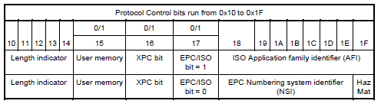 | Accepted
JP 5 |  | 10.4 | Figure 4 | Ed | “(ORM_SupplyChain_Figure_1736x.ai)” immediately below the figure title is unnecessary. | Remove “(ORM_SupplyChain_Figure_1736x.ai)”. | Accepted
JP 6 |  | 11.2 | 2nd line | Ed | The table number should be ”Table 5”, not ”Table 4”. | Change from Table 4 shows ….” to ”Table 5 shows …”. | Accepted
JP 7 |  | Annex A.4 | Figure 1 | Ed | The figure number is incorrect. | Change from Figure 1 to Figure A.1. | Accepted
JP 8 |  | Annex A.4 | Figure 2 | Ed | The figure number is incorrect. | Change from Figure 2 to Figure A.2. | Accepted
JP 9 |  | Annex A.5 | Figure 3 | Ed | The figure number is incorrect. | Change from Figure 3 to Figure A.3. | Accepted
JP 10 |  | Annex A.7.3 | Figure 4 | Ed | The figure number is incorrect. | Change from Figure 4 to Figure A.4. | Accepted
JP 11 |  | Annex A8.7.5 | Table 1 | Ed | The table number is incorrect. | Change from Table 1 to Table A.1. | Accepted
JP 12 |  | Annex A.9.1.7 | Figure 5 | Ed | The figure number is incorrect. | Change from Figure 5 to Figure A.5. | Accepted
JP 13 |  | Annex A.9.1.8.3 | 3rd paragraph | Ed | Whereas this is an ISO standard, the model type (an Intermec 1555 or a Psion 7535) of a particular manufacturer is described here. | Remove “for example an Intermec 1555²) or a Psion 7535²)]” from the sentence.  Following this change, the footnote 2) “The Intermec 1555 and Psion 7535 are … by ISO of these products.” at the bottom of the page should also be deleted. | Accepted
JP 14 |  | Annex C.1 | Figure C.1 | Ed | “(See MB01-MB11_Graphic_20090729.ai)” immediately below the figure title is unnecessary. | Remove “(See MB01-MB11_Graphic_20090729.ai)”. | Accepted
JP 15 |  | Annex C.1 | Figure C.2 | Ed | “(See MB01_Graphic_20090622.ai)” immediately below the figure title is unnecessary. | Remove “(See MB01_Graphic_20090622.ai)”. | Accepted
JP 16 |  | Annex C.2 | Figure C.3 | Ed | “(See Code128HarmonizedCoding.ai)” immediately below the figure title is unnecessary. | Remove “(See Code128HarmonizedCoding.ai)”. | Accepted
JP 17 |  | Annex C.3.1.2 | Figure C.4 | Ed | The addresses of the memory maps 0X0F, 0x10, 0x1F, 0x 20 and 0x2F are incorrect.  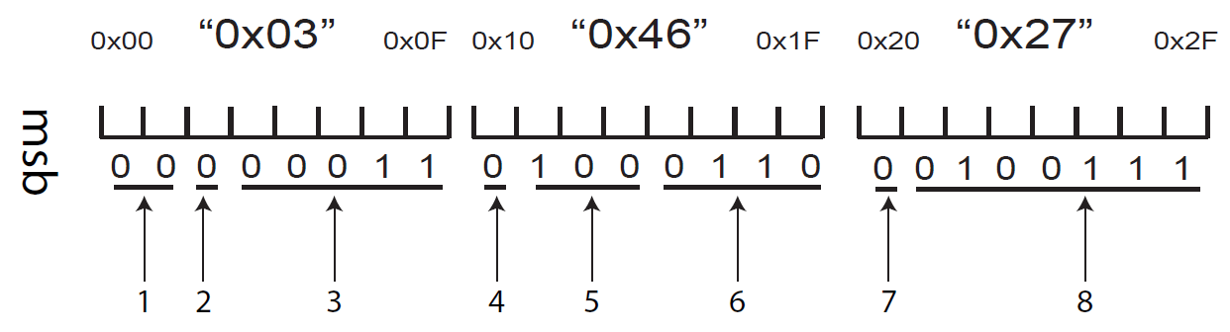 | Correct each addresses as follows.  0x0F to 0x07,  0x10 to 0x08,  0x1F to 0x0F,  0x20 to 0x10,  0x2F to 0x17 | Accepted
JP 18 |  | Annex C.3.1.2 | Figure C.4 | Ed | “(See MB11_1st16bits_23h_20h.ai)” immediately below the figure title is unnecessary. | Remove “(See MB11_1st16bits_23h_20h.ai)”. | Accepted
JP 19 |  | Annex C.3.1.2 | Figure C.4 | Ed | “1st 16 bits” in the figure title is incorrect. This is because the number of bits is 24 bits, not 16 bits. | Correct from “1st 16 bits” to “1st 24 bits”. | Accepted
JP 20 |  | Annex C.3.1.2 | Figure C.4 | Ed | The notation of addresses in 9 “Physical memory addresses (00, 0F, 10, 1F, 20, 2F) is incorrect. | Correct from (00, 0F, 10, 1F, 20, 2F) to (00, 07, 08, 0F, 10, 17). | Accepted
JP 21 |  | Annex C.4.1 | Process 6 | Ed | As this process is described as the “padding bits” in the process 8, the description “as padding bits” should be appended at the end of the sentence. | Rewrite Process 6 as follows:  Add the first 2 or 4 bits of an <EOT> character (i.e. ‘10’or ‘1000’) or the entire <EOT> character (i.e. ‘100001’ from the 6-bit character set) to fill un-encoded bits in the last byte, if any as padding bits. | Accepted
JP 22 |  | Annex C.4.2 | Process 4 | Ed | Table U.1 is incorrect. | Change from Table U.1 to Table C.1. | Accepted
JP 23 |  | Annex C5.1 | Step 4 | Ed | Table U.1 is incorrect. | Change from Table U.1 to Table C.1. | Accepted
JP 24 |  | Annex C.5.2 | Step 2 | Ed | Table U.1 is incorrect | Change from Table U.1 to Table C.1. | Accepted
JP 25 |  | Annex C.5.3 |  | Ed | Table C.5 is missing as Table C.6 is placed after Table C.4 (Annex C.2).  Table C.6 should be Table C.5 in this section. | Change from ”See Table C.6.” right before Table C.6 to “See Table C.5”.  Change the table title from Table C.6 to Table C.5. | Accepted
JP 26 |  | Annex C.5.3 | Table C.6 | Ed | ”0000011” in the DSFID column is incorrect. | Correct from ”0000011” to ”00000011”. | Accepted
JP 27 |  | Annex C.5.3 | Table C.6 | Ed | The bit pattern (codeword) is not provided in the pad column. | Add ”100001” to the pad column. | Accepted
JP 28 |  | Annex C.5.3.1 |  | Ed | 39 bytes of data is 52 6-bit characters consisting of 51 6-bit characters plus six pad bits. In this regards, the sentence needs further explanation. | Rewrite to:  Using the Access Method 0 Format 3 encoding, including a DSFID, 15434 Precursor byte,39 bytes of data (compressing 51 6-bit characters including the <EOT>) and six pad bits, the final tag encodation in hexadecimal is as follows. | Accepted
JP 29 |  | Annex C.6 | Figure C.5 | Ed | The control characters such as <RS>, <GS> and <EOT> are encoded as the character string in QR Code. But they should be encoded as the control characters in QR Code. Therefore, QR Code needs to be corrected. | Replace Figure B.5 with the following QR Code symbol.   | Accepted
JP 30 |  | Annex C.6 | Figure C.5 | Ed | “(See QR_Code_HarmonizedCoding.ai)” immediately below the figure title is unnecessary. | Remove “(See QR_Code_HarmonizedCoding.ai)”. | Accepted
JP 31 |  | Annex C.6 | Figure C.6 | Ed | “(See DataMatrix_HarmonizedCoding.ai) ”immediately below the figure title is unnecessary. | Remove “(See DataMatrix_HarmonizedCoding.ai)”. | Accepted
SE 1 | The entire document |  |  | ge/te | To make sure that the standard can be understood from a packaging perspective as well as from a supply chain/ RFID perspective, changes in terms and definitions are proposed. | Sweden proposes changes in terms and definitions in ISO 17364 introducing the terms primary, secondary and tertiary package in exchange for product, product packaging and transport packaging.  If this is accepted; necessary changes should be made to the text of the draft standard to mirror the changes of terms and definitions.  The current title of the draft standard could also be potentially misleading and a possible revision should be considered. | The terms that Sweden requests have been added to the graphic proposed in SE03
SE 2 | 5.1 |  | Figure 1 | te | To further clarify the relations between the standards in the ISO 1736X series of standards Figure 1 should be updated. | Update Figure 1 in accordance to the attached proposal.  Add two explanatory notes:  NOTE: "Product" and "primary package" are essentially the same but definitions are seen from a supply chain/RFID perspective (product) or packaging perspective (primary package).  Note: "Secondary package" (product package) has a broader definition than primary package (product) and can cover more than one intermediate packaging level. | To be discussed
SE 3 | 5.1 |  |  | te | To illustrate the meaning of primary package, secondary package and tertiary package the insertion of a new picture is proposed. | Add the below figure to section 5.1:  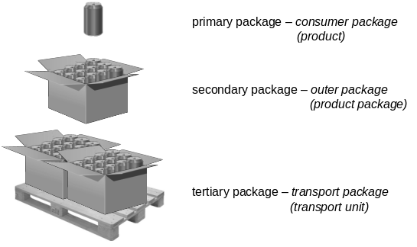 | Replaced with the following graphic:  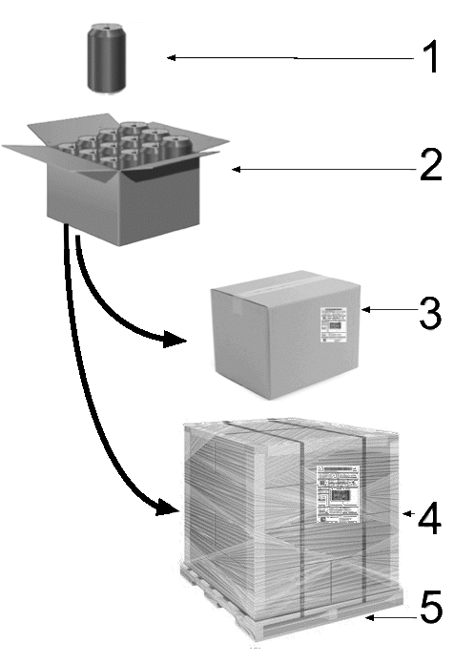  NOTE 1 Primary packaging – consumer packaging – (product)  NOTE 2 Secondary packaging – outer packaging – (product package)  NOTE 3 Tertiary packaging – transport packaging – (transport unit)  NOTE 4 Tertiary packaging – unitized transport packaging – (transport unit)  NOTE 5 Pallet – (Returnable transport item - RTI)

