** | Normative references |  |  | ed | In accordance with the ISO/IEC Directives Part 2, reference documents mentioned in the document should be listed in Clause 2, Normative References, only if they are normative, that is if the user of the document is obliged to consult them to implement the document.  If they are used for informative purposes only, they should be listed in the Bibliography.  Documents should not be listed in both the Normative References and in the Bibliography. | Please verify that all documents listed in the normative references clause are indeed cited in the document in a normative manner.  See the comments on ISO 17363 and ISO 17364 for examples.  Please also verify that the references don't appear in both the normative references clause and the Bibliography. | Accepted
** | General |  |  | ed | For any further guidance on drafting standards, please see the ISO/IEC Directives, Part 2 and the Rice Model:  http://isotc.iso.org/livelink/livelink?func=ll&objId=4230456&objAction=browse&sort=subtype  http://www.iso.org/iso/rice_model |  | Accepted
PL | Annex B |  | Table B.2 |  | Change “UII Tag Encoding” | To “UII Data Encoding” | Accepted
PL | Annex B |  | Table B.2 |  | Change “Reserved / AFI” | To “Attribute Bits” / AFI | Accepted
FR |  |  |  | ge | Lack of expertise in France |  | Accepted
AT1 | 2 |  |  | Ge | Reference to ISO/IEC TR 18046 is incorrect. ISO/IEC TR 18046 has been replaced by ISO/IEC IS 18046 and meanwhile ISO/IEC 18046 has been replaced by ISO/IEC 18046-1, -2 and -3 | Replace reference to ISO/IEC TR 18046 by reference to by ISO/IEC 18046-1, -2 and -3 | Accepted
AT2 | 3 |  |  | Ge | Reference to ISO/IEC TR 18046 is incorrect. ISO/IEC TR 18046 has been replaced by ISO/IEC IS 18046 and meanwhile ISO/IEC 18046 has been replaced by ISO/IEC 18046-1, -2 and -3 | Remove ISO/IEC TR 18046.  Add ISO/IEC 18046-1, -2 and -3. | Accepted
US 01 | global |  |  |  | Different versions of WORD have created editing errors in the document evidenced by strike troughs | PE to correct | Accepted
US 02 | FWD |  | FWD |  | Listing of annexes in forward is incomplete | Align 17366 forward with that of 17367 regarding Annexes A and B | Accepted
US 03 | 2 |  |  |  | Current title for 18000-6 Type C is 18000-63  This change needs to be made throughout the document – PE should check the full document for this | Replace 18000-6 Type C with 18000-63 | Accepted
US 04 | 3 |  |  |  | EPCglobal, Tag Data Standards, Version 1.5 title is incorrect | Remove Version number  Change standards to standard  Change EPCglobal to GS1 EPC Tag Data Standard. | One comment per entry please. EPC is considering a divergence between EPC and ISO. Consequently, 1.5 will be retained. Accept. Accept.
US 05 | 5 |  | Fig 1 |  | Combination of layers 3 and 4 creates unnecessary deviation from existing levels.  Change in numbering of the levels creates confusion;  Use of existing levels references is pervasive. throughout industry application standards and documentation. Arbitrary changes are unnecessary and disruptive.  Outside use of existing figure argues for not changing existing processes | Renumber layers  Insert new figure 1 | To be discussed
US 06 | 5 |  | Fig 1  Fig 4 |  | The underlying proposed Figures change layer numbering and reverses the Returnable and transport layers  These Figures have been institutionalized in many secondary and third level application and user application standards. The arbitrary changes to these figures will cause confusion and expense in the industry with no off setting payback. | The attached figures should be used to replace the existing figures in the draft revision. Specifically item layer should be 0 and proceeding upward to include container and movement vehicle. Returnable transport Item should be layer 3 while the Transport unit should be layer 2. | To be discussed
US 07 | 5 |  | Fig 1 |  | Figure 1 is divided horizontally by a series of dotted lines. These lines are both heavy and light and there is no explanation of why there are differences or what these differences mean. | Add the following:  The dotted lines that separate the various layers of Figures 1 and 4 are in different intensities. The lighter dotted lines show a higher degree of association between the layers than a heavy dotted line. Thus the marking and identification of layer 0 and layer 1 are more closely related to each other than either is to layer 2. Likewise layers 2 and 3 are closely related to each other. | To be discussed
US 08 | 5.3.2 |  |  |  | Text after bullet c requires updating to show undated reference to 15961 and the new designation 15961-3  UPDATE layers references with Figure 1 (comment 5) | 15961-3 rather than 15961:2004 | Accepted
US 09 | 5.3.2 |  | Last |  | Clarification of the words “can” is required. “Can” is used several times in this paragraph and is more appropriately a should and a shall | Change second sentence to read:  For the purposes of this International Standard a unique identifier should be no more than 35 characters in length excluding the Data Identifier (an3+an..35). See Table 2. With mutual agreement of the trading partners this length may be extended and shall be no more than 50 characters (an3+an..50). | Accepted
US 10 | 5.3.3 |  | First paragraphTable 3 and notes |  | TDS Version numbers are not needed. Throughout the document: Change name of TDS to GS1 EPC Tag Data Standard  Change table name to SGTIN-96  For clarity add the note in the first paragraph acknowledging the longer version of | Replace all occurrences of TDS 1.5 with GS1 EPC Tag Data Standard  Change SGTIN to SGTIN-96  Add after first sentence first paragraph. “While the remainder of the document describes an SGTIN-96 the GS1 EPC Tag Data Standard also describes a longer version.” | See US04 TDS version is required due to recent propensities within EPC. Accepted. Accepted.
US 11 | 7.2.2 |  |  |  | ISO/IEC 15434 is a syntax not a semantic | Remove ISO/IEC 15434 | Accepted
US 12 | 7.2.3 |  |  |  | ISO/IEC 15434 is not the only syntax allowed. | Remove reference to 15434 | Accepted
US 13 | 7.4 |  |  |  | For the description of bit 0x18, the last 2 in hte value should be a subscript – it is incorrectly shown as a normal 2. | Change 2 from normal to subscript | Accepted
US 14 | 7.4 |  | Table 4 |  | For clarity:  Segment the last line of the table to have different lines for ISO and for EPC  Bit 17 & 18 both are included in NSI  The AFI is the last 8 of the 9 bits | Segment the bottom line of the table to show one line for ISO bit= 1 and a second line for EPC bit = 0  Remove the vertical line between the 17 and 18 bit for the EPC line  Remove the vertical line between 1E and 1F for the ISO line  Add a note that says the AFI is the last 8 of the 9 bits | NSI is not addressed in the TDS. Attribute bits are the replacement for reserved. In EPC, HazMat is always 1F. AFI is shown as 8 bits. No need for note.
US 15 | 7.5.2 |  |  |  | The indication of hazardous material is not limited to one bit. Remove bit from second line first paragraph  It is not the setting of the bit noted in line 3 but the indication that the flag gives that is important. | Remove “bit” from second line first paragraph  Use “This indication” vice “the setting of this bit (1)” | It is a “bit reference”.
US 16 | 7.5.1 |  |  |  | Clarity as written it can be interpreted to mean that we have coined a new term UII – Product Tagging. | The UII (product package) shall be present | Parentheses do not add clarity.
US 17 | 7.5.3 |  |  |  | Remove reference to 15434 and 15418 in the last sentence. | Remove next to last sentence and replace with “Optional data shall conform to Annex B” Remove last sentence. | Not accepted. Please read the last sentence.
US 18 | 7.7 |  | 2nd para |  | Remove “dash” from first line and put in parenthetical | Product package (RFID) tag data .... | Parentheses do not add clarity.
US 19 | 8.2 |  | 2nd sentence |  | Second sentence – the indefinite pronoun “this” can be misunderstood. Replace This with Locking data | Locking data shall be at the discretion of the user. | Locking of data shall be at the discretion of the user, except for Tag ID (MB10), which should be locked by the manufacturer.
US 20 | 8.2 |  | Third sentence |  | For clarity | The manufacturer shall have the option of locking memory bank 10 (TID). | Locking of data shall be at the discretion of the user, except for Tag ID (MB10), which should be locked by the manufacturer.
US 21 | 8.2 |  | Last sentence |  | To clarify which CRC-16 is located per the memory map | The location of the stored CRC-16 shall be as per ..... | Accepted
US 22 | 8.3 |  |  |  | No longer true with the evolution of privacy concerns worldwide. - non-traceable tags can hide their Tag ID. | Remove last sentence | Accepted, but thought ill-advised
US 23 | 8.4 |  |  |  | Performance degradation cannot be avoided when invoking non-repudiation | Remove last sentence | Accepted
US 24 | 8.5 |  |  |  | Add third sentence to address the serialization and locking of TID. | MB 10 should be serialized and locked by the tag manufacturer.  A locked serialized TID can aid in anti-counterfeiting | Accepted
US 25 | 9 |  |  |  | Figure 3 graphic is inverted | Correct figure 3 graphic | Figure 3 is not inverted in the master graphic
US 26 | 10.1 and 10.2 |  |  |  | First sentence is the exception and should come at the end of the section not the beginning. | Move first sentence to the end of the section | It is quite distracting to editing for commenters to simply copy and paste their comments from other standards. The original comment was to 17364 where a comment on optional was included. Such a comment is inappropriate in this case.
US 27 | 10.4 |  | Figure 4 |  | Consistency with Figure 1 | See comment 5 and repeat | See US 5 and repeat
US 28 | 11.1 |  |  |  | Annex B is a more complete description of syntax. | Drop ISO/IEC 15434 and refer only to Annex B | Accepted
US 29 | 11.2 |  | Text line 2 |  | Reference to Table 4 is incorrect | Change to Table 5 | Accepted
US 30 | 11.2 |  | Line 3 |  | The reference to normal configurations is inaccurate. | Remove “operating in the two normal configurations” | Accepted
US 31 | 11.3 |  | Last line last paragraph |  | Last word - clarity | Change envisioned to considered | Accepted
US 32 | 11.7 |  |  |  | 100,000 is not realistic for all tags – see NXP and Alien documentation | Delete second sentence.  Tags attached to product packaging will be continuously used and shall last throughout the life of the product package. | Accepted
US 33 | 11.8 |  | First line |  | Set up requires clarification | Where the tags are optimally positioned... | 18046
US 34 | 11.9 |  |  |  | First sentence – clarity  Last sentence accuracy; should be readers not tags  Second sentence | Operate in either one of the two frequencies ...  The air interface specification recommended by this International Standard is ISO/IEC 18000-63, ISO/IEC 18000-2, Type A, the ASK air interface of ISO/IEC 18000-3, Mode 3, and ISO/IEC 18000-7 may be used with trading partner agreement. When available it is recommended that the user employ tags supporting ISO/IEC 18000-63, and ISO/IEC 18000-3, Mode 3. | This is a cut and paste from a different standard. Please do not do this in the future.
US 35 | 11.10 |  |  |  | Different air interfaces exist for different memory capacities – delete third sentence | Delete third sentence | Removed the sentence, however, the commenter needs to read the sentence.
US 36 | 11.11 |  |  |  | Para 11.11 no longer makes sense and should be deleted. | Delete 11.11 | Accepted
US 01 | 11.12 |  | 1st and 2nd para |  | First line – applies to both batteries and sensors  Second paragraph – this is not possible | Sensors and batteries integrated...  Delete | Sensors and batteries integrated into or onto a tag and their tag operations or management shall not interfere with the operation of the tag as required by this International Standard.  Sensor equipped Product Packaging RFID tags shall conform to ISO/IEC/IEEE 21451-7 for the wired or wireless interface.  The 2.45 GHz O-QPSK option of ISO/IEC/IEEE 8802-15-4 and ISO/IEC/IEEE 21451-5 shall be used for the wireless interface between the tag/access point and the sensor.
US 37 | 11.12 |  | 3rd para |  | Separate the paragraph into two sentences | Sensor equipped product RFID tags shall conform to ISO/IEC/IEEE 21451-7 for the wired or wireless interface.  ISO/IEC/IEEE 21451-5 shall also be used for the wireless interface between the tag/access point and the sensor | See US36
US 38 | 11.13 |  |  |  | No mention of the nature of the format of the time display as reported back to the tag. | Reference to ISO/IEC/IEEE 21450 for display format. | The representation of time shall be UTC and formatted as described in ISO 8601, namely, yyyy-mm-ddThh:ss, for example 2012-01-01T14:55Z.
US 39 | 11.15 |  |  |  | Last sentence does not conform with current privacy considerations for customer choice and untraceablity in tags. | Delete the last sentence | Accepted
US 40 | 11.16 |  | 1st paragraph |  | It does not matter where the tag was killed – if it is killed then it cannot be used. | Delete at point of sale | Accepted
US 41 | 13.2.1 |  | Line 2 |  | For clarity | Add “applicable” in front of personal | Accepted
US 42 | 13.2 |  |  |  |  | Renumber elements under 13.2 | Accepted
US 43 |  |  |  |  |  |  | Thank you!
US 44 | General |  |  |  | Consistency | Do a global search and replace for correct terms for EPC and GS1 proper terms | Accepted
US 45 | Annex B |  | Hanging intro bullet 3 |  | Hanging paragraph before B1  Third bullet require reference to 15962 | Correct hanging para.  A simplified structure, encoding an entire 15434 message as a unit, employing a no directory, encoding six-bit defined in 15962 as described in the remainder of this annex | Accepted
US 46 | Annex B |  | B.1 text just above Table B1 |  | Does not note that this is a format 03 encoding form | Change to :  A simplified format 03 encoding form.... | Not accepted. It is “this encoding form”, the one described in this Annex. Up and until this point “format 03” has not been defined.
US 47 | Annex B |  | B.4.2  Bullet 2 |  | Align content of B 4.2 with U 4.2 from ISO/IEC 15962 | Replace “take” with “process” | Accepted
US 48 | Annex B |  | Fig B.2 |  | Figure is a repeat of Fig B1 | Remove Fig B2 and renumber subsequent figures | Accepted
US 49 | Annex B |  | B 5.3  Text following table |  | No longer needed | Delete all text following the table | Accepted
US 50 | Annex B |  | B 6 |  | Paragraph is improperly number  Content is confusing and irrelevant – clarify by deleting text except for the last sentence of the first paragraph to introduce the example QR symbol | Change number to B5.3.3  Delete text except for 1st paragraph except last sentence.  Correct QR code graphic and Data Matrix graphic  Eliminate all text following Figure B6 | Accepted
GB | B2 |  | Encoding of Memory Bank ―01 Unique Item Identifier | te | The registration submitted for this standard under the ISO/IEC 15961-2 Data constructs registration was for a monomorphic UII, and for which 6-bit encoding was requested. The encoding rules of ISO/IEC 15962 do not support and <EOT> character. This means that the text in this standard is wrong. | Remove occurrences of <EOT> to align with the RFID encoding rules, to maintain the Data Constructs registration. Alternatively retain the <EOT> and expect the registration to be challenged and possibly withdrawn. | TC 122 will honor the agreement made with ISO/IEC 29162, however, BSi does not posses the ability to withdraw an AFI. Threats are not appreciated in ISO standards.
JP1 |  | 5.1 | Figure 1 | Ed | “See (Figure1_1736x.a)” immediately below the figure title is unnecessary. | Remove “See (Figure1_1736x.a)”. | Accepted
JP2 |  | 5.3.2 | Last paragraph | Ed | The Data Identifier (DI) is not included in 35 alphanumeric characters.  Therefore, the sentence “To define its class (in the ISO/IEC 15459 sense), the unique identifier shall have an ….. a unique identifier of product packages can be up to 35 alphanumeric characters in length, including the Data Identifier (an3+an..35)” is not correct. | Replace this sentence with:  To define its class (in the ISO/IEC 15459 sense), the unique identifier shall have an ….. a unique identifier of product packages can be up to 35 alphanumeric characters in length, excluding the Data Identifier (an3+an..35). | Accepted
JP3 |  | 7.2.1 | Last sentence in the last paragraph | Ed | The Data Identifier (DI) is not included in 35 alphanumeric characters.  Therefore, the sentence “For the purposes of this International Standard, a unique identifier of product packages can be up to 35 alphanumeric characters in length, including the Data Identifier (an3+an..35)” is not correct. | For the purposes of this International Standard, a unique identifier of product packages can be up to 35 alphanumeric characters in length, excluding the Data Identifier (an3+an..35). | Accepted
JP4 |  | 7.3.2 | Figure 2 | Ed | “See (MB01-MB11_Graphic_20090729.ai)” immediately below the figure title is unnecessary. | Remove “See (MB01-MB11_Graphic_20090729.ai)”. | Accepted
JP5 |  | 10.4 | Figure 4 | Ed | “(ORM_SupplyChain_Figure_1736x.ai” immediately below the figure title is unnecessary. | Remove “(ORM_SupplyChain_Figure_1736x.ai)”. | Accepted
JP6 |  | 11.2 | 2nd line | Ed | The table number should be ”Table 5”, not ”Table 4”. | Change from “Table 4 shows …” to “Table 5 shows …”. | Accepted
JP7 |  | Annex B.1 | Figure B.1 | Ed | “(See MB01-MB11_Graphic_20090729.ai)” immediately below the figure title is unnecessary. | Remove “(See MB01-MB11_Graphic_20090729.ai)”. | Accepted
JP8 |  | Annex B.1 | Figure B.2 | Ed | This is not a figure of Type C and Mode 3 Memory Bank “01”. | Replace with the figure below.  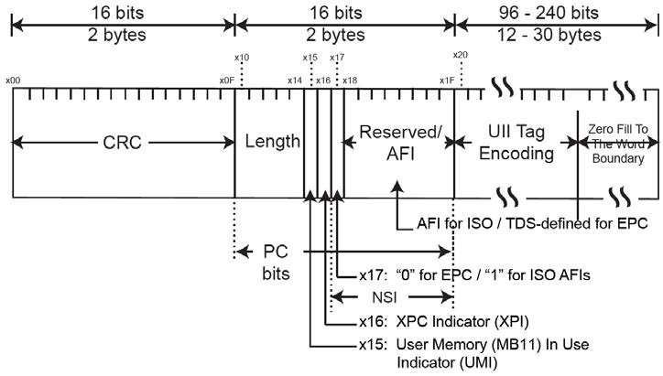 | Accepted
JP9 |  | Annex B.2 | Figure B.3 | Ed | “(See Code128HarmonizedCoding.ai)” immediately below the figure title is unnecessary. | Remove “(See Code128HarmonizedCoding.ai)”. | Accepted
JP10 |  | Annex B.3.1.2 | Figure B.4 | Ed | The addresses of the memory maps 0X0F, 0x10, 0x1F, 0x 20 and 0x2F are incorrect.  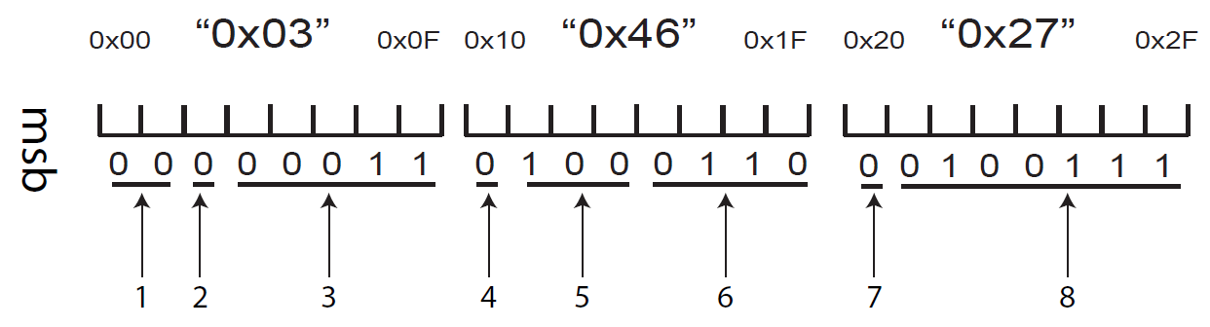 | Correct each addresses as follows.  0x0F to 0x07,  0x10 to 0x08,  0x1F to 0x0F,  0x20 to 0x10,  0x2F to 0x17 | Accepted
JP11 |  | Annex B.3.1.2 | Figure B.4 | Ed | “(See MB11_1st16bits_23h_20h.ai)” immediately below the figure title is unnecessary. | Remove “(See MB11_1st16bits_23h_20h.ai)”. | Accepted
JP12 |  | Annex B.3.1.2 | Figure B.4 | Ed | “1st 16 bits” in the figure title is incorrect. This is because the number of bits is 24 bits, not 16 bits. | Correct from “1st 16 bits” to “1st 24 bits”. | Accepted
JP13 |  | Annex B.4.1 | Process 6 | Ed | As this process is described as the “padding bits” in the process 8, the description “as padding bits” should be appended at the end of the sentence. | Rewrite Process 6 as follows:  Add the first 2 or 4 bits of an <EOT> character (i.e. ‘10’or ‘1000’) or the entire <EOT> character (i.e. ‘100001’ from the 6-bit character set) to fill un-encoded bits in the last byte, if any as padding bits. | Accepted
JP14 |  | AnnexB.4.2 | Process 4 | Ed | Table U.1 is incorrect. | Change from Table U.1 to Table B.1. | Accepted
JP15 |  | Annex B.5.1 | Step 4 | Ed | Table U.1 is incorrect. | Change from Table U.1 to Table B.1. | Accepted
JP16 |  | Annex B.5.2 | Step 2 | Ed | Table U.1 is incorrect. | Change from Table U.1 to Table B.1. | Accepted
JP17 |  | Annex B.5.3 |  | Ed | Table B.5 is missing as Table B.6 is placed after Table B.4 (Annex B.2).  Table B.6 should be Table B.5 in this section. | Change from ”See Table B.6.” right before Table B.6 to “See Table B.5”.  Change the table title from Table B.6 to Table B.5 | Accepted
JP18 |  | Annex B.5.3 | Table B.6 | Ed | ”0000011” in the DSFID column is incorrect. | Correct from ”0000011” to ”00000011”. | Accepted
JP19 |  | Annex B.5.3 | Table B.6 | Ed | The bit pattern (codeword) is not provided in the pad column. | Add ”100001” to the pad column. | Accepted
JP20 |  | Annex B.5.3.1 |  | Ed | 39 bytes of data is 52 6-bit characters consisting of 51 6-bit characters plus six pad bits. In this regards, the sentence needs further explanation. | Rewrite to:  Using the Access Method 0 Format 3 encoding, including a DSFID, 15434 Precursor byte,39 bytes of data (compressing 51 6-bit characters including the <EOT>) and six pad bits, the final tag encodation in hexadecimal is as follows. | Accepted
JP21 |  | Annex B.6 | Figure B.5 | Ed | The control characters such as <RS>, <GS> and <EOT> are encoded as the character string in QR Code. But they should be encoded as the control characters in QR Code. Therefore, QR Code needs to be corrected. |   Replace Figure B.5 with the following QR Code symbol. | Accepted
JP22 |  | Annex B.6 | Figure B.5 | Ed | “(See QR_Code_HarmonizedCoding.ai)” immediately below the figure title is unnecessary. | Remove “(See QR_Code_HarmonizedCoding.ai)”. | Accepted
JP23 |  | Annex B.6 | Figure B.6 | Ed | “(See DataMatrix_HarmonizedCoding.ai)” immediately below the figure title is unnecessary. | Remover “(See DataMatrix_HarmonizedCoding.ai)”. | Accepted
BE |  |  |  | ge | No reply from experts |  | Accepted
SE01 | The entire document |  |  | ge/te | To make sure that the standard can be understood from a packaging perspective as well as from a supply chain/ RFID perspective, changes in terms and definitions are proposed. | Sweden proposes changes in terms and definitions in ISO 17364 introducing the terms primary, secondary and tertiary package in exchange for product, product packaging and transport packaging.  If this is accepted; necessary changes should be made to the text of the draft standard to mirror the changes of terms and definitions.  One example of such change is the rewriting of 5.3.1, Paragraph 1 from:  Unique product packaging identification is a process that assigns a unique data string to an individual package, or in this case to an RFID tag that is associated to the product package. The unique data string is called the unique product package identifier. Unique item identification of product packaging allows data collection and management at a granular level.  to:  Unique package identification is a process that assigns a unique data string to an individual package, or in this case to an RFID tag that is associated with the product package. The unique data string is called the unique package identifier. Unique item identification of product packages allows data collection and management at a granular level.  The current title of the draft standard could also be potentially misleading and a possible revision should be considered. | See SE 03
SE02 | 5.1 |  | Figure 1 | te | To further clarify the relations between the standards in the ISO 1736X series of standards Figure 1 should be updated. | Update Figure 1 in accordance to the attached proposal.  Add two explanatory notes:  NOTE: "Product" and "primary package" are essentially the same but definitions are seen from a supply chain/RFID perspective (product) or packaging perspective (primary package).  Note: "Secondary package" (product package) has a broader definition than primary package (product) and can cover more than one intermediate packaging level. | See SE 03
SE 03 | 5.1 |  |  | te | To illustrate the meaning of primary package, secondary package and tertiary package the insertion of a new picture is proposed. | Add the below figure to section 5.1:  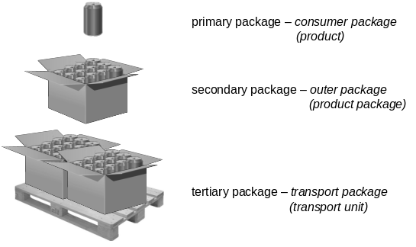 | Replaced with the following graphic:  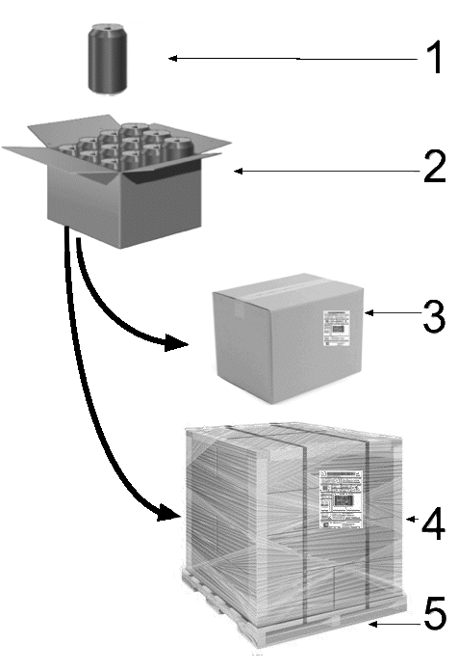  NOTE 1 Primary packaging – consumer packaging – (product)  NOTE 2 Secondary packaging – outer packaging – (product package)  NOTE 3 Tertiary packaging – transport packaging – (transport unit)  NOTE 4 Tertiary packaging – unitized transport packaging – (transport unit)  NOTE 5 Pallet – (Returnable transport item - RTI)

