** |  |  | ed | The terms and definitions are missing. | Either add terms and definitions or redraft the introductory paragraph to read as follows:  "For the purposes of this document, the terms and definitions given in ISO 445, ISO 830, ISO 17364, ISO/IEC 19762-1, ISO/IEC 19762-3, and ISO 21067 apply." | Unsure of how to respond. In the DIS draft submitted for ballot included the identical language suggested by ITTF.
** | Normative references |  | ed | In accordance with the ISO/IEC Directives Part 2, reference documents mentioned in the document should be listed in Clause 2, Normative References, only if they are normative, that is if the user of the document is obliged to consult them to implement the document.  If they are used for informative purposes only, they should be listed in the Bibliography.  Documents should not be listed in both the Normative References and in the Bibliography. | Please verify that all documents listed in the normative references clause are indeed cited in the document in a normative manner.  Please also verify that the references don't appear in both the normative references clause and the Bibliography.  See the comments on ISO 17363 and ISO 17364 for examples. | Accepted
 |  |  |  | For any further guidance on drafting standards, please see the ISO/IEC Directives, Part 2 and the Rice Model:  http://isotc.iso.org/livelink/livelink?func=ll&objId=4230456&objAction=browse&sort=subtype  http://www.iso.org/iso/rice_model |  | Accepted
PL 1 | Annex A | Table A.2 |  | Change “UII Tag Encoding” | To “UII Data Encoding” | Accepted
PL 2 | Annex A | Table A.2 |  | Change “Reserved / AFI” | To “Attribute Bits” / AFI | Accepted
AT 1 | All |  | Ed | Strange formating e.g. Double-underline in begin of introduction | Correct to normal text | This is a formatting issue between MS Word for English and MS Word for Japanese. We will save as Acrobat in English. The “strange formatting” was supposed to be a single quote mark.
AT 2 | 2 |  | Ge | Reference to ISO/IEC TR 18046 is incorrect | ISO/IEC IS 18046 has been published a while ago. Furthermore, it shall be considered that ISO/IEC 18046 will be replaced by ISO/IEC 18046-1, -2 and -3 in summer, if the FDIS 18046-1 ballot passes | Accepted
AT 3 | 3 |  | Ge | Reference to ISO/IEC TR 18046 is incorrect | ISO/IEC IS 18046 has been published a while ago. Furthermore, it shall be considered that ISO/IEC 18046 will be replaced by ISO/IEC 18046-1, -2 and -3 in summer, if the FDIS 18046-1 ballot passes | Accepted
AT 4 | A.2 |  | Ed | Title of A2 shows 0 and 1 printed on top of each other, followed by strange printing of 0 and 1 in the chapter | Replace by 01, 0 and 1 respectively | See AT 1
FR 1 |  |  | ge | Lack of expertise in France |  | Accepted
US 1 | global |  |  | Global open quotes created by versions of WORD | PE to correct | Accepted
US 2 | global |  |  | TDS Version numbers are not needed  Throughout the document: Change name of TDS to GS1 EPC Tag Data Standard | Replace all occurrences of TDS 1.5 with GS1 EPC Tag Data Standard | Given the GS1 recent propensity to change their TDS so as to be incompatible with ISO, it may be a mistake to accept the most recent version of the TDS
US 3 | global |  |  | Current designation for 18000-6 Type C is 18000-63 | Replace 18000-6 Type C with 18000-63 | Accepted
US 4 | global |  |  | Consistency | Do a global search and replace for correct terms for EPC and GS1 proper terms | Conceptually accepted, however, GS1 is not consistent in its references
US 5 | 3 |  |  | TDS Version 1.5 title is incorrect | Remove Version number  Change standards to standard  Change EPCglobal to GS1 EPC Tag Data Standard. | See US 2
US 6 | 5 | Fig 1 |  | Combination of layers 3 and 4  Use legacy  Outside use of existing figure argues for not changing existing processes | Renumber layers | To be discussed
US 7 | 5 | Fig 1  Fig 4 |  | The underlying proposed Figures change layer numbering and reverses the Returnable and transport layers  These Figures have been institutionalized in many secondary and third level application and user application standards. The arbitrary changes to these figures will cause confusion and expense in the industry with no off setting payback. | The attached figures should be used to replace the existing figures in the draft revision. Specifically item layer should be 0 and proceeding upward to include container and movement vehicle. Returnable transport Item should be layer 3 while the Transport unit should be layer 2. | Disagree. To embrace RPIs the “institutionalized” figures will need to be changed anyway. It is time to make them right. It is agreed that a transport unit is in some ways subordinate to an RTI and an RTI is not subordinate to a transport unit. There are cases where they are co-equal.
US 8 | 5.1 | Fig 1 |  | Figure 1 is divided horizontally by a series of dotted lines. These lines are both heavy and light and there is no explanation of why there are differences or what these differences mean. | Add the following:  The dotted lines that separate the various layers of Figures 1 and 4 are in different intensities. The lighter dotted lines show a higher degree of association between the layers than a heavy dotted line. Thus the marking and identification of layer 0 and layer 1 are more closely related to each other than either is to layer 2. Likewise layers 2 and 3 are closely related to each other. | To be discussed
US 9 | 5.4.2 |  |  | After c Update | 15961-3 rather than 15961  UPDATE layers references | There is no distinction between the “15961 Data Constructs Register”, the “15961-3 Data Constructs Register”, and the “Data Constructs Register”. “15961 Data Constructs Register” is adequate
US 10 | 5.4.2 | Last |  | Clarification of the words “can” is required, | Unique identifier should be no more than 20 characters in length excluding the Data Identifier. With mutual agreement of the trading partners this length may be extended and shall be no more than 50 characters. | “can” to “may” is sufficient
US 11 | 7.2.2 |  |  | 15434 is a syntax not a semantic | Remove 15434 | Accepted
US 12 | 7.2.3 |  |  | Remove reference to 15434 and reference only to Annex A | Make everything Annex A | Accepted
US 13 | 7.3.1 |  |  | “Tag header” is now an ambiguous term | Change title to: UII (transport unit) | Accepted
US 14 | 7.3.1 |  |  | Clarity | UII (transport unit) shall contain either an ISO/IEC defined AFI or an EPCglobal defined NSI. The ISO/IEC 15961 AFI for transport units is 0xA2, in bits 0x18 – 0x1F as described in Tables 1 and 4. Support for ISO standards (including AFIs) is indicated when bit 0x17 is set to 1. Alternately, support for EPCglobal coding is indicated when bit 0x17 is set to “0” as described in the EPC Tag Data Standard | Accepted
US 15 | 7.3.3 b. |  |  | NSI includes bit 17 (thus is 9 bits) | UII memory: shall contain a CRC-16 at memory addresses 0x00 to 0x0F, Protocol-Control (PC) bits at memory addresses 0x10 to 0x1F, and a code, i.e. a UII, that identifies the object to which the tag is or will be attached beginning at address 0x20. The PC word is subdivided (See Table 4 and Figure A.2.) The CRC-16, PC, and UII shall be stored MSB first (the UII‘s MSB is stored in location 0x20). | Accepted
US 16 | 7.3.3 c second para |  |  | Consistency | For EPC tags whose ISO/IEC 15963-allocation class identifier is 111000102 (0xE2), this identifying | Accepted
US 17 | 7.4 | Table 4 |  | Segment the last line of the table to have different lines for ISO and for EPC  Bit 17 & 18 both are included in NSI  The AFI is the last 8 of the 9 bits | Show 1F  Add text to indicate that bit 17 is part of the NSI  Dot the line between 17 and 18 | Redefined as Attribute bits
US 18 | 7.5.1 |  |  | clarity | The UII (transport unit) shall be present | Accepted
US 19 | 7.5.2 |  |  | Remove “bit” from first line first paragraph  Line 3 – “This indication” vs. “this setting” |  | Disagree. The commenters suggestion does not define that it is a bit
US 20 | 7.5.3 |  |  | Clarify  For semantics add Annex A  For syntax Remove reference to 15434 and 15418 | Dependent upon the tag type and capacity, optional data may be written to tags as required. Agreement between trading partners is not required. Optional user data may be encrypted or otherwise secured at the discretion of the tag writer. The semantics of optional user data shall conform to ISO/IEC 15961 and ISO/IEC 15418. The syntax of optional user data shall conform to Annex A. ISO 15394 provides specific examples of other data elements using the ISO/IEC 15418 semantics and the ISO/IEC 15434 syntax. | Accepted
US 21 | 7.7.1 | 2nd line |  |  | Change second sentence to:  All tags shall have the tag ID written to them by the manufacturers in accordance with ISO/IEC 15963 and locked. | Accepted
US 22 | 7.8 | 2nd para |  | Remove “dash” from first line and put in parenthetical |  | Removed dash, no parenthetical
US 23 | 8.2 |  |  | Second sentence – locking data shall be at the discretion of the user | Locking shall be at the discretion of the user. | Reworded paragraph
US 24 | 8.2 | Third sentence |  | For clarity replace third sentence | The manufacturer shall have the option of locking memory bank 10 (TID). | Reworded paragraph
US 25 | 8.2 | Last sentence |  | To clarify which CRC-16 is located per the memory map | The location of the stored CRC-16 shall be as per ..... | Accepted
US 26 | 8.4 |  |  | No longer true - non-traceable tags would not do this | Remove last sentence | Accepted, though the further one goes down this path, the less usable the tagging become. Again, remember that we are defining transport unit.
US 27 | 8.5 |  |  | Performance degradation cannot be avoided | Remove last sentence | Accepted
US 28 | 8.3 |  |  | The rationale for not killing the tag is that the RTI does not change owner ship to the consumer – No change recommended |  | This is not an RTI
US 29 | 10.4 | Figure 4 |  | Consistency with Figure 1 |  | Accepted
US 30 | 11.2 | Text line 2 |  | Reference to Table 5 is correct but the table is mis-numbered  Make sure the table and reference agree | Change Table number to 5 | Accepted
US 31 | 11.2 | Third sentence |  | The phrase normal configurations is misleading - | Remove “operating in the three normal configurations” Should now read  Table 5 shows the typical performance requirements for the three passive and one active tag configurations shown. | Accepted
US 32 | 11.3 |  |  | Last word - clarity | Change envisioned to “considered” | Accepted
US 33 |  | Table 1 |  | Table following para 11.2 is mislabelled as Table 1 | Renumber to table 5. | See US 30
US 34 | 11.7 | Last sentence |  | 100,000 is not realistic for all tags – see NXP and Alien | Delete last sentence.  Tags attached to the transport unit will be continuously used and should last throughout the life of the transport unit. | Accepted  It is good to know that 18000-63 is not a technology for high usage applications.
US 35 | 11.8 |  |  | Set up requires clarification – insert optimally | Systems where the tags are optimally positioned... | Not accepted.  “Optimally” changes it from mandatory (shall) to an upper limit.
US 36 | 11.9 |  |  | First sentence  Last sentence  Second sentence | The air interface specification recommended by this International Standard is ISO/IEC 18000-63, ISO/IEC 18000-2, Type A, the ASK air interface of ISO/IEC 18000-3, Mode 3, and ISO/IEC 18000-7 may be used with trading partner agreement. When available it is recommended that the user employ tags supporting ISO/IEC 18000-63, and ISO/IEC 18000-3, Mode 3. | Not accepted. We have the opportunity to lead development. The reworked language does not provide direction for the industry.
US 37 | 11.10 |  |  |  | Delete third sentence | Accepted
US 38 | 11.11 |  |  |  | Delete 11.11 | Accepted
US 39 | 11.12 |  |  | First  Second | Sensors and batteries integrated...  Delete | Accepted
US 40 | 11.12 |  |  | Separate the ‘third paragraph into two sentences | Sensor equipped transport unit RFID tags shall conform to ISO/IEC/IEEE 21451-7 for the wired or wireless interface.  ISO/IEC/IEEE 21451-5 and ISO/IEC IEEE 8802-15-4 shall also be used for the wireless interface between the tag/access point and the sensor. | Accepted
US 41 | 11.13 |  |  | No mention of the nature of the format of the time display as reported back to the tag. | Reference to: Presentation shall be as described in ISO/IEC/IEEE 21450 | Format defined as follows:  The format of the date and time shall be in the following format YYYYMMDD hhmmssZ, using a 24-hour clock in UTC. This format is defined in ISO 8601.
US 42 | 11.15 |  |  | Section does not add anything and can conflict with privacy considerations | Remove entire section | Accepted
US 43 | 11.16 |  |  | Not applicable in 17365 | remove | Accepted
US 44 | 13.2 |  |  | Number headings  In the first instance or personal | Add applicable in front of personal | Accepted
US 45 | Annex A | Hanging intro bullet 3 |  |  | A simplified structure, encoding an entire 15434 message as a unit, employing a no directory, encoding six-bit defined in 15962 as described in the remainder of this annex | Accepted
US 46 | Annex A | A.1 just above Table A1 |  |  | Change to :  A simplified format 03 encoding form.... | Not accepted. It is “this encoding form”, the one described in this Annex. Up and until this point “format 03” has not been defined.
US 47 | Annex A | A.4.2  Bullet 2 |  | Align A 4.2 with U 4.2 (15962) | Replace “take” with “process” | Accepted
US 48 | Annex A | A 5.3  Text following table |  | No longer needed | Delete all text following the table | Accepted
US 49 | Annex A | A 6 |  |  | Change number to A5.3.3  Delete text except for 1st paragraph except last sentence.  Correct QR code graphic and replace Data Matrix symbol  Eliminate all text after Figure A6 | Accepted, changed QR Code, Data Matrix symbol is perfectly scannable
GB 1 | 1 | all | te | The draft is not technically correct at this time and needs more work. Unfortunately at time of voting we are unable to provide specific detailed comments. |  | Unacceptable comment
BE 1 |  |  | ge | No reply from experts |  | Accepted
FR 1 |  |  | ge | Lack of expertise in France |  | Accepted
SE 1 | 5.1 | Figure 1 | te | To further clarify the relations between the standards in the ISO 1736X series of standards Figure 1 should be updated. | Update Figure 1 in accordance to the attached proposal.  Add two explanatory notes:  NOTE: "Product" and "primary package" are essentially the same but definitions are seen from a supply chain/RFID perspective (product) or packaging perspective (primary package).  Note: "Secondary package" (product package) has a broader definition than primary package (product) and can cover more than one intermediate packaging level. | See SE 02
SE 2 | 5.1 |  | te | To illustrate the meaning of primary package, secondary package and tertiary package the insertion of a new picture is proposed. | Add the below figure to section 5.1:  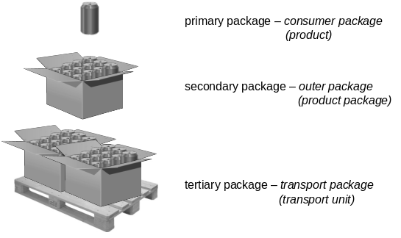 | Replaced with the following graphic:  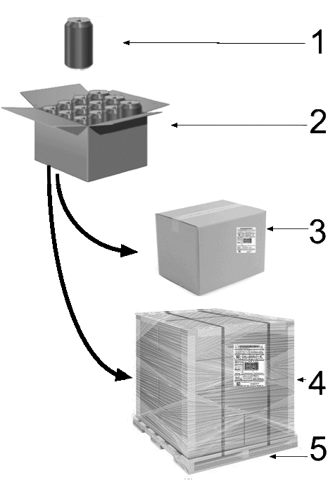  NOTE 1 Primary packaging – consumer packaging – (product)  NOTE 2 Secondary packaging – outer packaging – (product package)  NOTE 3 Tertiary packaging – transport packaging – (transport unit)  NOTE 4 Tertiary packaging – unitized transport packaging – (transport unit)  NOTE 5 Pallet – (Returnable transport item - RTI)
JP 1 | 5.1 | Figure 1 | Ed | “(Figure1_1736x.al)” immediately below the figure title is unnecessary. | Remove “(Figure1_1736x.al)”. | Accepted
JP 2 | 5.4.2 | Last paragraph | Ed | The data length of the Data Identifiers J, J1, J2, J3 and J4 is (an3+an..35), while that of J5 and J6 is (an3+an..20). However, there is only the description on the data length of the DI J5 and J6. | Rewrite to:  To define its … with the Data Identifier ‘1J, 2J, 3J, 4J, 5J, 6J or J’. The unique identifier of transport units ‘J, 1J, 2J, 3J and 4J’ can be up to 35 alphanumeric characters in length, excluding the Data Identifier (an..2+an..35) and the unique identifier of transport units ‘5J, and 6J’ can be up to 20 alphanumeric characters in length, excluding the Data Identifier (an..2+an..20). With the mutual agreement of … extended to 50 characters (an3+an..50). See Table 2. | Accepted
JP 3 | 5.4.2 | Table2 | Ed | Following the change mentioned above, Table 2 should also be revised to indicate the data length of J and J1 to J4 as well as that of J5 and J6. | Correct Table 2 as follows:  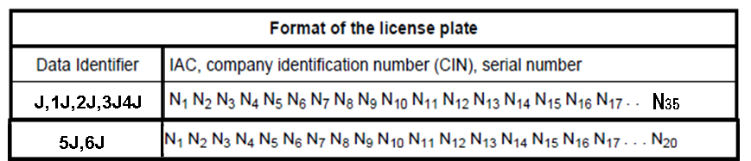 | Accepted
JP 4 | 5.4.3 | Table 3 | Ed | No space is inserted between “GS1 Company Prefix” and “Serial Reference” in the terms of GS1 Company Prefix Serial Reference in the serial shipping container code (SSCC). This may cause confusion about the number of items, i.e., a single item or two items. | Insert a space between “GS1 Company Prefix” and “Serial Reference” to explicitly distinguish them, or rewrite them in accordance with GS1 specification. | Added a solidus
JP 5 | 7.2.1 |  | Ed | The data length of the Data Identifiers J, J1, J2, J3 and J4 is (an3+an..35), while that of J5 and J6 is (an3+an..20). However, there is only the description on the data length of the DI J5 and J6. | Rewrite to:  The unique identifier of transport units ‘J, 1J, 2J, 3J and 4J’ can be up to 35 alphanumeric characters in length, excluding the Data Identifier (an..2+an..35) and the unique identifier of transport units ‘5J and 6J’ can be up to 20 alphanumeric characters in length, excluding the Data Identifier (an..2+an..20). | Accepted
JP 6 | 7.3.2 | Figure 2 | Ed | “See (MB01-MB11_Graphic_20090729.ai)” immediately below the figure title is unnecessary. | Remove “See (MB01-MB11_Graphic_20090729.ai)”. | Accepted
JP 7 | 10.4 | Figure４ | Ed | “(ORM_SupplyChain_Figure_1736x.ai)” immediately below the figure title is unnecessary. | Remove “(ORM_SupplyChain_Figure_1736x.ai)”. | Accepted
JP 8 | 11.2 | Table 1 | Ed | The table number should be ”Table 5”, not ”Table 1”. | Change from ”Table 1” to ”Table 5”. | Accepted
JP 9 | Annex A.1 | Figure A.1 | Ed | “(See MB01-MB11_Graphic_20090729.ai)” immediately below the figure title is unnecessary. | Remove “(See MB01-MB11_Graphic_20090729.ai)”. | Accepted
JP 10 | Annex A.1 | Figure A.2 | Ed | “(See MB01_Graphic_20090622.ai)” immediately below the figure title is unnecessary. | Remove “(See MB01_Graphic_20090622.ai)”. | Accepted
JP 11 | Annex A.2 | Figure A.3 | Ed | “(See Code128HarmonizedCoding.ai)” immediately below the figure title is unnecessary. | Remove “(See Code128HarmonizedCoding.ai)”. | Accepted
JP 12 | Annex A.3.1.2 | Figure A.4 | Ed | The addresses of the memory maps 0X0F, 0x10, 0x1F, 0x 20 and 0x2F are incorrect.  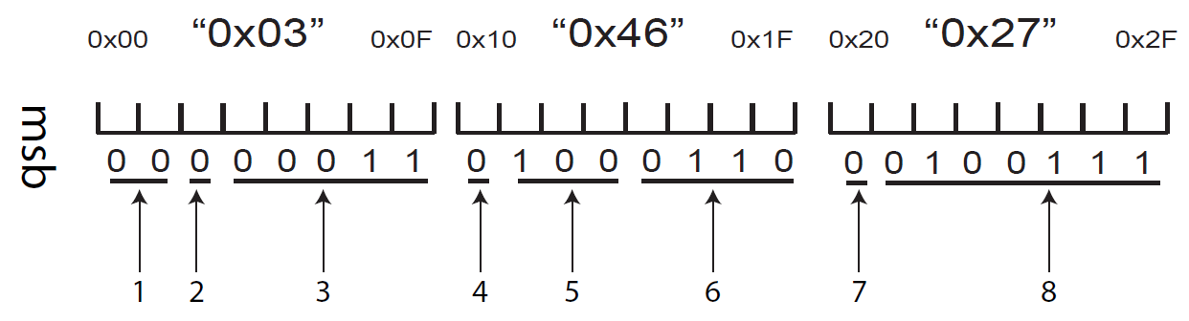 | Correct each addresses as follows.  0x0F to 0x07,  0x10 to 0x08,  0x1F to 0x0F,  0x20 to 0x10,  0x2F to 0x17 | Accepted
JP 13 | Annex A.3.1.2 | Figure A.4 | Ed | “(See MB11_1st16bits_23h_20h.ai)” immediately below the figure title is unnecessary. | Remove “(See MB11_1st16bits_23h_20h.ai)”. | Accepted
JP 14 | Annex A.3.1.2 | Figure A.4 | Ed | “1st 16 bits …” in the figure title is incorrect. This is because the number of bits is 24 bits, not 16 bits. | Correct from “1st 16 bits” to “1st 24 bits”. | Accepted
JP 15 | Annex A.3.1.2 | Figure A.4 | Ed | The notation of addresses in 9 “Physical memory addresses (00, 0F, 10, 1F, 20, 2F) is incorrect. | Correct from (00, 0F, 10, 1F, 20, 2F) to (00, 07, 08, 0F, 10, 17). | Accepted
JP 16 | Annex A.4.1 | Process 6 | Ed | As this process is described as the “padding bits” in the process 8, the description “as padding bits” should be appended at the end of the sentence. | Rewrite Process 6 as follows:  Add the first 2 or 4 bits of an <EOT> character (i.e. ‘10’or ‘1000’) or the entire <EOT> character (i.e. ‘100001’ from the 6-bit character set) to fill un-encoded bits in the last byte, if any as padding bits. | Accepted
JP 17 | Annex A.4.2 | Process 4 | Ed | Table U.1 is incorrect. | Change from Table U.1 to Table A.1. | Accepted
JP 18 | Annex A.5.1 | Step 4 | Ed | Table U.1 is incorrect. | Change from Table U.1 to Table A.1. | Accepted
JP 19 | Annex A.5.2 | Step 2 | Ed | Table U.1 is incorrect. | Change from Table U.1 to Table A.1. | Accepted
JP 20 | Annex A.5.3 |  | Ed | Table A.5 is missing as Table A.6 is placed after Table A.4 (Annex A.2).  Table A.6 should be Table A.5 in this section. | Change from ”See Table A.6.” right before Table A.6 to “See Table A.5”.  Change the table title from Table A.6 to Table A.5. | Accepted
JP 21 | Annex A.5.3 | Table A.6 | Ed | ”0000011” in the DSFID column is incorrect. | Correct from ”0000011” to ”00000011”. | Accepted
JP 22 | Annex A.5.3 | Table A.6 | Ed | The bit pattern (codeword) is not given in the pad column. | Add ”100001” to the pad column. | Accepted
JP 23 | Annex A.5.3.1 |  | Ed | 39 bytes of data is 52 6-bit characters consisting of 51 6-bit characters plus six pad bits. In this regards, the sentence needs further explanation. | Rewrite to:  Using the Access Method 0 Format 3 encoding, including a DSFID, 15434 Precursor byte,39 bytes of data (compressing 51 6-bit characters including the <EOT>) and six pad bits, the final tag encodation in hexadecimal is as follows. | Accepted
JP 24 | Annex A.6 | Figure A.5 | Ed | The control characters such as <RS>, <GS> and <EOT> are encoded as the character string in QR Code. But they should be encoded as the control characters in QR Code. Therefore, QR Code needs to be corrected. |   Replace Figure A.5 with the following QR Code symbol. | Accepted
JP 25 | Annex A.6 | Figure A.6 | Ed | “(See QR_Code_HarmonizedCoding.ai)” immediately below the figure title is unnecessary. | Remove “(See QR_Code_HarmonizedCoding.ai)”. | Accepted
JP 26 | Annex A.6 | Figure A.6 | Ed | “(See DataMatrix_HarmonizedCoding.ai) ” immediately below the figure title is unnecessary. | Remove “(See DataMatrix_HarmonizedCoding.ai)”. | Accepted

