Reference number of working document: ISO/TC 000/SC 0 N 000
Date: 2012-07-18
Reference number of document: ISO/WD nnn-n
Committee identification: ISO/TC 000/SC 0/WG 0
Secretariat: XXXX
Internet of Things (IoT) in the supply chain — Containerized cargo
Internet des objets (IdO) dans la chaîne d'approvisionnement - Le fret conteneurisé
Document type: International standard
Document subtype: if applicable
Document stage: (20) Preparation
Document language: E

Warning
This document is not an ISO International Standard. It is distributed for review and comment. It is subject to change without notice and may not be referred to as an International Standard.
Recipients of this draft are invited to submit, with their comments, notification of any relevant patent rights of which they are aware and to provide supporting documentation.

Copyright notice
This ISO document is a working draft or committee draft and is copyright-protected by ISO. While the reproduction of working drafts or committee drafts in any form for use by participants in the ISO standards development process is permitted without prior permission from ISO, neither this document nor any extract from it may be reproduced, stored or transmitted in any form for any other purpose without prior written permission from ISO.
Requests for permission to reproduce this document for the purpose of selling it should be addressed as shown below or to ISO’s member body in the country of the requester:
ISO copyright office
Case postale 56 • CH-1211 Geneva 20
Tel. + 41 22 749 01 11
Fax + 41 22 749 09 47
E-mail copyright@iso.ch
Web www.iso.ch
Reproduction for sales purposes may be subject to royalty payments or a licensing agreement.
Violators may be prosecuted.

Contents Page
Foreword v
Introduction vi
1 Scope 1
2 Normative references 1
3 Terms, definitions, symbols, and abbreviated terms 1
4 The Internet of Things 1
4.1 Understanding the components 1
4.1.1 Communications 2
4.1.2 Localization and tracking 2
4.1.3 Devices 2
4.1.4 Sensors 2
4.1.5 Actuators 2
4.1.6 Storage 3
4.1.7 Processing 3
4.1.8 Security 3
4.1.9 Identification 3
4.2 The ontology of “things” 3
5 Applications of the Internet of Things compliant to this International Standard 4
5.1 Cold chain 4
5.2 Asset location 5
5.2.1 Identification technologies to be used 6
5.2.1.1 Communications 6
5.2.1.1.1 ISO/IEC/EEE 8802-11 - WiFi 6
5.2.1.1.2 ISO/IEC/EEE 8802-15-4 - WPAN 6
5.2.1.1.3 3G/4G 6
5.2.1.1.4 SATCOM 6
5.2.1.2 Localization and tracking 6
5.2.1.2.1 GPS 6
5.2.1.2.2 GPRS 6
5.2.1.3 Devices – RFID – ISO/IEC 18000-63 6
5.2.1.4 Sensors 6
5.2.2 Storage 6
5.2.2.1 Processing 6
5.2.2.2 Security 6
5.2.2.3 Identification 6
Annex A (normative) Annex title 7
A.1 General 7
A.2 Clause 7
A.2.1 Subclause (level 1) 7
A.2.1.1 Subclause (level 2) 7
A.2.1.1.1 Subclause (level 3) 7
Annex B (informative) Which styles correspond to which element — Quick reference guide 8
Bibliography 9

Foreword
ISO (the International Organization for Standardization) is a worldwide federation of national standards bodies (ISO member bodies). The work of preparing International Standards is normally carried out through ISO technical committees. Each member body interested in a subject for which a technical committee has been established has the right to be represented on that committee. International organizations, governmental and non-governmental, in liaison with ISO, also take part in the work. ISO collaborates closely with the International Electrotechnical Commission (IEC) on all matters of electrotechnical standardization.
International Standards are drafted in accordance with the rules given in the ISO/IEC Directives, Part 2.
The main task of technical committees is to prepare International Standards. Draft International Standards adopted by the technical committees are circulated to the member bodies for voting. Publication as an International Standard requires approval by at least 75 % of the member bodies casting a vote.
Attention is drawn to the possibility that some of the elements of this document may be the subject of patent rights. ISO shall not be held responsible for identifying any or all such patent rights.
ISO nnn-n was prepared by Technical Committee ISO/TC 122, Packaging.
Introduction
For more than a decade ISO TC 122 has written standards addressing linear bar code symbols, two-dimensional symbols, RFID, and the basics of sensor technology for containerized cargo. It is now possible to provide any time connection from anywhere to anything through the use of IoT technology. The use of location-based technologies, combined with Internet connectiveity, and mobile phone-like communications are now able permit a cargo owner to identy where that cargo is located, anywhere in the world, by simply calling the cargo. Likewise, if the cargo is exposed to environmental conditions beyond those defined, by introducing sensor technology, the cargo is able to call the cargo owner, advise of its condition, and report its location.
The need exists within all IoT applications to define the means to achieve any time/any where/any thing connectivity.
Internet of Things (IoT) in the supply chain — Containerized cargo

Scope
This International Standard specifies the component pieces necessary for the effective implementation of Internet of Things applications for containerized cargo. This International Standard specifies the necessary forms of identification, communications, types of devices, sensors, actuators, means of localization and tracking, appropriate security, methods of storage, and processing of IoT data.

Normative references
The following referenced documents are indispensable for the application of this document. For dated references, only the edition cited applies. For undated references, the latest edition of the referenced document (including any amendments) applies.
ISO/IEC 19762, Information technology -- Automatic identification and data capture techniques -- Harmonized vocabulary

Terms, definitions, symbols, and abbreviated terms
For the purposes of this document, the terms and definitions given in ISO/IEC 19762 and the following apply.
3.1
term
definition

The Internet of Things

Understanding the components
Figure 1 is a representation of the components of the Internet of Things (IoT).
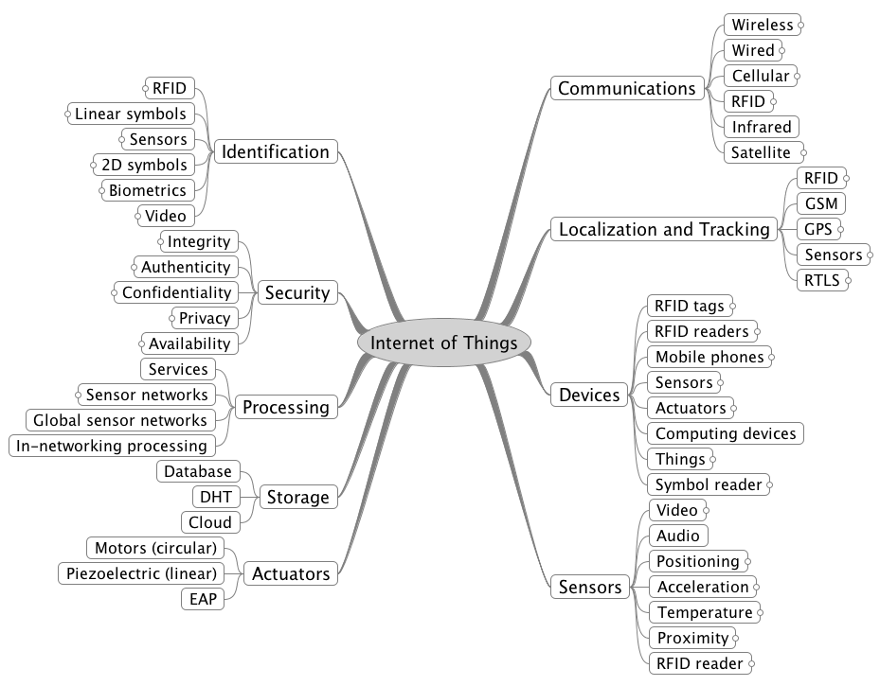
Figure 1 – Map of the Internet of Things (IoT)

Communications
A paragraph.

Localization and tracking
A paragraph.

Devices
A paragraph.

Sensors
A paragraph.

Actuators
A paragraph.

Storage
A paragraph.

Processing
A paragraph.

Security
A paragraph.

Identification
A paragraph.

The ontology of “things”
Figure 2 provides an ontology of “entities” or “things”

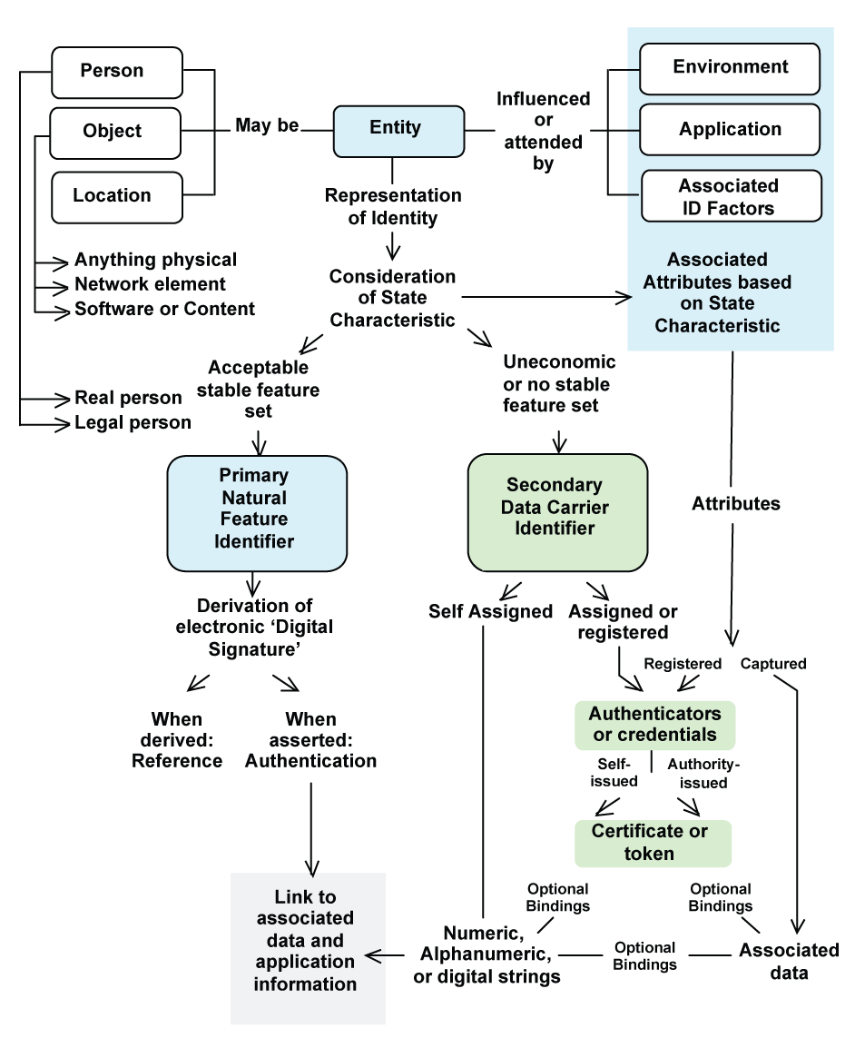
Figure 2 – The ontology of things

A paragraph.

Applications of the Internet of Things compliant to this International Standard

Cold chain
A paragraph.

Asset location
A paragraph.
Figure 3 is a representation of cargo equipped with IoT electronics
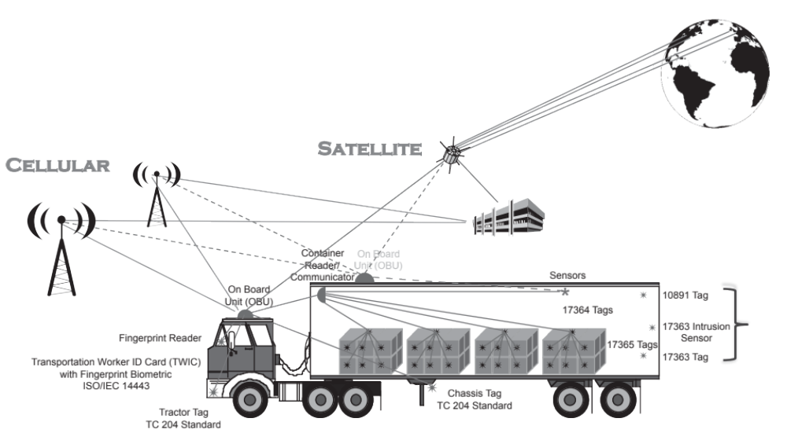

Figure 3 – IoT pallet
Figure 4 is a breakout of the electronics of an IoT cargo device
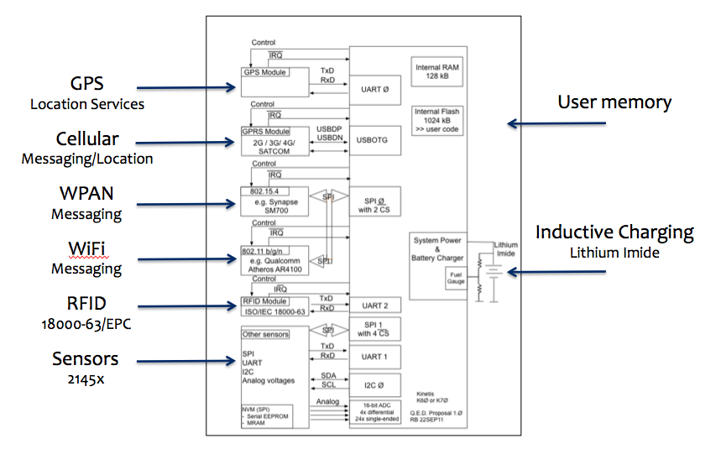
Figure 4 – IoT cargo device electronics

Identification technologies to be used

Communications

ISO/IEC/EEE 8802-11 - WiFi
A paragraph.

ISO/IEC/EEE 8802-15-4 - WPAN
A paragraph.

3G/4G
A paragraph.

SATCOM
A paragraph.

Localization and tracking

GPS
A paragraph.

GPRS
A paragraph.

Devices – RFID – ISO/IEC 18000-63
A paragraph.

Sensors
A paragraph.

Storage
A paragraph.

Processing
A paragraph.

Security
A paragraph.

Identification
A paragraph.
…
Annex A
(normative)
Annex title

A.1 General
Annexes shall appear in the order in which they are cited in the text. Each annex shall be designated by a heading comprising the word “Annex” followed by a capital letter designating its serial order, beginning with “A”, e.g. “Annex A”. The annex heading shall be followed by the indication “(normative)” or “(informative)”, and by the title, each on a separate line. Numbers given to the clauses, subclauses, tables, figures and mathematical formulae of an annex shall be preceded by the letter designating that annex followed by a full-stop. The numbering shall start afresh with each annex. A single annex shall be designated “Annex A”.
Normative annexes give provisions additional to those in the body of the document. Their presence is optional. An annex’s normative status (as opposed to informative) shall be made clear by the way in which it is referred to in the text, by an indication in the table of contents and under the heading of the annex.
Informative annexes give additional information intended to assist the understanding or use of the document. They shall not contain requirements, except as described in the following paragraph. Their presence is optional. An annex’s informative status (as opposed to normative) shall be made clear by the way in which it is referred to in the text, by an indication in the table of contents and under the heading of the annex.
Informative annexes may contain optional requirements. For example, a test method that is optional may contain requirements but there is no need to comply with these requirements to claim compliance with the document.

A.2 Clause

A.2.1 Subclause (level 1)

A.2.1.1 Subclause (level 2)
A paragraph.

A.2.1.1.1 Subclause (level 3)
A paragraph.

A.2.1.1.1.1 Subclause (level 4)
A paragraph.

A.2.1.1.1.2 Subclause (level 4)
A paragraph.
Annex B
(informative)
Which styles correspond to which element — Quick reference guide

Bibliography
- ISO/IEC Directives, Part 2, Rules for the structure and drafting of International Standards, 2001
- ISO 10241, International terminology standards — Preparation and layout

