MH10.8.16 – 2012

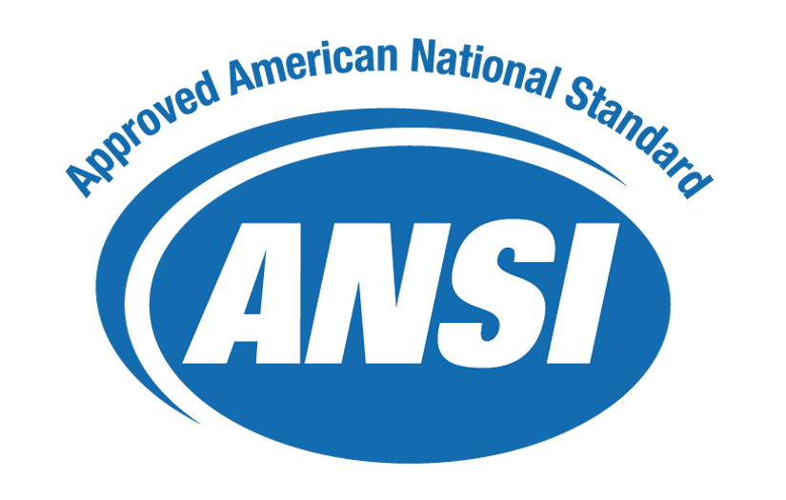

American National Standard for Material Handling – Label Adhesive Characteristics, Print Image Durability and Label Recyclability

Approved: xx XXXXXX 2012

Abstract
This standard provides test specifications and testing procedures for label adhesives, print image durabiity, and label recyclability for a wide range of applications in the supply chains of multiple industries.

Developed by:

MH10 Committee, Unit-Loads and Transport-Packages
Subcommittee 8, Coding & Labeling of Unit-Loads

Published by MH10 Secretariat:

Material Handling Industry of America
8720 Red Oak Blvd., Suite 201
Charlotte, NC 28217-3992
mhstandards@mhia.org



American National Standard

Approval of an American National Standard requires verification by ANSI that the requirements for due process, consensus, and other criteria for approval have been met by the standards developer.

Consensus is established when, in the judgment of the ANSI Board of Standards Review, substantial agreement has been reached by directly and materially affected interests. Substantial agreement means much more than a simple majority, but not necessarily unanimity. Consensus requires that all views and objections be considered, and that a concerted effort be made toward their resolution.

The use of American National Standards is completely voluntary; their existence does not in any respect preclude anyone, whether he has approved the standards or not, from manufacturing, marketing, purchasing, or using products, processes or procedures not conforming to the standards.

The American National Standards Institute does not develop standards and will in no circumstances give an interpretation of any American National Standard. Moreover, no person shall have the right or authority to issue an interpretation of an American National Standard in the name of the American National Standards Institute. Requests for interpretations should be addressed to the sponsor whose name appears on the title page of this standard.

CAUTION NOTICE: This American National Standard may be revised or withdrawn at any time. The procedures of the American National Standards Institute require that action be taken periodically to reaffirm, revise or withdraw this standard. Purchasers of American National Standards may receive current information on all standards by calling or writing the American National Standards Institute.

© 2012 by Material Handling Industry of America (MHIA)
All rights reserved.

No part of this publication may be reproduced in any form,
in an electronic retrieval system or otherwise, without
prior written permission of the Materials Handling Institute of America,
MH10 Secretariat, 8720 Red Oak Blvd., Suite 201, Charlotte, NC 28217-3992
Phone: 704-676-1190, Fax: 704-676-1199

Printed in the United States of America.

ANSI MH10.8.16

American National Standard
for Material Handling –
Label Adhesive Characteristics, Print Image Durability and Label Recyclability

Secretariat
Material Handling Industry

Approved Month Day, XXXX
American National Standards Institute, Inc.

Table of Contents
Foreword ii
1 Scope 1
2 References 2
3 Definitions 4
4 General 5
4.1 Requirements 5
4.1.1 Label Thickness 5
4.1.2 Nature of Adhesive 6
4.1.3 Adhesion Strength 6
4.1.4 Label Requirements after Conditioning and Printed Circuit Board Processing 6
4.1.5 Abrasion 6
4.2 Method of Test 6
4.2.1 Label Thickness 6
4.2.2 Nature of Adhesive 6
4.2.3 Adhesive Strength 6
4.2.3.1 Test Label Size 7
4.2.3.2 Label Test Panel Preparation 7
4.2.3.3 Initial Adhesion Strength 7
4.2.3.4 Short Term 100 Degrees Celsius - Medium Temp 7
4.2.3.5 Short Term 49 Degrees Celsius 95% RH - Temp/Humidity 7
4.2.3.6 Long Term 82 Degrees Celsius - Medium Temp 7
4.2.3.7 Long Term 32 Degrees Celsius 95% RH - Temp/Humidity 8
4.2.4 Additional Label Conditioning Tests for Labels or Marks Required to Withstand Printed Circuit Board Processes 8
4.2.4.1 Short Term 260 Degrees Celsius - High Temp - for Bottom Side Labels for Printed Circuit Boards 8
4.2.4.2 Initial Cleaning 8
4.2.4.3 IR Reflow 9
4.2.4.4 Post IR Reflow Cleaning 9
4.2.4.5 Wavesolder 9
4.2.4.6 Post Wavesolder Cleaning 9
4.2.5 Abrasion test 9
4.2.6 Label Recyclability 10
5 Bibliography (Informative) 13

Foreword
(This Foreword is not part of American National Standard MH10.8.16

This American National Standard was prepared by Subcommittee 8 of the MH10 (Unit-Loads and Transport-Packages) ANSI Accredited Standards Committee (ASC). This standard was established in response to a growing need for extracting the label adhesive characteristics, mark durability and recyclability from ANSI MH10.8.7 in order to retire that standard in favor of ISO 28219. This standard was developed using Industry Specifications as primary references.

At the time of approval, the MH10/SC 8 committee consisted of the following members:

AIAG (Automotive Industry Action Group) Bill Hoffman
Allied AIDC LLC Joe Lemieux
CDO Technologies Don Ertel
DoD Logistics AIT Office Dan Kimball
Ericsson US Bob Fox
Evanhoe & Associates Chuck Evanhoe
FedEx Services Mark Thomas
GS1 Frank Sharkey
HighTech Aid Steve Halliday
Intermec Technologies Sprague Ackley
Monode Marking Products J.T. Mackey
Motorola Solutions Rick Schuessler
Northrop Grumman Heather Weier
Q.E.D. Systems Craig K. Harmon
United Parcel Service Vanessa Armorer
United States Air Force Mark Reboulet
U.S. DoD (AT&L)/DPAP/PDI Rob Leibrandt
Vossel LLC Rich Vossel

Committee approval of this standard does not necessarily imply that all committee or subcommittee members voted for its approval. At the time of MH10.8.16 approval, MH10 committee membership consisted of the following organizations:

AIM Global | International Safe Transit Association
American Trucking Associations | Material Handling Industry
American Wood Packaging Association | Material Handling Management Society
APA - The Engineered Wood Association | Millwood, Inc.
Association of American Railroads | National Wooden Pallet & Container Association
Assoc. of Professional Material Handling Consultants | Packaging Machinery Manufacturers Institute
ASTM | Paper Shipping Sack Mfg. Association
Automotive Industry Action Group | Plastic Drum Institute
Containerization & Intermodal Institute, Inc. | Q.E.D. Systems
Fibre Box Association | Rack Manufacturers Institute
Flexible Intermediate Bulk Containers Association | Reusable Industrial Packaging Association
Glass Packaging Institute | Steel Shipping Container Institute
GS1 US | The Coca-Cola Company
IDEAlliance | The Soap & Detergent Association
Institute of Packaging Professionals | U.S. Air Force
Integrated Business Communications Alliance | U.S. Dept. of Agriculture
Intermec Technologies Corporation | U.S. Dept. of Defense AIT Office
International Association of Movers | U.S. Forest Products Laboratory
International Cargo Handling Coordination Association | United Parcel Service
International Foodservice Distributors Association | Virginia Tech – Center for Unit Load Design

Suggestions for improvement and questions regarding interpretation of this standard will be welcome. They should be sent to: MH 10 Committee (MHIA), Material Handling Industry of America, 8720 Red Oak Blvd., Suite 201, Charlotte, NC, 28217-3992 or mhstandards@mhia.org.

Scope
This American National Standard:
- Provides test specifications for determining adhesive characteristics of labels, print image durability and provide guidance on recyclability of materials used in labels;
- Is intended to help ensure that labels can withstand extended long term exposure to a variety of indoor environments, which could include an assembly process, remain affixed to products and are scannable for the intended life of the product;
- Includes testing procedures for label adhesive characteristics and print image durability;
- Is intended for applications which include, but are not limited to, support of systems that automate the control of items during the processes of:
  - production
  - inventory
  - distribution
  - field service
  - point of sale
  - repair
- Is intended to include, but it is not limited to, multiple industries including:
  - automotive
  - aerospace
  - chemical
  - consumer items
  - electronics
  - health care
  - marine
  - rail
  - telecommunications

This standard does not supersede or replace any applicable safety or regulatory labeling requirements. This standard is meant to satisfy the minimum product package requirements of numerous applications and industry groups. As such its applicability is to a wide range of industries, each of which may have specific implementation guidelines for this standard. This standard is to be applied in addition to any other mandated testing requirements.

This document consists of four sections.
Section 1 Defines the scope and purpose of this standard.

Section 2 Lists references to support this standard.

Section 3 Refers to the definitions of terms contained in this standard.

Section 4 Provides the referenced requirements and specified tests.

In this document, the word "shall" indicates a requirement and the word "should" indicates a recommendation.

Before implementing this specification, suppliers and manufacturers should review and mutually agree on specific labeling details with their trading partners.

The figures contained herein are illustrative and not necessarily to scale or to the quality requirements in this document.

References
The following referenced documents are indispensible for the application of this document. For dated references, only the edition cited applies. For undated references, the latest edition of the referenced document (including any amendments) applies.

Normative References

ISO 28219 Packaging — Labelling and direct product marking with linear bar code and two-dimensional symbols

ISO/IEC 15415 Bar Code Symbol Print Quality Test Specification - Two Dimensional Symbols

ISO/IEC 15416 Bar Code Print Quality Test Specification - Linear symbols

ISO/IEC 19762 Information Technology Automatic Identification and Data Capture Techniques - Harmonized Vocabulary Check existance prior to publishing

ANS HIBC 2, Health Industry Supplier Labeler Standard

ASTM D1000-93 Pressure-Sensitive Adhesive-Coated Tapes Used for Electrical and Electronic Applications

NASA-STD-6002 Applying Data Matrix Identification Symbols on Aerospace Parts

Reference Acquisition

International Symbology Specifications and AIM Inc.:
- One Landmark North, 20399 Route 19 Suite 203 Cranberry Township, PA 16066
(V): +1 724 742 4470, (F): +1 724 742 4476, (U): http://www.aimglobal.org/

American National Standards T1 and X3, and ASCII/ISO:
- American National Standards Institute (ANSI), 25 West 43rd Street, Fourth Floor, New York, NY 10036; Phone 212-642-4900; Internet http://www.ansi.org

ASTM Standards
- ASTM, 100 Barr Harbor Drive, West Conshohocken, PA 19428-2959; Phone 610-832-9585; Fax 610-832-9555; Email service@astm.org; Web http://www.astm.org

GS1 Standards & Specifications:
- Blue Tower, Avenue Louise, 326, BE 1050 Brussels, Belgium, (V):+32 2 788 7800, (F): +32 2 788 7899, (U): http://www.gs1.org/
- GS1 GO GSMP,Inc., Princeton Pike Corporate Center, 1009 Lenox Drive, Suite 202, Lawrenceville, NJ 08648, (V): +1 609 620 0200, (F): +1 609 620 1200,
(U): http://www.gs1.org

ANSI Standards:
- Global Engineering Documents, World Headquarters, 15 Inverness Way East, Englewood, CO USA 80112-5776; Phone 800-854-7179; Fax 303-397-2740; Internet http://global.ihs.com; Email global@ihs.com

MH10 Secretariat:
- MH10 Secretariat, The Material Handling Industry, 8720 Red Oak Blvd., Suite 201, Charlotte, NC 28217-3992; Phone 704-522-8644

Definitions
For the purposes of this document, the terms and definitions given in ISO/IEC 19762 as well as the following apply.

ANSI (abbreviation for “American National Standards Institute”)
A non-governmental organization responsible for the coordination of voluntary national (United States) standards. ANSI, 25 West 43rd Street, New York, NY 10036, Telephone: (212) 642-4900 Telefax: (212) 302-1286
ASC MH 10
An ANSI accredited committee responsible for the development of American national standards on unit-load & transport-package sizes, package testing standard, definitions & terminology, standardization of unit-load height, sacks & multi-wall bag standards, coding & labelling of unit-loads.
ASC MH 10/SC 8
An ANSI accredited committee responsible for the development of American national standards on the coding and labelling of transport packages and unit loads, product packaging, and radio frequency identification for returnable containers. ANSI/MH 10/SC 8 serves as the U.S. Technical Advisory Group (TAG) to ISO TC 122.
Cell
The smallest element of a two-dimensional matrix symbol.
Components
For the purposes of this document parts (e.g., bare printed circuit board, integrated circuits, capacitor, diodes, switch, valve, spring, bearing, bracket, bolt, etc.) of a first level/modular assembly.
First Level/Modular Assembly
For the purposes of this document, a manufactured item (populated printed circuit board, hydraulic pump, starter, dashboard assembly, door assembly, etc.) made up of components.
Intrusive Marking
Any device designed to alter a material surface to form a human or machine readable symbol. This marking category includes, but is not limited to, devices that abrade, burn, corrode, cut, deform, dissolve, etch, melt, oxidize or vaporize a material surface. Intrusive marking methods laser etch, chemical etch, dot peen and micro-sandblast.
Label
For the purposes of this document, an adhesive backed media capable of being marked with information in machine-readable and/or human-readable form. Both labels and direct marking methods are referred to in this standard under the term “label”.
Manufacturer
Actual producer or fabricator of an item; not necessarily the supplier in a transaction.
Non-Intrusive Marking
A method of forming markings by adding material to a surface. Non-intrusive marking methods include ink jet, laser bonding, liquid metal jet, silk screen, stencil and thin film deposition.
Product
A first level or higher assembly that is sold in a complete end-usable configuration.
Supplier
In a transaction, the party that produces, provides, or furnishes an item or service.

General
The following requirements and tests are intended to ensure that labels and marks can withstand extended long term exposure to a variety of indoor environments, which could include an assembly process, remain affixed to products and are scannable for the intended life of the product.

NOTE--Additional tests may be required for specific exports to specific countries.

ISO 28219 covers the manufacturing and printing requirements for pressure sensitive adhesive backed bar code labels intended primarily to automate product tracking, inventory control and serialized warranty systems. Labels being tested for conformance to Clauses A.3.4 and A.3.5 are intended to withstand harsh environment exposures.

It is the responsibility of the trading partners to agree upon specifications of labels covered by this standard and to test the label in their operating environment prior to acceptance.

All labels shall be easily separable from the release liner without damage, be smudge-resistant and be reasonably flat. Label stock should be examined visually for evidence of particles of paper, dust, or other foreign material that would adversely affect print quality.

Observed or calculated values obtained from analysis, measurement, or test shall be rounded off in accordance with the Rounding-Off Method per ASTM E 29 to the nearest unit in the last right-hand place of figures used in expressing the specified limit.

Where reference is made to an ASTM designation in this standard, the issue listed in the latest published ASTM index to standards shall apply unless otherwise specified.

Generation of voltage levels significant enough to cause ESD and damage to sensitive components can occur when using pressure sensitive labels. If meeting the requirements for ESD protected areas outlined in EIA-625 Requirements For Handling Electrostatic-Discharge-Sensitive [ESDS] Devices is required, using static control measures such as static dissipative labels or air ionization may be necessary.

Requirements

The labels shall be capable of meeting the requirements of Clause 4.4, Symbol Requirements, in ISO 28219, and this Clause 4.1, when tested in accordance with Clause 4.2, Methods of Test.

Labels shall not show delamination within the label, blistered areas, or chipped edges. The bar code symbol and all alphanumeric characters printed on each label should be black on white substrate. Bar code labels shall be scannable and reasonably free from scratches, marks,voids, dots or misplaced color. All labels should have minimum outside corner radii of 0.03 inch (0.76 mm) unless otherwise specified.

Label Thickness

The maximum overall thickness of the label (not including the release liner) shall be 0.22 mm (0.0085 inch).

Nature of Adhesive

The adhesive shall be pressure sensitive and permanent. It shall be applied in a uniform layer and be free from bubbles and foreign matter.

Adhesion Strength

The minimum initial adhesion strength two hours ±10 minutes after application at ambient room temperature and humidity shall be 0.23 Newton/mm. (25.0 oz/inch).

The minimum adhesion strength after stainless-steel test panel (ASTM D1000, Section 40.2) application and conditioning, per Clause 4.2.3, shall be 0.44 Newton/mm (40.0 oz/inch).

The labels shall show no evidence of delamination, bubbles, adhesive migration or degraded image quality for either the text or the bar code symbol.

Although the test requirements specify stainless steel test panels, these adhesion tests should also be conducted using the target substrate to assure appropriate performance. Rough or textured surface may require increases in adhesive thickness, for example.

Label Requirements after Conditioning and Printed Circuit Board Processing

The labels shall meet the minimum print quality requirements of ISO 28219, Clause 4.4.2.5, after conditioning and passing through the printed circuit board processing cycles.

The minimum adhesion strength after test panel application and conditioning shall be 0.44 Newton/mm (40.0 oz/inch).

The labels shall show no evidence of delamination, bubbles, adhesive migration or degraded image quality for either the text or the bar code symbol.

Abrasion

Labels or marks shall be capable of meeting the requirements of the appropriate clauses in ISO 28219, 4.4, Symbol Requirements, after being subjected to the abrasion test in clause 4.2.5.

Method of Test
See Figure 2 for a flow chart to determine which of the tests described below should be used.

Label Thickness

Conformance to the overall label thickness requirements shall use the ASTM D 374, Method C as referenced and modified in ASTM D 1000. Measure the thickness of the label plus the release liner, the release liner alone, and obtain the label thickness by subtraction.

Nature of Adhesive

The general nature of the adhesive shall be permanent, pressure sensitive and free from bubbles, voids, and foreign matter.

Adhesive Strength

The determination of the adhesive strength of test labels consist of the proper test label size, panel preparation and panel conditioning for the appropriate application.

Test Label Size

A minimum label size of 10 mm (0.25 inch) by 25.4 mm (1.0 inch) should be used for adhesion measurements. When possible, it is recommended to use the actual label size intended for the application. Obtain a rubber-covered steel roller (per ASTM D-100 Section 40.3) and prepare at least 2 stainless steel panels (per ASTM D 1000, Method A).

Label Test Panel Preparation

Remove labels from the release liner and apply at least four labels to an ASTM stainless steel test panel, and roll per ASTM D 1000 Section 42 taking care to leave approximately 3 mm (0.125 inch) of release liner on each label for clamping purposes.

Initial Adhesion Strength

Remove at least three labels from the release liner, apply them to 1 or more stainless steel panels, and roll per ASTM D 1000 Section 42 taking care to leave approximately 3 mm (0.125 inch) of release liner on each label for clamping purposes. In 2 hours (±10 minutes), measure the adhesion strength to conform to the requirements of 4.2.3 using a crosshead tensile tester making a 90-degree peel (see Figure 1) at a rate of 50 mm (2 inch) per minute using a wire length of approximately 762 mm (30 inch). Calculate the average value of adhesion.

Short Term 100 Degrees Celsius - Medium Temp

Place the panel in an oven maintained at 100 degrees Celsius (212 degrees Fahrenheit). At the end of 168 hours, remove the panel and allow it to cool to room temperature. Within 1 to 3 hours of removing the panel from the conditioning chamber, measure the bar code print quality of the labels on one panel in accordance with clause 4.4.2.5 of ISO 28219 or as appropriate and the adhesion strength of the labels on the other panel in accordance with Clause 4.2.3 to determine conformance with the requirements of Clause 4.1.3. Determine the adhesion strength by measuring the adhesive strength of at least 3 test labels and averaging the results for the overall value. The labels shall show no evidence of self-lifting, delaminating, smudging, or discoloring after conditioning.

Short Term 49 Degrees Celsius 95% RH - Temp/Humidity

Place the panel in an oven maintained at 49 degrees Celsius (120 degrees Fahrenheit) and a controlled relative humidity of 95% non-condensing. At the end of 96 hours remove the panel and allow it to cool to room temperature. Within 1 to 3 hours of removing the panel from the conditioning chamber, measure the bar code print quality of the labels on one panel in accordance with Clause 4.4.2.5 of ISO 28219 or as appropriate and the adhesion strength of the labels on the other panel in accordance with Clause 4.2.3 to determine conformance with the requirements of Clause 4.1.3. Determine the adhesion strength by measuring the adhesive strength of at least 3 test labels and averaging the results for the overall value. The labels shall show no evidence of self-lifting, delaminating, smudging, or discoloring after conditioning.

Long Term 82 Degrees Celsius - Medium Temp

Place the panels in a circulating air oven at 82 degrees Celsius ± 3 degrees Celsius (180 degrees Fahrenheit ± 5 degrees Fahrenheit. At the conclusion of 30 days, measure the bar code print quality of the labels on one panel in accordance with Clause 4.4.2.5 of ISO 28219 or as appropriate and the adhesion strength of the labels on the other panel in accordance with Clause 4.2.3 to determine conformance with the requirements of Clause 4.1.3. Determine the adhesion strength by measuring the adhesive strength of at least 3 test labels and averaging the results for the overall value. The labels shall show no evidence of self-lifting, delaminating, smudging, or discoloring after conditioning.

Long Term 32 Degrees Celsius 95% RH - Temp/Humidity

Place two panels of labels in a circulating air oven at 32 degrees Celsius ± 3 degrees Celsius (90 degrees Fahrenheit ± 5 degrees Fahrenheit and 95 ± 2 percent relative humidity non-condensing. At the conclusion of 30 days, measure the bar code print quality of the labels on one panel in accordance with Clause 4.4.2.5 of ISO 28219 or as appropriate and the adhesion strength of the labels on the other panel in accordance with Clause 4.2.3 to determine conformance with the requirements of Clause 4.1.3. Determine the adhesion strength by measuring the adhesive strength of at least 3 test labels and averaging the results for the overall value. The labels shall show no evidence of self-lifting, delaminating, smudging, or discoloring after conditioning.

Additional Label Conditioning Tests for Labels or Marks Required to Withstand Printed Circuit Board Processes

The tests described in the subsections of Clause 4.2.4 represent a baseline to approximate the performance of pressure-sensitive labels in a variety of application processes. These tests are not intended to precisely duplicate the processes encountered in a manufacturing environment. To precisely predict the performance of the label it is recommended to test the process used in the intended manufacturing application.

Short Term 260 Degrees Celsius - High Temp - for Bottom Side Labels for Printed Circuit Boards

This test applies only to labels applied to the bottom side of printed circuit boards that are intended to withstand wavesolder processes. Place six labeled, printed ASTM D1000 test panels in an oven maintained at 260 degrees Celsius (500 degrees Fahrenheit). After seven minutes, remove the printed test panels and allow them to cool to room temperature. Within one to three hours, measure the bar code print quality of the labels in accordance with Clause 4.4.2.5 of ISO 28219 or as appropriate. Determine the adhesion strength by measuring the adhesive strength of at least 3 test labels using a crosshead tensile tester making a 90-degree peel (see Figure 1) at a rate of 50 mm (2 inch) per minute using a wire length of approximately 762 mm (30 inch). Calculate the average value of adhesion to determine conformance to the requirements specified in Clause 4.1.4. The labels shall show no evidence of self-lifting, delaminating, smudging, or discoloring after conditioning.

If the requirements of Clause 4.4 of ISO 28219 are met, then subject one of the labeled test panels to the short term 100 degree Celsius test described in Clause 4.2.3.4 and the remaining labeled test panels to the short term 49 degree Celsius 95% RH test described in Clause 4.2.3.5. Determine conformance to the bar code print quality requirements of Clause 4.4.2.4 of ISO 28219 or as appropriate and the adhesion requirements of Clause 4.1.4.

If the labels pass both short term tests then simultaneously subject a set of labeled test panels that has successfully gone through the short term 260 degree Celsius - High Temp test to each of the Long Term tests described in Clause 4.2.3.6 and 4.2.3.7. Determine conformance to the bar code print quality requirements of clause 4.4.2.5 of ISO 28219 or as appropriate and the adhesion requirements of Clause 4.1.4.

Initial Cleaning

Apply at least four labels to sample printed circuited boards. Subject the circuit board to an aqueous water cleaning process and then proceed to submit the labels to the IR Reflow test described in Clause 4.2.4.3. The substitution of other cleaners for the aqueous water cleaner may adversely affect the adhesive and/or bar code print quality of the labels. When such a substitution is necessary, the labels shall be inspected to meet the requirements of Clause 4.1.4 after the initial cleaning cycle.

IR Reflow

Subject the labels to an IR reflow process test that meets the conditions in Table 1. The temperatures in Table 1 are the actual board temperatures.

Conditions | Temperature
Conditions | Degrees Celsius | Equivalent Degrees Fahrenheit
Preheat Temperature | 150 +/- 5 | 302 +/- 8
Peak Temperature | 232 +/- 2.5 | 450 +/- 4.5
Maximum  Temperature Rise | 2 degrees per second | 4 degrees per second
Time Above  180 degrees Celsius | 120 seconds +/- 5 seconds
Table 1 IR Reflow Conditions & Temperatures

Post IR Reflow Cleaning

Within one hour of completing the IR Reflow test, subject the labels to an aqueous water cleaning process and proceed to subject the labels to the Wavesolder test described in Clause 4.2.4.5. The substitution of other cleaners for the aqueous water cleaner may adversely affect the adhesive and/or bar code print quality of the labels. When such a substitution is necessary, the labels shall be inspected to meet the requirements of Clause 4.1.4 after the Post IR Reflow cleaning cycle.

Wavesolder

Subject the labels to a wavesolder process at the conditions indicated in Table 2. Within one hour of the completion of the Wavesolder test, subject the labels to Post Wavesolder Cleaning as described in Clause 4.2.4.6.

Conditions | Temperature
Conditions | Degrees Celsius | Equivalent Degrees Fahrenheit
Preheat Temperature | 90 | 194
Maximum Preheat Temperature Rise | 2 degrees per second | 4 degrees per second
Solder Temperature | 260 | 500
Conveyor Angle | 7 degree angle from the horizontal plane
Process Time | 4 to 9 minutes
Table 2 Wavesolder Conditions

Post Wavesolder Cleaning

Subject the labels to an aqueous water cleaning process. The substitution of other cleaners for the aqueous water cleaner may adversely affect the adhesive and/or bar code print quality of the labels. When such a substitution is necessary, the labels shall be inspected to meet all the requirements of Clause 4.1.4, after the Post Wavesolder cleaning cycle.

Abrasion test

The Teledyne Taber Abraser Model 5130 has been found to be a suitable apparatus for abrasion testing. The components needed for this abrasion procedure are:

- Specimen Holder E100-125.
- Specimen Plate S-16.
- Abrading Wheel CS-10.

- The specimen plate shall be clean and dry. Two labels shall be attached to the specimen plate in such a position that the path of abrasion covers a maximum area of the bar code symbol. The labels shall not be trimmed; rather they are allowed to extend beyond the path of the abrasive wheel. The test labels shall be attached to the specimen plate in accordance with ASTM D-1000, where applicable.
- When possible the test will be conducted in atmosphere controlled to 50 percent humidity and 21-23 degrees Celsius (70-74 degrees Fahrenheit). The test samples should be conditioned in the test atmosphere for at least 24 hours before testing.
- Select one character from the middle of the bar code symbol on each label and measure all the bars and spaces.
- The specimen plate shall be rotated beneath the abrasion wheels for a period of 100 cycles ± 1 cycle with 250 grams of weight. After the required number of cycles, remove the specimen plate and examine the test character on each label.
- Following the abrasion test, linear symbols must meet the print quality requirements of the applicable Clause 4.4.2.5 of ISO 28219. Following the abrasion test two-dimensional symbols must meet the print quality requirements of the applicable Clause.

Label Recyclability

When possible, the label material, printing ink and adhesive should be specified to be recyclable materials. In particular, care should be taken that all label materials be compatible with the substrate packaging material for purposes of recyclability.

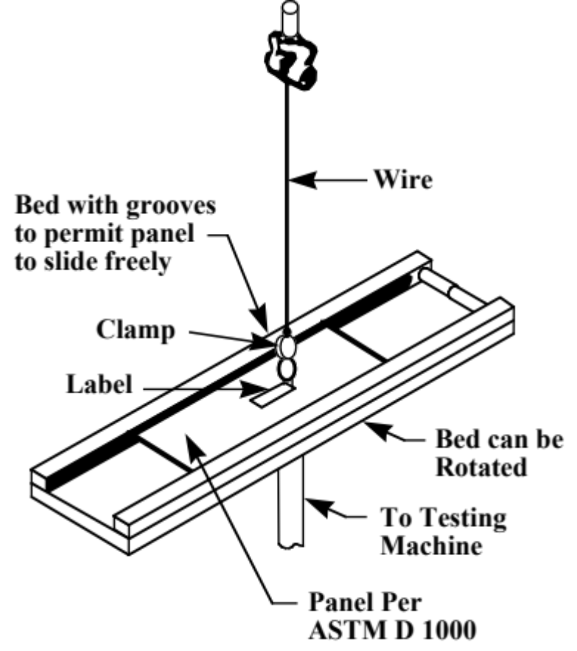

Figure 1 90 Degree Peel Test Apparatus

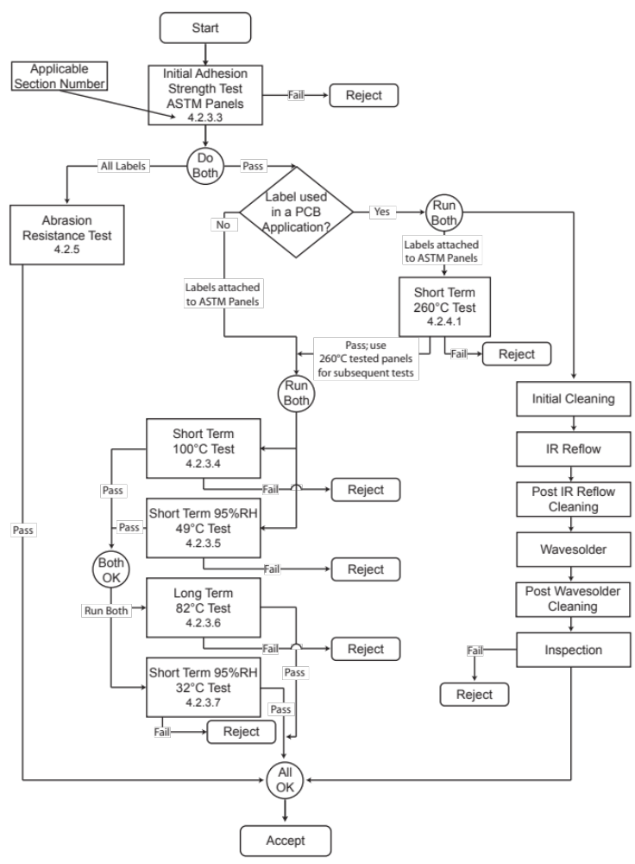Figure 2 Flow Chart

Bibliography (Informative)

ANSI MH10.8.12 Component Marking Standard,

GR-383-CORE COMMON LANGUAGE® Equipment Codes (CLEI™ Codes)— Generic Requirements for Bar Code Labels

MIL-STD-130 Department of Defense Standard Practice Identification Markings of U.S. Military Property

ATIS-0300038 Product Marking Implementation Guideline

