Proposed XML translation of ISO/IEC 15434 Data
Rick Schuessler
Symbol Technologies, a Motorola Company
August 12,2010

Based on this morning’s phone call, the consensus is for a single XML format, that is somewhat more generic than the original proposal, but promotes identical processing for all 15434 format envelopes. Also, it is a very simple translation process from 15434 to XML, because no format-specific parsing rules are required. Finally, as I proposed on the call, the scanner output should not include any space or tab characters for indentation; XML editors will automatically indent the input (I see this both using Windows Explorer, and Microsoft’s freeware “XML Notepad” editor, and I assume most other XML editors will provide similar formatting).

With these changes, the first example is translated from 15434 syntax to XML as follows:

Original input, as decoded by the scanner:

[)> ^{R}_{S} 06 ^{G}_{S} 25SUN043325711MH8031200000000001 ^{G}_{S} 1T110780 ^{G}_{S} Q21 ^{G}_{S} 4LUS ^{R}_{S} ^{E}O_{T}

Following are two representations of the Scanner’s XML output, as would be received through a USB Wedge. Figure 1 shows the data as plain text through the keyboard wedge (I’ve attached this output file as “xml20100812a.txt,” and Figure 2 shows the same file, when viewed through the XML Notepad editor.

Figure 1: plain text translation of the first example:

<?xml version="1.0" encoding="iso-8859-1"?>
<MSG_ISO_IEC_15434>
<FMT FI="06">
<GS/>
<data>25SUN043325711MH8031200000000001</data>
<GS/>
<data>1T110780</data>
<GS/>
<data>Q21</data>
<GS/>
<data>4LUS</data>
<RS/>
</FMT>
<EOT/>
</MSG_ISO_IEC_15434>

Figure 2: Figure 1’s output, as viewed in an XML editor:

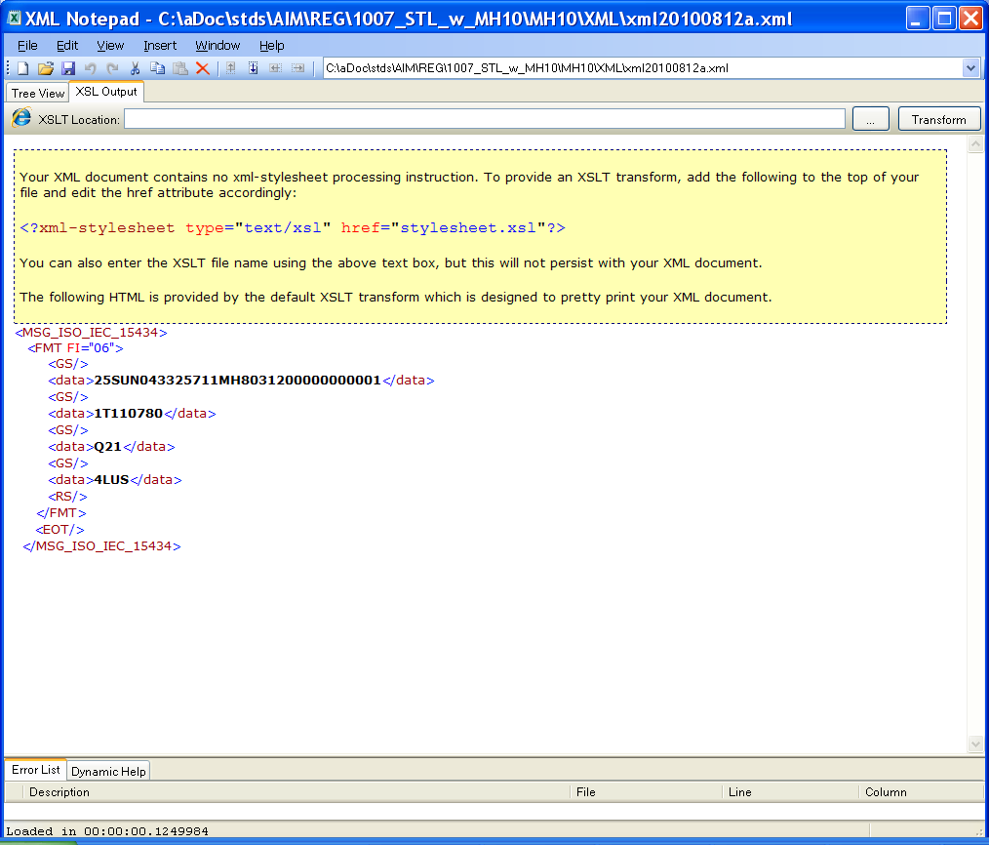

The multi-format AIAG example (as described in Don’s paper), now results in the XML as shown below:
<?xml version="1.0" encoding="ISO-8859-1"?>
<MSG_ISO_IEC_15434>
<FMT FI="06">
<GS/>
<data>25SUN98765432187654321A2B4C6D8E</data>
<RS/>
</FMT>
<FMT FI="06">
<GS/>
<data>P34567812</data>
<data>12V 345678912</data>
<data>TCC09030333333333</data>
<RS/>
</FMT>
<FMT FI="06">
<GS/>
<data>P23456781</data>
<data>12V 234567891</data>
<data>TBB09018222222222</data>
<RS/>
</FMT>
<FMT FI="06">
<GS/>
<data>P12345678</data>
<data>12V 123456789</data>
<data>TAA08274111111111</data>
<RS/>
</FMT>
<FMT FI="06">
<GS/>
<data>P45678123</data>
<data>12V 456789123</data>
<data>TDD09019444444444</data>
<RS/>
</FMT>
<FMT FI="06">
<GS/>
<data>P56781234</data>
<data>12V567891234</data>
<data>TEE09016555555555</data>
<RS/>
</FMT>
<EOT/>
</MSG_ISO_IEC_15434>

The processings steps are given below, for all 15434 formats except Format 09
- [NOTE: if “nn” equals “09”, this is the Binary format, which triggers some special processing rules (not given in this draft of the paper), because the translator needs to parse the encoded “number of bytes” field, and translated the subsequent data into one or more XML lines
<bytes>HHHHHH..HH</bytes>
until the indicated number of bytes have been translated. In particular, the Format 09 processing ignores any RS or EOT characters that may be found within the run of data bytes. The steps below therefore apply to all formats except Format 09, but it should not be difficult to add the rules for Format 09 processing once everything else is solidified]

The translation from 15434 to XML is based on the following processing steps:
- The input message begins with “[)>”, triggering the first two output lines of XML:
<?xml version="1.0" encoding="iso-8859-1"?>
<MSG_ISO_IEC_15434>
- The next input is always ^{R}_{S} nn; set process variable inFormat = True and emit the XML line:
<FMT FI="nn">
- Set process variables foundEOT and inDataString to False
- Loop until either an EOT is found, or the end of the input message is reached:
  - If inDataString is True, and the next input character is not printable ASCII, then:
    - Set inDataString to False;
    - terminate the currently stored XML line with “</data>”, and
    - emit this line of XML.
    - Proceed to the immediately-following set of “If” statements, to process this same next input character
  - If the next character is RS, then:
    - Set inFormat to False, and emit the following two XML lines:
<RS/>
</FMT>
    - Following this RS character, valid 15434 input will continue with either EOT or two decimal digits. If EOT, it will be processed by the next loop iteration, but if two decimal digits “nn” are found, then set inFormat to True, and emit
<FMT FI="nn">
and continue to the next loop iteration
  - Else, if the next character is EOT, then emit the two lines
<EOT/>
</MSG_ISO_IEC_15434>
Set foundEOT = True, and exit the loop, because processing is completed
  - Else, if the next character is either GS, FS, or LF then emit a line consisting of <GS/>, <FS/>, or <LF/> and continue loop processing,
  - Else, if the next character is non-printable, then
    - begin a new XML line with
<Bytes>
    - translate the character into two Hex characters from the set [0-9A-F]
    - continue translating to Hex until the next printable character is encountered;
    - terminate the current XML line with
<\Bytes>
and emit this XML line
    - set inDataString to True (we’ll process this next char on next loop iteration)
    - start a new XML line with “<data>”
  - Else (the next character is a printable character)
    - If inDataString is False
      - Set inDataString to True
      - start a new XML line with “<data>”
    - add the printable character to the current XML line and continue

After exiting the main loop, if foundEOT is still false (this will be the outcome for Format 02 and Format 08, and maybe for some future 15434 formats too), then emit the following lines of XML:
</FMT> (emit this XML line only if inFormat is still True)
</MSG_ISO_IEC_15434>

