Based upon our initial research into creating a standard XML format structure and to help maintain consistency with the ISO standard formatting, Figure 1, we believe the following XML format structure, Table 1, would work for the “05”, “06” and “12” Format Indicators.

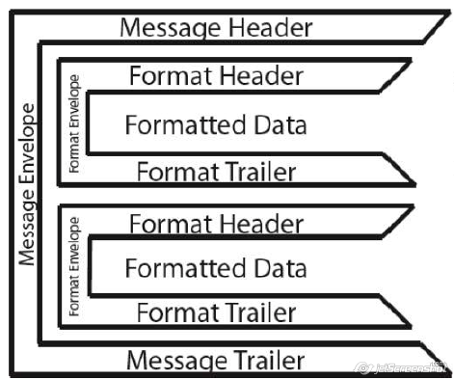

Figure : ISO Message Format

MSG – Message Envelope root element

FMT – Format Envelope element with a 2 character attribute indicating the associated Format Indicator

DE – Data Element child element

Table : XML Format Structure

|  |
| --- |
| <?xmlversion="1.0" encoding="ISO-8859-1"?>  <MSG>  <FMT FI="##">  <DE></DE>  </FMT>  <FMT FI="##">  <DE></DE>  <DE></DE>  <DE></DE>  <DE></DE>  </FMT>  </MSG> |

As for the other Format Indicators, Figure 2, we will continue to develop the format as there are extra formatting restrictions/parameters placed within those. For example: FI “07” indicates that two line feeds identify paragraphs, so the structure will have to take that into consideration as to not lose any information when presenting the returned information.

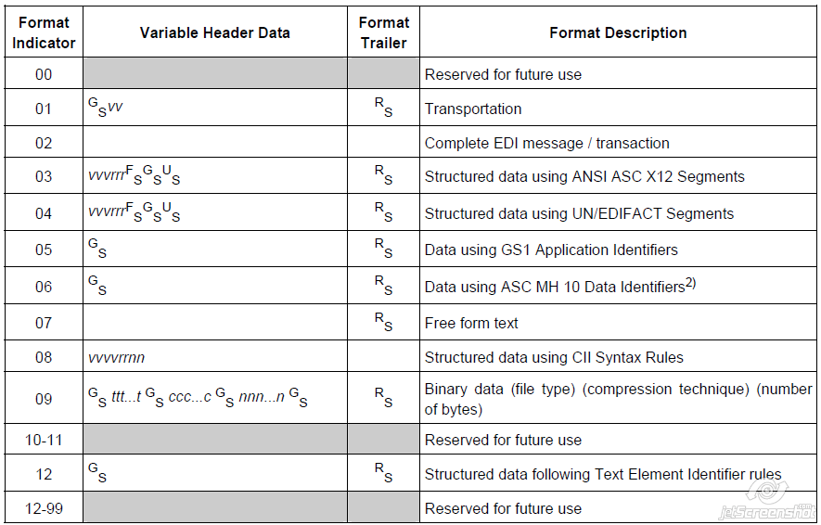

Figure : Format Indicators

Sample ISO/IEC 15434 messages:

**First Example:**

The first example, is from the new annex in ISO/IEC 15962 on 15434 support:

[)> RS 06 GS 25SUN043325711MH8031200000000001 GS 1T110780 GS Q21 GS 4LUS RS EOT

Table : First XML Example

|  |
| --- |
| <?xmlversion="1.0" encoding="ISO-8859-1"?>  <DATA>  <FMT FI="06">  <DE>25SUN043325711MH8031200000000001</DE>  <DE>1T110780</DE>  <DE>Q21</DE>  <DE>4LUS</DE>  </FMT>  </DATA> |

**Second Example:**

The second example, is from the AIAG’s B11 Item-Level Radio Frequency Identification (RFID) Standard. It contains multiple “Format 06” (DI) format envelopes within a single 15434 Message envelope, to represent a series of “records,” each record being one component of a completed assembly:

Which is the 15434 representation of the following table:

|  |  |  |  |  |  |  |
| --- | --- | --- | --- | --- | --- | --- |
| **Asmbly** | **DI** | **Part Number** | **DI** | **DUNS** | **DI** | **Trace Code** |
| **Gas Tank** | **25S** | **12345678** |  | **987654321** |  | **A2B4C6D8E** |
| **A** | **P** | **34567812** | **12V** | **345678912** | **T** | **CC09030333333333** |
| **B** | **P** | **23456781** | **12V** | **234567891** | **T** | **BB09018222222222** |
| **C** | **P** | **12345678** | **12V** | **123456789** | **T** | **AA08274111111111** |
| **D** | **P** | **45678123** | **12V** | **456789123** | **T** | **DD09019444444444** |
| **E** | **P** | **56781234** | **12V** | **567891234** | **T** | **EE09016555555555** |

Table : Second XML Example:

|  |
| --- |
| <?xmlversion="1.0" encoding="ISO-8859-1"?>  <DATA>  <FMT FI="06">  <DE>25SUN98765432187654321A2B4C6D8E</DE>  </FMT>  <FMT FI="06">  <DE>P34567812</DE>  <DE>12V 345678912</DE>  <DE>TCC09030333333333</DE>  </FMT>  <FMT FI="06">  <DE>P23456781</DE>  <DE>12V 234567891</DE>  <DE>TBB09018222222222</DE>  </FMT>  <FMT FI="06">  <DE>P12345678</DE>  <DE>12V 123456789</DE>  <DE>TAA08274111111111</DE>  </FMT>  <FMT FI="06">  <DE>P45678123</DE>  <DE>12V 456789123</DE>  <DE>TDD09019444444444</DE>  </FMT>  <FMT FI="06">  <DE>P56781234</DE>  <DE>12V567891234</DE>  <DE>TEE09016555555555</DE>  </FMT>  </DATA> |