YouTube Audio Transcription Workflow (n8n + OpenAI Whisper)
This document describes the n8n workflow developed to automatically transcribe YouTube videos using OpenAI's Whisper API. The workflow extracts the audio from a YouTube video, processes large files by splitting them into manageable chunks, transcribes each chunk, and then recombines the full transcript into a Google Docs file.

Workflow Overview
The automation begins with a YouTube URL input and performs the following tasks:
1. Extracts the YouTube video ID.
2. Downloads the audio from the video using an HTTP Request node connected to a YouTube MP3 API.
3. Splits large audio files (>20 MB) into smaller chunks.
4. Sends each chunk sequentially to OpenAI Whisper for transcription.
5. Combines all transcripts into one continuous text.
6. Creates a Google Docs file containing the complete transcript.
7. (Optional) Updates a Google Sheets log or notifies via Slack.
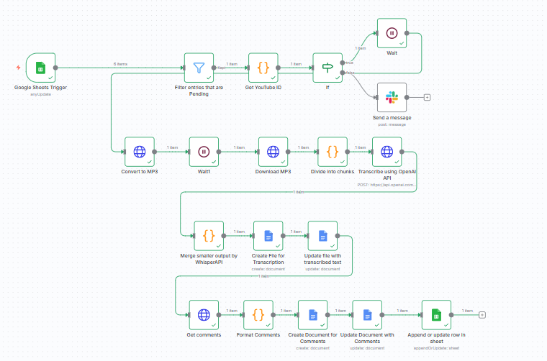

Node Descriptions

YouTube URL Input
Accepts the YouTube video URL as input (manual or from Google Sheets trigger).

Function Node – Extract Video ID
Extracts the unique YouTube video ID using a regex pattern for various URL formats.

HTTP Request – Get MP3 Link
Connects to a YouTube-to-MP3 API (e.g., RapidAPI) to retrieve an audio download link.

HTTP Request – Download Audio
Downloads the audio as binary data, stored in the workflow for processing.

Function Node – Split Audio File
Splits the binary audio file into 20MB chunks for compatibility with the Whisper API's file upload limits.

Split In Batches
Ensures each audio chunk is processed one at a time when calling the Whisper API.

HTTP Request – Whisper API
Sends each chunk to the OpenAI Whisper transcription endpoint and returns transcribed text.

Function Node – Combine Transcripts
Merges all partial transcripts into a single combined text output.

Google Docs – Create Document
Generates a new Google Doc containing the complete transcript, named based on the video title or ID.

Error Handling
• If the audio file is smaller than 20 MB, the Split Audio function bypasses chunking.
• The workflow validates video URL format and handles missing or invalid links.
• Failed API calls trigger n8n's built-in 'Continue on Fail' option for retries.
• The workflow ensures the correct order of transcript recombination.

Cost Considerations
The only costs associated with this workflow are API usage charges:
• YouTube MP3 API (RapidAPI): small per-request fee.
• OpenAI Whisper API: approximately $0.006 per minute of audio.
All Google integrations (Sheets, Docs, Drive) are free within Workspace limits.

Summary
This YouTube-to-Transcript workflow provides a reliable and automated way to convert video content into text. It leverages n8n’s modular automation capabilities, handles large files intelligently, and produces organized Google Docs ready for review or analysis.
Demo URL: https://www.loom.com/share/aecdb7d2641442de993fbc85ea1bd54c

