**Background**

I wrote UI automation tests for verifying Subscription prompt for an article on Financial Review web page.

# Tools/ Library Used

* Selenium Java library
* Extent report plugin
* TestNG execution engine

# Solution Components

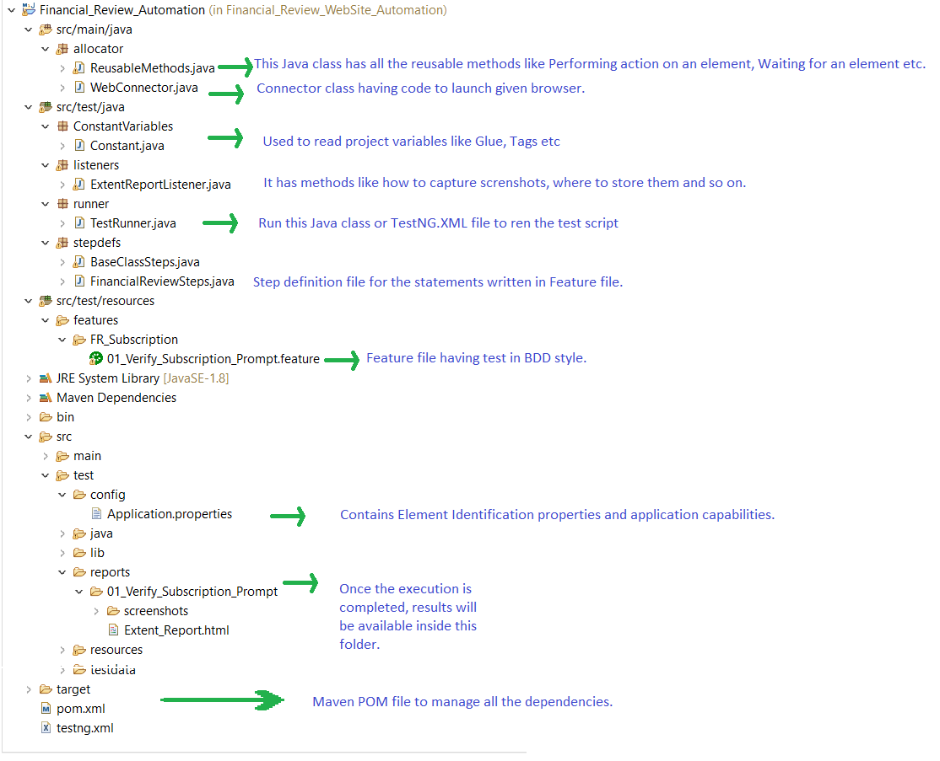

**How to Execute?**

*Please follow below steps:*

1. Ensure that Java and Maven is available on the machine.
2. Extract all the files from ZIP.
3. Launch Command Prompt.
4. Navigate to the project directory in CMD.

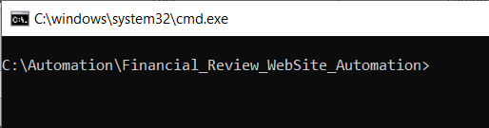

1. Once done, run the below Maven command to trigger execution:

## mvn clean test

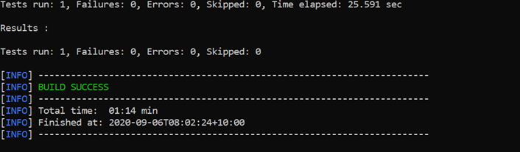

6. Once the execution is over, open the Extent_Report.html file from below path:

## .\Financial_Review_WebSite_Automation\src\test\reports\01_Verify_Subscription_Prompt

**Execution Results**

Once execution is completed successfully, HTML report will be generated, and will look like below:

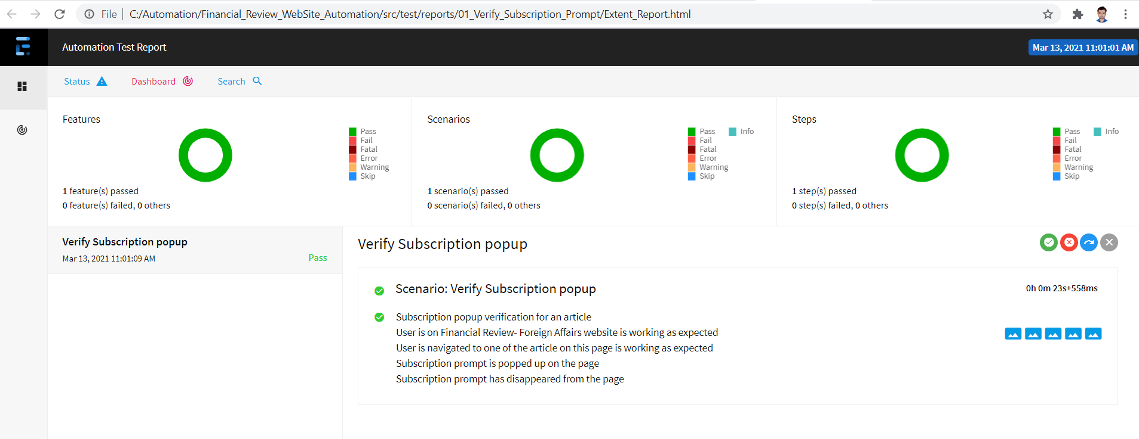

# Suggested Enhancements

Some of the ideas which is coming in my mind,

* 1. Currently the solution is Single Threaded, in future we can enhance this to multithreading.
  2. Integration with CI/ CD tool.
  3. Integration with Jira, so that Jira ticket will be updated by automation test itself.
  4. Containers Implementations.
  5. Can be integrated with tools like JACOCO or Sonarqube for Code Analysis.
  6. We can write Groovy to capture execution logs from Jenkins console and have a summarized HTML page.