How the Combined Sheet Works
A stakeholder guide to the JCPL Purchase "combined" tab — where its data comes from, how it is assembled, and what reads it
Prepared for the JCPL Enterprise Portal · 20 August 2026

1. What this document is
The "combined" tab is the single sheet every Purchase dashboard and every built Control in the JCPL Portal reads from. It is not typed by anyone — every cell is a formula that pulls from one of four other tabs in the same spreadsheet, or is calculated from another column in the same row. This document sets out, in plain terms and with diagrams, where that data comes from, how the sheet puts it together, what can go wrong, and what happens to it once it leaves the spreadsheet.
Everything marked verified live below was checked directly against the working sheet on 20 August 2026 by opening the cell and reading its actual formula. Everything marked inferred is a high-confidence conclusion from matching column names and values across tabs, not a formula we opened and read ourselves — flagged this way on purpose, so nobody mistakes a strong inference for a confirmed fact.

2. Where the data comes from
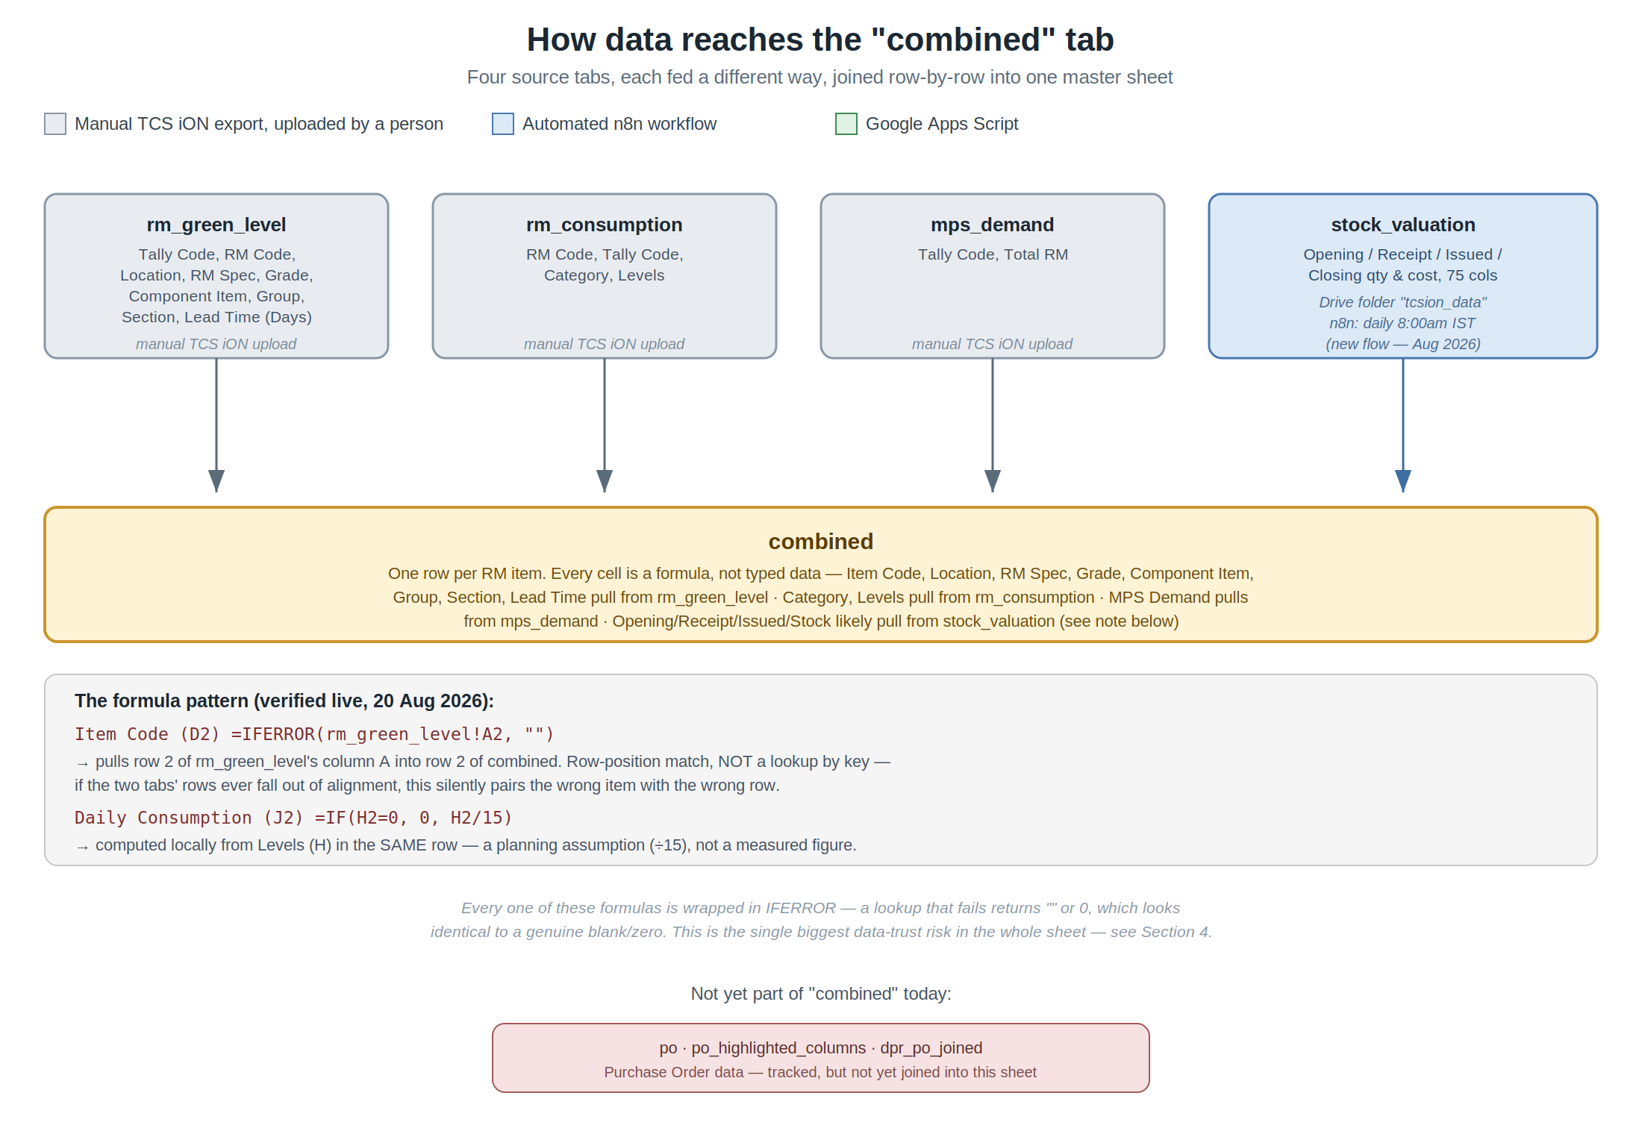

2.1 The four source tabs
Tab | Holds | Fed by | Feeds into "combined"
rm_green_level | Tally Code, RM Code, Location, RM Specification, Grade, Component Item, Group, Section, Lead Time (Days), Lead Time Consumption | Manual TCS iON export, uploaded by a person | Item Code, Location, RM Specification, Grade, Component Item, Group, Section, Lead Time (Days) — verified live
rm_consumption | RM Code, Tally Code, Category, Levels | Manual TCS iON export | Category, Levels — inferred from matching names/values
mps_demand | Tally Code, Total RM | Manual TCS iON export | MPS Demand — inferred
stock_valuation | 75 columns — Opening/Receipt/Issued/Closing quantity and cost per item, per TCS iON's Stock Valuation report | New n8n workflow — Drive folder "tcsion_data" polled daily at 8:00am IST, since 20 Aug 2026 | Opening, Receipt, Issued, Current Stock — inferred (matching column names; not individually formula-checked)

Green Level appears to simply mirror the Levels column — every row sampled on 20 Aug 2026 showed an identical value in both columns. This was observed from the displayed values, not confirmed by opening the Green Level formula, so it is noted here as an open question rather than a fact.

2.2 Not yet part of "combined"
Three tabs — po, po_highlighted_columns, and dpr_po_joined — hold Purchase Order Register data (86 columns per PO line, including PO Number, Date, Vendor, Ordered Qty, Rate and Status) but are not joined into "combined" today. This is exactly the feed Controls 1 and 2 ("is it already on order" / "did anyone order it") are waiting on — worth knowing that the raw data already exists in the spreadsheet, even though the join hasn't been built yet.

3. How the formulas actually work
Two formulas were opened directly in the live sheet on 20 August 2026 to confirm the mechanism:
Column (cell) | Formula | What it means
Item Code (D2) | =IFERROR(rm_green_level!A2,"") | Row-position copy from rm_green_level, column A. NOT a lookup by key.
Daily Consumption (J2) | =IF(H2=0,0,H2/15) | Computed from Levels (H) in the same row — a planning assumption, not a measurement.

The pattern that matters for every other column: "combined" copies row 2 of a source tab into row 2 of itself, row 3 into row 3, and so on — by position, not by matching an item code between the two tabs. If rm_green_level, rm_consumption or mps_demand is ever re-sorted, has a row inserted, or has a row deleted without the same change happening in every other tab at the same row number, every column pulled that way will silently show the wrong item's data. Nothing will look broken — the sheet will still show a plausible-looking number, just for the wrong row.

4. What can go wrong — and already has

4.1 IFERROR hides failures as blanks
Every formula seen in "combined" is wrapped in IFERROR, returning "" or 0 when the lookup fails. A failed lookup and a genuinely empty value are then indistinguishable on the sheet. This is the same pattern Rajeev Joshi's Control 7 ("is that zero a real zero, or a failed search") was written to catch, and it is confirmed present here at the source.

4.2 Positional joins break silently
Because the join between tabs is by row position and not by Tally Code, a single misaligned row in any source tab propagates to every column pulled from it, on every row below the misalignment, with no error and no warning.

4.3 A real example — 19–20 August 2026
The "combined" tab's own layout changed for several hours (a different join — Delivery/PO data — was substituted in its place), with no announcement. The portal's fetch job found no "Sr No." column, correctly detected the shape had changed, and — after a fix made the same day — began refusing to promote an empty or malformed fetch to "current," instead keeping the last known-good data live and emailing a warning. Before that fix, the empty result had been silently accepted for several hours, and every dashboard and control showed zero. This is the direct, real-world version of the risk described in 4.1 and 4.2 above.

5. What happens after "combined"
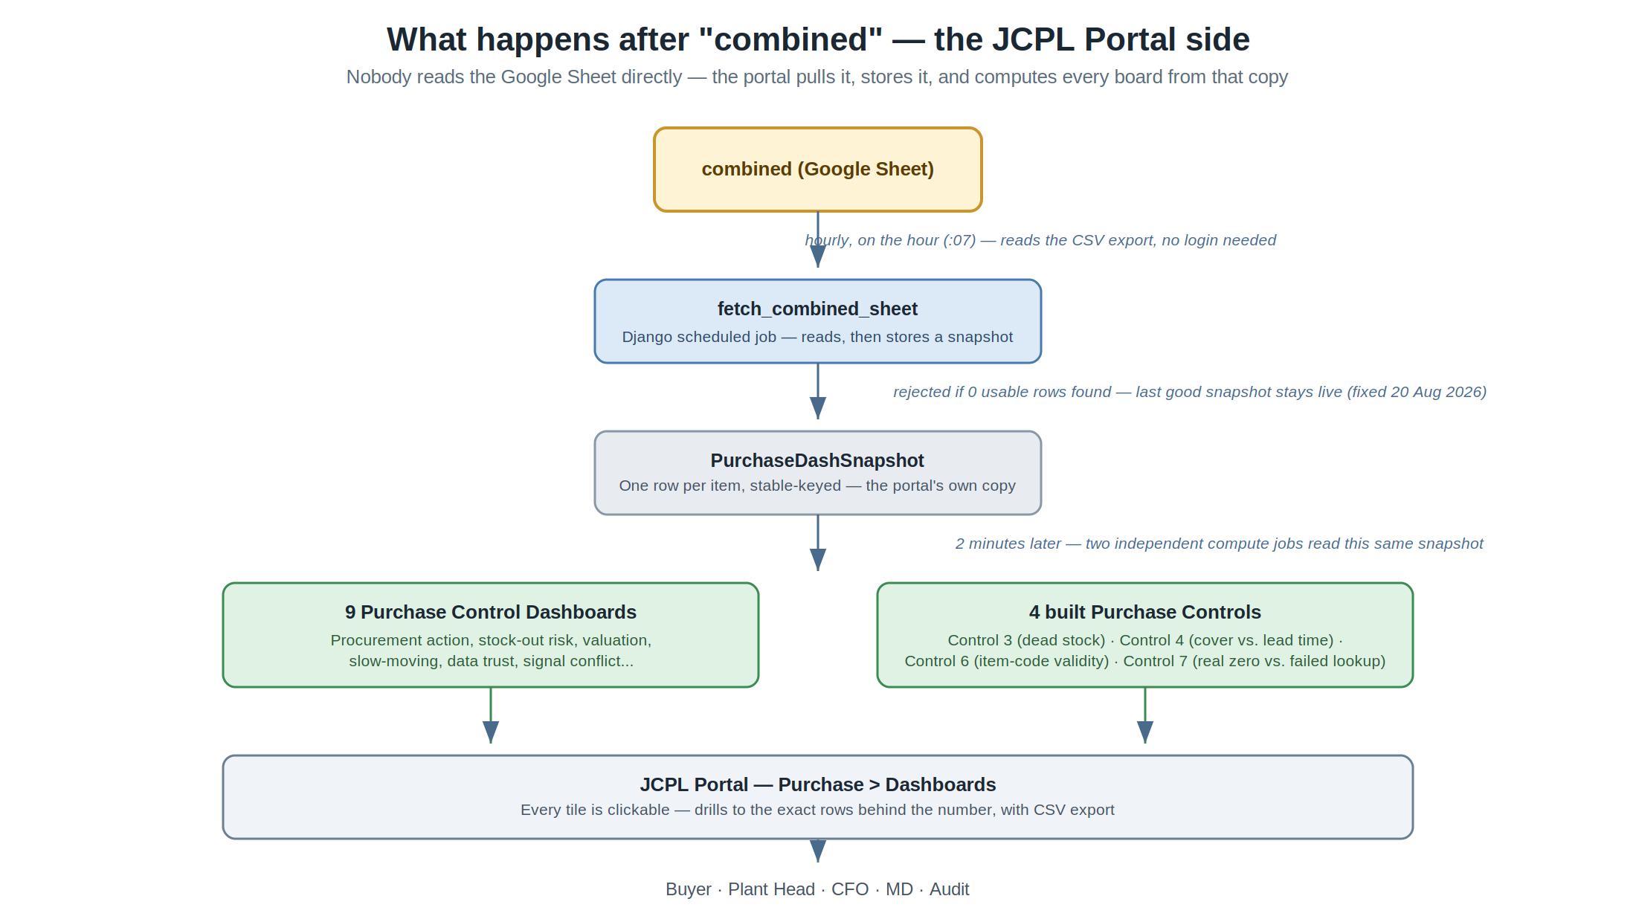
Nobody in the portal reads the Google Sheet directly. An hourly job (fetch_combined_sheet) pulls the whole tab, stores its own copy (one row per item, keyed by stable field names rather than column letters, so a header rename doesn't break anything downstream), and two minutes later two independent jobs compute every dashboard and every built Control from that stored copy. Neither the dashboards nor the Controls ever touch the Google Sheet themselves.
As of this document, four of the Seven Purchase Controls specified by STFATG Consultancy are built and live — Control 3 (dead-stock challenge), Control 4 (cover vs. lead time), Control 6 (item-code validity) and Control 7 (real zero vs. failed lookup). Controls 1, 2 and 5 remain specified but not built, pending the Purchase Order Register, Vendor Ledger and Goods Receipt feeds described in Section 2.2 and the original Control Build Specification.

6. Full tab reference
Tab | Role | Populated by
combined | The master sheet every dashboard and control reads. Formula-only. | Formulas reading the tabs below
rm_green_level | Item identity + lead time master list | Manual TCS iON upload
rm_consumption | Category + usage Levels | Manual TCS iON upload
mps_demand | Sales demand per item | Manual TCS iON upload
stock_valuation | Opening/Receipt/Issued/Closing qty & cost — 75 columns | New n8n flow, daily 8:00am IST, from Drive folder "tcsion_data"
stock_valuation_columns | A curated subset of stock_valuation's highlighted columns, rewritten every run | Google Apps Script, called after every stock_valuation write
dpr_po_joined | Append-only history of stock_valuation_columns — never cleared | Google Apps Script
po | Full TCS iON Purchase Order Register export — 86 columns | n8n PO workflow
po_highlighted_columns | A curated subset of po's highlighted columns, rewritten every run | Google Apps Script

7. Open questions worth a human answer
- Is the Green Level = Levels equality (Section 2.1) intentional, or should Green Level be its own policy figure?
- Should the row-position join (Section 3) be replaced with a real Tally-Code lookup, to remove the silent-misalignment risk in Section 4.2?
- When will the Purchase Order Register (po / po_highlighted_columns) be joined into "combined", unlocking Controls 1 and 2?
- Who owns the "combined" tab's formulas, and can a change to them be announced before it goes live — the incident in Section 4.3 happened with no notice?

