SMTP Credential Setup — Security Record
How outbound email is configured for the JCPL Enterprise Portal, what protects the credential, and one known exposure and its remediation
JCPL Enterprise Portal · 20 August 2026

1. What this document is
On 20 August 2026 the portal was wired to send real email — login alerts, upload confirmations, combined-tab fetch failures, dashboard/control recompute summaries — through a Google Workspace mailbox. This document records exactly what was configured, where the credential lives, what protects it, and a real exposure that happened during setup, so there is a single accurate reference rather than relying on chat history.
No secret values appear anywhere in this document — field names and configuration facts only. Anyone who needs the actual credential should read it from /root/.env directly on the server.

2. What's configured
Setting | Purpose
JCLP_SMTP_HOST | smtp.gmail.com — Google Workspace's SMTP relay
JCLP_SMTP_PORT | 587 — STARTTLS submission port, not the older unencrypted port 25
JCLP_SMTP_USER | automation@jollyclamps.com — the authenticating mailbox
JCLP_SMTP_PASSWORD | A Google App Password, not the account's real login password — scoped to SMTP only, revocable independently of the main account credential
JCLP_SMTP_TLS | True — connections are encrypted in transit, not sent in the clear
JCLP_SMTP_FROM | automation@jollyclamps.com — matches the authenticated user, so Gmail won't reject or flag it as spoofed
JCLP_ALERT_EMAIL | automation@jollyclamps.com — where every alert is sent

Using an App Password rather than the mailbox's real password is deliberate: it can be revoked on its own without changing the account's main login, Google requires 2-Step Verification to be enabled on the account before one can even be issued, and it cannot be used to sign in to the account interactively — only for the one purpose (SMTP, in this case) it was created for.

3. Where it lives, and what protects it
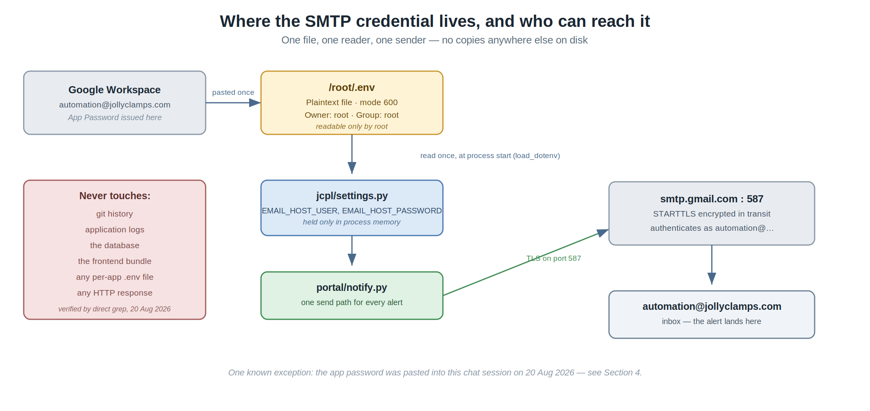
Check | Status | Detail
File permissions | OK | /root/.env is mode 600, owned by root:root — no other user or process on this server can read it
Single source of truth | OK | Exactly one file, one call site (jcpl/settings.py) reads it — no per-app copies exist anywhere
Version control | OK | No git repository exists anywhere in the deployment — the credential cannot have been committed
Application logs | OK | Directly checked (grep) — the password does not appear anywhere in logs/django.log
Transport encryption | OK | TLS (STARTTLS) enforced on port 587 — the credential and message body are encrypted in transit
Failure handling | OK | portal/notify.py never raises — a send failure cannot surface the credential in an error page or stack trace
Chat exposure | EXPOSED | The App Password was pasted directly into the Claude Code chat session during setup on 20 Aug 2026 — see Section 4

4. Known exposure and remediation
During setup, the Google App Password was typed directly into the chat session rather than entered on the server. Claude declined to write it into any file at that point and asked for it to be entered directly on the server instead; it was pasted in chat again immediately afterward, and Claude flagged at the time that the credential should be treated as compromised and rotated.
Whether that rotation has actually been carried out is not something this session can confirm on its own — recorded here as an open action item rather than assumed done.

4.1 To rotate it
- Google Account → Security → App Passwords → revoke the existing one for this purpose.
- Generate a new App Password.
- On the server: nano /root/.env, replace the JCLP_SMTP_PASSWORD= line with the new value, save.
- No restart is required for this specific change if the running process re-reads .env on its next SMTP send; if in doubt, restarting the Django process picks it up immediately.
- Ask whoever has access to this chat's history to treat the old value as void — it no longer matters once revoked, but worth confirming no other automation was ever pointed at it.

5. Recommendations
- Rotate the App Password now if this hasn't already happened (Section 4).
- Do not paste credentials into chat going forward — the correct pattern, used successfully for every other secret in this project, is to edit /root/.env directly on the server.
- Consider a calendar reminder to rotate this App Password periodically (e.g. every 90 days) even without a known exposure, as routine hygiene.
- If more automations start sending mail, keep them all going through portal/notify.py's single send path rather than each holding its own copy of the credential.

6. Adjacent findings (not SMTP, but noticed along the way)
Two unrelated Django settings were observed while reviewing this configuration. Neither is part of the SMTP setup, but both are worth a deliberate decision rather than staying as defaults indefinitely:
Setting | Currently
JCLP_DJANGO_DEBUG | True — Django's debug pages (full stack traces, settings values) would be shown on an unhandled error. Standard for active development; worth turning off before this is someone's daily production tool with no further development happening.
JCLP_DJANGO_ALLOWED_HOSTS | * — accepts any Host header. Fine behind the current nginx setup; worth narrowing to the server's actual hostnames/IP if this is ever exposed more broadly.

