Alerts in Selenium WebDriver

In this tutorial, we will discuss alert that pop-up while working with web applications and how to handle them. The very first question that arises is***“What is an Alert?”***

* Alert is a small box that appears on the display screen with a message and an OK button.
* The message can be some information or a warning.
* Alerts couldn’t be ignored. It needs to be accepted or rejected before you can proceed ahead with your further actions on the web page. For example- You click on any button on a web page it gives an alert with some message. Now you can either accept that alert or reject it.

Exception : **UnhandledAlertException: Modal dialog present**

**NoAlertPresentException: Message: no such alert**

## Types of Alerts

Java scrip provides mainly following three types of alerts:  
***1. Simple alert***

***2. Confirmation alert***

***3. Prompt alert***

## Handling alerts using Selenium WebDriver

Selenium provides us with an interface called ***Alert***. It is present in the ***org.openqa.selenium.Alert*** package. Alert interface gives us following methods to deal with the alert:

* ***accept()*** To accept the alert
* ***dismiss()*** To dismiss the alert
* ***Text()*** To get the text of the alert
* ***sendKeys()*** To write some text to the alert

Lets use these to handle the above mentioned types of alerts one by one.

## Simple alert

Simple alerts just have a***OK*** button on them. They are mainly used to display some information to the user. The first alert on our test page is a simple alert. Following code will read the text from the Alert and then accept the alert. Important point to note is that we can switch from main window to an alert using thedriver.switch_to.alert()***.*** Below is the usage of that also:

Alert = driver.switch_to.alert()

Alert.accept()

## Confirmation Alert

This alert comes with an option to accept or dismiss the alert. To accept the alert you can use **Alert.accept()** and to dismiss you can use the***Alert.dismiss()***. Here is the code to dismiss a prompt alert.

Alert = driver.switch_to.alert()

Alert.accept() # for positive flows like ok, yes etc

#Or

#Alert.dismiss() # for negative flows like cancel, no etc

## Prompt Alerts

In prompt alerts you get an option to add text to the alert box. This is specifically used when some input is required from the user. We will use the ***sendKeys()***method to type something in the Prompt alert box. Here is the code

Alert = driver.switch_to.alert()

Alert.send_keys() # for entering the values in text box

Alert.text() #for getting the value from UI

SCENARIO-1

Step 1- Navigate to URL <http://www.w3schools.com/js/tryit.asp?filename=tryjs_alert>

Step 2- Click “Try it” button.

Step 3- An alert will pop-up with a message “I am an alert box”. Get this message through the script.

Step 4- Click “OK” to accept the message.

Please refer below image for more clarity.

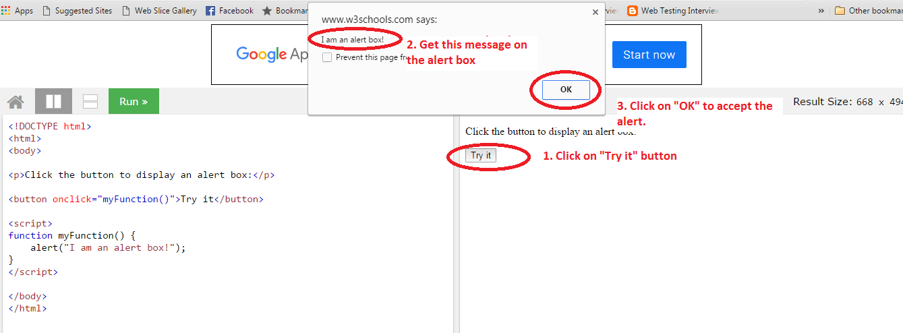

**So, here is the code for above steps:**

**from selenium import webdriver  
import time  
from selenium.webdriver.support.ui import Select  
  
driver = webdriver.Chrome (executable_path="D:\Webdriver\chromedriver.exe")  
  
#Example 1 - Simple Alert  
driver.set_page_load_timeout(45)  
driver.get("https://www.w3schools.com/js/tryit.asp?filename=tryjs_alert")  
driver.implicitly_wait(30)  
driver.maximize_window()  
  
driver.switch_to.frame(driver.find_element_by_xpath("//iframe[@id='iframeResult']"))  
driver.find_element_by_xpath("//button[@onclick='myFunction()']").click()  
print(driver.switch_to.alert.text)  
driver.switch_to.alert.accept() # click on Ok, Yes,  
  
*#Example 2 - Confirmation Alert*'''  
driver.get("https://www.w3schools.com/js/tryit.asp?filename=tryjs_confirm")  
driver.implicitly_wait(30)  
driver.maximize_window()  
  
driver.switch_to.frame(driver.find_element_by_xpath("//iframe[@id='iframeResult']"))  
driver.find_element_by_xpath("//button[@onclick='myFunction()']").click()  
time.sleep(5)  
#driver.switch_to.alert.dismiss()  
driver.switch_to.alert.accept()  
'''  
  
*# Example 3 Prompt Alert*driver.get("https://www.w3schools.com/js/tryit.asp?filename=tryjs_prompt")  
driver.implicitly_wait(30)  
driver.maximize_window()  
  
driver.switch_to.frame(driver.find_element_by_xpath("//iframe[@id='iframeResult']"))  
driver.find_element_by_xpath("//button[@onclick='myFunction()']").click()  
time.sleep(2)  
  
print(driver.switch_to.alert.text)  
driver.switch_to.alert.send_keys("Shaikat")  
driver.switch_to.alert.accept()**