Iframe handing in Selenium WebDriver

Iframes, in html, are used to divide a web page into multiple sections or to display a web page within another web page.

To interact with any WebElement of a frame. First, we have to switch to that frame and then only WebElements can be identified.

In this tutorial, i will be using word “frame” and “iframe” interchangeably.

***Note: Frames are generally not visible using “Firepath”, refer html tab of “Firebug” to identify a frame.***

Refer below image to see how frames are defined in a page. Inside a frame, another page is embedded.

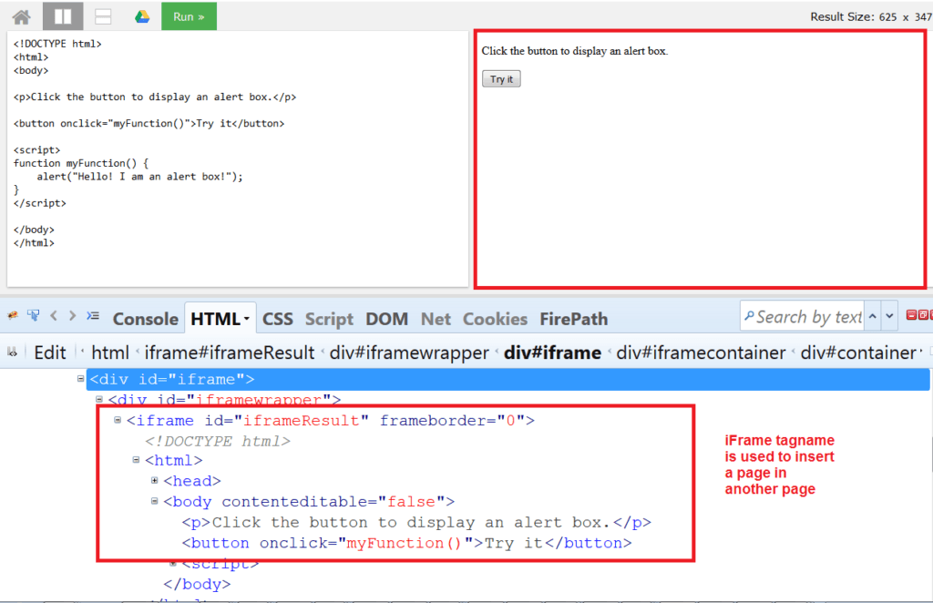

<iframe id="iframeResult" frameborder="0">

**iframe** tag is used to define a frame.

Now to switch to a frame we have three options:

* **Switch to a frame with an Index –** All the frames in a Web Page are assigned an index starting from 1.

***driver.switch_to.frame(1)***

* **Switch to a frame with an ID/ name –**Most of the time, frames has an ID/name attribute assigned to it. If a frame has an Id, we can use below method

***driver.switch_to.frame("iframeResult")***

* **Switch to a frame as a Web Element –**When a frame does not have an Id, and switch with an Index is never a good way. In that case, we are left with one option and that identifying a frame as a web element and then switch to it. Refer below code for better understanding:

## *driver.switch_to.frame(driver.find_element_by_xpath("//*[@name='iframeResult']"))*

## Switching back to Main page from frame:

There is an important command that will help us to get back to the main page. Main page is the page in which two frames are embedded. Once you are done with all the task in a particular frame, you can switch back to the main page using the **switchTo().defaultContent()**. Here is the sample code which switches the driver back to main page.

***driver.switch_to.default_content()***

***driver.switch_to.parent_frame()***

Note: To switch back to main page/frame,we can also use **switchTo().parentFrame()**.The difference between defaultContent() and parentFrame() is that the defaultContent() switches the control to the most parent page whereas the parentFrame() switches the control to the parent frame (in case of nested frames scenario)

## Exceptions while handling with frames:

The common exceptions we face while handling frames are:

### NoSuchElementException:

* + If we try to access the elements in frame without switching in to the frame; then “NoSuchElementException” will be thrown

### NoSuchFrameException:

* + We will get no Such frame exception if you try to switch to the frame which does not exist in the page or if you try to switch to another frame without switching back to the main page