## Task 2: AWS Cloud

Tasks:

1. Sign up for AWS, familiarize yourself with the basic elements of the AWS Home Console GUI.
2. Explore AWS Billing for checking current costs. **[I am using acloudguru LAB i.e. i don’t have access to billing]**
3. Create two EC2 Instance t2.micro with different operating systems (Amazon linux / Ubuntu ...). Try to stop them, restart, delete, recreate.
4. Make sure there is an SSH connection from your host to the created EC2. What IP EC2 used for it?
5. Make sure is an ping and SSH passed from one instance to another and vice versa. Configure SSH connectivity between instances using SSH keys.
6. Install web server (nginx/apache) to one instance;

* Create web page with text “Hello World” and information about OS version;
* Make sure web server accessible from internet and you can see your web page “Hello World” in your browser;
* Make sure in instance without nginx/apache you can see “Hello world” from instance with nginx/apache.

EXTRA:

1. Run steps 3-6 with instances created in different VPC. (connectivity must be both external and internal IP)
2. Write BASH script for installing web server (nginx/apache) and creating web pages with text “Hello World”, and information about OS version
3. Run step.6 without “manual” EC2 SSH connection.

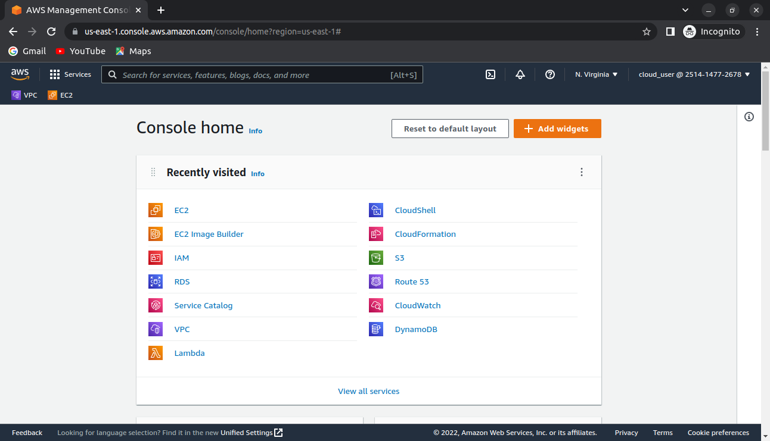Explore AWS Billing for checking current costs. **[I am using acloudguru LAB i.e. i don’t have access to billing]**

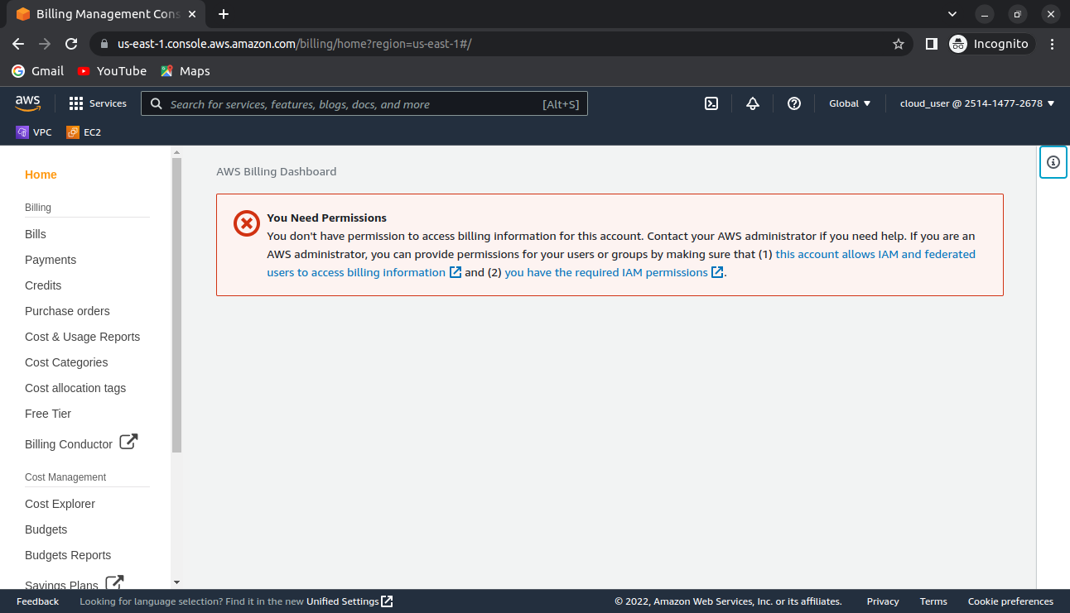

**Create two EC2 Instance t2.micro with different operating systems (Amazon linux / Ubuntu ...). Try to stop them, restart, delete, recreate.**

**Using default VPC.**

 