Task 2: AWS Cloud

Tasks:
- Sign up for AWS, familiarize yourself with the basic elements of the AWS Home Console GUI.
- Explore AWS Billing for checking current costs. [I am using acloudguru LAB i.e. i don’t have access to billing]
- Create two EC2 Instance t2.micro with different operating systems (Amazon linux / Ubuntu ...). Try to stop them, restart, delete, recreate.
- Make sure there is an SSH connection from your host to the created EC2. What IP EC2 used for it?
- Make sure is an ping and SSH passed from one instance to another and vice versa. Configure SSH connectivity between instances using SSH keys.
- Install web server (nginx/apache) to one instance;
- Create web page with text “Hello World” and information about OS version;
- Make sure web server accessible from internet and you can see your web page “Hello World” in your browser;
- Make sure in instance without nginx/apache you can see “Hello world” from instance with nginx/apache.
EXTRA:
- Run steps 3-6 with instances created in different VPC. (connectivity must be both external and internal IP)
- Write BASH script for installing web server (nginx/apache) and creating web pages with text “Hello World”, and information about OS version
- Run step.6 without “manual” EC2 SSH connection.
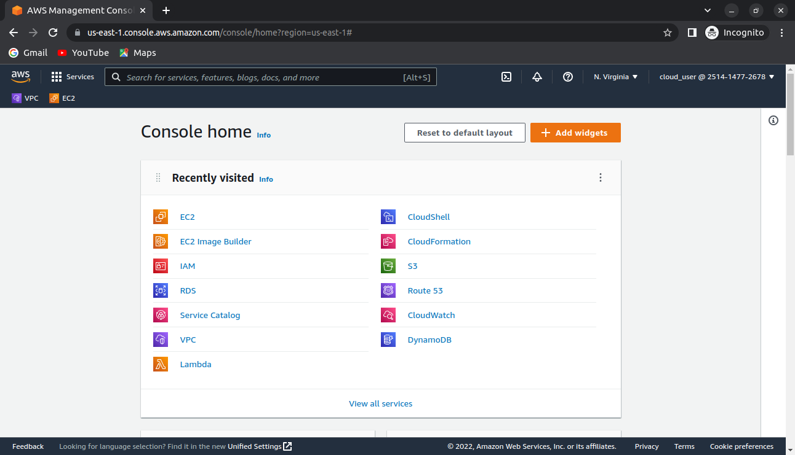
Explore AWS Billing for checking current costs. [I am using acloudguru LAB i.e. i don’t have access to billing]
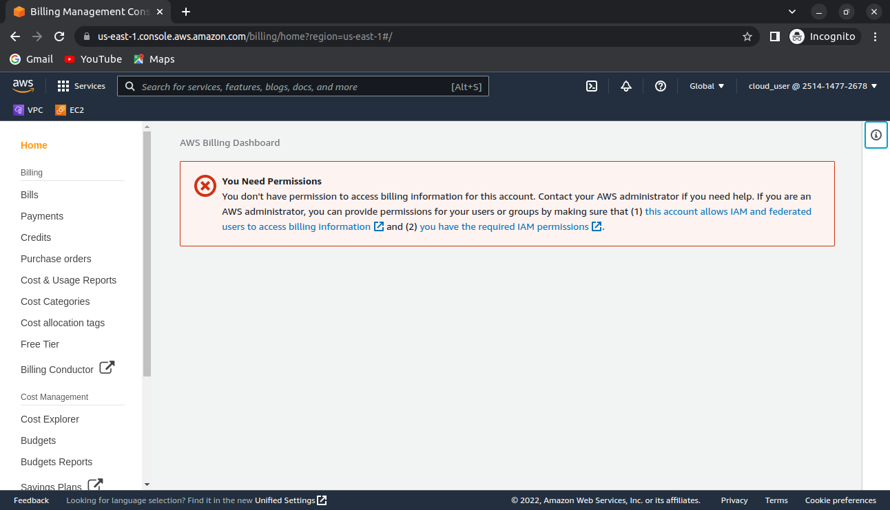
Create two EC2 Instance t2.micro with different operating systems (Amazon linux / Ubuntu ...). Try to stop them, restart, delete, recreate.

Using default VPC.
