**V1 Doc - Whiteboard Interview**

We focused most of our attention to QA for the V1 release

**Features**

All of our core features have been implemented. Throughout the quarter, we had many ideas for minor features / improvements. However, we felt that this phase we should focus on QA of the existing features. Still, we pretended there is a hypothetical future maintenance team. In which case, we added issues in our issue tracker for future fixes. However, we did add some features

- When refreshing the interview page, the language mode is saved between refreshing. Previously, it would default back to Java. This wasn’t a bug, but just an improvement.

- There was some ambiguity in the Requirements doc on how the create session interface would work. We did a bit of touchup here.

**Bug Fixes**

On the left is a sample screenshot of our issue tracker. We focused on testing, and writing “unit tests” for humans to read, to test user-centric features are working as expected, because we did not have time to implement automated testing of front end features. We also progressing towards being more formal, introduced a standard convention for bug reporting, screenshot on the right. Previously, it was pretty ad hoc. Our convention indicates Severity, Description, How to reproduce the bug, and utilizes Github issue tracker to assign the bug to a fixer. (Pictures on next page)

|  |  |
| --- | --- |
|  |  |

In our testing phase, we accidentally triggered a bug that sent out a lot of emails, good thing we discovered this before the app really went public… We also decided to have all our docs on Git rather than a dropbox, and small administrative issues like that.

**User Interface**

We had UI update right before the Beta. Technically, it was not supposed to be part of Beta, and was instead an early release.

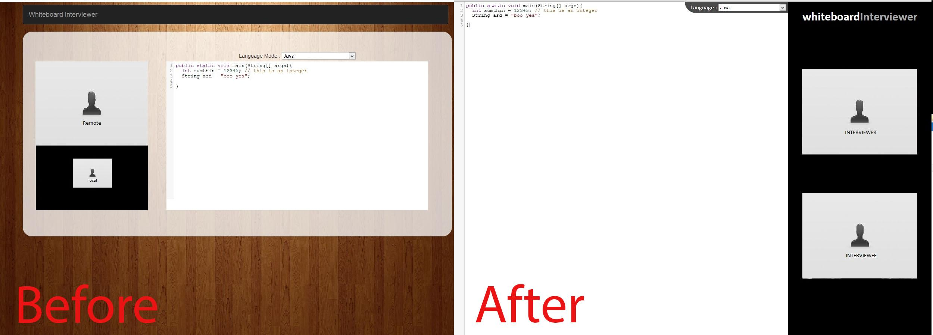

Our UI is very minimal. This is a decision where we felt we should not distract the user from the core feature of our program: programming & typing. Check out this blog post that reflect a similar philosophy: <http://lifehacker.com/5689579/five-best-distraction+free-writing-tools>. Whereas many text editors have loads and loads of features, the writing tools in that blog post have a single feature: typing. The UI is very minimal and has a clean monotone background, without buttons and menus everywhere.

**User Documentation**

See the documents section on our webpage <http://cubist.cs.washington.edu/projects/13au/cse403/cse403g/>, there is a new document called “Walkthrough”. Also, we added a FAQ section. We’ve implemented the FAQ section so we merely update a JSON formatted question / answer document, that will update our FAQ section on the page.