User Documentation for Underactuated
Three-link Biped

This is the only documentation you have other than the comments in the files. The authors do NOT support the software in any way. The software is offered for your free noncommercial use. The code has been run successfully on MATLAB 6.5 on a PC. Use of the software in a unix environment may require minor changes where directories and paths are involved.

The copyright © to all software in this package is held by Professor Jessy Grizzle, University of Michigan, Professor Eric Westervelt, The Ohio State University, and Mr. Ben Morris, University of Michigan. Any use of this software that results in a publication of any sort must be accompanied with a proper citation to the source of the software. You are not permitted to distribute this software. You may edit the software for your own use as long as you include a citation to the original source. If use of the edited software results in a publication of any sort, you must still make a proper citation to the source of the original software.

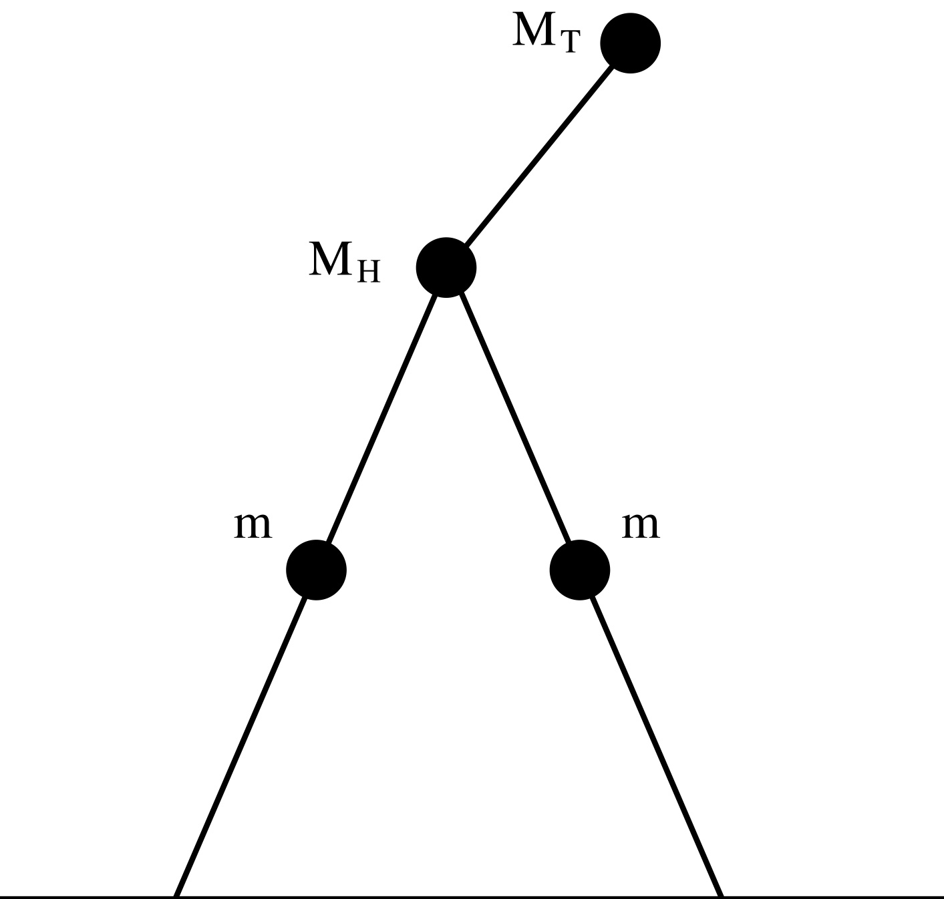

The following directories should be present:
- symbolic
- functions_auto_gen
- functions_manual
- simulation

symbolic: this directory contains files that use the symbolic toolbox in MATLAB to generate the dynamic model of the robot using the method of Lagrange. The main file is symb_model_biped_3dof.m which computes the 3-DOF swing phase dynamics and the 5-DOF dynamics required for the impact model. In addition, it symbolically computes functions required for the feedback controller based on hybrid zero dynamics. Finally, this file calls other files that then write out the symbolic data as m-files that can be called in ODE45. These files are placed in the directory functions_auto_gen. The coordinate system used in the model is documented in the file fig_biped_newer_coordinates.jpg

functions_auto_gen: this directory contains the m-files that are produced by symb_model_biped_3dof.m When the symbolic file is run, the files in this directory are automatically updated. You may wish to make a backup copy of this directory before executing the symbolic code.

functions_manual: this directory contains miscellaneous m-files that have been hand coded. The files in this directory are permanent in the sense that executing the symbolic code does not change them.

simulation: this directory contains files that are specific to executing a complete simulation of the biped in closed loop with a controller based on the hybrid zero dynamics. The main file is test_full_simu.m It first sets the parameters in the controller, the initial conditions of the robot, and a few gait parameters. It then calls the function
[x,t]=full_simul(x0,a,theta_minus,steps,do_animation,draw_graphs)
which simulates the closed-loop system, produces relevant plots, and performs and animation of the gait.

Quick start: start MATLAB, “cd” to the directory “simulation” and execute the m-file “test_full_simul”. The default is to take 10 steps, perform an animation of the motion, and plot the trajectories of the joint angles and the torques.

